[Connect-us] Stock Verification Activity

07.09.2023

Priyanka Suhas Gole

Priyanka.gole@techneai.com

**Functional Requirement Document**

**CONTENTS**

1. TICKET DETAILS 2

2. VERSION CONTROL 2

3. APPROVALS 2

4. ESTIMATION 2

5. INTRODUCTION 3

6. BUSINESS REQUIREMENT 3

7. SCOPE 3

8. BUSINESS & SYSTEM RULES 3

9. ABBREVIATIONS & TERMS 3

10. EXISTING SYSTEM 3

11. GRAPHICAL REPRESENTATION 3

12. PROPOSED SYSTEM 3

13. TEST DATA 4

14. ODUS 4

15. REFERENCES OF THE USERS 5

1. **TICKET DETAILS**

|  |  |
| --- | --- |
| **Ticket ID** | TT13634 |
| **Ticket description** | Correct the error message on mismatched daily stock verification activity |
| **Created by** | @Annapa Tikone |
| **Created on** | //28-06-2023 |
| **Priority** | high |

1. **VERSION CONTROL**

|  |  |  |  |  |
| --- | --- | --- | --- | --- |
| **Sr. No** | **Version no** | **Version Date** | **User name** | **User department** |
| **1** | **1** | **07-09-2023** | **Annapa Tikone** | **Akluj Branch** |
| **2** | **2** | **07-09-2023** | **Vijay Gophane** | **Akluj Branch** |
|  |  |  |  |  |

1. **APPROVALS**

|  |  |  |
| --- | --- | --- |
| **Field** | **Name of the User** | **Approved date by the user** |
| **Actual User Name Actual User Department Organization Name** | Annapa Tikone  Akluj Branch  CSPL |  |
| **Assigned BA** | Priyanka Gole |  |
| **Assigned Developer** |  |  |
| **Assigned Tester** |  |  |

1. **ESTIMATION**

|  |  |  |  |  |
| --- | --- | --- | --- | --- |
| **Department name** | **Estimated Time (In hr)** | **Scheduled Date (Starting date)** | **Estimated date** | **Actual delivery date** |
| **BA** | 2 |  |  |  |
| **Development** |  |  |  |  |
| **Testing** |  |  |  |  |
|  |  |  |  |  |

1. **INTRODUCTION**

In the Connect-Us, to verify actual stock available at branch location is matching with stock available in the padm, stock verification activity is conducted.

In the Connect-us, stock verification activity is conducted to check whether stock available in the padm is matching with stock available at the branch location.

Padm is the web system used in the branch for multiple purpose starting from stock transfer to sale of the stock and reporting of each and everything.

1. **BUSINESS REQUIREMENT**

Stock verification activity in the connect-us checks stock availability in the system and actual location.

Enter the date and type to check the stock. For e.g todays date and type as mismatched. Check stock button will show all the mismatched entries.

Users requirement is to change the error message, coming after complete verification activity button by managers login. So change the error message.

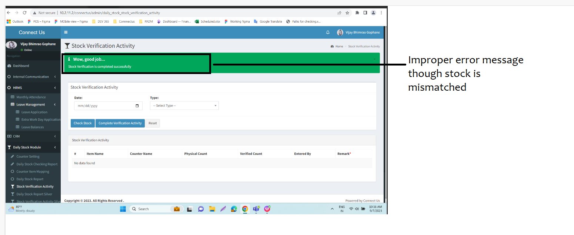

|  |  |  |  |
| --- | --- | --- | --- |
| **Requirement ID** | **Requirement Name** | **Short Description** | **Priority** |
| BR001 | Change error message | change the error message if stock is not matched with physical stock and verified stock. | Medium |

1. **SCOPE**

Scope of the project is to change the error message if stock is not matched with physical stock and verified stock.

1. **BUSINESS & SYSTEM RULES**

* User should be logged in.
* System should display error message for incorrect details if entered.
* System should pop up a message, if any issues in the system is detected.

1. **ABBREVIATIONS & TERMS**

Connect-Us - CU

1. **EXISTING SYSTEM**

Existing system giving improper error message though stock is not matched

1. **GRAPHICAL REPRESENTATION**

Following is the process flow

Logged in by In out role

Stock verification Activity

Enter Date and type as mismatched

Data displayed in the gridview

If data is not matching then display proper message.

User checks and adds verified count and remark then clicks on complete verification activity

1. **PROPOSED SYSTEM**

By using Daily stock report, sales person enters the stock count available on the counter and its matched with system. If it is matching then shows below notification

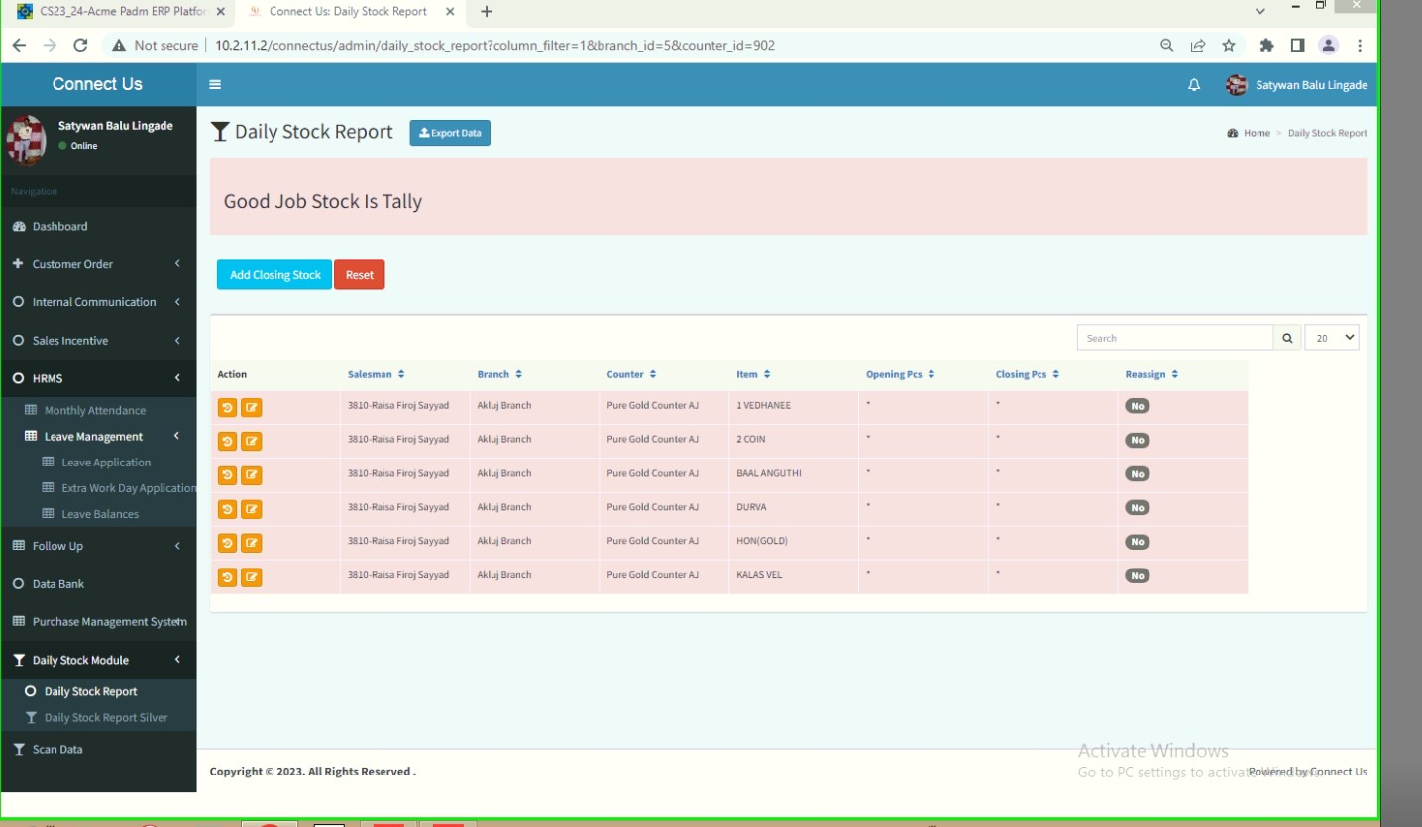

If not matched by sales person login for 3 times then below message displayed on CU system

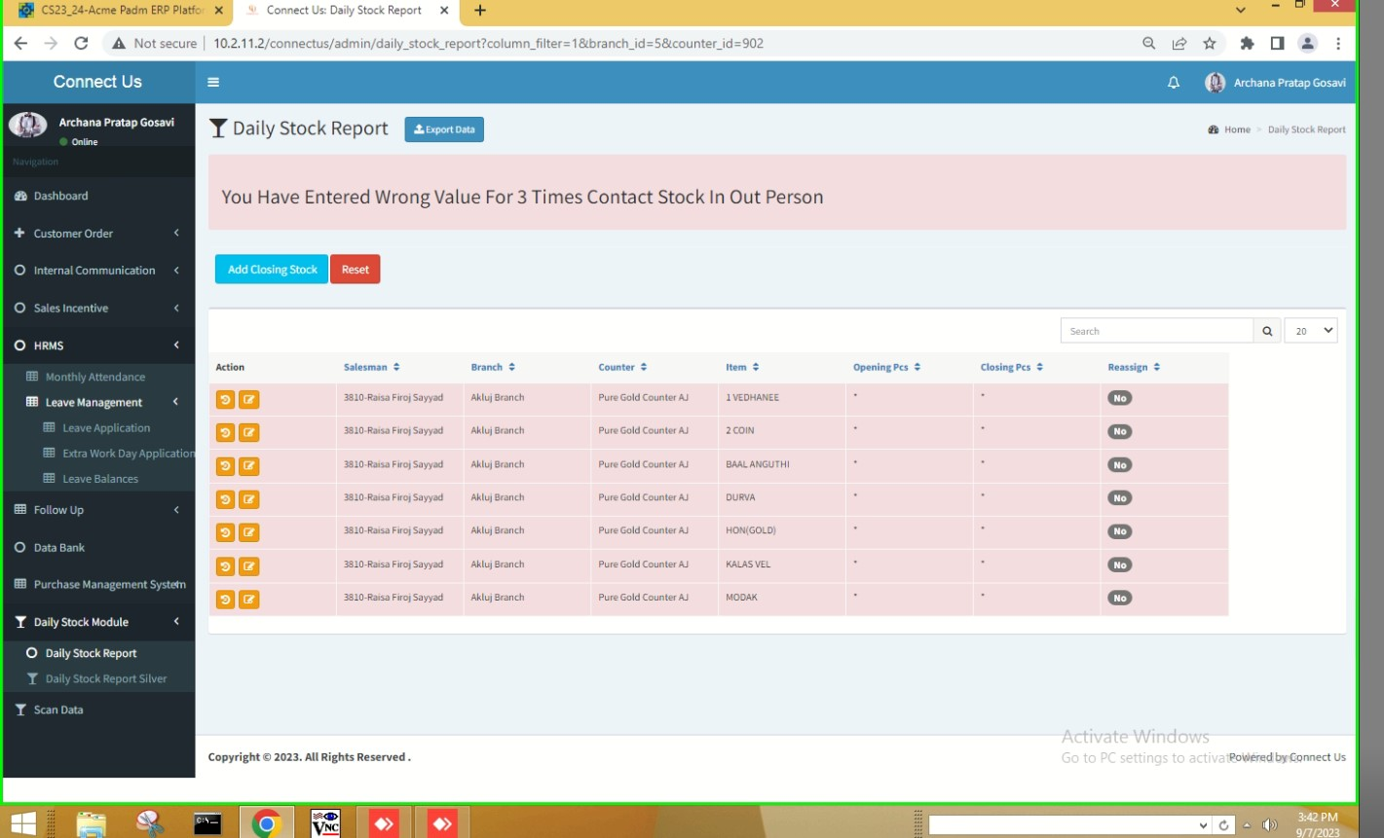

If it is mismatched then manager completes the process by verifying it.

Though it is not matched, system giving message as “Wah good job”

So change the message as “Stock is not matching. ”

Due this improper message, Inout person not get which stock not matching with padm system.

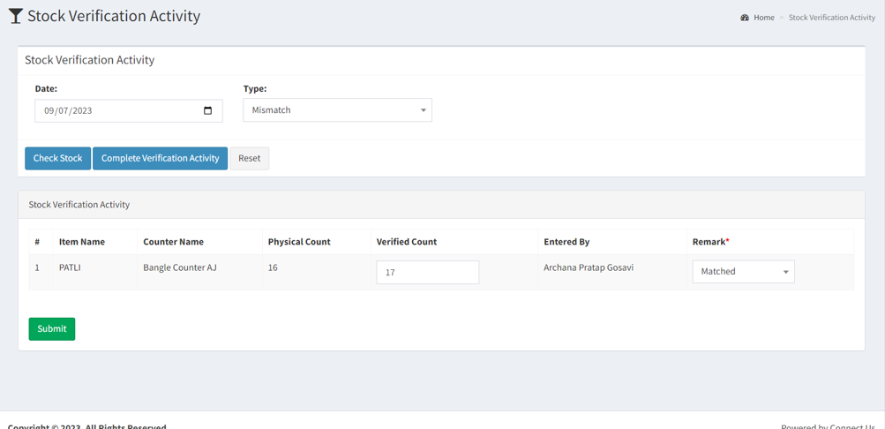

Not matching



**Input table**

|  |  |  |  |
| --- | --- | --- | --- |
| **FIELDS** | **INPUT TYPE** | **MANDATORY/ OPTIONAL** | **DESCRIPTION** |
| Change the message | Warning message |  | * Change the warning message to “Stock count is not matching” |
|  |  |  |  |
|  |  |  |  |

1. **TEST DATA**

NA

1. **ODUS ( Open Discussed Unhanded scenarios )**

NA

1. **REFERENCES OF THE USERS**

|  |  |  |  |
| --- | --- | --- | --- |
| **User** | **Name** | **Mail** | **Contact number** |
| **Actual user** | Annapa Tikone |  |  |
| **Ticket created by (if any)** | Annapa Tikone |  |  |
| **Assigned business analyst** | Priyanka Gole |  |  |
| **Assigned developer** | Yogita Jagtap |  |  |
| **Assigned tester** |  |  |  |