|  |  |
| --- | --- |
| **Ticket ID** | TT9172 |
| **Ticket description** | ConnectUS > Laser Marking Module Madhe :- Jameche All Doc And Stock Transfer Doc Pan Add Karta Aale Pahije |
| **Created by** | Tushar Shivaji Nikam |
| **Created on** | 31/01/2023 |
| **Priority** | Medium |
| **Version** | 1 |

**Version**

|  |  |  |  |  |
| --- | --- | --- | --- | --- |
| **Sr. No** | **Version no** | **Version Date** | **User name** | **User department** |
| 1 | 1 | 10.02.2023 | Tushar Shivaji Nikam | Inventory Silver HO |

**Approvals**

|  |  |  |
| --- | --- | --- |
| **Field** | **Name of the User** | **Approved date by the user** |
| **Actual User Name** | Tushar Shivaji Nikam | 31.01.2023 |
| **Actual User Department** | Inventory Silver HO |  |
| **Organization Name** | C S Jewellers |  |
| **Sign-off** |  |  |
| **Assigned BA** | Mounika KrishnaVeni Annamneedi | 10.02.2023 |
| **Assigned Developer** |  |  |
| **Assigned Tester** |  |  |

**Estimation**

|  |  |  |  |  |
| --- | --- | --- | --- | --- |
| **Department name** | **Estimated Time (In hr)** | **Scheduled Date (Starting date )** | **Estimated date** | **Actual delivery date** |
| **BA** | 2 | 10.02.2023 | 10.02.2023 |  |

**Business requirement**

Bulk upload format and bulk upload in laser marking - add laser marking

**Existing system**

In the existing system, there is no such fields in sub-supplier.

**Proposed system**

* Creation of bulk upload format and bulk upload in connect us.

Step 1

In Connect Us >> Laser marking >> Add laser marking

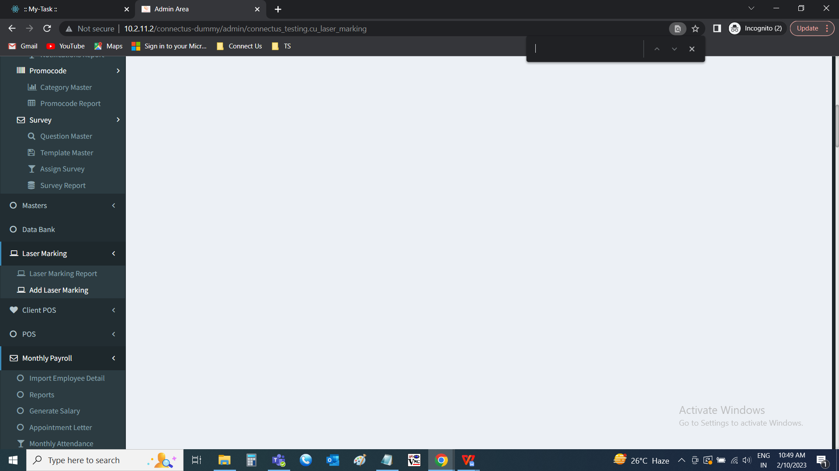

Creation of bulk upload format and bulk upload buttons on add laser marking

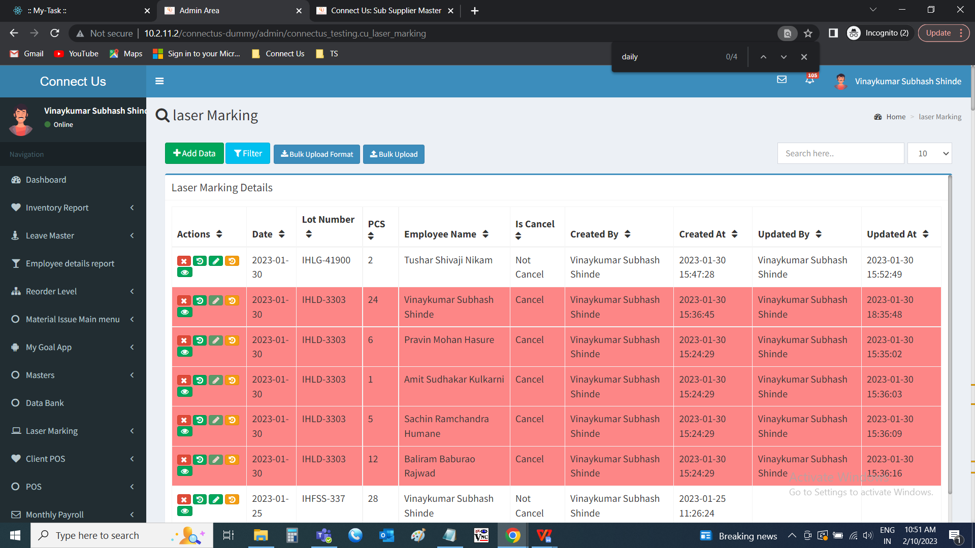

Step 2

Bulk upload format

The bulk upload format button downloads the format of the file to be uploaded in bulk upload. The file consists of the following fields.

* Lot number
* Item name
* Employee name

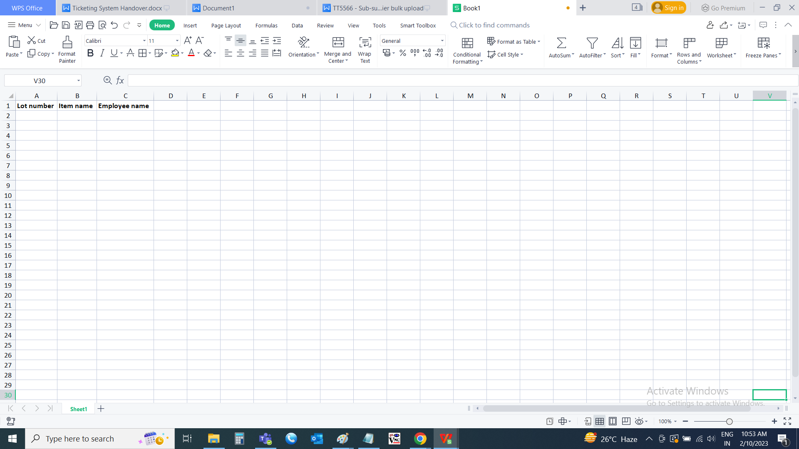

Step 3

Bulk upload

The bulk upload button is used to attach the file for adding the masters. When the user clicks on the bulk upload, the following pop-up opens. The pop-up consists of the following fields.

* Choose file
* Upload
* Back

|  |  |  |  |
| --- | --- | --- | --- |
| **FIELDS** | **INPUT TYPE** | **MANDATORY/ OPTIONAL** | **DESCRIPTION** |
| Choose file | File attachment | Optional | The file to upload is attached |
| Upload | Button | Optional | The upload button to upload the file |
| Back | Button | Optional | The back button to close the pop-up |

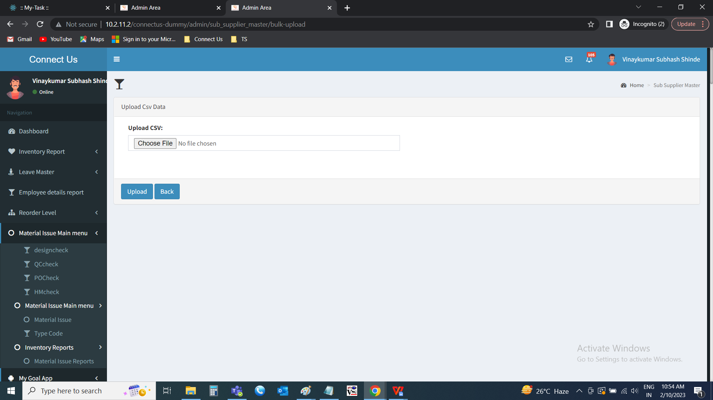

When the empty file uploaded, then error message is displayed “Something went wrong - Empty file uploaded”.

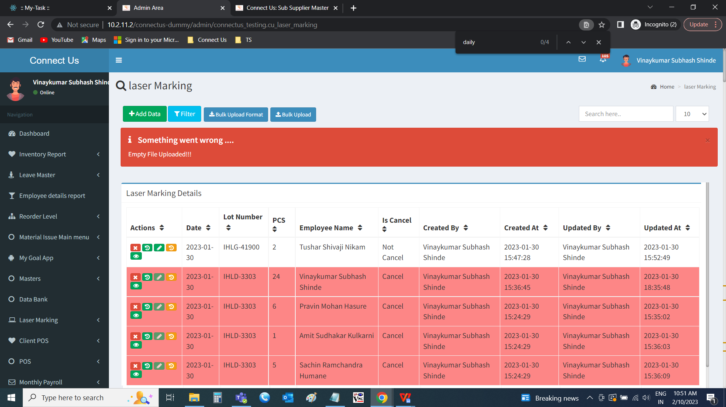

When the wrong file uploaded, then error message is displayed “Something went wrong - Invalid file type”.

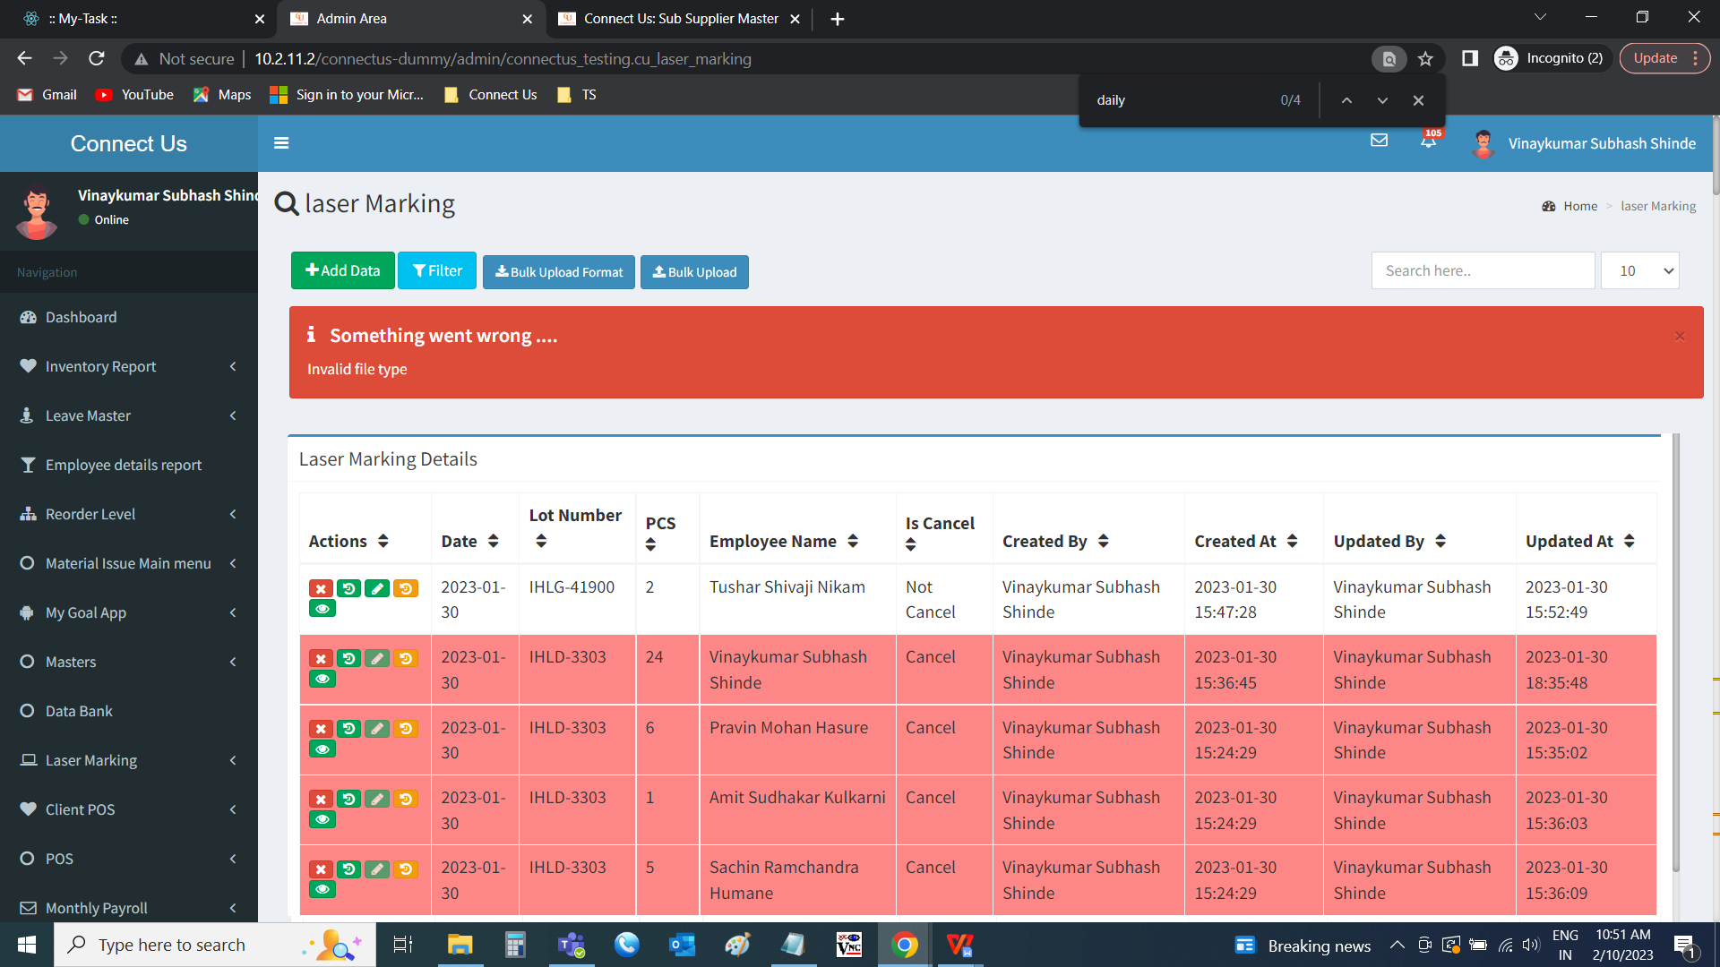

Validations for the input fields.

|  |  |
| --- | --- |
| **FIELDS** | **DESCRIPTION** |
| Lot number | The lot number is entered. The lot numbers are the documents fetched from the Padm - documents naming as follows. 1. stock tranfer   1. RD 2. Karagir Jama |
| Item name | The item name is optional. If item name is mentioned and employee name is mentioned, then it should assign to that employee. If not mentioned, the employee will be same for all the items. |
| Employee name | The employee name is entered. The employee name is fetched from the employee master (in connect us >> masters >> general masters >> employee master). |

Note :

1. When the data uploaded, the data should be auto generated the current date when it is uploading.
2. The pcs should be displayed the same against the item against the document.
3. Is cancel will be is cancel at the time of uploading
4. Created by field is displayed the user who uploaded the data.
5. Created at is displayed when the data is uploaded.

When any wrong validations given in the file, an error file is shown to download.

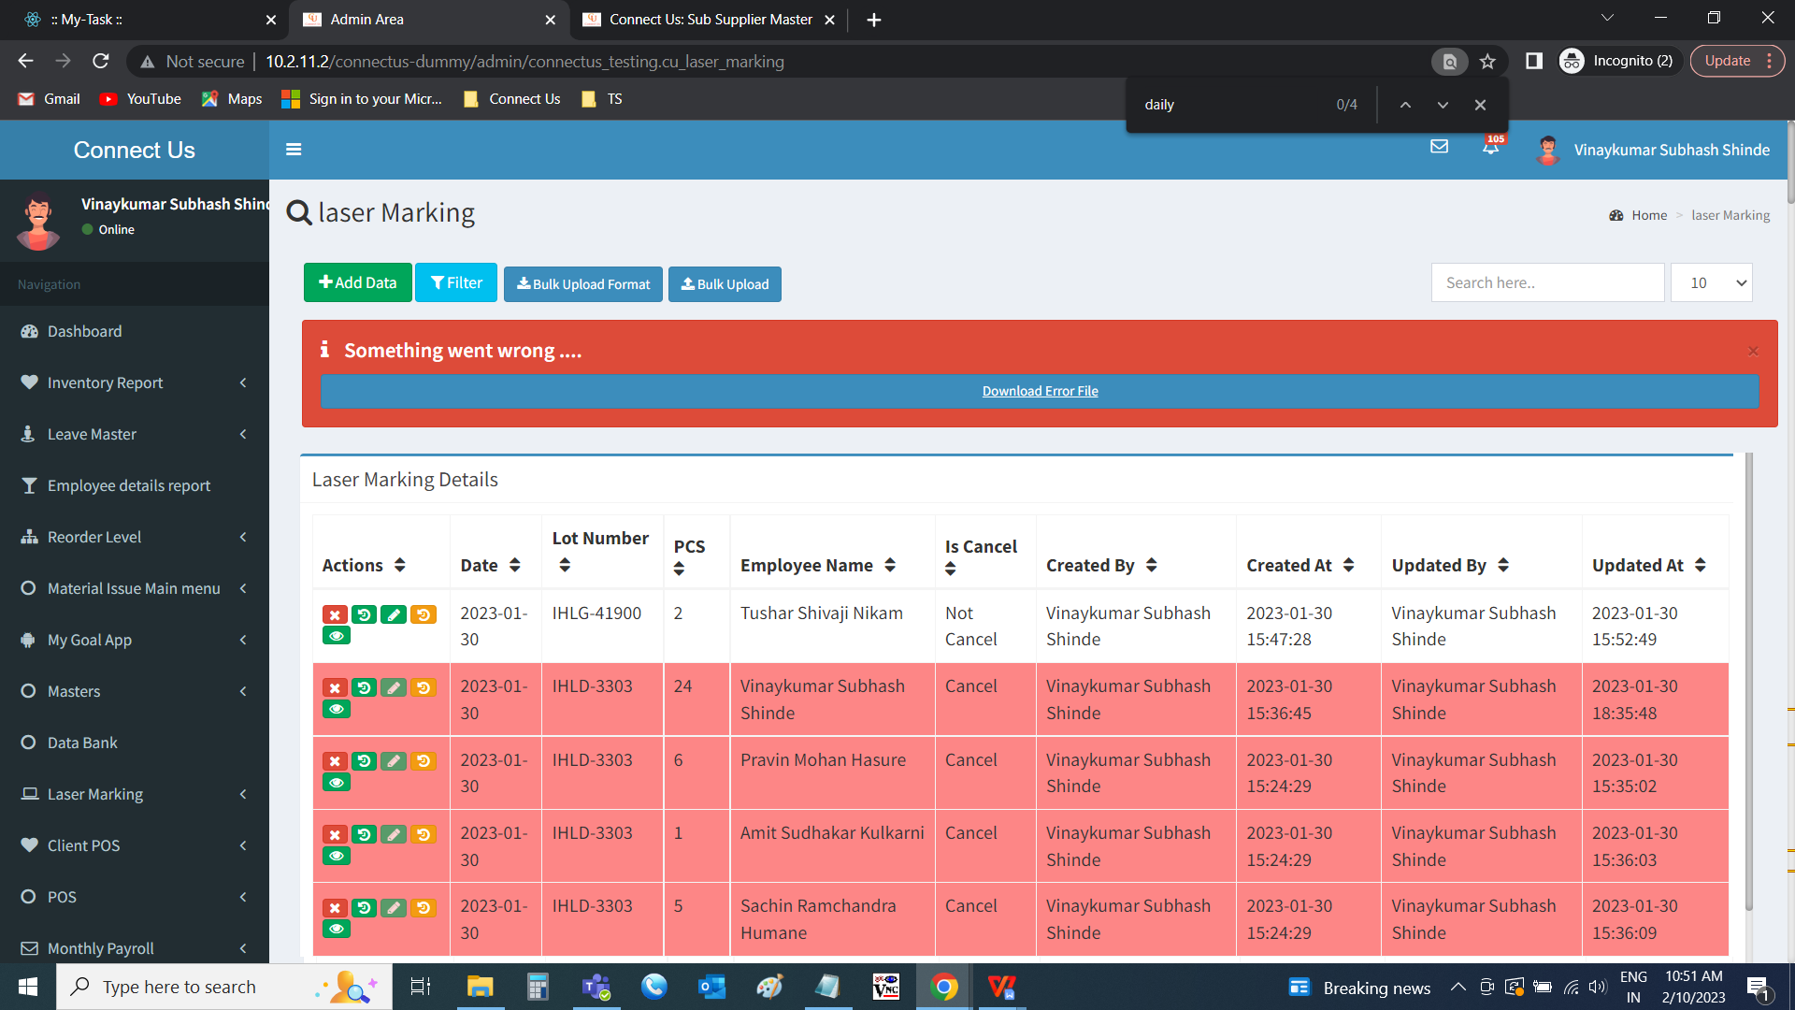

Downloaded file is as follows.

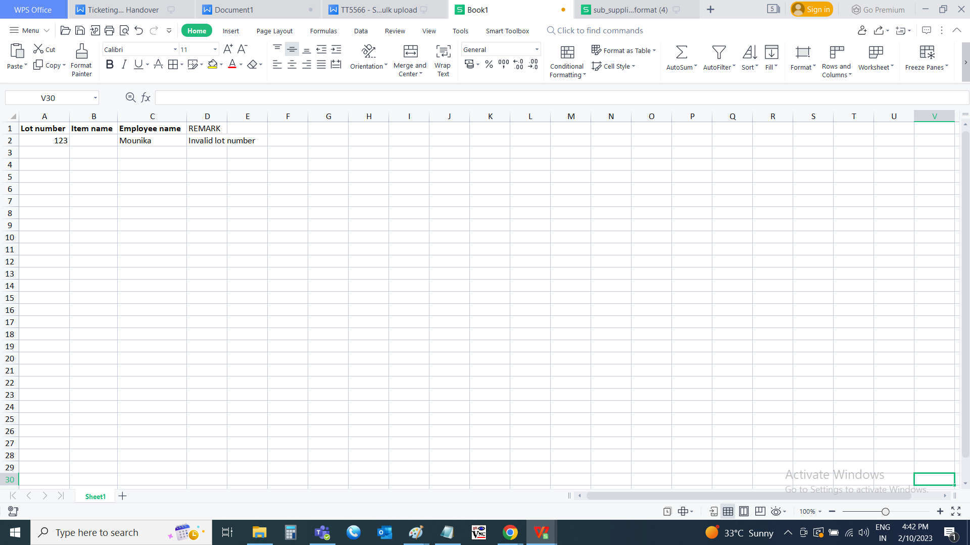

When the file uploaded successfully, file successfully uploaded, is displayed.

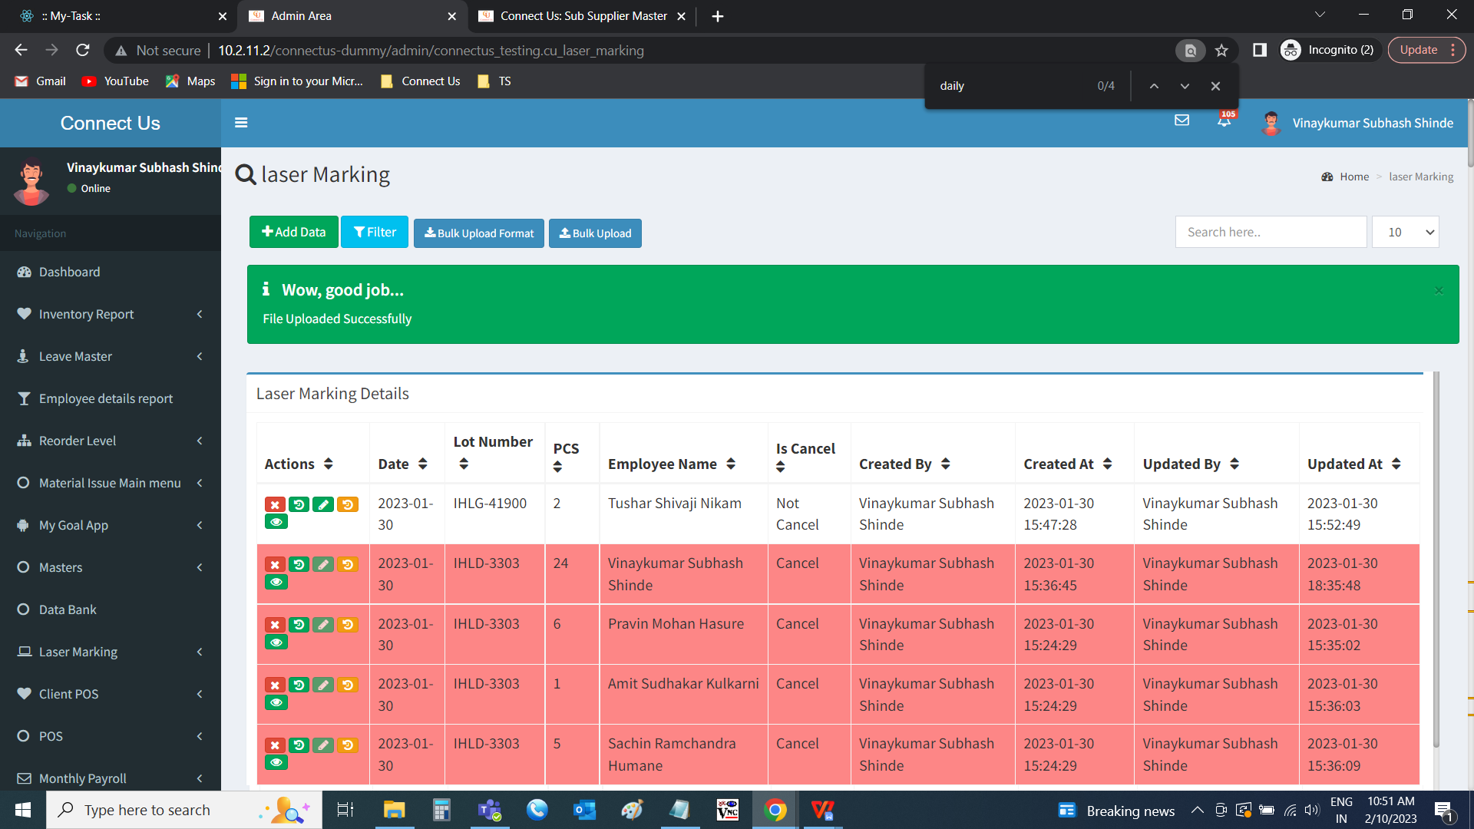

**References of the users**

|  |  |  |  |
| --- | --- | --- | --- |
| **User** | **Name** | **Mail** | **Contact number** |
| **Actual user** | Tushar Shivaji Nikam | itinv@csjewellers.com |  |
| **Assigned business analyst** | Mounika KrishnaVeni Annamneedi | Mounika.annamneedi@techneai.com | 9885900039 |