|  |  |
| --- | --- |
| **Ticket ID** | *T180998* |
| **Ticket description** | *Internal communication मध्ये तिकीट download केल्यानंतर hours आणि day काउन्ट आला पाहजे*  *१) create date आणि SOLVE date चा hours आला पाहजे*  *२) create date आणि SOLVE date चा day आला पाहजे* |
| **Created by** | *Mallikarjun kumkhar* |
| **Created on** | *10/01/2022* |
| **Priority** | *high* |
| **Version** | *0* |

**Version**

|  |  |  |  |  |
| --- | --- | --- | --- | --- |
| **Sr. No** | **Version no** | **Version Date** | **User name** | **User department** |
| 1 | 0 | 10-01-2022 | Mallikarjun kumkhar | IT application support |

**Approvals**

|  |  |  |
| --- | --- | --- |
| **Field** | **Name of the User** | **Approved date by the user** |
| **Actual User Name** | *Mallikarjun kumkhar* |  |
| **Actual User Department** | IT Application support |  |
| **Organization Name** | Techne AI |  |
| **Assigned BA** | Akash rewade |  |
| **Assigned Developer** | Nikhil bhosale |  |
| **Assigned Tester** | Maruti hakke |  |

**Estimation**

|  |  |  |  |  |
| --- | --- | --- | --- | --- |
| **Department name** | **Estimated Time (In hr)** | **Scheduled Date (Starting date )** | **Estimated date** | **Actual delivery date** |
| **BA** |  |  |  |  |
| **Development** | 4 hr |  |  |  |
| **Testing** |  |  |  |  |

**Introduction**

*New requirement*

**Business requirement**

User required to get the reports in no of days for Confirmation Tickets & Solved Tickets from passing Ticket date. So that they can know where the Ticket is pending also User required to get the report in No hour for confirmation tickets & Solved ticket from passing ticket date . So that they can know how many hour to take to solved ticket .

**Abbreviations & terms**

*Connect US > CU*

**Existing system**

In connect us > Internal communication > IC Admin, So that format is download In existing system user don’t have the column Ticket Solved ( In hour ).

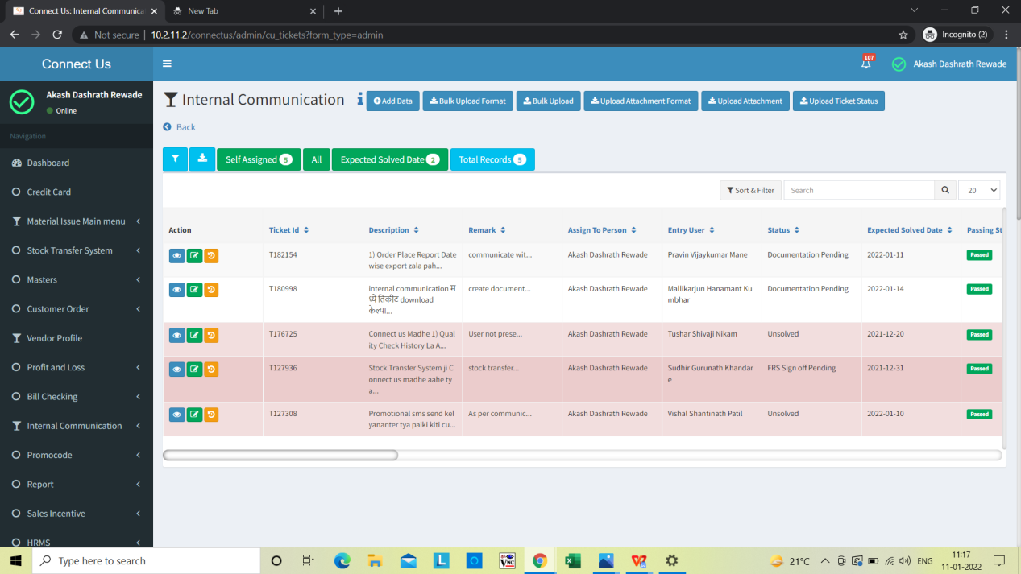

Click on download

In connect us > Internal communication

*Image 1- Internal communication bulk ticket*

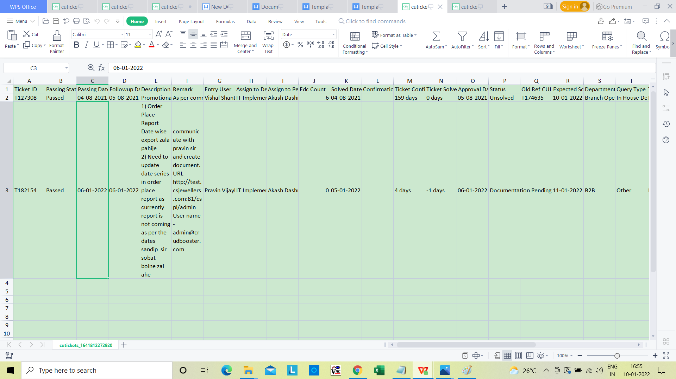

*Image 2 - Internal communication bulk ticket*

**Proposed system**

* In connect us > Internal communication > IC Admin,click on download So that format is download User Want two below column as shown in below Image 3 .

**1) Ticket solved (In Hour)** = Difference days from point passing hour to point solved hour. **Ticket solved (In Hour)** = Create at (–) Solved date

= 05/08/2021 - 04/02/2022

= 182 days

= 182 * 12

= 2184 Hr

1. **Ticket solved (In Days)** = Difference days from point passing hour to point solved hour.

**Ticket solved (In Days)** = Create at (–) Solved date

= 05/08/2021 - 04/02/2022

= 182 days

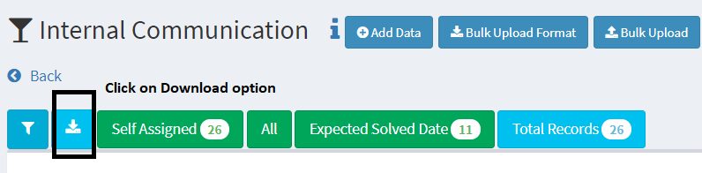

*Image 3*

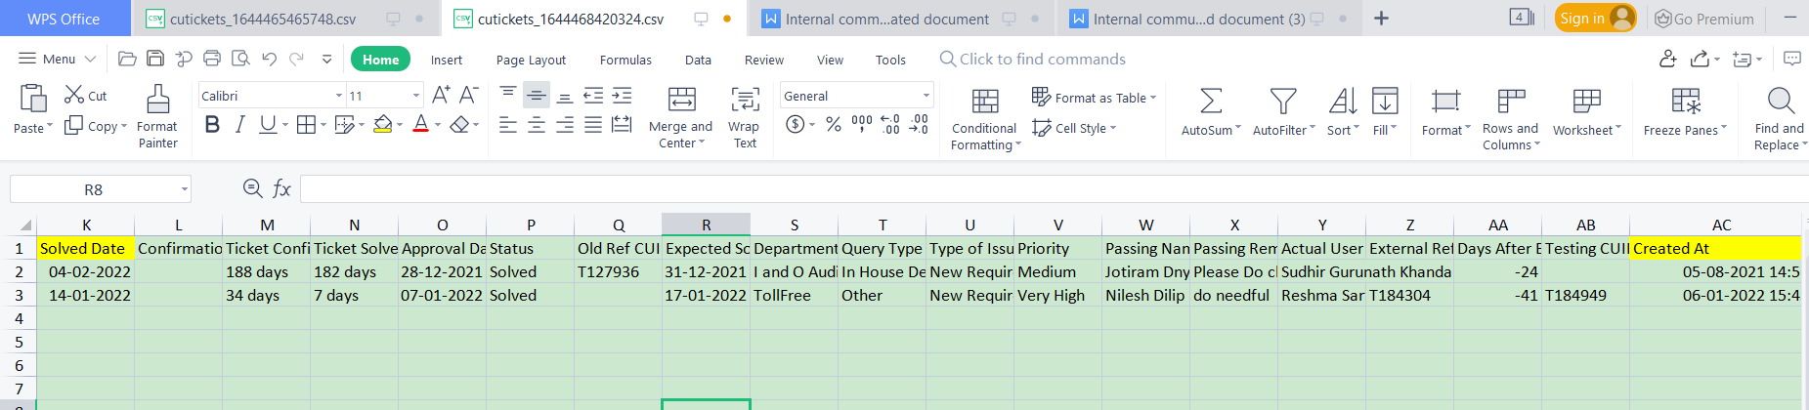

**Image 4 - Internal communication proposed system**

1. **Ticket View**

In Ticket view should be show field Ticket solved ( In hour).

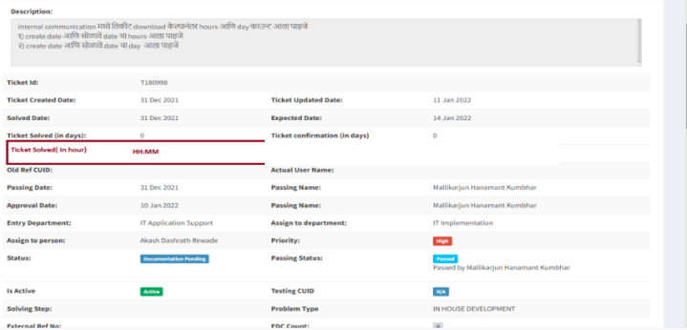

**Image 5**

**References of the users**

|  |  |  |  |
| --- | --- | --- | --- |
| **User** | **Name** | **Mail** | **Contact number** |
| **Actual user** | *Mallikarjun kumkhar* |  |  |
| **Ticket created by (if any)** |  |  |  |
| **Assigned business analyst** | Akash rewade | Akash.rewade@techneai.com | 8669917920 |
| **Assigned developer** | Nikhil bhosale | nikhil.bhosale@techneai.com |  |
| **Assigned tester** | Maruti hakke | maruti.hakke@techneai.com |  |