|  |  |
| --- | --- |
| **Ticket ID** | TT10271 |
| **Ticket description** | In BVC System we should select the other vendors for generation of Challan (Logistic Challan) |
| **Created by** | Pritam Mehta |
| **Created on** | 11/03/2023 |
| **Priority** | Very high |
| **Version** | 1.0 |

**Approvals**

|  |  |  |
| --- | --- | --- |
| **Field** | **Name of the User** | **Approved date by the user** |
| **Actual User Name** | Sanjay Danole |  |
| **Actual User Department** | Golds |  |
| **Organization Name** | CSJ |  |
| **Assigned BA** | Manali bhadirage |  |
| **Assigned Developer** | Prathmesh Shinde |  |
| **Assigned Tester** | Priyanka Dupargude |  |

**Introduction**

Through Connect us -> stock transfer system, user enters the details of the stock which is to be transferred by us own or by BVC from one location to another location. User enters all the details in stock transfer system which gets reflected in stock transfer details. Through stock transfer details, user confirms the data and prints the challan.

**Business requirement**

The existing system includes internal stock transfer ('from location' and 'to location' are both of CSPL). We need to create BVC challan through stock transfer system and stock transfer details for purchase return and sales bill. It should include Third Party Stock Transfer BVC and Third Party Stock Transfer own.

**Proposed system**

In stock transfer system, we will have to create new menu “BVC vendor transfer system”.

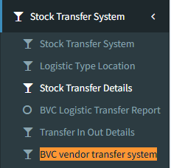

Fig: New BVC vendor transfer system

It will have following fields:

* Transfer Type:
* Our location
* Vendor location
* Select branch
* From series no.
* To series no.
* Add (button)
* Stock transfer details
* Action
* Sr. No.
* Tag no.
* Series doc no.
* 'from location'
* 'to location'
* Vendor
* Product group
* Pcs
* Net wt
* Fine wt
* HSN Code
* Diamond wt
* Diamond pcs
* Rate
* Stone amount
* Item amount
* GST amount
* Net amount
* Box count
* Save (button)

|  |  |
| --- | --- |
| **FIELDS** | **DESCRIPTION** |
| Transfer type | It will display two fields in the drop-down:   * Our location * Vendor location   Our location -   1. When stock is to be transferred from one branch to another branch, then user will select ‘our location’ and will select branch to which user wants to transfer the stock. 2. Once user enters the series no., then in stock transfer details table, “'from location'” field will display the location as per the location displayed in padm and “'to location' field will display the location as per selected branch. 3. If user selects ‘our location’ transfer type and enters series no, then ‘vendor’ field in stock transfer details table will be displayed blank.     Fig: Our loc  Vendor location -   1. When stock is to be transferred from one of our branch to the vendor’s address, then user will select ‘Vendor location’. 2. If user selects vendor location and enters series, then in 'from location' it will display the branch from which the branch is to be transferred and in ‘'to location'’ it will display the vendor’s name as in padm document location.     Fig: Vendor loc |
| Select Branch | If user selects ‘our location’ type, then user will have to select branch from the drop-down to which the stock is to be transferred.  User will have to first select branch, then enter the doc series no. And click on add button. Details will be displayed in row.  User can select different locations for each doc series no.  Example: User selected branch location and entered doc. No. JHPRA-45 and clicked on add. Further user selected branch as baramati midc and entered doc. No JHPRA-46 and clicked on add button. Once user clicks on submit button at bottom, then in stock transfer details it will display two rows as locations were different.    Fig: Stock transfer details grid |
| From series No. & To series No. | User will enter the series no. from padm -> documents -> all templates of purchase return /all templates of rd sales bill / all templates of karagir nave.  Once user enters series and clicks on add button, it will display following fields in table:   * Action * Sr. No. * Tag no. * Series doc no. * 'from location' * 'to location' * Vendor * Product group * Pcs * Net wt * Fine wt * HSN Code * Diamond wt * Diamond pcs * Rate * Stone amount * Item amount * GST amount * Net amount * Box count   Here, only tag no. And box count field will be editable.  As per entered series, it will display the 'from location' as mentioned in the padm against the entered document and 'to location' as per selected branch location or vendor.  Here ‘'from location'’ will be CSPL location always and 'to location' will be vendor’s name / our branch location as per selected transfer type.  User can add multiple series at a time while making entry. As per entered series, it will display ‘from location’ and ‘to location' in stock transfer details table as in padm for the entered document. |
| Save | Once user enters stock details and clicks on save, data will be added successfully, message will be displayed and thus added data will be displayed in “Stock transfer details” sub-module.  When user has entered ‘from series’ and ‘to series’ which has multiple documents in it, then it will display the list of multiple documents separated by comma if the ‘from location’ is same.  If user has entered multiple documents and their vendors are different (A and B) then in stock transfer details it will display one entry consisting all documents for vendor A and another entry for vendor B with its respective documents. |

In stock transfer details, it will have following fields:

* Action - view, download pdf
* Doc series no.
* Tag no.
* Doc no. - Doc no. will be displayed separated by comma of more than one series are scanned in stock transfer system of same vendor or else for same location.
* Product group
* Pcs
* Status
* Net wt
* Fine wt
* Rate
* Diamond pcs
* Diamond wt
* Stone amount
* Gst amount
* Item amount
* Net amount
* 'from location'
* 'to location'
* vendor
* Box count
* Print status
* Created at
* Created by

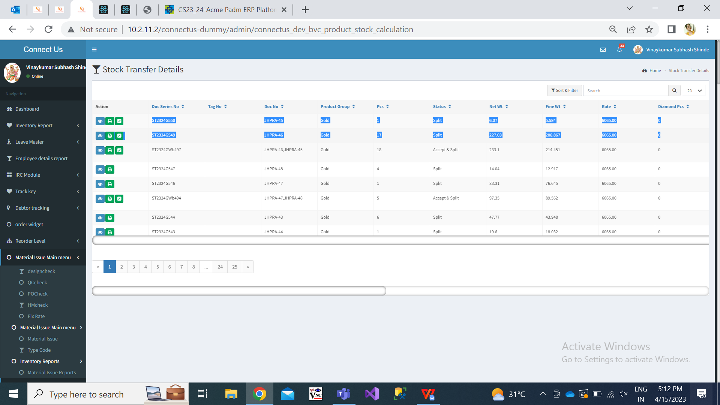

Fig: stock transfer details grid

|  |  |
| --- | --- |
| **FIELDS** | **DESCRIPTION** |
| Action | It has following actions:  View  Download  Accept / Split  Once data is added, then it will display the data of Gold, diamond and platinum in one entry with multiple series number mentioned in one entry whereas silver in another entry.  View action will display all data as added during stock transfer system. It should have additional fields as type (vendor loc / our loc) and vendor column in table.    Fig: Stock transfer details -> View action  Download - It will display the 'from location' and 'to location' on the pdf format. In consignee (i.e. from location), it will display “Chandukaka saraf & sons pvt td.” with ph no, gstin, pan no and state name of the same. In consignor (i.e to location), it will display address of branch as per branch master or else address of the vendor as in vendor master.    Fig: Download pdf challan |

**References of the users**

|  |  |  |  |
| --- | --- | --- | --- |
| **User** | **Name** | **Mail** | **Contact number** |
| **Actual user** | Sanjay Danole | gold@csjewellers.com |  |
| **Ticket created by (if any)** | Pritam mehta | ia@csjewellers.com |  |
| **Assigned business analyst** | Manali bhadirage | Manali.bhadirage@techneai.com | 9604640114 |
| **Assigned developer** | Prathmesh shinde | Prathmesh.shinde@techneai.com |  |
| **Assigned tester** | Priyanka dupargude | Priyanka.dupargude@techneai.com |  |