|  |  |
| --- | --- |
| **Ticket ID** | *TT1540* |
| **Ticket description** | *QC check history merge with QC check* |
| **Created by** | *Manali Bhadirage* |
| **Created on** | *15/04/2023* |
| **Priority** | *Very high* |
| **Version** | *1.0* |

**Approvals**

|  |  |  |
| --- | --- | --- |
| **Field** | **Name of the User** | **Approved date by the user** |
| **Actual User Name** | Sanjay danole |  |
| **Actual User Department** | gold |  |
| **Organization Name** | CSJewellers |  |
| **Assigned BA** | Manali Bhadirage |  |
| **Assigned Developer** | Prathmesh shinde |  |
| **Assigned Tester** | Priyanka dupargude |  |

**Introduction**

*When user adds lot no. or challan no. in connect us -> material issue, then items in Lot no. are forwarded to checking in phases. It is processed as design check, QC check, PO check and HM check in stepwise manner. Also, during QC check, authority enters details in quality check history regarding accepted-rejected quantity of items in doc by each employee.*

**Business requirement**

*Client require QC incharge process after design check phase. QC incharge will divide the pcs from slot among the number of present employees and thus employees will be further able to proceed for QC checking process.*

**Existing system**

*There is no such existing system.*

**Proposed system**

*Step 1. User will scan one challan no. and add the details of total item in material issue -> add data.*

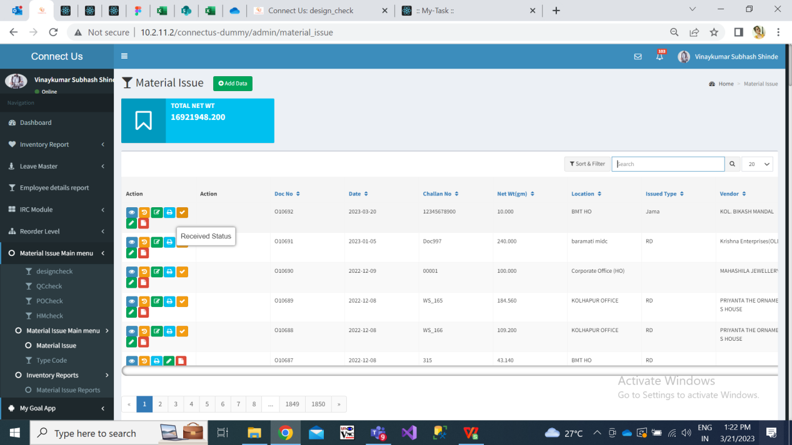

Fig: Material issue -> Home page

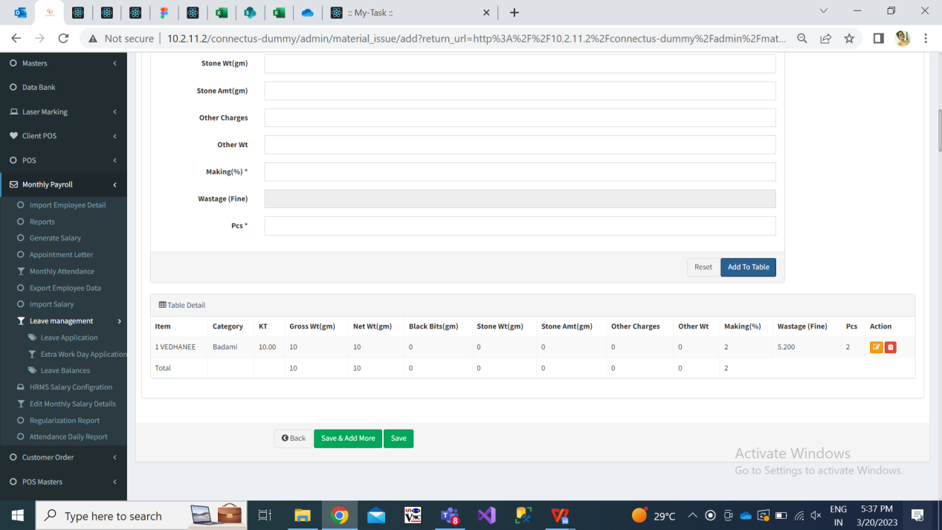

Fig: Material issue -> add data

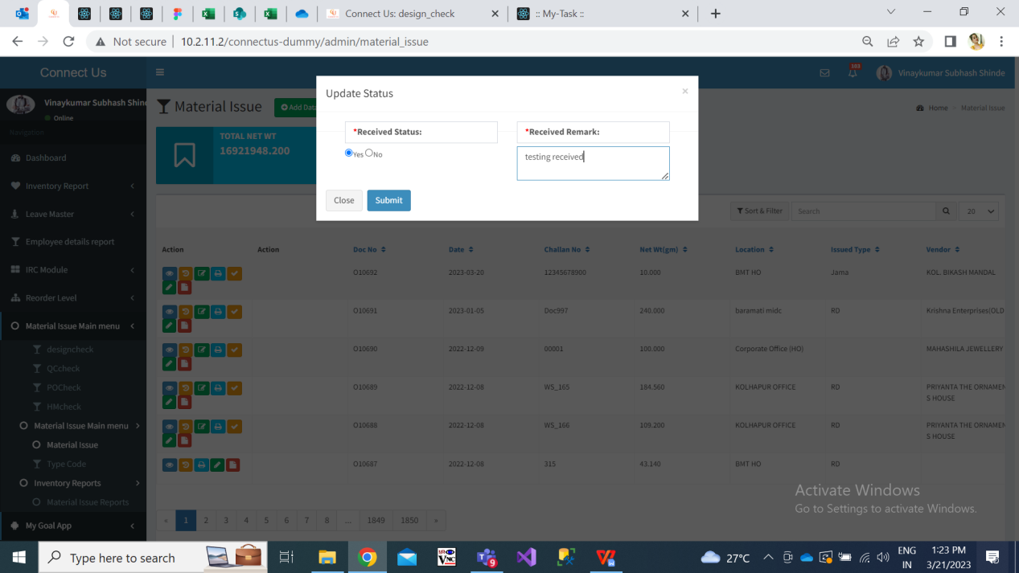

Fig: Material issue -> received status

Step 2. Once challan is entered in material issue and marked as received by authority, it is initially proceeded to Design check phase.

In design check phase, from Issue data action, user enters the details of accepted and rejected pcs and submits the challan to further process.

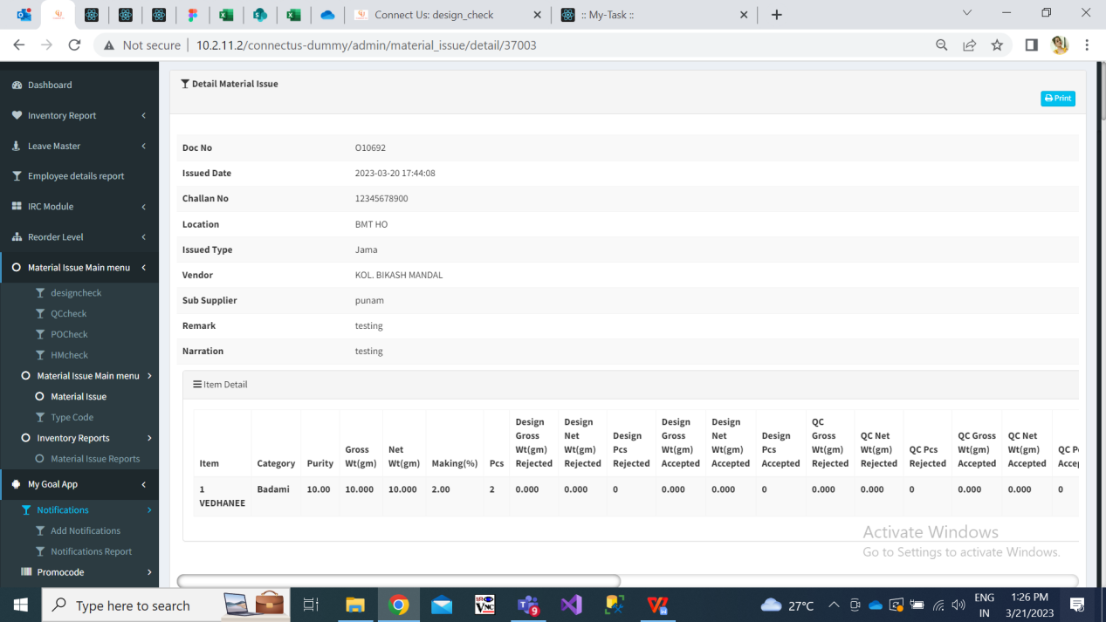

Fig: Design check

Step 3. Once design check is done, the accepted pcs and all details in the document will be forwarded to QC check process.

The documents received from design check process should be first displayed to QC incharge in QC check menu. Here, QC incharge will first split the document into present employees.

* Qc check grid will have following fields:
* Action- View, history, split / issued, quality check, split history
* Doc no.
* Challan no.
* Net wt
* Location
* Issued type
* Issued date
* Vendor
* Sub-supplier
* Received status

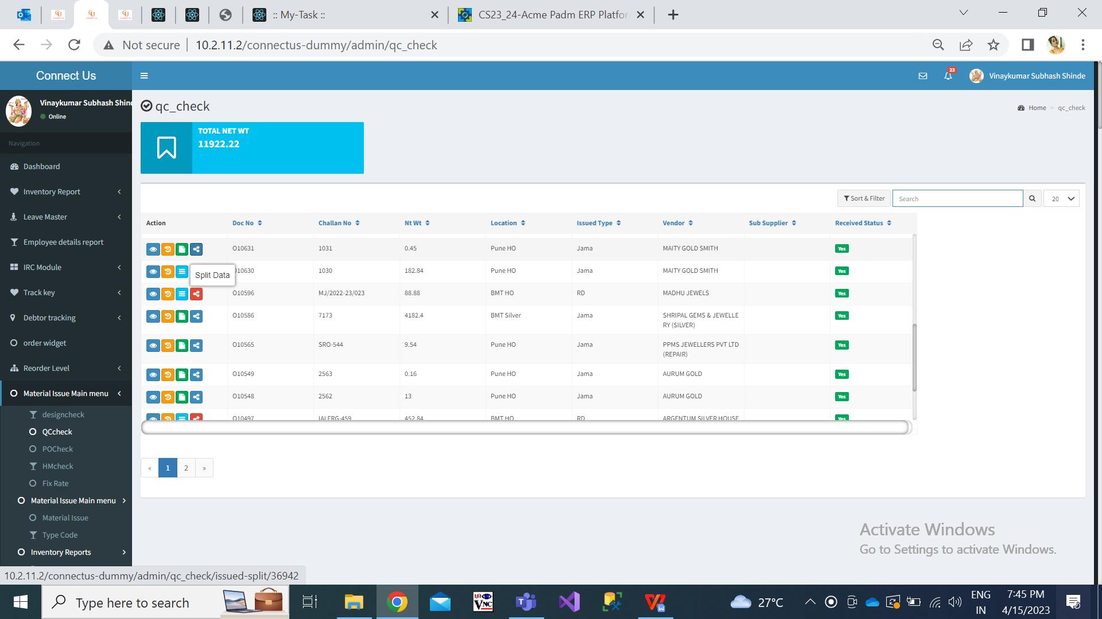

Fig: QC check

|  |  |
| --- | --- |
| **Fields** | **Description** |
| Split history action | In split history action, QC incharge will be able to view the accepted and rejected details of the items done by the assigned employees.  It will have following columns:   * Doc no. * Employee * Created at & by * Item * Category * Purity * Making * Pcs * Total net wt * Total gross wt * Qc accepted gross wt * Qc accepted net wt * Qc accepted pcs * Qc rejected gross wt * Qc rejected net wt * Qc rejected pcs   It will display qc accepted and qc rejected as 0.00 until the assigned employees haven’t done quality checking.  Once employee has entered qc accepted and rejected details for the item assigned to him / her, the same will be reflected in split history coulmns.  Once all employees have done qc check of items assigned to them for the assigned document, Qc incharge will be able to review it and then can go on “Issue action” so as to forward the document to PC check process.    Fig: Split history |
| Split action | It will display following fields:   * Doc no. * Challan no. * Date * Jama Type * Total Design Gross wt accepted * Total Design net wt accepted * Total Design pcs wt accepted * Details of Item wise gross wt, net wt and pcs * Location * Vendor * Sub-supplier * Narration   Below, it will display following fields:   1. Item name 2. Employee name 3. Gross wt 4. Net wt 5. Pcs 6. + (button for each row as per split items in doc) 7. Submit   Initially, it will display list of rows as per item names in the doc. It will display total gross wt, net wt and pcs in the text boxes as in the document. However, gross wt, net wt, pcs will be editable. The QC incharge will select employee name from the drop-down and click on submit.    Further, as per entered / edited gross wt, net wt and pcs, the another row should appear as per remaining gross wt, net wt and pcs for the particular item.  Here, if pcs is only 1 for particular item, then gross wt, net wt and pcs field should be disabled. Only employee name should be editable.  Once data is submitted, split action should be removed for that particular document.  Example: for Doc no: O10467, total gross wt is 40.810, total net wt is 40.810 and pcs is 8. Out of it, gross wt 10.810, net wt 10 and pcs 2 are being split by QC InCharge to Nikhil Bhosale. And remaining gross wt 30, net wt 30.810, pcs 6 are being assigned to punam shinde. |
| Issued | Issued action should be displayed to QC incharge only.  QC incharge can either split the doc. into employees or himself will directly enter accepted and rejected details through issued action.  Once the assigned employees has entered accepted / rejected details of document assigned to them from their end, then further through issued action, QC incharge will get the total of accepted & rejected details pre-filled of the document as done by assigned employees.  Once employee clicks on issued action, it will display following details of the document:   * Doc no. * Challan no. * Date * Jama Type * Location * Vendor * Sub-supplier * Narration   Below, it will display following table for each item:   * Item name * employee name * gross wt * net wt * pcs * Rejected gross wt * Rejected net wt * Rejected pcs * Accepted gross wt * Accepted net wt * Accepted pcs * Narration   Here, item name, employee name, gross wt, net wt, pcs in table will be read only.  Once assigned employees have entered details in rejected / rejected fields, it will be displayed here. It will be pre-filled as well as editable.    Fig: Issued action |

Step 4. Once all the QC incharge has submitted details of accepted / rejected in QCcheck -> issued action, then total accepted gross wt, total accepted net wt, total accepted pcs should be displayed to POcheck process for the respective doc.

Step 5. Once data is accepted / rejected, its details should be displayed in following menus:

In view action of material issue

In view action of design check

In view action of qc check

In view action of qc check -> history

In view action of po check

In view action of hm check

In pdf /slip report of Hm check

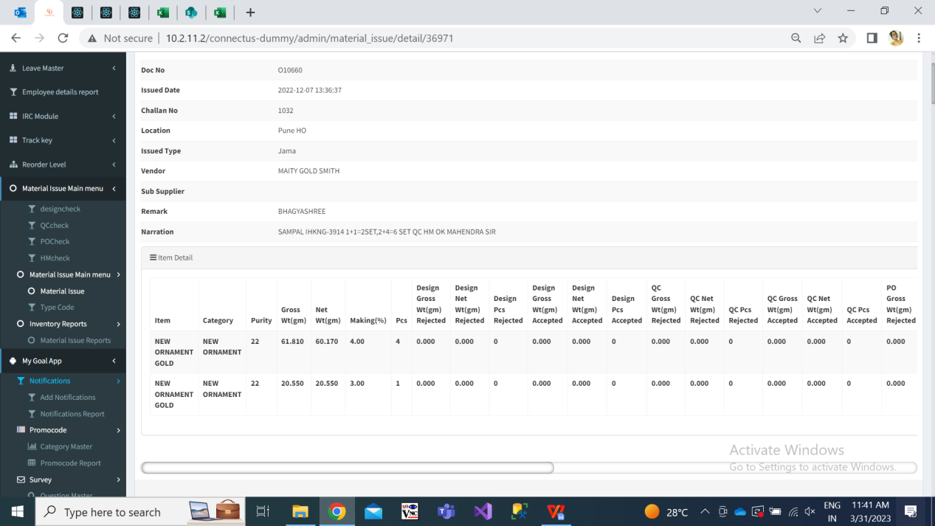

Fig: view action

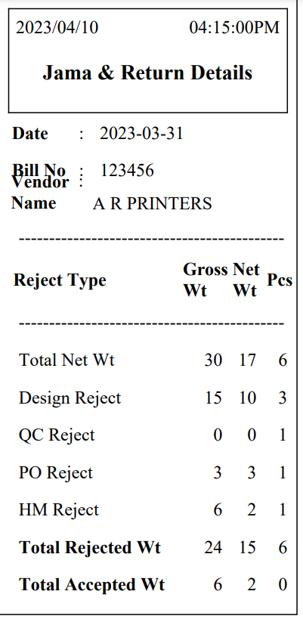

Fig: HM slip report

Step 6. We have to created ‘Quality incharge report’ in connect us. Through this report, user can export report of total gross wt and pcs quality checked by employees in the selected duration. It will have following fields:

* From Date
* To date
* Employee name
* Filter button
* Download button
* Reset button

|  |  |
| --- | --- |
| **Fields** | **Description** |
| From Date | User will select the date from which quality report is expected.  Future date should be disabled. |
| To Date | User will select the date till which quality report is expected.  Future date should be disabled. |
| Employee name | It will be multi-select field. It will display list of active employees from employee master. |

Once user clicks on filter, following columns of the report should be displayed:

1. Employee name
2. Doc No.
3. gross wt
4. net wt
5. pcs
6. Rejected gross wt
7. Rejected net wt
8. Rejected pcs
9. Accepted gross wt
10. Accepted net wt
11. Accepted pcs

|  |  |
| --- | --- |
| **Fields** | **Description** |
| Doc No. | It will display the doc no. quality checked by the employee in selected duration. |
| gross wt | Against specified doc no, it will display gross wt that was assigned to the employee by the QC incharge during split. |
| net wt | Against specified doc no, it will display net wt that was assigned to the employee by the QC incharge during split. |
| pcs | Against specified doc no, it will display pcs that was assigned to the employee by the QC incharge during split. |
| Rejected gross wt | It display gross wt rejected by the the employee out of assigned gross wt to him /her. |
| Rejected net wt | It display net wt rejected by the the employee out of assigned net wt to him /her. |
| Rejected pcs | It display pcs rejected by the the employee out of assigned pcs to him /her. |
| Accepted gross wt | It display gross wt accepted by the the employee out of assigned gross wt to him /her. |
| Accepted net wt | It display net wt accepted by the the employee out of assigned net wt to him /her. |
| Accepted pcs | It display pcs accepted by the the employee out of assigned pcs to him /her. |

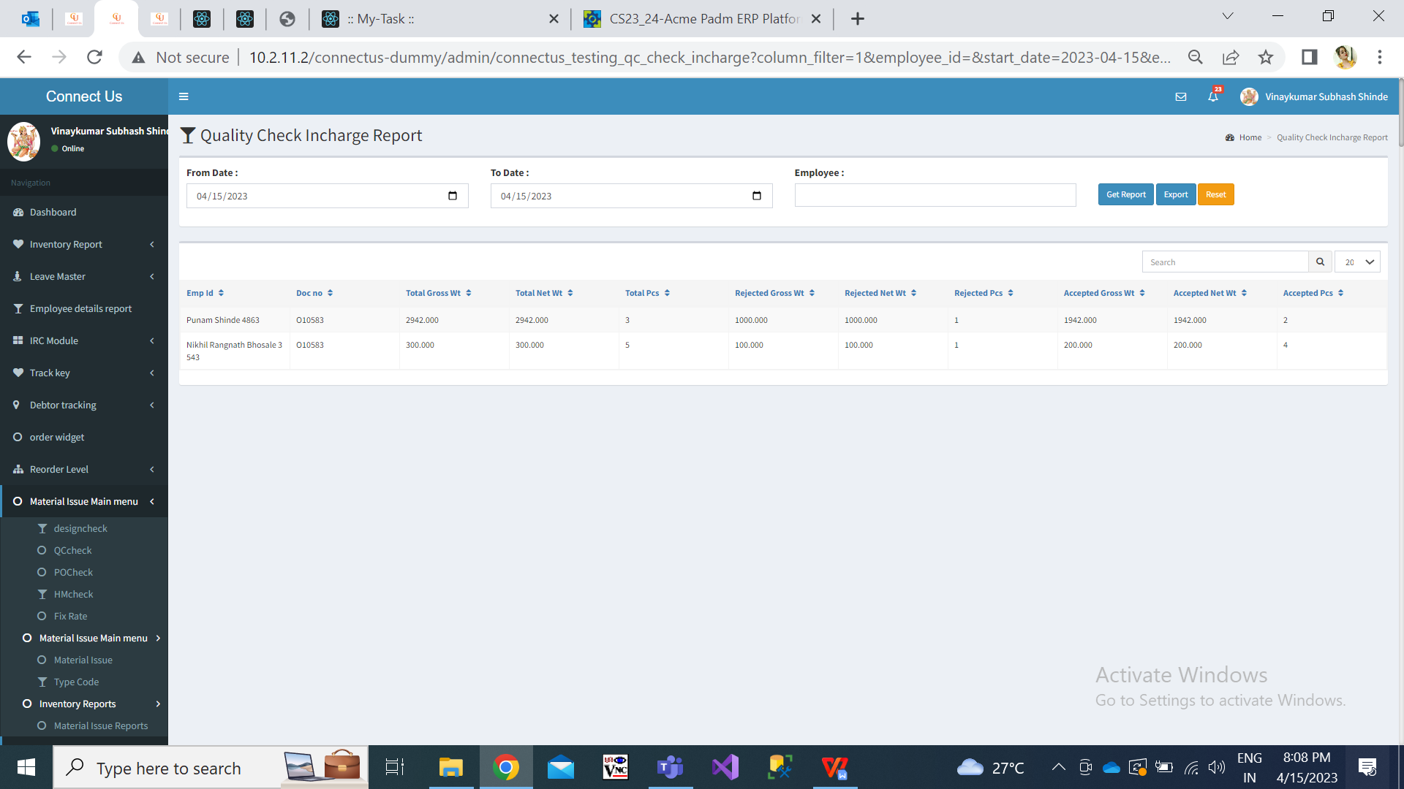

Fig: Quality check incharge report

**References of the users**

|  |  |  |  |
| --- | --- | --- | --- |
| **User** | **Name** | **Mail** | **Contact number** |
| **Actual user** | Sanjay Danole | gold@csjewellers.com |  |
| **Ticket created by (if any)** | Manali bhadirage | Manali.bhadirage@techneai.com |  |
| **Assigned business analyst** | Manali bhadirage | Manali.bhadirage@techneai.com |  |
| **Assigned developer** | Prathmesh shinde | Prathmesh.shinde@techneai.com |  |
| **Assigned tester** | Priyanka dupargude | Priyanka.dupargude@techneai.com |  |