|  |  |
| --- | --- |
| **Ticket ID** | *TT1540* |
| **Ticket description** | *QC check history merge with QC check* |
| **Created by** | *Manali Bhadirage* |
| **Created on** | *20/03/2023* |
| **Priority** | *Very high* |
| **Version** | *2.2* |

**Version**

|  |  |  |  |  |
| --- | --- | --- | --- | --- |
| **Sr. No** | **Version no** | **Version Date** | **User name** | **User department** |
| **1** | **1.0** | **20/03/2023** | **Pritam mehta** |  |
| **2** | **2.0** | **29/03/2023** | **Pritam mehta** |  |
| **3** | **2.1** | **30/03/2023** |  |  |
| **4** | **2.2** | **03/04/2023** |  |  |
| **5** | **2.3** | **04/04/2023** |  |  |
| **6** | **2.4** | **11/04/2023** |  |  |

**Approvals**

|  |  |  |
| --- | --- | --- |
| **Field** | **Name of the User** | **Approved date by the user** |
| **Actual User Name** | Pritam mehta |  |
| **Actual User Department** |  |  |
| **Organization Name** | CSJewellers |  |
| **Assigned BA** | Manali Bhadirage |  |
| **Assigned Developer** | Bhushan Patel |  |
| **Assigned Tester** | Priyanka dupargude |  |

**Estimation**

|  |  |  |  |  |
| --- | --- | --- | --- | --- |
| **Department name** | **Estimated Time (In hr)** | **Scheduled Date (Starting date )** | **Estimated date** | **Actual delivery date** |
| **BA** |  |  |  |  |
| **Development** |  |  |  |  |
| **Testing** |  |  |  |  |
|  |  |  |  |  |

**Introduction**

*When user adds lot no. or challan no. in connect us -> material issue, then items in Lot no. are forwarded to checking in phases. It is processed as design check, QC check, PO check and HM check in stepwise manner. Also, during QC check, authority enters details in quality check history regarding accepted-rejected quantity of items in doc by each employee.*

**Business requirement**

*Client needs to merge QC check and quality check history process. Client require QC incharge process after design check phase. QC incharge will divide the pcs from slot among the number of present employees and thus employees will be further able to proceed for QC checking process.*

**Existing system**

*There is no such existing system.*

**Proposed system**

*Step 1. User will scan one challan no. and add the details of total item in material issue -> add data.*

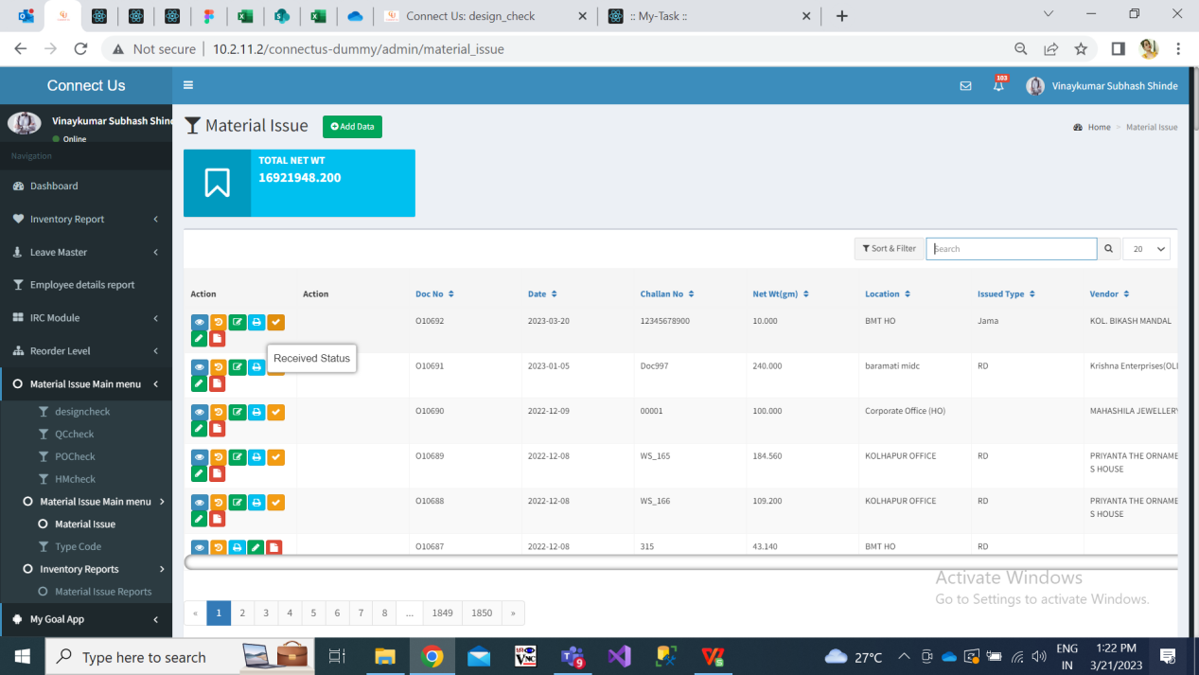

Fig: Material issue -> Home page

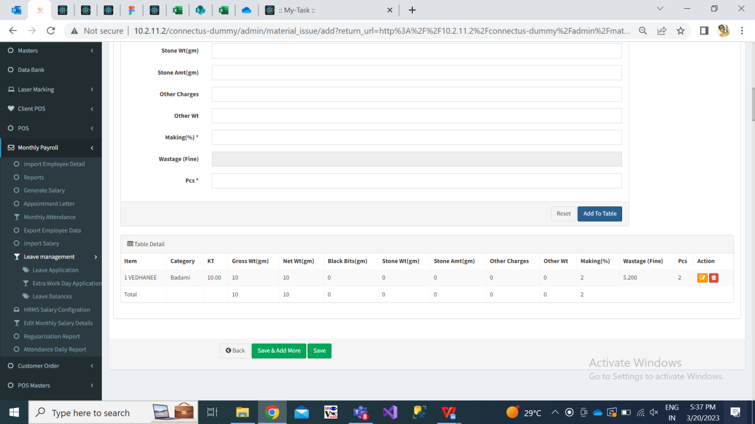

Fig: Material issue -> add data

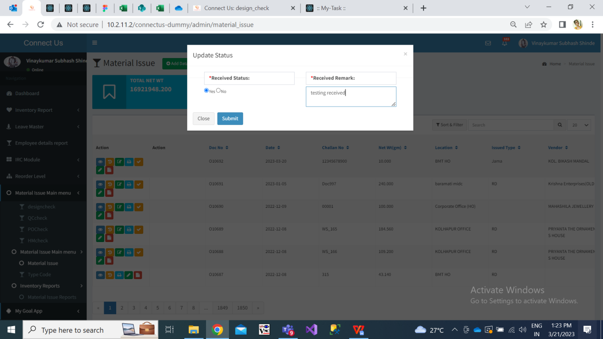

Fig: Material issue -> received status

Step 2. Once challan is entered in material issue and marked as received by authority, it is initially proceeded to Design check phase.

In design check phase, from Issue data action, user enters the details of accepted and rejected pcs and submits the challan to further process.

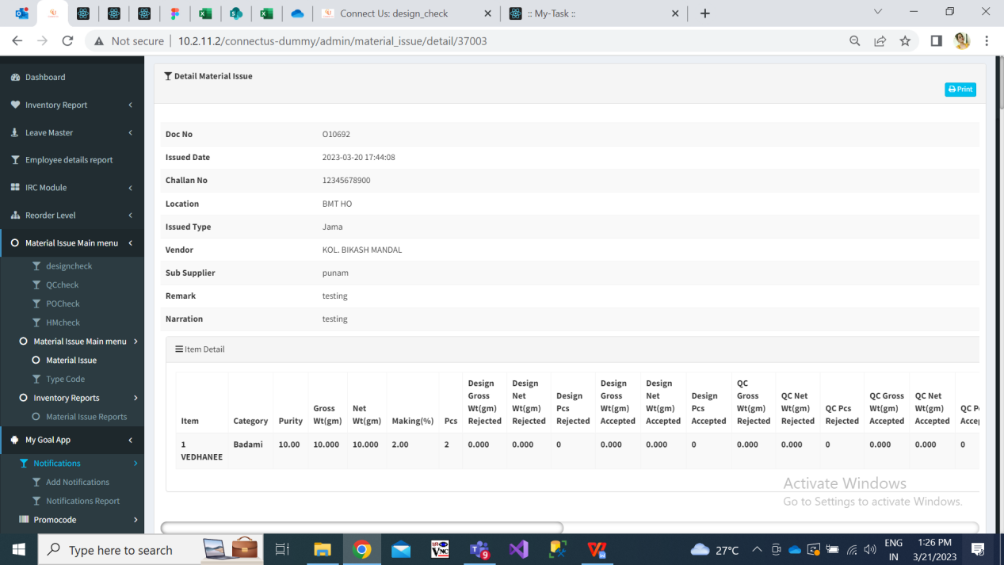

Fig: Design check

Step 3. Once design check is done, the accepted pcs and all details in the document will be forwarded to QC check process.

The documents received from design check process should be first displayed to QC incharge in QC check menu. Here, QC incharge will first split the document into present employees.

* Qc check grid will have following fields:
* Action- View, history, split / issued, split history
* Doc no.
* Challan no.
* Net wt
* Location
* Issued type
* Issued date
* Vendor
* Sub-supplier
* Received status

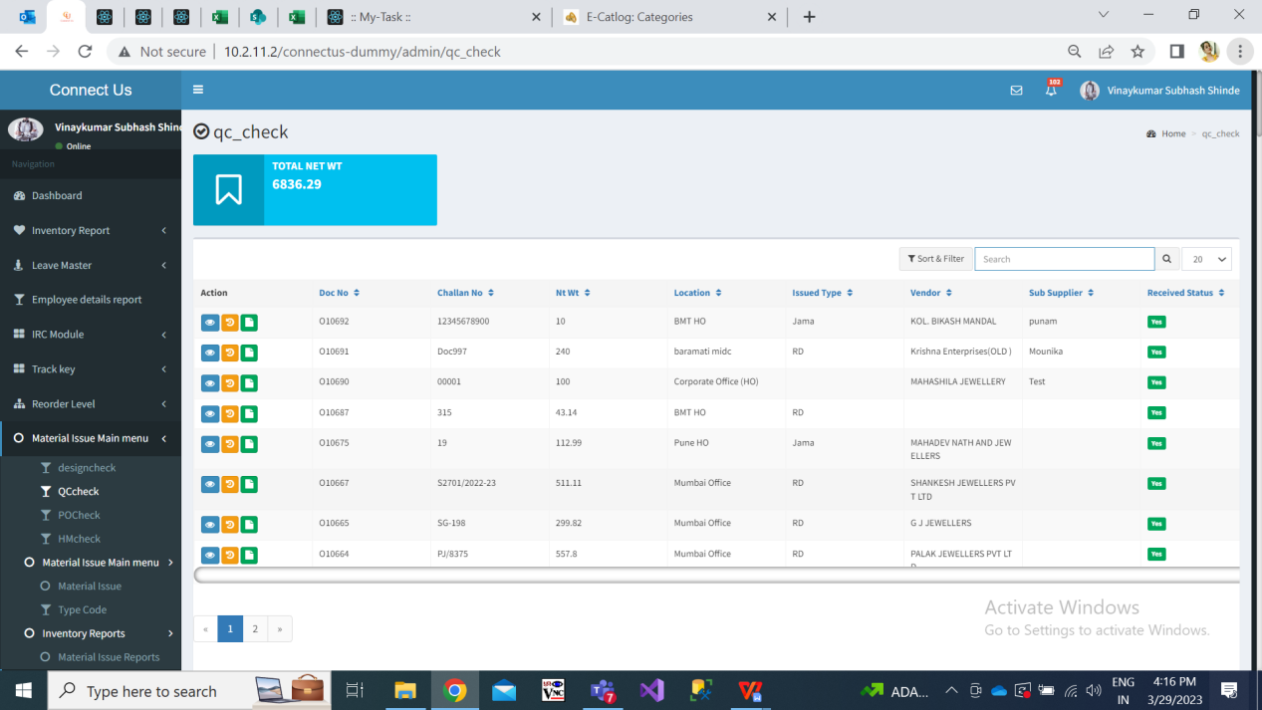

Fig: QC check

|  |  |
| --- | --- |
| **Fields** | **Description** |
| Split history action | In history action, add, edit, received, design check update, QC incharge split, qc check update should be displayed.  It should have following fields:  Action   * Doc no. * Challan no. * Date * Jama Type * Total Design Gross wt accepted * Total Design net wt accepted * Total Design pcs wt accepted * Details of Item wise gross wt, net wt and pcs * Location * Vendor * Sub-supplier * Narration * Split by * Split date & time   Below, it should display following fields in table for each item:  Item name  Employee name  Gross wt  Net wt  Pcs |
| Split action | It will display following fields:   * Doc no. * Challan no. * Date * Jama Type * Total Design Gross wt accepted * Total Design net wt accepted * Total Design pcs wt accepted * Details of Item wise gross wt, net wt and pcs * Location * Vendor * Sub-supplier * Narration   Below, it will display following fields:   1. Item name 2. Employee name 3. Gross wt 4. Net wt 5. Pcs 6. + (button for each row as per split items in doc) 7. Submit   Initially, it will display list of rows as per item names in the doc. It will display gross wt, net wt and pcs as in the document. However, gross wt, net wt, pcs will be editable. The QC incharge will select employee name from the drop-down and click on submit.  Further, as per entered / edited gross wt, net wt and pcs, the another row should appear as per remaining gross wt, net wt and pcs for the particular item.  If QC incharge has selected employee for particular item name, then the already selected drop-down shouldn’t be displayed in another row for the same item name.  Here, if pcs is only 1 for particular item, then gross wt, net wt and pcs field should be disabled. Only employee name should be editable.  Scenario 1: There are two items in QC check document as belows:  Vedhanee - Gross wt 20.00 - Net wt 24.00 - pcs 4  Bindi - Gross wt 5.00 - Net wt 6.00 - pcs 2  Then in split action, it should display two rows, one row of item vedhanee and another row of item bindi. Whereas, their respective gross wt, net wt and pcs will be pre-filled in text box.  Further, if QC incharge edits vedhanee gross wt as 11.00, net wt as 12.00, pcs as 1 and clicks on submit, then one more of vedhanee item should be displayed for the remaining wt and pcs i.e. one more row should be displayed for vedhanee with (remaining) gross wt 9.00, net wt 8.00, pcs 3.  Scenario 2: If there is only one pcs for the particular item in qc check -> split, then that item & its gross wt should not get split into more than one employee. (in such case disable pcs, gross wt, net wt field for single pcs item.)  Once data is submitted, split action should be removed for that particular document. |
| Issued | Issued action should be displayed to employees only once the doc is split by QC incharge.  Employees should have provision to ‘issued action’ only for the documents which are assigned to them by QC incharge.  Issued action should be provided to the doc. only for the documents which are been assigned by qc incharge to logged in employee.  Once employee clicks on issued action, it will display following details of the document:   * Doc no. * Challan no. * Date * Jama Type * Total Design Gross wt accepted * Total Design net wt accepted * Total Design pcs wt accepted * Details of Item wise gross wt, net wt and pcs * Location * Vendor * Sub-supplier * Narration   Below, it will display following table for each item:   * Item name * employee name * gross wt * net wt * pcs * Rejected gross wt * Rejected net wt * Rejected pcs * Accepted gross wt * Accepted net wt * Accepted pcs * Narration   Here, item name, employee name, gross wt, net wt, pcs in table will be read only.  Once employee enters details in rejected fields, accepted fields should be automatically calculated and displayed.  Once employee quality checks the items assigned to his/her login. The status of the same should be displayed in ‘compute’ action.    Fig: Issued action |

Step 4. Once all the employees has entered details of accepted / rejected and submitted, then total accepted gross wt, total accepted net wt, total accepted pcs should be displayed to POcheck process for the respective doc.

Step 5. Once data is accepted / rejected, its details should be displayed in following menus:

In view action of material issue

In view action of design check

In view action of qc check

In view action of qc check -> history

In view action of po check

In view action of hm check

In pdf /slip report of Hm check

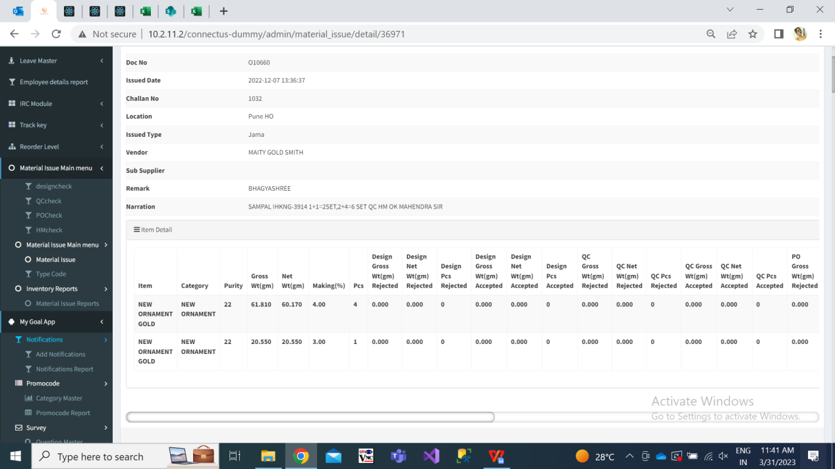

Fig: view action

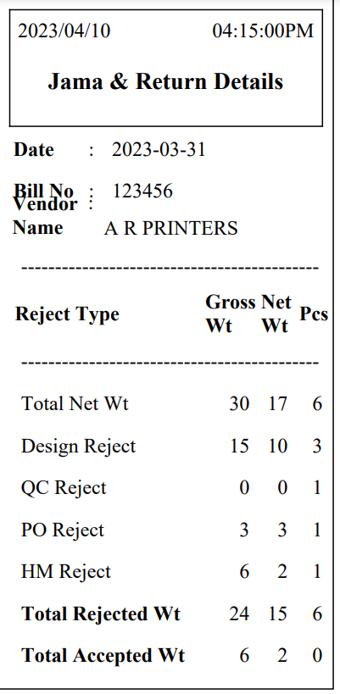

Fig: HM slip report

Step 6. Through connect us -> quality check report, user can export report of total gross wt and pcs quality checked by employees. It will have following fields:

* From Date
* To date
* Employee name
* Filter button
* Download button
* Reset button

|  |  |
| --- | --- |
| **Fields** | **Description** |
| From Date | User will select the date from which quality report is expected.  Future date should be disabled. |
| To Date | User will select the date till which quality report is expected.  Future date should be disabled. |
| Employee name | It will be multi-select field. It will display list of active employees from employee master. |

Once user clicks on filter, following columns of the report should be displayed:

1. Employee name
2. Total gross wt
3. Total net wt
4. Total pcs
5. Rejected gross wt
6. Rejected net wt
7. Rejected pcs
8. Accepted gross wt
9. Accepted net wt
10. Accepted pcs

|  |  |
| --- | --- |
| **Fields** | **Description** |
| Total gross wt | It display total gross wt from all documents received for quality check by employee. |
| Total net wt | It display total net wt from all documents received for quality check by employee. |
| Total pcs | It display total pcs from all documents received for quality check by employee. |
| Rejected gross wt | It display total gross wt rejected from all documents received for quality check by employee. |
| Rejected net wt | It display total net wt rejected from all documents received for quality check by employee. |
| Rejected pcs | It display total pcs rejected from all documents received for quality check by employee. |
| Accepted gross wt | It display total gross wt accepted from all documents received for quality check by employee. |
| Accepted net wt | It display total net wt accepted from all documents received for quality check by employee. |
| Accepted pcs | It display total pcs accepted from all documents received for quality check by employee. |

**References of the users**

|  |  |  |  |
| --- | --- | --- | --- |
| **User** | **Name** | **Mail** | **Contact number** |
| **Actual user** | Pritam mehta | ia@csjewellers.com |  |
| **Ticket created by (if any)** | Manali bhadirage | Manali.bhadirage@techneai.com |  |
| **Assigned business analyst** | Manali bhadirage | Manali.bhadirage@techneai.com |  |
| **Assigned developer** | Bhushan patel | Bhushan.patel@techneai.com |  |
| **Assigned tester** | Priyanka dupargude | Priyanka.dupargude@techneai.com |  |