|  |  |
| --- | --- |
| **Ticket ID** | *TT10956* |
| **Ticket description** | PO process - reorder vs current stock comparison (gaurav sir & pritam sir point) |
| **Created by** | *Manali Bhadirage* |
| **Created on** | *26/04/2023* |
| **Priority** | *Very high* |
| **Version** | *1.0* |

**Version**

|  |  |  |  |  |
| --- | --- | --- | --- | --- |
| **Sr. No** | **Version no** | **Version Date** | **User name** | **User department** |
| **1** | **1.0** | **26/04/2023** | **Rohit Shete** | **Inventory** |
|  |  |  |  |  |
|  |  |  |  |  |

**Approvals**

|  |  |  |
| --- | --- | --- |
| **Field** | **Name of the User** | **Approved date by the user** |
| **Actual User Name** | Rohit Shete |  |
| **Actual User Department** | Inventory |  |
| **Organization Name** | CSJ |  |
| **Assigned BA** | Manali bhadirage |  |
| **Assigned Developer** | Gaurav Shaha |  |
| **Assigned Tester** | Sanmati Shedbale |  |

**Introduction**

*Through connect us -> admin -> reorder level report, users maintain the stock of all the items at all locations. Through this report, user can know the current stock at each branch and based upon it can analyze the order required in upcoming three days at any particular location.*

**Developed system**

*In connect us -> admin -> reorder level report, user generates the report everyday at 9 am (before labeling & stock transfer process at inventory).*

*Once user generates the report, its entry will be displayed in grid of reorder level report menu. On grid, following columns are being displayed:*

* *Action - Stock level report and requisition report*
* *Report ID*
* *Start date*
* *Completed at*
* *Status*
* *Created by*

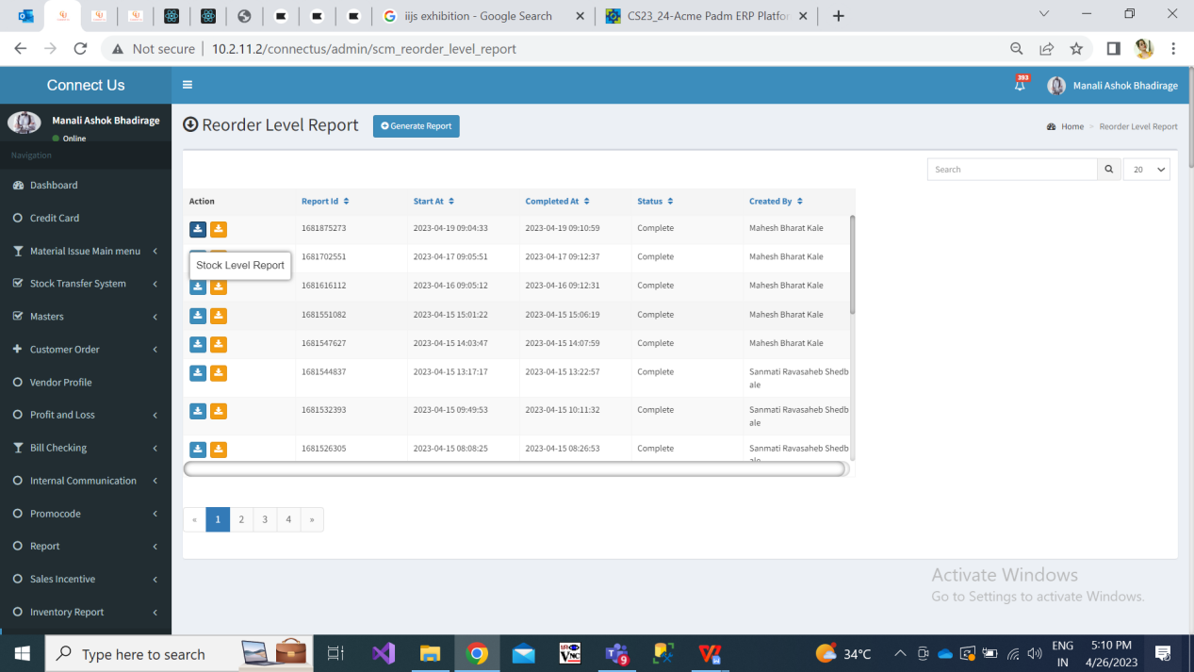

Fig: Connect us -> reorder level report menu

*Once user downloads ‘stock level report’, it will display following columns:*

* *Item*
* *Category*
* *Size*
* *Wt/Mrp Range*
* *Exact wt*
* *R, S, E/L of each branch*
* *Total R, S, E/L*

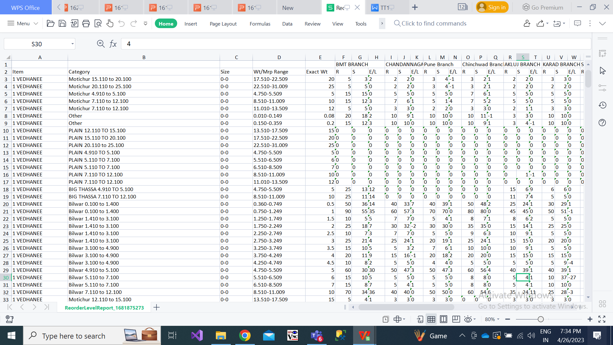

Fig: Stock level report

|  |  |
| --- | --- |
| **FIELDS** | **DESCRIPTION** |
| Item name | Items available at the location will be displayed in sheet as per padm -> master -> item. |
| Category | Categories mapped against the item and which are available at the location will be displayed in sheet as per padm -> master -> item. |
| Size | As per item master, it will display size of the item wise category which are available at the location as per item master. |
| Wt/MRP Range | As per item master, it will display wt / MRP range of the item wise category. |
| Exact wt | It will display the exact wt of the item - category - size - wt range as per item master. |
| Branch | It will display branch from per padm -> master -> location. |
| R | Here, it displays the count of pcs for particular item-category-size-wt range that is decided & supposed to be kept at each branch.  It will display the count of pcs from padm -> search menu -> set branchwise reorder levels (that means SCM item reorder level).  Step 1. Enter reorder in search menu of padm. Open set branchwise reorder levels.    Step 2. From SCM item reorder level report, tick checkbox for ‘all branch’ and enter item name and category.  MicrosoftTeams-image (25)    Step 3. The number in Reorder level column for dull season, it will be displayed as ‘R’ in CU-> reorder level report for that item - category - size - wt range. |
| S | The available stock at the branch is mentioned in this column.  It will display number from padm -> label/batchwise stock report.  Step 1. User will select all branch or any one of the branch that user wants to view, enter 1. Gold as product group and click on ‘Product groupwise export to excel’ button.    Step 2. The stock count of each branch is mentioned in ‘S’ column of our stock reorder level report. |
| E/L | Excess / Less = R-S for each branch.  If E/L shows positive numbers, that means the order has to be given to karagir for that item-category-size-wt range.  If E/L shows negative number, that means we have those much extra pcs of that item-category-size-wt range.  Example: For Chandan nagar branch, R is 5 and S is 3. Then E/L=5-3=2. Thus, for 1 vedhanee > motichur 15.110-20.100 > wt range 17.510-22.509, inventory will give order of 3 pcs to karagir. |
| Total | In total R, it will display sum of count in R column of all branches.  In total S, it will display sum of count in S column of all branches.  Total (E/L) = Total(R) - Total (S). |

**References of the users**

|  |  |  |  |
| --- | --- | --- | --- |
| **User** | **Name** | **Mail** | **Contact number** |
| **Actual user** | Mahesh Kale  Rohit shete | ginventory@csjewellers.com |  |
| **Ticket created by (if any)** | Manali bhadirage | Manali.bhadirage@techneai.com |  |
| **Assigned business analyst** | Manali bhadirage | Manali.bhadirage@techneai.com |  |
| **Assigned developer** | Gaurav shaha | Gaurav.shaha@techneai.com |  |
| **Assigned tester** | Sanmati Shedbale | Sanmati.shedbale@techneai.com |  |