|  |  |
| --- | --- |
| **Ticket ID** | *TT11273* |
| **Ticket description** | Generate BVC challan action to be provided in material issue. From location and To location will be drop-down. |
| **Created by** | *Manali Bhadirage* |
| **Created on** | *21/04/2023* |
| **Priority** | *Very high* |
| **Version** | *1.0* |

**Version**

|  |  |  |  |  |
| --- | --- | --- | --- | --- |
| **Sr. No** | **Version no** | **Version Date** | **User name** | **User department** |
| **1** | **1.0** | **21/04/2023** | **Sanjay Danole** |  |
|  |  |  |  |  |
|  |  |  |  |  |

**Introduction**

*Through stock transfer module, users enter series from padm -> document -> karagir nave / purchase return / rd sales bill, etc and transfer the stock from one of our branch location to our another branch location or to vendor’s location.*

**Business requirement**

User want to print the receipt of stock transfer for the documents which are not available in Padm but are entered in connect us -> material issue.

**Existing system**

*There is such option in material issue to select ‘from and to’ location and get print receipt.*

**Proposed system**

*Step 1. User will scan one challan no. and add the details of total item in material issue -> add data.*

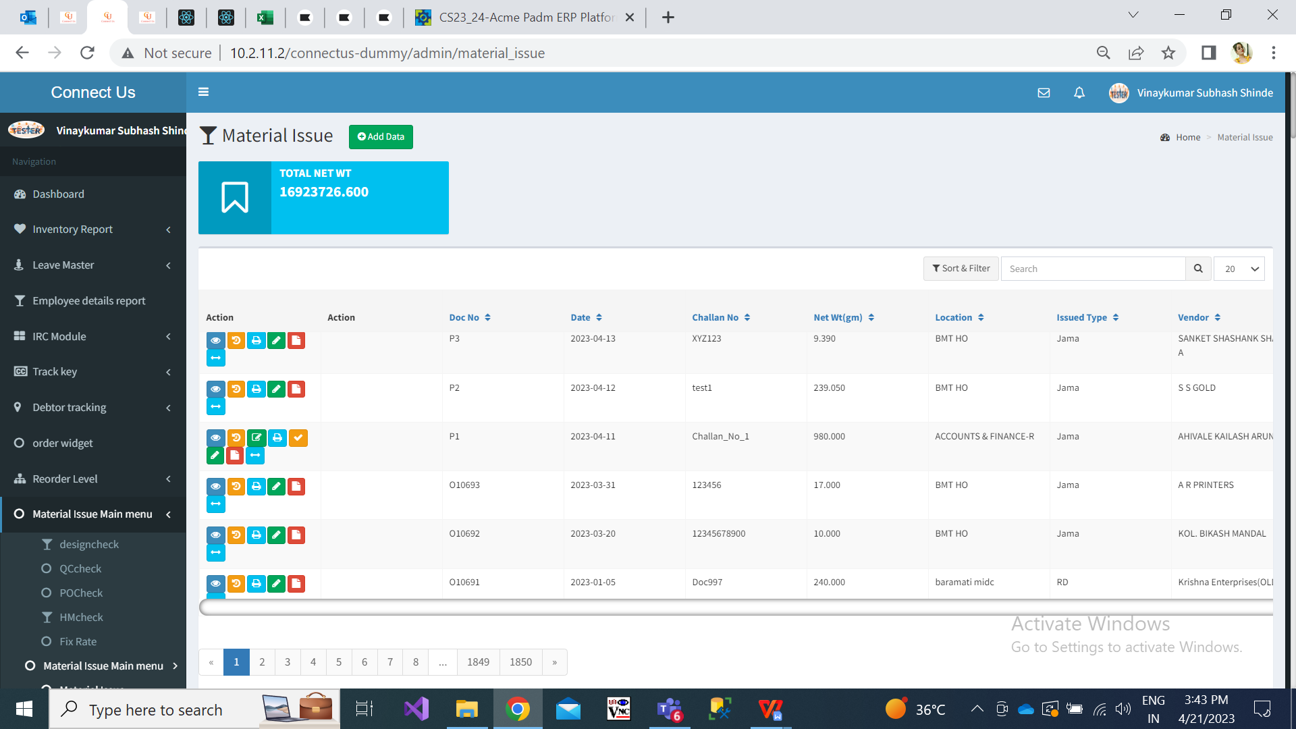

Fig: Material issue -> Home page

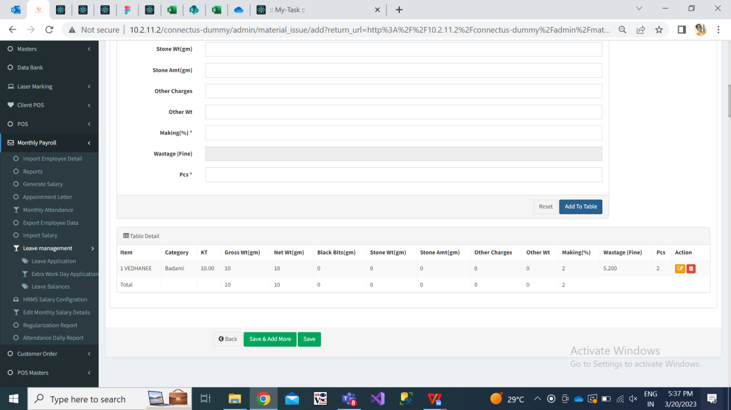

Fig: Material issue -> add data

Step 2. Once item is added and data is saved, doc. no. will be generated to it. It will have following actions:

* Edit
* View
* History
* Print
* Received
* Get attachment data
* BVC challan
* Take bvc print

|  |  |
| --- | --- |
| **FIELDS** | **DESCRIPTION** |
| BVC challan | This action will be provided based on authority through masters-> login special auth.  Through this action, user can enter the ‘from location’ and ‘to location’ and then can print the receipt of the same.  Once user has entered the details in BVC challan action, this action will be removed. |
| Take BVC print | Once authorized user has entered details of ‘from and to location’ through BVC challan, then only it will display BVC print action. It will be displayed to all users.  Users can download bvc challan print for the doc. multiple times.    Fig: Take BVC print action |

Step 3. Once authorized user clicks on BVC challan, it will display following fields:

* From location
* To location
* Ship via
* Submit (button)
* Reset (button)
* Details of doc.

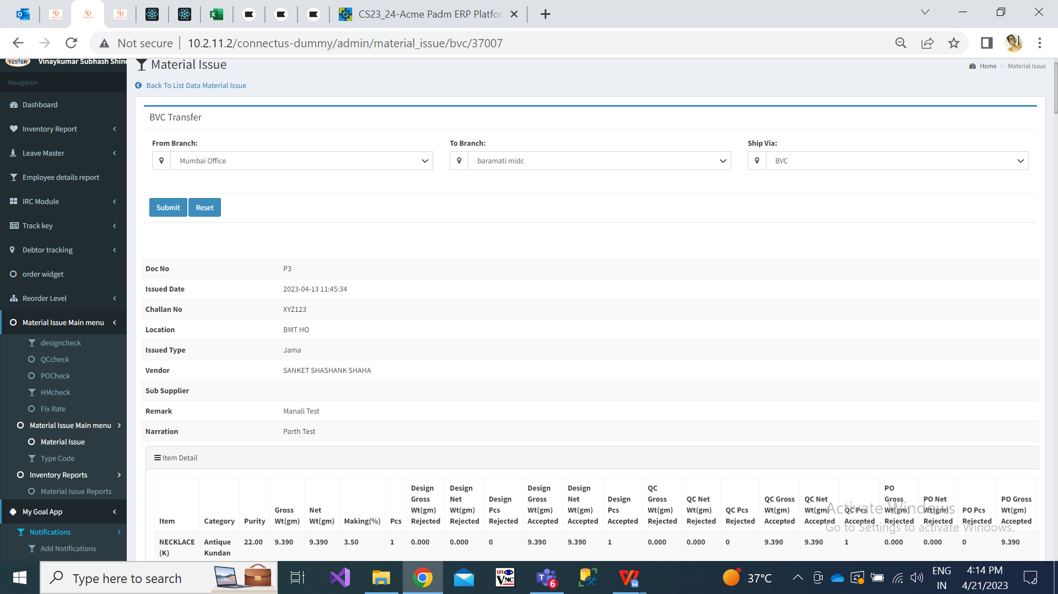

Fig: Material issue -> BVC challan

|  |  |
| --- | --- |
| **FIELDS** | **DESCRIPTION** |
| From location | It will be drop-down which consist list of branches from branch master.  It will be single select.  Authorized user will select the location from which the document is to be transferred. |
| To location | It will be drop-down which consist list of branches from branch master.  It will be single select.  Authorized user will select the location to which the document is to be transferred. |
| Ship via | It will be drop-down which consist BVC and Own in the list.  It will be single select.  Authorized user will select BVC when the stock / doc. Will be shipped via BVC logistics. If doc will be shipped by our own transport service, then user will select ‘Own’. |
| Submit | Once user clicks on submit button, data will be saved and ‘Take BVC print’ action will be displayed for that doc. And, the details will be displayed on the print preview. |

Once user has entered the details in BVC challan action and clicked on submit button, then ‘BVC challan’ action will be removed for that doc.

Step 4. Further, through ‘Take BVC print’ action user can print the challan multiple times.

Once user clicks on ‘Take BVC print’ action, a dialogue box will be displayed as “Do you really want to download pdf ? No / Yes”. Once user clicks on yes, then print preview of the challan will be displayed.

It will display following details on the print:

* From address as per selected branch in BVC challan action -> from location.
* To address as per selected branch in BVC challan action -> to location.
* Doc No. as per material issue when data is added and saved.
* Print date when the user clicks on ‘take bvc print’ action.

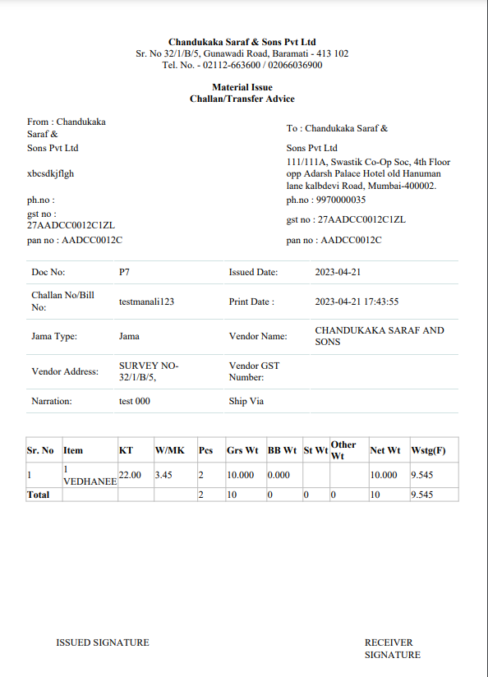

Fig: material issue -> BVC print

**References of the users**

|  |  |  |  |
| --- | --- | --- | --- |
| **User** | **Name** | **Mail** | **Contact number** |
| **Actual user** | Sanjay danole | gold@csjewellers.com |  |
| **Ticket created by (if any)** | Manali bhadirage | Manali.bhadirage@techneai.com |  |
| **Assigned business analyst** | Manali bhadirage | Manali.bhadirage@techneai.com |  |
| **Assigned developer** | Prathmesh shinde | Prathmesh.shinde@techneai.com |  |
| **Assigned tester** |  |  |  |