|  |  |
| --- | --- |
| **Ticket ID** | TT8086 |
| **Ticket description** | Discount Code User Wise Set Karta Aale Pahije. |
| **Created by** | Jotiram pawar |
| **Created on** | 2022-12-27 |
| **Priority** | medium |
| **Version** | 1.0 |

**Version**

|  |  |  |  |  |
| --- | --- | --- | --- | --- |
| **Sr. No** | **Version no** | **Version Date** | **User name** | **User department** |
| **1** | **1.0** | **10/03/2023** | **Jotiram pawar** | **Internal audit** |
| **2** | **2.0** | **10/04/2023** | **Pritam Mehta** | **Internal audit** |
|  |  |  |  |  |

**Approvals**

|  |  |  |
| --- | --- | --- |
| **Field** | **Name of the User** | **Approved date by the user** |
| **Actual User Name** | Jotiram pawar |  |
| **Actual User Department** | Internal audit |  |
| **Organization Name** | CSJ |  |
| **Assigned BA** | Manali bhadirage |  |
| **Assigned Developer** | Punam shinde |  |
| **Assigned Tester** | Maruti Hakke |  |

**Introduction**

Users offer discount on bills to customers. This discount is enabled through promo code (connect us -> my goal -> promo code -> category master) . On My CS app, we have created option where employee will click on Category (Types) and get the generated promo code. Further this authorisation code will be used by employees for billing purpose in padm. They will enter this code in ‘Token Code” field of sales bill. Also, we have created reports in back-end about promo code and its details.

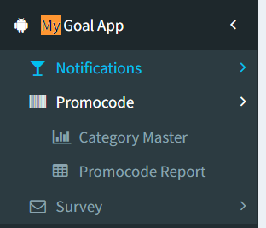

**Business requirement**

In existing system, we have option to select limit department wise to each category.

Now, need provision to create promo code user wise as well for each category.

User wise promo code limit is required because we have few exceptional users to whom we have to give more monthly limit in comparison to other users.

Note : Token code / Authentication Code / Auth code / Discount code / Promo code are same.

**Proposed system**

Step 1. We have created Category Master in back-end system (Connect Us-> my goal -> promo code). Category defines the type of discount that users wish to offer to customers. Category Master have following fields:

* Add Data (Button)
* Action
* Category Name
* Assigned to Designation
* Remark
* Is Active
* Created by & at
* Updated by & at

|  |  |
| --- | --- |
| **FIELDS** | **DESCRIPTION** |
| Add Data | User can add new category by clicking on ‘Add Data’ button. Once clicked, following input fields will be displayed:   * Category Name * Assigned to designation * Remark * Is Active * Submit (button)   Category Name field consists of input box where user will enter the name of the category. It will accept capital and small characters, numbers and space. Maximum 50 characters will be accepted. It will accept english / marathi both the languages.  Assigned to Designation field is mapped from Connect Us-> Master -> Designation master. This field specifies which designation should have provision to which category. User can select one or many designations at a time.  Example: If user enters ABC category name and selects two designations as branch manager and cluster manager. Then in grid, it will display two rows. One row of ABC category for branch manager designation. One row of ABC category for cluster manager designation.    Remark field consists of input box which enables user to enter additional comments if any. It accepts both capital and small characters, space and all special characters. (Max 100 characters) Remark column is not mandatory.  Is Active field consists of two icons namely ‘Yes’ and ‘No’. If user clicks ‘Yes’, then this particular category will be displayed as active and this category will be displayed to user on App for code generation. If user selects ‘No’, then this category won’t be displayed to user on App and subsequently will not be able to generate code under this category.  Once user fills the above details and clicks on submit, category will get added.  Once category is added, the name of the creator and date and time will be displayed.    Fig: Grid view    Fig: Add category |
| Action | This field consists of Set limit, Edit Data and View Data.  Edit data enable user to edit category name, remark and is active field.  Through set limit action user can set limit for promo code for each role.  View - It will display details of each category in vertical manner (same as while setting limit). It will have following read only fields:   * Category name * Assigned designation * Monthly limit * Created at & by * Updated at & by * Exceptional user along with their limit (multiple users having same limit will be displayed with comma separated)     Fig: category master -> view action |
| Assigned to Designation | The designations to which the particular category is assigned will be displayed here. |
| Remark | Any remark if added by user while adding category, it will be displayed here.  Maximum 50 characters will be accepted. It will accept english / marathi both the languages. |
| Is Active | Is Active column will display either Yes or No status of category. |
| Created at & by | It will display the name of the employee and date & time when the category was created. |
| Updated at & by | It will display name of the employee and date & time when the limit was set, when the category was edited and when monthly limit for user or general category is edited. |

Step 2 . Once category is added, user will have to set limit to each designation. Employee should click on “Set limit” action against designation entry from grid.

Example: Once we set limit against designation of software developer as “4” then software developer will be able to generate code only 4 times for this particular category in a month.

In addition to this , we have made provision to set limit user wise. When we will click on “set limit” button for ABC category with one selected designation, it will display following fields:

* Category name
* Assigned Designation
* Set monthly limit
* Save button
* Add button

----------------------------------------------------------------------------------------------------------Once user clicks on add button, following fields will be displayed in table below:

* Exceptional user
* Monthly used count
* extra limit
* Add more (+ button)
* Save button

|  |  |
| --- | --- |
| **FIELDS** | **DESCRIPTION** |
| Category Name  Assigned designation | As we have clicked on set limit button of one particular category and designation, it will display the particular selected category name and assigned designation.  They are read only fields. |
| Set monthly limit | This will represent monthly limit for general users in that designation.  User will enter the monthly limit for this category - designation.  Allow limit up to max 300th number only.  It won’t accept negative value, special characters, space, decimal value, characters.  Once user enters limit in this field, user will have to click on ‘save button’ so that this limit will be provided to general users of the mentioned designation. |
| Exceptional user | It is optional field.  As per selected designation, it will display list of active employees from masters-> general master -> employee master. Also, the same employee should be active in user master and have same designation in user master as in employee master.  (example: if designation is branch manager, then in this drop-down it will display all active branch managers)  It will be multi select. |
| Monthly used Count | It will display the count of code generated by the exceptional user for the particular category.  If there are multiple users, then in ‘monthly used limit’ it should display the count of monthly promo code generated by each user separated by comma. |
| Monthly extra limit | Besides ‘exceptional user’ provide “monthly Limit” field. Here user will enter the monthly limit for the selected user or list of users.  Example: For designation php laravel developer, general limit is 2 and for Baliram extra limit is 4. That means, Baliram will be able to generated code for total 6 (2 + 4) times.  Allow limit up to max 300th number only.  It won’t accept negative value, special characters, space, decimal value, characters.  Note: Limit for specific user wise will be as entered in “extra limit” field, however limit for for the rest of the general users of that designation will be as per the limit entered in “Set monthly limit” field above the table. |
| Add button (provided above table) | Once user clicks on add button above table, then one more row will be generated for setting limit for another exceptional user.  It will display one more row of exceptional user and extra limit field.  In this case, exceptional users field should display the list of active users from employee master as per selected designation. In addition to this, it will not display list of users which are already selected in above row exceptional user field. |
| Save | Once user clicks on save button, data will get added and successful message will be displayed.  Once limit is set for designation (general) then it will be displayed in grid. |

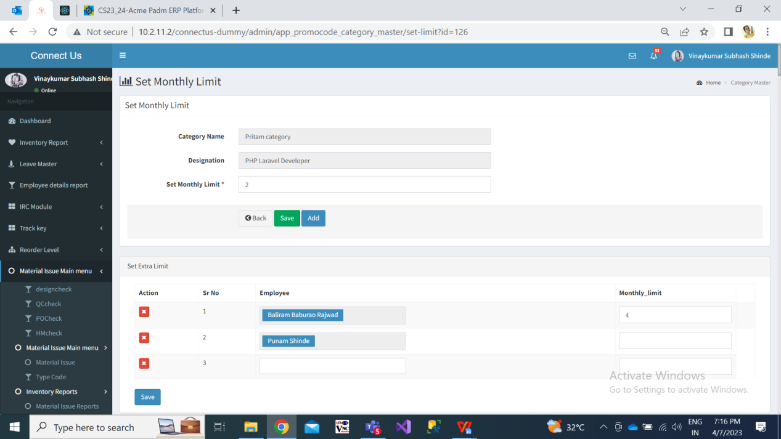

Fig: set limit

Step 3. Employees once signs in MY CS application, he will see “Authorisation Code” menu on home screen. Once user taps on this icon, he will be directed to page where employee will have to select the category from drop-down.

Categories assigned to this employees designation will be displayed here. Once employee selects the category, “generate” button will be displayed.

Once employee taps on generate button pop-up message will appear asking employee to confirm for generation of code.

Once employee clicks yes, Auth code will be generated and category name will be displayed.

Auth code format is kept such that it has 7 digits. Each time unique auth code will be generated. First digit refers to the category number and later 6 digits will be unique each time.

This generated code will be entered by employees in padm bills in the field named as “Token Code”.

Please note that, if employee has used all his limit for generating code for that particular category, then once again if he clicks to generate code it will display message “Your monthly limit has exceeded”.

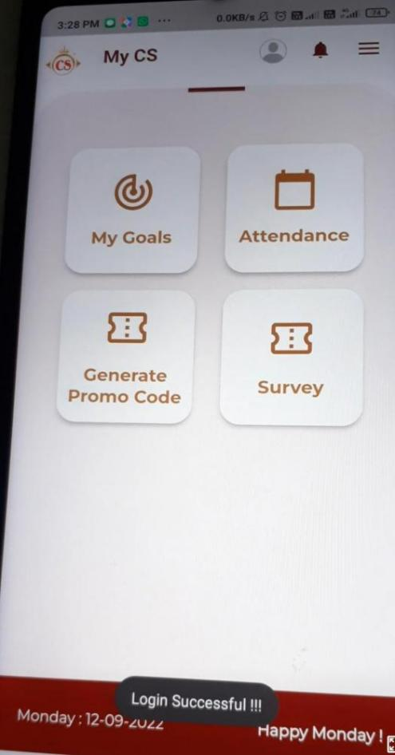 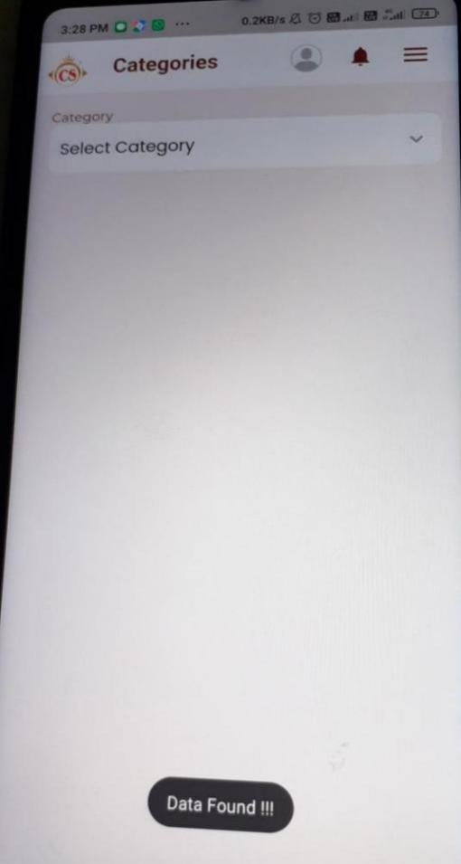

Fig: Code menu in MY CS app Fig: Category drop-down in MY CS

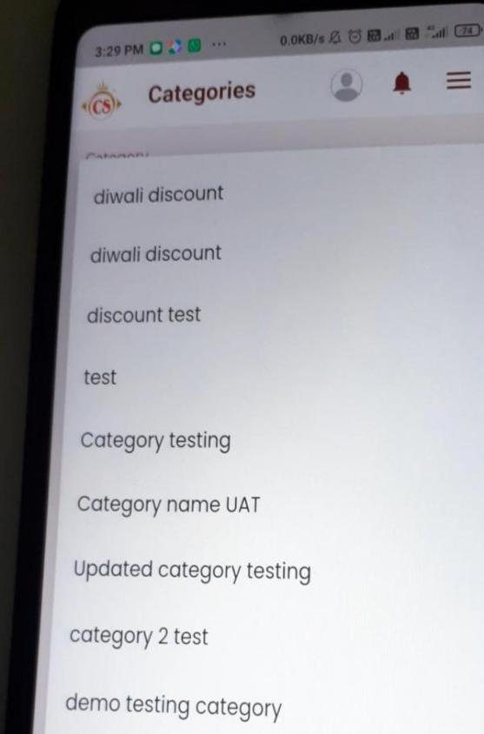

Fig: list of categories assigned tho this designation

Step 4. Moreover, at back-end user should have provision to extract report for the details of codes. Hence, create menu in connect-us namely “Promo Code Report”. It should consists of following input fields:

* From Date - Mandatory field
* To Date - Mandatory field
* Designation
* User : It will be drop-down consisting list of active employees from employee master.
* Reset button
* Submit button
* Export Button (export button will be displayed after report is generated & displayed. Once user clicks on export button, report will get download in .csv file containing same columns)

Once user enters input fields, following columns should be displayed in grid stating details of each code:

* Sr. No.
* Date
* Time
* Promo Code
* Category
* Designation
* User - Username of the person who generated the code. This user name should be displayed as per the login of each user account.

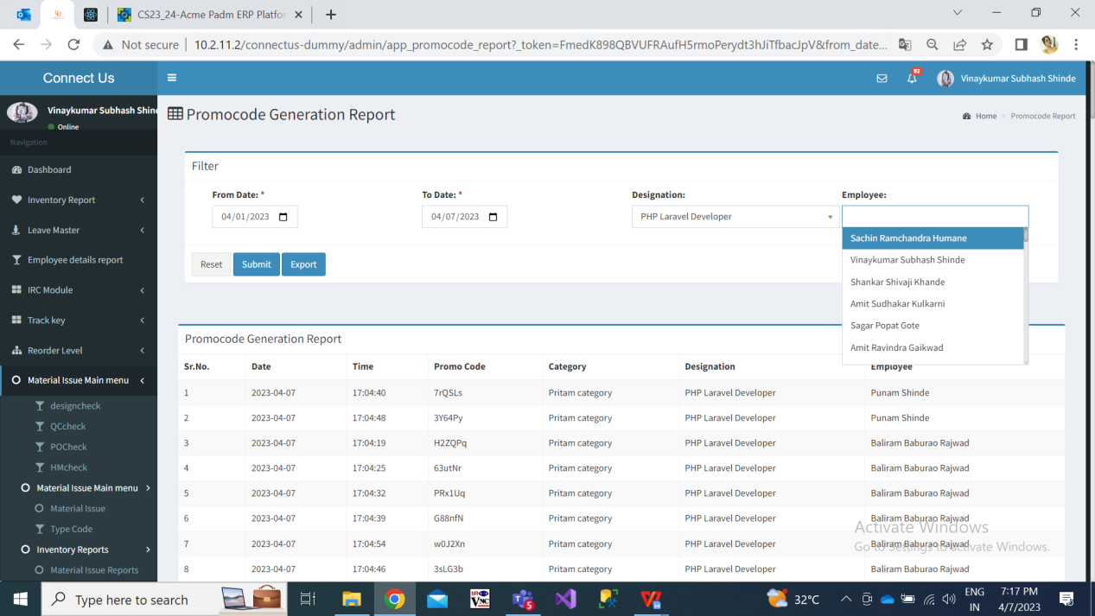

Fig: Promocode report

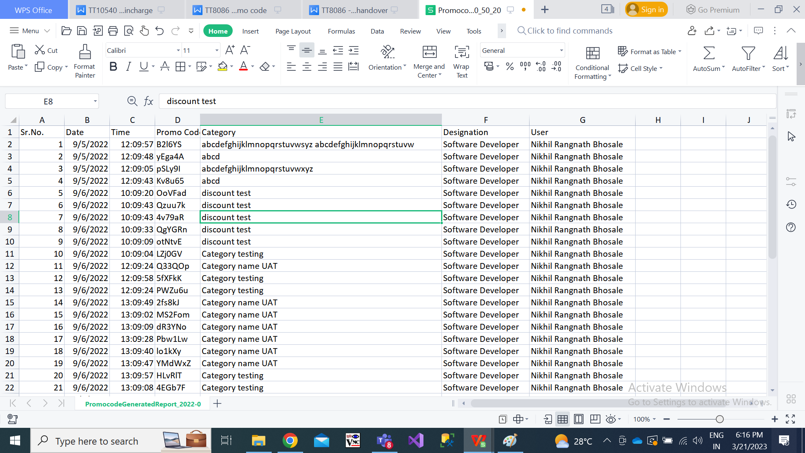

Fig: Promocode report .csv

**References of the users**

|  |  |  |  |
| --- | --- | --- | --- |
| **User** | **Name** | **Mail** | **Contact number** |
| **Actual user** | Jotiram pawar |  |  |
| **Ticket created by (if any)** | Jotiram pawar |  |  |
| **Assigned business analyst** | Manali bhadirage | Manali.bhadirage@techneai.com |  |
| **Assigned developer** | Prathamesh shinde | prathmesh.shinde@techneai.com |  |
| **Assigned tester** | Priyanka dupargude | Priyanka.dupargude@techneai.com |  |