|  |  |
| --- | --- |
| **Ticket ID** | *TT11380* |
| **Ticket description** | *Customer promotional SMS (point by pritam sir and gaurav sir). Point to be developed on separate connect us. Create data bank which will have data of customers from multiple sources like walk in, padm, d2d. Then sms should be sent to customers. Further response rate should be understood from the received cx responses. Analysis will be done for sales purpose.* |
| **Created by** | *Manali Bhadirage* |
| **Created on** | *19/04/2023* |
| **Priority** | *Very high* |
| **Version** | *1.0* |

**Version**

|  |  |  |  |  |
| --- | --- | --- | --- | --- |
| **Sr. No** | **Version no** | **Version Date** | **User name** | **User department** |
| **1** | **1.0** | **19/04/2023** | **Pritam mehta** | **audit** |
| **2** | **1.1** | **27/04/2023** | **Pritam mehta** | **audit** |
|  |  |  |  |  |

**Approvals**

|  |  |  |
| --- | --- | --- |
| **Field** | **Name of the User** | **Approved date by the user** |
| **Actual User Name** | Pritam mehta |  |
| **Actual User Department** | audit |  |
| **Organization Name** | CSJ |  |
| **Assigned BA** | Manali bhadirage |  |
| **Assigned Developer** | Nikhil bhosale |  |
| **Assigned Tester** | Priyanka dupargude |  |

**Estimation**

|  |  |  |  |  |
| --- | --- | --- | --- | --- |
| **Department name** | **Estimated Time (In hr)** | **Scheduled Date (Starting date )** | **Estimated date** | **Actual delivery date** |
| **BA** |  |  |  |  |
| **Development** |  |  |  |  |
| **Testing** |  |  |  |  |
|  |  |  |  |  |

**Introduction**

*We have to build a new project - Customer SMS campaign in separate connect us. Through it, we will be sending sms to customers. It may include promotional sms, transaction sms, requesting to complete surveys, registering for events, feedback, etc. It will be helpful to track the sales, trace the quality of the SMS based on received responses, create intended reports, etc.*

**Existing system**

*There is no such existing system.*

**Proposed system**

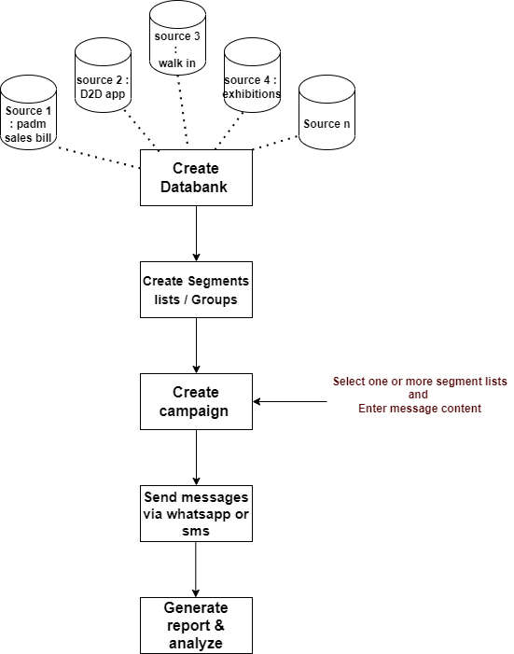

*Step 1. We have to create databank which will include multiple sources consisting information of the customers. List of sources include:*

1. *D2D*
2. *Padm sales bill*
3. *Bulk purchase (paid data from agencies)*
4. *Exhibition*
5. *CSJ website*
6. *Walk ins*
7. *GTS scheme*

*Each source will have following information of the customers:*

* *Name*
* *Mobile no.*
* *WhatsApp no.*
* *Email address*
* *Address*
* *Pincode*
* *State*
* *City*
* *Gender*
* *Date of birth*
* *Age*
* *Date of anniversary*
* *Source(s)*
* *Branch location*
* *Profession*
* *Education*
* *DND*
* *Preferred media*
* *Aadhar no.*
* *PAN no.*
* *First purchase date*
* *Recent Purchase Date*
* *Preferred time to talk*
* *User definable fields*

*Step 2. Once we have list of customers, in our separate connect us -> we will have to create following modules :*

* *Dashboard*
* *Masters*
* *Customer master*
* *Tenant master*
* *Country - State - City master*
* *Segment list*
* *Campaign*
* *Report*
* *User Management*
* *Menu management*
* *Settings*

*Step 3. We will have to create menu as ‘Create segmented list’. Segmented list can be made based on customers who purchase the most, customers who participate in season events / offers, etc.*

*It will have following fields on main page:*

* *Create segment (button)*
* *Search menu*
* *Grid :-*
* *Sr. No.*
* *Action - view, edit*
* *Segment list name*
* *Total count of customers*
* *Status*
* *Created at & by*
* *Updated at & by*

|  |  |
| --- | --- |
| **FIELDS** | **DESCRIPTION** |
| Create Segment list | Through this button, user can create new segment list and select customer list. |
| Search menu | User can search by segment list name, created by and updated by. |
| Sr. No. | I, grid, it should display the recently created segment list at top.  It should display sr. no. in decremented manner. |
| Action | In grid, it will have view and edit action buttons.  Through edit, user can edit the already created segment list.  Through view user can view the details of the created segment list. |
| Segment list name | In grid, it will display the name of the segment list created. |
| Total count of customers | It will display the total count of customers selected in the created segment list. |
| Created at & by | It will display the name and date & time when the segment list was created. |
| Updated at & by | It will display the name and date & time when the segment list was updated through edit action. |

*Once user clicks on ‘create segment list’ button, it will display following fields in form:*

* *Segment List name*
* *Group by :- city, branch location, DOB - from and to date, date of anniversary - from & to date, whatsapp no, source, gender, profession, first purchase date, etc.*
* *Remark*
* *Status*
* *Save button*

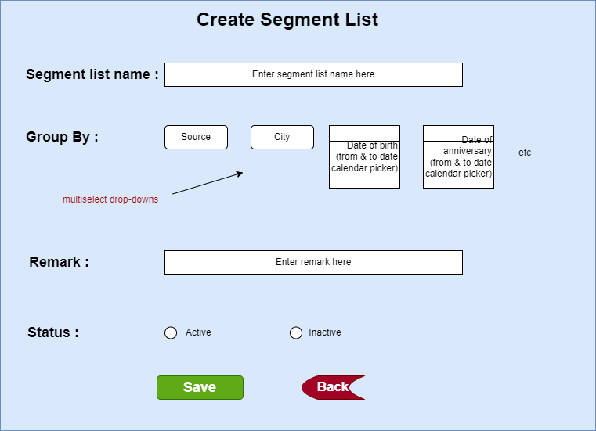

|  |  |  |  |
| --- | --- | --- | --- |
| **FIELDS** | **INPUT TYPE** | **MANDATORY / OPTIONAL** | **DESCRIPTION** |
| Segment list name | Text | Mandatory | It should accept characters, special characters, numbers and space.  It should accept English and devanagiri language.  It should accept maximum 50 characters.  It should be unique. |
| Source type | Drop-down | Mandatory | It should display all the sources from which we have created our databank.  It will be multi-select |
| Group by |  | Mandatory | User will have to select at least one field from below:-  City - It will be drop-down displaying list of cities in India. It will be multi-select.  Branch location - It will be drop-down displaying list of branches in India. It will be multi-select.  Date of birth - It will provide calender picker for from date and to date. It should display date only till today.  Date of anniversary - It will provide calender picker for from date and to date. It should display date only till today.  WhatsApp number - It will be check-box. If user clicks on it then it should include customers who have specified their whatsapp number in data source.  Source - It will be drop-down displaying list of sources from databank. It will be multi-select.  Gender - It will be multi-select. It will display male, female and others in drop-down.  Profession - It will be drop-down and will have multi-select option. It will display list of profession from sources.  First purchase date - It will provide calender picker for from date and to date. It should display date only till today.  As per selected chosen group by options, the list of customers should get sorted from databank. |
| Remark | Text | Optional | It should accept characters, special characters, numbers and space.  It should accept English and devanagiri language.  It should accept maximum 50 characters. |
| Status | Radio button | Mandatory | By default it should be displayed as Yes.  It should be display yes / No accordingly in grid as user changes the status.  If user clicks on No, then this created segment list name should not be displayed in create campaign -> segment list names drop-down. |
| Save | Click |  | Once user fills mandatory fields, the segment list should get created and message should be displayed at top as “Segment list created successfully. Then, user should be directed on grid page.  Created segment list name should be displayed at the top. |
| Back | click |  | Once user clicks on back button, user should be directed back to grid and data whichever is entered shouldn’t be saved. |

*Step 4. We will have to create new menu as ‘Create campaign’. Through this user can select the segment and enter the content of the message (text, media, links, images).*

*It will have following fields on main page:*

* *Create campaign*
* *.CSV SMS*
* *Search menu*
* *Grid*
* *Sr. No.*
* *Action - view, edit*
* *Medium*
* *Message Type*
* *Campaign name*
* *Content*
* *Attachment*
* *Segment list names*
* *Total count of customers*
* *Created at & by*
* *Sent at*

|  |  |
| --- | --- |
| **FIELDS** | **DESCRIPTION** |
| Create Campaign (button) | Through this button, user can create new campaign list and select customer list. |
| .CSV SMS (button) | Through this button user can send different message content to each customer in bulk at a time. |
| Search menu | User can search by segment list name, created by and updated by. |
| Sr. No. | In grid, it should display the recently created campaign name at top.  It should display sr. no. in decremented manner. |
| Action | * View - In grid, it will display action column having view action button. Once user clicks on view action button, It will display the medium, campaign name, content, attachments, segment list names, total count of customers to whom the campaign is sent, created at & by details. In attachment it should display the thumbnails of attached files and have the option to zoom and download them. * Edit - Edit action should be displayed only when the scheduled date & time hasn’t passed for the created campaign. Through edit action, user can edit all fields in the form of ‘create campaign,. |
| Medium | It will display either SMS or WhatsApp. |
| Campaign name | In grid, it will display the name of the campaign which was created. |
| Content | In grid, it will display the content of the created campaign. |
| Attachment | It will display either yes or no if files are attached. |
| Segment list names | It will display the segment list separated by comma if multiple are selected by user while creating campaign. |
| Total count of customers | In grid, it will display the total count of all the customers as per selected segment lists in created campaign. |
| Created at & by | It will display the user name and date & time when the campaign was created by user. |
| Sent at | It will display the date and time at which the message was sent to customers. |

*Once user clicks on ‘create campaign’ button, it will displaying following fields of form:*

* *Medium:- SMS / WhatsApp*
* *Message Type*
* *Campaign name*
* *Content*
* *Attachment*
* *Segment list names*
* *Send now (button)*
* *Schedule (button)*

|  |  |  |  |
| --- | --- | --- | --- |
| **FIELDS** | **INPUT TYPE** | **MANDATORY / OPTIONAL** | **DESCRIPTION** |
| Medium | Drop-down | Mandatory | User will select whether the messages are supposed to be sent via text SMS or via WhatsApp. |
| Message Type | Drop-down | Optional | User will select Transaction */ Promotional / registration / Survey from the drop-down.*  *It will be single select.* |
| Campaign name | Text | Mandatory | It should accept characters, special characters, numbers and space.  It should accept English and devanagiri language.  It should accept maximum 50 characters.  It should be unique. |
| Content | Text | Mandatory | It should accept characters, special characters, numbers and space.  It should accept English and devanagiri language.  If user has selected SMS medium, then it should accept maximum 2000 characters.  If user has selected WhatsApp medium, then it should accept maximum 2000 characters. |
| Attachments | Attach | Optional | It will be displayed only if user has selected medium as ‘WhatsApp’.  User can attach files of jpeg, jpg, pdf and png extension only. |
| Segment List names | Drop-down | Mandatory | It will display active segment list names in drop-down from created segment list names.  It will be multi-select.  It will have ‘All’ option in the drop-down which will include all active segment lists. |
| Send now | click |  | Once user clicks on this button, it should display dialogue box as ‘Are you sure you want to create this campaign? YES/ NO’.  Once user clicks on yes, then user it should display message as ‘Campaign created successfully’ and user should be directed to grid page.  Once campaign is created, then it should be displayed at top. |
| Schedule | click |  | Once user clicks on this button, it should display calender, time and submit button.  Through provided calender picker, user will select the date on which the messages are to be sent to customers. It should disable past dates and should display dates from today till the 30 days.  User will select the time (HH:MM) at which messages are to be sent to customers on selected day.  Once user enters date & time on which the messages are to be sent and clicks on submit button, then it should display dialogue box as ‘Are you sure you want to create this campaign? YES/ NO’. Once user clicks on yes, then user it should display message as ‘Campaign created successfully’ and user should be directed to grid page. However, the messages should be sent to the customers on scheduled date & time.  Further, if the scheduled date & time hasn’t passed, till then user can edit the scheduled campaign. |

*Once user clicks on .CSV message button, it will display following fields in form:*

* *Message type*
* *Campaign Name*
* *Segment list names*
* *Download format (button)*
* *Upload file (button)*
* *Send now (button)*
* *Schedule (button)*

|  |  |  |  |  |
| --- | --- | --- | --- | --- |
| **FIELDS** | **INPUT TYPE** | **MANDATORY / OPTIONAL** | **DESCRIPTION** | |
| Message Type | Drop-down | Optional | User will select *Transactional / Promotional / registration / Survey from the drop-down.*  *It will be single select.* | |
| Campaign name | Text | Mandatory | | It should accept characters, special characters, numbers and space.  It should accept English and devanagiri language.  It should accept maximum 50 characters.  It should be unique. |
| Segment List names | Drop-down | Mandatory | | It will display active segment list names in drop-down from created segment list names.  It will be multi-select.  It will have ‘All’ option in the drop-down which will include all active segment lists. |
| Download format | Click |  | | Once user clicks on download button, it will download .csv file which will have following columns:   * Customer name * Customer mobile no. * Content   As per selected segment list, customer name and mobile no. should be displayed in the downloaded file. |
| Upload file | Click |  | | User will upload the downloaded & updated file here. |
| Send now | click |  | | Once user clicks on this button, it should display dialogue box as ‘Are you sure you want to create this campaign? YES/ NO’.  Once user clicks on yes, then user it should display message as ‘Campaign created successfully’ and user should be directed to grid page.  Once campaign is created, then it should be displayed at top. |
| Schedule | click |  | | Once user clicks on this button, it should display calender, time and submit button.  Through provided calender picker, user will select the date on which the messages are to be sent to customers. It should disable past dates and should display dates from today till the 30 days.  User will select the time (HH:MM) at which messages are to be sent to customers on selected day.  Once user enters date & time on which the messages are to be sent and clicks on submit button, then it should display dialogue box as ‘Are you sure you want to create this campaign? YES/ NO’. Once user clicks on yes, then user it should display message as ‘Campaign created successfully’ and user should be directed to grid page. However, the messages should be sent to the customers on scheduled date & time.  Further, if the scheduled date & time hasn’t passed, till then user can edit the scheduled campaign. |

*Step 5. Once messages are sent, then it will be tracked.*

*If the message was related to feedback or registering for event or review, we can get the quality of message as per response received from customers.*

*For other messages, we can track the quality of the messages as per latest purchase done by the customer after the SMS was sent.*

**References of the users**

|  |  |  |  |
| --- | --- | --- | --- |
| **User** | **Name** | **Mail** | **Contact number** |
| **Actual user** | Pritam mehta | ia@csjewellers.com |  |
| **Ticket created by (if any)** | Manali bhadirage | Manali.bhadirage@techneai.com | 9604640114 |
| **Assigned business analyst** | Manali bhadirage | Manali.bhadirage@techneai.com |  |
| **Assigned developer** | Nikhil bhosale | Nikhil.bhosale@techneai.com |  |
| **Assigned tester** | Priyanka dupargude | Priyanka.dupargude@techenai.com |  |