|  |  |
| --- | --- |
| **Ticket ID** | *TT4420* |
| **Ticket description** | ConnectUS Madhe Product GroupWise, Item, Category wise Product Details And Pick Sathi Provision Karun Pahije Aahe Ref By :- Vinay Sir |
| **Created by** | *Tushar Nikam* |
| **Created on** | *23/08/2022* |
| **Priority** | *Medium* |
| **Version** | *1.0* |

**Approvals**

|  |  |  |
| --- | --- | --- |
| **Field** | **Name of the User** | **Approved date by the user** |
| **Actual User Name** | Tushar Nikam |  |
| **Actual User Department** | Inventory |  |
| **Organization Name** | CSJewellers |  |
| **Assigned BA** | Manali Bhadirage |  |
| **Assigned Developer** | Punam Shinde |  |
| **Assigned Tester** | Abhijeet Ghodke  Maruti Hakke |  |

**Introduction**

*Inventory department has new and old employees and so new employees need to know the information of each item. User requires a module where they will enter the details of the item - product group wise, item category wise and size wise. Through this, the actual user in inventory can view the details of the item and its image and work accordingly.*

**Business requirement**

*In CU -> Inventory Report -> Product details needs to be created through which user can :*

* *Add Data*
* *Filter Data*
* *Edit*
* *View*
* *Cancel*
* *Export*
* *Details of item will be - Image, product group, item , category, sub-category, design code, hallmark, laser mark, pcs and information.*

**Developed system**

*In Connect US -> inventory report, we have to create ‘Pick item details’ module. It will have following fields:*

* *Add (button)*
* *Bulk Upload format (button)*
* *Bulk upload (button)*
* *Filter (button)*
* *Export (button)*
* *Search (menu)*
* *Pagination count*
* *Grid*

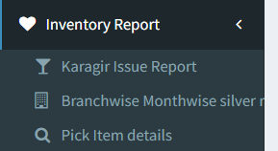

Fig: Pick item details menu

|  |  |  |
| --- | --- | --- |
| **FIELDS** | **INPUT TYPE** | **DESCRIPTION** |
| Add | button | Add button will be provided based on authority.  Through add button, user will add the item and its details.  Once data is added, it will be displayed in grid on main page. |
| Bulk Upload Format | button | Through this button, user can download the bulk upload format (.csv file).  It will have columns namely:   * Barcode * Product Group * Item name * Category * Sub-category * Barcode * Design code * Pcs * Consider Size * Enter Size * Consider Design code * Hallmark * Laser mark * Information * Image attachment 1 * Image attachment 2 * Image attachment 3   Here, in image column user will write the complete name of the file (imagename.extension). |
| Bulk Upload | button | It will be provided based on authority.  It will consist of two buttons - Upload csv file and Upload photos.  User will fill the details of the item through bulk upload format and will upload file of details here through upload csv file button.    Through upload photos, user can attach multiple images. Once user clicks on submit, then images will get assigned as per the name written in bulk upload file. |
| Filter | button | Actual user will be able to get filtered data. Once filter fields are applied and actual user clicks on filter, then filtered data will be displayed in grid. |
| Export | button | Through export button, user will be able to export grid data in .csv file. |
| Grid | Table | All the added data will be displayed in grid.  After applying filter, all filtered data will be displayed in grid. |

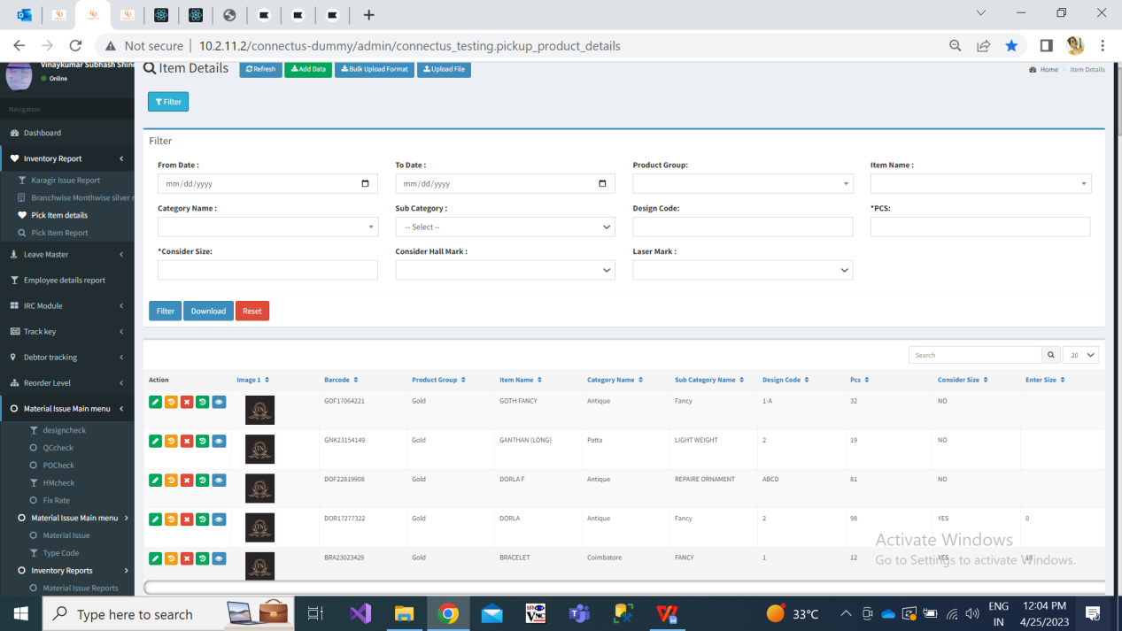

Fig: Pick item details -> Grid

Once user clicks on **add** button, a form will be displayed which will have following fields:

* + Barcode
  + Product Group
  + Item name
  + Category
  + Sub-category
  + Design code
  + Pcs
  + Consider Size
  + Enter size
  + Consider Design code
  + Hallmark
  + Laser mark
  + Information
  + Images
  + Save (button)
  + Back (button)

|  |  |  |
| --- | --- | --- |
| **FIELDS** | **INPUT TYPE** | **DESCRIPTION** |
| **Barcode** | Text | 1. It will be optional field. 2. It will be alphanumeric field. 3. It will be unique. Same barcode cannot be added again. 4. Maximum length will be 15 digit. 5. It will have first three letters compulsorily. 6. It is not case sensitive however letters entered (even if entered in lowercase), it will be displayed in uppercase only.   Example : NEK123456789012  BNG098765432109 |
| **Image** | Attachment | 1. It is mandatory field. 2. User will add maximum 3 photos of item. 3. Image format will be .jpg, .jpeg, .heif and .png with maximum size of 5 MB per image. 4. The firstly attached image of particular item will be considered as main image and it will be displayed in grid. 5. If user has attached any image, it’s name will be displayed and image in small form will be displayed with delete button to top-left corner of each image. |
| **Product Group** | Drop-down | 1. It is mandatory field 2. Display list of product groups in drop-down namely Diamond, Platinum, Gold, Silver, Stone, MRP and forming. |
| **Item name** | Drop-down | 1. It is mandatory field.   List of items will be displayed either from Padm -> master -> item.   1. User will be able to enter few inputs in this drop-down and then relevant details will be displayed in drop-down. |
| **Category** | Drop-down | 1. It is mandatory field. 2. All mapped categories will be displayed as per selected item from Padm -> master -> item -> category list in that item. 3. User will be able to enter few inputs in this drop-down and then relevant details will be displayed in drop-down. |
| **Sub-category** | Text | 1. It is optional field. 2. User will manually enter sub-category. 3. It will accept characters and -. 4. Maximum 25 characters will be accepted. |
| **Design Code** | Text | 1. It is optional field. (only while entering new item from inventory, they require design code.) 2. It will accept alphanumeric value. 3. It will accept only numbers or only characters or combination of both. 4. It can be repeated but against this design code, barcode will be different each time while adding data. 5. It will accept maximum 25 digits. |
| **Pcs** | Text | 1. It is optional. 2. User will manually enter the number of pcs of that item - category. 3. Provide incremental & decrement keys into this field for numbers. 4. It will only accept non-decimal numeric value. |
| **Consider Size** | Check-box | Provide three check-box button for:  Yes  No  Optional  If user selects yes for consider size, then display field as ‘**enter size**’. Enter size field will accept decimals (single value only after decimal point). It will accept maximum “100” number only in this field. It will be optional field.  If user selects optional for consider size, then display field as ‘enter size’. Enter size field will accept decimals (single value only after decimal point). It will accept maximum “100” number only in this field. Here, it will be mandatory field. |
| **Consider Design Code** | Check-box | Provide three check-boxes as:  Yes  No  Optional |
| **Consider Hallmark** | Radio button | Provide two radio buttons for:  Yes  No |
| **Laser mark** | Radio Button | Provide two radio buttons for:  Yes  No |
| **Information** | Text | 1. User will manually enter information / details of the item. 2. It will accept English and Devanagari script. 3. It will accept characters, number, space and special characters. 4. Maximum length of 200 inputs. 5. Marathi inputs once entered, it will be displayed in Marathi script on grid. |
| **Save** | button | Once user fills above fields and clicks on save, data will get added and displayed on grid on main page. |
| **Back** | button | Once user clicks on back button, user will be directed to main page without saving any data. |

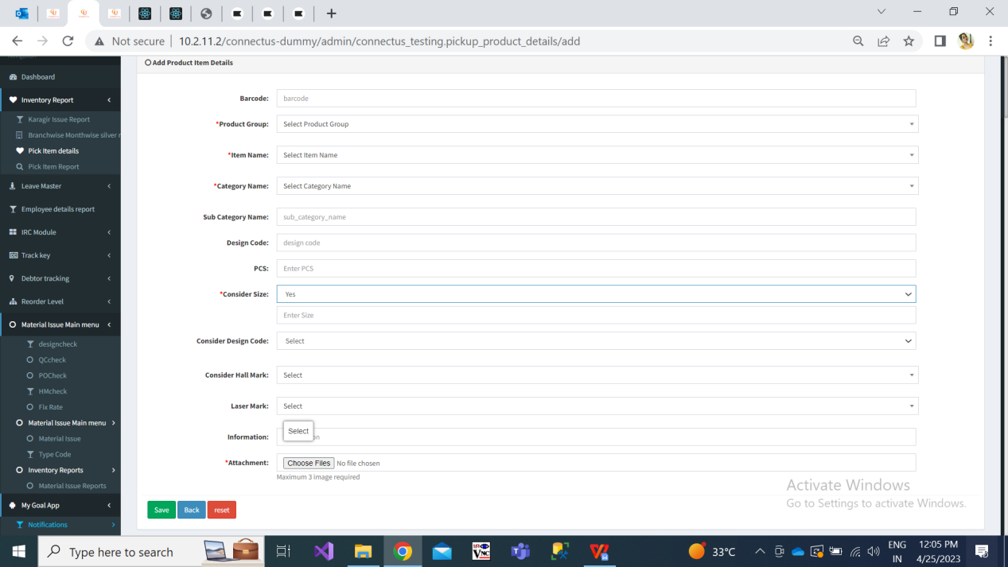

Fig: Pick item details -> Add data

In case, user has added one data, then cancelled it and is adding the same details / same data again, then data will get added because the previous added entry is cancelled.

Once data is added, it will display message as ‘data added successfully’ and it will be displayed the recently added data at top in **grid**. Grid will have following columns:

* Sr. No.
* Image
* Product Group
* Item name
* Category
* Sub-category
* Barcode
* Design code
* Pcs
* Consider Size
* Enter Size
* Consider Design code
* Hallmark
* Laser mark
* Information
* Is Cancelled

|  |  |
| --- | --- |
| **FIELDS** | **DESCRIPTION** |
| Action | View, Edit, Cancel, Restore and History action button will be displayed. |
| Sr. No. | It will display incremental serial numbers for each added entry.  Recently added entries will be displayed at the top. |
| Image | The firstly attached image of particular item will be considered as main image and it will be displayed here in grid.  By clicking on image here, it will zoom on the same page. |
| Product Group | Display list of product groups as chosen while adding - Diamond / Platinum / Gold / Silver / MRP and forming. |
| Item name | Item name will be displayed as chosen while adding. |
| Category | Category name will be displayed as chosen while adding. |
| Sub-category | Sub-category name will be displayed as written while adding.  If it is not mentioned while adding, then keep this field blank in grid. |
| Barcode | If any data is entered in this field, then it will be displayed in grid. |
| Design Code | Design code will be displayed as written while adding.  If it is not mentioned while adding, then keep this field blank in grid. |
| Pcs | Count of pcs will be displayed as chosen while adding.  If it is not mentioned while adding, then keep this field blank in grid |
| Consider Size | Yes / No / Optional will be displayed in grid. |
| Enter Size | Display the number entered in this field. If not then keep it blank for grid. |
| Consider Design Code | Yes / No / Optional will be displayed in grid. |
| Consider Hallmark | Yes / No will be displayed in grid as chosen while adding. |
| Laser mark | Yes / No will be displayed in grid as chosen while adding. |
| Information | All the information mentioned while adding will be displayed here |
| Created By | Name of the user who has added the data will be displayed here. |
| Created At | Date (DD/MM/YYYY) and time when the data was added will be displayed here. |
| Updated By | If any changes are made by any user then his/her name will be displayed here. |
| Updated At | Date and time when the data was updated will be displayed here. |
| Is Cancelled | If any item entry is cancelled, it will display ‘yes’ in this column. |

**Actions in grid**: View, Edit, Cancel, Restore and History.

|  |  |
| --- | --- |
| **FIELDS** | **DESCRIPTION** |
| View action | It will display following fields of the individual item in vertical form:   * Barcode * Product Group * Item name * Category * Sub-category * Design code * Pcs * Consider Size * Enter size (display numbers whichever entered for consider size - optional / yes) * Consider Design code * Hallmark * Laser mark * Information * Image - Images will zoom on same page when clicked.     Fig: View action |
| Edit  Action | It will be provided based on authority.  User can edit individual details of item. It will have following fields:   * Barcode * Product Group * Item name * Category * Sub-category * Design code * Pcs * Consider Size * Enter Size * Consider Design code * Hallmark * Laser mark * Information * Images * Save (button) * Back (button)  1. All fields are editable. 2. Once user clicks on edit action, it will display all pre-filled data of that item. 3. If user edits product group, then item name and category drop-down list will get updated. 4. Same existing barcode number will n’t be accepted. 5. User can attach maximum 3 images. 6. User can remove any previously attached image. 7. Once details are edited and saved, it will display updated data in grid.     Fig: edit action |
| Cancel  Action | 1. Cancel action button will be authority based. 2. Cancelled data / entry will be highlighted. Through cancelled data, actual users will understand that this particular item-category is not considered currently.     Fig: Cancel action |
| Restore  Action | 1. Authorised User can restore cancelled data. 2. Restore button will be provided based on authority. 3. Once item-category is restored, its highlighted colour will be removed and its cancelled status will be changed to ‘Not cancelled’. 4. In case user has added one data, then cancelled it and added same data, same details for second time. Then the data which was added first time, it will not get restored because second time (same) data is available in grid.     Fig: Restore |
| History  Action | It will display following columns:   * Operation - Add / Update * Product Group * Item name * Category * Sub-category * Barcode * Design code * Pcs * Consider Size * Enter size * Consider Design code * Hallmark * Laser mark * Information * Is cancelled * Created at * Created by * Updated at * Updated by   Whenever edit is made in any data, it will add the row of update with all the details and the edited one will be highlighted.    Fig: History |

**Filter** (button)

Actual user can view filtered data out of all added data. Through filter button, the actual user will be able to view the information of the item. It will have following fields:

* From Date
* To Date
* Product Group
* Item name
* Category
* Sub-category
* Barcode
* Design code
* Pcs
* Consider Size
* Size
* Consider Design code
* Hallmark
* Laser mark

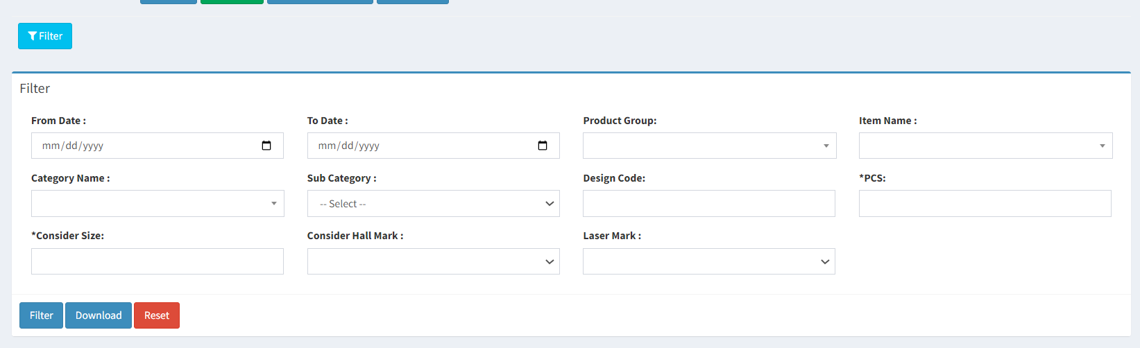

Fig: pick item details -> filter

|  |  |
| --- | --- |
| **FIELDS** | **DESCRIPTION** |
| From Date | It will display the date from which data was first added.  Future date will be disabled. |
| To Date | It will display the date in calendar till current date.  Future date will be disabled. |
| Product Group | It is mandatory field.  It will be drop-down consisting gold, silver, diamond, platinum, mrp and forming in the list. |
| Item name | It is mandatory field.  It will be drop-down displaying list of items from Padm -> master -> item. |
| Category | It is optional field.  As per selected item, list of categories will be displayed here in drop-down from Padm -> master -> item -> category list in that item. |
| Sub-category | As per item and category, all the related sub-categories (the ones which are added and available in grid) will be displayed here in list. |
| Design code | As per item and category, all the related design code (the ones which are added and available in grid) will be displayed here. |
| Pcs | As per item and category, all the related pcs count will be displayed here. |
| Consider Size | It will display yes / no / optional in the drop-down here. |
| Consider Design code | It will display yes / no / optional in the drop-down here. |
| Hallmark | It will display yes / no in the drop-down here. |
| Laser mark | It will display yes / no in the drop-down here. |

Once user applies filters, all the relevant data will be displayed in the grid.

It will have **download** button. Through download button, user can get .csv file of the data in the grid. Exported file will have following columns:

* Sr. No.
* Product Group
* Item name
* Category
* Sub-category
* Barcode
* Design code
* Pcs
* Consider Size
* Size
* Consider Design code
* Hallmark
* Laser mark
* Information
* Created at & by
* Updated at & by

**References of the users**

|  |  |  |  |
| --- | --- | --- | --- |
| **User** | **Name** | **Mail** | **Contact number** |
| **Actual user** | Vinay Shinde | silver@csjewellers.com |  |
| **Ticket created by (if any)** | Tushar Nikam | itinv@csjewellers.com | 2607 |
| **Assigned business analyst** | Manali bhadirage | Manali.bhadirage@techneai.com | 2965 |
| **Assigned developer** | Punam Shinde | Punam.shinde@techneai.com | 2965 |
| **Assigned tester** | Abhijeet ghodke  Maruti Hakke | [Abhijeet.ghodke@techneai.com](mailto:Abhijeet.ghodke@techneai.com)  Maruti.hakke@techneai.com | 2965 |