09.05.2023

Techne AI Leave Management

Manali Ashok Bhadirage

Manali.bhadirage@techneai.com

**Functional Requirement Document**

**CONTENTS**

1. TICKET DETAILS 2

2. VERSION CONTROL 3

3. APPROVALS 3

4. ESTIMATION 3

5. INTRODUCTION 3

6. BUSINESS REQUIREMENT 3

7. SCOPE 5

8. BUSINESS & SYSTEM RULES 6

9. ABBREVIATIONS & TERMS 6

10. EXISTING SYSTEM 6

11. GRAPHICAL REPRESENTATION 6

12. PROPOSED SYSTEM 7

13. TEST DATA 24

14. REFERENCES OF THE USERS 24

1. **TICKET DETAILS**

|  |  |
| --- | --- |
| **Ticket ID** | TT8823 |
| **Ticket description** | We need leave management module for techne ai employees. 1) Through this, employees should be able to apply leaves from their end. 2) applied leave should get sent for approval to respective authorities. 3) through this module, employees should also be able to view their leave history and balance. 4) Authorities should be able to approve / reject their respective teammates leaves. Authorities should have access only to their teammates leave balance. 5) system should have provision to apply for extra working day. 6) in case of medical emergency, employees should be able to apply leaves for back dated days (only for medical emergency) 7) medical leaves should be auto approved by system till 2 days. Notification should be sent to authorities. 8) for medical leaves for more than 2 days, approval needs to be taken and it should have attachment option. (It should also have option to verify attachment) Please see attached screenshots. Please reach out to minal for detailed requirement. |
| **Created by** | Minal Pawar |
| **Created on** | 19/01/2023 |
| **Priority** | Medium |

1. **VERSION CONTROL**

|  |  |  |  |  |
| --- | --- | --- | --- | --- |
| **Sr. No** | **Version no** | **Version Date** | **User name** | **User department** |
| **1** | **1.0** | **09/05/2023** | **Minal Pawar** | **HR** |
| **2** | **1.1** | **16/05/2023** | **Minal Pawar** | **HR** |
|  |  |  |  |  |

1. **APPROVALS**

|  |  |  |
| --- | --- | --- |
| **Field** | **Name of the User** | **Approved date by the user** |
| **Actual User Name Actual User Department Organization Name** | Minal pawar  HR  Techne AI |  |
| **Assigned BA** | Manali bhadirage |  |
| **Assigned Developer** | Prathmesh shinde |  |
| **Assigned Tester** | Poonam Deshmukh |  |

1. **ESTIMATION**

|  |  |  |  |  |
| --- | --- | --- | --- | --- |
| **Department name** | **Estimated Time (In hr)** | **Scheduled Date (Starting date)** | **Estimated date** | **Actual delivery date** |
| **BA** |  |  |  |  |
| **Development** |  |  |  |  |
| **Testing** |  |  |  |  |
|  |  |  |  |  |

1. **INTRODUCTION**

We need to create a leave management module in Techne AI connect us through which all Techne AI employees can apply leaves, apply for extra working and know their leave balance. Authorized person should be able to approve their leaves and notification should get sent to the respective employee.

1. **BUSINESS REQUIREMENT**

|  |  |  |  |
| --- | --- | --- | --- |
| **Requirement ID** | **Requirement Name** | **Short Description** | **Priority** |
| BR001 | Create leave management menu | We need to create new menu as leave management under which it will have leave application, leave balances, extra working modules under it. | High |
| BR002 | Add functionality in leave balance | It will be authority based. Authorized user can add details of the employee and count of total paid leaves of that concerned employee.  Authorized person should be able to apply leaves on behalf of employees. | High |
| BR003 | View functionality in leave balances module | Employee should be able to view his/her leave balances and leaves details in leave balance module.  Also all added details should be displayed in grid. | Medium |
| BR004 | Edit functionality in leave balance module | Through edit action authorized person should be able to edit details in leaves balance. | High |
| BR005 | Filter functionality in leave balance module | Filter functionality should be provided to authorized person so that they could view balance details of each employee. | Medium |
| BR006 | Bulk upload functionality in leave balances module | Through bulk upload, authorized person should be able to add details of leaves balances of multiple employees at a time. | High |
| BR007 | Apply functionality in leave application module | Employees should be able to apply leave through leave application.  Also, applied leaves should be displayed on grid. | High |
| BR008 | Update leave balance in leave balance module | As per applied & approved leaves, leave balance should get updated and displayed in leave balance module. | High |
| BR009 | View functionality in leave application | Employee should be able to view their applied leaves. | Medium |
| BR010 | Edit functionality on leave application | Employees should be able to edit their applied leaves until the day for which the leave was applied hasn’t passed yet.  Employee should be able to cancel applied leaves.  Authorized person should be able to approve or reject leaves of employees under him. | High |
| BR011 | Filter functionality in leave application module | Provide filter functionality so that employees and authorized person can search details as per desired filters. | Medium |
| BR012 | Apply extra working days | Employees should be able to apply for extra working. | High |
| BR013 | Edit functionality in extra working days module | Employee should be able to edit details about extra working day.  Authorized person should be able to approve or reject extra working day. | High |
| BR014 | Filter functionality in extra working days module | Through filter option, employees and authorized person should be able to fetch desired data. | Medium |
| BR015 | Send notification | Notification should be sent via email to authorized person, hr and employee about applied leave, applied extra working day, approved or rejected leave, approved or rejected extra working day, canceled leave by employee himself. | Medium |

1. **SCOPE**

* Employees should be able to apply leaves, cancel leaves, view their leave balance, apply for extra working.
* Authorized person should be able to apply leave, approve or reject leaves of employees assigned under them (as per employee master - leave authority managers), approve or reject extra working.
* In case of absence of leave authority managers, then HR / Project Head / Management should be able to approve or reject leaves and extra working days. If leave authority managers are changed, then further leave request should get sent to newly assigned leave authority manager.
* Leave authority manager / HR / Project head / Management should be able to apply for leaves or extra working on behalf of employees. These applied leaves and extra working should be displayed in grid of respective employee as well as in grid of leave authority manager for approval or rejection.
* National holidays shouldn’t be considered as leave. (15 aug, 26 jan, 1 may, 2 oct)
* Authorized person can be leave authority manager / HR / Project Head / Manager.
* Applied leaves of all employees should be displayed in leave application module of project head and HR.
* Applied extra working of all employees should be displayed in leave application module of project head and HR.

1. **BUSINESS & SYSTEM RULES**

* User should be registered in the system.
* User should be logged in.
* System should display error message for incorrect details if entered.
* System should pop up a message, if any issues in the system is detected.
* All forms should have on field validations. System should display on field errors in case of incorrect inputs.

1. **ABBREVIATIONS & TERMS**

Enter all the abbreviations used in the document.

1. **EXISTING SYSTEM**

There is no existing system in Techne AI connect us.

1. **GRAPHICAL REPRESENTATION**

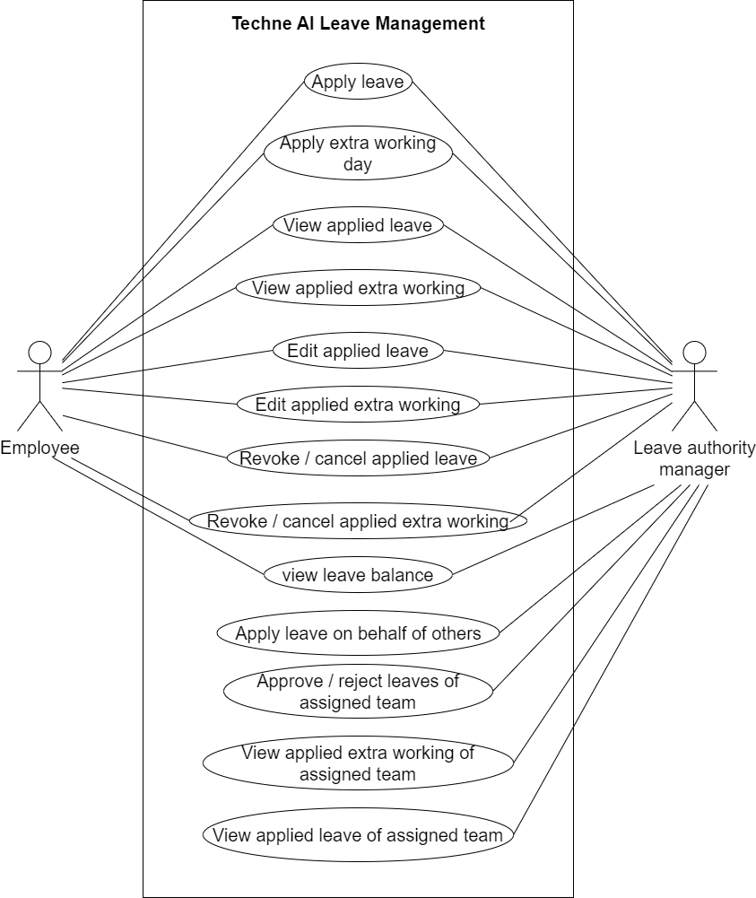

Fig 1: Techne AI leave Management Use Case Diagram

1. **PROPOSED SYSTEM**

We need to create a menu named as Leave Management in Techne AI connect us. It will have following modules under it:

* Leave Application
* Leave Balances
* Extra Working days
  1. **Leave Balance**

It will display the total count of leaves allotted to the employee, the used leaves count and remaining leaves count. It will display following fields on grid page:

* Add entry
* Download Bulk format
* Bulk Upload
* Filter
* Export
* Edit action
* Employee ID
* Employee name
* Total leave allotted
* Leaves used/ exhausted
* Leaves remaining
* Unpaid leaves
* Created by
* Created at
* Updated by
* Updated at
* Is Active - Active or resigned as per employee master

Here; it will display the details of the leaves of employees. Add entry, bulk upload will be displayed based on authority.

In grid of leave balances, employees should be able to view details only of their own leave. Whereas, HR and project head should be able to view details of all employees.

|  |  |
| --- | --- |
| **FIELDS** | **DESCRIPTION** |
| Employee ID | Once authorised person has added entry and submitted, it will be displayed in grid.  It will display the employee ID of the employee from employee master. |
| Employee name | It will display the employee name as entered by the authority while adding entry. |
| Total leave allotted | It will display the count of total leaves allotted to the employee as entered while adding entry. |
| Leaves used / exhausted | It will display the count of paid leaves used by employee.  All leaves applied by employee through leave application module, then it should be displayed here.  The count should get changes automatically as per newly added leaves, canceled leave or rejected leave. |
| Leaves remaining | It should display the count  Leave remaining = total leave allotted - leaves used / exhausted. |

1. From leave balances, once authorized person clicks on add entry, it will display following fields:

* Date
* Employee name
* Leave type
* No. of leaves
* Remark
* Submit

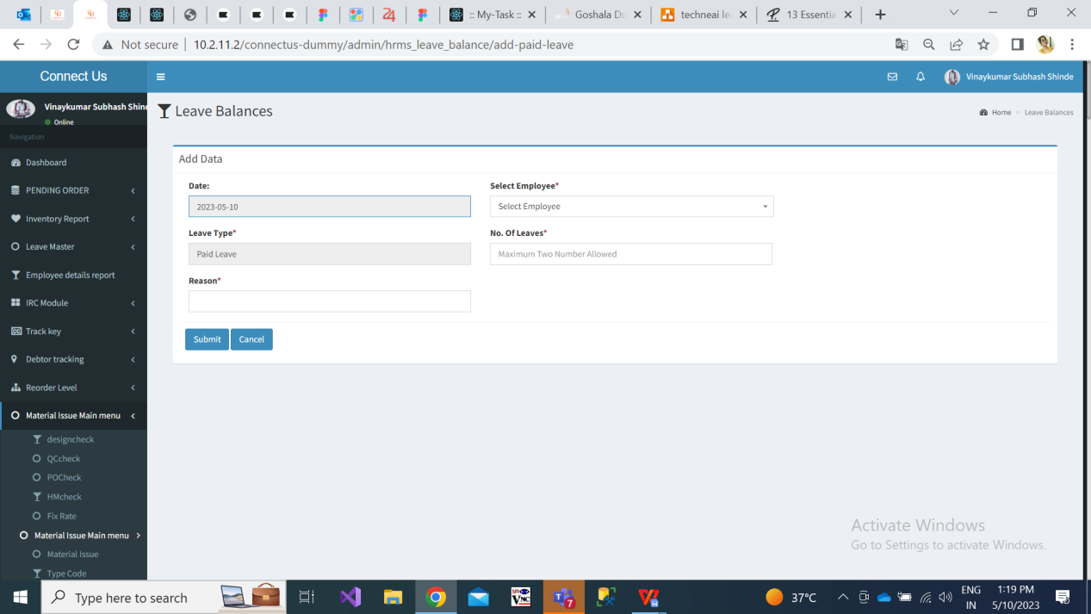

Fig: leave balance -> add entry

|  |  |  |  |
| --- | --- | --- | --- |
| **FIELDS** | **INPUT TYPE** | **MANDATORY/ OPTIONAL** | **DESCRIPTION** |
| Date | Date | Mandatory | It will display today’s date on which authorized person is adding leave details of employee.  It will be read only. |
| Employee name | Drop-down | Mandatory | It will be single select having list of all active employees from employee master.  It will have employee ID and employee name. |
| Leave type | Text | Mandatory | It will display ‘Paid leave’.  It will be read only field. |
| No. of leaves | Text | Mandatory | Here authorised person will mention the count of paid leaves which are being allotted to the employee for the current year.  It should accept only numbers between 0 to 100.  It should not accept characters and special characters. Only decimal point . should be accepted as special character and only once. Only 5 should be accepted after decimal point. Example - 10.5. |
| Remark | Text | Optional | User will mention the remark here.  It should accept marathi, english language.  It should accept special characters, space, numbers, small case letters and upper case letters.  Maximum length will be 50. |
| Submit | Click | Optional | Once user enters above details and clicks on submit, it should be displayed in grid of leave balance module.  As per total leave count mentioned here, employee should be able to apply leaves out of the allotted count only.  For the first time, when employee is applying leave then the count mentioned here should be displayed in leave application module -> apply leave -> leave balance field.  For newly added employee leave details, the leave used count and leave remaining count should be displayed as 0 on grid. |

1. From download bulk format button in leave balance module, authorised user can download .csv file and can upload bulk data at a time through bulk upload button. Bulk upload file will have following columns:

* Employee name
* Leave type
* No. of leaves
* Remark

Once bulk upload file is uploaded, then date should be automatically displayed in grid as on the date when file is uploaded.

1. From filter button in leave balance module, authorised user can search data from grid. It will have following fields:

* From Date
* To Date
* Employee name - It will be multi-select drop down displaying list of active employees from employee master.
  1. **Leave Application**

Once employee clicks on leave application module, it will display following fields on grid page:

* Apply leave
* Filter button
* Export button
* View action
* Edit action
* Application Date
* Employee ID
* Employee name
* Leave Type
* Sub-leave type
* Extra working done on
* From Date
* To Date
* Resume on
* Leave Days
* Reason
* Status
* Canceled on
* Full Day/ Half day
* Approved / Rejected by
* Rejection reason
* Approved / Rejected At

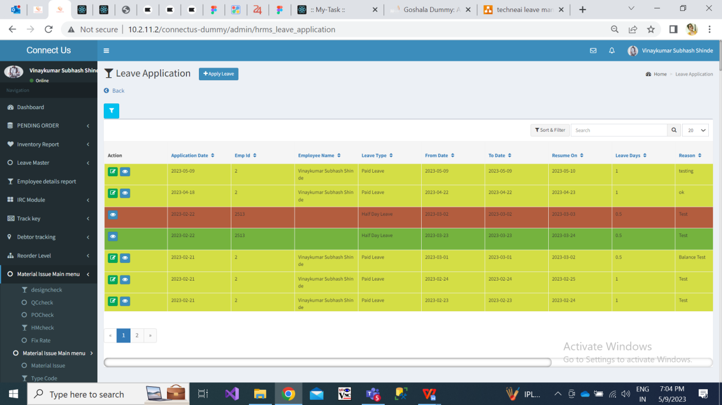

Fig: Leave application grid view

1. Once user clicks on ‘apply leave’ button, it will display following fields on next page:

* On behalf of
* Date
* Leave type
* Leave Sub type
* Extra working done on
* Select Day Type
* Start Date & its type (first half or second half)
* End Date & its type (first half or second half)
* Medical certificate attachment
* Resume On
* Leave Days Count
* Leave Balance
* Reason
* Submit

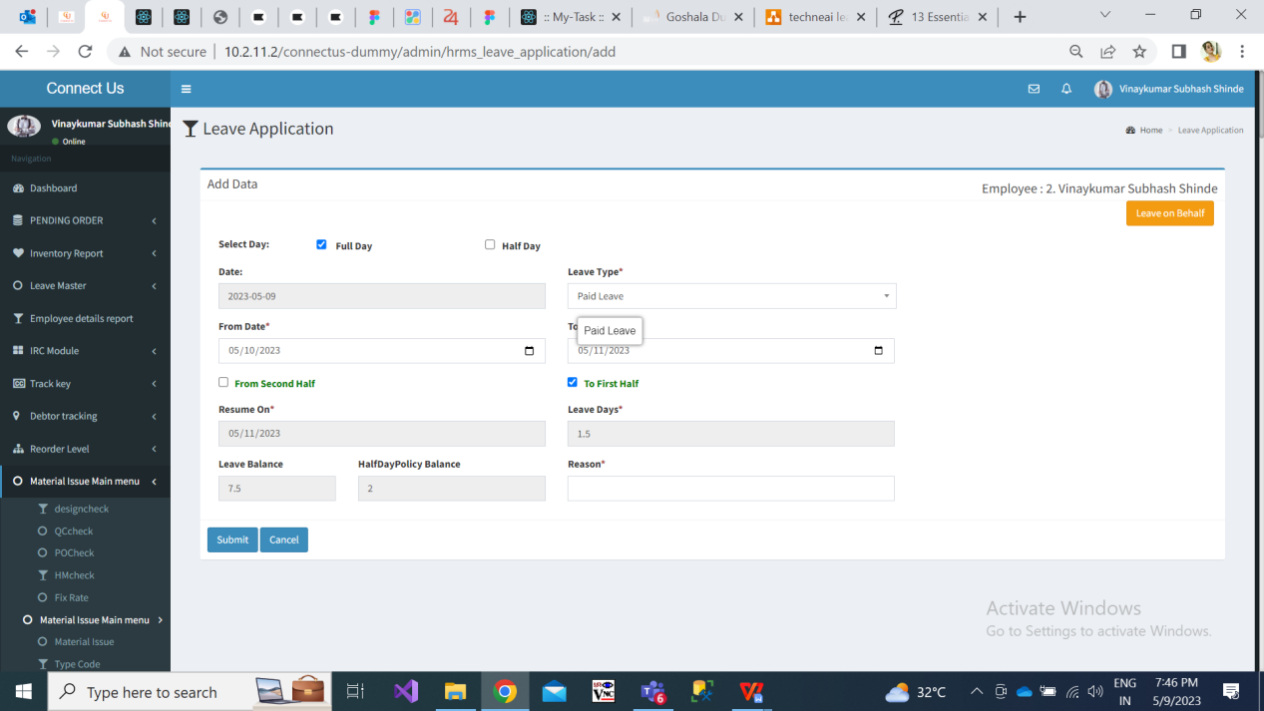

Fig: Leave application -> apply leave

|  |  |  |  |
| --- | --- | --- | --- |
| **FIELDS** | **INPUT TYPE** | **MANDATORY/ OPTIONAL** | **DESCRIPTION** |
| On behalf of | Click | Optional | This button will be provided based on authority.  For employees who do not have this provision, this button shouldn’t be displayed to them.  Once authorized person clicks on this button, it will display list of employees in drop-down which are assigned this authorized person from employee master -> leave authority manager.  Once user selects employee name, it will display the name of the employee in the top left corner.  Once authorized fills the leave details and clicks on submit, then the leave will be displayed in the grid of the employee on whose behalf the leave was applied as well as it will be displayed in the grid of the employee’s respective leave authority manager. |
| Date | Date | Mandatory | It will display the today’s date on which employee or authorized person is applying the leave.  It will be read only field. |
| Leave Type | Drop-down | Mandatory | It will display Paid leave / Unpaid leave in the drop-down.  It will be single select.  If employee applies paid leave, then the leave balance should get calculated and displayed after leave is applied.  If employee applied for unpaid leave, then employee’s leave balance shouldn’t get affected. |
| Leave sub-type | Drop-down | Mandatory | It will display following in the list of this field:  Sick leave  Casual leave  Maternity leave  Marriage leave  Compensatory off leave  Others  It will be single select.  In case of compensatory off leave, then employee will have to mention the date on which the employee has done extra working on. Also, while applying for compensatory off leave, then leave balance shouldn’t get affected. |
| Extra working done on | Calendar picker | Mandatory in case of comp off leave | If employee is applying for compensatory off leave, then ‘extra working done on’ field should be displayed.  Here, employee will have to mention the date on which the employee has done extra working on.  In calendar employee should be able to select only current month’s date.  Also, while applying for compensatory off leave, then leave balance shouldn’t get affected.  Here, system should first verify whether the extra working was applied or not on mentioned date and then only employee should be able to apply for comp off. |
| Day leave type | Drop-down | Optional | It will display following in the list:  Half day leave  Full day leave |
| Start Date | Calendar picker | Mandatory | In case of medical leaves, employee should be able to select back dated leaves of current year.  In case of other leaves, back dated calendar should be disabled.  Employees will select the date from which they will be absent.  National holidays and Saturday, Sunday should be disabled from calender.  Example : If user applies leave for 30.04.2023 to 04.05.2023. And 01.05.2023 is National holiday. Then the count of leaves should be considered as 4 days I.e. first of may shouldn’t be considered as leave. |
| first half or second half  (this is of start date) | Radio button | Optional | Employee will select whether he/she will be absent from first half or second half on selected start date.  In case employee doesn’t select first half or second half, then it will be considered as full day leave of start date. |
| End Date | Calendar picker | Mandatory | Employee will select date till which he/she will be absent.  It should disable back dates as per selected start date.  National holidays and Saturday, Sunday should be disabled from calender.  Example : If start date selected is 05/05/2023 then in ‘end date calendar it will disable all dates before 05/05/2023.  Example 2 : In case employee has selected start date and end date both as 05/05/2023. |
| first half or second half  (this is of end date) | Radio button | Mandatory | Employee will select whether he/she will be absent till first half or second half on selected end date.  In case employee doesn’t select first half or second half, then it will be considered as full day leave of end date. |
| Medical certificate attachment | Attach file button | Mandatory | When employee selects medical leave from drop-down, then attachment field should be displayed.  It should accept png, jpeg, jpg, pdf files only.  In case employee selects date of 2+ days, then attaching certificate should be mandatory.  For medical leaves of one or two days, attachment field will be optional. |
| Resume On | Date | Mandatory | It will be read only field.  It will display the date on which employee will resume to work after leave.  It will display the next day of end date.  In case of Saturday & Sunday, it should display resume date of Monday.  Example 1: Start date is Monday, 01/05/2023. End date is Tuesday 02/03/2023. Then it will display, Resume on date as 03/03/2023 i.e. Wednesday.  Example 2: Start date is Thursday, 04/05/2023. End date is Friday 05/03/2023. Then it will display, Resume on date as 08/03/2023 i.e. Monday because Saturday and Sunday are not working days for Techne AI employees. |
| Leave Days count | Text | Mandatory | It will be read only field.  It will display the count of days as per selected start date and end date.  In case of half days, it will display count as 0.5. |
| Leave Balance | Text | Mandatory | It will be read only field.  It will display the count of leaves remaining.  The count of leave balance of particular employee as in leave balance module should be considered and Leave Days count as mentioned in form while applying this leave should be deducted.  If already leave balance is 0, then employee shouldn’t be able to apply new leave again. It should display message as “Your leave balance is 0”. |
| Reason | Text | Mandatory | Employee will mention the reason for leave here.  It should accept marathi, english language  It should accept special characters, space, numbers, small case letters and upper case letters.  Maximum length will be 50. |
| Submit | Click |  | Once employee submits leave, it will display successful message and direct user to grid page. It will display applied leave in grid of employee in leave application module and also in the grid of the leave authority manager of respective employee.  Recently applied leaves should be displayed on top of grid.  Highlighted colour should be changed for approved / rejected / canceled leaves.  Once leave is applied, its email should get sent automatically to employee, leave authority manager, HR, Project Head.  Status of newly added leaves should be ‘On Hold’ until it isn’t canceled / approved / rejected. |

1. From leave application grid view, once user clicks on view action, it will display details of leaves as per following read only fields:

* Date
* Leave type
* Leave Sub type
* Select Day Type
* Start Date & its type (first half or second half)
* End Date & its type (first half or second half)
* Medical certificate attachment
* Resume On
* Leave Days Count
* Leave Balance
* Reason
* Status
* Revoked / Canceled on
* Verified medical certificate
* Approved / Rejected by
* Rejection Reason
* Approved / Rejected At

In attachment, it should display the thumbnail of the attached image. User should be able to zoom it.

Approved / rejected by and at fields will be displayed blank until authorized person doesn’t approve or reject it.

1. From leave application grid view, once user clicks on edit action, it will display following fields:

* Date
* Leave type
* Leave Sub type
* Select Day Type
* Start Date & its type (first half or second half)
* End Date & its type (first half or second half)
* Medical certificate attachment
* Verified medical certificate?
* Resume On
* Leave Days Count
* Leave Balance
* Revoke / Cancel my leave
* Leave authority action - Approve / Reject
* Rejection Reason
* Reason
* Submit

It will display all the details as entered by the employee or authorized person while applying leave.

Employees should be able to edit their applied leaves until the day for which the leave was applied hasn’t passed yet.

|  |  |  |  |
| --- | --- | --- | --- |
| **FIELDS** | **INPUT TYPE** | **MANDATORY/ OPTIONAL** | **DESCRIPTION** |
| Verified medical Certificate | Radio button | Optional | This field will be displayed based on authority.  Leave authority manager can view the certificate and mark as verified or not by Yes / No radio button. |
| Cancel my leave | Check box | Optional | It will displayed only to employees.  Employees himself / herself may have to to cancel / revoke their applied leaves.  Once employees ticks on this check box and clicks submit, then it should display dialogue box “Are you sure you want to cancel this leave? Yes/ No”.  Once employee clicks on yes, it should display message and direct user to grid page.  Canceled leave should be highlighted with different colour.  Once leave is revoked/ canceled, its email should be sent to employee, leave authority manager, HR, project head.  Edit action should be removed for canceled leave. |
| Leave authority action - Approve / Reject | Radio button | Optional | This field will be displayed based on authority.  Authorized person can approve or reject leave.  Once authorized user approves or rejects leave, email should be sent to employee, hr, leave authority manager, project head.  On leave approval or rejection, the leave should be highlighted with different colours in grid of employee and leave authority manager. |
| Rejection Reason | Text | Optional | If authorized person rejects leave of employee, then he / she will mention the reason for rejection in the text box.  It should accept marathi, english language  It should accept special characters, space, numbers, small case letters and upper case letters.  Maximum length will be 50. |

1. From leave application grid view, once user clicks on filter action, it will display following fields:

* From Date
* To Date
* Employee name
* Status
* Leave Type
* Leave sub type
* Filter button
* Reset button

Through filter, employees can filter data only of their own applied leaves as displayed in their own grid.

Whereas, leave authority manager can filter data of their own applied leaves as well as leaves applied by their assigned team employees.

HR and project head can filter data of all employees as well as their own.

|  |  |  |  |
| --- | --- | --- | --- |
| **FIELDS** | **INPUT TYPE** | **MANDATORY/ OPTIONAL** | **DESCRIPTION** |
| From Date | Calendar picker | Optional | All users should be able to select date of current year and get filtered data of leaves as available in their own grid. |
| To Date | Calendar picker | Optional | All users should be able to select date of current year and get filtered data of leaves as available in their own grid. |
| Employee name | Drop-down | Optional | Employees should be able to display only their own name in this field.  Leave authority manager should be able to view list of all employees who are assigned to them as well as her/ her won name.  HR and project head should be able to view list of all employees in this drop-down.  It will be multi-select. |
| Status | Drop-down | Optional | It will display on hold, canceled, approved and rejected in the list.  It will be multi-select. |
| Leave type | Drop-down | Optional | Paid or Unpaid  It will be multi select. |
| Leave sub type | Drop-down | Optional | It will display sick leave, casual leave, maternity leave, compensatory off leave and others in the list.  It will be multi-select. |
| Filter | Click | Optional | It will display filtered data in grid as per selected filtered fields. |

1. From leave application grid view, once user clicks on export action, user can download data as in grid either filtered or all in .csv file. Exported file will have following columns:

* Application Date
* Employee ID
* Employee name
* Leave Type
* Sub-leave type
* From Date
* To Date
* Resume on
* Leave Days
* Reason
* Status
* Canceled on
* Full Day/ Half day
* Approved / Rejected by
* Rejection reason
* Approved / Rejected At

**12.3 Extra working days**

Once employee clicks on leave application module, it will display following fields on grid page:

* Apply Extra working
* Edit action
* View action
* Application date
* Employee ID
* Employee name
* Extra working on
* Type - Full day / half day
* Status
* Canceled on
* Remark
* Approved / Rejected by
* Rejection reason
* Approved / Rejected At

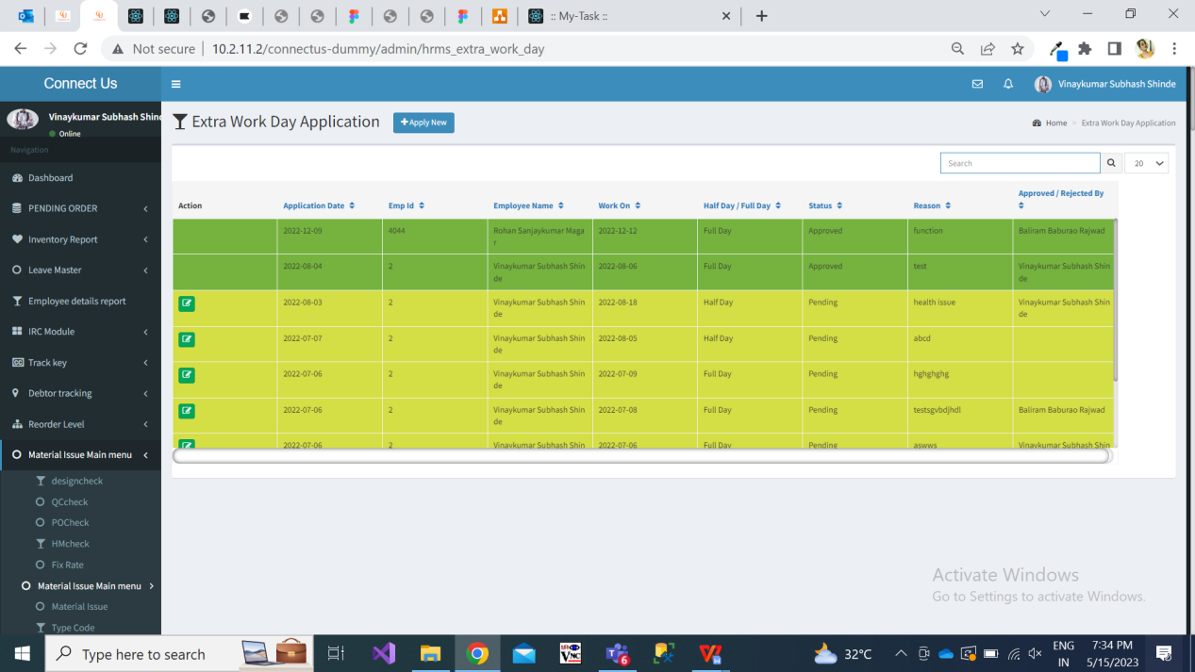

Fig: Extra working

1. Once user clicks on ‘apply extra working’ button, it will display following fields on next page:

* On behalf of
* Application Date
* Extra working on
* Type : Full day / half day
* Remark
* Submit button
* Reset button

|  |  |  |  |
| --- | --- | --- | --- |
| **FIELDS** | **INPUT TYPE** | **MANDATORY/ OPTIONAL** | **DESCRIPTION** |
| On behalf of | Click | Optional | This button will be provided based on authority.  For employees who do not have this provision, this button shouldn’t be displayed to them.  Once authorized person clicks on this button, it will display list of employees in drop-down which are assigned this authorized person from employee master -> leave authority manager.  Once user selects employee name, it will display the name of the employee in the top left corner.  Once authorized person fills the extra working details and clicks on submit, then the extra working detail will be displayed in the grid of the employee on whose behalf it was applied as well as it will be displayed in the grid of the employee’s respective leave authority manager. |
| Application Date | Date | Mandatory | It will be read only field. It will display current date I.e. the date on which user is applying extra working on. |
| Extra working on | Calendar picker | Mandatory | It will display dates of current year in calendar.  User can apply extra working for back dated or post dated days. |
| Type | Radio-button | Mandatory | User will mention whether he/she will be working for full day or half day on extra working date as selected. |
| Remark | Text | Mandatory | User will enter comments in this section.  It should accept marathi, english language  It should accept special characters, space, numbers, small case letters and upper case letters.  Maximum length will be 50. |

Once extra working is applied, it should be displayed at top in grid of employee who has applied extra working as well as in grid of the leave approving authority. Also, it should be displayed on the grid of HR and project head.

1. Once employee clicks on edit action through grid of extra working module, it will display following pre-filled fields:

* On behalf of
* Application Date
* Extra working on
* Type : Full day / half day
* Revoke or Cancel : Yes / No
* Remark
* Submit button
* Reset button

Through cancel radio button, employee can cancel his already applied extra working.

Once extra working is canceled by employee, the status of the same and the date should be displayed in view action and grid. Also, canceled extra working should be highlighted with different colour.

1. Once authorised user clicks on edit action through grid of extra working module, it will display following pre-filled fields:

* On behalf of
* Application Date
* Extra working on
* Type : Full day / half day
* Action : Approve or reject
* Remark
* Submit button
* Reset button

Through action radio button, authority can approve or extra working applied by employee.

Once extra working is approve or rejected by employee; status, approved or rejected by name and and the date should be displayed in view action and grid. Also, approved / rejected extra working should be highlighted with different colour.

1. **TEST DATA**



1. **ODUS ( Open Discussed Unhanded scenarios )**

|  |  |  |  |  |
| --- | --- | --- | --- | --- |
| **Sr. No.** | **Topic** | **Priority**  **(High / medium / low)** | **Remark** | **Status**  **(Open/**  **Closed)** |
| 1 | Date : Query and its description |  | Write solution which is decided by user or head or us. | Open for queries which are recently asked and which are pending. |
| 2 |  |  |  |  |
| 3 |  |  |  |  |
|  |  |  |  |  |
|  |  |  |  |  |

1. **REFERENCES OF THE USERS**

|  |  |  |  |
| --- | --- | --- | --- |
| **User** | **Name** | **Mail** | **Contact number** |
| **Actual user** | Minal Pawar | Minal.pawar@techneai.com |  |
| **Ticket created by (if any)** | Minal Pawar | Minal.pawar@techneai.com |  |
| **Assigned business analyst** | Manali Bhadirage | Manali.bhadirage@techneai.com |  |
| **Assigned developer** | Prathmesh Shinde | Prathmesh.shinde@techneai.com |  |
| **Assigned tester** | Poonam Deshmukh | Poonam.deshmukh@techneai.com |  |