|  |  |
| --- | --- |
| **Ticket ID** | TT6510 / TT2844 |
| **Ticket description** | Bill Checking Implementation In Ticketing System |
| **Created by** | Manali Bhadirage |
| **Created on** | 28/10/2022 |
| **Priority** | High |
| **Version** | 1.0 |

**Version**

|  |  |  |  |  |
| --- | --- | --- | --- | --- |
| **Sr. No** | **Version no** | **Version Date** | **User name** | **User department** |
| **1** | **1.0** | **10/28/2022** |  |  |
| **2** | **1.1** | **30/03/2023** |  |  |
| **3** | **1.2** | **04/04/2023** |  |  |
| **4** | **1.3** | **07/04/2023** |  |  |
| **5** | **1.4** | **06/06/2023** |  |  |
| **6** | **1.5** | **07/06/2023** |  |  |

**Approvals**

|  |  |  |
| --- | --- | --- |
| **Field** | **Name of the User** | **Approved date by the user** |
| **Actual User Name** | Aditya Shah  Gaurav Shah |  |
| **Actual User Department** |  |  |
| **Organization Name** |  |  |
| **Assigned BA** | Manali Bhadirage |  |
| **Assigned Developer** | Punam Shinde  Rushikesh Harkare |  |
| **Assigned Tester** | Amreen Shaikh  Abhijeet Ghodke |  |

**Estimation**

|  |  |  |  |  |
| --- | --- | --- | --- | --- |
| **Department name** | **Estimated Time (In hr)** | **Scheduled Date (Starting date )** | **Estimated date** | **Actual delivery date** |
| **BA** |  |  |  |  |
| **Development** |  |  |  |  |
| **Testing** |  |  |  |  |
|  |  |  |  |  |

**Introduction**

We need to build Bill Checking module in our Ticketing System. Through bill checking module in ticketing system, client can add the bill in the system. The submitted bill is assigned to the HOD. When HOD approves the bill, there are two ways for the completion of the payment as below:

1) This bill is assigned to account team for the approval. The account team checks the bill and the bill is passed if there is no query. Further, account team enters the bill in the system and releases payment of that bill.

2) This bill is assigned to account team for the approval. The account team checks the bill and the bill is passed to the audit team. Then the audit team checks the bill, enters the bill in the system and releases the payment of that bill.

**System Rules**

Provide on field validations to all fields in entire bill checking module (web app + mobile app)

**Proposed system**

**List of Masters**

Following are the masters that we require in our module:

* Country Master
* State Master
* City Master
* Department Master
* Designation Master
* Employee Master
* Role Master
* Tenant Master
* Vendor Master
* Payment Template Master
* Bill Type Master

We require following sub-modules:

* Bill Checking Transaction
* Authority Based Mapping
* **Vendor Master**

Following are the field we need while adding the vendor:

* Vendor Name
* Address
* Country
* State
* City
* Pin Code
* Mobile No.
* Email
* Adhar No.
* Adhar No. Attachment
* Pan No.
* Pan No. Attachment
* MSME No.
* MSME No. Attachment
* GST No.
* GST Attachment
* ERP account name
* Consider in payment (yes/no/petty cash)
* Bank Name
* Bank Branch Name
* Account No.
* IFSC Code
* Beneficiary Name
* Bank Passbook Attachment
* Cheque Attachment
* Payment Template
* Save (button)
* Back (button)

|  |  |
| --- | --- |
| **FIELDS** | **DESCRIPTION** |
| Vendor ID | While adding vendor, vendor ID field will not be displayed.  Vendor ID field will be displayed only after vendor is added and in edit.  For each new addition of vendor, vendor ID will be displayed in auto incremental number. Vendor ID should be disabled field in edit action. |
| Vendor Name | User will enter vendor name in this field. It should accept characters, numbers and space. It should accept English / Devanagari script.  Maximum length of 50 characters should be accepted. |
| Address | User will enter vendor’s address in this field. It should accept characters, numbers, special characters and space.  Maximum length of 50 characters should be accepted. |
| Country | It will be drop-down consisting of list of countries. (list of countries from country master) |
| State | It will be drop-down consisting of list of states as per selected country. (list of states from state master) |
| City | It will drop-down consisting of list of cities as per selected state. (list of cities from city master) |
| Pin Code | User will enter pin code of respective city as per address. It should accept numbers. |
| Mobile No. | User will enter vendor’s mobile 10 digit mobile no.  Consecutive ten zeros shouldn’t be accepted. |
| Email | User will enter email address of vendor. It should accept characters, numbers, space and special characters. Maximum length should be of 50 inputs. |
| Adhar No. | User will enter 12 digit Adhar No.of vendor.  Beside this input field, it should have icon to attach file user will attach the image of Adhar Card of the vendor. If user just attaches image of Adhar no., then vendor name and Adhar no. Should get auto-filled whereas these fields will also be editable.  One Adhar no. should be used for registration only once. (each vendor will have unique Adhar no.)  Attachment should accept single file of png, jpeg, jpp and pdf extensions only. |
| PAN No. | User will enter 10 digit alphanumeric PAN No. of vendor.  Beside this input field, it should have icon to attach file user will attach the image of Pan Card of the vendor. If user just attaches image of pan no., then vendor name and pan no. Should get auto-filled whereas these fields will also be editable.  One PAN no. should be used for registration only once. (each vendor will have unique pan no.)  Attachment should accept single file of png, jpeg, jpp and pdf extensions only. |
| MSME No. | Optional field  User may enter vendor’s MSME number if any.  It could be either udyog adhar number or udyam number.  It should be of minimum 12 digits and maximum 19 digits.  Udyog adhaar number consist of 12 digits. (only numbers like adhaar number). It should not accept twelve consecutive zeros.  Udyam number format:-  First 5 Letters, Next 2 Digits represent state code, Next 2 Digits represent city code, Next 7 Digits are special Udyam Code assigned to a company, similar to an Aadhar number.  Beside this input field, it should have icon to attach file user will attach the image of MSME certificate of the vendor.  One MSME no. should be used for registration only once. (each vendor will have unique MSME no.)  Attachment should accept single file of png, jpeg, jpp and pdf extensions only.  Once files are attached, it should have option to zoom as well as delete.  Once files are attached it should be displayed with hyperlink. |
| GST No. | User will enter 15 digit GST No. of vendor.  The first 2 digits of the 15 digit GSTIN represents the state code. The next 10 digits are the [PAN](https://groww.in/p/pan-card) of the person or the business entity.  The thirteenth digit is based on the number of registrations done by the firm within a state under the same PAN.  The fourteenth digit will be the alphabet "Z" by default.  The last digit is called the check code to detect errors and can be denoted by either a number of an alphabet.  Beside this input field, it should have icon to attach file user will attach the image of GST certificate of the vendor. If user just attaches image of GST no., then vendor name and GST no. should get auto-filled whereas these fields will also be editable.  One GST no. should be used for registration only once. (each vendor will have unique GST no.)  Attachment should accept single file of png, jpeg, jpp and pdf extensions only.  Once files are attached, it should have option to zoom as well as delete.  Once files are attached it should be displayed with hyperlink. |
| ERP Account Name | Optional field.  It should display vendor name in the field whereas it should also be editable. Vendor name and ERP account name can be same as well as can be different.  Maximum length of 50 characters should be accepted. |
| Consider in payment | It will be drop-down consisting list of Yes, No & Petty Cash.  If user selects Petty Cash from drop-down, then it should display three more fields namely:   * Card No. - It should accept only numbers up to 20 digits only without space. * Reference No. - It should accept alphanumeric inputs upto 20 digits. It should accept hyphen and space. * Narration - It should accept alphanumeric inputs with maximum length of 20. It should accept space. |
| Bank Name | User will manually enter bank name of the vendor. It should accept characters, numbers and space.  Maximum length of 50 characters should be accepted. |
| Bank Branch Name | User will manually enter bank branch name of the vendor. It should accept characters, numbers and space.  Maximum length of 25 characters should be accepted. |
| Account No. | User will manually enter bank account number of the vendor. It can be alphanumeric.  Maximum length of 25 characters-numbers should be accepted. |
| IFSC Code | User will manually enter IFSC code of the vendor. It can be alphanumeric.  Maximum length of 20 characters should be accepted. |
| Beneficiary Name | User will manually enter the name of the vendor on bank account in this field.  It should accept characters, numbers and space.  Maximum length of 50 characters should be accepted. |
| Bank Passbook Attachment | user will attach the single image of bank passbook of vendor.  Attachment should accept single file of png, jpeg, jpp and pdf extensions only.  Once files are attached, it should have option to zoom as well as delete.  Once files are attached it should be displayed with hyperlink. |
| Cheque Attachment | user will attach the single image of cheque attachment.  Attachment should accept single file of png, jpeg, jpp and pdf extensions only.  Once files are attached, it should have option to zoom as well as delete.  Once files are attached it should be displayed with hyperlink. |
| Template | Payment template is set against vendor .  So, this field has drop-down which consist of list of active templates from payment template master. |
| Status | It will have Active / Deactive radio button. By default while adding vendor, active radio button should be enabled at beginning. |
| Save (button) | Once details of vendor is added, it should get saved and displayed in the grid once saved. |
| Back / Close (button) | If any details are added , it shouldn’t get saved if user clicks on clicks on save / close. |

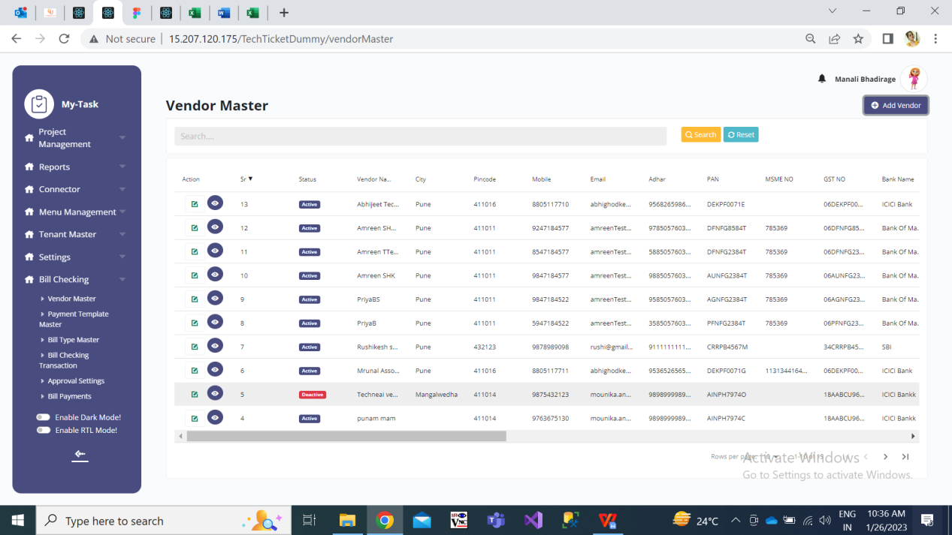

Fig: Vendor Master

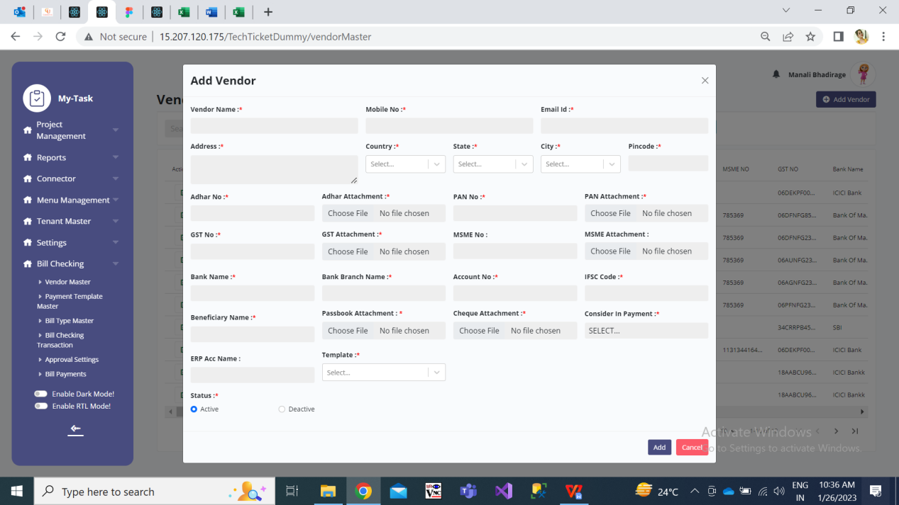

Fig: Add Vendor

Once the vendor is added, it will be displayed in the grid. **Grid** will have following columns in list:

* Action - View, Edit
* Vendor ID - While adding vendor, vendor ID field will not be displayed. Vendor ID field will be displayed only after vendor is added and in edit. For each new addition of vendor, vendor ID will be displayed in auto incremental number. Vendor ID should be disabled field in edit action.
* Vendor Name
* Address
* Country
* State
* City
* Pin Code
* Mobile No.
* Email
* Adhar No.
* Pan No.
* MSME No.
* GST No.
* Acme Account Name
* Consider in payment (yes/no/petty cash)
* Bank Name
* Bank Branch Name
* Account No.
* IFSC Code
* Beneficiary Name
* Template
* Drop-down of attachments (it will display name of all attachments and have provision to view)
* Status
* Created at
* Created by
* Updated at
* Updated by
* **Payment Template Master**

Payment template is set against Vendor. It has following fields:

* Template Name
* Payment Type
* Bill Date Type
* Min Days
* Payment weekly
* Bill Day
* Remark
* Is Active
* Save (button)
* Back / Close (button)

|  |  |
| --- | --- |
| **FIELDS** | **DESCRIPTION** |
| Template Name | User will enter name for the template in this field. It should accept characters, special characters, numbers and space.  Template name will be unique (same template shouldn’t get added more than once.) |
| Payment Type | It consists of drop-down consisting “monthly” and “weekly” in the list.  If user selects “monthly” from this drop-down, then “Payment weekly” field will be disabled.  If user selects “weekly” from this drop-down, then “Bill Day” field will be disabled. |
| Bill Date Type | It consists of drop-down consisting “Bill Date” and “Received Date” in the list. |
| Min Days | User will manually enter the number of minimum days in this field. It should accept only numbers. |
| Payment weekly | If user selects “monthly” from Payment type drop-down, then “Payment weekly” field will be disabled.  If user selected “weekly” from Payment Type drop-down, then Payment weekly field will display drop-down consisting Sunday, Monday, Tuesday, Wednesday, Thursday, Friday and Saturday in the list. It will be multi-select. |
| Bill Day | If user selects “weekly” from Payment type drop-down, then “Bill Day” field will be disabled.  If user selects “monthly” from Payment type drop-down, then user will manually enter number in Bill Day column.  It should accept comma. |
| Remark | Optional.  User will enter additional notes in this field. It should accept characters, numbers and space. It should accept English / Devanagari script.  Maximum length will be 50 characters. |
| Is Active | It will have radio button for yes and no.  By default while adding template, it should display radio button as Yes. |
| Save (button) | Once details of vendor is added, it should get saved and displayed in the grid once saved. |
| Back / Close (button) | If any details are added , it shouldn’t get saved if user clicks on clicks on save / close. |

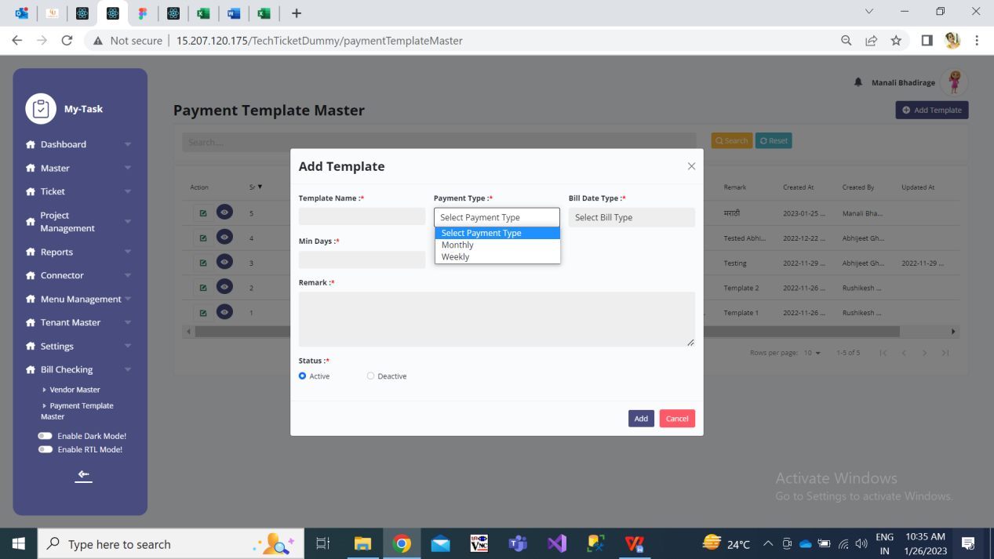

Fig: Add -> Payment Template

All the added templates should be displayed in the **grid of payment template master**. List will have following fields:

* Edit action
* Sr.
* Status
* Template name
* Payment type
* Bill date type
* Bill day
* Payment weekly
* Min days
* Remark
* Created at
* Created by
* Updated at
* Updated by

Also, the added templates should be reflected in Template drop-down of vendor master.

* **Bill Type Master**

All the added bill types should be reflected in “Bill type” Drop-down of Bill Checking Transaction module. It has following fields:

* Bill Type
* Assigned user(s)
* Remark
* Status
* Save (button)
* Back / Close (button)

|  |  |
| --- | --- |
| **FIELDS** | **DESCRIPTION** |
| Bill Type | User will enter name for the Bill Type in this field. It should accept characters, special characters, numbers and space. |
| Assigned user(s) | It will be drop-down displaying list of active users from user master.  User can map multiple users for one bill type.  By selecting employees, it specifies that the particular bill can be assigned to specified users only.  Example: If we create bill type named as “Light bill” and in assigned person we select manali, harshali and rushikesh then while submitting light bill from add -> bill checking transaction then only these assign user can be displayed in “assign to” drop-down. |
| Remark | User will enter additional notes in this field. It should accept characters, numbers and space. It should accept English / Devanagari script.  Maximum length of 50 characters should be accepted. |
| Status | It will have radio button stating active / inactive fields in it.  It should keep “active” status by default.  If any bill type is made inactive by user, it shouldn’t be displayed in “Bill Type” drop-down of Transaction module. |
| Save (button) | Once details of vendor is added, it should get saved and displayed in the grid once saved. |
| Back / Close (button) | If any details are added , it shouldn’t get saved if user clicks on clicks on save / close. |

Once the bill type is added, it should be displayed in the **bill type master -> grid** with following fields:

* Action - view, edit
* Sr. no.
* Status
* Bill type
* Remark
* Created by
* Created at
* Updated at
* Updated by

**Bill Checking Transaction**

On dashboard of Bill Checking Payment, we will display following menus:

* Add Data
* Filter
* List of all bills submitted assigned to logged in person

Through filter button, user can search the bill from entire bill checking system. It gives provision to user to search bills which might be assigned to anyone or created by anyone. (Bills which are not created / assigned to the user who has logged in, then he/she will not have access to any edit action in the bill.) Once user clicks on **Filter** button, it should direct user to further page which will display following fields:

* Bill ID
* Vendor Bill No
* Bill Type
* Vendor Name
* Bill Status - Solved, unsolved, canceled.
* Assigned to
* Bill Date
* Received Date
* Payment Date
* Search (button)

|  |  |
| --- | --- |
| **FIELDS** | **DESCRIPTION** |
| Bill ID | User will manually enter single Bill ID.  It should display expected bill id and its details in grid.  In case entered bill id doesn’t exist, then it should display message as ‘There are no such records.’. |
| Vendor bill no | User will manually enter single vendor bill no.  It should display expected bill vendor bill no. and its details in grid.  In case entered bill id doesn’t exist, then it should display message as ‘There are no such records.’. |
| Bill type | It will display bill types from bill type master. It will be multi-select.  It can display deactive bill types from bill type master because there are possibilities of having bill types which might be added earlier however disabled later. |
| Vendor name | It will display vendor names from vendor master. It will be multi-select.  It can display deactive vendor names from vendor master because there are possibilities of having bill of the selected vendor which might be added earlier however disabled later. |
| Bill status | It will be multi-select drop-down. It will display following status in the list - solved, unsolved and canceled.  Bills having payment status as Hold, hold till audit, release will be displayed under unsolved bills.  Paid will be displayed in solved bills.  If total net amount is 1000/-. Out of this, 800/- is hold till audit and 200/- is release. Then as ticket holds both the status for amount, then this bill should be displayed when user is searching either for hold till audit or for release. |
| Assigned to | It shoukd display list of active users from user master. It will be multi-select. |
| Bill date | It will display the date in calender picker till current financial year. |
| Received date | It will display the date in calender picker till today. |
| Payment date | It will display the date in calender picker till current financial year. |

Following are the fields in “**Add Bill Data**” of Bill checking Transaction sub-module:

* Bill Type
* Assign to
* Vendor Name
* Branch Name
* Expected Bill Received Date (only in case of advance given bill)
* Vendor Bill No.
* Bill Date
* Received Date
* Debit Advance
* Taxable amount
* GST - IGST
* Round off
* TCS Amount
* Bill Amount
* TDS Applicable (check-box)
* TDS %
* TDS Section
* TDS Constitution
* TDS Amount
* Net Payment
* Net Payment in words
* Remark
* Audit Remark
* Attach Invoice
* Save (button)
* Back / Close (button)

|  |  |
| --- | --- |
| **FIELDS** | **DESCRIPTION** |
| Bill ID | It will be unique auto-incremental and disabled field. Bill Id will be displayed in grid after the bill is added. |
| Bill Type | It will display drop-down where list of bill types will be displayed from “Bill Type Master”. |
| Assign To | As per selected bill type, it will display the list of users here to whom the selected bill type was mapped.  As per selected bill type, list of users should be displayed. |
| Vendor Name | It will display drop-down where list of bill types will be displayed from “Bill Type Master”. |
| Branch Name | When “Light bill” bill type is selected, then Branch Name field will be displayed.  It will have drop-down displaying list of branches from ‘branch master’. |
| Expected Bill Received Date | This field will only be displayed in cases where bill is yet to be received. (example - Advance give bill type) |
| Vendor Bill No. | User will manually enter the vendor’s bill no.  It should accept both characters and numbers.  It should accept maximum length of 25 values.  It should accept only - . / special characters. |
| Bill Date | User will manually select the bill date from calender.  (the date on bill)  User can select back date or future date. |
| Received Date | It should automatically display today’s date and should be read only field. |
| Debit Advance | Advance amount is considered when we have given few amount to the vendor or any earlier bills extra amount was kept with vendor. This advance amount will be debited from newly added bill.  Whenever any advance amount is already paid and bill is submitted for the remaining amount, then user will manually enter the advance amount in this field.  It should accept decimal values.  It should accept decimal point only once.  It should accept maximum two digits after decimal point.  It should accept negative value. |
| Taxable Amount | User will manually enter the amount in this field on which tax should be applied.  It should accept decimal values.  It should accept decimal point only once.  It should accept maximum two digits after decimal point. |
| IGST / GST | IGST will have checkbox.  If user doesn’t tick on checkbox, then it will be considered as “GST” amount which will further be divided equally as CGST and SGST.  If user ticks on checkbox, then it will be considered as IGST amount.  It should accept decimal values.  It should accept decimal point only once.  It should accept maximum two digits after decimal point. |
| Round Off | User will manually enter the amount in this field which will not be considered for tax.  It should accept decimal values.  It should accept decimal point only once.  It should accept maximum two digits after decimal point. |
| TCS | Where total turnover is more than Rs. 10 crores in the previous financial year and receives sale consideration of any products of more than Rs. 50 lakhs, such seller must collect TCS upon receiving consideration from the buyer on such amount over and above Rs. 50 lakhs  Amount will be entered manually.  It should accept decimal values.  It should accept decimal point only once.  It should accept maximum two digits after decimal point. |
| Bill Amount | It will auto-calculate and display Bill amount.  Bill Amount = Taxable Amount + GST + Round Off + TCS  It is read only field. |
| TDS Applicable | Employers and organisations with a valid TAN are qualified for filing TDS returns.  In a scenario where, credit or payment to a contractor under TDS Section 194C is below TDS threshold limit of INR 1,00,000 in aggregate in a financial year and single transaction threshold limit INR 30,000, TDS will not be deducted.  It will be check-box. If user ticks on it, it will display following fields:   * TDS Section * TDS Constitution * TDS % * TDS Amount   When yearly bill amount of particular vendor exceeds 50,00,000/- then it is mandatory to fill TDS details.  **TDS Section** will have drop-down displaying list as - 194A, 194CB, 194J, 194I, 194H and 194IB.  If user selects 194A, then it should display “non company deductee” in drop-down TDS constitution.  If user selects 194CB, then it should display “Company with surcharge” and “Non company without surcharge” in drop-down of TDS Constitution.  If user selects 194J / 194I, then it should display “Company without surcharge” and “Non company without surcharge” in drop-down of TDS Constitution.  If user selects 194H / 194IB, then it should keep TDS constitution field as blank.  **TDS% -**  If user selects 194A and “non company deductee” as TDS constitution, then it should display 10% in **TDS%** field.  If user selects 194CB and “company with surcharge” as TDS constitution, then it should display 2% in TDS% field. If user selects 194CB and “Non company without surcharge” as TDS constitution, then it should display 1% in TDS% field.  If user selects 194J / 194I and “company with surcharge” / “Non company without surcharge” as TDS constitution, then it should display 10% in TDS%field.  If user selects 194H / 194IB, then TDS % should be kept 0 by default.  **TDS Amount** should be auto-calculated and displayed as per taxable amount against TDS%.  TDS Amount = Taxable amount * (value in TDS% field / 100) |
| TCS Applicable | It will be checkbox (based on authority).  For others, do not display this field.  (For purchase of more than 50,00,000, TCS is applicable to seller and the authorised person checks this box, which defines that TCS will be applicable on this bill for this seller.) |
| Original Bill needed | For some bills, original should be attached compulsorily.  It will be checkbox (based on authority).  For others, do not display this field. |
| Net Payment | It is read only field.  Net Payment = Bill Amount - Debit Advance - TDS Amount  Net payment will display amount by discarding decimal numbers if it is below 0.50. Whereas, Net payment will display amount by +1 if decimals of bill amount is beyond 0.50.  Moreover, in case of TDS if there is any tiny decimal number, it is considered as 1 rupee.  Example 1: If taxable amount is 10000.51, GST = 0, Round off = 0, TCS =0, then bill amount will be 10000.51 and net amount = 10001.  Example 2: If taxable amount is 10000.49, GST = 0, Round off = 0, TCS =0, then bill amount will be 10000.49 and net amount = 10000.  Example 3: If taxable amount is 10000.49, GST = 0, Round off = 0, TCS =0, then bill amount will be 10000.49. If we select 194A - non company deductee, then TDS % will be 10% and TDS amount will be 1001. Thus, net payment = 10000-1001 = 8999.  Example 4: If taxable amount=1022.49, GST = 333.52, round off = 200.20, TCS = 10.10 then bill amount = 1656.31. If we select 194a section and non company deductee, then TDS%= 10 and thus TDS amount = 1022.49 * (10/100) = 102.249 which will be considered as 103.  Thus net payment = 1656 - 103 = 1553.  If debit advance > net payment, then reset debit advance to 0 and display message "Debit advance cannot be greater than net payment." |
| Net Payment in words | It should display Net payment in words. |
| Remark | User will enter additional notes in this field. It should accept characters, numbers and space. It should accept English / Devanagari script. |
| Audit Remark | Audit team will enter additional notes in this field. It should accept characters, numbers and space. It should accept English / Devanagari script. |
| Attachments | User will attach the invoice of the bills here for reference.  It would be multi select.  It should accept png, jpg, jpeg and pdf files.  It should accept maximum 50 files.  Once files are attached, it should have option to zoom as well as delete. |
| Save (button) | Once details of vendor is added, it should get saved and displayed in the grid once saved. |
| Back / Close (button) | If any details are added , it shouldn’t get saved if user clicks on clicks on save / close. |

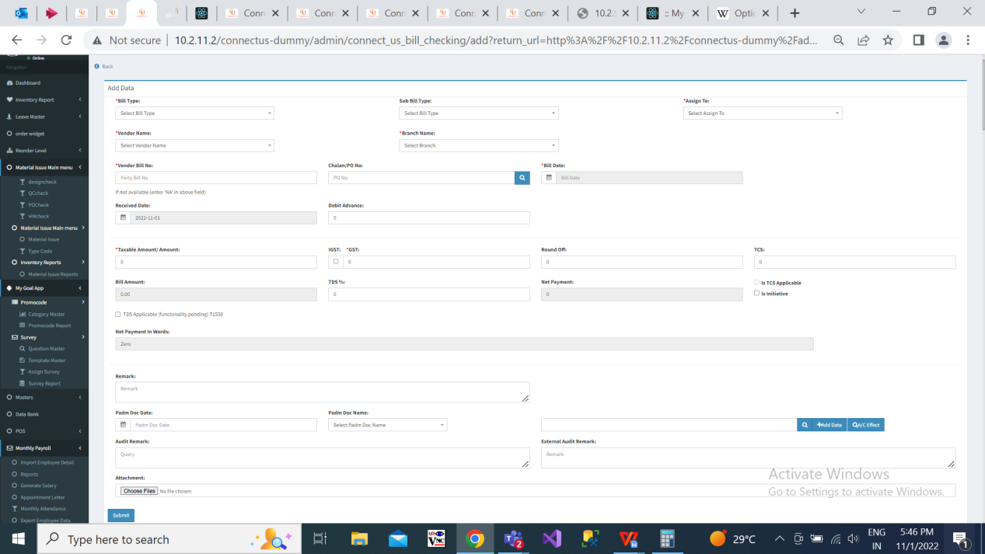

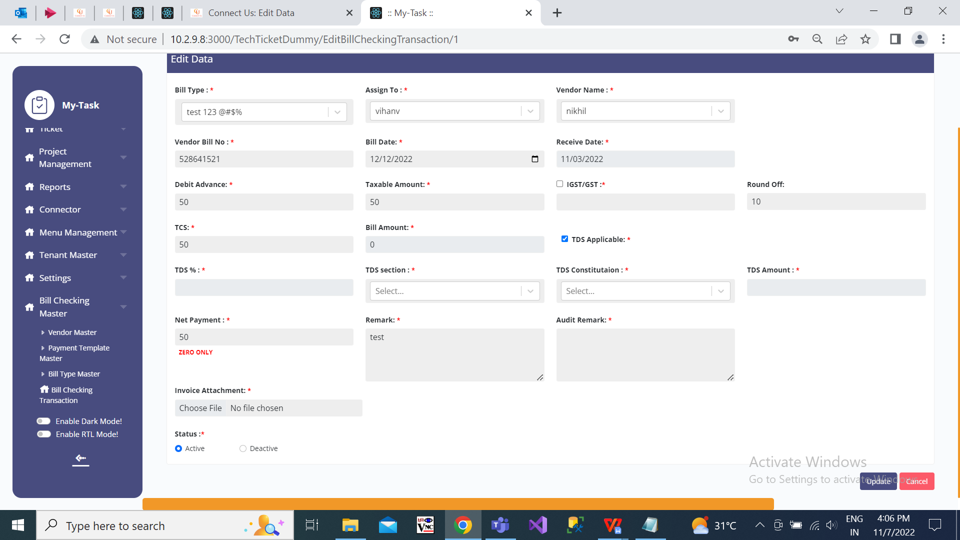

Fig: Add Data

Once the bills are submitted, it should be displayed in the list of the employee to whom the bill is assigned to. List will display following columns:

* Actions
* Sr No.
* Bill ID
* vendor name
* Payment date
* Bill no.
* Actual payment date
* Bill amount
* Net amount
* Net amount in words
* Bill status - Unsolved (hold, hold till audit, release) / unsolved (paid)
* Bill type
* Assign from
* Assign to
* Taxable amount
* Debit advance
* Bill date
* Received date
* Hold amount
* Actual paid
* Cancel Bill - Is active will be either yes or no.
* TCS Applicable
* Authorised by HOD
* Authorised by Management
* Created at
* Created by
* Updated at
* Updated by

Bill should be displayed in the grid of person to whom the bill is assigned to.

Actions will have following fields:

1. View
2. Cancel Bill
3. Edit
4. History
5. Payment History
6. Payment Detail
7. Assign Person Detail
8. Bifurcate Amount

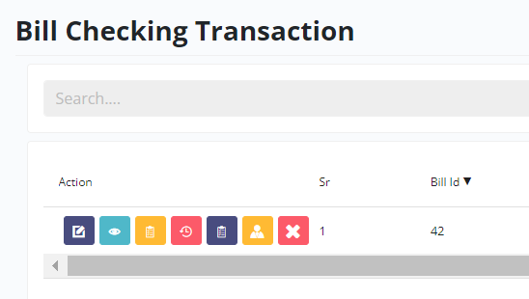

Fig: Bill checking transaction -> list of actions

1. **View Action** - It will display all the fields of added bill.

* Bill ID
* Bill Type
* Assign to
* vendor name
* vendor bill no
* bill date
* received date
* debit advance
* igst/gst
* taxable amount
* round off
* tcs
* bill amount
* TDS details - It will display 0 in TDS amount if TDS wasn’t applied. In case TDS field was filled while adding bill, then in view it will display all tds details. (TDS section, TDS constitution, TDS%, TDS Amount)
* net payment
* net payment in words
* remark
* internal audit remark
* external remark
* Authorised by HOD
* Authorised by Management
* Cancel
* updated by, updated at
* Attachments

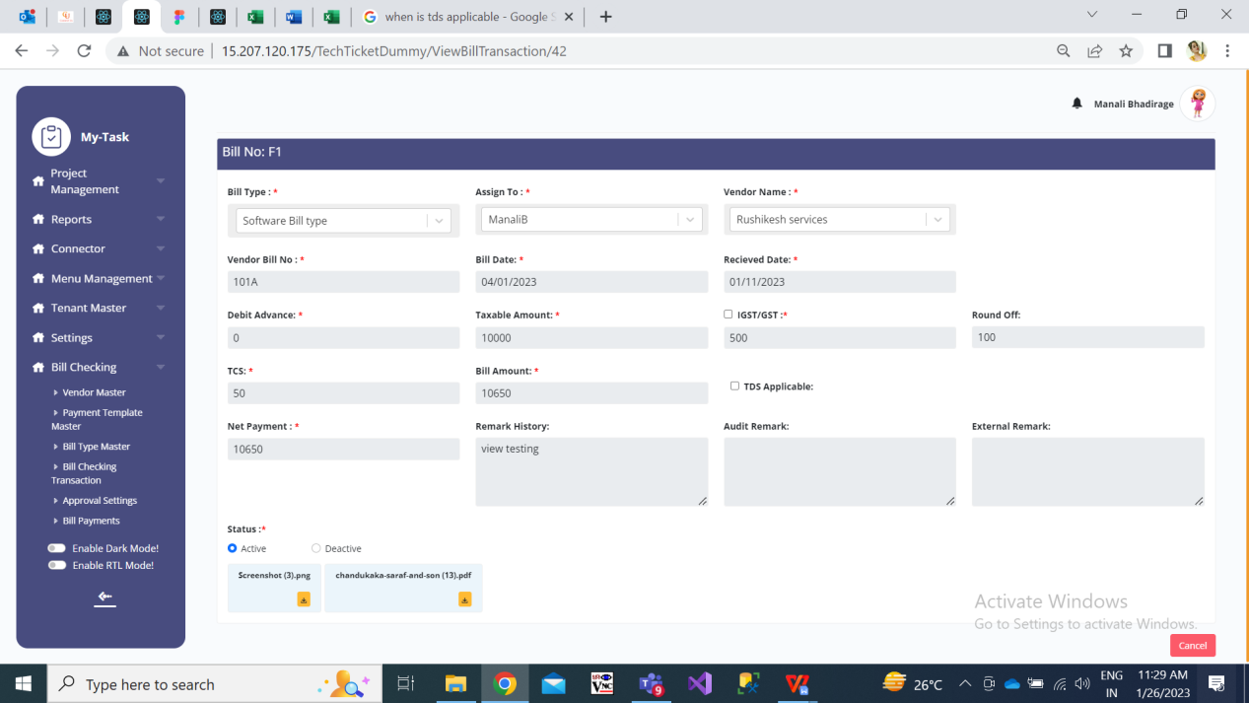

Fig: View Action

1. **Edit Action**

Following are the fields in “Add Data” of Bill checking Transaction sub-module:

* Bill ID
* Bill Type
* Assign to
* Vendor Name
* Branch Name
* Expected Bill Received Date (only in case of advance given bill)
* Vendor Bill No.
* Bill Date
* Received Date
* Debit Advance
* Taxable amount
* GST - IGST
* Round off
* TCS Amount
* Bill Amount
* TDS Applicable (check-box)
* TDS %
* TDS Section
* TDS Constitution
* TDS Amount
* Net Payment
* Net Payment in words
* Original Bill Received (checkbox)
* Internal Audit - based on authority.
* External Audit Authorised by HOD - (checkbox based on authority)
* Authorised by Management - (checkbox based on authority)
* Bifurcate By (drop-down)
* Remark
* Remark History - It should display all the remarks added by previous person along with date, time and login name.
* Internal Audit Remark
* External Audit remark
* Attach Invoice
* Is Active (yes / No) - If user wants to cancel the bill, it will be marked as in active. Provision to mark active or inactive will be based on authority. Once the bill is canceled / deactivated it should be highlighted and its status should be ‘canceled’. Canceled bills won’t be displayed in the assigned person’s login or the person who has submitted the bill. Canceled bill can be retrieved through filter button of bill checking transaction-> with it’s status as canceled.
* Save (button)
* Back / Close (button)

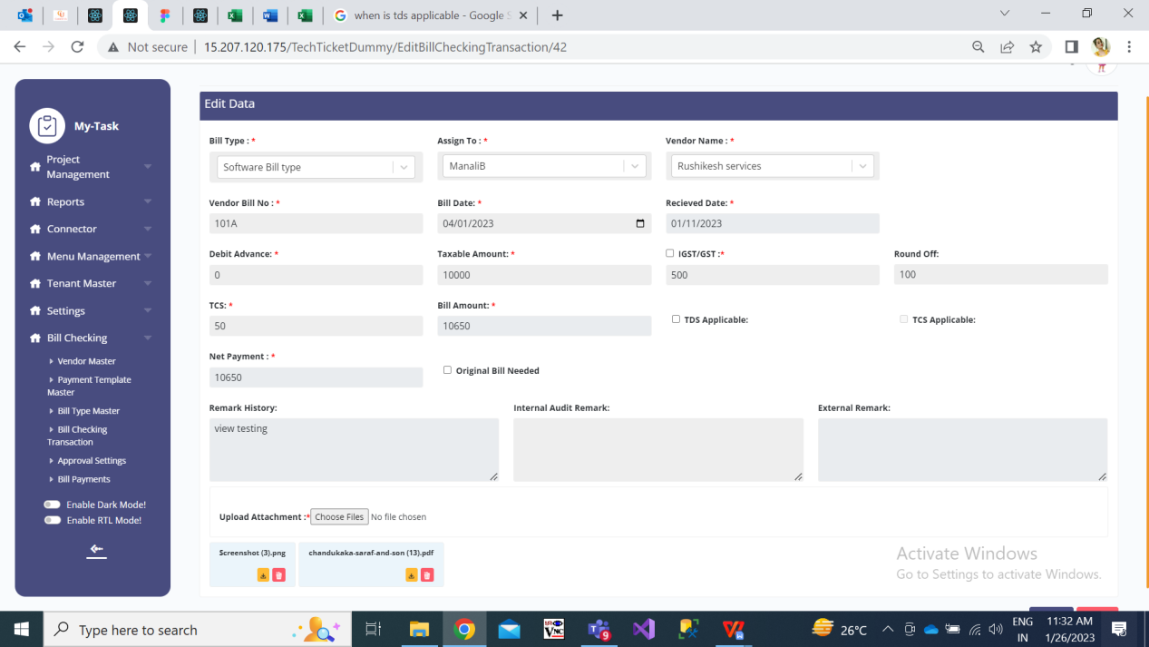

Fig: Edit action of bill checking transaction

|  |  |
| --- | --- |
| **FIELDS** | **EDITABLE** |
| Bill ID | No |
| Bill Type | Yes |
| Assign To | Yes |
| Vendor Name | Yes (based on authority) |
| Branch Name  (like for light bill) | yes |
| Expected Bill Received Date  (like for advance given) | yes |
| Vendor Bill No. | Yes |
| Bill Date | Yes ( past year bill date based on authority) |
| Received Date | No (based on authority) |
| Debit Advance | Yes |
| Taxable Amount | Yes |
| IGST / GST | Yes |
| Round Off | Yes |
| TCS | Yes |
| Bill Amount | No (autofilled) |
| TDS Applicable | Yes |
| Net Payment | No (autofilled) |
|  |  |
| Net Payment in words | No (autofilled) |
| Cancel | Yes (based on authority) |
| Bifurcate By | Yes |
| Remark History | No |
| Internal Audit Remark | Only by internal audit team |
| External Remark | Yes |

|  |  |
| --- | --- |
| **FIELDS** | **DESCRIPTION** |
| Original Bill Received | It will be checkbox based on authority. |
| Bifurcate By | In “bifurcate by” following fields are displayed:   * Drop-down * Calculate button * Reset Button   In drop-down, user selects the method to bifurcate the bill as below:   * Equally * Manually % * Manually ₹   Through this, user can divide the amount equally / percentage wise / manual amount among selected branches.  Once user selects any one out of these option from drop-down, user has to fill the following details in the box appearing below:   * Branch Name * Percentage % * Amount ₹ * Remark * Action (+ or X)   Before submiting  Fig: Bifurcate By |



Fig: Edit Action

1. **History Action**

It will have export button at the top and table below it will have following fields:

* Action Name (add / update)
* Bill ID
* Bill Type
* Vendor name
* Payment date
* Vendor bill no.
* Actual payment date
* Bill amount
* Net amount
* Net amount in words
* Bill status
* Bill type
* Assign from
* Assign to
* Taxable amount
* Debit Advance
* IGST / GST
* TDS
* Round off
* Bill Date
* Received Date
* IP Address
* Hold Amount
* Actual paid
* Attachments - It will have view button which display list of attachments edited and added. In case attachment is edited, then this column should be highlighted.
* Created By
* Created At
* Updated By
* Updated At

Whenever data was added, its history will be displayed. Further, it will add entry if any data was updated. Recent updates if made any should be displayed at the top. N number of updates if made any, then it should add history details N times.

Through export button, user can extract history details in .csv file.

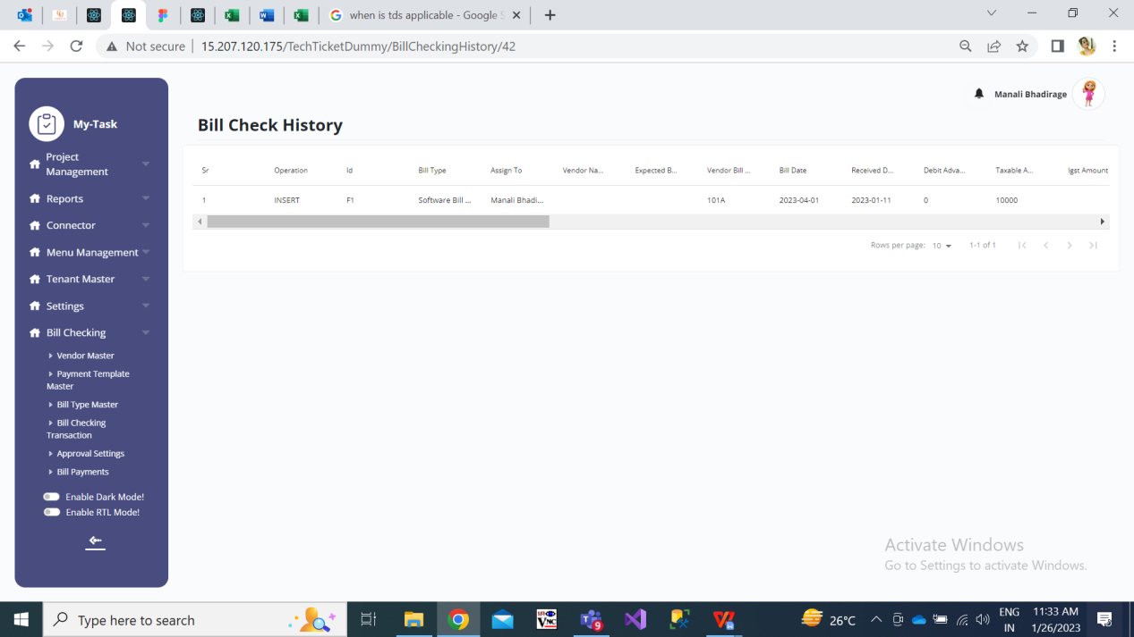

Fig: History -> Bill checking transaction

1. **Payment History Action**

It will display following fields in table:

* Action Name (add/ update)
* Transaction ID
* Key
* Bill Type
* Vendor Name
* Amount to be paid (net payment amount)
* Payment Date
* Payment Status (hold/ hold till audit / release / paid)
* Payment Ref No.
* IP Address
* User Agent - It is browser data of the person who adds / updates bill. Example: Mozilla/5.0 (Windows NT 10.0; Win64; x64) AppleWebKit/537.36 (KHTML, like Gecko) Chrome/106.0.0.0 Safari/537.36
* Remark
* Created By
* Created At
* Updated By
* Updated At

Whenever data was added, its history will be displayed. Further, it will add entry if any data was updated. Recent updates if made any should be displayed at the top. N number of updates if made any, then it should add history details N times.

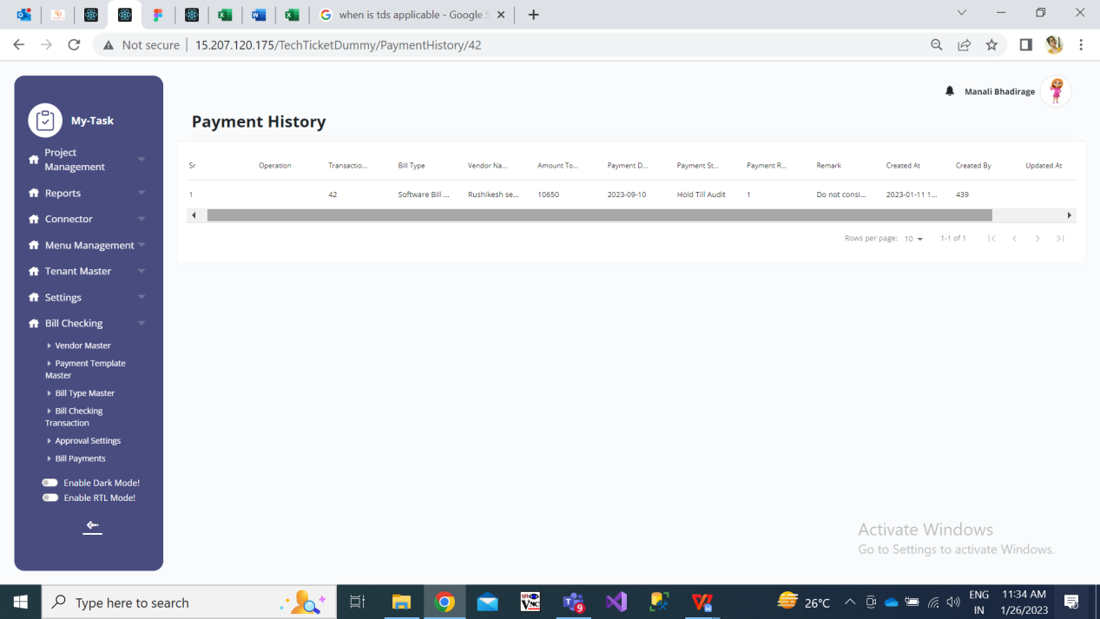

Fig: Payment history action of bill checking transaction

1. **Payment Detail Action**

It has export button at corner upside and table of payment details in it. Following details will be displayed in table:

* Amount to be paid - editable
* Status - editable
* Payment Date - editable
* Remark - editable
* Actual Payment Date
* Payment Ref No.
* Action - send sms

Status field will have drop-down displaying following list:

* Hold
* Hold till audit
* Paid
* Release

Provision to change the status to paid/ release will be authority based.

Further, in case the net payment is more than 99,00,000 then it classifies the amount and displays amount up to 99,00,00 in one row and the remaining amount in second row. Example: Net payment is 1,00,00,000. Then in payment details. It will display 99,00,000 in one row and remaining 1,00,000 in another row.

Through export button, user can extract history details in .csv file.

Example: If net amount = 300, then

|  |  |  |
| --- | --- | --- |
| **Sr No.** | **Payment Detail** | **Payment History** |
| 1st row | 300 | ADD- 300 |
| 1st row  2nd row | 200 (edited 300 amount as 200)  100 | UPDATE - 200  ADD - 100  ADD - 300 |
| 1st row  2nd row  3rd row | 50 (edited 200 amount as 50)  100  150 | ADD - 150  UPDATE - 50  ADD - 100  UPDATE - 200  ADD - 300 |

Eventually , the amount should be net amount in payment detail.

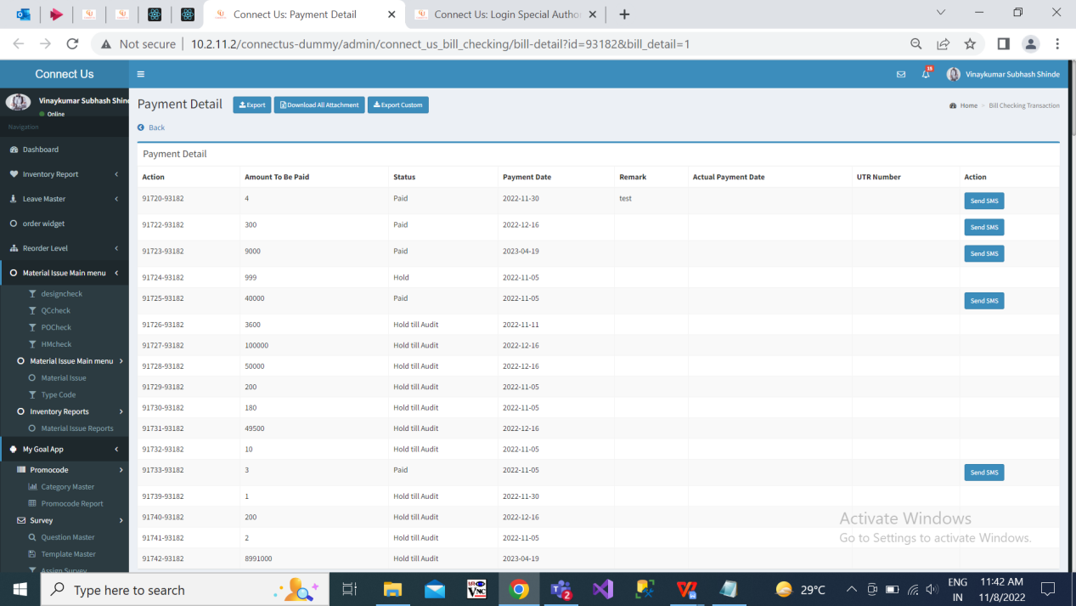

Fig: Payment detail

1. **Assign Person Detail Action**

It will display following fields in table:

* Sr No.
* Bill ID
* Assign Person Name
* Total Days
* Assigned on Date
* Status

|  |  |
| --- | --- |
| **FIELDS** | **DESCRIPTION** |
| Bill ID | It will be display the bill ID of selected bill. |
| Assign Person Name | It will display the list of employees to whom the bill was assigned to.  As bill is passed from one user to another, it will display the names of employees in table. |
| Total Days | It will display the number of days that particular bill was assigned to particular person.  It will display the count of days passed / finished for the bill to be assigned to this person.  It will display the days count as 0 initially. (If bill has been assigned to this person today, then it will display days count at 0 to that person along with along and status as bill is currently assigned to this person’. Then on next day, it will display days count as 1. ) |
| Assigned on Date | As one bill is passed from one person to another, so here the date on which the particular bill was assigned to that person should be displayed. |
| Status | When bill is assigned from person A to person B, then in the row od person A it should display status as ‘Bill is forwarded to another person’.  When bill is currently assigned to person B, for the row of person B it should display status as ’Bill is currently assigned to this person’. |

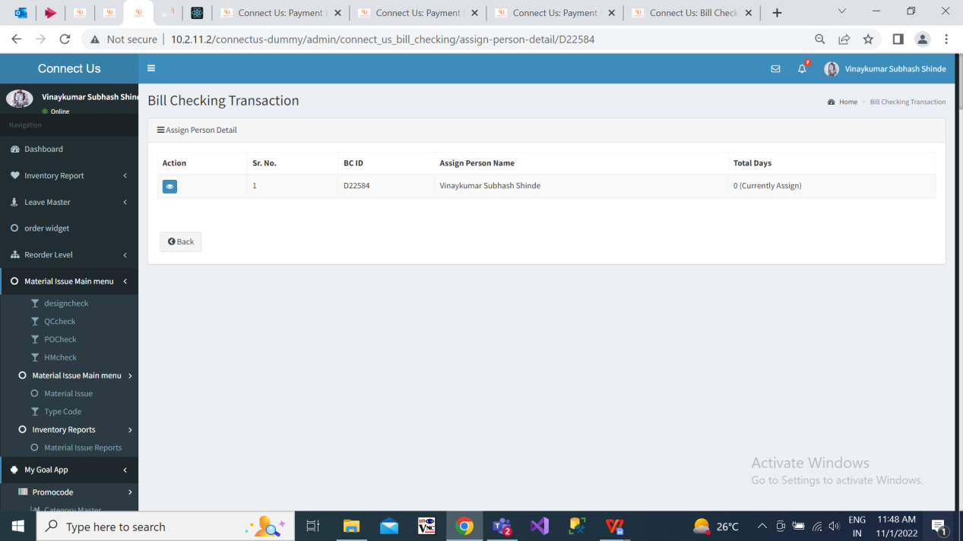

Fig: Assign Person Detail

1. **Bifurcate Amount**

* **Authority Based Mapping**

Following provisions will be given to the users from back-end:

* Allow edit - Authorised by HOD
* Allow edit - Authorised by Management
* Allow paid entry change
* Bill Payment
* Auto Update payment
* Download Payment
* Edit in bill
* Bill Date
* Vendor Bill No.
* Vendor Name
* Delete Bill Attachments
* Edit Vendor master - bank details
* Internal Audit
* External Audit
* Past financial year bill date
* Prepone Payment Date
* Record Room
* Received date
* TCS applicable
* Update ERP account name
* Payment status release
* Original Bill Received
* Update Payment Details
* Payment status paid
* Payment Reference Details
* Actual Payment Date
* All Update Bill

|  |  |
| --- | --- |
| **FIELDS** | **DESCRIPTION** |
| Allow Edit - Authorised by HOD | In Bill Checking Transaction -> Edit, enable option to click Authorised by HOD button.  For others, it will be disabled. |
| Allow edit - authorised by management | In Bill Checking Transaction -> Edit, enable option to click Authorised by management button.  For others, it will be disabled. |
| Allow paid entry change | If status of bill is paid in payment details, then others don’t have authority to make changes in status, its date and remark further.  Person having “allow paid entry change” authority, she/ she can change status to hold/hold till audit / release, its date & remark. |
| Bill Payment | In Bill payments module, it gives provision to authorised user to auto **update payment button and download payment button**.  User can upload bank file through “Auto Update Payment” button.  In Bill payments module, it enables user to download txt files through “Download Payment” button. Files can be downloaded only once.  If authorised person has downloaded files earlier and clicks on download button for another time, then it should display message “Files can be downloaded only once.” |
| Edit in bill | Through this authority, user will have provision to **edit bill date, edit vendor bill no., edit vendor name and delete bill attachments**.  (Bill checking transaction -> edit bill action) |
| Edit Vendor Master Bank Details | Authorised person will be able to edit bank details in Vendor master.  (bank name, bank branch name, account no, ifsc code, beneficiary name, passbook attachment, cheque attachment) |
| Internal Audit | Only audit team will be given this authority to edit / enter remark in this field.  For others this field should be read only. |
| External Audit | Authority to edit / enter remark in this field.  For others this field should be read only. |
| Past financial Year Bill Date | Through this provision, authorised person can select ‘Bill Date’ before 31st March of current year in Bill checking transaction -> Add Data and Edit Data. |
| Prepone Payment Date | Enables authorized person to edit and prepone payment date in payment details action of bill. (this authorised person can prepone as well as postpone date)  Other who don’t have this authority can just postpone payment date. (cannot prepone) |
| Record Room | Authority to assign the bill to record room. |
| Received date | Authority to edit received date in bill checking transaction -> edit of bill. |
| TCS Applicable | In Bill checking transaction -> Add data & Edit data, authorised person can check this checkbox.  For others, checkbox will be not be displayed. |
| Update ERP Account Name | Update erp acc name in vendor master -> edit. |
| Original Bill Received | Authority to check original bill received checkbox in bill checking transaction -> edit. |
| Update Payment Details | Provision to change payment status to paid.  Provision to change payment status to release.  Payment Reference Details  Provision to change actual payment date in payment details. |
| All update Bill | Authority to update all bills even if it is not assigned to the user himself. Authorised user will be able to edit bills assigned to his login as well as can edit bills which are assigned to some another user. |

In ticketing system, we need to create sub module as ‘Authority settings’ under bill checking module. It will have following fields on main page:

* Search by
* Add authority button
* Sr. No.
* Edit action
* View action
* Assign authority action
* Authority name
* Remark
* Status
* Created at & by
* Updated at & by

Once user clicks on add authority button, it will display following fields:

* Authority name
* Sub module name
* Remark
* Submit button
* Reset button

|  |  |
| --- | --- |
| **FIELDS** | **DESCRIPTION** |
| Authority name | It will be mandatory text field.  Here user will mention the name of the authority as specified in authority names list.  It should accept maximum 50 characters. It should accept space and alphanumeric value. |
| Sub module name | It will be mandatory drop-down field displaying list of sub modules in bill checking. |
| Remark | It will be optional text field.  Here user will mention the additional comments.  It should accept maximum 100 characters. It should accept space, special characters and alphanumeric value. |
| Submit | Once user enters authority name, user name and clicks on submit then it should display message as authority created successfully and display in the grid at top.  Also, as per authority given to the selected user, it should be reflected in the login of user. (User should be able to perform special actions as given by authority). |

Once user clicks on edit action from grid, it will display all following editable fields:

* Authority name
* Remark
* Is Active (yes / no)
* Submit button
* Reset button

Once user clicks on ‘assign authority’ action, it will display following fields:

* Authority name:- display created authority and it will be read only here)
* Sub module name:- display sub module name as entered while creating authority and it will be read only here.
* Assign authority to users :- Here user will select the name of the user to whom the authority is to be given. It will be mandatory drop-down field displaying list of users from user master.
* Valid from :- It will be mandatory field displaying calender picker. User will select date from which the authority is to be given to user.
* Valid till:- It will be mandatory field displaying calender picker. User will select date till which the authority is to be given to user. It should disable previous dates as per selected ‘valid from’ date.
* + button:- Through add more button, end user can assign authority to more users. Once user clicks on + button, it should display one more row of fields as Assign authority to users, valid from and valid till.
* X button:- Through delete button, user should be able to remove the row which was added.
* Submit button:- Once end user adds users and clicks on submit, then the users to whom the authority was assigned should be able to perform actions as per provided authority.
* **Bill Payments**

Through bill payments module, user will initially download all details of the bill whose status is ‘Release’ in Bill Transaction -> Payment details. User will download the file (txt and xlx) and submit the same to bank. Once we receive the payment file from bank, it will be uploaded in Bill payment module. Then as per the payment successful / unsuccessful record, the status of the bill gets is updated as ‘Paid’ or ‘Bank Rejected’.

Bill Payments module will have following fields in it:

* Auto Update Payment (button at top)
* Bill Type
* Till Date
* Filter (Button)
* Reset (button)
* Details (table)
* Download Txt (button)
* Excel Sheet (button)

|  |  |
| --- | --- |
| **FIELDS** | **DESCRIPTION** |
| Bill Type | It will be drop-down which will display all the bill types assigned to logged in user.  It should enable multi-select option in drop-down.  If user doesn’t select any bill type and only selects till date and clicks on filter button, then data of all bill types should be displayed in grid below. |
| Till Date | Mandatory field.  User will manually select the date from calender till which user want to get details of vendor and payment. |
| Filter (button) | Once user clicks on filter button after selecting desired bill type and till date, it should display the details of vendor and payment.  If user clicks on filter button without entering data in bill type / till date field, it should display error message “This field is mandatory” at bill type and till date. |
| Reset (button) | Once user clicks on reset button, it should clear all already entered data. |
| Details | It will be table displaying details of bills with release status. It will have following columns:   * Action * Vendor Name * Bill Type * Padm Name * Padm Balance * Total payment amount * Vendor Bill No. * Transaction IDs * Bill IDs * Acme No. * Paid * SBI Amount * Remark * Advance IDs * Advance amount * Beneficiary Name * Bank Name * Branch Name * Account No. * IFSC Code * Card No. * Reference No. * Narration |
| Download Txt (button) | User can download zip files which will include multiple txt files of the payments.  If user attempts to download txt files for another time, it should display message as “Files were already downloaded.”  Types of txt files will be Sbi_payee.txt, RTGS_payee.txt, NEFT_payee.txt and payee.txt.  In Sbi_payee.txt, RTGS_payee.txt and NEFT_payee.txt files, first row will have **our bank details** in format as below:  (00000033534353557)#(IFSC_code)#(date)#(total_payment)##(unique_key)(identifier)#(SBI_unique_key)#(identifier)(newline)  As our bank account is of SBI, in case vendor’s bank account is of SBI too then **SBI**_payee.txt file will be generated for the respective vendor’s bill. Its format as below: (bank details)(account number)#(IFSC_code)#(date)##(total_payment)#(unique_key)-(vendor id)#(SBI_unique_key)#(newline)  If total payment amount for vendor is upto 2 lakh, then **NEFT**_payee.txt will be generated. Format as below: (bank details)(account number)#(IFSC_code)#(date)##(total_payment)#(unique_key)-(vendor id)#(NON SBI NEFT_unique_key)#NEFT(newline)  If total payment amount for vendor is more than 2 lakh, then **RTGS**_payee.txt will be generated. Format as below: (bank details)(account number)#(IFSC_code)#(date)##(total_payment)#(unique_key)-(vendor id)#(NON SBI NEFT_unique_key)#NEFT(newline)  Consolidated details of all the SBI payee / RTGS payee / NEFT payee txt files will be included in one **Payee**.txt file. Format as below:  (bank file)(account type.#A#(vendor name)#(account number)#(space)#(ifsc_code)#(bank name)#(bank branch name)#(new line)  If vendor’s consider in payment is **petty cash**, then for that vendor petty cash text file will get generated. Format as below: (bank details)(card number)|(reference number)|(total payment)|(bank branch name)|(mobile number)(space)(new line)  Once the user downloads the file, the status of the released bill gets updated as ‘Confirmation Pending’. |
| Excel (button) | Once user clicks on Excel, it will download xlx or .csv file which will have following columns:   * Vendor Name * Acme Name * Account Balance * Transactions * Bill ID * Vendor Bill Nos. * Acme No. * Total Payment * Remark * Beneficiary Name * Bank Name * Bank Branch Name * Account No. * IFSC Code * Card No. * Reference No. * Narration * Export Date |
| Auto Update Payment (button) | Once authorised user clicks on auto update payment button, it will direct user to add attachment button where user will upload bank file (If sbi then text file will be uploaded, if icici bank then xlx or csv will be displayed).  Once bank files are uploaded, then status of the bill gets updated in ‘Payment details’ as paid as per successful / unsuccessful status of that particular transaction. |

Below is the description of fields in ‘Details’ table:

|  |  |
| --- | --- |
| **FIELDS** | **DESCRIPTION** |
| Action | It will have view action which will display the details of the all the bills of the particular vendor. It will display details in tabular form having following columns:   1. Action 2. Bill ID 3. Vendor Name 4. Amount 5. TDS 6. IGST 7. GST 8. Net Payment 9. Acme No. 10. Amount to be paid 11. Payment Date 12. Payment Status 13. Actual Payment Date 14. Payment Ref No. |
| Vendor Name | It will display the name of the vendor whose bills is in release state on payment details page. |
| Bill Type | Bill type of the vendor’s bill will be displayed here from transaction page whose bills are in release state. |
| Padm Name | Padm Name will be acme account name of the vendor. (the one which we enter while adding vendor in vendor master) |
| Padm Balance | It will display the Padm account balance.  This column will be displayed only to the person who have “Update Acme Account Name” authority. |
| Payment Amount | It will display the total of Net payment of bills of this particular vendor.  Example: We have one bill of 5197.5/- amount to be paid to city cable system vendor. We have another bill of 10642.5/- to be paid to city cable system vendor. Therefore, it will display 15840 in Payment amount filed for this vendor. |
| Vendor Bill No. | It will display the list of bill numbers of particular vendor for which status is release. |
| Transaction | It will display the list of transaction numbers against bill from padm. |
| Bill ID | It will display the list of bill IDs of particular vendor for which status is release. |
| Acme No. |  |
| Paid |  |
| SBI Amount |  |
| Remark |  |
| Advance IDs |  |
| Beneficiary Name | Name of the vendor as per bank account will be displayed here. |
| Bank Name | Bank Name of the particular vendor as in Vendor master should be displayed here. |
| Branch Name | Branch Name of the particular vendor as in Vendor master should be displayed here. |
| Account No. | Account No. of the particular vendor as in Vendor master should be displayed here. |
| IFSC Code | IFSC Code of the particular vendor as in Vendor master should be displayed here. |
| Card No. | When ‘Consider in Payment’ field is petty cash of vendor master, then Card No. of the vendor will be displayed here. |
| Ref No. | When ‘Consider in Payment’ field is petty cash of vendor master, then Reference No. of the vendor will be displayed here. |
| Narration | When ‘Consider in Payment’ field is petty cash of vendor master, then Narration of the vendor will be displayed here. |

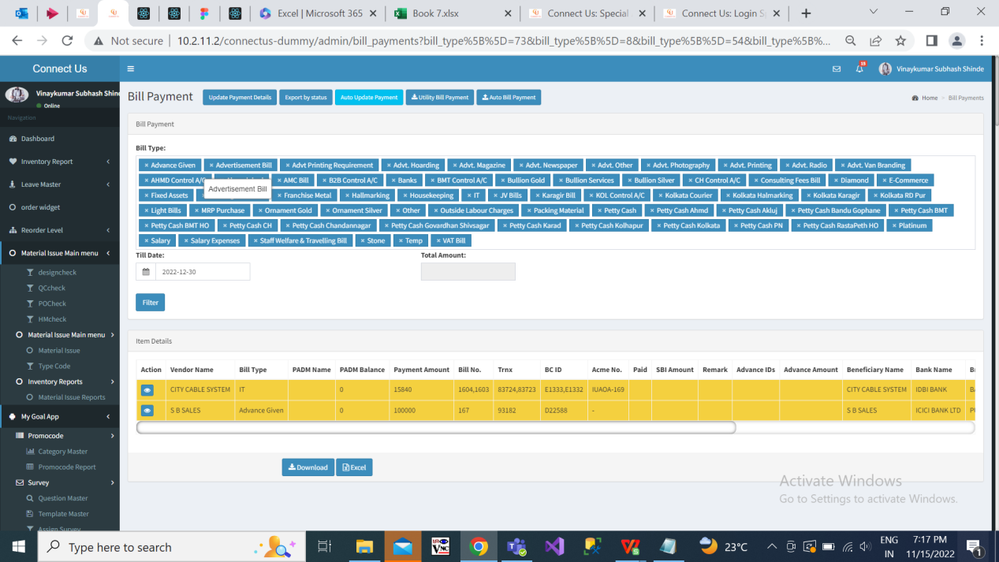

Fig: Bill Payments

* **Bill Approval**

We need to process the submitted bills in such a way that depending upon the type of the bill and the amount, it should get forwarded to level 1 / level 2 / level 3 / level 4. Once the bills gets approved by level 1 approver, it should proceed to level 2 approver and likewise till the final approver. (All bills may not require approval from all levels/authorities.)

Initially, we need to create a master. It will include following fields:

* Bill Type
* Amount
* Level 1 approver
* Level 2 approver
* Level 3 approver

(Not all bills will need approval from all levels. Few bills may needonly HOD approval, whereas few bills may need HOD approval, management approval & audit team approval.)

Once the user submits the bill, then it will get sent to the approver (say level 1 – leader) based on bill type and amount. Approver will click on edit action of the bill through bill checking transaction, click on approver checkbox and will submit it. Further, based on level set in master it will get forwarded to another approver (say level 2 – HOD). When approvers approve the bill, the name of the approver should be displayed on the bill and in grid.

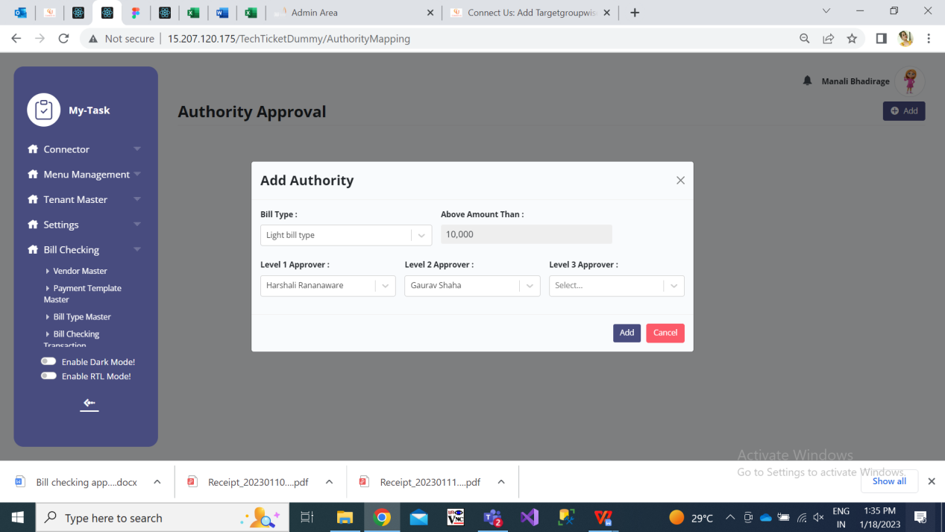

Fig: Bill Approval

Example: If we set that for light bill above 10, 00 should get approval from Harshali and Gaurav Shaha.

Case I) Manali has submitted a light bill of bill amount=50000 and assigned to Rushikesh, then the bill will directly get assigned to rushikesh.

Case II) Manali has submitted a light bill of bill amount = 11000 and assigned to Rushikesh. Then as the amount is above 10,000 then as per setting, when Manali submits the bill it should get firstly submitted to Harshali. Once Harshali approves it and clicks on submit, it should get submitted to Gaurav Shaha. Also, the name of the level 1 approve I.e Harshali should be displayed on bill. Later, once Gaurav Shaha approves the bill and clicks on submit, it will get assigned to - Rushikesh.

Here, Rushikesh will be able to see that the bill has been approved by Harshali and Gaurav Shaha.

**References of the users**

|  |  |  |  |
| --- | --- | --- | --- |
| **User** | **Name** | **Mail** | **Contact number** |
| **Actual user** |  |  |  |
| **Ticket created by (if any)** | Manali Bhadirage | manali.bhadirage@techneai.com | 2964 |
| **Assigned business analyst** | Manali Bhadirage | manali.bhadirage@techneai.com | 2964 |
| **Assigned developer** | Punam Shinde  Rushikesh Harkare | [punam.shinde@techneai.com](mailto:Punam.shinde@techneai.com)  [rushikesh.harkare@techneai.com](mailto:Punam.shinde@techneai.com) | 2964 |
| **Assigned tester** | Amreen Shaikh  Abhijeet Ghodke | Amreen.shaikh@techneai.com  Abhijeet.ghodke@techneai.com | 2964 |