Manali ashok bhadirage

Manali.bhadirage@techneai.com

26.04.2023

IMPS PAYMENT - ENTRY USER IN VIEW ACTION

**Functional Requirement Document**

**CONTENTS**

1. TICKET DETAILS 2

2. VERSION CONTROL 2

3. APPROVALS 2

4. ESTIMATION 2

5. INTRODUCTION 3

6. BUSINESS REQUIREMENT 3

7. SCOPE 3

8. BUSINESS & SYSTEM RULES 3

9. ABBREVIATIONS & TERMS 3

10. EXISTING SYSTEM 3

11. GRAPHICAL REPRESENTATION 3

12. PROPOSED SYSTEM 3

13. TEST DATA 4

14. ODUS 4

15. REFERENCES OF THE USERS 5

1. **TICKET DETAILS**

|  |  |
| --- | --- |
| **Ticket ID** | TT12838 |
| **Ticket description** | IMPS Payment System point view Details Entry user wrong data show please find the attachment |
| **Created by** | Amar Landge |
| **Created on** | 03/06/2023 |
| **Priority** | Medium |

1. **VERSION CONTROL**

|  |  |  |  |  |
| --- | --- | --- | --- | --- |
| **Sr. No** | **Version no** | **Version Date** | **User name** | **User department** |
| **1** | **1.0** | **14/08/2023** | **Amar Landge** | **Audit** |
|  |  |  |  |  |
|  |  |  |  |  |

1. **APPROVALS**

|  |  |  |
| --- | --- | --- |
| **Field** | **Name of the User** | **Approved date by the user** |
| **Actual User Name Actual User Department Organization Name** | Amar Landge  Audit  CSJ |  |
| **Assigned BA** | Manali bhadirage |  |
| **Assigned Developer** |  |  |
| **Assigned Tester** |  |  |

1. **ESTIMATION**

|  |  |  |  |  |
| --- | --- | --- | --- | --- |
| **Department name** | **Estimated Time (In hr)** | **Scheduled Date (Starting date)** | **Estimated date** | **Actual delivery date** |
| **BA** |  |  |  |  |
| **Development** |  |  |  |  |
| **Testing** |  |  |  |  |
|  |  |  |  |  |

1. **INTRODUCTION**

IMPS payment, a sub-module in Connect US -> Bill Checking, is used during 12 URD purchase transactions done in Padm. The payments of URD purchases are processed through IMPS payment module i.e. we have to pay the mentioned payment amount to the customer. The user enters the document series number from Padm and the data as per document number gets displayed. Further these bills are assigned to another user. The authorized person verifies the bill and then changes the status hold / hold till audit / release / paid. Once payments status is changed to release then that bill gets displayed in list of download payment. Moreover, once user enters the bank file then the successful payments get displayed as paid in imps payment module.

1. **BUSINESS REQUIREMENT**

Currently, entry user name is displayed incorrectly in view action, grid and edit action of IMPS payment.

|  |  |  |  |
| --- | --- | --- | --- |
| **Requirement ID** | **Requirement Name** | **Short Description** | **Priority** |
| BR001 | Entry user name in view action | When user views the bill, then it should display the correct name of the entry user in view action. | High |
| BR002 | Entry user name in edit action | When user views the bill, then it should display the correct name of the entry user in view action. | High |
| BR003 | Entry user name in Grid | When user views the bill, then it should display the correct name of the entry user in grid -> entry user name column. | Medium |

1. **SCOPE**

Once bill is added by the entry user then it should be displayed in grid of the user to whom the bill is assigned to. Once bill is added then it should display all correct details in view action, grid and history action. Further, when assigned person clicks on edit action then all the details should be displayed correctly as it was entered by entry user while adding the bill.

1. **BUSINESS & SYSTEM RULES**

* User should be registered in the system.
* User should be logged in.
* System should display error message for incorrect details if entered.
* System should pop up a message, if any issues in the system is detected.

1. **ABBREVIATIONS & TERMS**

IMPS - Immediate Payment Service

IFSC code - Indian financial system code

RTGS - Real time gross settlement

NEFT - national electronic fund transfer

1. **EXISTING SYSTEM**

In existing system, entry users are adding bill and assigning to the entry user. However, once bill is submitted, then it is displaying incorrect entry user name in view action, edit action and grid. It is displaying the name of the logged person in entry user name field even if that logged person is not the entry user of the bill.

1. **GRAPHICAL REPRESENTATION**

Display correct details in grid, view, history, edit action

Assign bill to assigned user

Auto-fill & display fields from padm & submit

Add

Enter URD purchase doc series

Fig: Context Diagram

1. **PROPOSED SYSTEM**

Once entry user **adds** the bill, it will display following fields:

* Series no. And search button
* Branch name
* Customer name
* Mobile no.
* Address
* Adjust amount
* Padm credit balance
* Payment amount
* Assign to
* Type
* Bank name
* Bank branch
* Ifsc code
* Account number
* Confirm account number
* Attachments
* Remark
* submit button

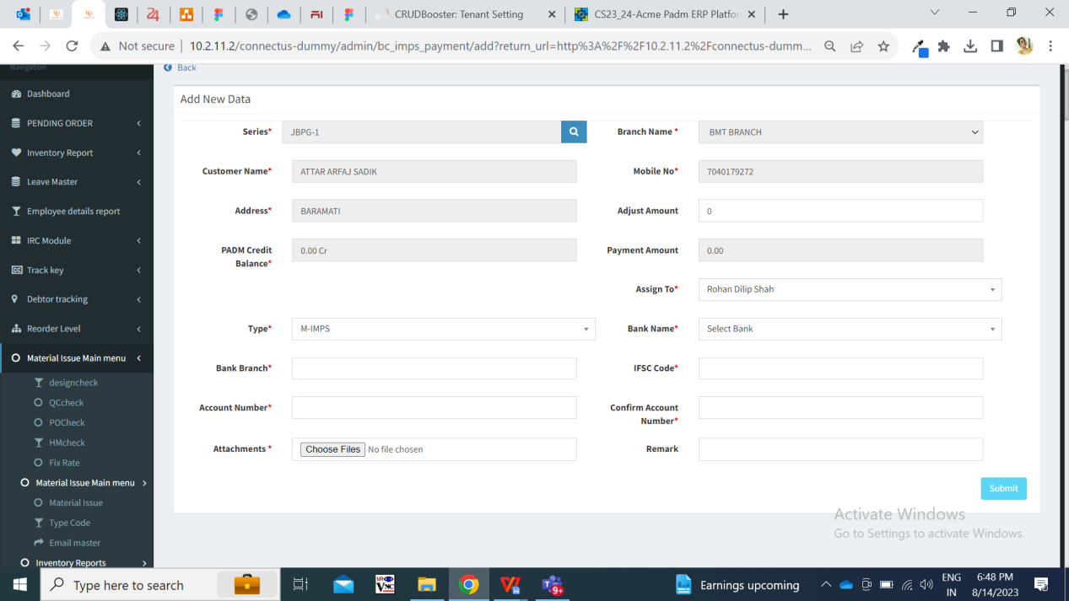

Fig: IMPS Payment -> add action

|  |  |  |  |
| --- | --- | --- | --- |
| **FIELDS** | **INPUT TYPE** | **MANDATORY/ OPTIONAL** | **DESCRIPTION** |
| Series number | text | Mandatory | User will enter the document number from Padm -> document -> 12 Gold URD purchase. |
| Branch name | text | Mandatory | It will display the branch name of the logged in person who is adding bill. It will display the branch of logged in person as mentioned in employee master against that logged in person.  It will be read only. |
| Customer name | Text | Mandatory | Once user enters the document number, then it will pre-fill and display the customer name from number against entered series number from padm. |
| Mobile number | Text | Mandatory | Once user enters the document number, then it will display the mobile number of the customer from number against entered series number from padm. |
| Address | Text | Mandatory | Once user enters the document number, then it will pre-fill and display the address of the customer from number against entered series number from padm. |
| Adjust amount | Text | Optional | User will manually enter the amount that is to be rounded off I.e. not to be considered for payment out of net payment. |
| Padm credit balance | Text | Mandatory | It will be read only.  It will display the net payment value as per entered series number. |
| Payment amount | Text | Mandatory | It will be read only.  Once document number is entered, it will display the value in net payment amount in this field.  Further, if any value is entered in adjust amount field, then it will calculate and display amount which is to be paid to the customer. Payment amount = padm credit balance - adjust amount |
| Assign to | Drop-down | Mandatory | It will display the name of the user to whom the bill is to be assigned. (currently we have only added Rohan shah name in the list as only this user is handling URD bills) |
| Type | Drop-dwon | Mandatory | By default it will display M- Imps from the list.  It has RTGS, NEFT and M IMPS in the list. |
| Bank name | text | Mandatory | User will enter the customer’s bank name.  Validation: Maximum 30 digits / characters should be accepted. It shouldn’t accept space. |
| Bank branch | text | Mandatory | User will enter the customer’s bank branch name.  Validation: Maximum 25 digits / characters should be accepted. |
| IFSC code | text | Mandatory | User will enter the bank IFSC code.  Validation: Maximum 25 digits should be accepted. |
| Account number | text | Mandatory | User will enter the customer’s bank account number.  Validation: Maximum 25 digits should be accepted. |
| Confirm account number | text | Mandatory | User will enter the customer’s bank account number as same as entered in above account number field.  Validation: Maximum 25 digits should be accepted. It should display on field error message if account number is not as same as account number field. |
| Attachments | Attach | Mandatory | User will attach the images of customer’s account document like passbook, cheque, purchase bill invoice, etc.  Validation: It should accept maximum 25 attachments. It should accept png, jpg, jpeg, pdf, doc, heic, webp file extensions only. |
| Remark | text | Optional | User will mention the additional comments in this section.  Validation: Maximum 250 chacacters / digits. |
| Submit | Click |  | Once bill is submitted, ID for bill will be created and bill will be displayed in the imps payment grid of the assigned person.  Also, it will be displayed in the logged in person’s grid as per branch assigned to him. |

Once bill is submitted, it gets display in the grid of the assigned user and in the ggrid of the users of their branch. Once bill is displayed in **grid**, it will display following columns in grid:

* View action
* Edit action
* History action
* Payment detail action
* ID
* IMPS ID
* Payment status
* Customer name
* Transaction
* Assigned to
* Branch name
* Payment date
* Customer account
* Series
* Payment amount
* Adjust amount
* IFSC code
* Bank name
* Entry user name
* Active
* Remark
* Entry time

|  |  |  |  |
| --- | --- | --- | --- |
| **FIELDS** | **INPUT TYPE** | **MANDATORY/ OPTIONAL** | **DESCRIPTION** |
| Entry user name | Text | Mandatory | Once user submits the bill, then it should display the correct entry user name in entry user column of grid.  Currently, it is showing incorrect entry user name on dummy. It is displaying the logged in person name even when that logged in person has not created the bill. (This bugs is to be solved on dummy. On live, it is displaying correct name in grid) |

Once users click on **view** action, it will display following fields:

* IMPS ID
* Series
* Branch name
* Customer name
* Mobile no.
* Entry user
* Address
* Adjust amount
* Padm balance
* Payment amount
* Assign to
* Type
* Payment status
* Bank name
* Bank branch
* Ifsc code
* Account number
* Attachments
* Remark
* Is active
* Created at
* Updated at & by

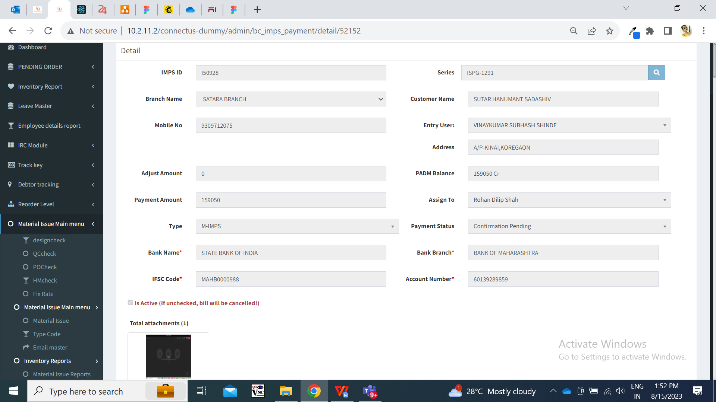

Fig: IMPS payment -> View bill

All the details should be displayed correctly as entered while adding the bill or when bill is edited and submitted.

|  |  |  |  |
| --- | --- | --- | --- |
| **FIELDS** | **INPUT TYPE** | **MANDATORY/ OPTIONAL** | **DESCRIPTION** |
| Entry user name | text | Mandatory | It will display the name of the employee who has created the bill.  Currently it is showing incorrect entry user name. It is displaying the name of the logged in person in this field for all bills even if logged in person has not created that bill. (This bug is to be solved both on live and dummy) |
| Created at | text | Mandatory | It should display the date and time when the bill was created. |
| Updated at & by | Text | Mandatory | It should display the name of the employee and date and time when the bill is recently updated. |

Once assigned user clicks on **edit** action of the bill, it will display following pre-filled fields:

* IMPS ID
* Series
* Branch name
* Customer name
* Mobile no.
* Entry user
* Address
* Adjust amount
* Padm balance
* Payment amount
* Assign to
* Type
* Payment status
* Bank name
* Bank branch
* Ifsc code
* Account number
* Attachments (to attach)
* Delete / download already added attachments
* Remark
* Is active
* Submit button

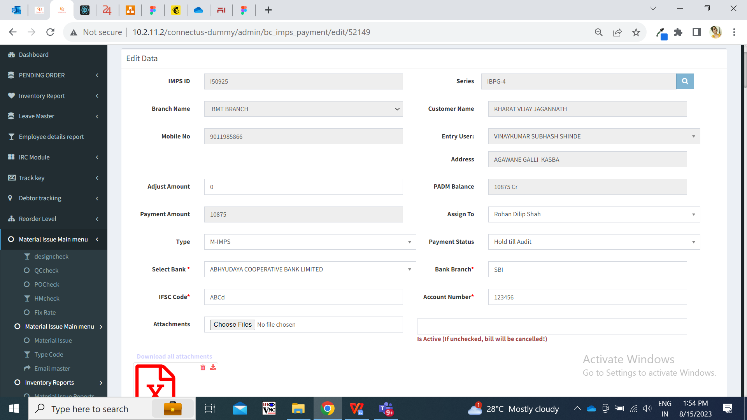

Fig: IMPS payment -> edit action

|  |  |  |  |
| --- | --- | --- | --- |
| **FIELDS** | **INPUT TYPE** | **MANDATORY/ OPTIONAL** | **DESCRIPTION** |
| Entry user name | text | Mandatory | It will display the name of the employee who has created the bill.  Currently it is showing incorrect entry user name on dummy. It is displaying the name of the logged in person in this field for all bills even if logged in person has not created that bill. (This bug is to be solved on live dummy. On live it is showing correct entry user name.) |

Further, when we export data, then file will be exported and it will display columns as selected in export option with correct data as in grid. (File is not getting downloaded on dummy. It is working on live)

1. **TEST DATA**



1. **ODUS ( Open Discussed Unhanded scenarios )**

|  |  |  |  |  |
| --- | --- | --- | --- | --- |
| **Sr. No.** | **Topic** | **Priority**  **(High / medium / low)** | **Remark** | **Status**  **(Open/**  **Closed)** |
| 1 |  |  |  |  |
| 2 |  |  |  |  |
| 3 |  |  |  |  |

1. **REFERENCES OF THE USERS**

|  |  |  |  |
| --- | --- | --- | --- |
| **User** | **Name** | **Mail** | **Contact number** |
| **Actual user** | Pritam Metha | [ia@csjewellers.com](mailto:ia@csjewellers.com) |  |
| **Ticket created by (if any)** | Amar Landge |  |  |
| **Assigned business analyst** | Manali bhadirage | Manali.bhadirage@techneai.com | 2965 |
| **Assigned developer** |  |  |  |
| **Assigned tester** |  |  |  |