05.01.2023

Pending Order Check

Manali Ashok Bhadirage

Manali.bhadirage@techneai.com

**Functional Requirement Document**

**CONTENTS**

1. TICKET DETAILS 2

2. VERSION CONTROL 2

3. APPROVALS 2

4. ESTIMATION 3

5. INTRODUCTION 3

6. BUSINESS REQUIREMENT 3

7. SCOPE 4

8. BUSINESS & SYSTEM RULES 4

9. ABBREVIATIONS & TERMS 4

10. EXISTING SYSTEM 4

11. GRAPHICAL REPRESENTATION 4

12. PROPOSED SYSTEM 4

13. TEST DATA 11

14. ODUS 12

15. REFERENCES OF THE USERS 12

1. **TICKET DETAILS**

|  |  |
| --- | --- |
| **Ticket ID** | TT4393 |
| **Ticket description** | Inventory Silver Department Sathi ConnectUS Madhe New Report Create Karne Report Name :- Pending Order Check Ref By :- Vinaykumar Shinde Sir (Attachment Send In Mail) |
| **Created by** | Tushar Nikam |
| **Created on** | 22/08/2023 |
| **Priority** | Medium |

1. **VERSION CONTROL**

|  |  |  |  |  |
| --- | --- | --- | --- | --- |
| **Sr. No** | **Version no** | **Version Date** | **User name** | **User department** |
| **1** | **1.0** | **01/05/2023** | **Tushar Nikam** | **itinv** |
| **2** | **2.0** | **08/07/2023** | **Vinay Shinde** | **Silver HOD** |
| **3** | **3.0** |  | **Gaurav Shaha** | **Project Head** |
| **4** | **4.0** |  | **Aditya Shah** | **Management** |
|  |  |  |  |  |

1. **APPROVALS**

|  |  |  |
| --- | --- | --- |
| **Field** | **Name of the User** | **Approved date by the user** |
| **Actual User Name Actual User Department Organization Name** | Vinay Kumar Shinde  Silver  CSJ |  |
| **Assigned BA** | Manali bhadirage |  |
| **Assigned Developer** | Prathmesh shinde |  |
| **Assigned Tester** | Priyanka dupargude |  |

1. **ESTIMATION**

|  |  |  |  |  |
| --- | --- | --- | --- | --- |
| **Department name** | **Estimated Time (In hr)** | **Scheduled Date (Starting date)** | **Estimated date** | **Actual delivery date** |
| **BA** |  |  |  |  |
| **Development** |  |  |  |  |
| **Testing** |  |  |  |  |
|  |  |  |  |  |

1. **INTRODUCTION**

In connect us -> inventory report user needs to create a Pending Order checking report through which user can understand the count of pcs which are given for labeling and which are pending from the karagir side. Through reorder level report, user gets to know the count of pcs / order that is to be given to karagir for particular SCM (item - category - weight range - size). The order of one particular SCM is divided and given to one or more karagirs. So, order number is generated for each karagir. This is called as purchase order. Further, out of total pcs in one order given to karagir is again divided as per delivery dates.

Example: Angathi- Fancy - 2.760-3.759 - 0 has total requirement of 40 pcs. Then this order of 40 pcs is divided and given to multiple karagirs. Like, 12 pcs order is given to karagir A (PO1), 18 pcs order is given to karagir B (PO2) and 10 pcs order is given to karagir C (PO3). Further, PO1 of 12pcs can be sub-divided as per delivery date. Delivery date for 5 pcs can be set 18/05/2023 and delivery date for 7 pcs can be set 21/05/2023.

1. **BUSINESS REQUIREMENT**

We need to create new menu as ‘Pending order’ in connect us.

|  |  |  |  |
| --- | --- | --- | --- |
| **Requirement ID** | **Requirement Name** | **Short Description** | **Priority** |
| BR001 | Upload user excel | User will upload an excel file with details of pcs of item - category -wt range -size - purity range - karagir. | High |
| BR002 | Grid | Once excel file is uploaded, entry should be displayed in grid with PO no. And PO date I.e. order date. | Medium |
| BR003 | Authority to upload user excel file | Uploading excel file should be based on authority. | Medium |
| BR004 | Upload labeling file from padm | Authorized user should be able to upload the labeling file which will have details of SCM code and pcs which are into labeling process. | High |
| BR005 | Labeling report | User needs labeling report which will be updated and displayed each time when user definable report is uploaded.  Labeling report will display the list of item-category-pcs that are knocked off, extra, accepted and returned to vendor. | High |
| BR005 | PO report | As per uploaded excel file and labeling report, user will get label which will display the total ordered pcs, labeling pcs and the remaining once which are pending means yet to be received from karagirs. | High |
| BR006 | PO cancel | Authorized user can also cancel the order of pcs which was given to karagir.  Canceled pcs should get deducted and PO report should display data accordingly. | Medium |

1. **SCOPE**

Through pending order check report, user will upload the excel file of item details. Whereas, through output, users will be able to predict orders so as to equally distribute the orders among karagir for each particular item category. Through menu, user will only upload the excel file whereas the details of pending pcs and labeling pcs are expected to be displayed correctly from padm system. Labeling pcs and pending pcs are expected to be updated and displayed daily as per change in the pcs in padm system.

1. **BUSINESS & SYSTEM RULES**

* User should be registered in the system.
* User should be logged in.
* System should pop up a message, if any issues in the system is detected.
* Each time when user logs onto the menu and if data is updated then it should display messages as “Data updated as per change in padm. Please refresh”.

1. **ABBREVIATIONS & TERMS**

PO - Pending Order

SCM code- item, category, weight range, size range, purity range

1. **EXISTING SYSTEM**

There is no such existing system. All work of labeling pcs and new order is done on excel manually and through vlookup formulas they get the count of pending pcs.

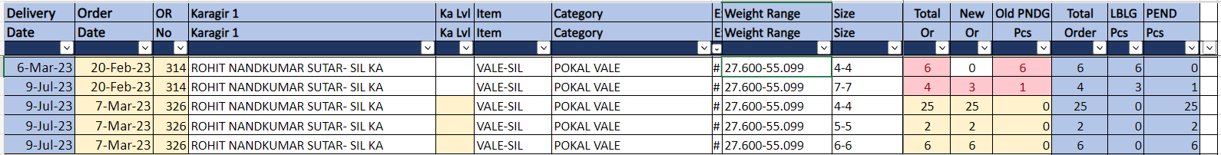

Fig: Current pending pcs order report

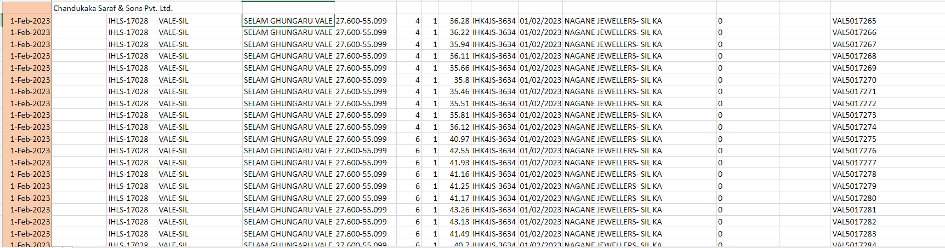

Fig: labeling pcs sheet

1. **GRAPHICAL REPRESENTATION**

Upload labeling file

**Display PO report and export**

Display in grid & view action

Upload excel file

Update cancel pcs count

Update accepted pcs count

1. **PROPOSED SYSTEM**

Step 1. In Connect us -> inventory, we have to create new menu as ‘Pending order’ module.

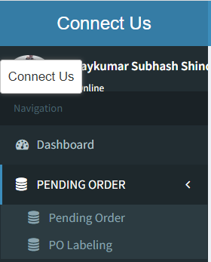

* 1. **Pending order**

Through pending order user will upload the excel file which contains the details of orders that is given for Karagirs as per SCM code. It will have following fields:

* Bulk upload format
* Upload file
* View action
* History action
* Edit action
* PO date
* PO no.
* Vendor name
* Created at
* Created by
* Updated at
* Updated by

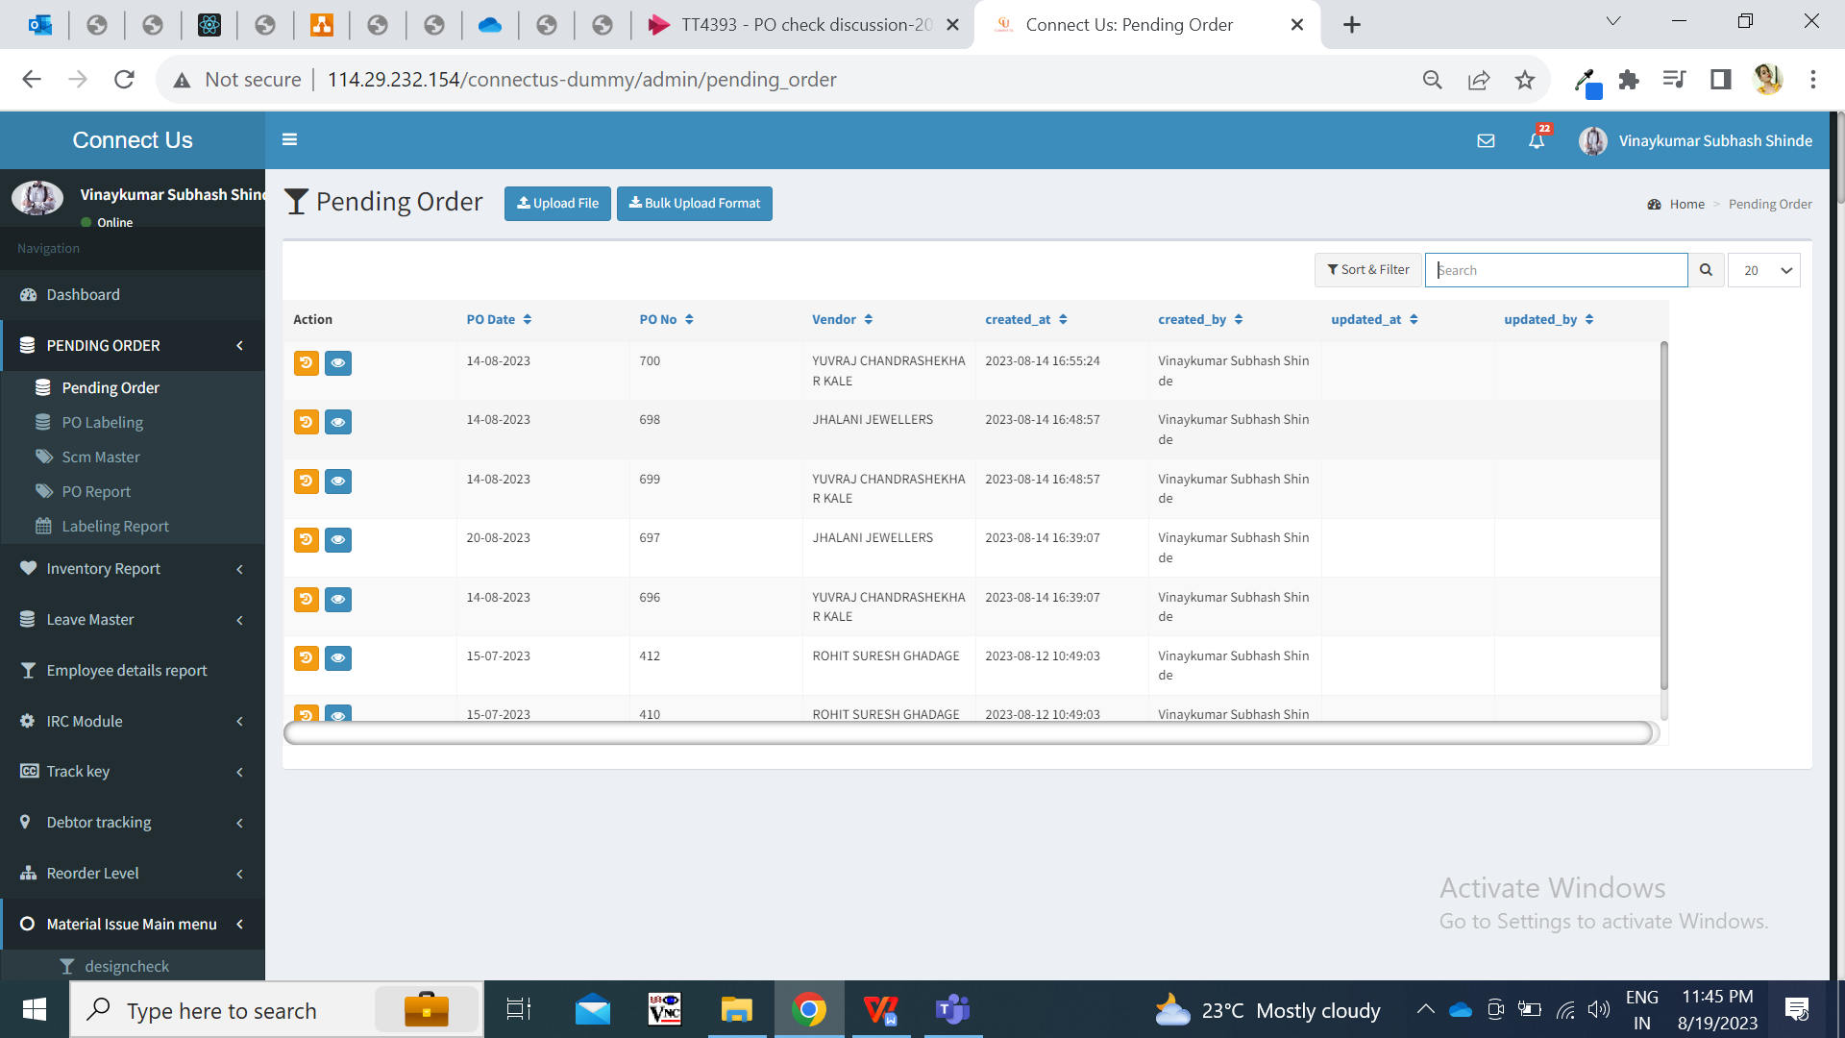

All the values in each column of grid will be displayed once file is uploaded through ‘upload file’ button.

Once user clicks on bulk upload format, excel file will be downloaded which will have following columns:

* Delivery date
* Order date
* Order no.
* Karagir
* Item category
* Exact wt
* Weight range
* Size range
* New order

|  |  |
| --- | --- |
| **FIELDS** | **DESCRIPTION** |
| Delivery Date | User will enter the delivery date on which the items will be delivered of particular SCM from karagir.  Delivery date will always be dates prior to order date. |
| Order date | It will be the date on which the order is given to karagir for particular SCM. |
| Order no. | As each order is divided and given to Karagirs, then purchase order number will be mentioned here.  Purchase order can be same but delivery date or karagir name will be different in this case as we can divide one order &assign to multiple karagirs. |
| karagir | User will mention the name of the karagir to whom the order is given. |
| Item | User will mention the name of the item from padm -> item master. |
| category | User will mention the name of the category of selected item from padm. |
| Exact wt | User will mention the exact wt of the item - category that order has been placed for.  (User enters the exact wt, weight range and size range from padm -> enter SCM in menu -> define scm entry -> enter one particular item name and click on ok.) |
| Weight range | User will mention the weight range of the item - category that order has been placed for.  (User enters the exact wt, weight range and size range from padm -> enter SCM in menu -> define scm entry -> enter one particular item name and click on OK) |
| Size range | User will mention the exact wt of the item - category that order has been placed for.  (User enters the exact wt, weight range and size range from padm -> enter SCM in menu -> define scm entry -> enter one particular item name and click on OK.) |
| New order | User will enter the count of pcs that is to be ordered from the karagir for SCM. |

Once file is uploaded, then the collated data will be displayed as per Order date, order no and karagir name and SCM code. (order date, karagir name, SCM code and PO no is considered as one header).

For each new order, if scm code and karagir name is same, then the new order pcs will get added in the same existing order if delivery date is not different.

Through **view action** of each PO, details of that order will be displayed as below:

* delivery date
* total pcs ordered
* accepted pcs count
* Canceled pcs count
* Cancel action
* Table of canceled pcs details

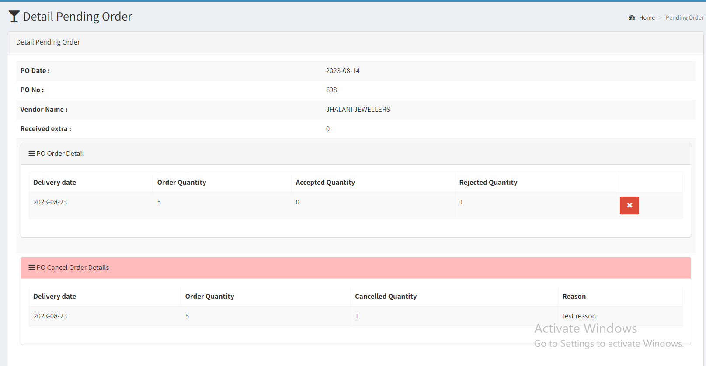

|  |  |
| --- | --- |
| **FIELDS** | **DESCRIPTION** |
| Delivery Date | Delivery date of scm code and karagir order will be displayed as per excel file which was uploaded. |
| Count of total pcs ordered | It will display the count of total pcs of order that has been given to karagir. It will be displayed as per uploaded excel file |
| Accepted pcs | Once pcs are being received from the karagir and labeling is done, then will be considered as accepted. As and when the labeling file is uploaded (step 2) for SCM category and karagir, the accepted pcs count will get updated here. |
| Canceled pcs | It will display the total pcs of order that have been canceled by the authorized user. |
| Cancel action button | This button will be provided based on authority.  Through cancel action, authorized user can cancel the entire order or few pcs from the order that has already been given to karagir. Once authorized user clicks on cancel button, it will display below fields:   * Cancel count * Cancel reason * Confirm button     Cancel count will be text field where user will mention the number of pcs that has to be canceled. If total order count = total accepted count, that means all pcs have been received and labeled. Then in such case, “cancel action button” should be disabled. Also, user should be able to cancel pcs out of total pcs ordered only.  Cancel reason - Once user mentions the cancel pcs count, then user will have to compulsorily mention the reason for cancellation in this text field.  Once user clicks on submit button, dialogue box should be displayed as “Are you sure you want to cancel?” Once user clicks yes, then the count of canceled pcs should be displayed in ‘canceled pcs’ field.  Canceled pcs count should get deducted from the total pcs orders and accordingly pending pcs count will be displayed in report. User can cancel the item pcs out of total order pcs only. However, if user has canceled any pcs and still those are being received and uploaded in po labeling I.e user definable report then those canceled pcs will be considered as extra and will be displayed in labeling report. |
| Table of canceled details | It will display details of canceled pcs in table having following columns:   * Delivery date * Order quantity * Canceled quantity * Reason * Canceled by * Canceled date and time |

* 1. **PO labeling**

PO labeling menu will have following fields:

* Upload file button
* View action
* ID
* Actual jama date
* Invert jama date
* Invert doc no.
* Vendor id
* Sub karagir id
* Created at & by
* Updated at & by

In upload button, user will upload PO labeling file from padm -> user definable reports (register). It contains data of each SCM category for which labelling is done at inventory which means that order is given by karagir and is available at us in inventory. User definable file has following columns:

* Order no
* Labeling no
* Item
* Category
* Weight range
* Size
* Pcs
* Net wt
* Lot no
* Labeling date
* Barcode no

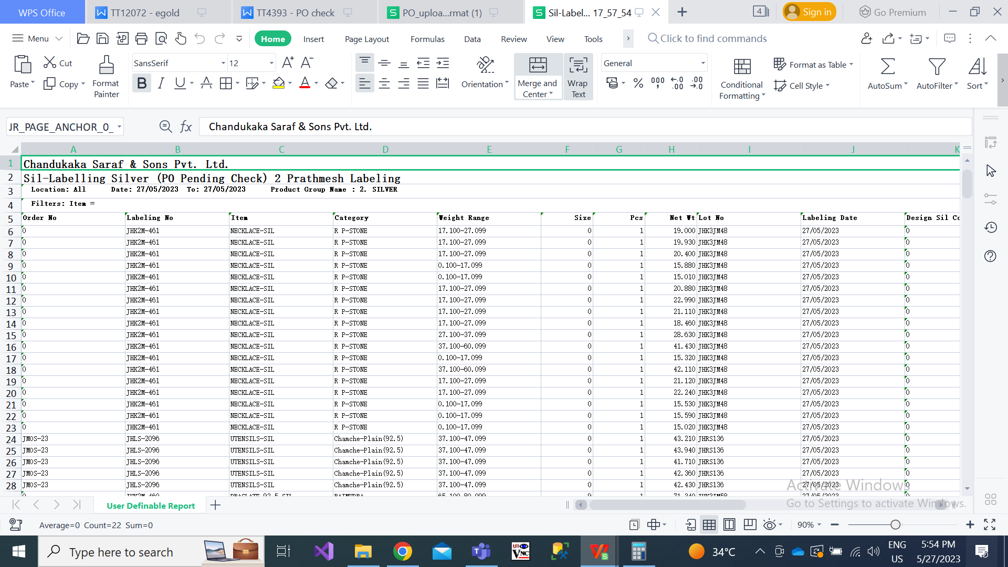

Here, it displays each SCM with 1 pcs count generally. Example, if order of 5 pcs is given to karagir 1 for 001 SCM code. Then, in labeling file it displays five rows of 001 SCM code with pcs count as 1 in each row. In some items, pcs count can be more than 2 like for example bangdi item.

In view action of this grid, it will display the details of each barcode that means each item which was in this order.

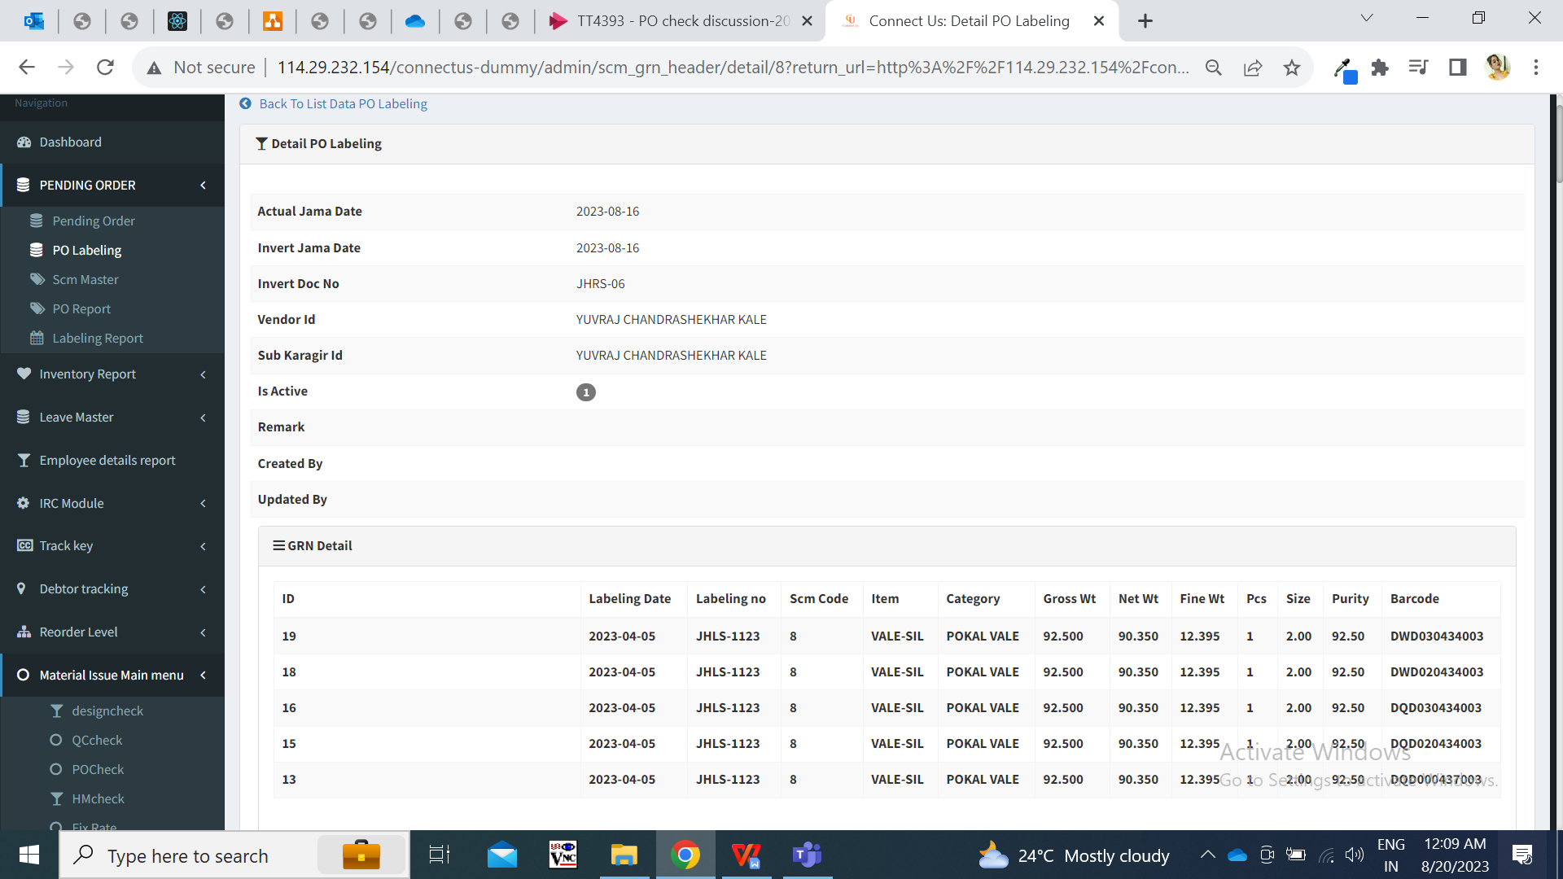

If labeling file is not uploading, then the same old labeling pcs count will be considered until labeling file isn’t uploaded.

* 1. **Labeling report**

Labeling report will display the count of pcs that are extra, that are Knocked off. Also, further through this report user can accept the extra pcs or return them to vendor.

It will display following fieds:

* From date
* To date
* Type - Extra / knocked off / accepted / returned to vendor
* Filter button
* Download button
* Reset button.

Here, user will select the duration (dates) from which user wants to view the details of the orders. Once user selects the type and clicks on filterbutton, then following fields will be displayed:

* View action
* Edit action
* Accept action (if extra type id selected while filter)
* Return to vendor action (if extra type id selected while filter)

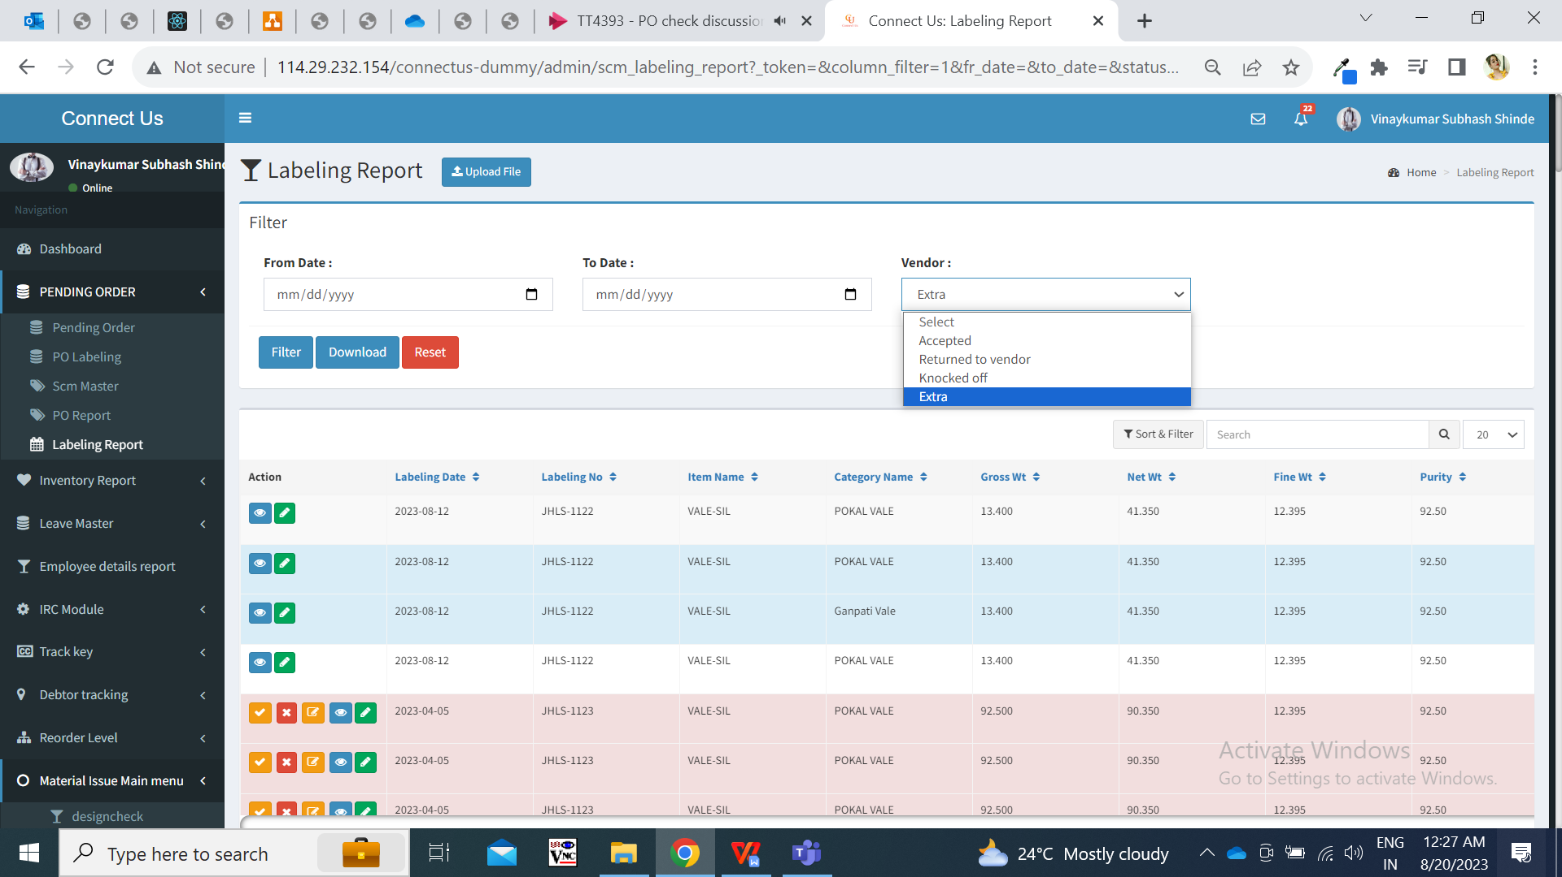

Through edit action, user can only change the category number. Once the category is changed then it will get knocked off against that order number - item - category - weight range - size range - karagir - purity and will be displayed in po labeling -> view action.

Extra pcs:- User can either accept the extra pcs or return to the vendor. Once the pcs are accepted, then it will be it will be knocked off with the order as per order number - item - category - weight range - size range - karagir - purity. Once pcs are accepted / returned to vendor then only edit and view action will be displayed against them.

Edit action:- User can only change the category name of the item. This is done when inventory has received item from different category and we are still adjusting and accepting it.

* 1. **PO report**

In PO report, it will display following fields:

* From date
* To date
* Filter button
* Reset button
* Export button

|  |  |  |  |
| --- | --- | --- | --- |
| **FIELDS** | **INPUT TYPE** | **MANDATORY/ OPTIONAL** | **DESCRIPTION** |
| From Date | Calender picker | Mandatory | User will select the order date from which the report is to be extracted. |
| To Date | Calender picker | Mandatory | User will select the order date till which the report is to be extracted. |
| Filter | click |  | Once user clicks on filter, the report will be displayed below and export button will be displayed.  Report will have following fields:   * Sr no. * Order no. * Order date * Delivery date * Karagir * Item * Category * Wt range * Size range * New order pcs * Old order pcs * Labeling pcs * Canceled pcs * Total order * Pending order |
| Export | Click |  | Export button will be display after user clicks on filter and data will be displayed.  Once user clicks on export button, excel file will be downloaded displaying data in following columns:   * Sr no. * Order date * Delivery date * Karagir * Item * Category * Wt range * Size range * New pcs * Old pcs * Labeling pcs * Canceled pcs * Total order * Pending order   Downloaded excel file name should be PO report followed by date. |

As per excel file uploaded in pending order menu for new order, following data should be displayed in the report:

|  |  |
| --- | --- |
| **FIELDS** | **INPUT TYPE** |
| Order no. | It will display the order as mentioned in excel file. |
| Order date | It should be displayed as mentioned in uploaded excel file for SCM code and karagir. |
| Delivery date | It should be displayed as mentioned in uploaded excel file for SCM code and karagir. |
| Karagir | It should be displayed as mentioned in uploaded excel file for SCM code and order no. |
| Item - category - wt range - size range | It should be displayed as mentioned in uploaded excel file for SCM code and karagir and order no. |
| New pcs | It will display new pcs count as and when excel file is uploaded for scm code and Karagir. |
| Old order pcs | It will display the old order pcs count until the new pcs of same scm code and karagir order is not given with different delivery date. |
| Total order | New order + old order = total order |
| Labeling pcs | It will display labeling pcs count as per labeling file uploaded in PO labeling menu which will have count as per SCM code and karagir. |
| Canceled pcs | As and when pcs are canceled by the user through cancel action on pending order menu, it will display cancel pcs count here as per SCM and karagir. |
| **Pending pcs** | **Total order - labeling order - canceled pcs = pending pcs**  **From these pending pcs, the inventory team and authorized person can analyse pending order of scm code and karagir and can further assign new orders to another karagir.** |

1. **TEST DATA**

PO labeling test data:-



1. **ODUS ( Open Discussed Unhanded scenarios )**

|  |  |  |  |  |
| --- | --- | --- | --- | --- |
| **Sr. No.** | **Topic** | **Priority**  **(High / medium / low)** | **Remark** | **Status**  **(Open/**  **Closed)** |
| 1 | If user clicks dates for report, then it will display report as per selected dates only. What to do in case any order is pending from back dates (before selected date in filter)  Report should be such that all back dated pending data till today’s date should be displayed. | high |  | Open |
| 2 |  |  |  |  |
| 3 |  |  |  |  |
|  |  |  |  |  |
|  |  |  |  |  |

1. **REFERENCES OF THE USERS**

|  |  |  |  |
| --- | --- | --- | --- |
| **User** | **Name** | **Mail** | **Contact number** |
| **Actual user** | Vinay shinde |  |  |
| **Ticket created by (if any)** | Tushar nikam | itinv@csjewellers.com |  |
| **Assigned business analyst** | Manali bhadirage | [Manali.bhadirage@techneai.com](mailto:Manali.bhadirage@techneai.com) |  |
| **Assigned developer** | Prathmesh shinde  Punam shinde | Prathmesh.shinde@techneai.com |  |
| **Assigned tester** | Priyanka dupargude | Priyanka.dupargude@techneai.com |  |