04.07.2023

AWS Image Rekognition

Manali Ashok Bhadirage

Manali.bhadirage@techneai.com

**Solution Design Document**

**CONTENTS**

1. INTRODUCTION 2

2. CUSTOMER OVERVIEW 2

3. SUMMARY OF EXISTING FUNCTIONALITY 2

4. REQUIREMENT DETAILS 2

5. PROJECT SCOPE 3

6. PROPOSED SOLUTION 3

I. List Of Technology Solution Used 3

II. Architecture 4

III. Low Level Design 8

IV. AWS Pricing Calculator 8

V. Sample Data 8

7. IMAPCT ANALYSIS 8

8. DELIVERABLES RACI MATRIX 9

9. TIMELINE 9

10. SUCCESS CRITERIA 9

11. CONFIDENTIALITY MEASURES ..........................................................................................................10

12. ODUS.................................................................................................................................................10

1. **INTRODUCTION**

The customer is in need of a service that allows them to upload images of items, with the expectation that the machine accurately presents the features associated with each item based on the uploaded image.

1. **CUSTOMER OVERVIEW**

Chandukaka Saraf & Sons Pvt. Ltd, a renowned jeweler in western India, has been dedicated to the art of crafting jewelry for over 196 years. Customer has built a legacy of ethical business practices since 1827, instilling trust among customers. The jewelry business encompasses various aspects such as inventory management, sales management, item and order tracking, finance management, etc. To streamline these operations, Chandukaka Saraf Jewelers utilize few applications that incorporate images and information about items.

1. **SUMMARY OF EXISTING FUNCTIONALITY**

The current process of manually specifying features of multiple images is time consuming. To address these challenges, we have recommended our customer to utilize a AWS machine learning (ML) service that automates repetitive tasks, enhances efficiency, enables precise and speedy image analysis, and ultimately boosts productivity.

1. **REQUIREMENT DETAILS**

We should have provision to upload the images as provided by customer. By using AWS APIs, we should be able to seamlessly execute critical tasks such as creating a custom model, labeling images, training the model, evaluating its performance, managing model versions, and performing inference. The utilization of these powerful AWS APIs will enable us to deliver robust image processing capabilities and meet the project's objectives effectively.

1. **PROJECT SCOPE**

The scope of the project include training custom models using labeled datasets and evaluating the model's performance to achieve the desired 95% and above accuracy level. Around 1K images will be uploaded by the customer on daily basis. If the attached image represents a piece of jewelry, the machine should exhibit the product group and its associated features.

1. **PROPOSED SOLUTION**
2. **List Of Technology Solution Used**

* Amazon S3

We need Amazon S3 to store and analyze large volume of media files with ease.

To begin the tasks, it is necessary to store project files (images) in an Amazon S3 bucket. The images intended for processing are uploaded to the Amazon S3 bucket. Subsequently, Amazon Rekognition service is employed to enable access for reading images from the S3 bucket. This facilitates the initiation of actual analysis tasks on the images. When utilizing API calls with Amazon Rekognition, you provide the input parameter of the S3 bucket location and file name. As a result, the Rekognition service accesses and analyzes the media files (images and manifest file) stored in the specified bucket.

* Amazon Rekognition custom labels

We will utilize Amazon Rekognition custom labels to train the model, following a structured process. The initial step involves creating the project, establishing training and test datasets, training the model, refining its performance, and evaluating its effectiveness.

For dataset creation, we have the flexibility to import images from either our local computer or our Amazon S3 bucket or manifest file. Alternatively, we can leverage an existing Amazon Rekognition custom labels dataset by making a copy.

During the training process, Amazon Rekognition custom labels will assess the performance of the trained model. In the event of unsuccessful model training, debugging information will be provided, while charges will only apply for successful model training. We consider the model training to be successful when it achieves an accuracy of 95% or higher.

* Amazon Rekognition custom labels console / SDK

We will train the model by using Amazon Rekognition Custom Labels console or SDK.

* Amazon SageMaker Ground Truth Job

By specifying an Amazon S3 bucket, Amazon Rekognition Custom Labels will be used to import SageMaker Ground Truth manifest files. The service encompasses support for a range of essential SageMaker Ground Truth tasks, including:

1. Image Classification: To classify images accurately by assigning them specific labels or classes.
2. Bounding Box: To define bounding boxes around objects or areas of interest within images, facilitating detailed analysis and extraction of valuable information.

By incorporating SageMaker Ground Truth tasks, the integration of Amazon Rekognition Custom Labels enables us to enhance its capabilities significantly. This integration offers a comprehensive solution for image classification and bounding box annotation, catering to our unique project requirements. We can leverage this powerful combination to achieve accurate image analysis and detailed object recognition, effectively supporting our specific needs. Bounding Box will be utilized to achieve intended accuracy when all features are not detected by machine by custom labeling.

* API

To utilize the Amazon Rekognition Custom Labels functionality, developers will leverage the existing Amazon Rekognition APIs. These APIs enable various key tasks such as creating a custom model, training the model, evaluating its performance, managing model versions, and performing inference. Additionally, once the model is successfully trained, developers will rely on the APIs to seamlessly integrate Amazon Rekognition into customer’s applications and leverage its capabilities. These APIs provide the necessary programmatic interface to interact with Amazon Rekognition and incorporate its functionalities into their software solutions.

Note:- The list of technologies mentioned in the PoC Demo serves as an initial reference point. However, as we progress with the actual PoC implementation and witness its functionality firsthand, we will gain a clearer understanding of the services and alternatives that best align with our requirements. This iterative process will allow us to make informed decisions and explore additional technologies that may enhance the PoC's effectiveness.

1. **Architecture**

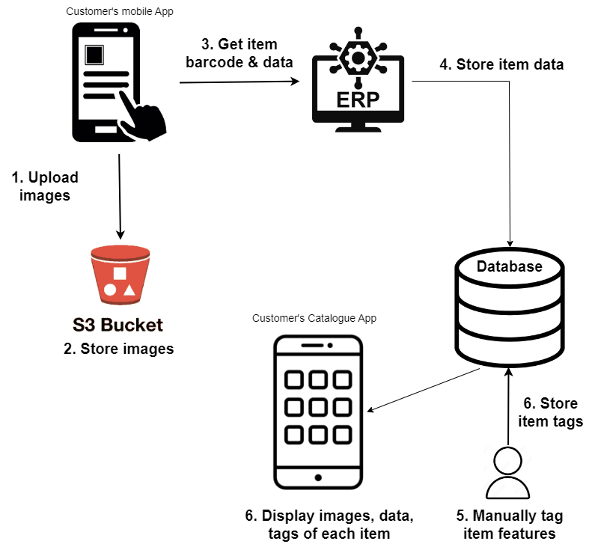

Fig: Customer’s current tagging process

The workflow involves several key steps: project creation, training and validation data set creation, model training, model evaluation, and endpoint creation. Once the model is deployed for inference, there might be a need to retrain it when new data becomes available or based on real-world feedback. To retrain the model, we will begin with bounding box labeling. Automating this entire workflow can significantly reduce manual effort and streamline the process.

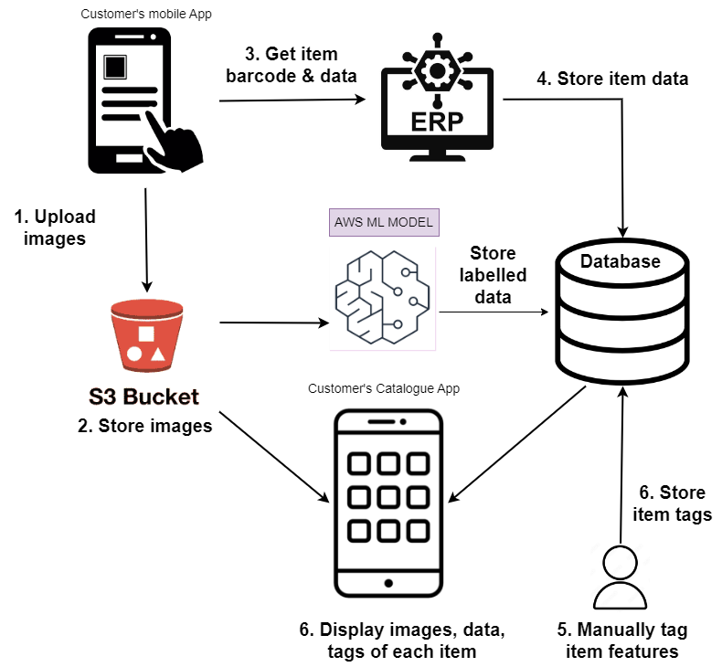

Fig: Planned process

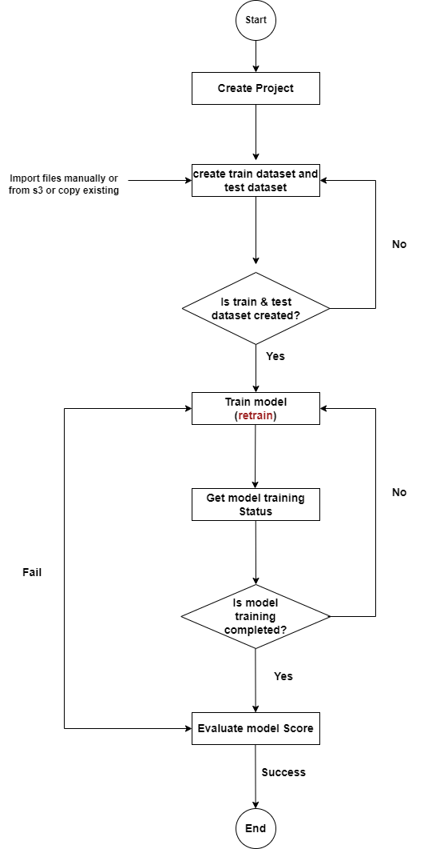

Fig: Workflow

1. **Low Level Design**

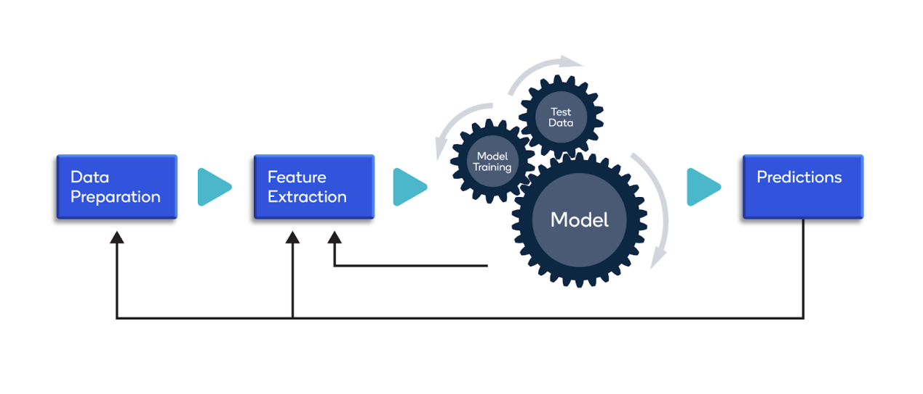

The workflow begins by creating the project. Simultaneously, we will create both the training dataset and the test dataset. These datasets will be accompanied by detailed descriptions. Once the datasets and their descriptions are prepared, we will initiate the model training process and monitor its progress. Once the model training is finished, we will evaluate its performance based on predefined metrics.

1. **AWS Pricing Calculator**

Upon completion of the PoC, we will have a comprehensive understanding of the precise services needed to fulfill our project requirements. Subsequently, we can compile the definitive list of required services and attach the pricing calculator once all the services are finalized. This approach ensures that our service selection is based on real-world insights, leading to a more accurate estimation of costs and a well-informed decision-making process.

1. **Sample Data**



1. **IMAPCT ANALYSIS**

By **automating** the analysis and interpretation of images with a **high accuracy** threshold of 95% or more, the implementation of Amazon Rekognition will significantly **enhance efficiency and productivity**, reducing the reliance on manual intervention for customer.

Through the analysis of image data, Amazon Rekognition can offer **valuable insights** to customer that can drive informed decision-making and support business intelligence efforts. Additionally, the service facilitates image-based search functionality and enables visual data exploration, allowing our customer to **uncover hidden patterns** and trends that might have otherwise remained unnoticed.

1. **DELIVERABLES RACI MATRIX**



1. **TIMELINE**

|  |  |  |
| --- | --- | --- |
| **Sr. No.** | **Task** | **Duration** |
| 1 | Data collection from customer & uploading manually on S3 bucket | 1 week |
| 2 | Custom labeling, training model and evaluate | 2 week |
| 3 | Tagging with bounding box, retrain model again and evaluate | 1.5 week |
| 4 | Custom code if accuracy isn’t met | 2 week |
| 5 | API integration with customer’s applications on success | 1.5 week |

The estimated timelines provided serve as a starting point, but the actual timeline will be determined once we commence the actual work. It is important to note that timelines are subject to revision as we progress and gain a deeper understanding of the project's intricacies. This flexibility allows us to adapt and refine the timeline based on real-time progress, ensuring a more realistic and achievable project schedule.

1. **SUCCESS CRITERIA**

**Accuracy**: The primary measure of success is the accuracy of the trained custom models. Success can be defined by achieving a specified accuracy threshold, such as **95%** or higher, in correctly classifying the objects and features of interest in images along with the **lesser time taken** to train the model.

|  |  |  |
| --- | --- | --- |
| **sr no.** | **Criteria** | **Status** |
| 1 | Accuracy of all images more than 95% | successful |
| 2 | Accuracy of each image more than 95% | successful |
| 3 | Accuracy of all images less than 95% | Unsuccessful and retrain |
| 4 | Accuracy of each image less than 95% | Unsuccessful and retrain |
| 5 | Accuracy of each feature in image more than 95% | successful |
| 6 | Accuracy of each feature in image less than 95% | Unsuccessful and retrain |

Customization: Success can also be measured based on the ease of creating **custom labels**, defining specific classes or attributes to be detected, and the **flexibility** to train models for different image analysis tasks.

Integration: The success of Amazon Rekognition Custom Labels can be gauged by its integration capabilities. The **seamless incorporation** of Amazon Rekognition Custom Labels into existing workflows and systems determines its overall success, enabling users to leverage the service's functionalities within their established frameworks and maximizing its value as a part of their broader ecosystem.

Furthermore, we will evaluate the **user experience, responsiveness of the service, and its real-world performance** to gauge its success. Monitoring the user experience will involve assessing the ease of use, availability of support, and overall satisfaction of users. Evaluating the responsiveness of the service will help ensure timely and efficient processing of image analysis tasks. Additionally, measuring the real-world performance and **impact on the business** will provide insights into the service's effectiveness in achieving desired outcomes and delivering tangible benefits to the organization.

1. **CONFIDENTIALITY MEASURES**

The document, project requirements, and shared images contain sensitive and confidential information. We trust that you will uphold the utmost level of confidentiality in handling these materials of our valued customer.

1. **ODUS ( Open Discussed Unhanded scenarios )**

|  |  |  |  |  |
| --- | --- | --- | --- | --- |
| **Sr. No.** | **Topic** | **Priority**  **(High / medium / low)** | **Remark** | **Status**  **(Open/**  **Closed)** |
| 1 | 05/07/2023 : Need list / types of machine learning algorithms used to train model | High | Deep learning based models in the back end. | Open |
| 2 |  |  |  |  |
| 3 |  |  |  |  |
|  |  |  |  |  |
|  |  |  |  |  |