Manali ashok bhadirage

Manali.bhadirage@techneai.com

20.09.2023

IMPS PAYMENT - IFSC CODE & ACCOUNT NUMBER VALIDATION

**Functional Requirement Document**

**CONTENTS**

1. TICKET DETAILS 2

2. VERSION CONTROL 2

3. APPROVALS 3

4. ESTIMATION 3

5. INTRODUCTION 3

6. BUSINESS REQUIREMENT 3

7. SCOPE 4

8. BUSINESS & SYSTEM RULES 4

9. ABBREVIATIONS & TERMS 4

10. EXISTING SYSTEM 4

11. GRAPHICAL REPRESENTATION 4

12. PROPOSED SYSTEM 5

13. TEST DATA & SCENARIOS 13

15. REFERENCES OF THE USERS 13

1. **TICKET DETAILS**

|  |  |
| --- | --- |
| **Ticket ID** | TT14060 |
| **Ticket description** | दिलेल्या फोटो प्रमाणे connect -us मध्ये कॅशियर लॉगिनला अकाउंट नंबर Hide करणे तसेच IFSC CODE ११ अंकी पाहिजे . |
| **Created by** | Firoj Shaikh |
| **Created on** | 12/07/2023 |
| **Priority** | Medium |

1. **VERSION CONTROL**

|  |  |  |  |  |
| --- | --- | --- | --- | --- |
| **Sr. No** | **Version no** | **Version Date** | **User name** | **User department** |
| **1** | **1.0** | **20/09/2023** | **Firoj Shaikh** |  |
|  |  |  |  |  |
|  |  |  |  |  |

1. **APPROVALS**

|  |  |  |
| --- | --- | --- |
| **Field** | **Name of the User** | **Approved date by the user** |
| **Actual User Name Actual User Department Organization Name** | Firoj Shaikh  Treasure  CSJ |  |
| **Assigned BA** | Manali Bhadirage |  |
| **Assigned Developer** |  |  |
| **Assigned Tester** |  |  |

1. **ESTIMATION**

|  |  |  |  |  |
| --- | --- | --- | --- | --- |
| **Department name** | **Estimated Time (In hr)** | **Scheduled Date (Starting date)** | **Estimated date** | **Actual delivery date** |
| **BA** |  |  |  |  |
| **Development** |  |  |  |  |
| **Testing** |  |  |  |  |
|  |  |  |  |  |

1. **INTRODUCTION**

IMPS payment, a sub-module in Connect US -> Bill Checking, is used during 12 URD purchase transactions done in Padm. The payments of URD purchases are processed through IMPS payment module i.e. we have to pay the mentioned payment amount to the customer. The user enters the document series number from Padm and the data as per document number gets displayed. Further these bills are assigned to another user. The authorized person verifies the bill and then changes the status hold / hold till audit / release / paid. Once payments status is changed to release then that bill gets displayed in list of download payment. Moreover, once user enters the bank file then the successful payments get displayed as paid in imps payment module.

1. **BUSINESS REQUIREMENT**

Currently, users (cashiers) are entering the account number and copy-pasting the same in confirm account number field without confirming it. IFSC code doesn’t have any validations.

|  |  |  |  |
| --- | --- | --- | --- |
| **Requirement ID** | **Requirement Name** | **Short Description** | **Priority** |
| BR001 | Decrypt account number field | Through add / edit action, once user enters the values in ‘account number’ field, we have to decrypt it (display asterisk when entered). | High |
| BR002 | IFSC code validation | In add / edit action, IFSC code field should accept only 11 digits valid format and display error message in case of incorrect format. | High |

1. **SCOPE**

While adding / editing the bill, when user enters account number, then it should be displayed in asterisk. User should not be able to copy asterisk value. IFSC code field should accept maximum 11 digits compulsorily. In case, user enters less than 11 digits, then it should display on field error message. Once bill is added by the entry user then it should be displayed in grid of the user to whom the bill is assigned to. Once bill is added then it should display all correct details in view action, grid and history action. Further, when assigned person clicks on edit action then all the details should be displayed correctly as it was entered by entry user while adding the bill.

1. **BUSINESS & SYSTEM RULES**

* User should be registered in the system.
* User should be logged in.
* User should not be able to copy value from account number field.
* IFSC code field should display on field error message in case of incorrect values.

1. **ABBREVIATIONS & TERMS**

IMPS - Immediate Payment Service

IFSC code - Indian financial system code

RTGS - Real time gross settlement

NEFT - national electronic fund transfer

1. **EXISTING SYSTEM**

As account number is visible in existing system, users (cashiers) are able to directly copy the account number and directly paste it in confirm account number field without verifying with the customer again. Hence, we need to decrypt account number field so that user will verify the account number again with customer while entering in ‘confirm account number’ field. Also, IFSC code is 11 digit alphanumeric code that is used for online fund transfer via NEFT, RTGS and IMPS. Hence, we need to apply validations to this field so that correct IFSC code of each bank will be entered by users to avoid any failed transactions.

1. **GRAPHICAL REPRESENTATION**

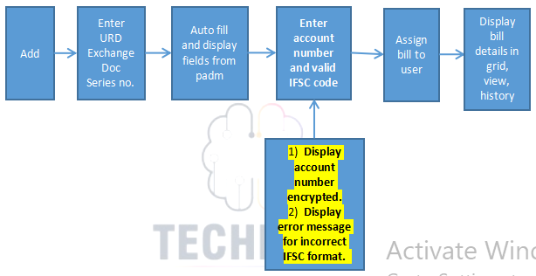

Fig: General context Diagram

1. **PROPOSED SYSTEM**

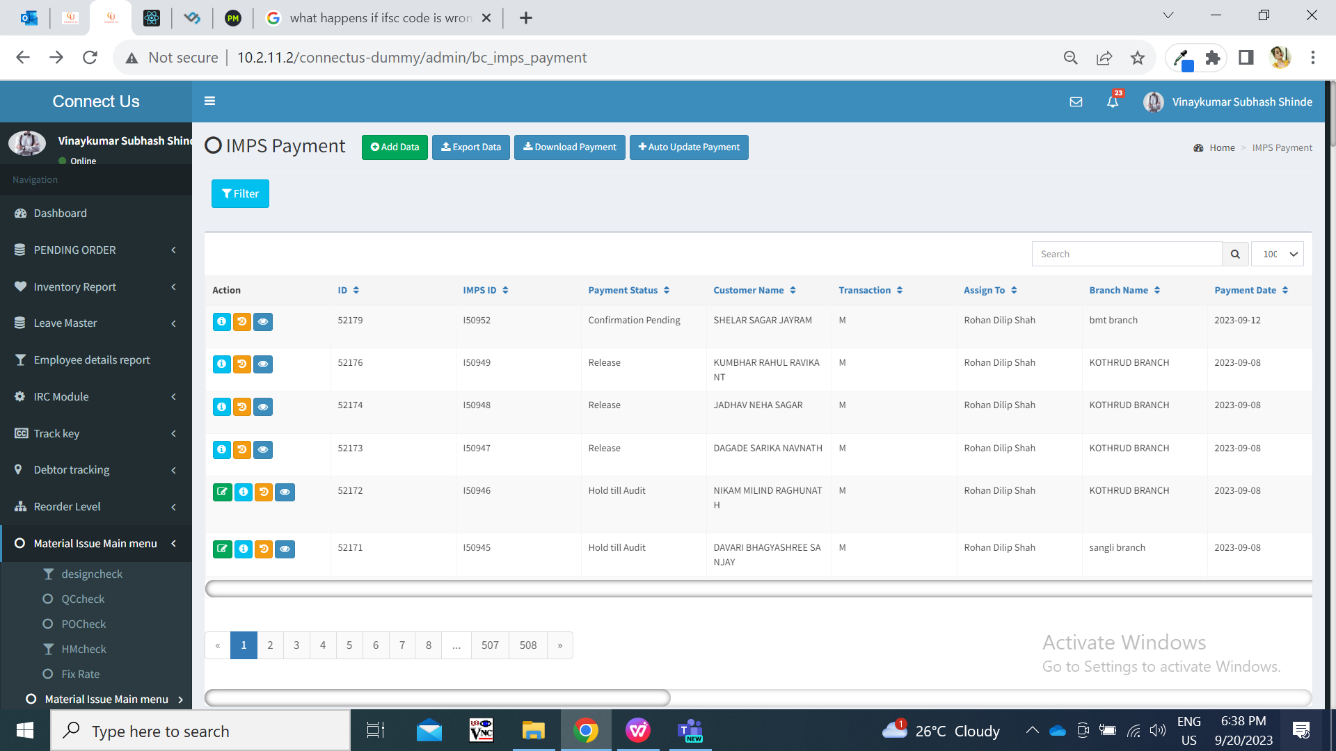

Fig: IMPS Payment menu

Once entry user clicks on **add button** to enterthe bill, it displays following fields:

* Series no. And search button
* Branch name
* Customer name
* Mobile no.
* Address
* Adjust amount
* Padm credit balance
* Payment amount
* Assign to
* Type
* Bank name
* Bank branch
* Ifsc code
* Account number
* Confirm account number
* Attachments
* Remark
* submit button

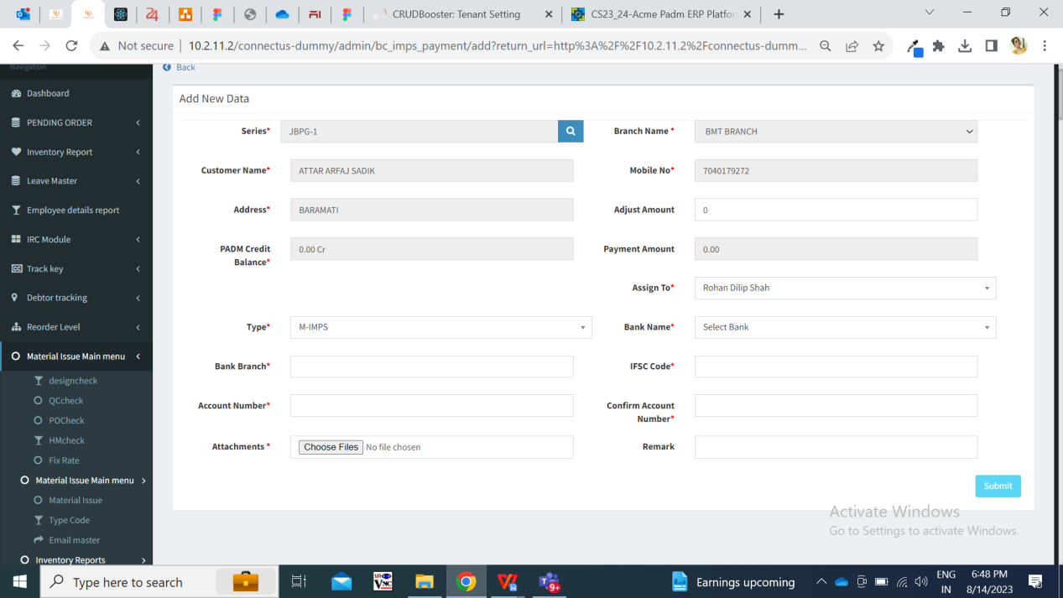

Fig: IMPS Payment -> add action

|  |  |  |  |
| --- | --- | --- | --- |
| **FIELDS** | **INPUT TYPE** | **MANDATORY/ OPTIONAL** | **DESCRIPTION** |
| Series number | text | Mandatory | User enters the document number from Padm -> document -> 12 Gold URD purchase. |
| Branch name | text | Mandatory | It displays the branch name of the logged in person who is adding bill. It displays the branch of logged in person as mentioned in employee master against that logged in person.  It will be read only. |
| Customer name | Text | Mandatory | Once user enters the document number, then it will pre-fill and display the customer name from number against entered series number from padm. |
| Mobile number | Text | Mandatory | Once user enters the document number, then it displays the mobile number of the customer from number against entered series number from padm. |
| Address | Text | Mandatory | Once user enters the document number, then it will pre-fill and display the address of the customer from number against entered series number from padm. |
| Adjust amount | Text | Optional | User manually enters the amount that is to be rounded off I.e. not to be considered for payment out of net payment. |
| Padm credit balance | Text | Mandatory | It will be read only.  iIt displays the net payment value as per entered series number. |
| Payment amount | Text | Mandatory | It will be read only.  Once document number is entered, it displays the value in net payment amount in this field.  Further, if any value is entered in adjust amount field, then it will calculate and display amount which is to be paid to the customer. Payment amount = padm credit balance - adjust amount |
| Assign to | Drop-down | Mandatory | It displays the name of the user to whom the bill is to be assigned. (currently we have only added Rohan shah name in the list as only this user is handling URD bills) |
| Type | Drop-dwon | Mandatory | By default it displays M- Imps from the list whereas user can change it from the drop-down.  It has RTGS, NEFT and M IMPS in the list. |
| Bank name | text | Mandatory | User will enter the customer’s bank name.  Validation: Maximum 30 digits / characters should be accepted. It shouldn’t accept space. |
| Bank branch | text | Mandatory | User will enter the customer’s bank branch name.  Validation: Maximum 25 digits / characters should be accepted. |
| IFSC code | text | Mandatory | User will enter the bank IFSC code.  Validation: Maximum 11 digits should be accepted. User shouldn’t be able to enter more than 11 digits. In case user enters less than 11 digits and submits bill, then it should display on field validation error message. |
| Account number | text | Mandatory | User will enter the customer’s bank account number.  As and when user enters the account number, each input should be displayed with asterisk. User should not be able to copy it.  Validation: Maximum 25 digits should be accepted. |
| Confirm account number | text | Mandatory | User will enter the customer’s bank account number as same as entered in above account number field.  Validation: Maximum 25 digits should be accepted. It should display on field error message if account number is not as same as account number field. |
| Attachments | Attach | Mandatory | User will attach the images of customer’s account document like passbook, cheque, purchase bill invoice, etc.  Validation: It should accept maximum 25 attachments. It should accept png, jpg, jpeg, pdf, doc, heic, webp file extensions only. |
| Remark | text | Optional | User will mention the additional comments in this section.  Validation: Maximum 250 chacacters / digits. |
| Submit | Click |  | Once bill is submitted, ID for bill will be created and bill will be displayed in the imps payment grid of the assigned person.  Also, it will be displayed in the logged in person’s grid as per branch assigned to him. |

Once bill is submitted, it gets display in the grid of the assigned user and in the grid of the users of their branch. Once bill is displayed in **grid**, it displays following columns in grid:

* View action
* Edit action
* History action
* Payment detail action
* ID
* IMPS ID
* Payment status
* Customer name
* Transaction
* Assigned to
* Branch name
* Payment date
* Customer account
* Series
* Payment amount
* Adjust amount
* IFSC code
* Bank name
* Entry user name
* Active
* Remark
* Entry time

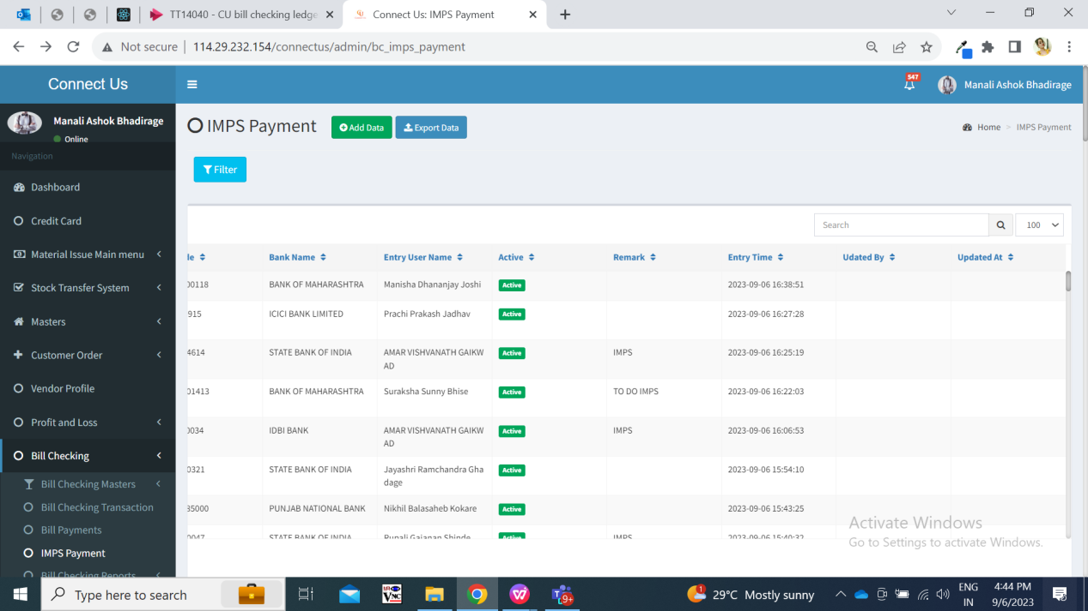

Fig: IMPS payment -> grid

Once data is added / edited, then updated data should be displayed in grid and view action of that bill. Once users click on **view** action, it displays following fields:

* IMPS ID
* Series
* Branch name
* Customer name
* Mobile no.
* Entry user
* Address
* Adjust amount
* Padm balance
* Payment amount
* Assign to
* Type
* Payment status
* Bank name
* Bank branch
* Ifsc code
* Account number
* Attachments
* Remark
* Is active
* Entry time
* Updated at & by

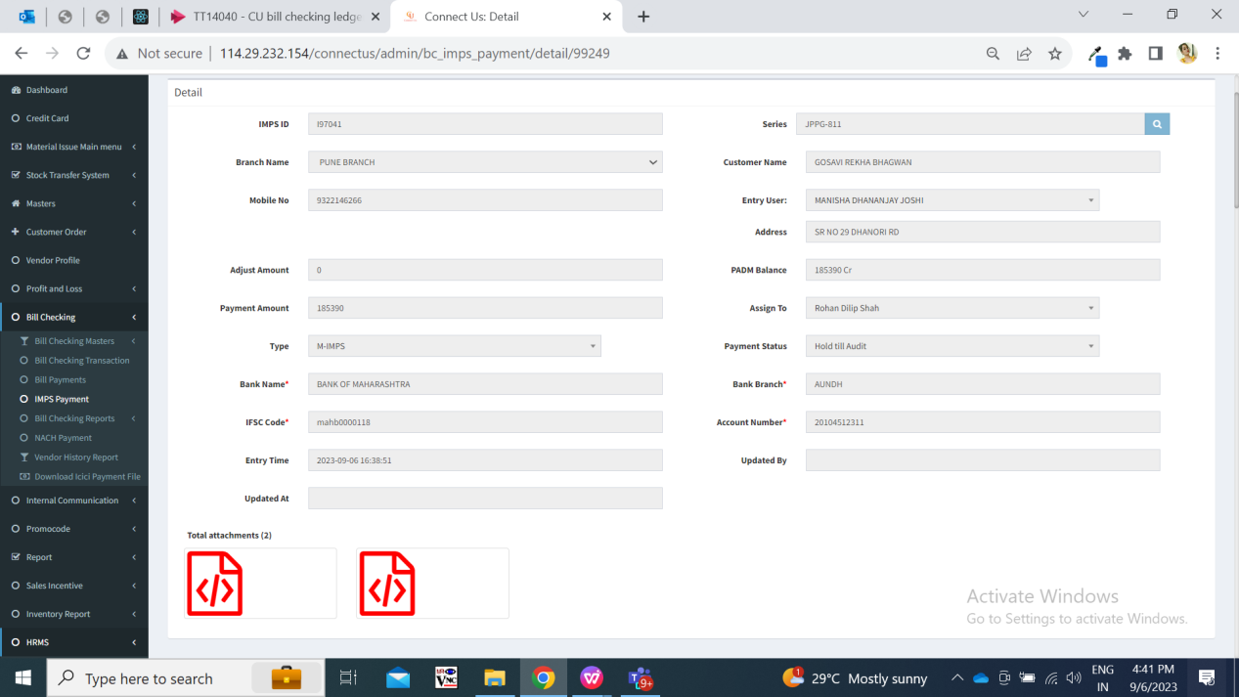

Fig: IMPS payment -> View bill

All the details will be displayed correctly as entered while adding the bill or when bill is edited and submitted.

Once assigned user clicks on **edit** action of the bill, it displays following pre-filled fields:

* IMPS ID
* Series
* Branch name
* Customer name
* Mobile no.
* Entry user
* Address
* Adjust amount
* Padm balance
* Payment amount
* Assign to
* Type
* Payment status
* Bank name
* Bank branch
* Ifsc code
* Account number
* Attachments (to attach)
* Delete / download already added attachments
* Remark
* Is active
* Submit button

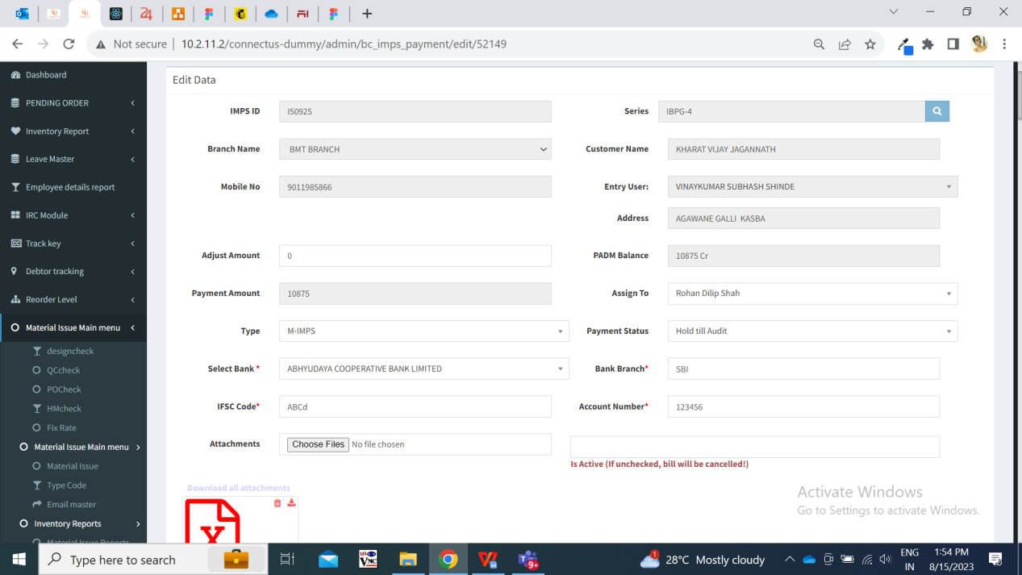

Fig: IMPS payment -> edit action

|  |  |  |  |
| --- | --- | --- | --- |
| IFSC code | text | Mandatory | User will enter the bank IFSC code.  Validation: Maximum 11 digits should be accepted. User shouldn’t be able to enter more than 11 digits. In case, user enters less than 11 digits and submits bill, then it should display on field validation error message as ‘Please enter valid IFSC code’. |
| Account number | text | Mandatory | User will enter the customer’s bank account number.  As and when user enters the account number, each input should be displayed with asterisk. User should not be able to copy it.  Validation: Maximum 25 digits should be accepted. |
| Confirm account number | text | Mandatory | User will enter the customer’s bank account number as same as entered in above account number field.  Validation: Maximum 25 digits should be accepted. It should display on field error message if account number is not as same as confirm account number field. |

1. **TEST DATA & SCENARIOS**



1. **ODUS ( Open Discussed Unhanded scenarios )**

|  |  |  |  |  |
| --- | --- | --- | --- | --- |
| **Sr. No.** | **Topic** | **Priority**  **(High / medium / low)** | **Remark** | **Status**  **(Open/**  **Closed)** |
| 1 | 20/09/2023 : Should user be able to view hidden account number? | Medium | Rohan shah: View action near account number is not required. Only asterisk is enough as we need user to confirm account number again from customer. | Closed |

1. **REFERENCES OF THE USERS**

|  |  |  |  |
| --- | --- | --- | --- |
| **User** | **Name** | **Mail** | **Contact number** |
| **Actual user** | Firoj shaikh | brpayment@csjewellers.com |  |
| **Ticket created by (if any)** | Firoj shaikh | brpayment@csjewellers.com |  |
| **Assigned business analyst** | Manali bhadirage | Manali.bhadirage@techneai.com |  |
| **Assigned developer** |  |  |  |
| **Assigned tester** | Vaishnavi khandwe | Vaishnavi.khandwe@techneai.com |  |