Gift voucher OTP for GTS scheme closure

22.06.2023

Manali Ashok Bhadirage

Manali.bhadirage@techneai.com

**Functional Requirement Document**

**CONTENTS**

1. TICKET DETAILS 2

2. VERSION CONTROL 2

3. APPROVALS 2

4. ESTIMATION 2

5. INTRODUCTION 3

6. BUSINESS REQUIREMENT 3

7. SCOPE 4

8. BUSINESS & SYSTEM RULES 4

9. ABBREVIATIONS & TERMS 4

10. EXISTING SYSTEM 5

11. GRAPHICAL REPRESENTATION 5

12. PROPOSED SYSTEM 5

12.1 Scheme closure verification 5

12.2 Scheme closure verification report 9

13. TEST DATA 14

15. REFERENCES OF THE USERS 15

1. **TICKET DETAILS**

|  |  |
| --- | --- |
| **Ticket ID** | TT13216 |
| **Ticket description** | Scheme Closer verification Madhye "Gift Voucher" La Unique Code Chi Authority Dene. |
| **Created by** | Jotiram pawar |
| **Created on** | 15/06/2023 |
| **Priority** | medium |

1. **VERSION CONTROL**

|  |  |  |  |  |
| --- | --- | --- | --- | --- |
| **Sr. No** | **Version no** | **Version Date** | **User name** | **User department** |
| **1** | **1.0** | **22/06/2023** | **Jotiram pawar** | **Stock audit team** |
|  |  |  |  |  |
|  |  |  |  |  |

1. **APPROVALS**

|  |  |  |
| --- | --- | --- |
| **Field** | **Name of the User** | **Approved date by the user** |
| **Actual User Name Actual User Department Organization Name** | Jotiram Pawar  Stock Audit team  CSJ |  |
| **Assigned BA** | Manali bhadirage |  |
| **Assigned Developer** | Punam shinde |  |
| **Assigned Tester** | Priyanka dupargude |  |

1. **ESTIMATION**

|  |  |  |  |  |
| --- | --- | --- | --- | --- |
| **Department name** | **Estimated Time (In hr)** | **Scheduled Date (Starting date)** | **Estimated date** | **Actual delivery date** |
| **BA** |  |  |  |  |
| **Development** |  |  |  |  |
| **Testing** |  |  |  |  |
|  |  |  |  |  |

1. **INTRODUCTION**

Through Connect Us -> scheme closure verification, users enter the order number of the GTS scheme of the customer and unique code gets generated and gets sent as a OTP to the customer’s registered number. It doesn’t accept the order number of the schemes which have got closed. It display’s error message as “Scheme is already closed”. Also, the report of unique codes which are sent to customer gets generated through CU -> scheme closure verification report.

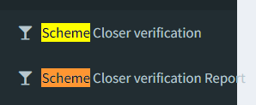

Fig: CU -> menu

GTS is a scheme of 10th months in customers pays the decided amount each month. When customer begins GTS scheme, it is processed through Padm -> document -> GTS plus new member. Once entry user enters details of the customer for opening GTS scheme and saves it, then order number gets generated for the GTS scheme for that customer and each month customer pays monthly installment against that generated order number. After 10th month tenure the scheme gets closed and customer purchases the gold out of the amount which was saved in GTS scheme + 1000 /- from CSPL. As per GTS scheme rule, after 10 months, if customer doesn’t purchase any jewellery till 360th day from date of commencement, then scheme will be dissolved and gift voucher as per calculated amount will be provided to customer.

Whenever gift voucher is generated, serial number gets generated to it and it is displayed in padm -> gift voucher bulk printing.

1. **BUSINESS REQUIREMENT**

Connect Us -> scheme closure verification doesn’t accept the order numbers of the schemes which have closed. So, it should accept the serial number of the gift vouchers.

|  |  |  |  |
| --- | --- | --- | --- |
| **Requirement ID** | **Requirement Name** | **Short Description** | **Priority** |
| BR001 | Serial no. | In Connect Us -> scheme closure verification, we need to add serial number field in add action, grid and report. It should accept serial number of gift vouchers from padm -> gift voucher bulk printing. | High |
| BR002 | Send message | Once serial number of gift voucher is entered, then as per message type selected SMS / Whats-app, the message of OTP should get sent to the customer . | High |
| BR003 | Display in grid | Once the message is submitted to customer, then unique code will be generated against gift voucher’s serial number and should be displayed in grid of Connect Us -> scheme closure verification. | medium |
| BR004 | Report | Once message of unique code is sent to customer, then it should get reflected in connect us -> scheme closure report. | medium |
| BR005 | Export report | The data as displayed in report of connect us -> scheme closure report should get exported in excel and displayed correctly. | medium |

1. **SCOPE**

Each serial number of the gift voucher has data of customer against it. From serial number; we can get customer’s mobile number, customer name, branch name and address in padm. The order no. field in Connect Us -> scheme closure verification should accept order number of GTS schemes which are open as well as serial number field will accept serial number of printed gift voucher.

1. **BUSINESS & SYSTEM RULES**

* User should be registered in the system.
* User should be logged in.
* System should display error message for incorrect details if entered.
* Order number field in Connect Us -> scheme closure verification should not accept order number of GTS scheme which has got closed. Serial number field should not accept order numbers of GTS scheme.
* Currently, we use pinnacle template to send SMS and whats-app analytic template to send whats-app message. The template may get changed each time as and when required.

1. **ABBREVIATIONS & TERMS**

CU - Connect Us.

GTS - Gold Tree Scheme.

SMS - Short Message Service.

1. **EXISTING SYSTEM**

In existing system Connect Us -> scheme closure verification doesn’t accept the order numbers of the schemes which have closed. Order number field in scheme closure verification module only accepts series-doc number of the GTS schemes which are ongoing.

1. **GRAPHICAL REPRESENTATION**

**Send OTP to customer’s mobile no. as available in Padm**

**Select message type: SMS / WhatsApp / manually**

**Enter Order number of GTS scheme / Serial number of gift voucher**

**Display unique code in grid & in report along with customer details against enetered serial no or order no.**

Fig: Context Diagram of scheme closure verification

1. **PROPOSED SYSTEM** 
   1. Scheme closure Verification

Through this menu, Cashier sends message of unique code to the customer. Once user clicks on add data, it displays following fields:

* Order number
* Serial number
* Message type
* Submit button
* Back Button

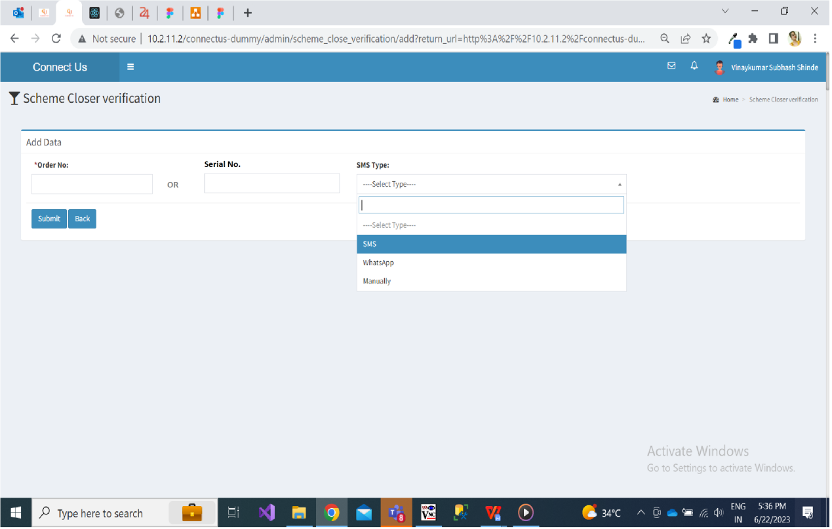

Fig: Add data of scheme closure verification to send message

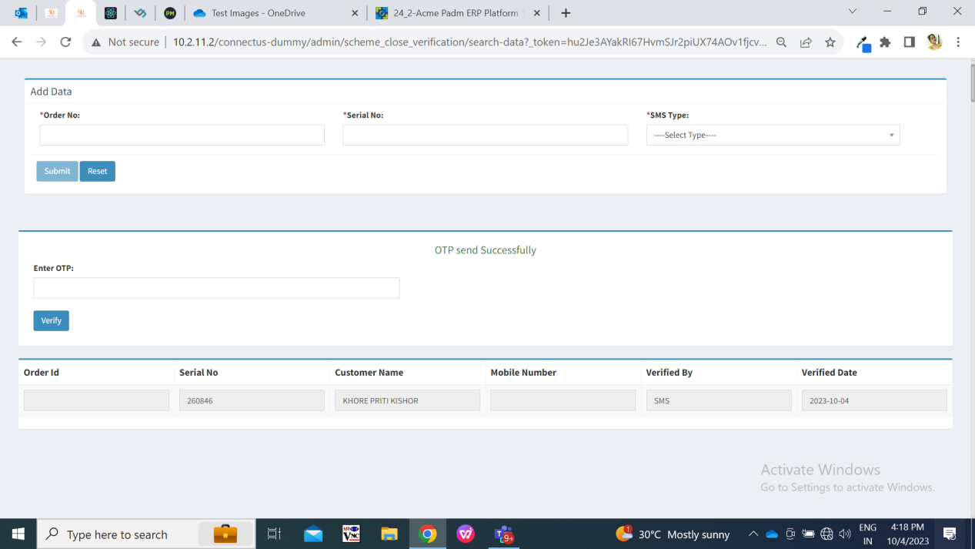

Fig: Verification after OTP is sent to customer’s mobile number

**Input table**

|  |  |  |  |
| --- | --- | --- | --- |
| **FIELDS** | **INPUT TYPE** | **MANDATORY/ OPTIONAL** | **DESCRIPTION** |
| Order no | text | Mandatory | In order number field, cashier enters the order number of the GTS scheme from padm. It is in format as Doc-series no.  If scheme is not closed then cashier will enter the order number. If scheme is closed, then cashier will enter serial number of gift voucher. |
| Serial no. | text | Mandatory | If scheme is not closed then cashier will enter the order number. If scheme is closed, then cashier will enter serial number of gift voucher. So, either order number is mandatory or else serial number is mandatory.  Pre-condition:- This field will be blank initially.  Post condition:- If user enters correct serial no. of gift voucher bulk printing -> printed, selects message type and clicks on submit then : A) message of OTP should get sent on the customer’s mobile number.  B) Successful message will be displayed as ‘OTP sent to the customer’s mobile number’.   1. Below that user will enter the OTP for verification. If OTP is correct then it will display successful message and direct user to grid page. Else, it will display error message to enter correct OTP. 2. The added serial no, its unique code and customer’s details should be displayed in scheme closure verification report.   Validation:- It should only accept numeric value. It shouldn’t accept space / characters / special characters. It should accept maximum 8 digits. It should accept serial number from padm -> gift voucher bulk printing -> **printed gift voucher only.** |
| Message type | Drop-down | Mandatory | Cashier will select the medium through which message of OTP should be sent to the customer.  Precondition:- Initially, it should be blank.  Post condition:- User will select either SMS / Whats-app / Manually from the drop-down. Once user enters serial number and message type and clicks on submit button then message of OTP will get sent to the customer’s mobile number via medium selected by cashier in message type.  Validation:- It will be single select. |
| Submit | Click |  | Precondition:- All mandatory fields should be filled.  Post condition:- Once user enters serial number and message type and clicks on submit button, then message of OTP should get sent to the customer’s mobile number via SMS / Whats-app whichever type was selected.  Against serial number, we have customer’s data in padm. It includes customer’s name, mobile number and branch name.  MicrosoftTeams-image (32)  Fig: Padm -> gift voucher bulk printing  Once successful message is displayed, then user will have to reenter the sent OTP for verification purpose. Once correct OTP is entered by the user in verification field, then user should be directed to grid page and the unique code should get generated for the recently made entry. Recently made entry should be displayed on top row of grid.  Also, if entered serial number already exist in grid, then when user clicks on submit button, then it should display message as “Record already exists”.  Validation:- Once button is clicked, then it should be disabled until successful message is displayed. |

Once OTP is sent to the customer, unique code should get generated for the recently made entry of serial number and it should be displayed in grid. Grid will have following columns:

* Id
* Unique code
* Order no
* Serial no
* Customer name
* Mobile no
* Branch name
* Message type - SMS / Whats-app / manually
* Verified by - Name of the employee who generated this entry and sent code to customer.
* Verified date and time

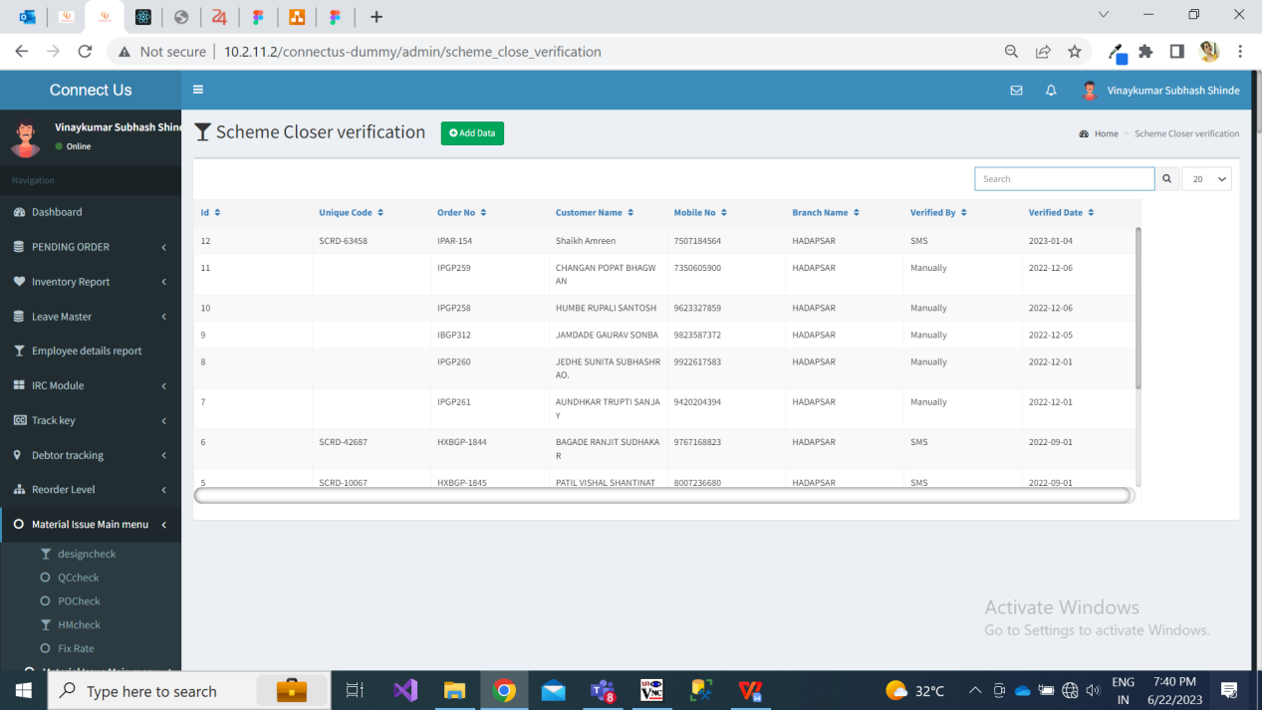

Fig: Scheme closure verification grid

* 1. Scheme closure verification report

Through scheme closure verification report menu, auditor can get report of OTP that has been sent to customer’s in specified duration. Once auditor clicks on scheme closure verification report, it will display following fields:

* From date
* To date
* Branch
* Submit button
* Reset button

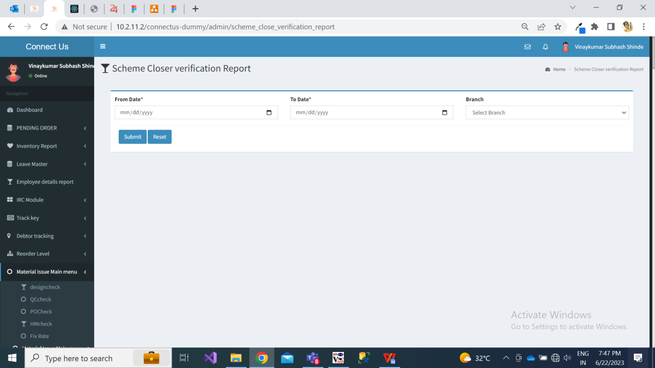

Fig: Scheme closure verification report

**Input table**

|  |  |  |  |
| --- | --- | --- | --- |
| **FIELDS** | **INPUT TYPE** | **MANDATORY/ OPTIONAL** | **DESCRIPTION** |
| From Date | Calendar picker | mandatory | Auditor will select the date from which he/she wish to get the data when OTP was sent to customer’s.  Precondition:- Initially this field will be blank.  Post condition:- Once user clicks on this field, then calendar should be displayed for auditor to select the date. Once date is selected from calendar picker, then it should fill the date in ‘From date field’.  Validation:- It should display dates till current date. |
| To Date | Calendar picker | mandatory | Auditor will select the date till which which he/she wish to get the data when OTP was sent to customer’s.  Precondition:- Initially this field will be blank.  Post condition:- Once user clicks on this field, then calendar should be displayed for auditor to select the date. Once date is selected from calendar picker, then it should fill the displayed the selected date in ‘To date field’.  Validation:- It should display dates till current date. |
| Branch | Drop-down | Optional | Auditor will select the branch of which he/she wants to view the data of OTP sent to customer’s. If auditor wants to view data of all branches then he/she will only have to selected dates and keep branch field blank, then it will display data of all branches.  Precondition:- Initially it will be blank.  Post condition:- If user doesn’t select any branch and clicks on submit button, then it will display details of all customer’s to whom the OTP was sent. If user selects any one of the branch and clicks on submit button, then it will display the data of the customers of selected branch only.  Validation:- It will be single select. It will display all active branches from branch master. |
| Submit | Click |  | Precondition:- From date and to date field should be selected.  Post condition:- Once user selects from date, to date and clicks on submit button, then it should display the details of the all customers to whom OTP was sent in selected duration.  Validation:- Once user clicks on submit button, then it will be disabled until report is displayed below. |
| Reset | click |  | Precondition:- Minimum one field should be selected.  Post condition:- Once auditor clicks on reset button, then it should clear all prefilled data in the fields.  Validation:- Once user clicks on reset button, then it will be disabled until all pre-filled fields get cleared. |

Once dates are selected and user clicks on submit button, it will display report in following columns and will have export button to export the report in .xls file:

* Sr. No.
* Unique code
* Order no
* Serial no
* Customer name
* Mobile no
* Branch name
* OTP
* Message type
* Verified by
* Verified date

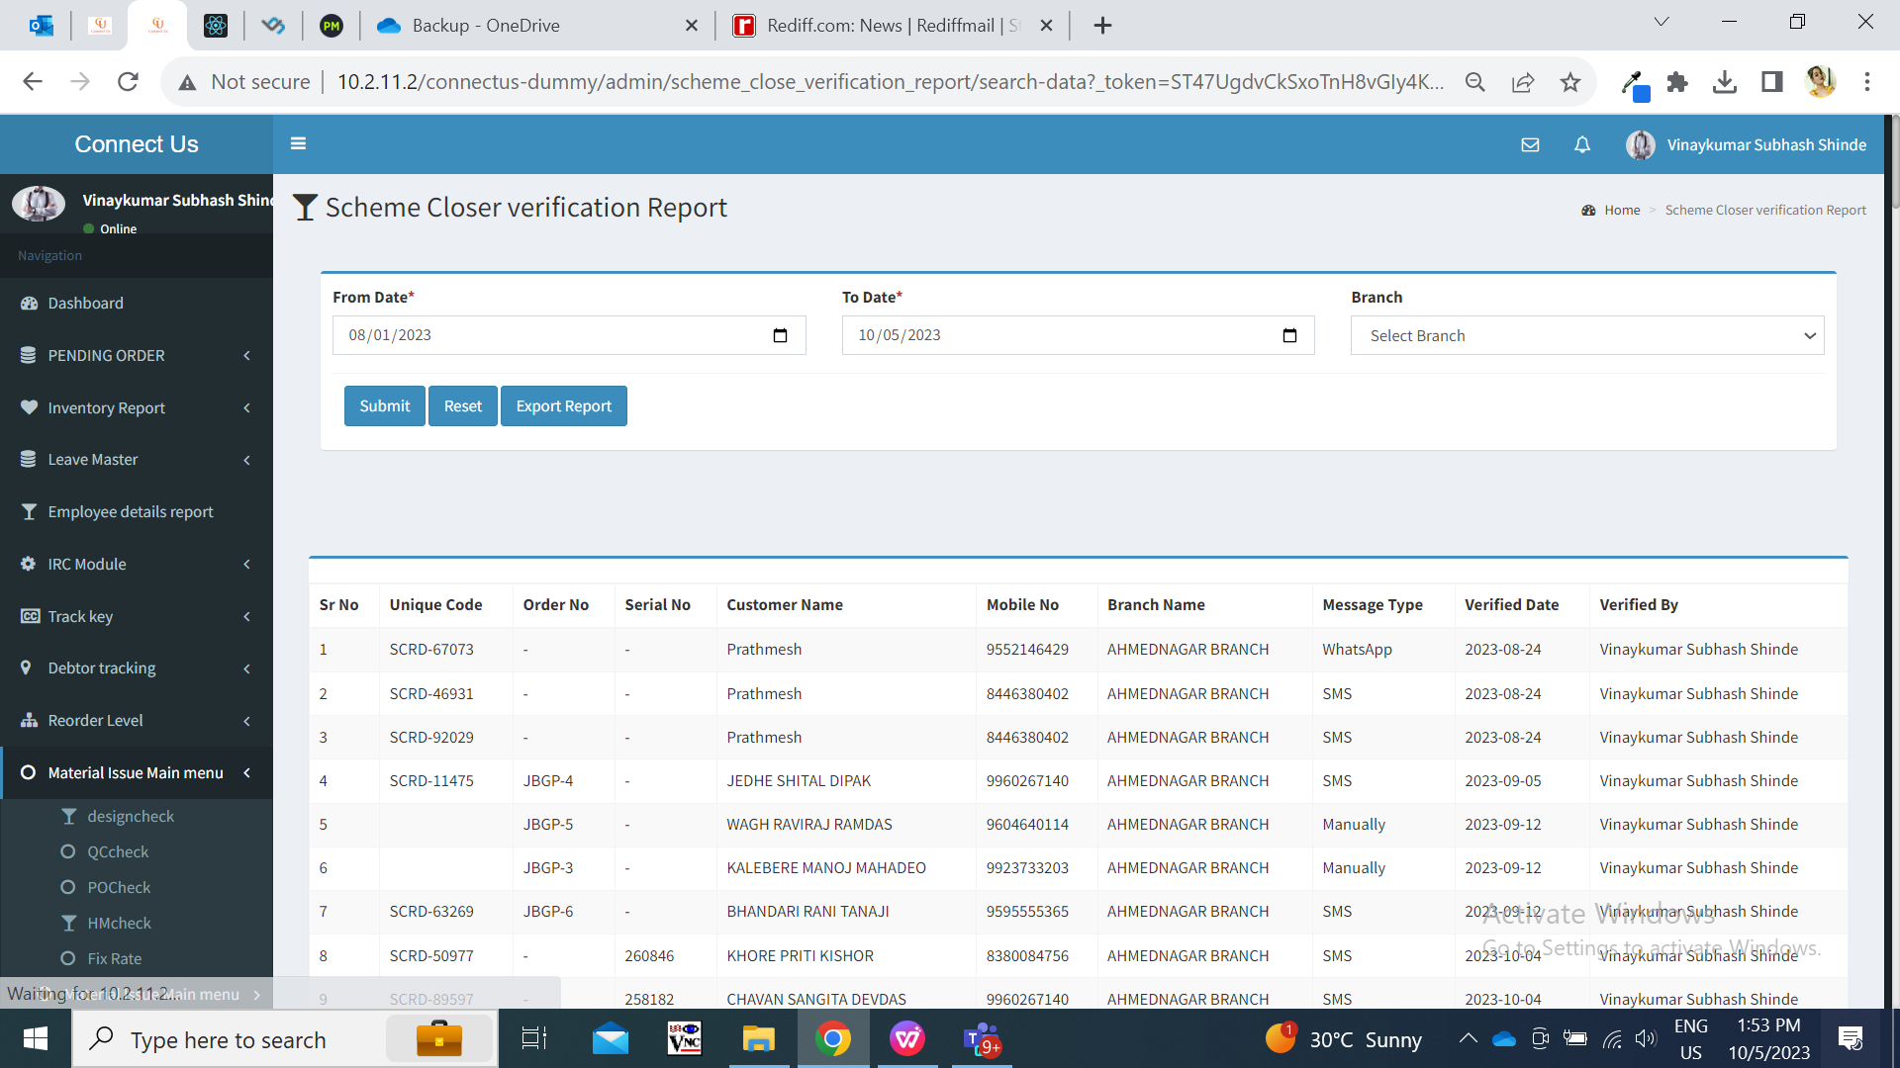

Fig: Scheme Closure verification report

Here, if order number was entered then serial number against that row will be displayed blank. Alternatively, if serial number was entered then order number against that row will be displayed blank.

Exported file will display data in following columns:

* Sr no.
* Unique code
* Order no
* Serial no
* Customer name
* Mobile no
* Branch name
* OTP
* Message type (SMS/ Whats-app / Manually)
* Verified by - ID and employee Name who generated this entry.
* Verified date

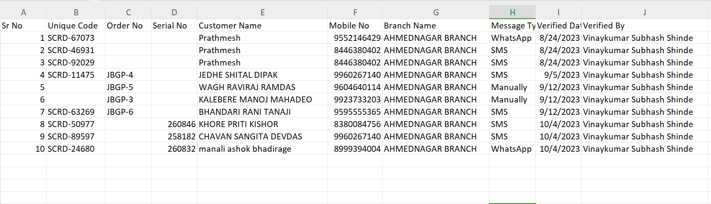

Here, if order number was entered then serial number against that row will be displayed blank. Alternatively, if serial number was entered then order number against that row will be displayed blank.

1. **TEST DATA**

Below is the data as per Padm, however do not send OTP to the mentioned customer’s number. Please change the mobile number in dummy of the customer and then test or else create new gift voucher with your own number and name in dummy and test if OTP is getting sent to your number or not. You can take contact numbers of our own employees only for testing.



1. **ODUS ( Open Discussed Unhanded scenarios )**

|  |  |  |  |  |
| --- | --- | --- | --- | --- |
| **Sr. No.** | **Topic** | **Priority**  **(High / medium / low)** | **Remark** | **Status**  **(Open/**  **Closed)** |
| 1 | 22/08/2023 : Printed and non printed serial number of gift voucher should be allowed or not? | Medium | Only **printed** gift voucher serial number should be accepted. Confirmed by Jotiram sir. | Closed |

1. **REFERENCES OF THE USERS**

|  |  |  |  |
| --- | --- | --- | --- |
| **User** | **Name** | **Mail** | **Contact number** |
| **Actual user** | Jotiram pawar | isa@csjewellers.com |  |
| **Ticket created by (if any)** | Jotiram pawar | isa@csjewellers.com |  |
| **Assigned business analyst** | Manali bhadirage | Manali.bhadirage@techneai.com |  |
| **Assigned developer** | Prathmesh shinde  Yogita jagtap | [Prathmesh.shinde@techneai.com](mailto:Prathmesh.shinde@techneai.com)  Yogita.jagtap@techneai.com |  |
| **Assigned tester** | Priyanka dupargude | Priyanka.dupargude@techneai.com |  |