10.08.2023

Tech Ticket App - Phase 1

Manali ashok bhadirage

Manali.bhadirage@techneai.com

**Handover Document**

**CONTENTS**

1. TICKET DETAILS 2

2. INTRODUCTION 2

3. BUSINESS REQUIREMENT 2

4. SCOPE 2

5. BUSINESS & SYSTEM RULES 2

6. ABBREVIATIONS & TERMS 3

7. EXISTING SYSTEM 3

8. GRAPHICAL REPRESENTATION 3

9. DEVELOPED SYSTEM 3

10. REFERENCES OF THE USERS 3

1. **TICKET DETAILS**

|  |  |
| --- | --- |
| **Ticket ID** | TT3711 |
| **Ticket description** | Ticketing system mobile application - Phase 1 |
| **Created by** | Mounika Annamneedi |
| **Created on** | 27/07/2022 |
| **Priority** | High |

1. **INTRODUCTION**

Tech Ticket is tool designed for planning & managing your projects by creating tickets. It is easy to use IT software for scheduling tasks of team under each ticket and thus further increasing productivity of each member.

We have developed user-friendly mobile application for tech ticket management, empowering users to log in and effortlessly access their assigned tasks. With the ability to conveniently pause and resume tasks at any point, users can have greater control over their workflow. Additionally, the application enables instant report extraction for quick and efficient progress tracking.

1. **BUSINESS REQUIREMENT**

In phase 1 of tech ticket mobile application, we developed following requirements:

|  |  |  |  |
| --- | --- | --- | --- |
| **Requirement ID** | **Requirement Name** | **Short Description** | **Priority** |
| BR001 | login | Users can log into the application using their already created username and password. User will be able to login using updated password each time if changed. | High |
| BR002 | Forgot password | User will be able to get code on his entered email address and set new password. | Medium |
| BR003 | Remember me | When user enters username, password and clicks on remember me button, then it will save it and when user logs out, then username and password field will be prefilled. | low |
| BR004 | Dashboard | Insights - We are displaying the doughnut chart which represents total tasks that are pending, in progress and completed in the current week.  Task list - We are displaying the tasks in today’s list, pending list, upcoming list that are being scheduled by the user from web app as per end date. | High |
| BR005 | Play and pause | User can play and pause the task from the task list in dashboard. | High |
| BR006 | Notification playlist | User can play and pause the task from the notification playlist. User can play and pause previous and next task as well as can shuffle the list between today’s list / pending list / upcoming list. | High |
| BR007 | Update Variance report | The task time which was played will be updated and reflected in variance report in web. | High |
| BR008 | Sign out | User should be able to close app and log out from the application. | Medium |

1. **SCOPE**

The current scope includes login, forgot password, displaying count and list of tasks correctly and playing and pausing the task from notification list as well as from dashboard.

Further, once the task is played from the web, then once you refresh the dashboard page of mobile application it will display which task is being played recently from web and the same will be reflected in notification playlist. Vice versa.

1. **BUSINESS & SYSTEM RULES**

* User should be registered in the system.
* System should display error message for incorrect details if entered.
* Only one task can be played at a time.
* Notification playlist will get cleared if you pause any task and close the mobile application.
* Notification will be displayed even if you have closed the task but task is in played state.
* All tasks ass added from web will get reflected in task list on dashboard of mobile application once you refresh the dashboard page or else close the app.
* Time for which the task was played will get updated and displayed on dashboard after the task is paused.
* Functionality will be same for all android versions however the UI of fire-base notification may differ.

1. **ABBREVIATIONS & TERMS**

NA

1. **EXISTING SYSTEM**

Currently, the tech ticket system is available as a web application tool, and there is no mobile application counterpart for users. Unfortunately, users cannot play and pause tasks conveniently from the web application. To address this limitation and enhance user flexibility, a mobile application for tech ticket management is proposed.

To make this more **convenient** for the users, we have developed mobile application which will enable users to play and pause tasks efficiently and **remotely at any time**. Users can receive **real-time updates** on the status of their tasks, including progress updates, estimated resolution times, and notification when the issue is resolved.

1. **GRAPHICAL REPRESENTATION**

Play task from dashboard

View details of task and task list

Log into mobile app using credentials

Create user in user master from web

Reset password if needed

Display it as played in notification list and dashboard

Display played time in dashboard of mobile app and variance report

Pause task from dashboard / web app / notification list

Fig: Phase 1 Context Diagram

1. **DEVELOPED SYSTEM** 
   1. **Login**

Registered user from web will be able to log into the mobile application. Login page will have following fields:

* Logo
* Username
* Password
* Remember me check-box
* Forgot password button
* Login button

|  |  |  |  |
| --- | --- | --- | --- |
| **FIELDS** | **INPUT TYPE** | **MANDATORY/ OPTIONAL** | **DESCRIPTION** |
| User name | text | Mandatory | User have to enter the user name as mentioned in the user master by the admin.  User can enter email address or username here. If entered email address has more than one users registered against it in the system, then it should display message to enter username.  Validation:- Max limit will be 25 characters. It shouldn’t accept space. It will be unique. |
| Password | Text | Mandatory | User will enter the password as provided by the admin.  It will have hide / expose button to view password or display it as encrypted.  Validation:- Maximum limit would be 25 characters. It shouldn’t accept space. |
| Login | Click |  | Precondition:- User should be registered.  Post condition:- Once user enters valid username and password, it will display successful message and direct user on dashboard page of application. In case of invalid user name and password, user won’t be able to log into the system.  Validation: login button should be disabled until user gets directed to dashboard page. |
| Remember me | Check box | Optional | This is to save the user name and password in the application, so that next time when user logs out and visits login page then it will pre-fill the recently saved username and password.  Validation: It will display only the recently saved password. Only one credentials are getting saved saved at a time. |
| Forgot password | Click | Optional | Through forgot password button, code will get sent to the user’s registered email address and then user can reset his password. The password of the account will get reset for which the email address is entered.  Once user clicks on forgot password button, it will direct to next page where user will enter email address on which code will be sent to the user.    Once user enters email and clicks on submit, code will be sent to the user’s email address. User will mention the correct code and will be able to further set new password.  Furthermore, after setting new password, user whose email address was entered for code, his account’s password will get updated. Thus, later user can log into the application using new password.  Validation: As few users have common email address but unique username, hence user name should be mandatory once user clicks on forgot password. |

* 1. **Dashboard**

Once user logs into the application successfully, it will display insights and task list on the dashboard.

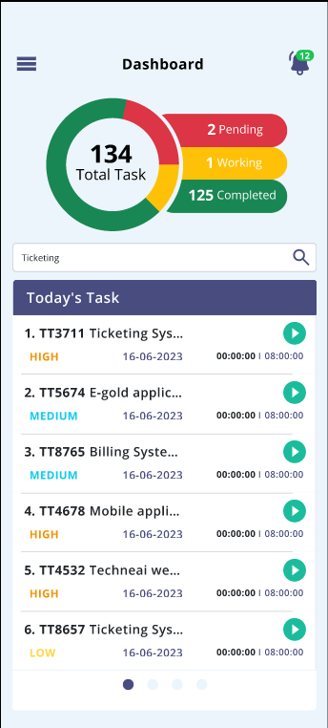

* **Insights**

It will display weekly analysis of tasks. It will display count of pending tasks of current week, pending tasks till now, upcoming tasks, completed tasks of current week and total tasks.

Total tasks = Pending + upcoming + in progress tasks + completed….. [provided none of the task is common]

These count will be updated and displayed as and when the tasks are added from my tickets -> task -> add task through tech ticket web.

If any task is being displayed in pending, today’s and current list then it will be counted as one tasks only and will be displayed as one in insights.

Tasks which are not played yet and has passed scheduled date, it will be displayed in pending list. Tasks which are in today’s list or upcoming list and are played even once, then it will be displayed in ‘in progress / working’ count. Tasks which are in upcoming list and not played even once, then it will be displayed in upcoming count.

* **Task list**

It will display the tasks in today’s list, pending list and upcoming list.

* Today’s tasks

It will display all the tasks whose start date is scheduled for the today’s date / current date. It will display following fields:

* Ticket ID - Task name
* Priority
* Date
* Task Played time
* Scheduled hours
* Play and pause button

All the details will be displayed as per task added by the user or any task that has been assigned to user by another person.

|  |  |  |  |
| --- | --- | --- | --- |
| **FIELDS** | **INPUT TYPE** | **MANDATORY/ OPTIONAL** | **DESCRIPTION** |
| Task Name | Text | Mandatory | It will display serial number, ticket ID and the task name when user adds the task from tech ticket web -> my tickets -> task -> add task.  Whenever task name is edited by the user from my tickets -> edit task, then it will be reflected on dashboard task list of web as well as mobile app.  In addition to this, whenever future tasks are added and being displayed in upcoming list, then it will be displayed in today’s task list when the current date arrives as per task schedule and it will not be displayed in upcoming task list.  If any task is not completed by today, then this task will be displayed in pending list from next day. |
| Priority | text | Mandatory | It will display high / medium / low priority as mentioned while adding the task. As and when task is edited and its priority is changed then its updated priority will be displayed on dashboard. |
| Date | Text | Mandatory | It will display today’s date as task is planned for today. (I.e end date of task)  Whenever task date is edited by the user from my tickets -> edit task, then it should be reflected on dashboard task list as well. |
| Task played time | Timer | Mandatory | It will be display the actual time that user has worked on the particular task in HH:MM:SS format.  Initially it will display 00:00:00 when task is added and not played. Further when user clicks on play button, then timer will be displayed. Once user clicks on pause button, then updated time will be displayed. This time will also be displayed in variance report for that task and user. |
| Scheduled hours | Time | Mandatory | It will display the total time that has been scheduled by user while adding the task in HH:MM:SS format.  Whenever scheduled hours is edited by the user from my tickets -> edit task, then it should be reflected on dashboard task list as well. |
| Play and pause | Click | Mandatory | Through this user will play the task when user is actually on working it.  Once play button is clicked, then timer will be displayed for that task. Once task is played from the dashboard / notification / manage task -> task of web, then it will display as paused in dashboard task list (web and mobile) as well as in manage task -> task of web.  Once user plays the task, then it will be displayed at top of that list.  In addition to this, notification of task list will be displayed and the task will be played. Once task is paused from the notification, then it will display as paused in dashboard task list as well as in manage task -> task of web.  Once task is marked as completed, then it will be removed from today’s task list of dashboard. |

* Pending tasks

If any task is scheduled for the dates till yesterday and are not being completed, then it will be displayed in pending task list. It will display following fields:

* Ticket ID - Task name
* Priority
* Date
* Task Played time
* Scheduled hours
* Play and pause button

In date field, it will display the date for which that task was scheduled. Once user plays the task, then it should be displayed in top of that list. Once task is marked as completed, then it will be removed from pending task list.

* Upcoming tasks

If any task is scheduled for the dates from tomorrow, then it will be displayed in upcoming task list. It will display following fields:

* Ticket ID - Task name
* Priority
* Date
* Task Played time
* Scheduled hours
* Play and pause button

In date field, it will display the date for which that task was scheduled. Once user plays the task, then it will be displayed in top of that list. Once task is marked as completed, then it will be removed from upcoming task list.

In addition to this, if start date and end date of task is such that task lies in pending, today’s and upcoming task list, then when user plays that task from any of the list then that task will get played from all three lists.

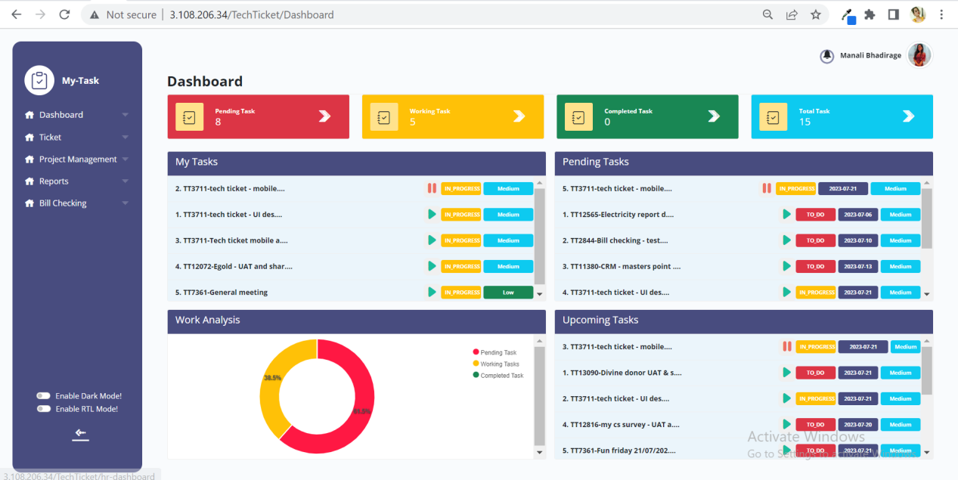

* Search button

Through search user can search the task from any of the three lists and can get directed to that list.

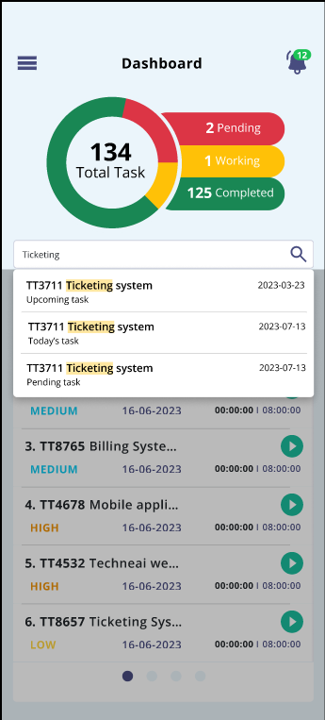

Once user enters task name or ticket id and if any task is available in any of the list - pending / today’s / upcoming, then it will display the relevant search results in the drop down. Further, once user clicks on the desired task from the search result, then user will be directed to that task list and that selected task will get highlighted.

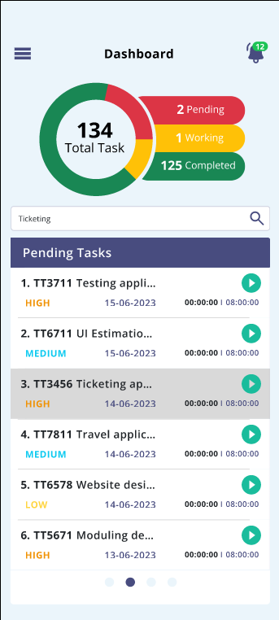

* 1. **Notification task play list**

Once user plays any particular task from manage task or from dashboard then task play list will be displayed in notification. It will display following fields:

* Task list name
* Ticket ID - Task name
* Task played time & Scheduled hours
* Play button
* Pause button
* Next button
* Previous button
* Shuffle button

|  |  |  |  |
| --- | --- | --- | --- |
| **FIELDS** | **INPUT TYPE** | **MANDATORY/ OPTIONAL** | **DESCRIPTION** |
| Task list name | text | Mandatory | It will display today’s task / pending task / upcoming task as per the task which is being played. |
| Ticket ID - task name | Text | Mandatory | It will display the ticket ID and the task name that is being played. |
| Play | Click |  | User should be able to play the task. Whereas if any task is being played from the dashboard or manage task -> task, then it should display the played tasks as played in the notification as well as in web. |
| Pause | Click |  | User should be able to pause the played task. Once task is paused, then updated timer should be displayed in dashboard as well as in variance report for that task. |
| Next | Click |  | When user clicks on next, then the next task of that task list should be displayed.  Further, suppose there are 10 tasks on today’s list and user has played first one. Then each time when user clicks on next button, then next task of today’s list will be displayed. Further, once user has reached to tenth task and clicks on next button, then it will go to first task again of today’s task list. |
| Shuffle | Click |  | User can shuffle entire task list from today’s task to pending task and to upcoming task.  User should be able to shuffle the list even when task from one of the list is played, however that played tasks should remain played I.e. shouldn’t get affected.  User can further also play and pause the task after shuffling the task list. |

Once the task is played from dashboard, then notification gets display regarding task played. However, the notification won’t get cleared until the played task is paused.

* 1. **Sign out**

User should be able to sign out from the application. Once user signs out, it will direct user to login page.

1. **REFERENCES OF THE USERS**

|  |  |  |  |
| --- | --- | --- | --- |
| **User** | **Name** | **Mail** | **Contact number** |
| **Actual user** | Manali Bhadirage | Manali.bhadirage@techneai.com |  |
| **Ticket created by (if any)** | Mounika Annamneedi | Mounika.annamneedi@techneai.com | 2966 |
| **Assigned business analyst** | Manali bhadirage | Manali.bhadirage@techneai.com | 2965 |
| **Assigned developer** | Prathmesh shinde  Goverdhan Bollu | [Prathmesh.shinde@techneai.com](mailto:Prathmesh.shinde@techneai.com)  Goverdhan.bollu@techneai.com |  |
| **Assigned tester** | Disha Jadhav  Preeti Bokade  Priyanka Dupargude  Vaishnavi Khandwe | [Disha.jadhav@techneai.com](mailto:Disha.jadhav@techneai.com)  [Preeti.bokade@techneai.com](mailto:Preeti.bokade@techneai.com)  [Priyanka.dupargude@techneai.com](mailto:Priyanka.dupargude@techneai.com)  Vaishnavi.khandwe@techneai.com |  |