26.04.2023

Customer Messages

Manali ashok bhadirage

Manali.bhadirage@techneai.com

**Functional Requirement Document**

**CONTENTS**

1. TICKET DETAILS 2

2. VERSION CONTROL 2

3. APPROVALS 2

4. ESTIMATION 3

5. INTRODUCTION 3

6. BUSINESS REQUIREMENT 3

7. SCOPE 4

8. BUSINESS & SYSTEM RULES 4

9. ABBREVIATIONS & TERMS 4

10. EXISTING SYSTEM 4

11. GRAPHICAL REPRESENTATION 4

12. PROPOSED SYSTEM 5

13. TEST DATA 25

14. ODUS 25

15. REFERENCES OF THE USERS 25

1. **TICKET DETAILS**

|  |  |
| --- | --- |
| **Ticket description** | Customer promotional SMS (point by pritam sir and gaurav sir). Point to be developed on separate connect us. Create data bank which will have data of customers from multiple sources like walk in, padm, d2d. Then sms should be sent to customers. Further response rate should be understood from the received cx responses. Analysis will be done for sales purpose. |
| **Created by** | Manali Bhadirage |
| **Created on** | 19/04/2023 |
| **Priority** | Very high |

1. **VERSION CONTROL**

|  |  |  |  |  |
| --- | --- | --- | --- | --- |
| **Sr. No** | **Version no** | **Version Date** | **User name** | **User department** |
| **1** | **1.0** | **19/04/2023** | **Pritam mehta** | **audit** |
| **2** | **1.1** | **27/04/2023** | **Pritam mehta** | **audit** |
| **3** | **1.2** | **26/05/2023** | **Gaurav Shaha** | **Project head** |
| **4** | **1.3** | **13/07/2023** | **Gaurav shaha** | **Project head** |

1. **APPROVALS**

|  |  |  |
| --- | --- | --- |
| **Field** | **Name of the User** | **Approved date by the user** |
| **Actual User Name Actual User Department Organization Name** | Pritam Mehta  Internal Audit  CSJ |  |
| **Assigned BA** | Manali bhadirage |  |
| **Assigned Developer** | Baliram Rajwad |  |
| **Assigned Tester** | Disha Jadhav  Priyanka Dupargude |  |

1. **ESTIMATION**

|  |  |  |  |  |
| --- | --- | --- | --- | --- |
| **Department name** | **Estimated Time (In hr)** | **Scheduled Date (Starting date)** | **Estimated date** | **Actual delivery date** |
| **BA** |  |  |  |  |
| **Development** |  |  |  |  |
| **Testing** |  |  |  |  |
|  |  |  |  |  |

1. **INTRODUCTION**

We are tasked with creating a new project called "Customer SMS campaign/CRM" within a separate Connect Us platform. This project will enable users to send various types of messages to customers, including promotional messages, transaction messages, registration and OTP messages, surveys, event registrations, and feedback requests. The project aims to facilitate sales tracking, monitor the quality of SMS based on customer responses, and generate relevant reports for analysis and insights.

1. **BUSINESS REQUIREMENT**

|  |  |  |  |
| --- | --- | --- | --- |
| **Requirement ID** | **Requirement Name** | **Short Description** | **Priority** |
| BR001 | Tenant master | As software will be user by multiple users of multiple tenant, admin will add new tenant and edit existing once in tenant master. | High |
| BR002 | User master | Each tenant will have multiple users and they will be added by super admin / admin through user master. | High |
| BR003 | Create databank | Custpmer data from multiple sources will be gathered and stored in databank for each tenant. | High |
| BR004 | Customer master | New customer will be added under each tenant in customer master. | High |
| BR005 | Role master | As each user will have multiple roles and access to the features and menus will be given as per role, the roles will be added in role master. | Medium |
| BR006 | Dynamic form fields & map customers | As customer master will be having predefined fields, whereas each tenant will have different definable fields. Those fields will be added by tenant admin through dynamic field master. This created field will be displayed in add and edit action of customer master for that tenant. | Medium |
| BR007 | Creating segment list | User will create the group of customers I.e. segment list for sending them messages. | High |
| BR008 | Creating campaign | User will create campaign, mention the message content and will send messages to the selected segment list. | High |
| BR009 | Generate report | Reports will be generated which will display the messages delivery rate, response rate of the customers for each campaign. | High |
| BR010 | Subscription | As per subscription taken by tenant, based on amount and monthly duration, we will provide limit of messages of SMS/ Email / whats-app. | Medium |
| BR011 | Nested messaging | Once message is sent to the customer and then if customer doesn’t respond or based on the response sent by the customer, the second message will automatically sent to the customer. | Medium |
| BR012 | Shorten URL and track links | If any link is sent via message then we have track which customer has clicked on the links. If any customer has clicked on the link, we get to know the customers interest and then can target customers accordingly for sending further messages. | Medium |

1. **SCOPE**

The software should be scale-able enough to add multiple tenants and users with different privilege roles. Based on subscription, users of each tenant should be able to send messages to their respective customers. One customer can be available in multiple tenants and hence super admin can have same customer data in customer master where tenant name will be different. Whenever new customer data gets added in any of the source of tenant, then automatically the new customer should get added and displayed in customer master of that tenant.

1. **BUSINESS & SYSTEM RULES**

* System should display error message for incorrect details if entered.
* System should pop up a message, if any issues in the system is detected.
* All forms should have on field validations. System should display on field errors in case of incorrect inputs.
* Multiple users can be added under one tenant and they can log into software on multiple systems at a time.

1. **ABBREVIATIONS & TERMS**

CRM - customer relationship management

Cx - Customer

1. **EXISTING SYSTEM**

There is no such existing system at Techne-AI of sending messages from our own tool. Currently, we are using whats-app analytic, pinnacle, Gupshup, etc. to send messages to customers. Whereas, we are unable to track if the messages were really got delivered to the customers and neither there is provision to analyze the campaign’s response rate.

1. **GRAPHICAL REPRESENTATION**

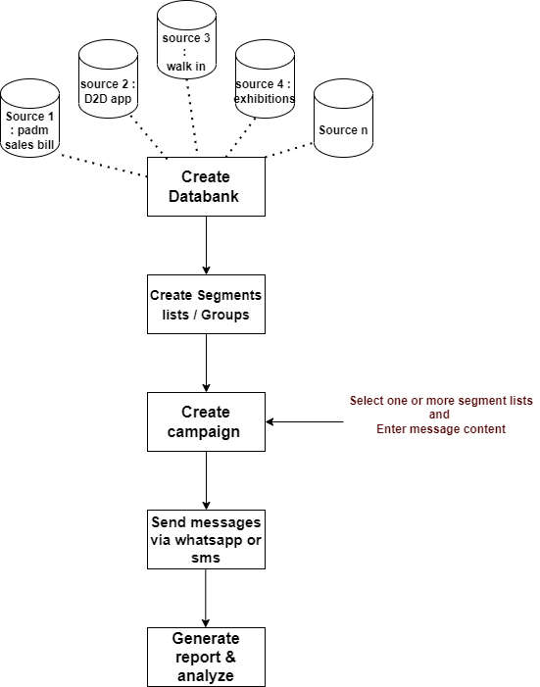

Fig: workflow

1. **PROPOSED SYSTEM**
2. **CREATE DATABANK**

We have to create databank for each tenant which will include multiple sources consisting information of the customers. List of sources include:

1. D2D
2. Padm sales bill
3. Bulk purchase (paid data from agencies)
4. Exhibition
5. CSJ website
6. Walk ins
7. GTS scheme

Once we have list of customers-> we will have to create following modules :

* Dashboard
* Masters
* Customer master
* Dynamic fields master
* Role master
* Tenant master
* Country - State - City master
* Subscription plans master
* Segment list
* Campaign
* Subscription and transactions
* Report
* User Management
* Menu management
* Settings
  1. **Tenant master**

Software will be used by multiple tenant and their respective multiple users. Tenant master will have following fields:

* Add tenant
* Edit action
* Tenant ID
* Tenant name
* Address
* Phone no.
* Email ID
* Status
* Create at & by
* Updated at & by

Once super admin clicks on ‘add tenant’ button, it will display following fields:

* Tenant name
* Mobile no.
* WhatsApp no.
* Email ID
* Address
* Country - State - City
* Logo Image
* GST no.
* PAN no.
* Aadhar no.
* Authority Name
* Authority contact no.
* Tenant Description
* Remark
* Status
  1. **Customer master**

Through each source, tenant will receive information of customers. Once admin / super admin clicks on customer master, it will display following fields:

* Add action
* Edit action
* View action
* Tenant name
* Customer ID
* Cx name
* Email id
* Contact number
* Status
* Created at & by
* Updated at & by

Once admin / super admin clicks on add button, it will display following fields in the form:

* Name
* Mobile no.
* WhatsApp no.
* Email address
* Address
* Pincode
* State
* City
* Gender
* Date of birth
* Age
* Date of anniversary
* Source(s)
* Branch location
* Profession
* Education
* DND
* Preferred media
* Aadhar no.
* PAN no.
* First purchase date
* Recent Purchase Date
* Preferred time to talk
* User definable fields
* Status
  1. **Dynamic fields master**

As we already have filled few fields in customer master as defined in database and code. However, we have to give provision to user to add fields from his end. User will add field and will map customer to that field. These fields will be used further by user while creating segment. Also, the created dynamic field should be displayed in add and edit action of customer for that tenant.

The main / grid page of dynamic fields master will have following fields:

* Add dynamic field
* Search button
* Edit action
* View action
* Map Customers
* Dynamic field name
* Data type
* Status
* Created at and by
* Updated at and by

Once user clicks on add dynamic field button, it will display following fields:

* Dynamic field name
* Data type
* Value
* Status
* Save button

|  |  |  |  |
| --- | --- | --- | --- |
| **FIELDS** | **INPUT TYPE** | **MANDATORY / OPTIONAL** | **DESCRIPTION** |
| Dynamic field name | Text | Mandatory | The dynamic field which is not in the customer master will be created by the tenant. The dynamic field created by the tenant should be displayed to that tenant only in add and edit action of customer master.  Validation: It should accept characters, special characters, numbers and space.  It should accept maximum 25 characters. It should be unique. |
| Data type | Drop-down | Mandatory | It will be display all possible data types like text, number, radio button, check box, drop-down, etc.  Validation: It will be single select. |
| Value |  | Mandatory | As per selected data type, the value will be displayed.  If data type selected is checkbox then tenant will specify the names of each checkbox. It will have add button to add more check-boxes and its associated name.  If data type is drop-down, then tenant will mention the list names. It will have add button to add more list in drop-down and its associated name.  If data type is radio button, then tenant will mention the name of the radio button options. It will have add button to add more radio buttons and its associated name.  If data type is text or number, then text field will be displayed and it will be blank. |
| Status | Radio button | Mandatory | It will display active or inactive.  Only active dynamic form fields should be displayed in the add and edit action of the customer master to that tenant.  Validation: By default it will be clicked on active. |
| Save | click |  | Once tenant creates dynamic form field, sets it data type, value and clicks on save button, then the created active dynamic field will be displayed in the add and edit action of the customer master to that tenant.  Further, if any dynamic field and its value was mentioned to the customer and later if that dynamic field was disabled, then disabled field shouldn’t be displayed in add action of customer master.  However, if any value was mentioned earlier to any customer then it should be displayed but shouldn’t be editable as the dynamic field itself is deactivated.  Furthermore, all the fields as in customer and dynamic fields which are created, it should be displayed while creating segment. |

Once the dynamic field is created, it will be displayed in add and edit action of customer master. For already created customers, the dynamic field will still be displayed in edit action whereas the data will be blank in it.

Through map customers button, user can map data into customer master -> created dynamic field by bulk upload or manually. Once user clicks on ‘map customers’ button, it will display following fields in grid:

* Bulk download format
* Bulk upload
* Dynamic Field Name
* Customer ID
* Customer Name
* Value

|  |  |  |  |
| --- | --- | --- | --- |
| **FIELDS** | **INPUT TYPE** | **MANDATORY / OPTIONAL** | **DESCRIPTION** |
| Bulk Upload | Click | Optional | Through bulk upload file, user can map values to multiple customers at a time. It will have following fields:   1. Dynamic Field Name 2. Customer ID 3. Customer Name 4. Value   Once user submits the bulk upload file, then the field name will get created in customer master add and edit action. Aldo, as per customer ID and customer name, the value will get added in that dynamic field for the existing customer.  In case of any incorrect data in bulk upload file, then value for correct customers should get added successfully whereas error file should display data for the incorrect values.  Once customers are mapped for the dynamic field, it will be displayed in the table. |

* 1. **Privilege Role Master**

One tenant can have multiple users with different roles. Through privilege role master, super admin can create multiple roles like admin, user, etc. and can give privilege to access menu / features as per roles. It will have following fields:

* Add action
* View action
* Edit action
* Privilege Role name
* Status
* Created at & by
* Updated at & by

Once user clicks on add action, it will display following fields:

* Privilege Role name
* Remark
* Status
* Privilege configuration
* Save button
* Reset button

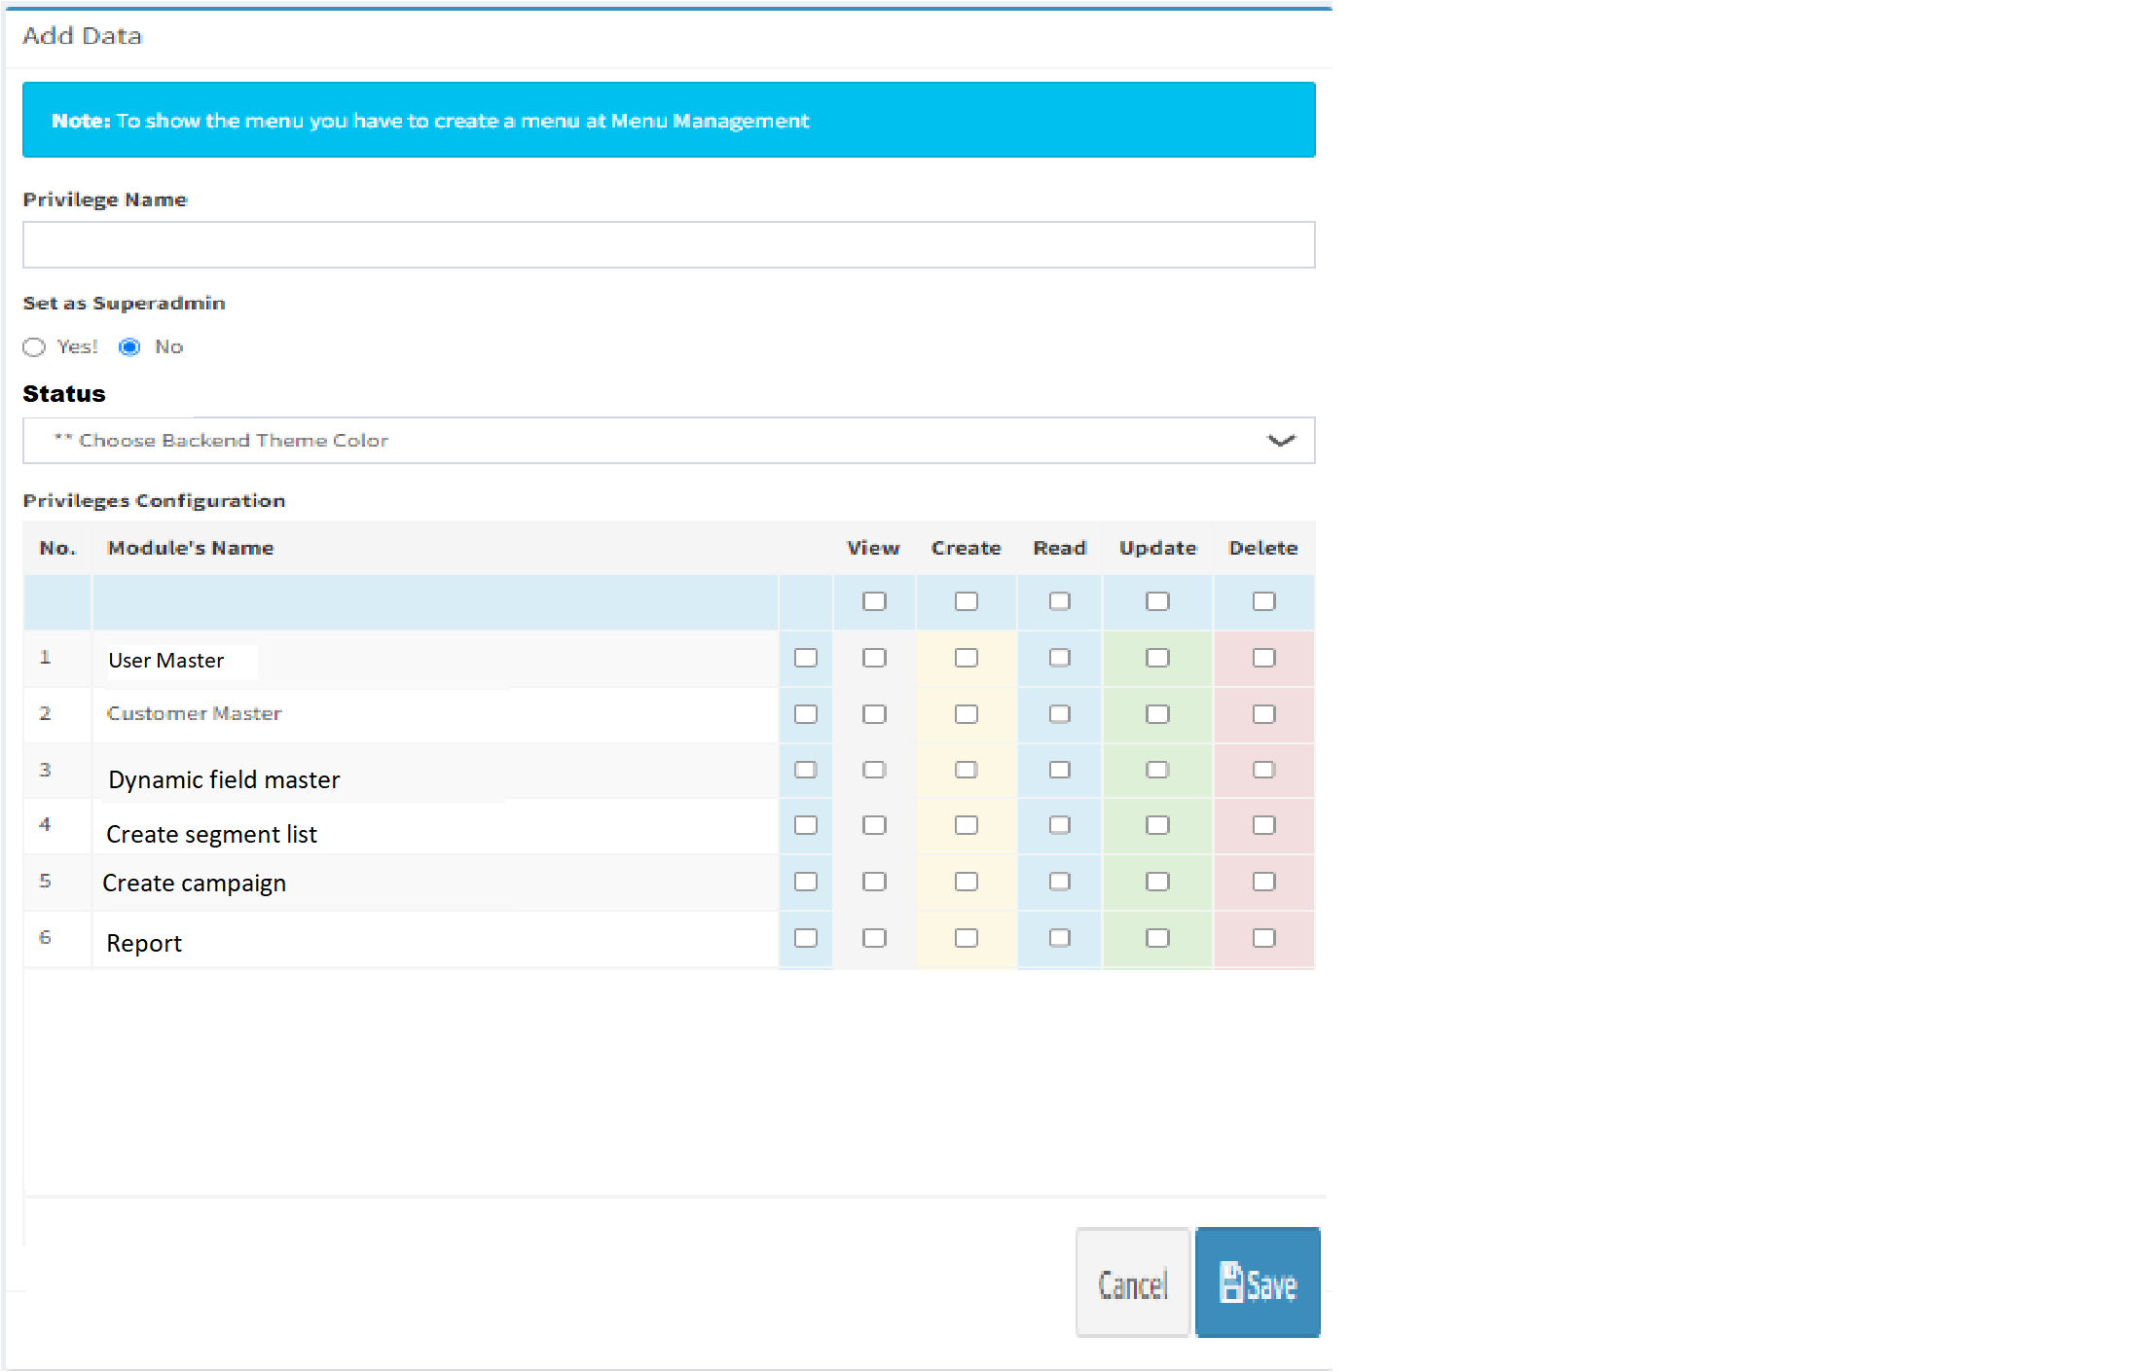

|  |  |  |  |
| --- | --- | --- | --- |
| **FIELDS** | **INPUT TYPE** | **MANDATORY / OPTIONAL** | **DESCRIPTION** |
| Privilege role name | Text | Mandatory | Super admin will mention the privilege role name. These roles will be assigned while creating user and as per role the user will have access to menus once user logs into the software.  Validation: It should accept characters, special characters, numbers and space.  It should accept maximum 25 characters. It should be unique. |
| Remark | text | Optional | Super admin will mention additional comments.  Validation: It should accept characters, special characters, numbers and space.  It should accept maximum 100 characters. |
| Status | Radio button | Mandatory | It will display active / inactive status. Only active privilege roles can be displayed in user master -> role drop-down.  Validation: By default it will be clicked on active option. |
| Privilege Configuration | Checkbox |  | It will display list of module created in the project. By checking on the check-box for each module, super admin defines that the particular created role will have access to the selected module.  Through edit action, all newly created as well as existing module names should be displayed here. |
| Save | Click |  | Once super admin creates role, selects module names and clicks on submit button then the whenever user is created and role is assigned to him, then that user will get access to modules as per his role. |

* 1. User master

Each tenant can have multiple users with different roles. When super admin adds the user, then super admin will have to select the tenant name. Whereas when admin of any particular tenant logs into the system and adds user, then tenant will be read only field for them.

It will have following fields:

* Add user
* Edit action
* View action
* Tenant name
* User ID
* User name
* Role
* Created at & by
* Updated at & by

Once super admin / admin clicks on add user button, it will display following fields:

* Tenant name
* User name
* Email address
* Contact no.
* Role
* Profile image
* Password
* Confirm password
* Save button
* Reset button

Once the user is created, then user will be able to log into the system using their email address and password. Once user logs into the system, menus and data will be displayed to the user as per privilege role and only about his tenant.

* 1. **Profile**

Each time when user logs into the software, it will display following fields in profile.

Tenant name

User ID

User Name

Role

Email address

Contact no.

Whats-app no.

Profile image

Change password - New password, confirm password

Save button

The details in the above fields will be displayed initially as added by the tenant admin / super admin while creating the user.

|  |  |
| --- | --- |
| **FIELD NAME** | **EDITABLE** |
| Tenant name | No |
| User id | no |
| User name | no |
| Role | no |
| Email address | yes |
| Contact no. | yes |
| Whats-app no. | yes |
| Profile image | yes |
| Change password - New password, confirm password | yes |

1. **CREATE SEGMENT LIST**

We will have to create menu as ‘Create segmented list’. Segmented list can be made based on customers who purchase the most, customers who participate in season events / offers, etc.

It will have following fields on main page:

* Create segment (button)
* Search menu
* Grid :-
* Sr. No.
* Action - view, edit
* Segment list name
* Total count of customers
* Status
* Created at & by
* Updated at & by

|  |  |
| --- | --- |
| **GRIED FIELDS** | **DESCRIPTION** |
| Create Segment list | Through this button, user can create new segment list and select customer list. |
| Search menu | User can search by segment list name, created by and updated by. |
| Sr. No. | I, grid, it should display the recently created segment list at top.  It should display sr. no. in decremented manner. |
| Action | In grid, it will have view and edit action buttons.  Through edit, user can edit the already created segment list.  Through view user can view the details of the created segment list. |
| Segment list name | In grid, it will display the name of the segment list created. |
| Total count of customers | It will display the total count of customers selected in the created segment list. |
| Created at & by | It will display the name and date & time when the segment list was created. |
| Updated at & by | It will display the name and date & time when the segment list was updated through edit action. |

Once user clicks on ‘create segment list’ button, it will display following fields in form:

* Segment List name
* Tag name
* Group by field name :- city, branch location, DOB - from and to date, date of anniversary - from & to date, whats-app no, source, gender, profession, first purchase date, etc.
* Value
* + icon
* Remark
* Status
* Save button

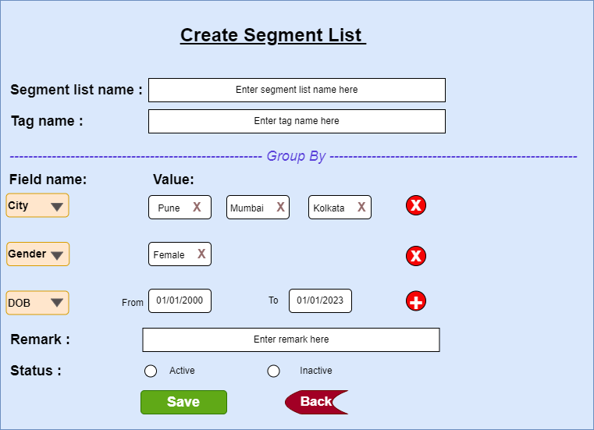

Fig: Create Segment List

|  |  |  |  |
| --- | --- | --- | --- |
| **FIELDS** | **INPUT TYPE** | **MANDATORY / OPTIONAL** | **DESCRIPTION** |
| Segment list name | Text | Mandatory | User will specify the name for the segment I.e. group of customers that he is creating.  Validation:- It should accept characters, special characters, numbers and space. It should accept English and Devanagari language.  It should accept maximum 50 characters.  It should be unique. |
| Tag name | text | Optional | User will give multiple tag names for the group that user is creating. Further, these tag names can be used by user while creating campaign.  Example : If customer is creating a segment as ‘Technical women webinar’ for Computer engineer women whose age is between 20 to 30.  Then for such segment user can give multiple tag names like computer, IT, technical, webinar, etc. These tag names will be used like relevant words while creating campaign. |
| Source type | Drop-down | Mandatory | It should display all the sources from which we have created our databank.  It will be multi-select |
| Group by field name | Drop-down | Mandatory | It will display list of fields from customer master as well as active dynamic fields created by the tenant.  It will display:   * Name * Mobile no. * WhatsApp no. * Pincode * State * City * Gender * Date of birth * Age * Date of anniversary * Source(s) * Branch location * Profession * Education * DND * Preferred media * Aadhar no. * PAN no. * First purchase date * Recent Purchase Date * DYNAMIC ACTIVE FIELDS   As per selected field name, the value will be displayed.  Validation:- It will be single select. Whereas, through + icon, user can add more field to add in segment list. |
| Value | Drop-down | optional | As per selected fields, the value will be displayed from customer master or dynamic fields form which are active.  Example: If any date related field is selected then, ‘from date’ and ‘to date’ fields will be displayed in value.  If gender field is selected, then male / female / others will be displayed in the value.  Validation:- It will be multi-select. It will display active values from the fields. |
| + icon | click | optional | If user wants to select multiple fields and its value, then user click on + icon.  Validation:- For each added field row, cross button should be displayed. |
| Remark | Text | Optional | User will mention the additional description of the segment list here.  Validation: It should accept characters, special characters, numbers and space.  It should accept English and Devanagari language. It should accept maximum 50 characters. |
| Status | Radio button | Mandatory | By default it should be displayed as Yes.  It should be display yes / No accordingly in grid as user changes the status.  If user clicks on No, then this created segment list name should not be displayed in create campaign -> segment list names drop-down. |
| Save | Click |  | Once user fills mandatory fields, the segment list should get created and message should be displayed at top as “Segment list created successfully. Then, user should be directed on grid page.  Created segment list name should be displayed at the top. |
| Back | click |  | Once user clicks on back button, user should be directed back to grid and data whichever is entered shouldn’t be saved. |

1. **SUBSCRIPTION**

User will have to subscribe first i.e. begin plan to send messages to customers. It will display following options:

* Subscription type (drop-down of monthly/ quarterly / yearly)
* Amount (display as per chosen subscription type)
* Messages limit (display as per chosen subscription type)
* Start date when user will subscribe
* End date (from start date till as per chosen subscription type)
* Pay button

Once user clicks to pay, it should direct user to enter bank account details or card details and as per payment gateway, user will enter cvv or pin and click on confirm button. On successful payment it should display message as “Your subscription has begun successfully.” and it should enable user to create campaign and send messages.

Once plan is expired or limit is finished, then it should be display alert to user as “Your subscription has ended. Please renew your plan”.

Details of plans activated and renewed by user each time should be displayed to customer in subscription and transaction details module.

1. **CREATE CAMPAIGN**

User should be able to create campaign only if users plan is active.

We will have to create new menu as ‘Create campaign’. Through this user can select the segment and enter the content of the message (text, media, links, images).

It will have following fields on main page:

* Details of subscription of particular tenant
* Create campaign
* .CSV SMS
* Search menu
* Grid
* Sr. No.
* Action - view, edit
* Medium
* Message Type
* Campaign name
* Content
* Attachment
* Segment list names
* Total count of customers
* Created at & by
* Sent at

|  |  |
| --- | --- |
| **FIELDS** | **DESCRIPTION** |
| Details of subscription of particular tenant | As tenant will be subscribing for the monthly or early limit to send messages to the customers. The details of the messages will be displayed here. It will display subscription plan (monthly / quarterly / yearly), subscription amount, start date and end date of the subscription, total count of messages sent out of subscription, count of messages left out of the subscription.  If monthly subscription of the user has ended, then it should display alert at top as “Subscription ended. Please renew your plan”. |
| Create Campaign (button) | Through this button, user can create new campaign list and select customer list. |
| .CSV SMS (button) | Through this button user can send different message content to each customer in bulk at a time. |
| Search menu | User can search by segment list name, created by and updated by. |
| Sr. No. | In grid, it should display the recently created campaign name at top.  It should display sr. no. in decremented manner. |
| Action | * View - In grid, it will display action column having view action button. Once user clicks on view action button, It will display the medium, campaign name, content, attachments, segment list names, total count of customers to whom the campaign is sent, created at & by details. In attachment it should display the thumbnails of attached files and have the option to zoom and download them. * Edit - Edit action should be displayed only when the scheduled date & time hasn’t passed for the created campaign. Through edit action, user can edit all fields in the form of ‘create campaign,. |
| Medium | It will display either SMS or WhatsApp. |
| Campaign name | In grid, it will display the name of the campaign which was created. |
| Content | In grid, it will display the content of the created campaign. |
| Attachment | It will display either yes or no if files are attached. |
| Segment list names | It will display the segment list separated by comma if multiple are selected by user while creating campaign. |
| Total count of customers | In grid, it will display the total count of all the customers as per selected segment lists in created campaign. |
| Created at & by | It will display the user name and date & time when the campaign was created by user. |
| Sent at | It will display the date and time at which the message was sent to customers. |

1. Once user clicks on ‘create campaign’ button, it will displaying following fields of form:

* Medium:- SMS / WhatsApp / Email /
* Message Type
* Campaign name
* Whats-app Template ID
* SMS Template ID
* Content
* Attachment
* Segment list names
* Send now (button)
* Schedule (button)

|  |  |  |  |
| --- | --- | --- | --- |
| **FIELDS** | **INPUT TYPE** | **MANDATORY / OPTIONAL** | **DESCRIPTION** |
| Medium | Drop-down | Mandatory | User will select whether the messages are supposed to be sent via text SMS or via WhatsApp or email. |
| Message Type | Drop-down | Optional | User will select Transaction / Promotional / Registration / OTP / Survey / Others from the drop-down.  It will be single select. |
| Campaign name | Text | Mandatory | User will mention name of the campaign.  Validation: It should accept characters, special characters, numbers and space.  It should accept English and Devanagari language. It should accept maximum 50 characters. It should be unique. |
| WhatsApp Template ID | text |  | This field will be disabled if user selects SMS medium.  If message mode selected is WhatsApp then user will mention template ID from whats-app analytic. Also, If customer is not available on whats-app, then message should get sent to that customer via SMS. Hence, we have to specify SMS template ID as well.  Validation: It will be numeric. It shouldn’t accept space. |
| SMS Template ID | text | mandatory | If user is sending message to customer via SMS, then user will mention template ID from pinnacle or another TRAI supported tool.  Validation: It will be numeric. It shouldn’t accept space. |
| Content | Text | Mandatory | Validation:- It should accept characters, special characters, numbers and space.  It should accept English and Devanagari language. If user has selected SMS medium, then it should accept maximum 250 characters. If user has selected WhatsApp medium, then it should accept maximum 2000 characters. |
| Attachments | Attach | Optional | It will be displayed only if user has selected message medium as ‘Whats-App’.  Validation:- User can attach files of jpeg, jpg, pdf and png extension only. Once file is attached, then attachment file name / hyperlink should be displayed and it should be clickable. Maximum 10 files can be attached. |
| Segment List names | Drop-down | Mandatory | User will select the segment list means groups of customers to whom the message is to be sent.  Validation:- It will display active segment list names in drop-down from created segment list names.  It will be multi-select.  It will have ‘All’ option in the drop-down which will include all active segment lists. |
| Send now | click |  | Once user clicks on this button, it should display dialogue box as ‘Are you sure you want to create this campaign? YES/ NO’.  Once user clicks on yes, then user it should display message as ‘Campaign created successfully’ and user should be directed to grid page.  Once campaign is created, then it should be displayed at top row in grid.  If user send messages to the customers more than his subscribed messages limit, then the messages should get sent only to the customers as per limit (as per first in / sequence). The messages shouldn’t get sent to the remaining customers. It should display message as “Your subscription limit has ended. Please renew your plan.” |
| Schedule | click |  | Once user clicks on this button, it should display calender, time and submit button.  Through provided calender picker, user will select the date on which the messages are to be sent to customers. It should disable past dates and should display dates from today till the 30 days.  User will select the time (HH:MM) at which messages are to be sent to customers on selected day.  Once user enters date & time on which the messages are to be sent and clicks on submit button, then it should display dialogue box as ‘Are you sure you want to create this campaign? YES/ NO’. Once user clicks on yes, then user it should display message as ‘Campaign created successfully’ and user should be directed to grid page. However, the messages should be sent to the customers on scheduled date & time.  Further, if the scheduled date & time hasn’t passed, till then user can edit the scheduled campaign. |

1. Once user clicks on .CSV message button, it will display following fields in form:

* Message type
* Campaign Name
* Segment list names
* Download format (button)
* Upload file (button)
* Send now (button)
* Schedule (button)

|  |  |  |  |  |
| --- | --- | --- | --- | --- |
| **FIELDS** | **INPUT TYPE** | **MANDATORY / OPTIONAL** | **DESCRIPTION** | |
| Message Type | Drop-down | Optional | User will select Transaction / Promotional / registration / Survey / OTP / Others from the drop-down.  It will be single select. | |
| Campaign name | Text | Mandatory | | It should accept characters, special characters, numbers and space.  It should accept English and devanagiri language.  It should accept maximum 50 characters.  It should be unique. |
| Segment List names | Drop-down | Mandatory | | It will display active segment list names in drop-down from created segment list names.  It will be multi-select.  It will have ‘All’ option in the drop-down which will include all active segment lists. |
| Download format | Click |  | | Once user clicks on download button, it will download .csv file which will have following columns:   * Customer name * Customer mobile no. * Content   As per selected segment list, customer name and mobile no. should be displayed in the downloaded file. |
| Upload file | Click |  | | User will upload the downloaded & updated file here. |
| Send now | click |  | | Once user clicks on this button, it should display dialogue box as ‘Are you sure you want to create this campaign? YES/ NO’.  Once user clicks on yes, then user it should display message as ‘Campaign created successfully’ and user should be directed to grid page.  Once campaign is created, then it should be displayed at top. |
| Schedule | click |  | | Once user clicks on this button, it should display calender, time and submit button.  Through provided calender picker, user will select the date on which the messages are to be sent to customers. It should disable past dates and should display dates from today till the 30 days.  User will select the time (HH:MM) at which messages are to be sent to customers on selected day.  Once user enters date & time on which the messages are to be sent and clicks on submit button, then it should display dialogue box as ‘Are you sure you want to create this campaign? YES/ NO’. Once user clicks on yes, then user it should display message as ‘Campaign created successfully’ and user should be directed to grid page. However, the messages should be sent to the customers on scheduled date & time.  Further, if the scheduled date & time hasn’t passed, till then user can edit the scheduled campaign. |

1. **REPORTS**

Once messages are sent, then it will be tracked. If the message was related to feedback or registering for event or review, we can get the quality of message as per response received from customers. For other messages, we can track the quality of the messages as per latest purchase done by the customer after the SMS was sent.

1. **Messages delivery report**
2. **Customer response report**

User will upload the excel file which will contain the list of customers who have reverted back as per messages sent to them. It will have following fields:

* Download response format button
* Upload response file button
* From date
* To date
* Campaign name (drop-down)
* Submit button
* Reset button
* Export button

Downloaded format file will have following columns:

* Sr No.
* Customer name
* Message type
* Campaign name
* Status - Delivered / Not delivered
* Response date
* Remark

Once user uploads the response file, then as per selected campaign name, it will compare the data of responses received with list of customers to whom messages were sent. It will display the list of customers who haven’t responded, the percentage of response rate, etc.

1. **TEST DATA**

Multiple examples can be mentioned in sheet. Provide multiple scenarios for each field in the module. Input value and expected output value should be specified. Live examples in existing or alternative system should be provided if possible.



1. **ODUS ( Open Discussed Unhanded scenarios )**

ODUS sheet will contain questions raised by team which needs to be confirmed from user, points to be discussed with user, confirmation of points which isn’t given from user yet.

|  |  |  |  |  |
| --- | --- | --- | --- | --- |
| **Sr. No.** | **Topic** | **Priority**  **(High / medium / low)** | **Remark** | **Status**  **(Open/**  **Closed)** |
| 1 |  |  |  |  |
| 2 |  |  |  |  |
| 3 |  |  |  |  |
|  |  |  |  |  |
|  |  |  |  |  |

1. **REFERENCES OF THE USERS**

|  |  |  |  |
| --- | --- | --- | --- |
| **User** | **Name** | **Mail** | **Contact number** |
| **Actual user** | Pritam mehta | ia@csjewellers.com |  |
| **Ticket created by (if any)** | Manali bhadirage | Manali.bhadirage@techneai.com | 9604640114 |
| **Assigned business analyst** | Manali bhadirage | Manali.bhadirage@techneai.com |  |
| **Assigned developer** | Baliram Rajwad | Baliram.rajwad@techneai.com |  |
| **Assigned tester** | Priyanka dupargude | Priyanka.dupargude@techenai.com |  |