Pranch wise Product wise performance report

20.05.2023

Manali ashok bhadirage

Manali.bhadirage@techneai.com

**Functional Requirement Document**

**CONTENTS**

1. TICKET DETAILS 2

2. VERSION CONTROL 2

3. APPROVALS 2

4. ESTIMATION 2

5. INTRODUCTION 3

6. BUSINESS REQUIREMENT 3

7. SCOPE 3

8. BUSINESS & SYSTEM RULES 3

9. ABBREVIATIONS & TERMS 3

10. EXISTING SYSTEM 3

11. GRAPHICAL REPRESENTATION 3

12. PROPOSED SYSTEM 3

13. TEST DATA 4

14. ODUS 4

15. REFERENCES OF THE USERS 5

1. **TICKET DETAILS**

|  |  |
| --- | --- |
| **Ticket ID** | TT11533 |
| **Ticket description** | Enter ticket description |
| **Created by** | Sagar Dahane |
| **Created on** | 21/04/2023 |
| **Priority** | medium |

1. **VERSION CONTROL**

|  |  |  |  |  |
| --- | --- | --- | --- | --- |
| **Sr. No** | **Version no** | **Version Date** | **User name** | **User department** |
| **1** | **1.0** | **20/05/2023** | **Sagar Dahane** | **Data analyst** |
|  |  |  |  |  |
|  |  |  |  |  |

1. **APPROVALS**

|  |  |  |
| --- | --- | --- |
| **Field** | **Name of the User** | **Approved date by the user** |
| **Actual User Name Actual User Department Organization Name** | Sagar Dahane  Data analyst  CSJ |  |
| **Assigned BA** | Manali bhadirage |  |
| **Assigned Developer** | Prathmesh shinde |  |
| **Assigned Tester** | Priyanka dupargude |  |

1. **ESTIMATION**

|  |  |  |  |  |
| --- | --- | --- | --- | --- |
| **Department name** | **Estimated Time (In hr)** | **Scheduled Date (Starting date)** | **Estimated date** | **Actual delivery date** |
| **BA** |  |  |  |  |
| **Development** |  |  |  |  |
| **Testing** |  |  |  |  |
|  |  |  |  |  |

1. **INTRODUCTION**

In connect US -> sales report, user needs branch wise product wise report through which they can understand actual sale quantity and amount and evaluate thus performance period wise as well as day wise.

1. **BUSINESS REQUIREMENT**

Enter details of the ticket requirement.

|  |  |  |  |
| --- | --- | --- | --- |
| **Requirement ID** | **Requirement Name** | **Short Description** | **Priority** |
| BR001 | Branch wise product wise report button | In sales incentive -> sales report, we need to add one button as ‘Branch wise product wise report’ for both period wise as well as day wise radio buttons. | High |
| BR002 | User should be able to select period and cluster | If user wants to view period wise BWPW report, then user will select the period and cluster. | high |
| BR003 | User should be able to enter from date and to date | If user wants to view day wise BWPW report, then user will select from date and to date. | high |
| BR004 | Display report in grid | Once user selects period and cluster or dates and clicks on BWPW report, then report should be displayed in grid. | Very High |
| BR005 | Export report | User should be able to export report in excel file. | Medium |

1. **SCOPE**

Through BWPW report, user should be able to cross verify the values as in Branch performance report and sales report as well as from Padm.

1. **BUSINESS & SYSTEM RULES**

* User should be registered in the system.
* User should be logged in.
* System should display error message for incorrect details if entered.
* System should pop up a message, if any issues in the system is detected.

1. **ABBREVIATIONS & TERMS**

BWPW - branch wise product wise

QTY - quantity

1. **EXISTING SYSTEM**

The existing system doesn’t include BWPW performance report.

1. **GRAPHICAL REPRESENTATION**

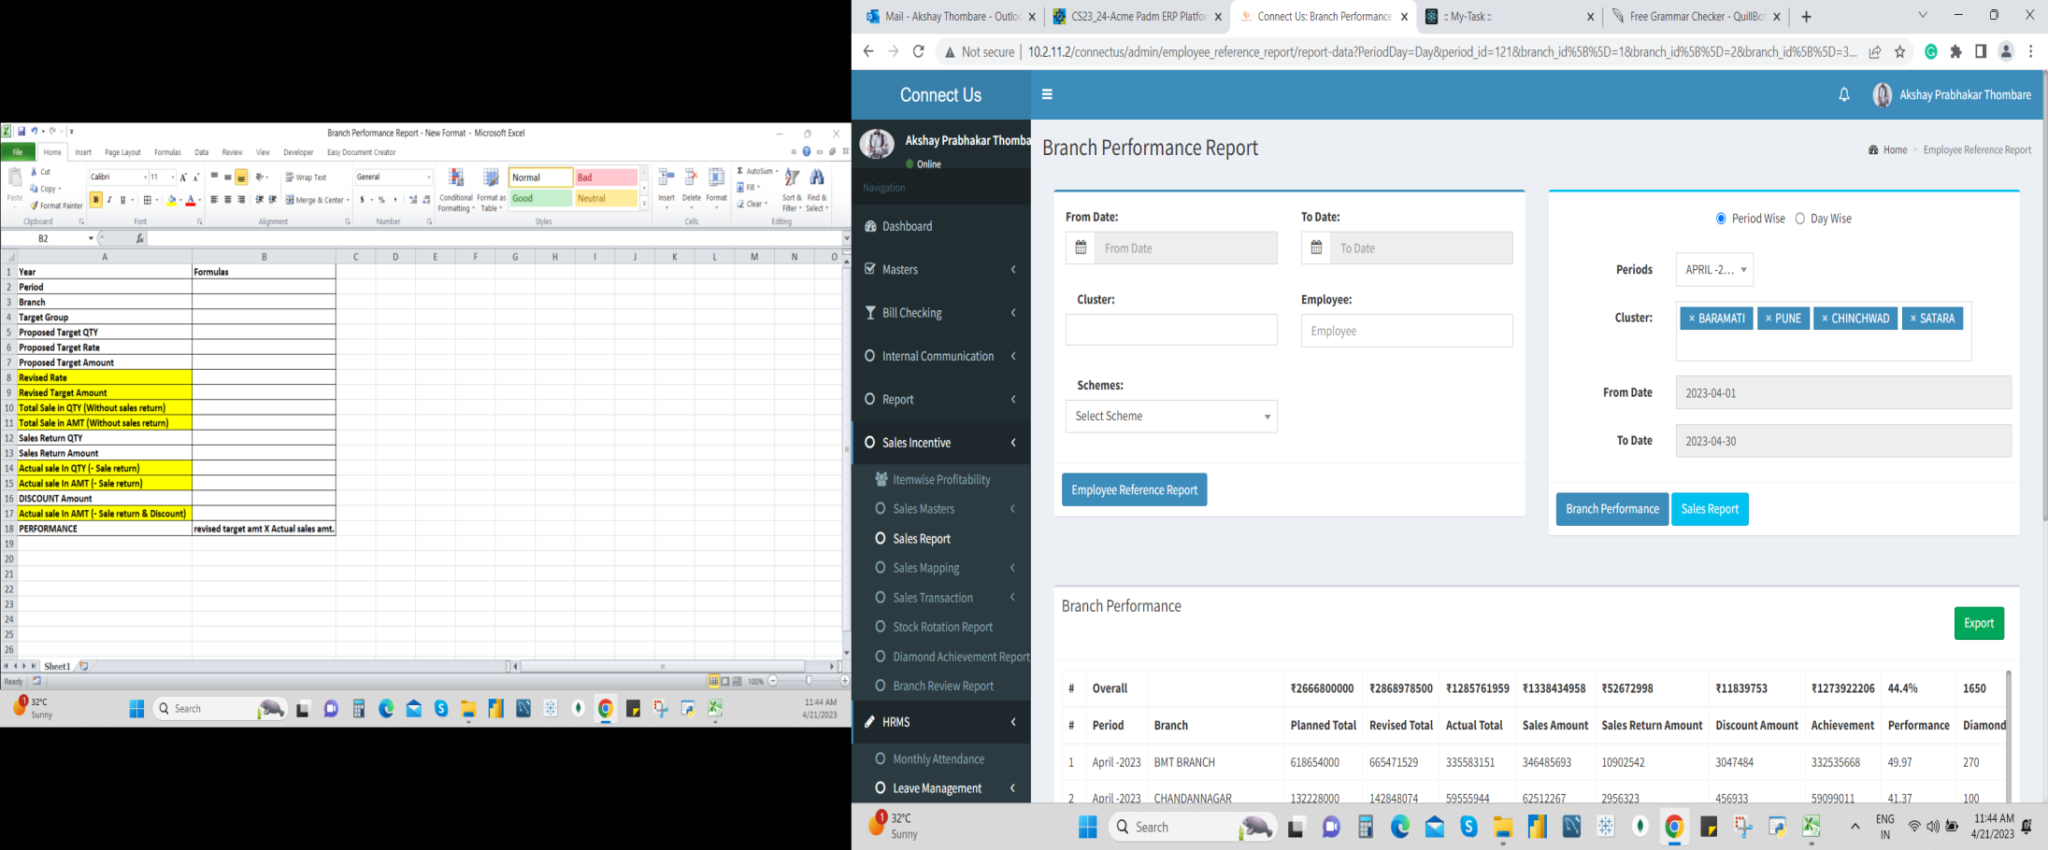

Branch wise product wise performance

BWPW-R

1. **PROPOSED SYSTEM**

Once user clicks on sales incentive -> sales report, it will display following fields:

* Period wise / day wise
* Periods
* Cluster
* From date
* To date
* Branch performance
* Sales report
* Branch wise product wise performance

**Input table**

|  |  |  |  |
| --- | --- | --- | --- |
| **FIELDS** | **INPUT TYPE** | **MANDATORY/ OPTIONAL** | **DESCRIPTION** |
| Period wise | Radio button | Mandatory | User can view report by period means of particular year, quarter or financial year. |
| Day wise | Radio button | Mandatory | User can view report of each particular day. |
| Periods | Drop-down | mandatory | If user selects period wise, then user will select the period from the drop-down.  User will select either particular month or quarter or any financial year which user wants to review report / data of. |
| Cluster | Drop-down | mandatory | Each cluster has branches mapped under it.  User will select the cluster name. It will be multi-select. |
| From Date | Calendar picker | mandatory | If user select period wise, then this field will be disabled.  If user selects day wise radio button, then this user will select the date from which user wants to review report. |
| To Date | Calendar picker | mandatory | If user select period wise, then this field will be disabled.  If user selects day wise radio button, then this user will select the date till which user wants to review report. |
| Branch wise product wise performance | Click | mandatory | Once user selects mandatory fields and clicks on BWPW performance button, then report should be displayed below in the grid. |

The exepcetd report in grid should have following columns:

* Sr No.
* Year
* Period
* Branch
* Target group
* Proposed target quantity (in gm)
* Proposed target rate
* Proposed target amount
* Revised rate
* Revised target amount
* Total sale quantity
* Total sale amount
* Sales return qty
* Sales return amount
* Actual sale qty
* Actual sale amount
* Discount amount
* Final sale amount
* Performance

|  |  |
| --- | --- |
| **FIELDS** | **DESCRIPTION** |
| Year | As per selected period or day, it should display the financial year of selected dates / period. |
| Period | As selected in ‘periods’ field drop-down, it should display period. |
| Branch | It should display names of branch as mapped under selected clusters. |
| Target group | It should display all group as under cluster & each branch like in branch wise report. |
| Proposed target Qty | It should display from sales incentive -> sales transaction -> period settings. Select period, branch and click on filter. This value in the ‘Proposed target’ column of report should be displayed in “Proposed target quantity” column of our BWPW performance report. |
| Proposed target rate | It should display from sales incentive -> sales transaction -> period settings. Select period, branch and click on filter. The value in the ‘Proposed target rate’ column of report should be displayed in “Proposed target rate” column of our BWPW performance report. |
| Proposed target amount | It should display calculated value.  Proposed target qty * proposed target rate = proposed target amount.  (plan qty * plan qty = proposed target amount) |
| Revised rate | Proposed rate * current rate = revised rate.  OR  Revised target amount / proposed target qty = Revised rate |
| Revised target amount | It should display from sales incentive -> sales transaction -> period settings. Select period, branch and click on filter. The value in the ‘Revised amount’ column of report should be displayed in “revised target amount” column of our BWPW performance report. |
| Total sale qty (without sales return) | It should display from sales incentive -> sales transaction -> period settings. Select period, branch and click on filter. The value in the ‘sales wt’ column of report should be displayed in “total value qty (without sales return)” column of our BWPW performance report.  OR  From sales incentive -> sales report -> branch performance report, the value in ‘sales net wt’ column should be displayed in “total value qty (without sales return)” column of our BWPW performance report. |
| Total sale amount (without sales return) | It should display from sales incentive -> sales transaction -> period settings. Select period, branch and click on filter. The value in the ‘sales amount’ column of report should be displayed in “total value in amount (without sales return)” column of our BWPW performance report. |
| Sales return qty | It should display from sales incentive -> sales transaction -> period settings. Select period, branch and click on filter. The value in the ‘sales return wt’ column of report should be displayed in “total value in amount (without sales return)” column of our BWPW performance report.  OR  From branch performance report, value in ‘sales return net wt’ column should be displayed in “total value in amount (without sales return)” column of our BWPW performance report. |
| Sales return amount | It should display calculated value. Sales return wt * revised rate = sales return amount.  OR  It should display from sales incentive -> sales transaction -> period settings. Select period, branch and click on filter. The value in the ‘sales return amount’ column of report should be displayed in “total value in amount (without sales return)” column of our BWPW performance report. |
| Actual sale qty (excluding sales return) | It should display calculated value.  Total sale qty (without sales return) - Sales return qty = Actual sale qty (excluding sales return) |
| Discount amount | It should display from sales incentive -> sales transaction -> period settings. Select period, branch and click on filter. The value in the ‘sales return amount’ column of report should be displayed in “Discount” column of our BWPW performance report. |
| Final sale amount | It should display calculated value. Total sale amount - Sales return amount - discount = Final sale amount. |
| Performance in % | It should display calculated value. (Revised target amount / final sale amount) * 100 = Performance in %. |

1. **TEST DATA**



1. **ODUS ( Open Discussed Unhanded scenarios )**

|  |  |  |  |  |
| --- | --- | --- | --- | --- |
| **Sr. No.** | **Topic** | **Priority**  **(High / medium / low)** | **Remark** | **Status**  **(Open/**  **Closed)** |
| 1 | 20/05/2023 : How can we exactly understand the calculation of revised rate? Proposed rate * current rate = revised rate. But how or from where can we know the exact current rate? | High |  | Open |
| 2 | 20/05/2023 : Total sales amount = total sale qty * revised rate. So, if revised rate goes wrong then total sales amount will also go wrong.  (Alternative solution, we are going to display total sales amount from ‘sales amount’ column of sales incentive -> sales transaction -> period settings report) | Medium |  | Open |
|  |  |  |  |  |
|  |  |  |  |  |
|  |  |  |  |  |

1. **REFERENCES OF THE USERS**

|  |  |  |  |
| --- | --- | --- | --- |
| **User** | **Name** | **Mail** | **Contact number** |
| **Actual user** | Sagar Dahane | da@csjewellers.com | 2917 |
| **Ticket created by (if any)** | Sagar dahane | da@csjewellers.com | 2917 |
| **Assigned business analyst** | Manali bhadirage | Manali.bhadirage@techneai.com | 2965 |
| **Assigned developer** |  |  |  |
| **Assigned tester** |  |  |  |