Manali Ashok Bhadirage

Manali.bhadirage@techneai.com

24.07.2023

Bill checking transaction - Ledger Balance field in add bill

**Functional Requirement Document**

**CONTENTS**

1. TICKET DETAILS 2

2. VERSION CONTROL 2

3. APPROVALS 2

4. ESTIMATION 3

5. INTRODUCTION 3

6. BUSINESS REQUIREMENT 3

7. SCOPE 4

8. BUSINESS & SYSTEM RULES 4

9. ABBREVIATIONS & TERMS 4

10. EXISTING SYSTEM 4

11. GRAPHICAL REPRESENTATION 4

12. PROPOSED SYSTEM 4

13. TEST DATA 7

14. ODUS 8

15. REFERENCES OF THE USERS 8

1. **TICKET DETAILS**

|  |  |
| --- | --- |
| **Ticket ID** | TT14040 |
| **Ticket description** | Bill Checking Transaction madhe bill payment la detana padm madhil ledger cha balance connect us la show zala pahije & jevd payment deyil tevda balance less zala pahije . |
| **Created by** | Tushar Koratkar |
| **Created on** | 12/07/2023 |
| **Priority** | Very high |

1. **VERSION CONTROL**

|  |  |  |  |  |
| --- | --- | --- | --- | --- |
| **Sr. No** | **Version no** | **Version Date** | **User name** | **User department** |
| **1** | **1.0** | **24/07/2023** | **Tushar Koratkar** | **Inventory Gold HO** |
|  |  |  |  |  |
|  |  |  |  |  |

1. **APPROVALS**

|  |  |  |
| --- | --- | --- |
| **Field** | **Name of the User** | **Approved date by the user** |
| **Actual User Name Actual User Department Organization Name** | Tushar Koratkar  Inventory Gold HO  CSJ |  |
| **Assigned BA** | Manali bhadirage |  |
| **Assigned Developer** | Prathmesh shinde |  |
| **Assigned Tester** | Priyanka dupargude |  |

1. **ESTIMATION**

|  |  |  |  |  |
| --- | --- | --- | --- | --- |
| **Department name** | **Estimated Time (In hr)** | **Scheduled Date (Starting date)** | **Estimated date** | **Actual delivery date** |
| **BA** |  |  |  |  |
| **Development** |  |  |  |  |
| **Testing** |  |  |  |  |
|  |  |  |  |  |

1. **INTRODUCTION**

Introducing "Bill Connect US": a seamless system that simplifies bill management for users. With this innovative platform, users can effortlessly submit vendor bills and facilitate swift payment processing. All payment records are meticulously maintained and audited to ensure transparency.

Integrating with Padm, "Bill Connect US" offers an added advantage by displaying the current balance of each vendor. This feature empowers entry users to make informed decisions when submitting bills, as they can analyze the available funds in the Padm account for each vendor. By having visibility into the vendor's balance, users can strategise their bill submissions, avoiding unnecessary work and streamlining the process.

In summary, "Bill Connect US" streamlines bill submissions and payment processing, providing valuable insights into vendor balances through integration with Padm. This empowers entry users to optimize their bill submissions and foster a more efficient workflow.

1. **BUSINESS REQUIREMENT**

User needs Ledger field in bill checking transaction -> add bill action where the ledger balance of vendor will be displayed.

|  |  |  |  |
| --- | --- | --- | --- |
| **Requirement ID** | **Requirement Name** | **Short Description** | **Priority** |
| BR001 | ledger balance field | In bill checking transaction -> add bill, we have to add ‘Ledger balance’ field which will display the Padm balance of the selected vendor. | High |
| BR002 | Updated ledger balance field | Once user enters the amount, then from ledger balance the net payment amount should get deducted and the updated ledger balance will be displayed.  It should display updated balance n real time. | Medium |

1. **SCOPE**

Through bill checking transaction -> add bill action, user will enter the bill details for each vendor. Once the bill is submitted, it gets displayed in grid and the bill gets assigned to the authorized person as per bill type settings. As we have ledger balance recorded for each vendor in Padm, we have to display the ledger balance of each vendor while submitting the bill.

The ledger balance and updated ledger balance field should get updated and displayed in real time.

1. **BUSINESS & SYSTEM RULES**

* User should be registered and logged in to the system.
* System should display error message for incorrect details if entered.
* All forms should have on field validations. System should display on field errors in case of incorrect inputs.

1. **ABBREVIATIONS & TERMS**

Dr - Debit

Cr - Credit

1. **EXISTING SYSTEM**

In existing connect us -> bill checking transaction-> add bill, ledge balance field is not displayed. Hence, entry users are required to open Padm link at the same time in new tab while submitting the bill so as to analyze the accounts. Hence, we need to add ledger balance field in add bill action where we will display the account balance of vendor as well as will display the balance that will get updated when ongoing bill will be submitted.

1. **GRAPHICAL REPRESENTATION**

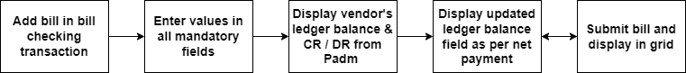

Fig: Workflow

1. **PROPOSED SYSTEM**

In Connect Us -> bill checking transaction -> add bill, it will have following fields:

* Bill type
* Sub bill type
* Assign to
* Vendor name
* Exhibition
* Vendor bill no
* Chalan / PO No.
* Bill date
* Received date
* Ledger balance
* Debit advance
* Taxable amount
* Igst / gst
* Round off
* TCS
* Bill amount
* TDS %
* Net payment
* Updated ledger balance
* Is initiative
* Net payment in words
* Is original bill received
* Remark
* Padm doc date
* Padm doc name
* Audit remark
* External audit remark
* Attachment
* Submit button

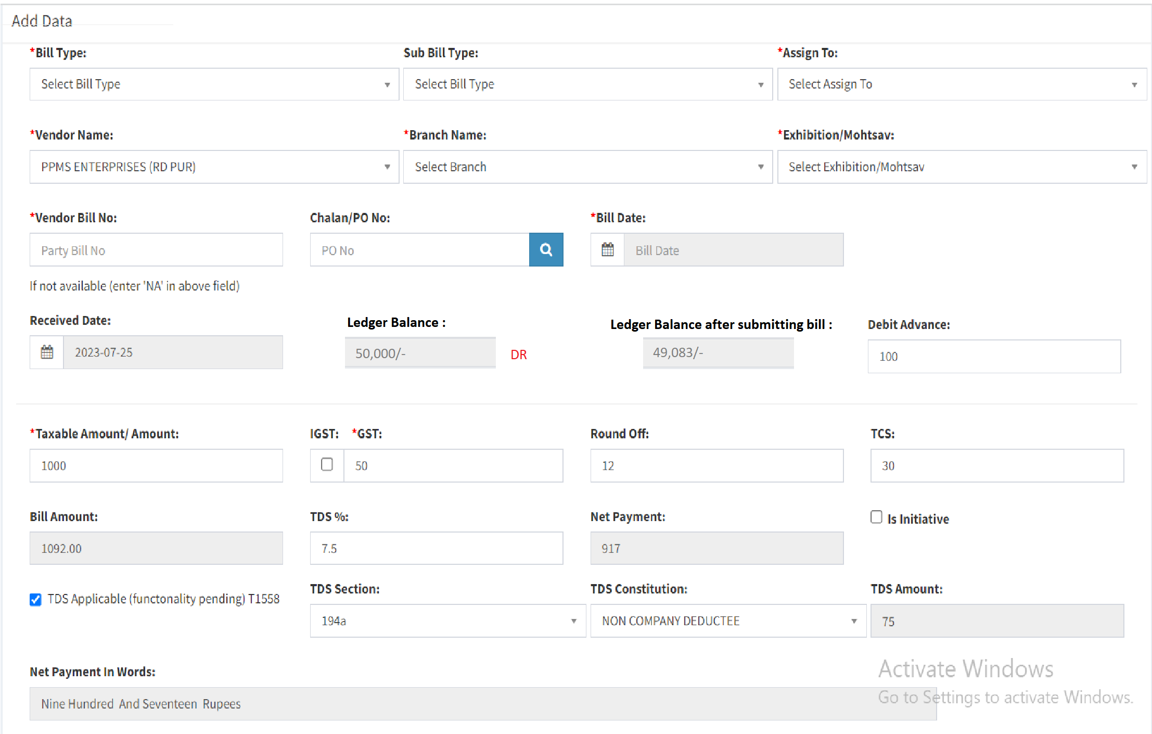

**Input table**

|  |  |  |  |
| --- | --- | --- | --- |
| **FIELDS** | **INPUT TYPE** | **MANDATORY/ OPTIONAL** | **DESCRIPTION** |
| Ledger balance | Text | Mandatory | As per selected vendor in ‘vendor name’ field, it will display the balance of that vendor from Padm -> ledger.  It will be read only.  It will display the balance of that vendor and Cr / Dr as in Padm -> ledger.  Here, even if the net amount is greater than ledger balance of that vendor, still entry user should be able to proceed and submit the bill. |
| Updated ledger balance / balance after submitting current bill | Text | Mandatory | Once user enters values in amount fields and net payment gets displayed, then the net payment then value in ‘updated ledger balance’ should be displayed.  Updated ledger balance indicates the value that will get displayed in ledger balance once the ongoing bill gets submitted and paid.  It will be read only.  Updated ledger balance = ledger balance - net payment of ongoing bill - (all bills in bill checking of that vendor whose status in not paid) |

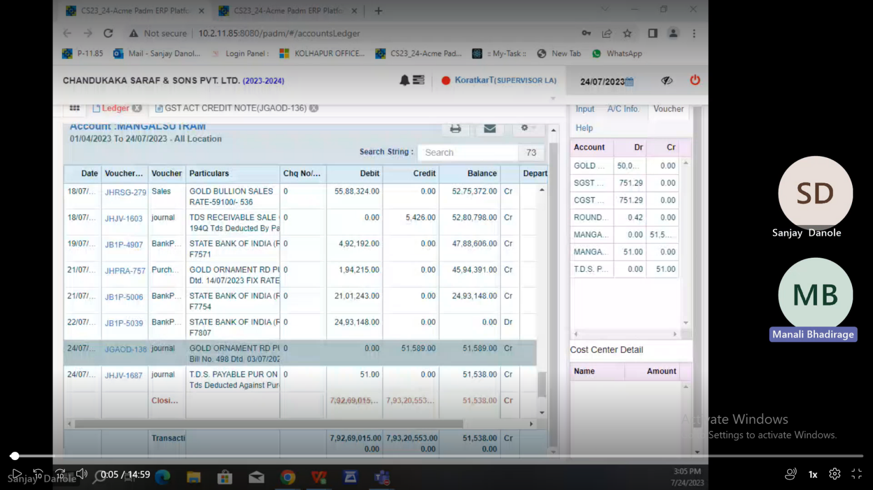

1. **TEST DATA**

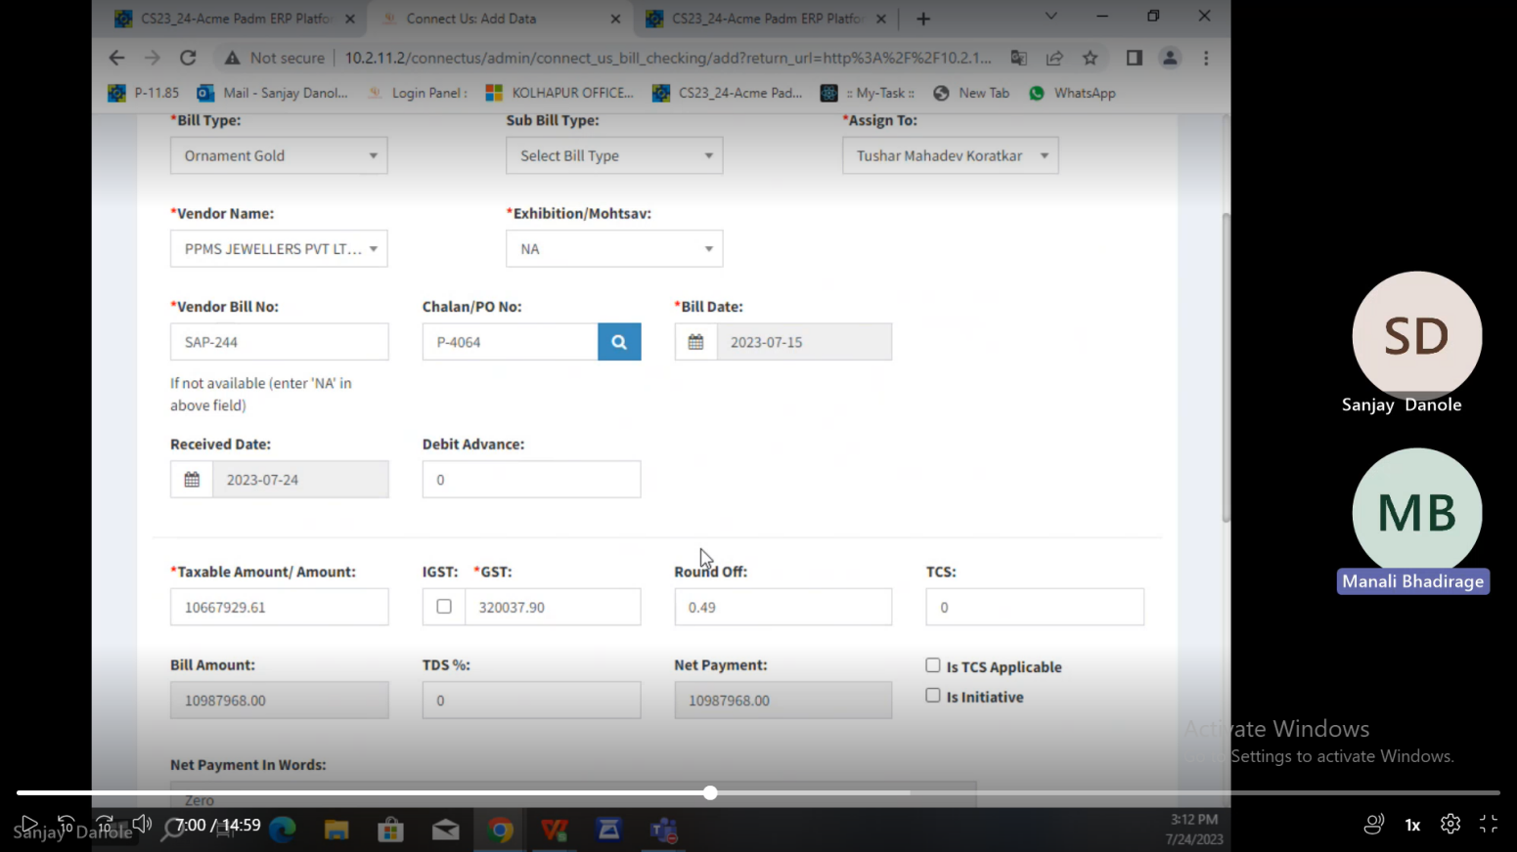

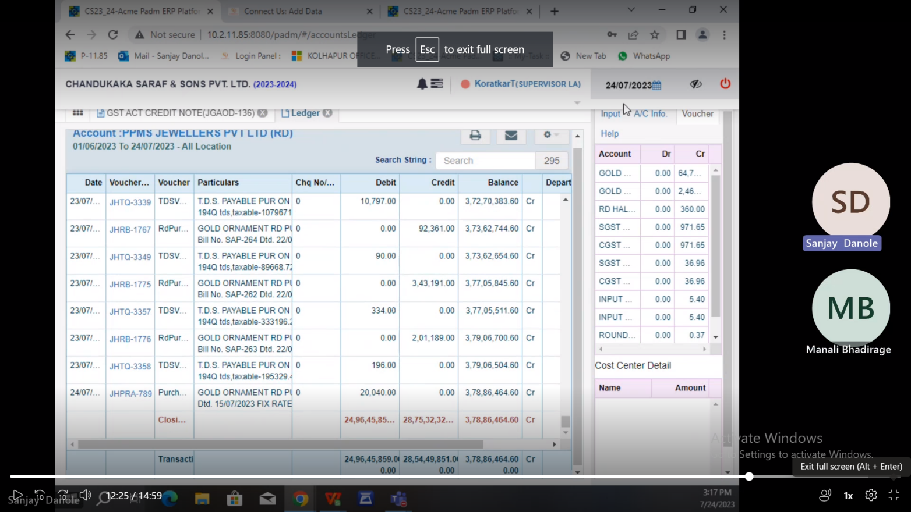

1. **ODUS ( Open Discussed Unhanded scenarios )**

|  |  |  |  |  |
| --- | --- | --- | --- | --- |
| **Sr. No.** | **Topic** | **Priority**  **(High / medium / low)** | **Remark** | **Status**  **(Open/**  **Closed)** |
| 1 | 25/07/2023 : Should bill proceed even if net payment is greater than ledger balance? | Medium | Yes, bill should get submitted. Because ledger balance of that vendor in Padm can get updated even after bill is processed. | Closed |

1. **REFERENCES OF THE USERS**

|  |  |  |  |
| --- | --- | --- | --- |
| **User** | **Name** | **Mail** | **Contact number** |
| **Actual user** | Tushar Koratkar | gold@csjewellers.com |  |
| **Ticket created by (if any)** | Tushar Koratkar | gold@csjewellers.com |  |
| **Assigned business analyst** | Manali ashok bhadirage | Manali.bhadirage@techneai.com |  |
| **Assigned developer** |  |  |  |
| **Assigned tester** |  |  |  |