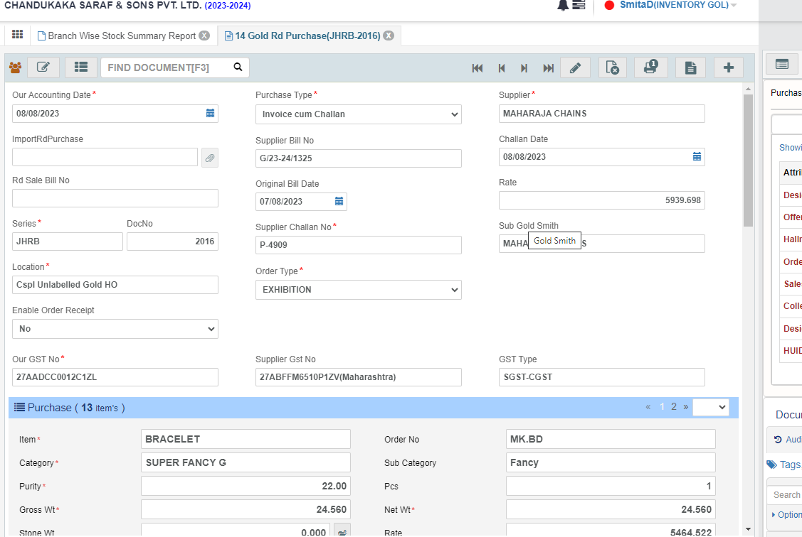

1)Doc Name- 11.Gold RD Purchase.

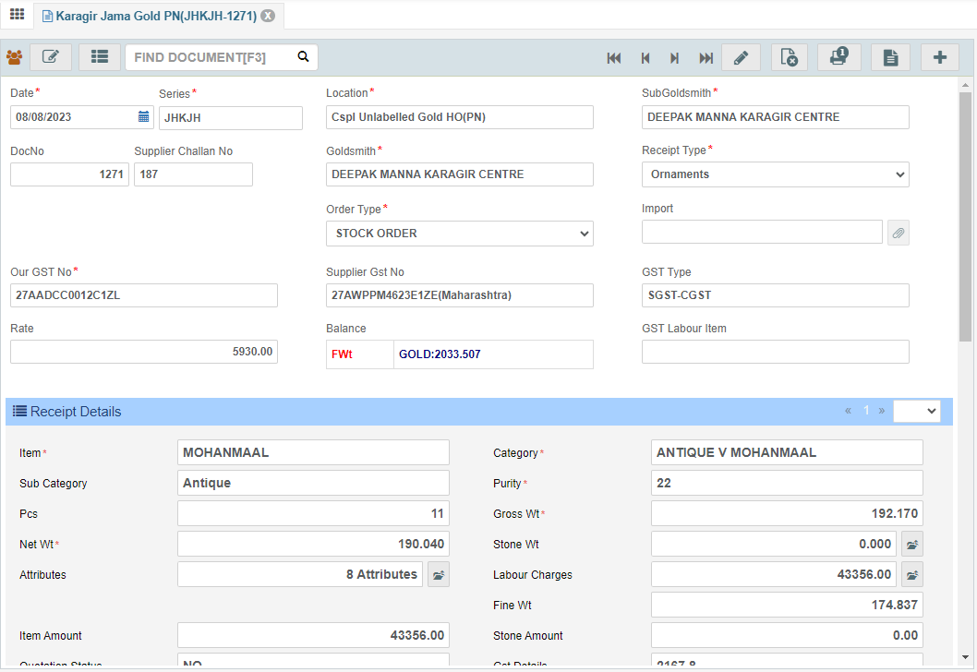

1. Doc Name-Karagir Jama Gold & Karagir Jama Gold PN.

3)CSV File- Upload

|  |  |  |  |  |  |  |  |  |  |  |  |  |  |  |  |
| --- | --- | --- | --- | --- | --- | --- | --- | --- | --- | --- | --- | --- | --- | --- | --- |
| LabelSrNo | Type | Item | Category | SubCategory | SelfBarCode | Set Item | Purity | Pieces | GrossWt | NetWt | LabourType | Labour Charges Lumpsum | OtherCharges | Rate | Amount |
| 1 | o | BRACELET | SUPER FANCY G |  |  |  | 22 | 1 | 24.56 | 24.56 |  |  |  | 0 | 0 |

4)Labelling Doc-Labelling Voucher Gold

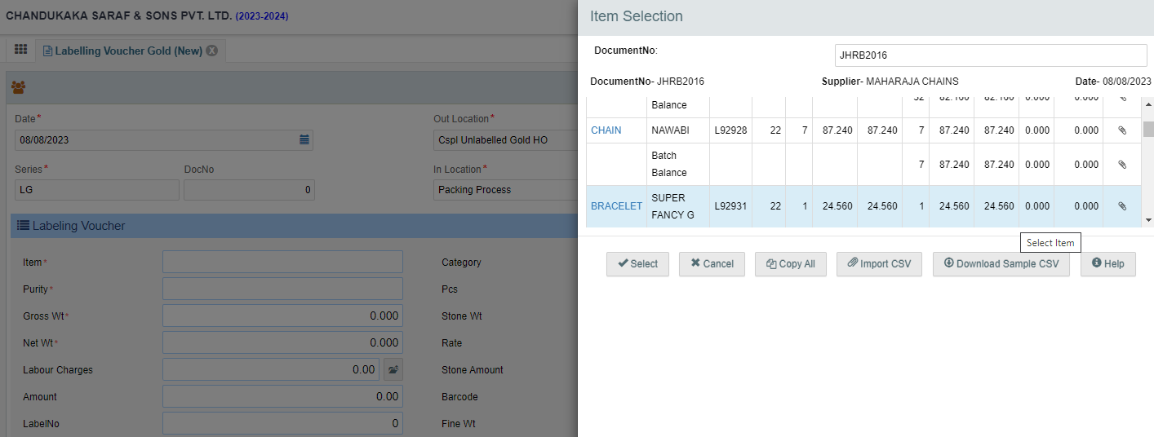

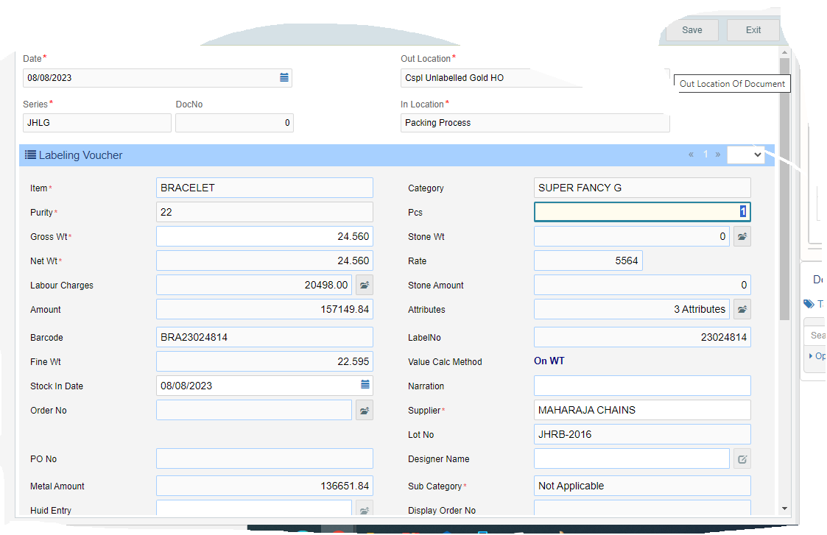

1) When the CSV file is uploaded, in the Labeling voucher, in the sub category- instead of fancy, Not Applicable is coming.

2) When the CSV File is uploaded, the Item-Category-Sub category- should be the picked up from receipt voucher/Rd voucher as same

