24.07.2023

MY CS - MY GOAL- SURVEY

Manali Ashok Bhadirage   
manali.bhadirage@techneai.com

**Functional Requirement Document**

**CONTENTS**

1. TICKET DETAILS 2

2. VERSION CONTROL 2

3. APPROVALS 2

4. ESTIMATION 3

5. INTRODUCTION 3

6. BUSINESS REQUIREMENT 3

7. SCOPE 3

8. BUSINESS & SYSTEM RULES 3

9. ABBREVIATIONS & TERMS 4

10. EXISTING SYSTEM 4

11. GRAPHICAL REPRESENTATION 4

12. PROPOSED SYSTEM 4

13. TEST DATA 11

14. ODUS 11

15. REFERENCES OF THE USERS 12

1. **TICKET DETAILS**

|  |  |
| --- | --- |
| **Ticket ID** | TT12816 |
| **Ticket description** | in my cs application Survey Submit after Wrong date showing |
| **Created by** | Amar Landge |
| **Created on** | 02/06/2023 |
| **Priority** | High |

1. **VERSION CONTROL**

|  |  |  |  |  |
| --- | --- | --- | --- | --- |
| **Sr. No** | **Version no** | **Version Date** | **User name** | **User department** |
| **1** | **1.0** | **24/07/2023** | **Amar Landge** | **audit** |
|  |  |  |  |  |
|  |  |  |  |  |

1. **APPROVALS**

|  |  |  |
| --- | --- | --- |
| **Field** | **Name of the User** | **Approved date by the user** |
| **Actual User Name Actual User Department Organization Name** | Amar Landge Audit  CSJ |  |
| **Assigned BA** | Manali bhadirage |  |
| **Assigned Developer** | Prathmesh shinde |  |
| **Assigned Tester** | Priyanka dupargude |  |

1. **INTRODUCTION**

We have successfully implemented a survey module within our Connect Us platform, as well as a corresponding survey menu in our MY CS application. This module allows authorities to effortlessly assign surveys to their employee which includes topics such as process knowledge, feedback, opinions, judgments, etc. The assigned employees can then respond to the surveys that have been assigned to them. Furthermore, the module offers the ability to export comprehensive reports regarding answers given by the employees.

Authorized user can export reports for each survey which will display the answer submitted by each employee and the date on which the employee has submitted survey.

1. **BUSINESS REQUIREMENT**

Once employees submits the survey from my cs mobile application then the recently submitted survey should be displayed at top in completed list and the date should be displayed correctly I.e. the date on which the employee has submitted survey.

1. **SCOPE**

Survey creation, assigning survey, receiving response on survey from employees, survey management and reporting & analysis lies within scope of this project. In addition to this, designing the survey module to handle a large number of surveys, respondents, and data points while maintaining optimal performance will be considered as scope of the project. Further, integrating the survey module seamlessly into the existing Connect Us platform and MY CS application, ensuring a cohesive user experience are part of our scope.

Any extensive redesign or revamp of the overall user interface of Connect Us or MY CS application beyond the survey module's specific requirements would be considered out of scope.

1. **BUSINESS & SYSTEM RULES**

* User should be registered and logged in to the system
* System should display error message for incorrect details if entered.
* All forms should have on field validations. System should display on field errors in case of incorrect inputs.

1. **ABBREVIATIONS & TERMS**

NA

1. **EXISTING SYSTEM**

Through existing survey report, authorized user can view the date on which the survey has been submitted by the employees. Whereas, the count of users who have submitted survey isn’t displayed. Hence we need to display the count of each type.

1. **GRAPHICAL REPRESENTATION**

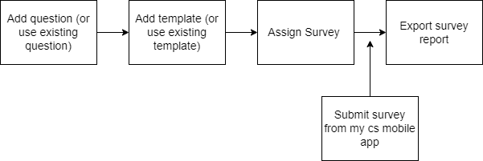

1. **PROPOSED SYSTEM**

**Step 1.** User (authority) will create Questions from Connect-us -> My Goal App -> Survey -> Question Master. It includes following fields:

* Add question button
* Action
* Question
* Answer Type
* Is Active
* Remark
* Created at and by
* Updated at and by

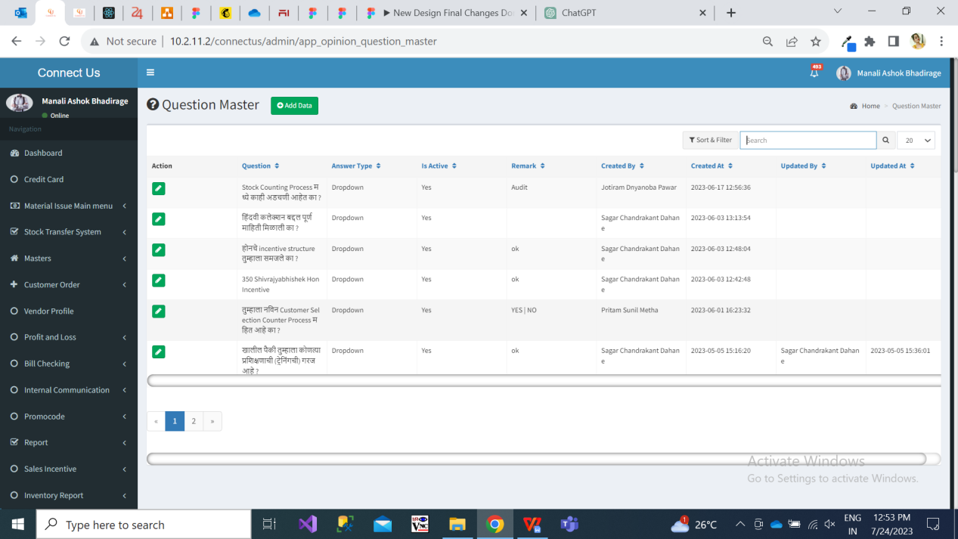

|  |  |
| --- | --- |
| **FIELDS** | **DESCRIPTION** |
| Add Question | Add question button consists of following fields:   * Question * Answer Type * Is Active * Remark     Question field accepts text, digits, space and special characters.  Answer type field includes either text or drop-down. If answer type is selected as text, then in application it will reflect text input box where employees will write their answer. Wheres, if answer type is selected as drop-down, then in application that question will display options out of which employees will select any one of the provided options.  Is active fields consist of yes or no button through which question can be kept active or inactive.  Remark field is input box where user may enter additional notes while adding question. It is not mandatory. |
| Action | Action field consist of edit action. |
| Question | Added question will be displayed in grid. |
| Answer Type | Text / drop-down of each question will be displayed in grid against each question. |
| Is Active | It displays either yes or no in grid. |
| Remark | Remark entered by user while adding questions will be displayed here. |
| Created at and by | It will display the name of the employee who created the question and the date and time when question was created. |
| Updated at and by | It will display the name of the employee who edited the existing question and the date and time when the update was made. In case any change is nor made, then it will be displayed blank. |

Example: We have created question as “Share your feedback about survey feature” and selected its answer type as “Text”. On the other hand, we have added another question as “Is it possible for you to give surveys each month?” and selected its answer type as “Drop-down”.

**Step 2.** Create template.

Once questions are added, user need to map these questions in template. Hence template needs to be created from Connect-us -> My Goal App -> Survey -> Template master. Template can be referred as Survey. It will consists of following fields:

* Add template button
* Action
* Template name
* Description
* Is Active
* Remark
* Created at and by
* Update at and by

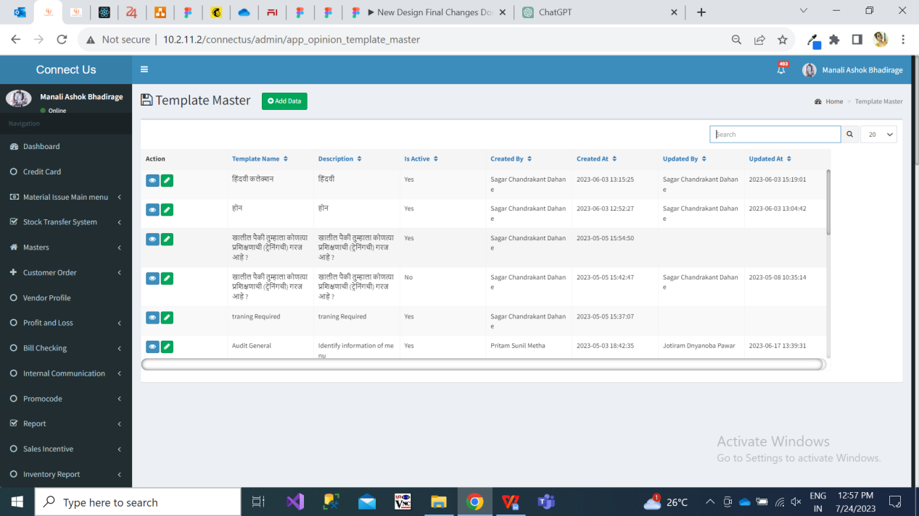

|  |  |
| --- | --- |
| **FIELDS** | **DESCRIPTION** |
| Add Template | Once clicked on Add template button, it displays following fields:   * Template name * Description * Map Question * Answer type * Is active   Template name consists of input box where user can mention the name of the template. It accepts text, digits and space.  Description specifies the details of the template.  User will map the questions to this particular template from question master.  Answer type field should be kept blank if answer type is text. Else user should mention the options if type of question is drop-down and use | when adding multiple options.  Is required field consist yes or no. If yes, then answering the question will be mandatory.  User will enter the number in Sort Order field which means sequence of the question. It is not mandatory.  Once question, answer type, sort order, is required are specified, user will have to click on “Add to table” button. This mapped question will be reflected at the bottom. Then once again user can map another question into this template.  Once questions are mapped to template, user will click save and thus template will get created. |
| Action | Action field consist of view and edit action.  Through edit option if user edits any fields in particular template and submits it, then updated fields of that particular template will be displayed in grid. |
| Template name | Added Template Name will be displayed in grid. |
| Description | Mentioned description of particular template will be displayed in grid. |
| Is Active | It will display either yes or no in grid. |

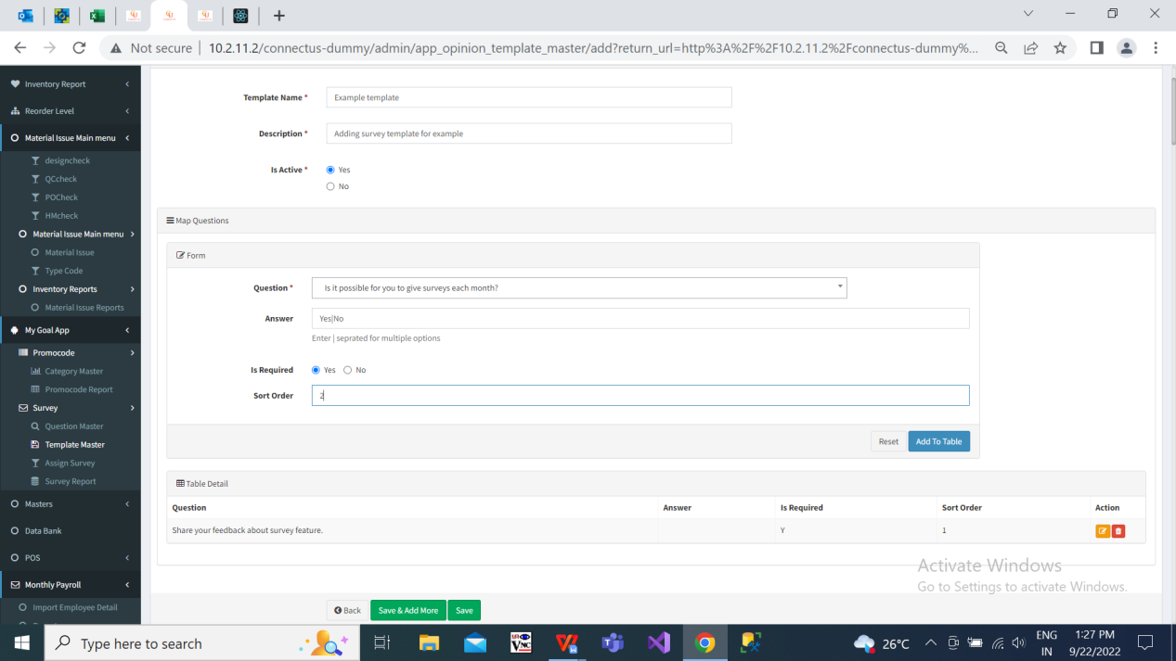

Fig: Mapping another question in same template.

Example: We have added template as “Example Template” and mapped two questions in it. First question, “Share your feedback about survey feature” and kept it answer field blank because answer type of this question is text in question master. Added another question, “Is it possible for you to give surveys each month?” and written Yes|No in answer field because answer type of this question is drop-down in question master.

**Step 3.** Once template is created, user can assign survey through Connect-us -> My Goal App -> Survey -> Assign Survey. It has following fields:

* Branch - (It includes All branches, All HO i.e. Pune HO and BMT HO, All i.e. all branches as well as all HO, and each branch in list individually)
* Department (All active department from dept. Master)
* Designation (All active designations from designation master)
* Gender (Male & Female)

Once user clicks submit, it will display the following input fields:

* Assign Survey
* Valid Date

Below above input fields, following details will be displayed

* Checkbox
* Sr. No
* Employee ID
* Employee name

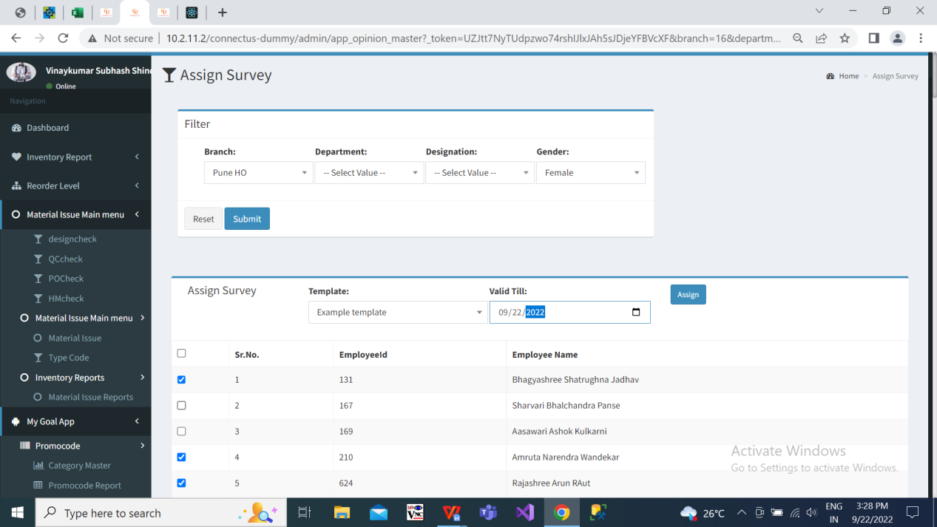

User can select any of the created template from drop-down in “Assign Survey” field, select valid date (the date till which survey will be valid to assigned employee) and then click on the checkbox to whom user want to assign survey.

**Step 4.** Employees will be able to give survey / test through “Survey” feature in MY CS application. Once clicked on survey feature, it will display two radio buttons namely Pending & Completed. Surveys which aren’t submitted by employee yet will be displayed in pending menu. Surveys which are submitted will be displayed in Completed menu. It will display following details:

* Name of the survey
* Status (Pending / Complete)
* Validity Date

Survey once submitted by employees cannot be edited. Once survey is submitted by the employee, then it will be displayed in my cs app -> survey menu -> completed list. It will display following fields:

* Name of survey
* Status
* Completed date

**Step 5.** Survey report can be exported of all the employees to whom the survey was assigned to and who have submitted the survey. It will have following input fields:

* From Date
* To Date
* Survey

Once details are filled in input fields and user clicks on submit, it will display following details in grid:

* Sr No.
* Survey Submitted Date
* Emp Id
* Employee name
* Branch
* List of Questions in selected template / survey.
* App verison

All the employees to whom the survey is assigned to will be displayed in report.

However, if the employee hasn’t submitted the survey yet (survey is still pending in MY CS app), then date and answers of questions will be kept blank. If employee has submitted survey, answers submitted by employee and the date on which employee submitted the survey, it will be displayed in report.

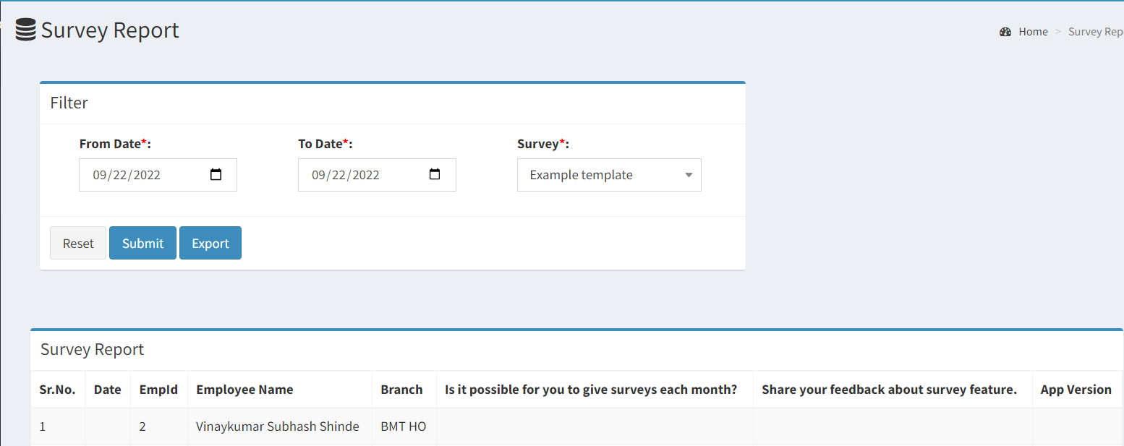

Fig: Survey Report

1. **TEST DATA**



1. **ODUS ( Open Discussed Unhanded scenarios )**

|  |  |  |  |  |
| --- | --- | --- | --- | --- |
| **Sr. No.** | **Topic** | **Priority**  **(High / medium / low)** | **Remark** | **Status**  **(Open/**  **Closed)** |
| 1 | Advanced report | low | Advanced report point will be solved in TT12887. It’s discussion is pending with pritam sir. | Open |
| 2 | Export button in all masters of survey module | low | It will be solved in TT12887. | Open |
| 3 | Firebase notification | low | It will be solved in TT12887. | Open |
| 4 | survey count is not getting updated and displayed until we close the app completely. | low | This has to be resolved in next ticket TT12887. | open |
| 5 | Display expired surveys list - suggestion from tester priyanka | low | Requirement not shared by user. It will be resolved in new point if users needs it. | Open |

1. **REFERENCES OF THE USERS**

|  |  |  |  |
| --- | --- | --- | --- |
| **User** | **Name** | **Mail** | **Contact number** |
| **Actual user** | Amar landge | isa@csjewellers.com |  |
| **Ticket created by (if any)** | Annappa thikane | isa@csjewellers.com |  |
| **Assigned business analyst** | Manali bhadirage | Manali.bhadirage@techneai.com |  |
| **Assigned developer** | Prathmesh shinde | Prathmesh.shinde@techneai.com |  |
| **Assigned tester** | Priyanka dupargude | Priyanka.dupargude@techneai.com |  |