BILL CHECKING - IMPS PAYMENT - IS ACTIVE FIELD

Manali Ashok Bhadirage

Manali.bhadirage@techneai.com

01.08.2023

**Functional Requirement Document**

**CONTENTS**

1. TICKET DETAILS 2

2. VERSION CONTROL 2

3. APPROVALS 2

4. ESTIMATION 2

5. INTRODUCTION 3

6. BUSINESS REQUIREMENT 3

7. SCOPE 3

8. BUSINESS & SYSTEM RULES 3

9. ABBREVIATIONS & TERMS 3

10. EXISTING SYSTEM 3

11. GRAPHICAL REPRESENTATION 3

12. PROPOSED SYSTEM 3

13. TEST DATA 4

14. ODUS 4

15. REFERENCES OF THE USERS 5

1. **TICKET DETAILS**

|  |  |
| --- | --- |
| **Ticket ID** | TT12988 |
| **Ticket description** | Please remove or hide check box ( is Active ) in imps payment |
| **Created by** | Rohan Shah |
| **Created on** | 07/06/2023 |
| **Priority** | Medium |

1. **VERSION CONTROL**

|  |  |  |  |  |
| --- | --- | --- | --- | --- |
| **Sr. No** | **Version no** | **Version Date** | **User name** | **User department** |
| **1** | **1.0** | **01/08/2023** | **Rohan Shah** | **Treasure** |
|  |  |  |  |  |
|  |  |  |  |  |

1. **APPROVALS**

|  |  |  |
| --- | --- | --- |
| **Field** | **Name of the User** | **Approved date by the user** |
| **Actual User Name Actual User Department Organization Name** | Rohan Shah  Treasure  CSJ |  |
| **Assigned BA** | Manali Bhadirage |  |
| **Assigned Developer** |  |  |
| **Assigned Tester** |  |  |

1. **ESTIMATION**

|  |  |  |  |  |
| --- | --- | --- | --- | --- |
| **Department name** | **Estimated Time (In hr)** | **Scheduled Date (Starting date)** | **Estimated date** | **Actual delivery date** |
| **BA** |  |  |  |  |
| **Development** |  |  |  |  |
| **Testing** |  |  |  |  |
|  |  |  |  |  |

1. **INTRODUCTION**

IMPS payment, a sub-module in Connect US -> Bill Checking, is used during URD transactions done in Padm. The payments of URD purchases are processed through IMPS payment module. The user enters the document series number from Padm and the data as per document number gets displayed. Further these bills are assigned from one user to another user. The authorized person verifies the bill and then changes the status hold / hold till audit / release / paid. Once payments status is changed to release then that bill gets displayed in list of download payment.

1. **BUSINESS REQUIREMENT**

|  |  |  |  |
| --- | --- | --- | --- |
| **Requirement ID** | **Requirement Name** | **Short Description** | **Priority** |
| BR001 | Hide Is active button | We have to hide ‘is active’ field from edit action. Whereas have to display it in grid and view action |  |
| BR002 | Authority based | Create authority for ‘is active’ field. As per authority, it will be displayed in edit action to users.  Whereas, it will display as active by default. |  |

1. **SCOPE**

We have to create an authority for is active field in IMPS payment and it should be displayed only to the users having authority to it. User will enter the document number from Padm -> document -> 12 Gold URD Purchase and details will be displayed as per document. The bills should be displayed in grid of the assigned user, whereas the bill should be displayed in download payment list after its status is changed to release.

1. **BUSINESS & SYSTEM RULES**

* User should be registered in the system.
* User should be logged in.
* System should pop up a message, if any issues in the system is detected.
* All forms should have on field validations. System should display on field errors in case of incorrect inputs.

1. **ABBREVIATIONS & TERMS**

IMPS - Immediate Payment Service

1. **EXISTING SYSTEM**

When users clicks on IMPS -> add action or edit action, then ‘is active’ field is displayed to all users in edit bill. This check-box is clicked by default which means that bill is active and not canceled. Once user un-checks this check-box of ‘is active’ field, that means the bill will get canceled and it will not be further processed. Once bill is canceled its status gets displayed as inactive in grid as well as in view action.

1. **GRAPHICAL REPRESENTATION**

Assign bill to user and display in grid

Auto-fill & display fields from padm & submit

Enter doc series no.

Add

Display ‘is active field’ if user has authority

Edit bill

Fig: System Context Diagram

1. **PROPOSED SYSTEM**

Once user clicks on add data in IMPS Payment, following fields will be displayed:

* Series
* Branch name
* Customer name
* Mobile no.
* Address
* Adjust amount
* Padm credit balance
* Payment amount
* Assign to
* Type
* Bank name
* Bank branch
* IFSC code
* Account number
* Confirm account number
* Attachments
* Remark
* Submit button

Once user enters series number and clicks on search then details from Padm will get auto-filled in branch name, customer name, mobile no., address, Padm credit balance and payment amount.

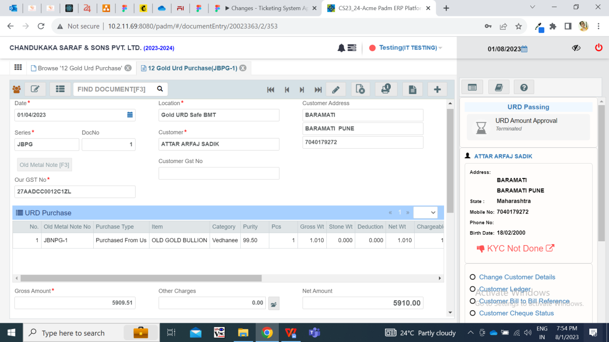

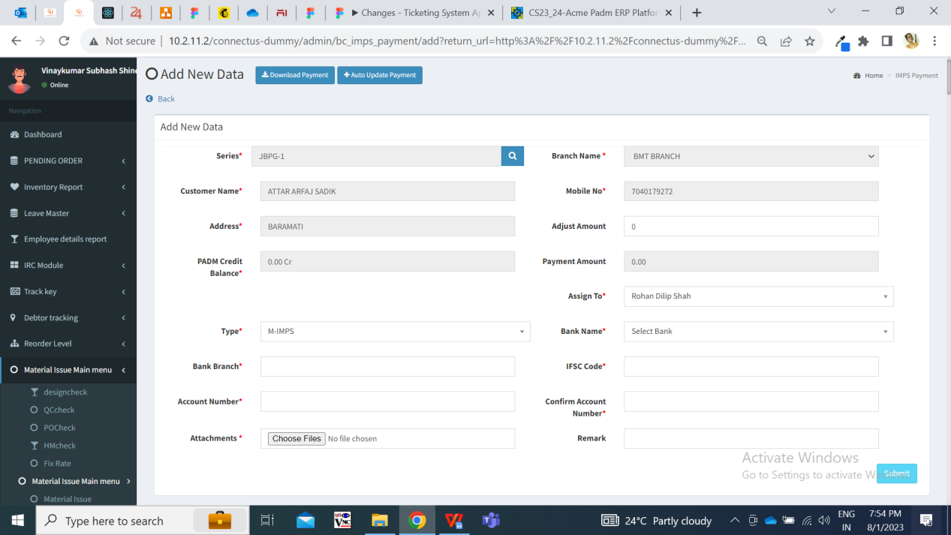

Once user enters other mandatory fields and submits, the bill gets added and assigned to the ‘assigned to user’ and gets displayed in the grid. Here, the bill status is displayed as ‘active’ in grid by default.

Once the bill gets displayed in grid, the assigned user and entry user can edit the bill. Once entry user and assigned user clicks on edit action, then following fields are displayed:

* Series
* Branch name
* Customer name
* Mobile no.
* Address
* Adjust amount
* Padm credit balance
* Payment amount
* Assign to
* Type
* Bank name
* Bank branch
* IFSC code
* Account number
* Confirm account number
* Attachments
* Remark
* Is Active (if unchecked, bill will be canceled)
* Submit button

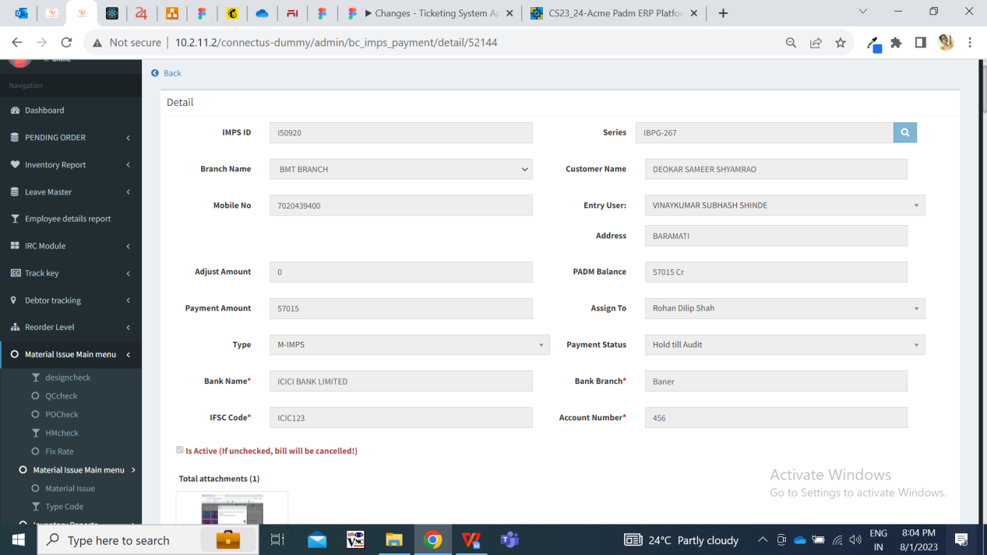

**Input table**

|  |  |  |  |
| --- | --- | --- | --- |
| **FIELDS** | **INPUT TYPE** | **MANDATORY/ OPTIONAL** | **DESCRIPTION** |
| Is Active (if unchecked, bill will be canceled) | Check-box | Optional | Once entry user or assigned user clicks on edit action, then ‘is active’ check-box will be checked by default.  This field should be displayed to the users based on the authority from masters -> login special auth.  If the entry user or assigned user has this authority, then they will be able to view this field as well will be able to check or un-check it.  Once user checks or un-checks this field, then its updated status as active / inactive will be displayed in view action and in grid. |

Special authority has been created from masters -> general masters ->special authority masters.

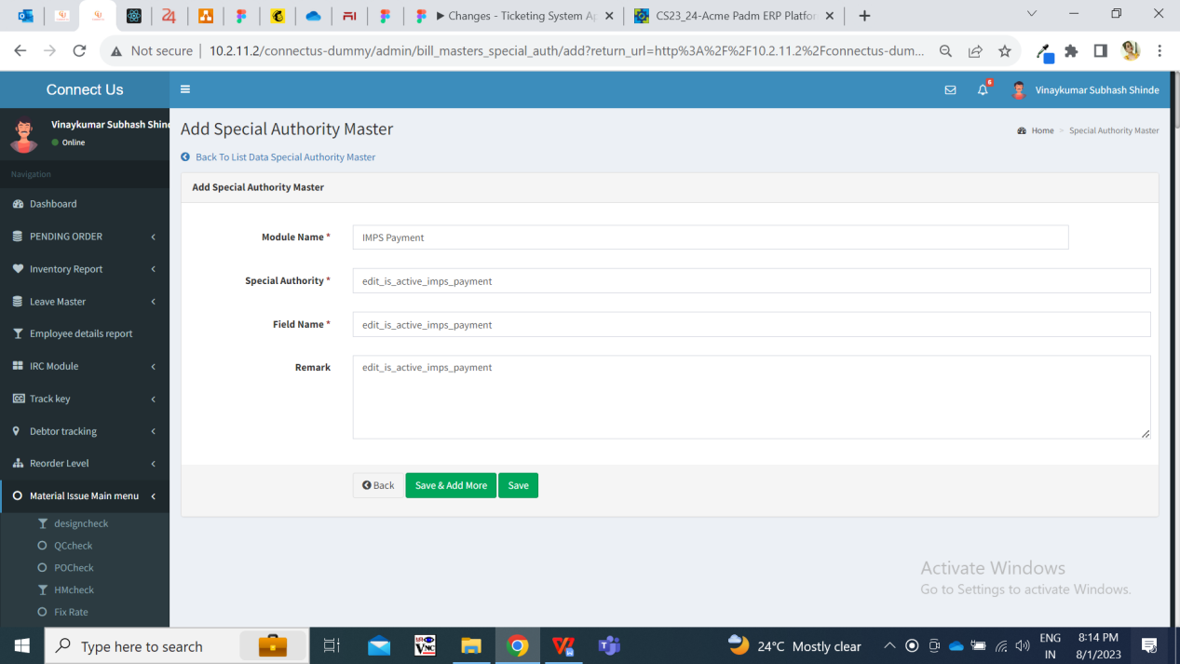

Once this authority is created in database and working is done from back-end, we will assign this authority to users from login special auth master.

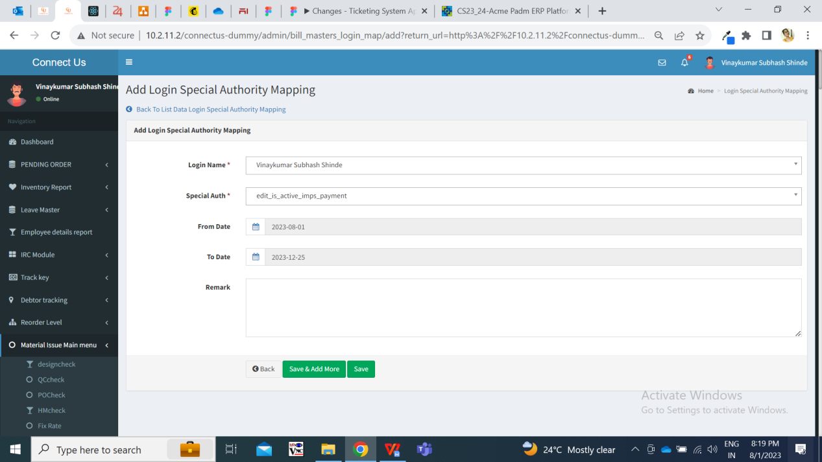

The users having this authority will be able to view ‘is active’ field in IMPS Payment -> edit bill and will be able to check / un-check it.

1. **TEST DATA**

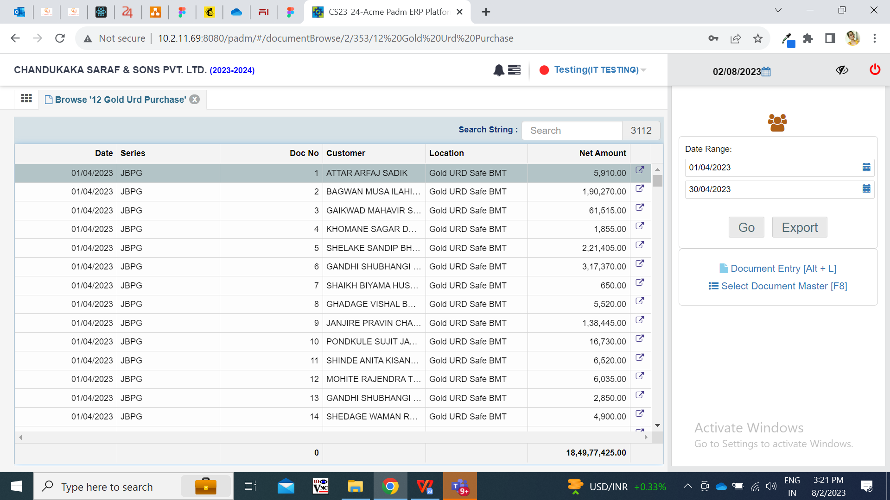

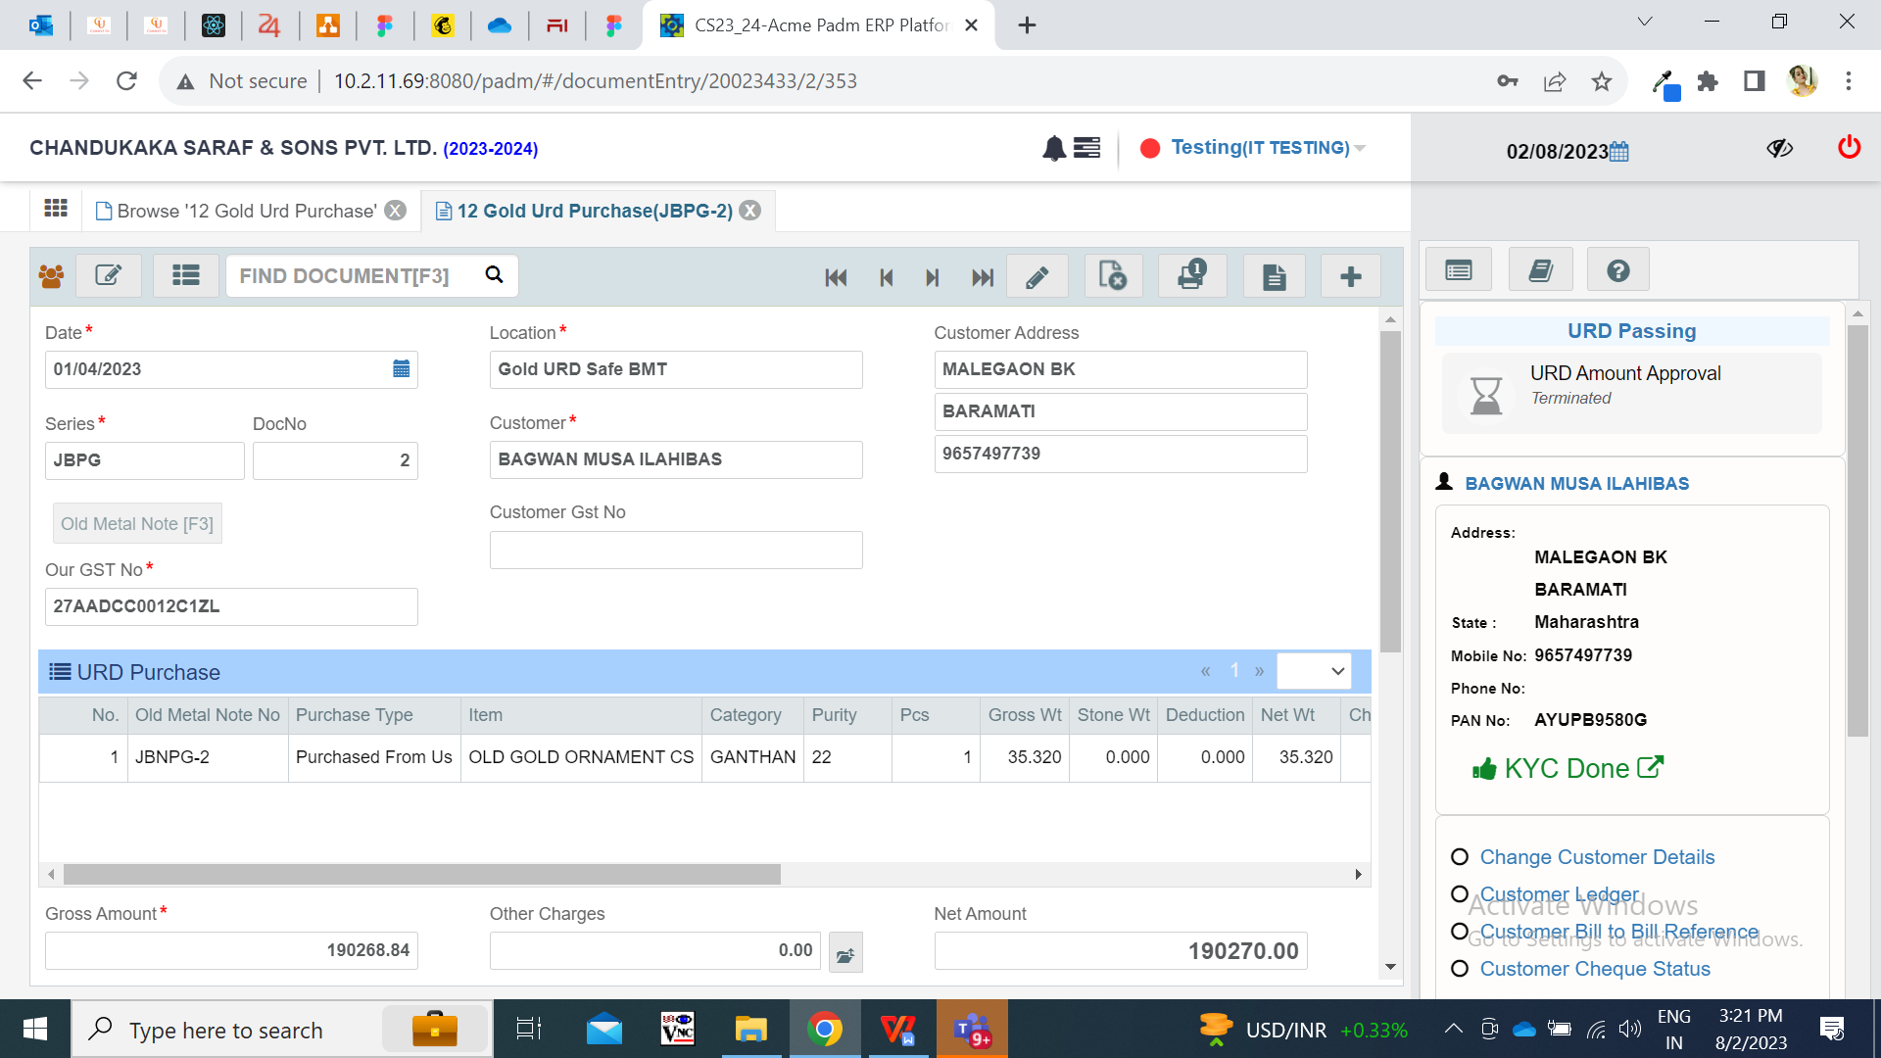

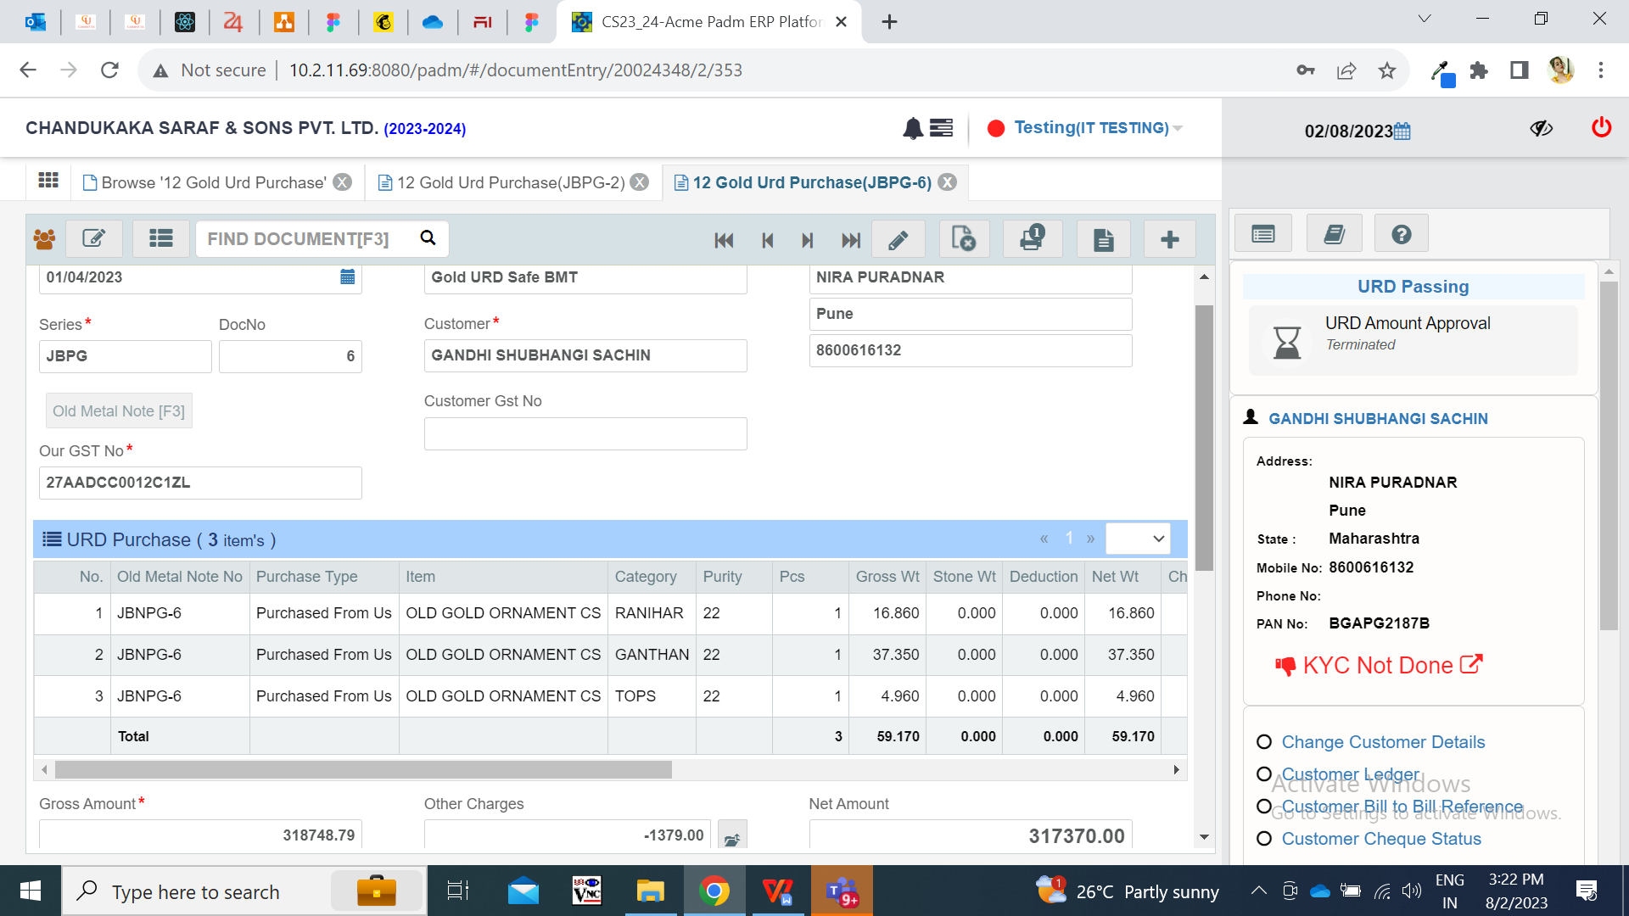

1. **ODUS ( Open Discussed Unhanded scenarios )**

|  |  |  |  |  |
| --- | --- | --- | --- | --- |
| **Sr. No.** | **Topic** | **Priority**  **(High / medium / low)** | **Remark** | **Status**  **(Open/**  **Closed)** |
| 1 |  |  |  |  |
| 2 |  |  |  |  |
| 3 |  |  |  |  |
|  |  |  |  |  |
|  |  |  |  |  |

1. **REFERENCES OF THE USERS**

|  |  |  |  |
| --- | --- | --- | --- |
| **User** | **Name** | **Mail** | **Contact number** |
| **Actual user** | Rohan Shah |  | 2569 |
| **Ticket created by (if any)** | Rohan Shah |  | 2569 |
| **Assigned business analyst** | Manali bhadirage |  |  |
| **Assigned developer** |  |  |  |
| **Assigned tester** |  |  |  |