Manali Ashok Bhadirage

Manali.bhadirage@techneai.com

07.08.2023

DIVINE DONOR - DONATION APP

**Handover Document**

**CONTENTS**

1. TICKET DETAILS 2

2. VERSION CONTROL 2

3. APPROVALS 2

4. ESTIMATION 2

5. INTRODUCTION 3

6. BUSINESS REQUIREMENT 3

7. SCOPE 4

8. BUSINESS & SYSTEM RULES 4

9. ABBREVIATIONS & TERMS 4

10. EXISTING SYSTEM 4

11. GRAPHICAL REPRESENTATION 4

12. PROPOSED SYSTEM 5

13. TEST DATA 62

14. REFERENCES OF THE USERS 63

1. **TICKET DETAILS**

|  |  |
| --- | --- |
| **Ticket ID** | TT10390 |
| **Ticket description** | Siddharth's sir point of - New Donation web and mobile development (tenant, user, organisation, license mapping) |
| **Created by** | Manali Bhadirage |
| **Created on** | 11.06.2023 |
| **Priority** | High |

1. **INTRODUCTION**

'Divine Donor' is a digital donation application to uncomplicate the donation process, help charities expand their support networks and make the app “the most thoughtful place on your mobile.” Through our donation app, user can safely and simply make donations under different organizations and tenants, share meaningful thoughts with the people they care and match words with good deeds by supporting each other’s favorite charities. It has provision to add multiple users & its organizations, to process donations and get reports of each donation type by just one click.

Through web application, super admin will add tenant first and then through mobile application, each tenant will be able to login & add their own users and organizations. Added organizations and users will be reflected in masters of web app as well as in report of mobile app. User will be mapped against organization and then user will able to fill donation details in the form. Added / processed donations will be reflected in mobile app report as well as web app report to that tenant.

1. **BUSINESS REQUIREMENT**

|  |  |  |  |
| --- | --- | --- | --- |
| **Requirement ID** | **Requirement Name** | **Short Description** | **Priority** |
| BR001 | Add tenant | Super admin will be able to add tenant through web app. | High |
| BR002 | Login as tenant | Tenant will be able to log into the web app and mobile app as per credentials entered by super admin while adding tenant. | High |
| BR003 | Add user | Tenant will be able to enter details of user and add through mobile app.  Added users will be mapped against organization. | High |
| BR004 | Display user list | Added users by tenant will be displayed in report-> users list of mobile app as well as in web app.  Tenant will be able to edit details of added user. | High |
| BR005 | Add organization | Tenant will be able to enter details of organization and add through mobile app.  Added organizations will be mapped against tenant. | High |
| BR006 | Display organizations list | Added users by tenant will be displayed in report-> organizations list of mobile app as well as in web app.  Tenant will be able to edit details of added organization. | High |
| BR007 | Login as user | User will be able to log into mobile app as per credentials set by tenant while adding user. | High |
| BR008 | Fill donation form | User will be able to fill the donation details that user will receive from donors. | High |
| BR009 | Display donation details | User will be able to view report of his own donations taken from donors.  Tenants will be able to view donations details processed by its users. | High |
| BR010 | Profile | User and tenant will be able to view details of their profile as well as will be able to edit fields in profile. | Medium |
| BR011 | Send messages | Message will get sent to donor configurable days prior to their birth date, anniversary date or relative’s punyatithi date. | medium |

1. **SCOPE**

Tenant will be able to view details of all the donors in the report which are added by their respective organizational users. Through mobile application, user will be able to fill forms of donations for different types of donations. Once donation is added by each user, it will be displayed in mobile application to user and the same will be displayed in web app to super admin. Data of each tenant varies and hence tenants shouldn’t be able to view any details of each other. Also, one donor can be added by multiple tenants. Moreover, in future days, application will be scale-able enough to have additional forms as per tenant’s requirements.

1. **BUSINESS & SYSTEM RULES**

* System should pop up a message, if any issues in the system is detected.
* All forms should have on field validations. System will display on field errors in case of incorrect inputs.
* Divine donor app doesn’t have any integration with another app / software.
* User use donations forms after the payment is done by the donor. Donation form is not used to initiate payment online, but it used to maintain the record of already made donation by the donor. Once donor pays donation by cash / cheque / upi online, then user adds that donation in donation form that means marks record of the made donation.

1. **ABBREVIATIONS & TERMS**

UPI - unified payment interface

1. **EXISTING SYSTEM**

There is no tenant based existing application to make donations.

1. **GRAPHICAL REPRESENTATION**

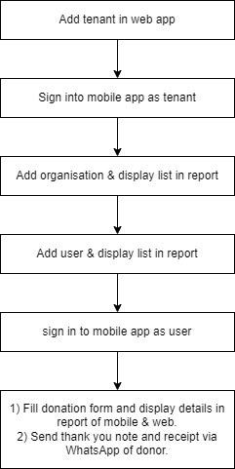

Fig: Workflow

1. **PROPOSED SYSTEM** 
   1. **ADD TENANT**

Super-admin will have add tenant option in web app through masters-> tenant master. Below is the link for web app:

<http://43.204.64.80/DonationApp/public/admin/tenant_master>

Once super admin / admin clicks on add button of tenant master, it will display following fields:

* Tenant name
* Email
* Password
* Contact
* Remark
* Profile image
* Is Active
* Back button
* Save & add more button
* Save button

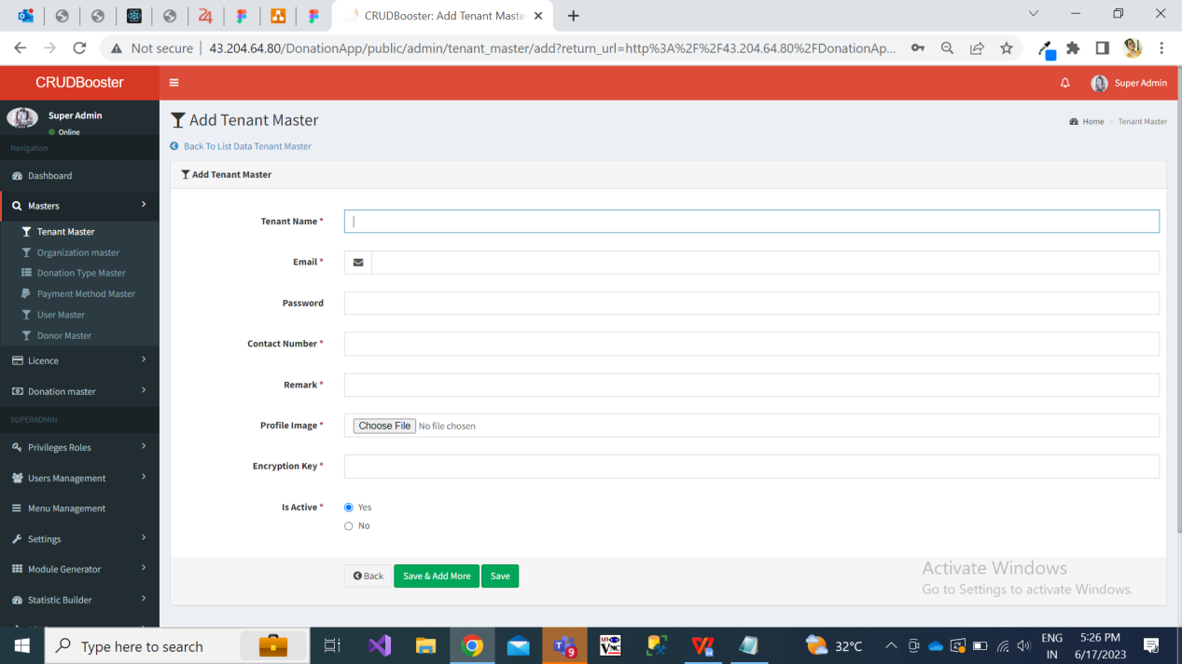

Fig: Add tenant

**Input table**

|  |  |  |  |
| --- | --- | --- | --- |
| **FIELDS** | **INPUT TYPE** | **MANDATORY/ OPTIONAL** | **DESCRIPTION** |
| Tenant name | Text | Mandatory | Precondition:- Initially this field will be blank.  Post condition:- Once super admin / admin enters tenant name, other fields and submits the form then the tenant will get added. And, added details and its tenant name will be displayed in top row of grid view of tenant master page. Also, this will be displayed in view action of the added tenant.  Validation:- It will be unique name. It should accept maximum 50 characters. It should accept characters, numbers and space. It shouldn’t accept double space after one word. |
| Email | Text | Mandatory | Precondition:- Initially this field will be blank.  Post condition:- Once super admin / admin enters email, other fields and submits the form then the tenant will get added. And, added details and its email will be displayed in top row of grid view of tenant master page. Also, this will be displayed in view action of the added tenant.  Validation:- It will be unique. It should accept maximum 50 characters. It should accept characters, number. It should not accept space. It should accept @ . _ and - special characters only. |
| Password | text | mandatory | Precondition:- Initially this field will be blank.  Post condition:- Once super-admin / admin enters tenant password, other fields and submits the form then the tenant will get added. And, added details will be displayed in top row of grid view of tenant master page. Also, details will be displayed in view action of the added tenant where password field will be kept blank.  Validation:- Minimum length will be 6 digits. It should accept characters, numbers, special characters. It shouldn’t accept space. |
| Contact Info | Text | Mandatory | Precondition:- Initially this field will be blank.  Post condition:- Once superadmin / admin enters contact number, other fields and submits the form then the tenant will get added. And, added details and its email will be displayed in top row of grid view of tenant master page. Also, this will be displayed in view action of the added tenant.  Validation:- It will be unique. It should accept maximum 10 characters. It should accept only numbers. It shouldn’t accept space / special characters / characters. It shouldn’t accept ten consecutive zeros or ten consecutive one. It should accept only 9 or 8 or 7 or 6 at the beginning. |
| Remark | Text | Optional | Precondition:- Initially this field will be blank.  Post condition:- Once super admin enters remark, other fields and submits the form then the tenant will get added. And, added details and its remark will be displayed in view action of the added tenant.  Validation:- It should accept maximum 250 characters. It should accept English and Marathi language. It should accept characters, numbers, special characters and space. It shouldn’t accept double space after one word. |
| Profile image | Attach | Mandatory | Precondition:- Initially this field will be blank and will display as no file chosen  Post condition:- Once super admin / admin uploads image from the system, other fields and submits the form then the name of the attached image will be displayed in this field. Once user submits the form, then tenant will get added and will be displayed in the grid view which will display profile image in it. Through grid view, once user clicks on image, it should zoom in on the the same page. Also once tenant is added, the details of the tenant will be displayed in view action along with the profile image which will be clickable.  Validation:- It should accept single image. It should accept jpg, jpeg, png, pdf, heic and webp extension image files only. |
| Is Active | Radio button | Mandatory | Precodnition:- By default, it should select “Yes” option.  Post Condition:- Once user submits the tenant form, then tenant will get added and its status as active yes / no will be displayed in grid as well as in view action of tenant.  Validation:- Both radio buttons shouldn’t get clicked at a time. |
| Save & add more | Click |  | Precondition:- All mandatory fields will be filled in the form.  Post condition:- Once user fills all mandatory fields in form, clicks on ‘save and add more’ button then the tenant will get added successfully and it will be displayed in grid view. At the same time, user should remain on the same add form page where all fields will be displayed as blank.  Validation:- Button will get disabled once clicked until the successful pop-up message isn’t displayed. |
| Save | Click |  | Precondition:- All mandatory fields will be filled in the form.  Post condition:- Once superadmin / admin fills all mandatory fields in form, clicks on ‘save’ button then the tenant will get added successfully and it will be displayed in grid view. And, user will be directed on grid page where recently added tenant will be displayed on top.  Validation:- Button will get disabled once clicked until the successful pop-up message isn’t displayed. |

Once super admin adds tenant, it will be displayed in the top row of the grid. Grid will have following columns:

* Tenant name
* Email
* Contact info
* Profile image
* Is active
* Created at & by
* Updated at & by
* View action
* Edit action

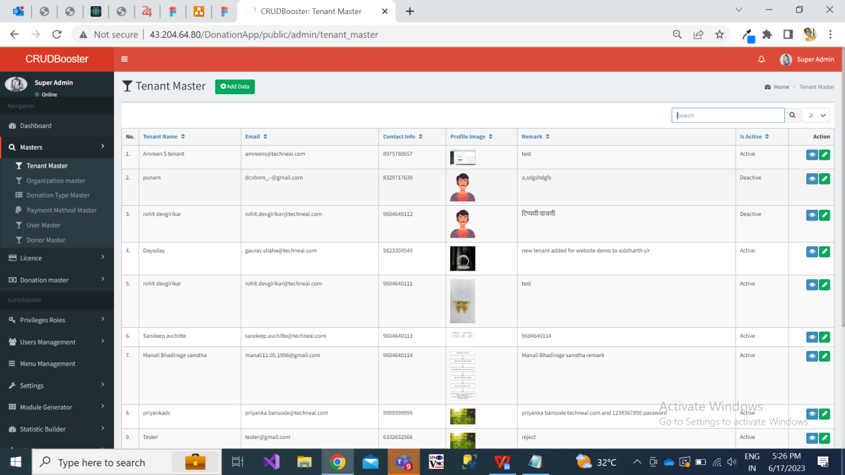

Fig: Tenant grid

Once user clicks on view action, it will display following details of added tenant:

* Tenant name
* Email
* Password
* Contact
* Remark
* Profile image
* Is Active
* Created at & by
* Update at & by
* Back button

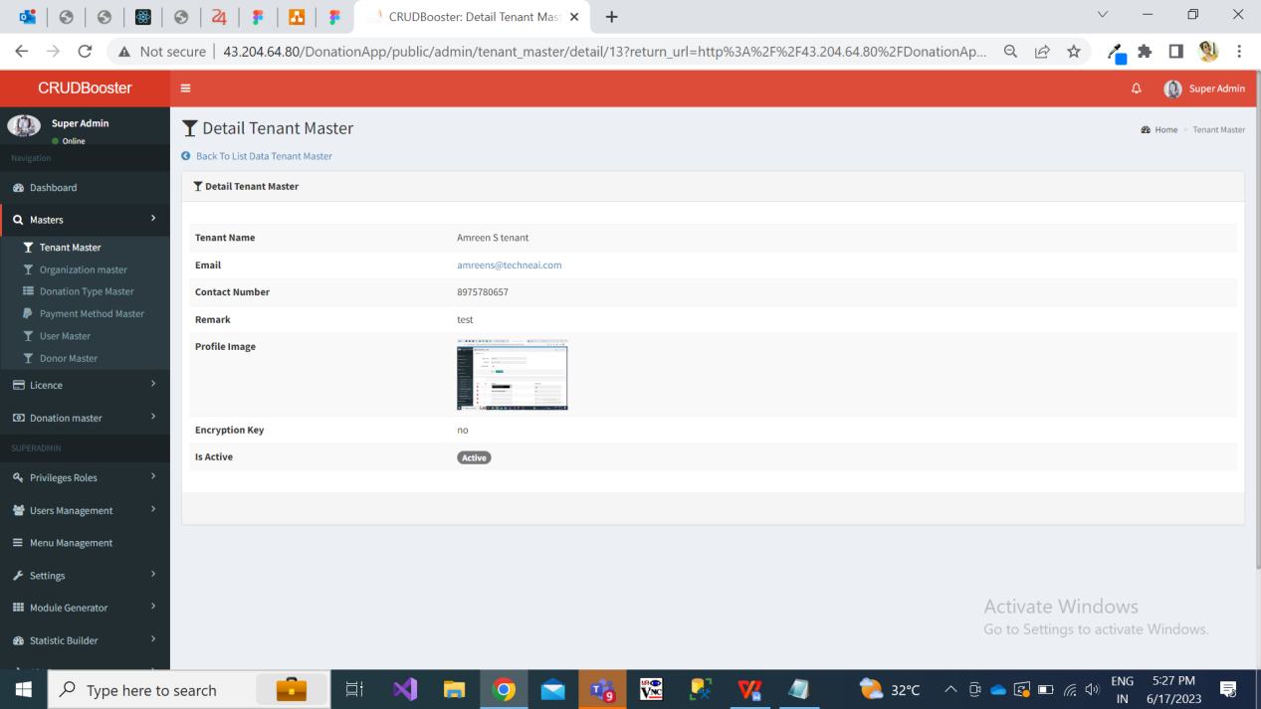

Fig: View added tenant

Once user clicks on edit action of added tenant, following prefilled fields will be displayed where all fields will be editable:

* Tenant name
* Email
* Password - It will be displayed blank.
* Contact
* Remark
* Profile image
* Is Active
* Back button
* Save button

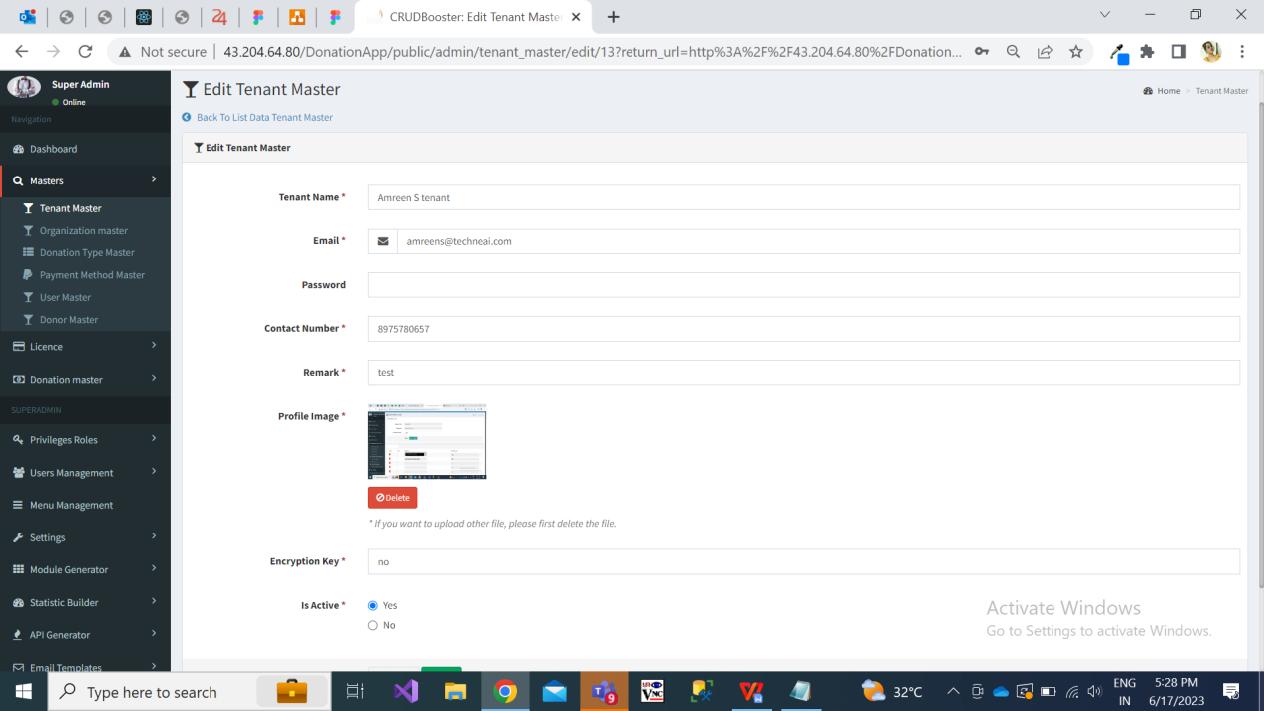

Fig: Edit tenant

In grid of tenant master, we need ‘Export’ button to download the list of tenants which are displayed in grid. Once user clicks on export button then excel file will get downloaded which will contain data as per grid and have following columns in it:

* Tenant ID
* Tenant name
* Email
* Contact
* Remark
* Is Active
* Created on - date and time

Further, once tenant is added, then tenant will be able to log into web application using his credentials. Tenant should have access only to his own data. Followinh menus will be displayed to tenant in web app:

* Dashboard
* Organization master
* User master
* Donation type master
* Donor master
* Donation master report
* Menu management
  1. **ADD ORGANIZATION**

Once Tenant logs into the mobile application or web application using his email and password, he can add organization through add menu. While adding organization, it will display following fields in form:

* Organization name
* Pan no
* Address 1
* Address 2
* Contact no
* WhatsApp no.
* GST no.
* 80G Number
* Is Active
* Cancel button
* Save button

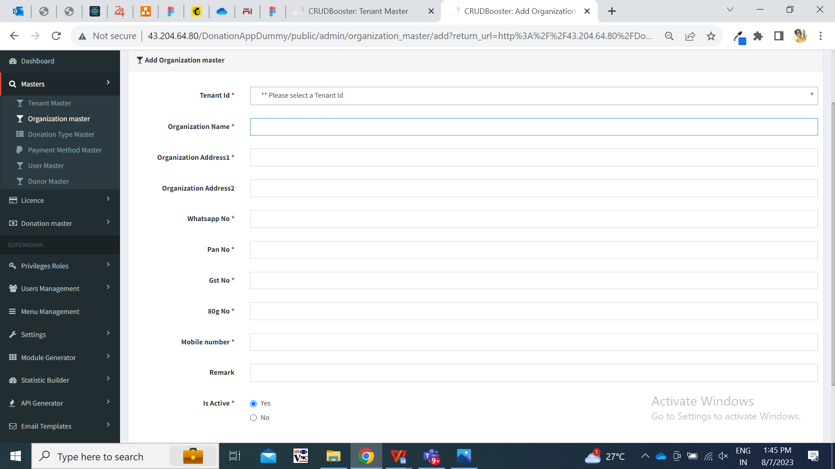

Fig: Add organization (web)

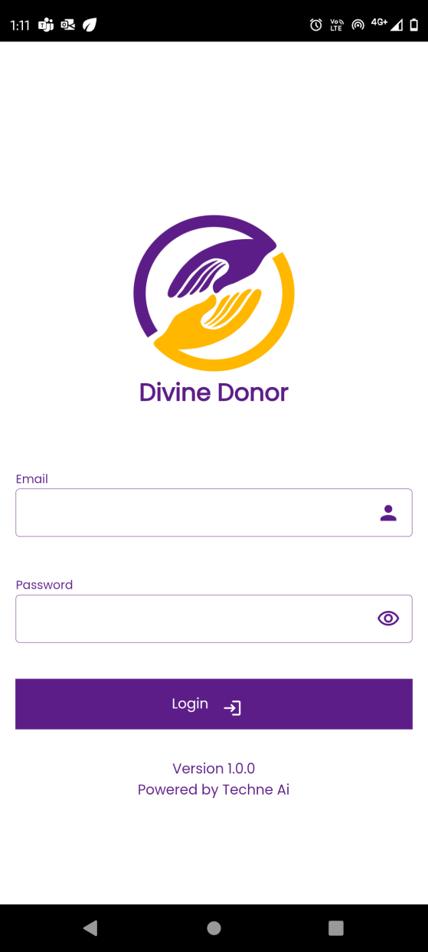

Fig: login (mobile)

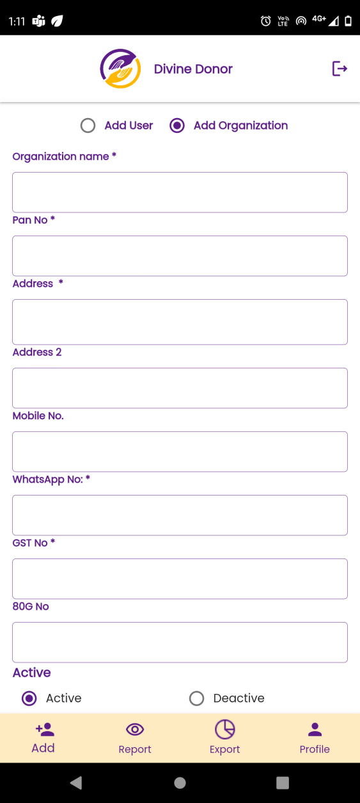

Fig: Add Organization (mobile)

**Input table**

|  |  |  |  |
| --- | --- | --- | --- |
| **FIELDS** | **INPUT TYPE** | **MANDATORY/ OPTIONAL** | **DESCRIPTION** |
| Organization name | Text | Mandatory | Precondition:- Initially this field will be blank.  Post condition:- Once tenant enters organization name, other fields and submits the form then the organization will get added against that tenant only. And, added details and its organization name will be displayed in top row of report -> organization list. Also, this will be displayed in view action of the added organization through report -> organization list -> view action.  Validation:- It should accept maximum 50 characters. It should accept characters, numbers and space. It shouldn’t accept double space after one word. |
| Pan No | Text | Mandatory | Precondition:- Initially this field will be blank.  Post condition:- Once tenant enters pan number, other fields and submits the form then the organization will get added against that tenant only. And, added details and its pan number will be displayed in top row of report -> organization list. Also, this will be displayed in view action of the added organization through report -> organization list -> view action.  Validation:- It should accept 10 characters for each tenant. It includes first five letters, followed by 4 numbers and last character. |
| Address 1 | Text | Mandatory | Precondition:- Initially this field will be blank.  Post condition:- Once tenant enters address, other fields and submits the form then the organization will get added against that tenant only. And, added details and its address 1 will be displayed in report -> organization list -> view action.  Validation:- It should accept maximum 100 characters. It should accept characters, numbers, special characters . - / only. It should not accept double space after each word. |
| Address 2 | Text | Optional | Precondition:- Initially this field will be blank.  Post condition:- Once tenant enters address, other fields and submits the form then the organization will get added against that tenant only. And, added details and its address 1 will be displayed in report -> organization list -> view action.  Validation:- It should accept maximum 100 characters. It should accept characters, numbers, special characters . - / only. It should not accept double space after each word. |
| Contact Info | Text | Mandatory | Precondition:- Initially this field will be blank.  Post condition:- Once tenant enters contact info, other fields and submits the form then the organization will get added against that tenant only. And, added details and its contact info will be displayed in report -> organization list -> view action.  Validation:- It will be unique for each tenant. It should accept maximum 10 characters. It should accept only numbers. It shouldn’t accept space / special characters / characters. It shouldn’t accept ten consecutive zeros or ten consecutive one. It should accept only 9 or 8 or 7 or 6 at the beginning. |
| WhatsApp no. | Text | Mandatory | Precondition:- Initially this field will be blank.  Post condition:- Once super admin / admin enters contact number, other fields and submits the form then the tenant will get added. And, added details and its email will be displayed in top row of grid view of tenant master page. Also, this will be displayed in view action of the added tenant.  Validation:- It will be unique for each tenant. It should accept maximum 10 characters. It should accept only numbers. It shouldn’t accept space / special characters / characters. It shouldn’t accept ten consecutive zeros or ten consecutive one. It should accept only 9 or 8 or 7 or 6 at the beginning. |
| GST no. | text | mandatory | Precondition:- Initially this field will be blank.  Post condition:- Once tenant enters gst no, other fields and submits the form then the organization will get added against that tenant only. And, added details and its gst no info will be displayed in report -> organization list -> view action.  Validation:- It will be unique for each tenant. It will be 15 digit value. The first 2 digits of the 15 digit GSTIN represents the state code. The next 10 digits are the [PAN](https://groww.in/p/pan-card) of the person or the business entity. The thirteenth digit is based on the number of registrations done by the firm within a state under the same PAN. The fourteenth digit will be the alphabet "Z" by default. The last digit is called the check code to detect errors and can be denoted by either a number of an alphabet. |
| 80G Number | Text | Mandatory | Precondition:- Initially this field will be blank.  Post condition:- Once tenant enters 80G no, other fields and submits the form then the organization will get added against that tenant only. And, added details and its 80g no info will be displayed in report -> organization list -> view action.  Validation:- It will be unique for each tenant. It should accept alphabets, numbers, space and special characters ( ) , - / only. |
| Is Active | Radio button | Mandatory | Precondition:- By default, it should select “Yes” option.  Post Condition:- Once user submits the tenant form, then tenant will get added and its status as active yes / no will be displayed in grid as well as in view action of tenant.  Validation:- Both radio buttons shouldn’t get clicked at a time. |
| Cancel | click |  | Precondition:- Initially one or more fields in the form will be filled.  Post condition:- Once tenant clicks on cancel button then all the fields filled in the form will get blank and organization shouldn’t get added. Also, user should remain on the same page.  Validation:- Button will get disabled once clicked until all fields in the form gets blank. |
| Save | click |  | Precondition:- All mandatory fields will be filled in the form.  Post condition:- Once tenant fills all mandatory fields in form, clicks on ‘save’ button then the organization will get added successfully and it will be displayed in report -> organization list view . And, user will be directed on the same page to fill the form for next organization.  Validation:- Button will get disabled once clicked until the successful pop-up message isn’t displayed. |

Once tenant adds organization, it will be displayed in report -> organization list of mobile app. It will display following columns in the table:

* ID
* Organization name
* Email
* Active status
* View action
* Edit action

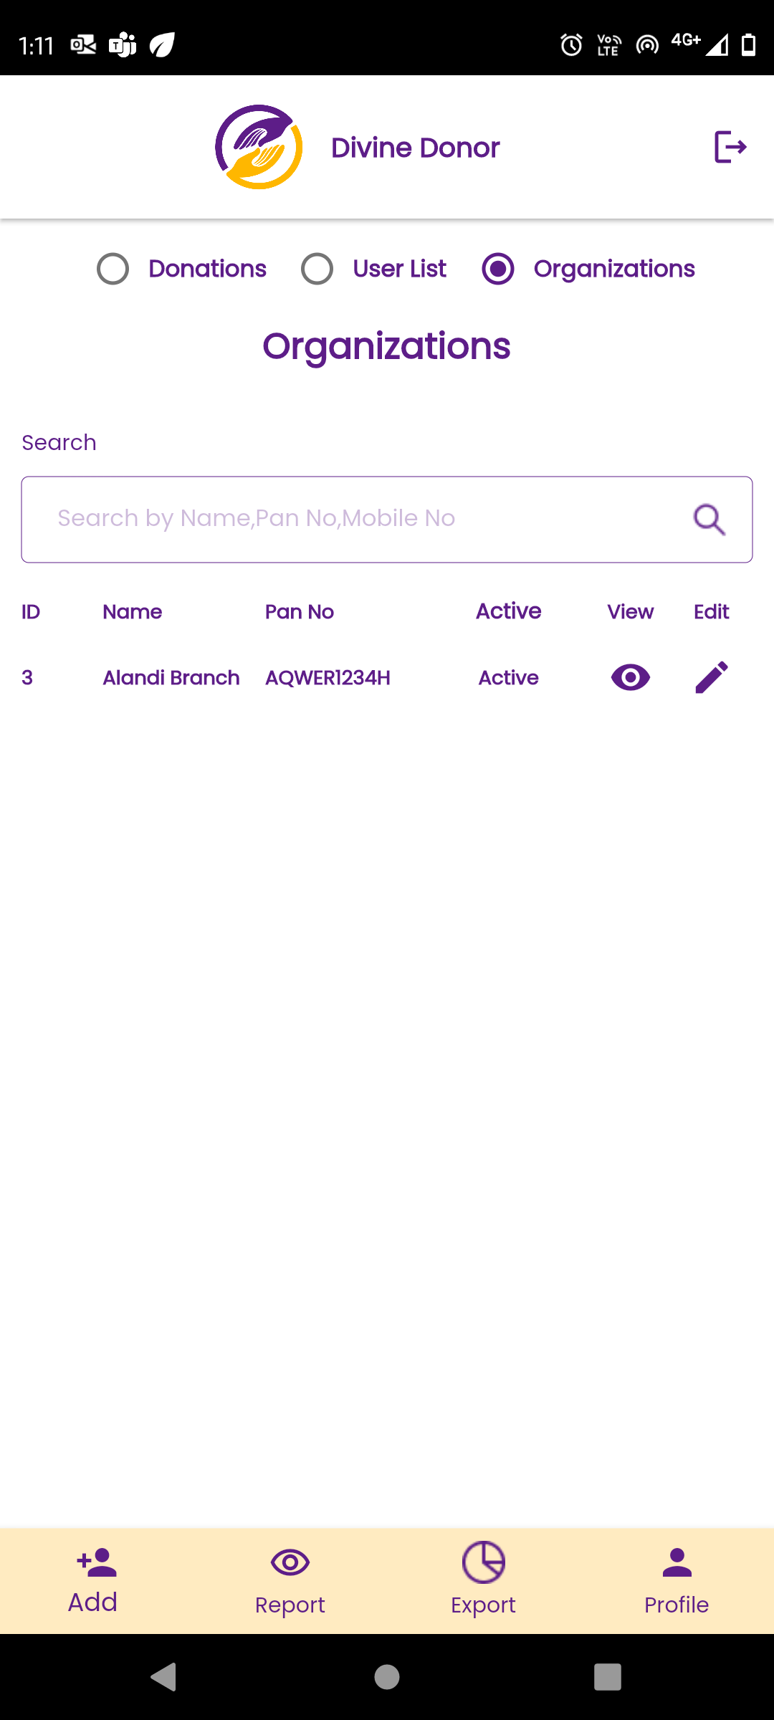

Fig: Organization list in report of mobile app

Once tenant clicks on view action of mobile app, it will display following read only fields:

* Organization name
* Pan no
* Address 1
* Address 2
* Contact no
* WhatsApp no.
* GST no.
* 80G Number
* Is Active
* created at and by
* Updated at and by

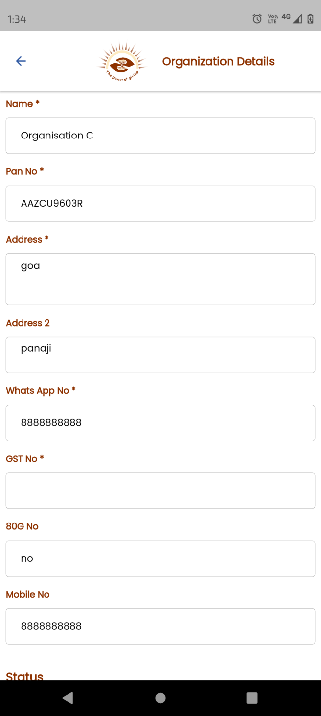

Fig: View action of organization report

Once tenant clicks on edit action of mobile app, following editable fields will be displayed:

* Organization name
* Pan no
* Address 1
* Address 2
* Contact no
* WhatsApp no.
* GST no.
* 80G Number
* Is Active
* Cancel button
* Save button

Also, once super admin / admin log into web app, added organization will be displayed in web app -> organization master. Following fields will be displayed in grid:

* Tenant id
* Organization name
* Contact info
* Whatsapp no.
* Pan no.
* Gst no.
* Status - active / inactive
* Created at and by
* View action
* Edit action

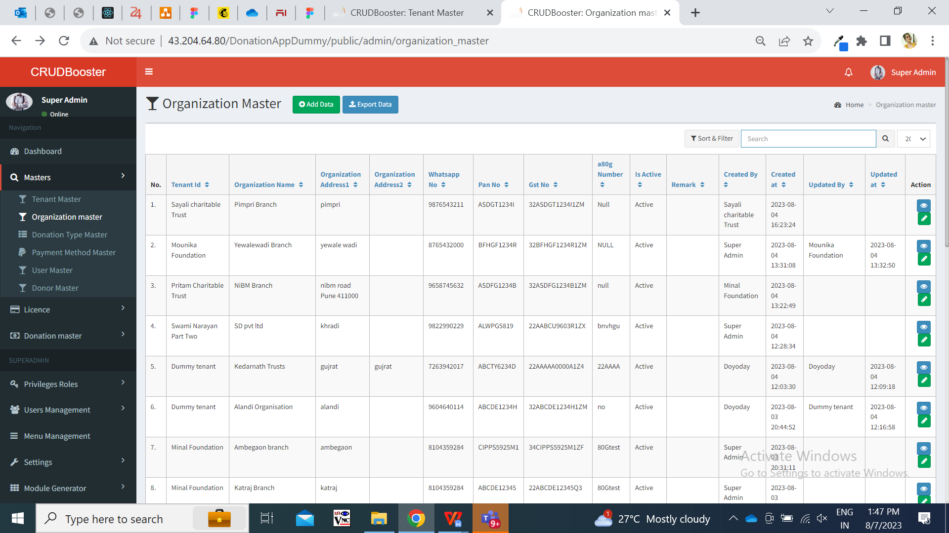

Fig: web app -> organization master -> grid

In grid of organization master, we need ‘Export’ button to download the list of organizations which are displayed in grid. Once tenant or super admin clicks on export button then excel file will get downloaded which will contain data as per grid and have following columns in it:

* Organization name
* Pan no
* Address 1
* Address 2
* Contact no.
* Whatsapp no.
* Gst no
* 80G number
* Is Active
* Created on - date and time
* Updated at and by

Here, for super admin it will display list of all organizations as in grid however for tenant it will display only organizations of his mapped tenants.

* 1. **ADD USER**

User will be created and mapped with multiple organization of that tenant. To fill the donation form in mobile app, user has to be created under tenant and one or more organizations has to be mapped to user.

Once Tenant logs into the mobile application using his email and password, he can add user through add menu. While adding user, it will display following fields in form:

* Name of user
* Email
* Select organization
* Password
* Mobile no.
* Whatsapp no.
* Photo
* Cancel button
* Save button

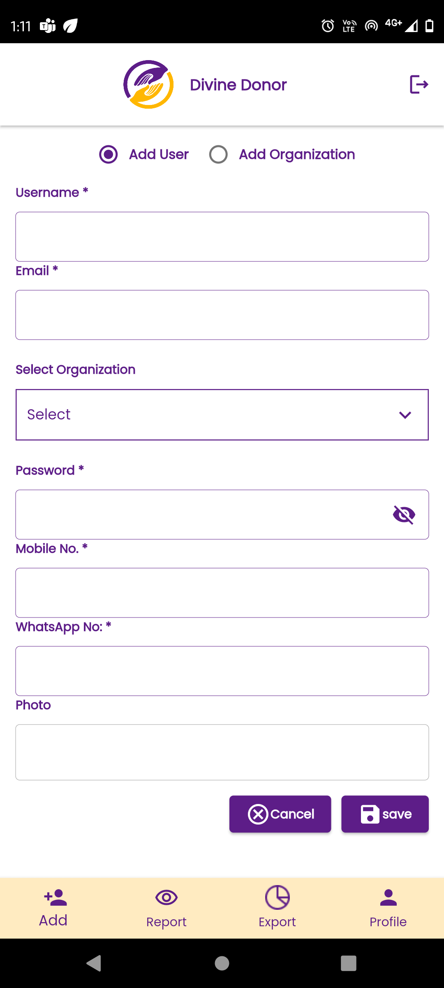

Fig: Add User (mobile)

**Input table**

|  |  |  |  |
| --- | --- | --- | --- |
| **FIELDS** | **INPUT TYPE** | **MANDATORY/ OPTIONAL** | **DESCRIPTION** |
| Name of user | Text | Mandatory | Precondition:- Initially this field will be blank.  Post condition:- Once tenant enters user name, other fields and submits the form then the user will get added against that tenant under selected organization only. And, added details and its user name will be displayed in top row of report -> user list. Also, this will be displayed in view action of the added user through report -> user list -> view action.  Validation:- It should accept maximum 25 characters. It should accept characters and numbers only. It shouldn’t accept space or special characters. |
| Email | Text | mandatory | Precondition:- Initially this field will be blank.  Post condition:- Once tenant enters email, other fields and submits the form then the user will get added against that tenant under selected organization only. And, added details and its user name will be displayed in top row of report -> user list. Also, this will be displayed in view action of the added user through report -> user list -> view action.  Validation:- It will be unique for each user. It should accept maximum 50 characters. It should accept characters, number. It should not accept space. It should accept @ . _ and - special characters only. |
| Select organization | Drop-down | Mandatory | Precondition:- Initially this field will be blank.  Post condition:- Once tenant selects organization names from the drop-down user name will be displayed in top row of report -> user list. Also, this will be displayed in view action of the added user through report -> user list -> view action.  Validation:- It will display active organization names under that tenant in this drop-down list. Tenant can select multiple organizations names that means one user can be mapped with multiple organizations of that tenant. |
| Password | text | mandatory | Precondition:- Initially this field will be blank.  Post condition:- Once tenant enters password, other fields and submits the form then the tenant will get added. And, added details will be displayed in top row of grid view of tenant master page. Also, details will be displayed in view action of the added tenant where password field will be kept blank.  Validation:- Minimum length will be 6 digits. It should accept characters, numbers, special characters. It shouldn’t accept space. |
| Mobile info | Text | Mandatory | Precondition:- Initially this field will be blank.  Post condition:- Once tenant enters contact info, other fields and submits the form then the organization will get added against that tenant only. And, added details and its contact info will be displayed in report -> organization list -> view action.  Validation:- It will be unique for each user. It should accept maximum 10 characters. It should accept only numbers. It shouldn’t accept space / special characters / characters. It shouldn’t accept ten consecutive zeros or ten consecutive one. It should accept only 9 or 8 or 7 or 6 at the beginning. |
| WhatsApp no. | Text | Mandatory | Precondition:- Initially this field will be blank.  Post condition:- Once tenant enters contact number, other fields and submits the form then the tenant will get added. And, added details and its email will be displayed in top row of grid view of tenant master page. Also, this will be displayed in view action of the added tenant.  Validation:- It will be unique for each user. It should accept maximum 10 characters. It should accept only numbers. It shouldn’t accept space / special characters / characters. It shouldn’t accept ten consecutive zeros or ten consecutive one. It should accept only 9 or 8 or 7 or 6 at the beginning. |
| Photo | Attach | Mandatory | Precondition:- Initially this field will be blank and will display as no file chosen  Post condition:- Once tenant uploads image from the system, other fields and submits the form then the name of the attached image will be displayed in this field. Once tenant submits the form, then user will get added and will be displayed in the grid view. Once tenant clicks on view action of added user, then profile image will be displayed and tenant will be able to zoom it.  Also, when user logs into the mobile application, the photo will be displayed in the profile of the user.  Validation:- It should accept single image. It should accept jpg, jpeg, png, heic and webp extension image files only. |
| Cancel | click |  | Precondition:- Initially one or more fields in the form will be filled.  Post condition:- Once tenant clicks on cancel button then all the fields filled in the form will get blank and organization shouldn’t get added. Also, user should remain on the same page.  Validation:- Button will get disabled once clicked until all fields in the form gets blank. |
| Save | click |  | Precondition:- All mandatory fields will be filled in the form.  Post condition:- Once tenant fills all mandatory fields in form, clicks on ‘save’ button then the organization will get added successfully and it will be displayed in report -> user list view . And, user will be directed on the same page to fill the form for next organization.  Validation:- Button will get disabled once clicked until the successful pop-up message isn’t displayed. |

Once tenant adds user, it will be displayed in report -> user list of mobile app. It will display following columns in the table:

* ID
* User name
* Email
* Active status
* View action
* Edit action

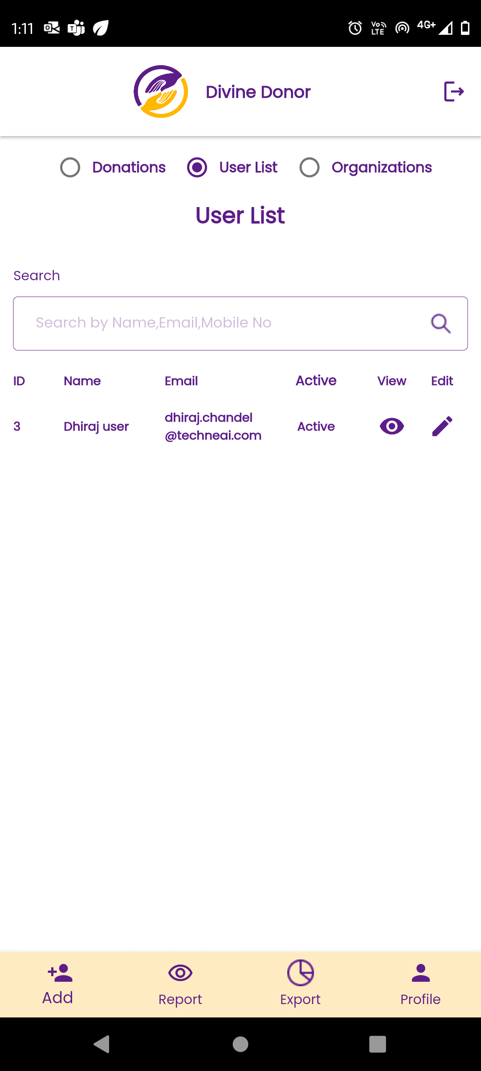

Fig: report -> list User (mobile)

Once tenant clicks on view action of mobile app, it will display following read only fields:

* Name of user
* Email
* Select organization
* Password
* Mobile no
* Whatsapp no
* Photo
* Active status

Once tenant clicks on edit action of mobile app, following editable fields will be displayed:

* Name of user
* Email
* Select organization
* Password
* Mobile no
* Whatsapp no
* Photo
* Active status
* Save button
* Back button

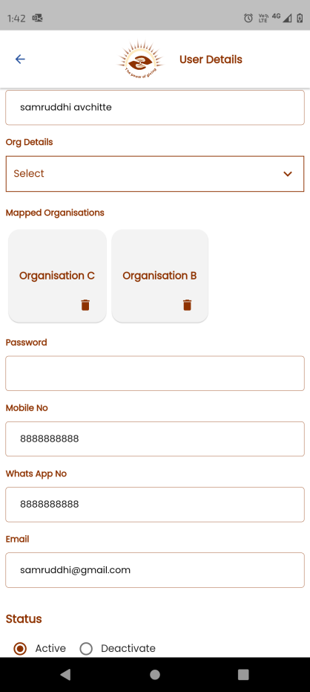

Fig: Edit action of user report in mobile

Also, once super admin / admin log into web app, added user will be displayed in web app -> user master. Following fields will be displayed in grid:

* Tenant id
* User name
* Email
* Profile
* Mobile no
* Whatsapp no
* View action
* Edit action

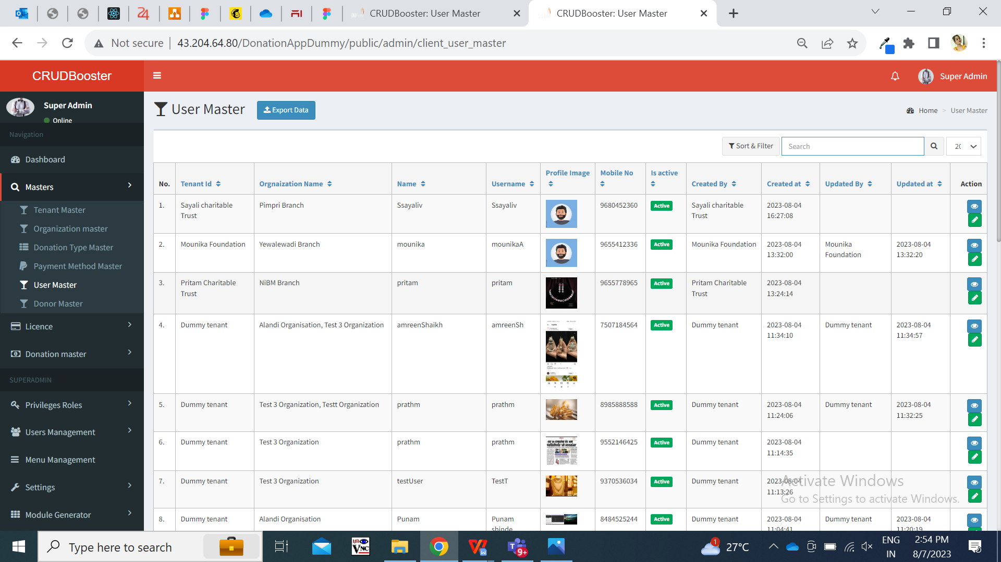

Fig: User master

In grid of user master, we need ‘Export’ button to download the list of users which are displayed in grid. Once tenant or super admin clicks on export button then excel file will get downloaded which will contain data as per grid and have following columns in it:

* User name
* Organizations
* Mobile no.
* Whatsapp no.
* Is Active
* Created on - date and time

Here, for admin it will display data of all users however for tenant it will display data only of his assigned user.

* 1. **DONATION TYPE MASTER**

Through donation type master, super admin will set the type of donations that will be displayed to each user as per his assigned organization.

Example; Sandeep Avchitte is tenant name. Organization A, Organization B and organization C are three organizations created & mapped under tenant - Sandeep Avchitte. Manali is the user mapped for organization A under tenant Sandeep Avchitte. Nivedita is the user mapped for organization A and organization B under tenant Sandeep Avchitte. Manisha is the user mapped for organization B and organization C under tenant Sandeep Avchitte.

Further, at organization A we have two donation types available Food donation and clothes donation mapped under it. Organization B has education and food donation type mapped under it. Organization C has food, clothes, education and land donation types mapped under it.

This means, when user Manali will log into mobile application and fill donation form then in donation type drop-down, manali will be able to see Food donation and clothes donation in the list.

Also, when user nivedita will log into mobile application and fill donation form then for organization A, nivedita will be able to see Food donation and clothes donation in the donation type list. Alternatively, when nivedita selects organization B then nivedita will be able to see education and food donation in the donation type drop-down.

Moreover, when user manisha will log into mobile application and fill donation form then for organization B, then manisha will be able to see education and food donation in the donation type list. Also, when manisha selects organization C then manisha will be able to see food, clothes, education and land donation types in the donation type drop-down.

Through web app, once admin clicks on add button of donation type master, it will display following fields:

* Tenant name
* Organization name
* Donation type name
* Remark
* Is active
* Save button
* Save & add more button
* Back button

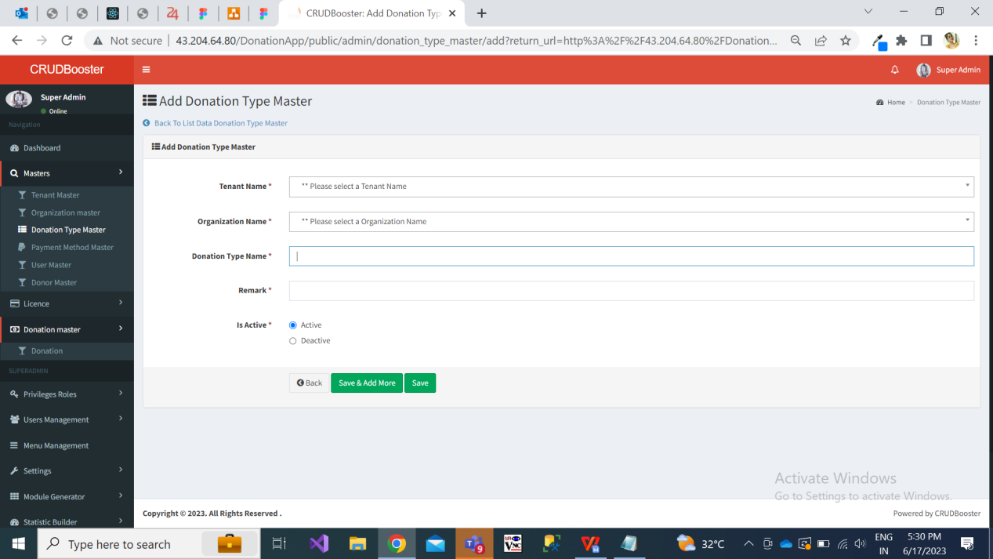

Fig: Add donation type

|  |  |  |  |
| --- | --- | --- | --- |
| **FIELDS** | **INPUT TYPE** | **MANDATORY/ OPTIONAL** | **DESCRIPTION** |
| Tenant name | Drop-down | Mandatory | Precondition:- Initially this field will be blank.  Post condition:- Once super admin selects tenant name, other fields and submits the form then the donation type will get added and mapped under the organization of the tenant. And, added details and its tenant name will be displayed in top row of grid of donation type master as well as in view action. Pop-up message of data added successfully will be displayed.  Validation:- It display active tenants in the list from tenant master. Only one tenant will get selected at a time. |
| Organization name | Drop-down | Mandatory | Precondition:- Initially this field will be blank.  Post condition:- Once super admin selects organization name, other fields and submits the form then the donation type will get added and mapped under the organization of the tenant. And, added details and its organization name will be displayed in top row of grid of donation type master as well as in view action. Pop-up message of data added successfully will be displayed. If user has entered multiple organizations, enters donation type and submits the form then in grid it will display added donation type for each organization separately.  Validation:- It display active organizations in the list from organization master. It will be multi select. |
| Donation type name | text | mandatory | Precondition:- Initially this field will be blank.  Post condition:- Once admin enters donation type name, other fields and submits the form then the donation type will get added and mapped under the organization of the tenant. And, added details and its organization name will be displayed in top row of grid of donation type master as well as in view action. Pop-up message of data added successfully will be displayed.  Validation:- It will be unique for each tenant wise organization. It should accept maximum 25 characters. It should accept characters, space, special characters and numbers. |
| Remark | text | mandatory | Precondition:- Initially this field will be blank.  Post condition:- Once super admin / admin enters remark, other fields and submits the form then the donation type will get added and mapped under the organization of the tenant. And, added details and its remark will be displayed in top row of grid of donation type master as well as in view action. Pop-up message of data added successfully will be displayed.  Validation:- It should accept maximum 100 characters. It should accept characters, numbers and space. It shouldn’t accept double space after one word. It should accept English and Marathi language. |
| Save & add more | Click |  | Precondition:- All mandatory fields will be filled in the form.  Post condition:- Once user fills all mandatory fields in form, clicks on ‘save and add more’ button then the tenant will get added successfully and it will be displayed in grid view. At the same time, user should remain on the same add form page where all fields will be displayed as blank.  Validation:- Button will get disabled once clicked until the successful pop-up message isn’t displayed. |
| Save | Click |  | Precondition:- All mandatory fields will be filled in the form.  Post condition:- Once super admin / admin fills all mandatory fields in form, clicks on ‘save’ button then the tenant will get added successfully and it will be displayed in grid view. And, user will be directed on grid page where recently added tenant will be displayed on top.  Validation:- Button will get disabled once clicked until the successful pop-up message isn’t displayed. |

Once donation type is added, it will be displayed in top row of grid in donation type master. The added donation types as per organization will be displayed in the mobile app -> donation form after user logs in.

Grid of donation type master will have following columns:

* Tenant name
* Organization name
* Donation type name
* Remark
* Created at and by
* Is active
* View action
* Edit action

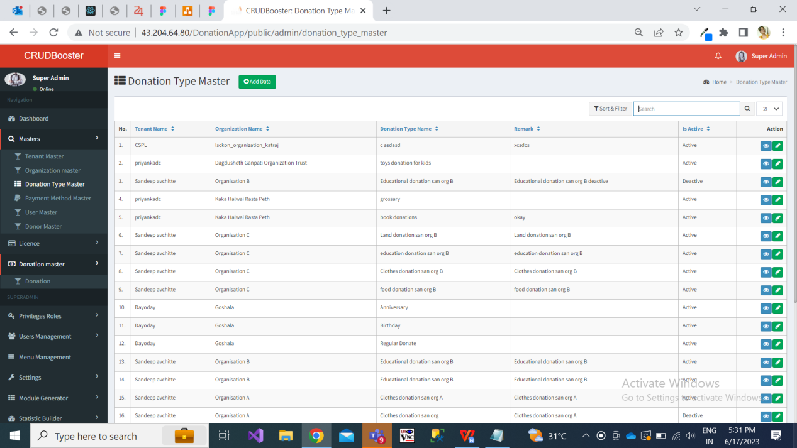

Fig: donation type master grid

Once user clicks on view action from grid, it will display following fields:

* Tenant name
* Organization name
* Donation type name
* Remark
* Is active
* Created at and by
* Updated at and by

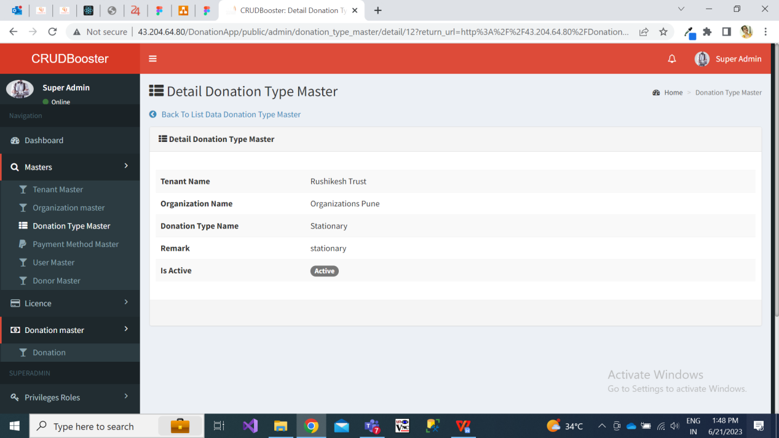

Fig: View action of donation type master

Once user clicks on edit action from grid, it will display following pre-filled and editable fields:

* Tenant name
* Organization name
* Donation type name
* Remark
* Is active
* Back button
* Save and add more button
* Save button

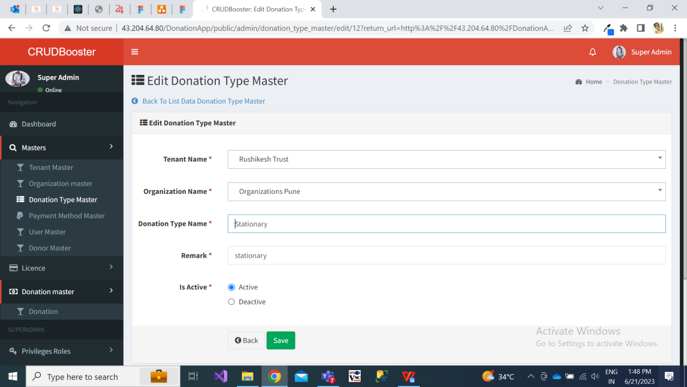

Fig: edit action of donation type master

In grid of donation type master, we need ‘Export’ button to download the list of users which are displayed in grid. Once tenant or super admin clicks on export button then excel file will get downloaded which will contain data as per grid and have following columns in it:

* Tenant name
* Organization name
* Donation type name
* Remark
* Is Active
* Created on - date and time
* Updated at and by
  1. **DONATION FORM**

Through donation form, user will fill the details of the donor and receipt will get sent on the donor’s whatsapp number. Also, the donation form once submitted, it will be displayed in the donation report of mobile app as well as in donation master -> donations of web app in super admin login.

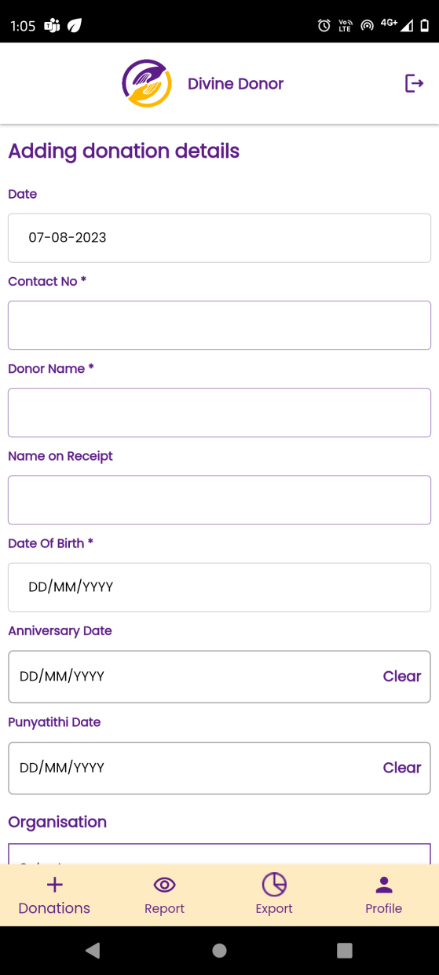

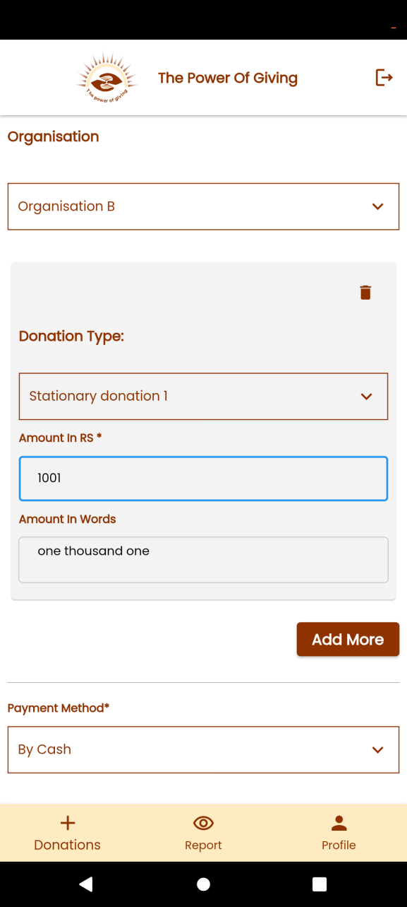

Fig: Add donation form (mobile)

Once user logs into mobile application using credentials entered by his tenant while creating user, it will display following fields in donation form:

* Date
* Contact no.
* Donor name
* Name on receipt
* Address
* Date of birth
* Anniversary date
* Punyatithi Date
* Organization
* Donation type
* Amount
* Amount in words
* Add more button
* Payment method
* Payment date
* Payment reference no. / UTR No. / Cheque no.
* Do you want 80g benefit
* Pan no
* Receipt type
* Save button
* Cancel button

|  |  |  |  |
| --- | --- | --- | --- |
| **FIELDS** | **INPUT TYPE** | **MANDATORY/ OPTIONAL** | **DESCRIPTION** |
| Date | Calendar picker | Mandatory | It is date on which user is submitting the donation form in the system.  Precondition:- By default it will display today’s date and it will be read only field.  Post condition:- Once user fill donation form details and clicks on submit, then donation form will be displayed in report of mobile app and web app where date will be displayed as while submitting form. Moreover, this date will be displayed in the whatsapp receipt which is sent to donor after submitting donation form.  Validation:- It will be read only field. It will display today’s date by default. |
| Contact no. | Text | mandatory | User will enter the mobile number of the donor. If the donor is giving donation for the first time, then user will have to manually fill all the fields of the donation form. If donor isn’t new, then as donor’s details are being saved in donor master, then second or another time when user will enter the donor’s number then details like donor name, name on receipt, DOB, anniversary date will get auto-filled as per data in donor master.  Precondition:- Initially this field will be blank.  Post condition:- Once user enters mobile number of the donor and if the number is already present in donor master against that tenant, then the other details like donor name, name on receipt, DOB, anniversary date will get auto-filled as per data in donor master. The fields which got auto-filled will be editable too. If number is new means not registered in donor master against that tenant, then user will have to manually fill all the details in the form. Once number is entered, all fields in form are filled and form is submitted then donation form will be displayed in report of mobile app and web app where number will be displayed in view action of donation detail.  Validation:- One mobile number of donor can be used by another tenant as donor may do donations at multiple tenants. It should accept only numbers and maximum 10 digits. It should accept space. It should accept 9 or 8 or 7 or 6 only at the beginning. |
| Donor name | Text | mandatory | User will enter the mobile number of the donor. If the donor is giving donation for the first time through registered contact number, then user will have to manually fill donor name and other all the fields of the donation form. If donor isn’t new, then donor name will get auto-filled after entering mobile number as per data in donor master.  Precondition:- Initially this field will be blank if contact number is new. Or else this field will get auto-filled if registered number already exist in our donor master under the specified tenant.  Post condition:- Once user enters mobile number of the donor and if the number is already present in donor master against that tenant, then donor name will get auto-filled as per data in donor master. The donor name which got auto-filled will be editable too. If number is new means not registered in donor master against that tenant, then user will have to manually fill all the details in the form including donor name. Once number is entered, all fields in form are filled and form is submitted then donation form along with donor name will be displayed in report of mobile app and web app will be displayed in view action of donation detail.  Validation:- Donor name field should accept maximum 50 characters. It should accept single space. It shouldn’t accept double space after one word. It shouldn’t accept numbers or special characters. |
| Name on receipt | text | mandatory | Name on receipt could be different from the donor name because there are cases where donor makes donation in the name of his relatives / family members / loved ones. When donation details form is submitted by user, then PDF receipt gets sent on donor’s whatsapp number. The receipt will contain name which is mentioned in ‘name on receipt’ field of donation form.  Precondition:- Initially this field will be blank if contact number is new. Or else this field will get auto-filled as per donor name.  Post condition:- Once user enters mobile number of the donor and if the number is already present in donor master against that tenant, then donor name will get auto-filled and the same will get auto-filled in ‘name on receipt’ field as per data in donor master. The name on receipt which got auto-filled will be editable too. If contact number is new means not registered in donor master against that tenant, then user will manually fill all the details in the form including donor name. As per name entered in donor master, it will be displayed in ‘name on receipt’ field. Once number is entered, all fields in form are filled and form is submitted then donation form along with donor name will be displayed in report of mobile app and web app will be displayed in view action of donation detail. Moreover, ‘name on receipt’ will be displayed in the whatsapp receipt which is sent to donor after submitting donation form.  Validation:- This field should accept maximum 50 characters. It should accept single space. It shouldn’t accept double space after one word. It shouldn’t accept numbers or special characters. |
| Address | text | mandatory | Address of the donor will be mentioned here.  Precondition:- Initially this field will be blank if contact number is new. Or else this field will get auto-filled as per donor contact number.  Post condition:- Once user enters mobile number of the donor and if the number is already present in donor master against that tenant, then address will get auto-filled as per data in donor master. Address will be editable too. If contact number is new means not registered in donor master against that tenant, then user will manually fill all the details in the form including address. Once number is entered, all fields in form are filled and form is submitted then donation form along with address will be displayed in report of mobile app and web app will be displayed in view action of donation detail.  Validation:- This field should accept maximum 100 characters. It shouldn’t accept double space after one word. It should accept characters, numbers special characters - / , only. |
| Date of birth | Calendar picker | mandatory | Date of birth of the donor will be mentioned here.  Precondition:- Initially this field will be blank if the entered contact number is new.  Post condition:- Once user enters mobile number of the donor and if the number is already present in donor master against that tenant, then DOB will get auto-filled as per data in donor master. It will be editable too. If number is new means not registered in donor master against that tenant, then user will have to manually fill all the details in the form including DOB. Once number is entered, all fields in form are filled and form is submitted then donation form will be displayed in report of mobile app and web app and also new donor / updated details of DOB will be displayed in grid & view action of donor master in web app.  Validation:- It will display dates only till today’s / current date. Only one date will get selected and displayed in DD/MM/YYYY format. |
| Donor’s Anniversary date | Calendar picker | Optional | Date of anniversary of the donor will be mentioned here.  Precondition:- Initially this field will be blank if the entered contact number is new.  Post condition:- Once user enters mobile number of the donor and if the number is already present in donor master against that tenant, then anniversary date will get auto-filled as per data in donor master. It will be editable too. If number is new means not registered in donor master against that tenant, then user will have to manually fill all the details in the form including date of anniversary. Once number is entered, all fields in form are filled and form is submitted then donation form will be displayed in report of mobile app and web app and also new donor / updated details of anniversary date will be displayed in grid & view action of donor master in web app.  Validation:- It will display dates only till today’s / current date. Only one date will get selected and displayed in DD/MM/YYYY format. Anniversary date shouldn’t be as same as DOB. |
| Relative’s Punyatithi date | Calendar picker | Optional | Date of death of relative on whose behalf / occasion the donor is making donation, it will be mentioned here.  Precondition:- Initially this field will be blank if the entered contact number is new.  Post condition:- Once user enters mobile number of the donor and if the number is already present in donor master against that tenant, then anniversary date will get auto-filled as per data in donor master. It will be editable too. If number is new means not registered in donor master against that tenant, then user will have to manually fill all the details in the form including date of anniversary. Once number is entered, all fields in form are filled and form is submitted then donation form will be displayed in report of mobile app and web app and also new donor / updated details of anniversary date will be displayed in grid & view action of donor master in web app.  Validation:- It will display dates only till today’s / current date. Only one date will get selected and displayed in DD/MM/YYYY format. Anniversary date shouldn’t be as same as DOB. |
| Organization | Drop-down | mandatory | User will select for which organization the donation has to be taken from the donor.  Precondition:- Initially this field will be blank.  Post condition:- Once user select the organization name from drop-down, user will have to enter the donation type details and submit the form. Once the donation form is submitted, it will be displayed in web app and mobile app -> donation report. Also, in view action of donation master from web app, it will display the organization type selected.  Validation:- It will display organizations only mapped to the user while adding user. It can be viewed from user master’s organization column. It will display only active organizations of organization master for particular tenant. It will be single select. |
| Donation type | Drop-down | mandatory | User will select for the donation type which has to be taken from the donor.  Precondition:- Initially this field will be blank.  Post condition:- Once user select the donation type name from drop-down, user will have to enter the amount details and submit the form. Once the donation form is submitted, it will be displayed in web app and mobile app -> donation report. Also, in view action of donation master from web app, it will display the donation type selected.  Validation:- It will display donation types only mapped under the selected organization from donation type master of web app. It will display only active donation type for particular tenant from donation type master of web app. It will be single select. |
| Amount | text | mandatory | User will enter the amount that donor is giving for particular donation type under selected organization.  Precondition:- Initially this field will be blank.  Post condition:- Once user enters the amount, then amount in words will be displayed below and user will submit the form. Once the donation form is submitted, it will be displayed in web app and mobile app -> donation report which will include donation amount. Also, in view action of donation master from web app, it will display the amount. Moreover, amount will be displayed in the whatsapp receipt which is sent to donor after submitting donation form.  Validation:- It should accept only numbers. It shouldn’t accept space or characters or special characters. It should accept maximum ten digit amount. It shouldn’t accept 0 in the beginning. |
| Amount in words | text | mandatory | User will enter the amount that donor is giving for particular donation type under selected organization. And as per entered amount, amount in words will be displayed.  Precondition:- Initially this field will be blank.  Post condition:- Once user enters the amount, then amount in words will be displayed below and user will submit the form. Once the donation form is submitted, it will be displayed in web app and mobile app -> donation report which will include donation amount. Also, in view action of donation master from web app, it will display the amount.  Validation:- It will be read only. |
| Add more | click | optional | If donor wants to do donation of more than one donation type, then user will click on add more button and fill details of another donation type.  Precondition:- Initially this button will remain un-clicked.  Post condition:- Once user clicks on add more button, it will display donation type, amount and amount in words fields which will be blank initially. Also, this new row which got added will have delete button to it.  Validation:- Button once clicked will be disabled until three fields aren’t displayed below.  Add more button will get clicked only the number of donation types are available in the list as per organization of that tenant. Example: organization C has four types of donations available in it. Hence add more button will get clicked only 3 times because one donation type box entry is going to be displayed by default. Hence, 1 + 3 other donation type boxes = 4. |
| Payment method | Drop-down | mandatory | Payment method of donation given by donor will be by cash, by cheque, and UPI / Online.  Pre condition:- Initially it will be blank.  Post condition:- If user select by cheque as payment method, then payment date and cheque no text field will be displayed below where user will enter the cheque number which donor has given. Else, if user selects UPI/online as payment method, then payment date and payment reference no. / UTR no. text field will be displayed below where user will enter the number which donor has given while making transaction.  Validation:- it will be active payment method from payment method master of web application in super admin login. It will be single select. |
| Payment date | Calendar picker | mandatory | User will have to mention the date on which the payment was made by the donor by cheque / upi / online method. It could be different from today’s date and hence this field is needed.  Pre condition- Initially it will be blank.  Post condition:- Once user enters the payment date, other fields and submits the form then the donation form is submitted, it will be displayed in web app and mobile app -> donation report which will include donation amount. Also, in view action of donation master from web app, it will display the amount. Moreover, amount will be displayed in the whatsapp receipt which is sent to donor after submitting donation form.  Validation:- It will display dates only till today / current date. |
| Cheque no / utr no / payment reference no | text | mandatory | If donor has given donation by cheque, then user will have to note down cheque number.  If donor has given donation by UPI / online then user will have to note down payment reference number / UTR number.  Precondition- Initially it will be blank.  Post condition:- If user select by cheque as payment method, then payment date and cheque no text field will be displayed below where user will enter the cheque number which donor has given. Else, if user selects UPI/online as payment method, then payment date and payment reference no. / UTR no. text field will be displayed below where user will enter the number which donor has given while making transaction.  Validation:- Cheque number field should accept only numbers and will be of maximum 15 digits.  UTR number should accept maximum 16 digits and should accept characters and numbers only.  Payment reference number should accept maximum 16 digits and should accept characters and numbers only. |
| Do you want 80g benefit? | Radio button | optional | If donor wants to have exemption in tax, then donor will apply for 80G benefit.  Precondition:- Initially it will be un-clicked.  Post condition:- Once user clicks on 80G radio button, then pan number text field will be displayed.  Validation:- Once clicked it will display pan number field. If user clicked on radio button again, then pan number field should disappear. |
| Pan no | text | mandatory | Once user clicks on 80G radio button, then pan number text field will be displayed.  Precondition:- Initially this field will be blank. Or else, if donor has already done previous donation and we have donor’s pan number in donor master, then that pan number will be displayed here as per registered number.  Post condition:- Once tenant enters pan number and submits the form then added details and its pan number will be displayed in donor master. Also, this donation will be displayed in report of mobile app and web app.  Validation:- It should accept 10 characters for each tenant. It includes first five letters, followed by 4 numbers and last character. |
| Receipt type | Radio button | mandatory | It will display manual or system generated receipt.  Precondition:- Initially system generated radio button will be clicked.  Post condition:- If user clicks on manual receipt, then field to attach image will be displayed where user will upload image of invoice copy which is available in his mobile. If user select system generated receipt option then there is no need to attach image. Once user clicks on submit, Also, this donation will be displayed in report of mobile app and web app.  Validation:- Attach image will accept jpg, jpeg, png, heic, webp and pdf extensions only. |
| save | click |  | Post condition:- Once donation form is submitted, successful pop-up message will be displayed on application and all fields in the form will get blank. At the same time, thank you note and receipt will be sent to the donor via whatsapp. Also, the donation will be reflected in report of mobile of that user as well as in donation master of web app in super admin login and tenant’s login.  Validation:- save button will be disabled until successful pop-up message gets displayed. |
| Cancel | click |  | Precondition:- minimum one field will be filled with some data.  post condition:- Once user clicks on cancel button, then all data filled in the fields will get blank and donation form shouldn’t get submitted. Whereas, user should remain on the same page of adding donation.  Validation:- cancel button will be disabled until all fields doesn’t get blank. |

Once donation form is submitted, then thank you note and receipt will be sent to the donor via whatsapp. Also, the donation will be reflected in report of mobile of that user as well as in donation master of web app.

Note:- Receipt of each tenant will differ that means header, logo and footer of the receipt format will vary from tenant to tenant (custom view).

In addition to this, every 3 days prior to the date of birth or date of anniversary or punyatithi date, message will get sent to donor via whatsapp and sms for recommending donor to make donation on the respective occasion. The message setting can be different for each tenant and hence need it on web app.

* 1. **DONOR MASTER**

Once donation form is submitted, then the details of the donor will be displayed in donor master. If donor’s number is new then it will be considered as new donor and its details will get saved in donor master.

In grid of donor master, following fields will be displayed:

* Tenant name
* Donor name
* Mobile no.
* Pan no.
* DOB
* Is active
* View action
* Edit action

Here, all details will be displayed as per the details entered by user while submitting the donation form. When user enters contact no of the donor in the donation form, then if mobile no. already exist in donor master, then the details (name, DOB, address, pincode, DOA, pan no.) of the donor will get auto-filled as per data available in donor master against the entered number.

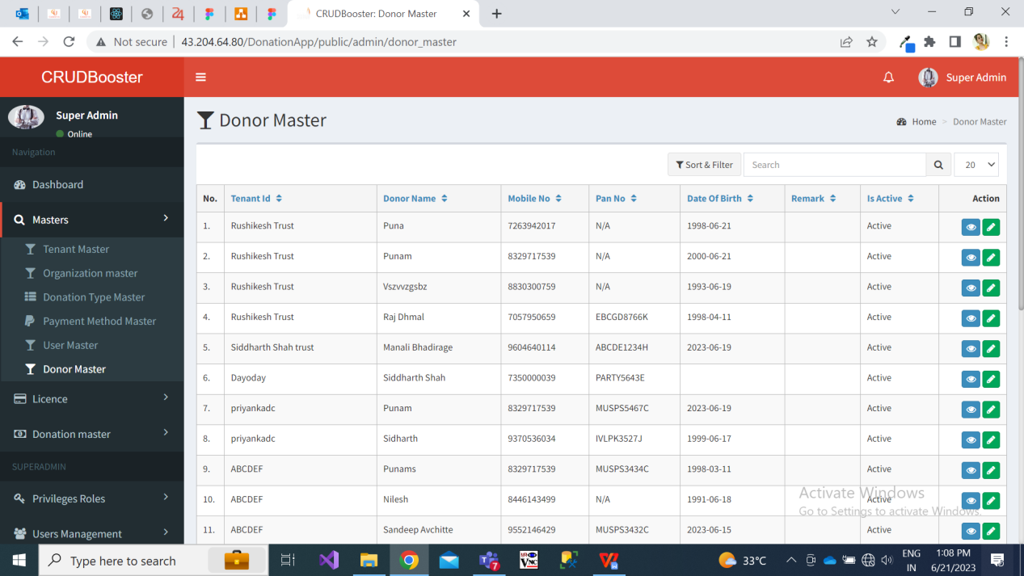

Fig: Donor master

Once user clicks on view action from grid of donor master, then it will display following read only fields:

* Tenant name
* Donor name
* Mobile no.
* Address
* Pin code
* Pan no.
* DOB
* DOA
* Is active

Once user clicks on edit action from grid of donor master, then it will display following pre-filled editable fields:

* Tenant name
* Donor name
* Mobile no.
* Address
* Pin code
* Pan no.
* DOB
* DOA
* Is active (yes / no radio button)
  1. **REPORT**

Each user will be able to view donations only processed by himself. Each tenant will be able to view all donations processed by all his mapped users. And, all donations of all tenants will be displayed in donation master on web app for super admin.

Report of donation in mobile will have following fields:

* Search menu
* Date
* Amount
* Donor name
* Donation type
* View action
* Download receipt action

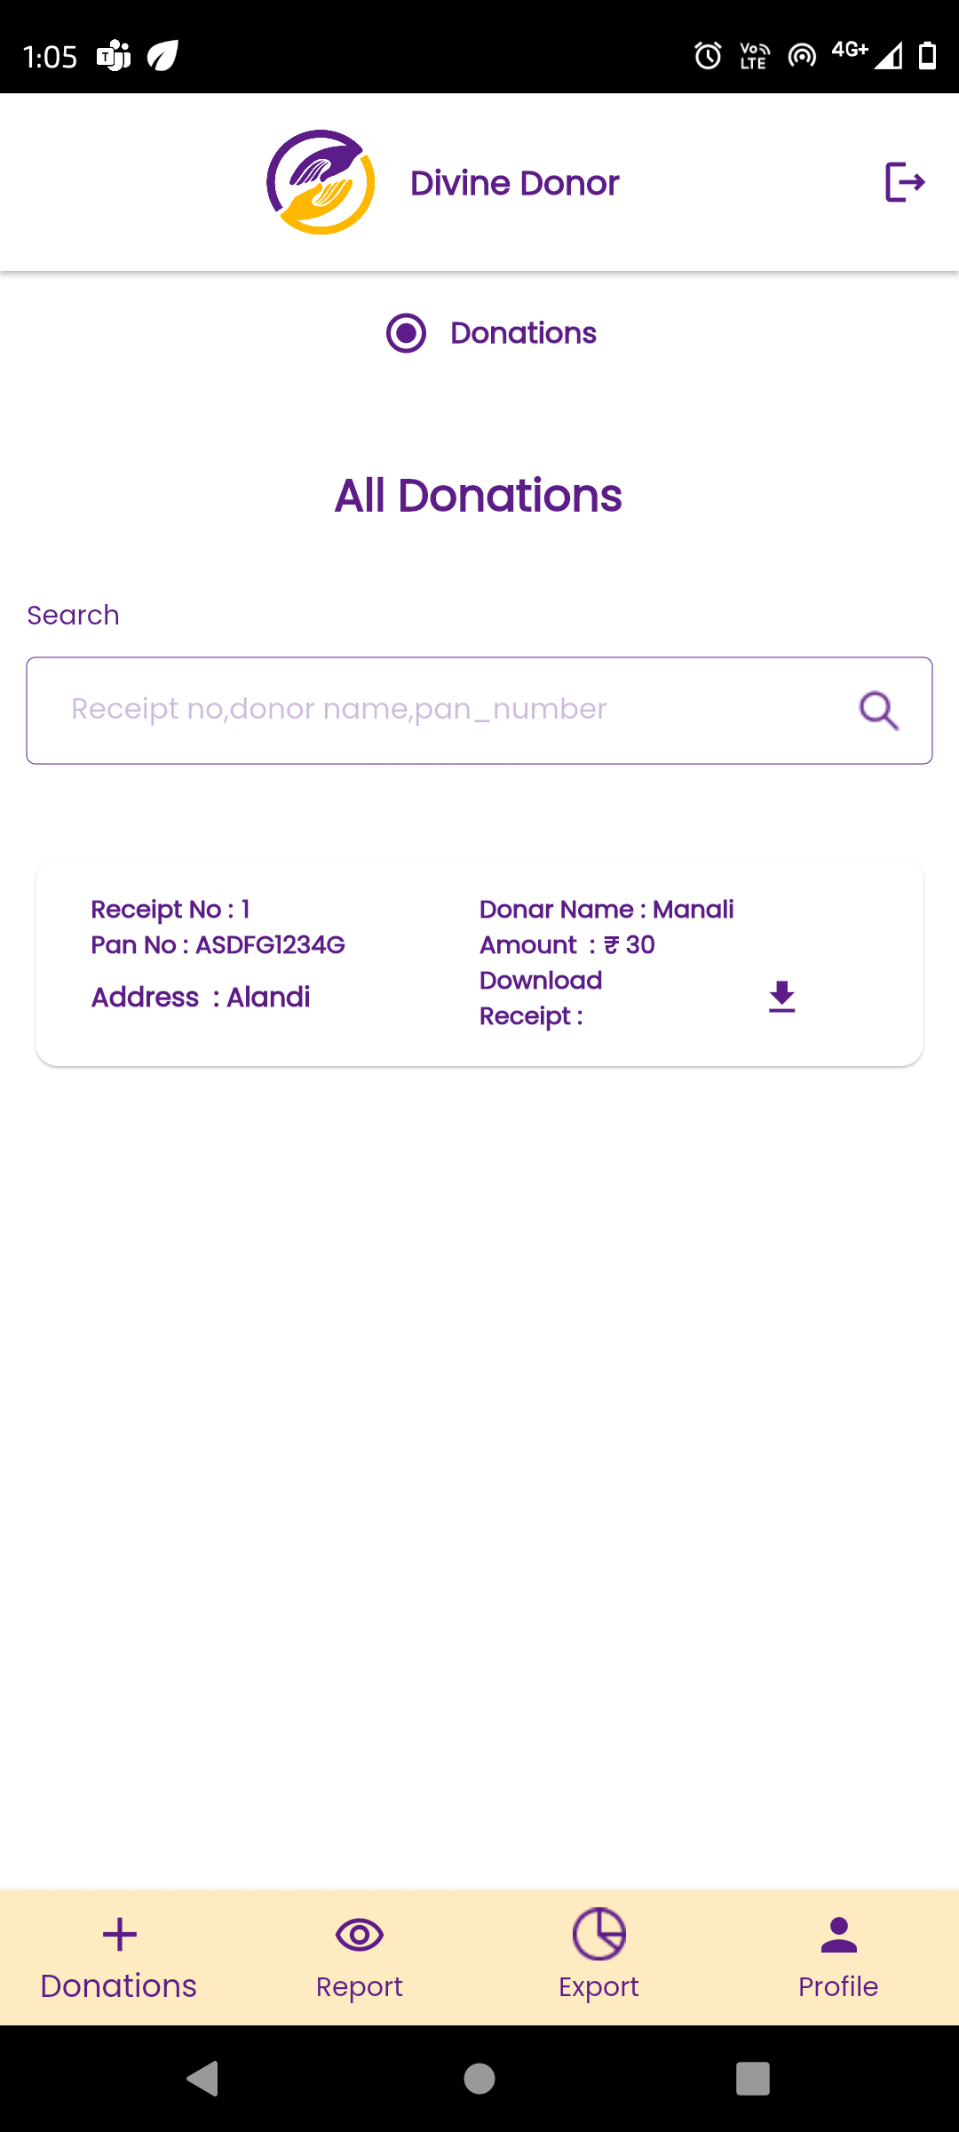

Fig: Donation report in mobile app

Here, recently done donation will be displayed on top. Receipt number will be displayed in incremental manner each time when donation is made by any user of tenant. All the details in the view action and receipt will be displayed as per the donation form which was submitted.

Through search menu, user or tenant can search by donor name or receipt number.

Through download receipt action, user or tenant can download the receipt in PDF extension.

Moreover, in export menu of donation mobile app, we need to provide ‘Download excel’ option through which user or tenant can get data of all his donations for each type in excel format. The downloaded excel file will contain data of donations in following columns:

* Sr. No.
* Receipt no.
* Donation Date
* Donation type
* Customer name
* Amount
* Payment method
* Donation processed by (user name)

Here, for tenant it will display all data of donations done by its users. If user has logged into app and downloads excel file of donations report, then in excel file it will display donation data only processed by user himself.

In web app -> donation master -> donation report, it will display following fields in grid as per donations done from user side:

* Export data button (Download all data as in grid)
* Receipt no.
* Date
* Tenant name
* Organization name
* Donor name
* Name on receipt
* Contact no.
* Amount
* Payment method
* Donation processed by (user name)
* Receipt type (manual / system generated)
* Donation source (website / mobile app)
* Receipt (hyperlink to download pdf)
* View action

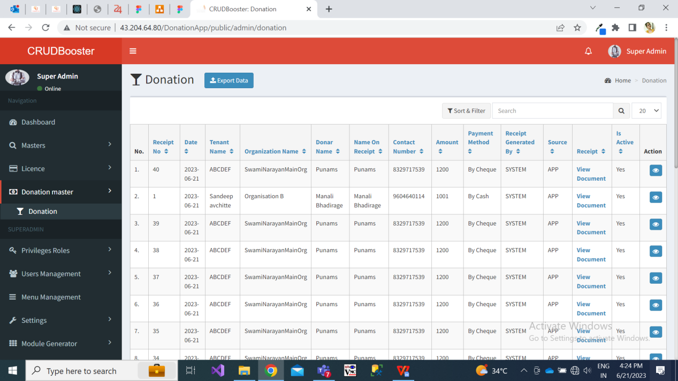

Fig: Donation report grid in web app

Once tenant / super admin clicks on view action, it will display all details of donation as mentioned while submitting donation form. It will display following read only fields:

* Receipt no.
* Date
* Tenant name
* Organization name
* Donor name
* Name on receipt
* Contact no.
* Donation type and its amount (display in table format if more than one donation type are selected for making donations)
* Payment method
* Payment ref no. / UTR no. / cheque no.
* Donation processed by (user name)
* Receipt type (manual / system generated)
* Donation source (website / mobile app)
* Receipt (hyperlink to download pdf)
  1. **PROFILE**

1. Tenant profile:-

Once tenant logs into **mobile application**, in profile menu it will display details of the tenant which was mentioned by super admin while creating the tenant. Its profile will have following fields:

* Profile image
* Name
* Email
* Contact no.
* New password
* Old password
* Apply changes button

|  |  |  |  |
| --- | --- | --- | --- |
| **FIELDS** | **INPUT TYPE** | **MANDATORY/ OPTIONAL** | **DESCRIPTION** |
| Profile image | attach | Mandatory | Precondition:- Initially it will display the image that was attached by super admin while creating the tenant.  Post condition:- Once tenant changes the image and clicks on apply changes, then updated image will be displayed in tenant’s profile i) on mobile app, ii) in grid and view action of tenant master at web app, iii) logo of mobile app in tenant master login and iv) logo of mobile app to users mapped under that tenant.  Validation:- It should accept png, jpg, JPEG, heic, PDF and webp extensions only. |
| Name | text | mandatory | Precondition:- Initially it will display the name of the tenant as entered by super admin while creating the tenant.  Post condition:- If tenant edits and changes the name, then the updated tenant name will be displayed in the web app and next time when tenant visits his profile page.  Validation:- It will be unique name. It should accept maximum 50 characters. It should accept characters, numbers and space. It shouldn’t accept double space after one word. |
| email | text | mandatory | Precondition:- Initially it will display the email as entered by super admin while creating the tenant.  Post condition:- If tenant edits and changes the email, then the updated email will be displayed in the web app and next time when tenant visits his profile page.  Validation:- It will be unique. It should accept maximum 50 characters. It should accept characters, number. It should not accept space. It should accept @ . _ and - special characters only. |
| Contact no. | text | mandatory | Precondition:- Initially it will display the contact no. as entered by super admin while creating the tenant.  Post condition:- If tenant edits and changes the contact number, then the updated contact number will be displayed in the web app and next time when tenant visits his profile page.  Validation:- It will be unique. It should accept maximum 10 digits. It should accept only numbers. It shouldn’t accept space / special characters / characters. It should accept only 9 or 8 or 7 or 6 at the beginning. |
| New password | text | optional | Pre condition:- Initially it will be blank.  Post condition:- If tenant wants to change the password then tenant will enter his new password in this field and click on apply changes. Password will get updated successfully. Next time when tenant has logged off from the mobile application and tries to log into the mobile application, tenant will have to enter his recently updated means new password.  Validation:- Minimum length will be 6 digits. It should accept characters, numbers, special characters. It shouldn’t accept space. |
| Old password | text | Optional | Pre condition:- Initially it will be blank.  Post condition:- To update new password, tenant will have to enter his old password as well. Once old password is entered correctly and tenant clicks on apply changes button, then password will get updated successfully. Next time when tenant has logged off from the mobile application and tries to log into the mobile application, tenant will have to enter his recently updated means new password.  Validation:- It has to match to the password which was set earlier. |
| Apply changes | click |  | Precondition:- It will be disabled if any changes are not made in any of the field in the profile page.  Post condition:- Once tenant has made any changes and clicks on apply changes button, then updated changes of tenant will be reflected in mobile app -> profile page of tenant as well as in tenant master on web app. It will display successful pop-up messages once changes are done and saved.  Validation:- It should disable once clicked until changes aren’t updated about profile. |

Once tenant admin logs into **web application**, it will display following fields in profile:

* Tenant Name
* Email
* Photo
* Password
* Confirm password
* SMS before days

|  |  |  |  |
| --- | --- | --- | --- |
| **FIELDS** | **INPUT TYPE** | **MANDATORY/ OPTIONAL** | **DESCRIPTION** |
| Tenant name | Text | Mandatory | Precondition:- Initially it will display the tenant name as mentioned by the super admin while adding this tenant.  Tenant can change his name and this updated tenant name will be displayed in tenant master of super admin, profile of tenant, tenant ID field in organization master.  Validation:- It will be unique name. It should accept maximum 50 characters. It should accept characters, numbers and space. It shouldn’t accept double space after one word. |
| Email | text | Mandatory | Precondition:- Initially it will display the email as mentioned by the super admin while adding this tenant.  Tenant can change his name and this updated email address will be displayed in tenant master of super admin and profile of tenant.  Validation:- It will be unique. It should accept maximum 50 characters. It should accept characters, number. It should not accept space. It should accept @ . _ and - special characters only. |
| Password | text |  | Precondition:- Initially it will be blank as it will be confidential.  Once tenant changes the password then tenant will be able to login into mobile as well as web application using new password.  Validation:- Minimum length will be 6 digits. It should accept characters, numbers, special characters. It shouldn’t accept space. |
| Confirm password | text | mandatory | Precondition:- Initially it will be blank.  If tenant enters some value in password field then tenant will have to compulsorily enter same values in confirm password field.  Validation:- Minimum length will be 6 digits. It should accept characters, numbers, special characters. It shouldn’t accept space. |
| Profile image | Attach | Mandatory | Precondition:- Initially it will display the image as attached by the super admin while adding this tenant.  Once tenant admin attachs new image, then it will be displayed in super admin -> tenant master, tenant profile, logo in user’s login and in receipt.  Validation:- It should accept single image. It should accept jpg, jpeg, png, pdf, heic and webp extension image files only. |

1. User profile:-

Once user logs in to mobile application ,then in profile page it will display the details which were entered by tenant while adding user. Profile page of user on mobile app should have following fields:

* Profile image
* Name of user
* Email
* organization
* Mobile no
* Whatsapp no
* New password
* Old password
* Apply changes

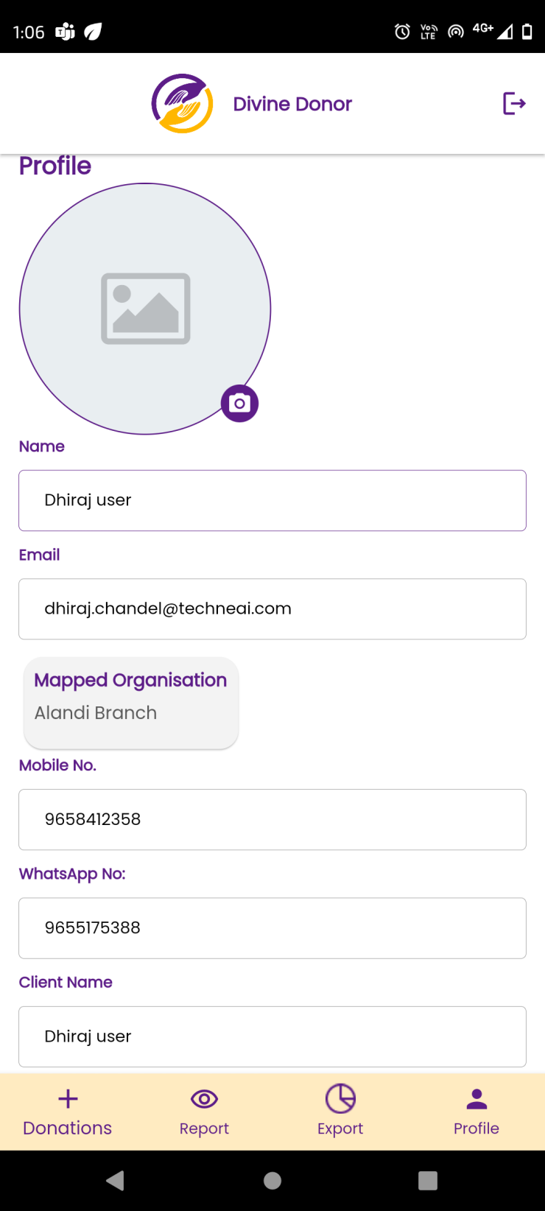

Fig: User profile in mobile app

|  |  |  |  |
| --- | --- | --- | --- |
| **FIELDS** | **INPUT TYPE** | **MANDATORY/ OPTIONAL** | **DESCRIPTION** |
| Profile image | attach | Mandatory | Precondition:- Initially it will display the image that was attached by tenant while creating the user.  Post condition:- Once user changes the image and clicks on apply changes, then updated image will be displayed in I) user’s profile on mobile app, ii) in grid and view action of user master at web app.  Validation:- It should accept png, jpg, JPEG, heic, PDF and webp extensions only. |
| Name of the user | text | mandatory | Precondition:- Initially it will display the name of the user that was entered by tenant while creating the user.  Post condition:- Once user changes the name and clicks on apply changes, then updated name will be displayed in I) user’s profile on mobile app, in user report of tenant’s mobile app and in user master of web app.  Validation:- |
| email | text | mandatory | Precondition:- Initially it will display the email of the user that was entered by tenant while creating the user.  Post condition:- Once user changes the email and clicks on apply changes, then updated email will be displayed in I) user’s profile on mobile app, in user report of tenant’s mobile app and in user master of web app.  Validation:- It should accept maximum 50 characters. It should accept characters, number. It should not accept space. It should accept @ . _ and - special characters only. |
| Contact no | text | mandatory | Precondition:- Initially it will display the contact no. of the user that was entered by tenant while creating the user.  Post condition:- Once user changes the contact number and clicks on apply changes, then updated contact number will be displayed in I) user’s profile on mobile app, in user report of tenant’s mobile app and in user master of web app.  Validation:- It will be unique. It should accept maximum 10 digits. It should accept only numbers. It shouldn’t accept space / special characters / characters. It should accept only 9 or 8 or 7 or 6 at the beginning. |
| Whatsapp no | text | mandatory | Precondition:- Initially it will display the whatsapp no. of the user that was entered by tenant while creating the user.  Post condition:- Once user changes the whatsapp number and clicks on apply changes, then updated contact number will be displayed in I) user’s profile on mobile app, in user report of tenant’s mobile app and in user master of web app.  Validation:- It can be as same as whatsapp number mentioned in above field. It should accept maximum 10 digits. It should accept only numbers. It shouldn’t accept space / special characters / characters. It should accept only 9 or 8 or 7 or 6 at the beginning. |
| organization | text | mandatory | Precondition:- Initially it will display the list of organizations of the user that was entered by tenant while creating the user.  Post condition:- Once tenant has edited details of user from user report of mobile app and has changed organization, then updated organization will be displayed in profile and user master report of mobile and web app.  Validation:- It will be read only. It will not display disabled organizations. |
| New password | text | optional | Pre condition:- Initially it will be blank.  Post condition:- If user wants to change the password then user will enter his new password in this field and click on apply changes. Password will get updated successfully. Next time when user has logged off from the mobile application and tries to log into the mobile application, user will have to enter his recently updated means new password.  Validation:- Minimum length will be 6 digits. It should accept characters, numbers, special characters. It shouldn’t accept space. |
| Old password | text | Optional | Pre condition:- Initially it will be blank.  Post condition:- To update new password, user will have to enter his old password as well. Once old password is entered correctly and user clicks on apply changes button, then password will get updated successfully. Next time when user has logged off from the mobile application and tries to log into the mobile application, tenant will have to enter his recently updated means new password.  Validation:- It has to match to the password which was set earlier. |
| Apply changes | click |  | Precondition:- It will be disabled if any changes are not made in any of the field in the profile page.  Post condition:- Once user has made any changes and clicks on apply changes button, then updated changes of user will be reflected in mobile app -> profile page of user as well as in user master on web app. It will display successful pop-up messages once changes are done and saved.  Validation:- It should disable once clicked until changes aren’t updated about profile. |

1. **REFERENCES OF THE USERS**

|  |  |  |  |
| --- | --- | --- | --- |
| **User** | **Name** | **Mail** | **Contact number** |
| **Actual user** | Siddharth Shah | sidshah@csjewellers.com |  |
| **Ticket created by (if any)** | Manali bhadirage | Manali.bhadirage@techneai.com |  |
| **Assigned business analyst** | Manali bhadirage | Manali.bhadirage@techneai.com |  |
| **Assigned developer** | Punam shinde  Prathmesh shinde  goverdhan bollu | [Punam.shinde@techneai.com](mailto:Punam.shinde@techneai.com)  Prathmesh.shinde@techneai.com  goverdhan.bollu@techneai.com |  |
| **Assigned tester** | Priyanka dupargude | [Priyanka.dupargude@techneai.com](mailto:Priyanka.dupargude@techneai.com) |  |