Manali ashok bhadirage

Manali.bhadirage@techneai.com

17.07.2023

DELIVERY COUTER WEIGHT Verification

**Functional Requirement Document**

**CONTENTS**

1. TICKET DETAILS 2

2. VERSION CONTROL 2

3. APPROVALS 2

4. ESTIMATION 2

5. INTRODUCTION 3

6. BUSINESS REQUIREMENT 3

7. SCOPE 3

8. BUSINESS & SYSTEM RULES 4

9. ABBREVIATIONS & TERMS 4

10. EXISTING SYSTEM 4

11. GRAPHICAL REPRESENTATION 4

12. PROPOSED SYSTEM 5

13. TEST DATA 11

14. ODUS 11

15. REFERENCES OF THE USERS 11

1. **TICKET DETAILS**

|  |  |
| --- | --- |
| **Ticket ID** | TT13215 |
| **Ticket description** | Branch Madhe Connect Us la Barcode Scan Kelya Ntr Physical Wt Takta Ale Pahije. New Module Karun Dene. Formant Barcode Scan Item Name Physical WT Actual Wt Remark |
| **Created by** | Annappa Thikane / Rakesh |
| **Created on** | 15/06/2023 |
| **Priority** | medium |

1. **VERSION CONTROL**

|  |  |  |  |  |
| --- | --- | --- | --- | --- |
| **Sr. No** | **Version no** | **Version Date** | **User name** | **User department** |
| **1** | **1.0** | **17/07/2023** | **Annappa Thikane** | **Stock audit Team** |
|  |  |  |  |  |
|  |  |  |  |  |

1. **APPROVALS**

|  |  |  |
| --- | --- | --- |
| **Field** | **Name of the User** | **Approved date by the user** |
| **Actual User Name Actual User Department Organization Name** | Annappa Thikane  Stock Audit  CSJ |  |
| **Assigned BA** | Manali ashok bhadirage |  |
| **Assigned Developer** |  |  |
| **Assigned Tester** |  |  |

1. **ESTIMATION**

|  |  |  |  |  |
| --- | --- | --- | --- | --- |
| **Department name** | **Estimated Time (In hr)** | **Scheduled Date (Starting date)** | **Estimated date** | **Actual delivery date** |
| **BA** | 6 | 10/07/2023 | 17/07/2023 |  |
| **Development** |  |  |  |  |
| **Testing** |  |  |  |  |
|  |  |  |  |  |

1. **INTRODUCTION**

We should develop a new module within our "Connect Us" system called "Delivery Counter Weight Verification." This module will enable entry users at our shop to manually weigh each item and record its details in the system. The primary goal is to ensure that entry users consistently weigh each item before it is handed over to customers, thus maintaining accurate records of the transaction.

1. **BUSINESS REQUIREMENT**

|  |  |  |  |
| --- | --- | --- | --- |
| **Requirement ID** | **Requirement Name** | **Short Description** | **Priority** |
| BR001 | Add delivery note document number | User will enter the delivery note number from padm and the details of all the items in that document should be displayed. | high |
| BR002 | Display weight | User’s system will be connected to the weighing machine. It should display weight of each item put on weighing scale. | high |
| BR003 | Display difference in weight | It should display the difference in actual weight as per weighing scale and the weight displayed in Padm of each item in entered document. | high |
| BR004 | Cancel and restore entry | Authorized person should be able to cancel the added document number. | medium |
| BR005 | View | Once delivery note number is added & saved, its details should be displayed in grid and in view action. | Medium |
| BR006 | Filter and export report | User should be able to export report of the added / canceled / restore data in the grid. | High |

1. **SCOPE**

The module will allow entry users at the shop to manually check the weight of each item and input the corresponding details into the system. The scope also encompasses the integration of this module with the weighing machine to track and record the weight verification data.

Delivery note number of gold, Silver and diamond should be accepted from Padm -> documents. The authority to add / cancel & restore document number should be given through masters -> login special auth.

The module should be designed and optimized to process and store data quickly, minimizing any delays or lags when recording the weight and details of each item into the system, providing a responsive user interface for the entry users.

It is important to note that while system speed is part of the scope, any hardware limitations or network issues that may affect the overall performance of the system might fall outside the immediate scope of the project.

1. **BUSINESS & SYSTEM RULES**

* User should be registered in the system and should be logged in.
* System should display error message for incorrect details if entered.
* All forms should have on field validations. System should display on field errors in case of incorrect inputs.
* If one document number id added and then canceled it, then user should be able to add it for the second time because it is canceled that means not in the active list. Whereas, once user adds that document for the second time, then the canceled document shouldn’t have restore option. System should display error message.
* The system should update in real-time, reflecting the latest weight verification information for each item. This allows for accurate tracking and visibility of the verification status at any given moment.

1. **ABBREVIATIONS & TERMS**

Doc - Document

Wt - Weight

1. **EXISTING SYSTEM**

Currently, weight checking of the item is being done at inventory and its details are tracked in Connect Us -> weight checking module.That module is done by inventory team before making stock available at the shops. Whereas, the weight checking of the item is done manually on scale at the shop by the salesperson but its details are not tracked in Connect Us. Also, there is no system to track whether all items are weighed or not by the salesperson or delivery executive compulsorily before handing them to customer.

1. **GRAPHICAL REPRESENTATION**

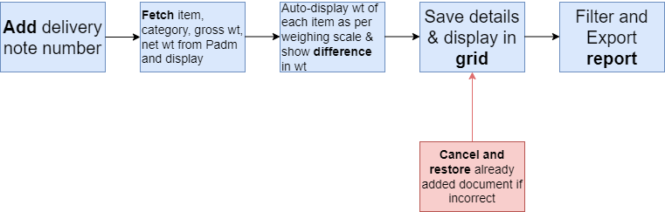

Fig: Workflow

1. **PROPOSED SYSTEM**

In connect Us, we have to create Delivery Counter weight verification module.

The main page will have following fields:

* From Date
* To Date
* Filter button
* Export button
* Reset button
* Add document button
* Search
* Grid
* Sr. No.
* Cancel action
* Restore action
* View action
* History action
* Date
* Delivery note no.
* Product group
* Bar-code no.
* Item
* Catgory
* Gross wt
* Physical wt
* Difference
* Employee ID & Name
* Branch name
* Canceled - yes / no
* Created at & by

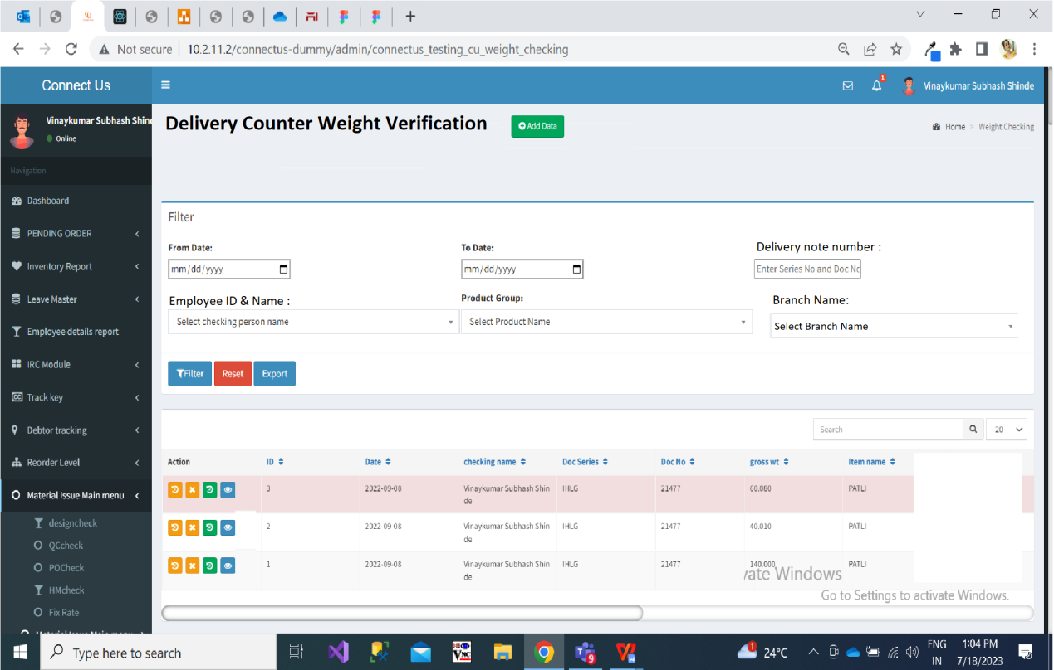

12.1 Once user clicks on **add** button, it will display following fields:

* Date
* Employee name
* Branch Name
* Delivery note number
* Product Group
* Search button
* Reset button

**Input table**

|  |  |  |  |
| --- | --- | --- | --- |
| **FIELDS** | **INPUT TYPE** | **MANDATORY/ OPTIONAL** | **DESCRIPTION** |
| Date | Text | Mandatory | It will display the date on which the document is added in the system.  Validation: It will display today’s / current date only. It will be read only. |
| Employee name | Text | Mandatory | It represents the name of employee who has done weight checking of the item / document by the scale.  It will automatically display the employee ID and employee name as per logged in person. Refer masters -> general master -> employee master for employee ID and employee name.  It will be read only. |
| Branch Name | Text | Mandatory | It will automatically display the branch name of the logged in person. It will be read only. |
| Delivery note no. | text | Mandatory | User will enter the document-series number here from Padm -> document -> delivery note gold / silver / diamond.  User cannot add already entered document number. It should display error message as “Document already exist”. |
| Product Group | text | mandatory | As per entered delivery note number, it will automatically display the product group. It will be read only. |
| Search | Click |  | Once user enters mandatory fields and clicks on submit button, then it will display the list of items available in that delivery note and will display their weights accordingly. |

Once user clicks on submit button, the above fields and buttons will be disabled whereas it will display following details below it in table:

* Bar-code no.
* Item
* Category
* Gross wt
* Physical wt
* Difference
* Remark
* Submit button
* Reset button

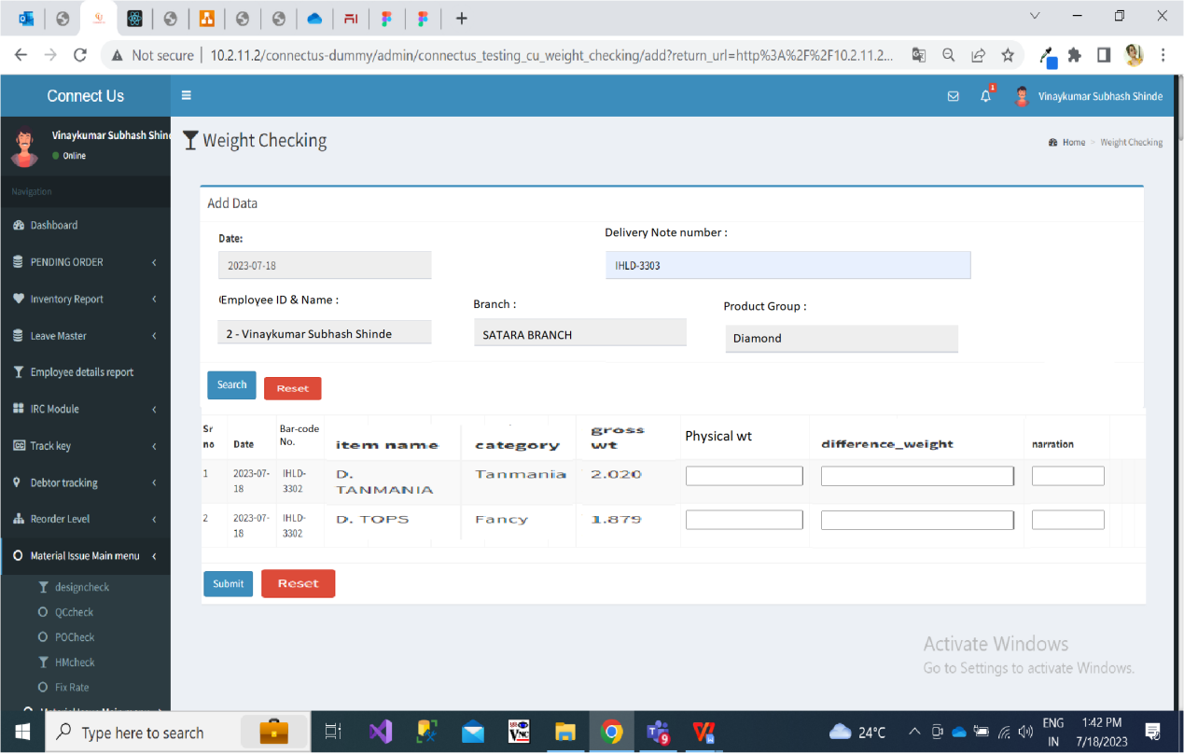

|  |  |  |  |
| --- | --- | --- | --- |
| **FIELDS** | **INPUT TYPE** | **MANDATORY/ OPTIONAL** | **DESCRIPTION** |
| Bar-code no. | Text | Mandatory | It will display the list of bar-codes available in the entered delivery note number. It will be read only. |
| Item | Text | Mandatory | It will display the list of items available in the entered delivery note number. It will be read only. |
| Category | Text | Mandatory | It will display the list of categories available in the entered delivery note number. It will be read only. |
| Gross wt | text | Mandatory | It will display the gross wt of each item as per delivery note from Padm.  It will be read only. |
| Physical wt | text | Mandatory | User will click on this field and it will auto fill the weight as displayed in the weighing machine. It will be read only.  For each item, user will click on the cursor of physical wt and then this field will get auto filled as per weight on weighing scale.  User should be able to clear / reset this displayed value if incorrect item is placed in weighing scale by user. |
| Difference | Text | Mandatory | It will be auto-filled. It will display the difference between gross wt from Padm and physical wt for each item.  It will be read only.  If the difference between gross wt and the physical weight is not more than configurable setting XXX weight, then it can be considered and user can proceed further. (The weight configurable settings will be considered from item group weight master. Refer point 12.5 for this.)  Whereas, if the difference between gross wt and the physical weight is more than configurable setting XXX weight, then email should get sent to the audit department. (The email address can be mentioned in the setting.) |
| Remark | Drop-down | Optional | User will mention the reason for the difference if found any.  It will display related module’s active reason from reason master. It will be multi select. |
| Submit | Click |  | Once user clicks on save button, it will display successful message and the added document will be displayed in the grid. It will display each item in different rows.  Example: If one delivery note is having 3 items in it, then in grid it will display 3 rows of each item. |

Once data is saved successfully, it will be displayed in grid.

12.2 **Cancel and restore** option should be displayed in grid -> action column based on authority.

Once user clicks on cancel button, then it will display message and all the items in that document number should get canceled. Whereas, if user restores one of the item then it will display successful message and all items in that document should get restored. Once item is canceled it will display status as yes canceled.

12.3 Once user clicks on **history** action, it will display following fields:

* Sr no.
* Action - Add / Cancel / Restore
* Date
* Delivery note no.
* Product group
* Bar-code no.
* Item
* Catgory
* Net wt
* Gross wt
* Physical wt
* Difference
* Employee ID & Name
* Branch name
* Canceled - yes / no
* Created at & by
* Updated at & by

Entry of recently made updates will be displayed in the top row.

12.4 User can **filter and export** report of the data displayed I the grid. It will display following fields on main page to export report:

* From date
* To date
* Delivery note number
* Employee ID & name
* Branch name
* Product group
* Filter button
* Reset button
* Export button

|  |  |  |  |
| --- | --- | --- | --- |
| **FIELDS** | **INPUT TYPE** | **MANDATORY/ OPTIONAL** | **DESCRIPTION** |
| From date | Calender picker | Mandatory | User will select the date from which user wants to export the report.  Validations: Future dates will be disabled. |
| To date | Calender picker | Mandatory | User will select the date from which user wants to export the report.  Validations: Future dates will be disabled. Dates before ‘from date’ should be disabled. |
| Delivery note number | Text | Optional | User can search the data from grid by delivery note number (document-series).  It should display error message in case of incorrect format. |
| Employee ID and name | Drop-down | Optional | User can search the data from grid by employee who have added the documents. |
| Product group | Drop-down | Optional | User can search the data from grid by product group as gold / silver / diamond. |
| Filter | Click |  | Once user selects dates and clicks on filter button, it will display desired data in grid.  If no data is available after applying filters, then it should display message in grid as ‘no records found’. |
| Export | Click |  | Once user clicks on export button, the filtered data as displayed in grid will be exported in excel sheet.  It will display following columns:   * Sr no. * Date * Delivery note no. * Product group * Bar-code no. * Item * Catgory * Net wt * Gross wt * Physical wt * Difference * Employee ID & Name * Branch name * Canceled - yes / no * Created at & by * Updated at & by   Button once clicked, it should be disabled until file gets downloaded successfully. |

12.5 When physical weight of each item is displayed in weighing scale, then it will display the difference between gross wt and physical wt. This difference should be considered based on settings. Hence we have to create ‘**Item classification group weight master’**. In this master we will define for which item -> category, how much difference in weight can be considered. If the difference between physical wt and gross wt lies as per allowed difference specified in master, then it can be considered. Else, email will get sent to the audit dept about it.

Item classification group weight master will display following fields in grid:

* Add button
* Action - view, edit
* Item classification group name
* Weight variance accepted
* Created at & by
* Updated at & by

Once user clicks on add button, it will display following fields:

* Item classification group name (drop-down displaying list from padm -> document -> item classification group)
* Weight variance accepted (text field. The value entered here means this much weight difference can be considered against the specified item classification group.)
* Reset button
* Save button

1. **TEST DATA**



1. **ODUS ( Open Discussed Unhanded scenarios )**

|  |  |  |  |  |
| --- | --- | --- | --- | --- |
| **Sr. No.** | **Topic** | **Priority**  **(High / medium / low)** | **Remark** | **Status**  **(Open/**  **Closed)** |
| 1 | Pritam metha: Add one more functionality while taking weighscale weight and same matches with system weight varaince up to XXX (Configurable Field) should be accepted . This will help us while creating report and other functionalities. | High |  | Closed |
| 2 | Pritam metha : with reference to above point, add auto mail functionality to audit department when weighing scale weight and system weight not matches and difference is more than XXXX gms (Configurable field) currently same functionality is used in stock verification system | Medium |  | Closed |
| 3 |  |  |  |  |
|  |  |  |  |  |
|  |  |  |  |  |

1. **REFERENCES OF THE USERS**

|  |  |  |  |
| --- | --- | --- | --- |
| **User** | **Name** | **Mail** | **Contact number** |
| **Actual user** | Annappa Thikane | isa@csjewellers.com |  |
| **Ticket created by (if any)** | Annappa thikane | [isa@csjewellers.com](mailto:isa@csjewellers.com) | 9404764322 |
| **Assigned business analyst** | Manali bhadirage | Manali.bhadirage@techneai.com |  |
| **Assigned developer** |  |  |  |
| **Assigned tester** |  |  |  |