16.05.2023

EGold

Manali Ashok Bhadirage

Manali.bhadirage@techneai.com

**Functional Requirement Document**

**CONTENTS**

1. TICKET DETAILS 23

2. VERSION CONTROL 23

3. APPROVALS 23

4. ESTIMATION 23

5. INTRODUCTION 23

6. BUSINESS REQUIREMENT 24

7. SCOPE 25

8. BUSINESS & SYSTEM RULES 25

9. ABBREVIATIONS & TERMS 26

10. EXISTING SYSTEM 26

11. GRAPHICAL REPRESENTATION 26

12. PROPOSED SYSTEM 26

12.1 Registration 27

12.2 Sign In 34

12.3 BUY 45

12.4 SIP 48

12.5 Manage SIP 53

12.6 Sell 55

12.7 Gold & Silver rates graph 58

12.8 Delivery 58

12.9 Set rate trigger 61

12.10 Profile 64

12.11 Notifications 67

12.12 Your Trades 68

12.13 Settings 71

12.14 eGifts 78

12.15 Offers 81

12.16 Help Desk 82

12.17 About Us 84

13. WEB APPLICATION 85

13.1 Tenant Master 86

13.2 Customer master 89

13.3 Occupation Master 91

13.4 Default Settings 91

13.5 Tenant settings 94

14. TEST DATA 96

16. REFERENCES 98

1. **TICKET DETAILS**

|  |  |
| --- | --- |
| **Ticket ID** | TT12072 |
| **Ticket description** | Egold mobile application for purchase and sell. (point by pritam sir, aditya sir and gaurav sir) |
| **Created by** | Manali Bhadirage |
| **Created on** | 10/05/2023 |
| **Priority** | High |

1. **VERSION CONTROL**

|  |  |  |  |  |
| --- | --- | --- | --- | --- |
| **Sr. No** | **Version no** | **Version Date** | **Customer name** | **Customer department** |
| **1** | **1.0** | **16/05/2023** | **Pritam Mehta** | **Internal Audit** |
| **2** | **1.1** | **27/06/2023** | **Aditya Shah** | **Management** |
| **3** | **1.2** | **02/09/2023** |  |  |

1. **APPROVALS**

|  |  |  |
| --- | --- | --- |
| **Field** | **Name of the User** | **Approved date by the user** |
| **Actual customer Name**  **Actual customer Department**  **Organization Name** | Pritam Mehta  Internal Audit  CSPL |  |
| **Assigned BA** | Manali Bhadirage |  |
| **Assigned Developer** | Prathmesh Shinde Nikhil Bhosale  Goverdhan Bollu Dhirjsingh Chandel |  |
| **Assigned Tester** | Priyanka dupargude  Preeti bokade |  |

1. **ESTIMATION**

|  |  |  |  |  |
| --- | --- | --- | --- | --- |
| **Department name** | **Estimated Time (In hr)** | **Scheduled Date (Starting date)** | **Estimated date** | **Actual delivery date** |
| **BA** |  |  |  |  |
| **Development** |  |  |  |  |
| **Testing** |  |  |  |  |
|  |  |  |  |  |

1. **INTRODUCTION**

*We need to build Egold mobile application through which customers will register themselves and can buy and sell metal (gold or silver) online. Through this mobile application, customers can view the current rate of per gram gold and silver and can instantly buy it online. In addition to this, customers can buy gold by setting monthly EMIs and also can gift gold to their closed ones.*

1. **BUSINESS REQUIREMENT**

Application will be tenant based where multiple customers will be mapped under each tenant.

|  |  |  |  |
| --- | --- | --- | --- |
| **Requirement ID** | **Requirement Name** | **Short Description** | **Priority** |
| BR001 | Register | customers should be able to register themselves either manually or through aadhar card number or by uploading aadhar photo. | High |
| BR002 | Sign in | Once customer registers himself, then customer shoulds be able to sign successfully into application using set credentials. | High |
| BR003 | View live rate | Once customer signs into the app, customer should be able to view live rates of metals (purchase rate and selling rate). | High |
| BR004 | Buy | Though this, customer should be able to purchase the egold as per his/her entered amount. As per current rate and entered amount, the metal weight should get calculated and should be booked for the customer. | Very High |
| BR005 | SIP | Customer should be able to set purchasing amount for each month and thus as per current rate of each month and the amount set by customer, the weight of the metal should bet calculated and booked for the customer.  Customer should be able to edit / cancel his created SIP. | Very High |
| BR006 | sell | Customer should be able to sell metal out of his/her total purchased metal weight. | Very High |
| BR007 | Set rate trigger | Customer should be able to set the rate triggers and when the current rate matches the set trigger rate then notification should get sent to the user. | High |
| BR008 | Send notifications | Notifications should get sent to customer via email / SMS/ whats-app about monthly purchase, rate triggers, one time purchase done, one time sell done, etc. | Medium |
| BR009 | eGifts | customer should be able to gift egold through his account to his friends via number. | Medium |
| BR010 | Change settings | Customer should be able to change settings of nominee, bank account, communication preferences, biometric settings, etc. | Medium |
| BR011 | Delivery | Customer should be able to enter details of the gold that he wants to get physically delivered at his address. | High |
| BR012 | Offers | Scratch code of offer should be displayed and customer should be apply to use this code while buy or sell. | Medium |
| BR013 | Your trades | All buy / sell / sip / delivery / egifts transaction and details should be displayed in your trades. | high |
| BR014 | Profile | Customer should be able to view all details in profile as mentioned while registering. Also few fields will be editable. | low |
| BR015 | About Us | It should display information about application, images, videos and other static information | low |
| BR016 | Codes and references | User should be able to copy promo code / referral codes and use it while buy / sell / delivery / sip. | low |
| BR017 | Log out | User should be able to logout through the application | high |

1. **SCOPE**

Through egold mobile application, customers should be able to purchase and sell all metals (gold / silver). The application should be user friendly and customized as per tenant’s themes, banners, videos, field names, set rate triggers, etc. The application should be scale able enough for many other features and menus which can be added as per clients / tenants / market requirements. The mobile application should work conveniently on android, iOS and tabs.

1. **BUSINESS & SYSTEM RULES**

* One customer can have same application of multiple tenants and hence we have to maintain data separately with tenant ID for each tenant wise customer.
* Application theme, colour, logo and/or current rate should be different for each tenant as per settings.
* Tutorial of using application needs to be displayed once application is installed and user visits the login page for the first time.
* System should display error message for incorrect details if entered.
* System should pop up a message, if any issues in the system is detected.
* All forms should have on field validations. System should display on field errors in case of incorrect inputs.

1. **ABBREVIATIONS & TERMS**

KT - Karat

Gm - grams

SIP - Systematic investment plan

1. **EXISTING SYSTEM**

There is no existing e-gold mobile application owned by Techne AI.

1. **GRAPHICAL REPRESENTATION**

Refer below figma link:

https://www.figma.com/proto/zoLllak3WHQ6OTncJm5Ac5/Egold-App?type=design&node-id=957-12077&scaling=contain&page-id=927%3A8353&starting-point-node-id=1358%3A17119&show-proto-sidebar=1

1. **PROPOSED SYSTEM**

*The log and the theme colour of the app will be displayed different for each tenant as per setting done in back-end web app. Once customer downloads application and goes on the app for the first time, then we will display the testimonial video to use the app. Customer will select the language in which he/she wants to view the video and video will be played having audio of selected language.*

*Further, Egold mobile application will have following features:*

* *Register*
* *Sign Up*
* *Forgot password*
* *Help Desk*
* *Dashboard*
* *View live rates*
* *Buy*
* *Sell*
* *SIP*
* *Manage SIP*
* *Set rate trigger*
* *Delivery*
* *Egifts*
* *Your trades*
* *Offers*
* *Profile*
* *KYC*
* *Notifications*
* *Settings*
* *About Us*
* *Log out*

**12.1 Registration**

*To purchase metal, firstly customer will have to register themselves by creating a account under tenant. Once customer registers himself, then unique customer ID will get generated and it will be displayed to customer in profile page as well as to super admin and tenant in web.*

*Once customer clicks on register page through mobile application, it will display following options:*

1. *Manual form*
2. *Through Aadhar number*
3. *Upload Aadhar image*

*customers can register themselves by any one of the above options.*

**Input table**

|  |  |  |
| --- | --- | --- |
| **FIELDS** | **INPUT TYPE** | **DESCRIPTION** |
| Manually | Click | Here, customer can manually enter all the details in the form for registration. |
| Aadhar number | click | Here, customer will enter the Aadhar number and click on validate button. Once Aadhar number is validated then as per Aadhar card, all other details will get prefilled. |
| Upload Aadhar image | click | Customer will upload the image of the Aadhar card,then as per the details in Aadhar card image the registration form will get prefilled. |

1. Once customer clicks on ‘**Manually’** option, it will display following fields of form on next page:

* Customer Name
* Address
* Pin code
* Country
* State
* city
* Mobile number
* Whatsapp number
* Date of birth
* Gender
* Email
* Occupation
* Date of anniversary
* Referral Code
* Aadhar card number
* Aadhar attachment
* Pan card number
* Pan attachment
* Confirm (button)

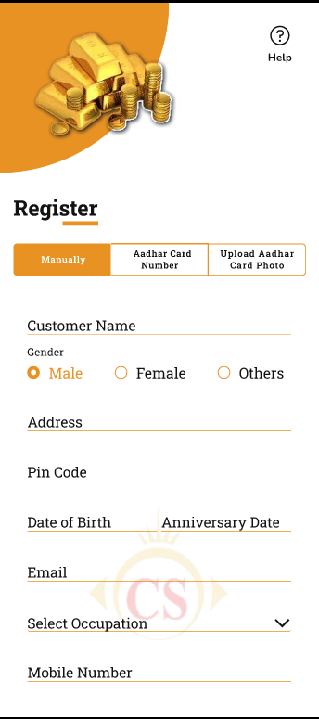 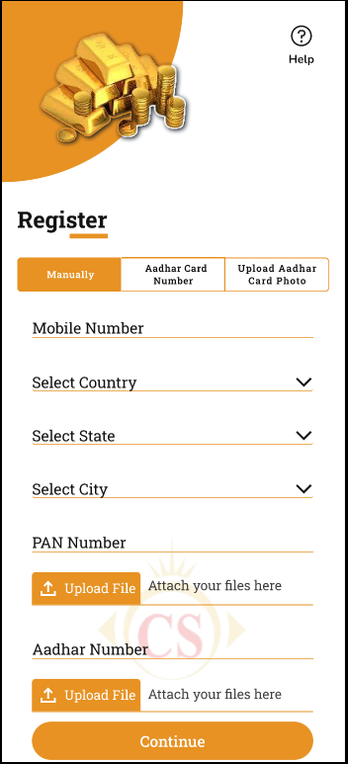

Fig: Manual registration

|  |  |  |  |
| --- | --- | --- | --- |
| **FIELDS** | **INPUT TYPE** | **MANDATORY / OPTIONAL** | **DESCRIPTION** |
| Customer name | Text | Mandatory | customer will enter their full name in this field as mentioned on their Aadhar card.   1. It should accept characters and space only. 2. Maximum length of input field should be 50 characters. 3. This field shouldn’t be case sensitive. |
| Address | Text | Mandatory | customer will enter their residential / official address in this field.  It should accept capital letters, numbers, special characters and space.  Maximum length of input field should be 50 characters.  It shouldn’t be case sensitive. |
| Pin code | Text | mandatory | It should accept numbers only. It shouldn’t accept characters, space, special characters. |
| Mobile number | Text | Mandatory | 1. Only numbers should be accepted. 2. Maximum 10 digits should be accepted. 3. It should be unique. 4. Consecutive ten zeros or consecutive ten ones shouldn’t be accepted as a number. |
| Date of birth | Calendar picker | mandatory | customer will select his/her date of birth from the calendar.  Future dates should be disabled. |
| Gender | Radio button | mandatory | customer will select either male or female or other as their gender. |
| Email | text | mandatory | 1. This field should accept “ @ - . “ only as special characters. 2. In case of invalid format, it should display on field error message as “Invalid email address”. 3. It shouldn’t accept space anywhere. 4. It should be unique. 5. Maximum length of input field should be 50 characters. |
| Occupation | Drop-down | optional | customer will select any one of the occupation from the drop-down list. |
| Date of anniversary | Calendar picker | optional | customer will select his/her date of marriage anniversary from the calendar.  Validation:- Future dates should be disabled. |
| Referral Code | Text | Optional | customer will mention the reference code of any other existing customer here.  It will be alphanumeric. It will accept maximum 8 characters.  It shouldn’t accept space or special characters. |
| Aadhar card number | text | mandatory | customer will enter 12 digit Aadhar Number.  One Aadhar no. should be used for registration only once. (each customer will have unique Aadhar no.)  In case of invalid aadhar card number format, it should display error message as “Invalid aadhar number”.  This aadhar number will be displayed in customer’s profile after login. |
| Aadhar card attachment | upload | mandatory | Customer will attach his aadhar card photo.  It should accept only one attachment of maximum 2MB size with jpeg, jpg, png, pdf, heic extensions only. |
| Pan card number | text | mandatory | 1. customer will enter 10 digit alphanumeric PAN No. of user. 2. One PAN no. should be used for registration only once. (each customer will have unique pan no.) 3. It includes first five letters, followed by 4 numbers and last character. 4. In case of invalid pan card number format, it should display error message as “Invalid pan number”.   This number will be displayed in customer’s profile after login. |
| Pan card attachment | upload | mandatory | Customer will attach his pan card photo.  It should accept only one attachment of maximum 2MB size with jpeg, jpg, png, pdf, heic extensions |
| Confirm | Click |  | Once customer clicks on submit button, then system should validate the entered Aadhar number, pan number, mobile number and the customer details (name, DOB, gender).  If the entered details are incorrect, then it will display error message as PAN number not valid / Aadhar number not valid / Aadhar & Pan both numbers not valid.  If entered details are correct, then it will direct customer to set password for the application.    New password : It should accept characters, numbers and special characters. Password should be case sensitive. Minimum length of password should be 8 letters and maximum length should be 10. Password must have at least one capital letter, at least one small letter, at least one special character and at least one number. In case of incorrect password format, display on field error message as “incorrect password format”.  Confirm password : his field should match with the inputs in Password field. If inputs doesn’t match, it doesn’t display on field error message below as “Password doesn’t match”.  After setting password, OTP will be sent to customers email and mobile number.    Once customer enters valid OTP and clicks on submit, it should display message as “Registration successful” and should direct customer to sign in page. |

1. If customer wants to register by entering **‘Aadhar card number’**, then it will display following fields:

* Aadhar card number
* Validate (button)
* Customer Name
* Address
* Pin code
* Mobile number
* Date of birth
* Gender
* Email
* Occupation
* Date of anniversary
* Referral code
* Pan card number & its Validate button
* Next (button)

Here, customer will enter the aadhar card number and will click on validate button. If the entered aadhar card number is valid, then the other details (name, address, mobile number, DOB, gender) will be pre-filled as per the aadhar number. customer will manually enter remaining details as date of anniversary, occupation and PAN number.

Further, once customer enters PAN number and clicks on validate then it will display ‘next’ button if entered PAN number is validated with customer details.

Once customer clicks on next button, customer can set password and then proceed to login page once account is created successfully.

1. If customer wants to register by ‘**uploading aadhar card photo**’, customer can either attach aadhar card image from gallery or click by camera. Then as per the details in image, it will fill details in name, address, mobile number, DOB, gender fields.

customer will manually enter remaining details as email, reference code, date of anniversary, occupation and PAN number.

Further, once customer enters PAN number and clicks on validate then it will display ‘next’ button if entered PAN number is validated with customer details.

Once customer clicks on next button, customer can set password and then proceed to login page once account is created successfully.

**12.2 Sign In**

Customer can log into app by two methods:

* Sign up with password
* Sign in with OTP

On sign in page, it will have following fields:

* Tenant logo
* Email / Phone number
* Password
* Forgot password button
* Sign Up button
* Sign with OTP button
* Help Desk button

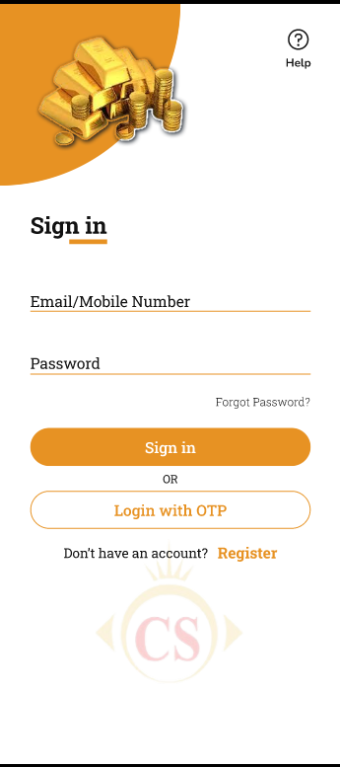

|  |  |  |  |
| --- | --- | --- | --- |
| **FIELDS** | **INPUT TYPE** | **MANDATORY / OPTIONAL** | **DESCRIPTION** |
| Email / Mobile No. | Text | Mandatory | customer will enter registered email address or mobile number as mentioned while registration.  It shouldn’t be case sensitive.  It should accept maximum 50 characters.  It should accept _ . - @ only as special character.  In case of incorrect details, display error message as “Please enter registered details”. |
| Password | Text | Mandatory | customer will mention password as mentioned while registration.  It should accept alphanumeric value and all special characters.  It should be case sensitive.  Minimum length of password should be 6 characters and maximum length should be 10.  Password must have at least one capital letter, at least one special character and at least one number.  In case of incorrect password, display notification above as “incorrect password”. |
| Forgot password | Click |  | Once customer clicks on forgot password button, it should direct customer to OTP page.  It will display message as “OTP sent on registered email & SMS”.  Once customer enters correct OTP, it will direct customer to next page for entering new password. It will display following fields:   * New password * Confirm new password * Submit (button)   Once customer sets new password, then it will display successful message and direct customer to login page. |
| Sign Up | Click |  | Once customer has entered correct credentials, customer should be able to successfully sign into application.  Else, it will display error message. |
| Sign in with OTP | Click | Optional | Customer will enter OTP which will be sent to his registered number. This Is to ensure security.  Once user will enter registered mobile number first. Then 4 digit OTP will be sent to customer. Then once customer enters valid OTP number, then customer will be successfully signed into app. Successful sign message will be displayed and customer will be directed to dashboard page.    Validation:- User should be registered first to sign in with OTP. |
| Help Desk | Click | Optional | It will display two options as Call or email. Once customer clicks on call, then it will be connected to application support team of tenant.  If customer selects email, then it will display following fields:   * Query Type * Text box * Submit button   Query type will be drop-down displaying query, application issue, feedback and others in the list.  Customer will write his query/ concerns / feedback in the text field. Once customer clicks on submit, it will display message as “Your response has been sent to support team. You will receive an update within 24 hours”. And, email will get sent to application support team of tenant. |

Once customer successfully signs into application, it will display following fields on home page:

* Hamburger menu in top right corner
* Dashboard / Home
* Gold and Silver current rate
* Sliders
* Buy button
* Sell button
* SIP button
* Set rate trigger button
* Application features
* Tenant logo
* Home, Your trades and notifications in footer of dashboard

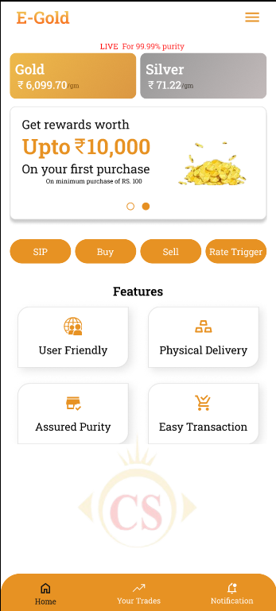

|  |  |  |
| --- | --- | --- |
| **FIELDS** | **INPUT TYPE** | **DESCRIPTION** |
| Hambergur menu | Click | Once customer clicks on hamburger menu, it will display list pf pages.   * Tenant logo * Profile * Your trades * Notifications * Settings * Nominee settings * Bank account settings * Preferences settings * Rate triggers * eGifts * Offers * Delivery * Manage SIP * Promo Codes & references * Help Desk * About Us * Sign out   Logo, background screen, dark mode / light mode, font color, font style will be changed from tenant’s web -> settings. |
| Gold and silver live rates | display | It will display live rates of gold and silver purchase in cards. Rates displayed will be different for each tenant as per settings done by tenant in back-end web app.  Rates displayed will be about buying 99.99% purity per gram.  It will be displayed as per tenant’s settings from web socket / web menu to change rates. |
| Sliders | Images | Sliders will be different for each tenant where tenant will display images related to their offers / new features / etc.  It will be changed from tenant’s web -> settings -> dashboard -> banner. |
| SIP | click | Once customer clicks on SIP button, customer can select date, tenure and amount for auto purchasing the metal each month.  Customer can explore sip process but cannot perform transaction until his KYC process is completed. |
| Buy | click | customer can purchase metal anytime by entering either amount or metal weight and book gold or silver in his account.  Customer can explore sip process but cannot perform transaction until his KYC process is completed. |
| sell | click | customer can sell metal anytime just by entering the metal weight out of the weight in his account and get money credited to his selected bank account.  Customer can explore sip process but cannot perform transaction until his KYC process is completed. |
| Gold rates scientific dot diagram | click | Once customer clicks on gold, it will display dot diagram of sell and purchase rate for each day.  Through this customer can analyze rates. |
| Silver rates scientific dot diagram | click | Once customer clicks on silver, it will display dot diagram of sell and purchase rate for each day.  Through this customer can analyze rates. |
| Set rate trigger | click | Customer can set the triggers / alerts that he/she wants to receive as notification so that it will be useful for customer for buying or selling purpose.  Customer can set multiple alerts for silver and gold individually. Once the rate matches as per set trigger, then notification will be sent to customer only one time and then the set trigger will get disabled and also will be saved in rate trigger history. |
| Application features | Display | It will display the features of the application which are read only. It will be changed from tenant’s web -> settings -> feature. |
| Tenant logo | Display | It will display the logo of the tenant as per tenant’s back-end settings from web app. |

**12.3 BUY**

Once customer clicks on **BUY button**, it will display following fields on next page:

* Buy live rate of gold and silver
* Purchase by rupees (button)
* Purchase in grams (button)
* Text box to enter weight or amount
* Calculated value of amount / grams
* Continue (button)

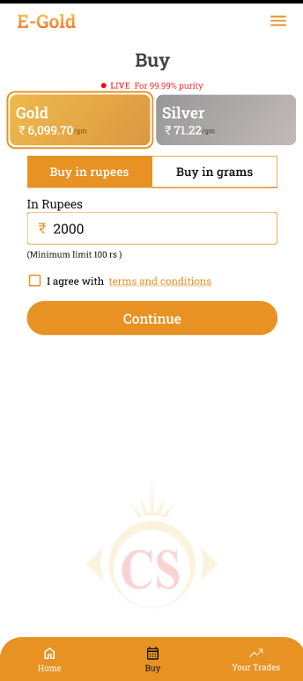

|  |  |  |  |
| --- | --- | --- | --- |
| **FIELDS** | **INPUT TYPE** | **MANDATORY / OPTIONAL** | **DESCRIPTION** |
| Live rates | Click | Mandatory | It will display live rates.  By default, it will click Gold live rate card.  If user clicks on silver card, then user will proceed to buy silver. |
| Purchase by rupees | Click | Mandatory | Customer can purchase metal by entering amount. And then as per entered amount and current rate, weight of the metal that can be purchased will get calculated.  It should accept max 3 digits after decimal point.  Below this text field, it will display the minimum and maximum grams / limit that customer can buy at a time as set by tenant settings.  One time transaction limit will be set as 5,00,000 by default whereas max limit will vary foe each tenant as per their settings from web. |
| Purchase in grams | Click | Mandatory | Customer can purchase metal by entering weight of metal. Then as per current rate and metal, the amount of purchase will get calculated and displayed.  Below this text field, it will display the minimum and maximum grams / limit that customer can buy at a time as set by tenant settings.  It should accept max 3 digits after decimal point. |
| Text box | Text | Mandatory | Once customer clicks on purchase by metal, then in text box customer will enter the amount in rupees.  If customer clicks on purchase in grams, then in text box customer will have to enter the weight of the metal in grams. |
| Calculated value | Display |  | As per entered amount, it will display the weight of metal that can be booked. Booked metal = purchasing amount / (current rate per gram + 3% Gst).  If customer has entered grams, then it will display calculated amount as per current rate and GST for the entered grams. Purchasing amount = (current rate of per gram + 3% GST) * value entered in purchasing gram field.  It should accept max 3 digits after decimal point. |
| Continue | Click | Mandatory | If customer clicks on continue button, it will display the billing information of the purchase and proceed to pay button. Here, it will have option to apply offer or paste **offer code**. Then as per applied offer code the discount should get deducted from total amount of bill and then final amount should be displayed for customer. |
| Pan number | Text |  | If customer is doing transaction of 2,00,000 or more than 2,00,000 then pan number field will be displayed.  (The limit will for which pan is required will be 2 lakh by default, else it will vary as per tenant’s setting in web.) |
| Proceed to pay | click |  | Once customer clicks on proceed to pay button, then rounded off total billing amount will be displayed and customer will be directed to bank payment gateway. Here, it will display the list of banks that customer has added to online payments on his mobile. If customer hasn't added any bank, then it will direct customer to add bank account details.  Once customer selects bank account, enters password and completes payment, then it will display successful message as “Metal booked for you” and it will be displayed in ‘Your Trades’ menu. Each time when purchase is done, then unique ID should be generated for that transaction and it will be displayed in ‘your trades’. |

**12.4 SIP**

Customer will set the date, amount and period till which customer wants to book the metal automatically and add in his account. Once customer clicks on SIP button, it will display following fields:

* Live rates of gold and silver
* Set Start Date
* Set Duration in months
* Period
* Monthly amount
* Continue button

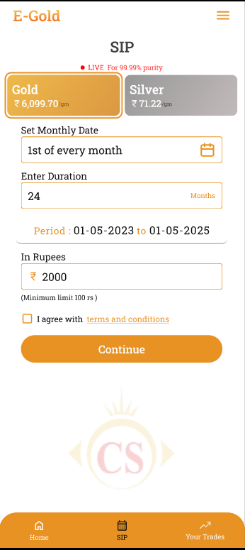

|  |  |  |  |
| --- | --- | --- | --- |
| **FIELDS** | **INPUT TYPE** | **MANDATORY / OPTIONAL** | **DESCRIPTION** |
| Live rates | Marquee tag | Mandatory | It will display live rates.  By default, it will click Gold live rate card.  If user clicks on silver card, then user will proceed to buy silver. |
| Set start date | Calendar picker | Mandatory | customer will select the date on which customer wants to get amount auto-deducted each month and book the metal.  Validation:- It will display dates of current month. Back dated dates will be disabled from calendar. It should select only one date a time. |
| Set Duration | Year | Mandatory | customer will select the year until which he wish to continue monthly auto-purchase.  Validation:- It should accept numbers only. |
| Period | Date | Mandatory | As per selected date and duration, it will display period of SIP.  Example: If customer selects Start date as 17/05/2023 and sets duration as 2025. Then in period it will display as : 17/05/2023 to 17/05/2025.  Validation:- It will be read only. It should display updated period as per changing date and duration entered by customer. |
| Monthly Amount | Text | Mandatory | Customer will enter the amount that will be deducted each month and metal will be booked as per current rate. As SIP monthly amount is fixed by customer, then from second installment, metal will get booked as as per SIP amount and current rate in that particular month.  Below this text field, it will display the minimum and maximum amount / limit that customer can create SIP of as set by tenant settings.  Validation:- It should accept only numeric value. It should accept max 3 digits after decimal point. |
| Continue | Click | Mandatory | Once customer clicks on continue button, it will display the billing information of the purchase and have ‘proceed to pay’ button.  While starting the SIP for first time, customer will have to make one payment of the current month even if the date selected hasn’t passed yet in the current month.  Once customer clicks on proceed to pay button, customer will be directed to bank payment gateway. Here, it will display the list of banks that customer has added through his settings -> add bank. If customer hasn't added any bank, then it will direct customer to add credit/debit card or UPI account details.    Post condition:- Once customer selects bank account, enters password and completes payment, then it will display successful message as “Payment successful and your SIP has started.”  SIP number will be generated and the created SIP will be displayed in hamburger menu -> manage SIP.  Also, it will display the transaction of each monthly auto-purchase in ‘your trades’ menu. Moreover, each time when transaction is done for monthly auto-purchase, notification should be sent to customer within app, sms and whatsapp.  Further, as current rate of each day keeps on changing, then the monthly grams to be booked should get calculated as per current rate of that particular day and the monthly amount chosen by user.  Example: If customer has chosen 17th date of each month and 5000/- amount as each month transaction. Then, 5000/- will be deducted on 17th of each month however the metal booked for each time will vary as per current rate.  Each month when transaction is done about purchase, then unique ID should be generated and it should be displayed in ‘your trades’. |

**12.5 Manage SIP**

All created SIP of gold and silver will be displayed in manage SIP. Customer can view details of his created SIP, change the SIP date or can cancel the SIP. Once customer clicks on ‘manage sip’ menu, it will display following details of each SIP where gold / silver will be displayed with respective colour:

* SIP number
* Start date
* Booked metal
* Amount
* Total paid SIP
* Upcoming SIP date
* View action
* Edit action

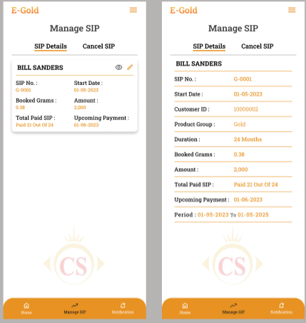

Once customer clicks on view action, it will display all details of SIP as customer entered while creating it. It will display following read only fields:

* SIP Number
* Start date
* Customer ID
* Product group
* Duration in months
* Booked metal in grams
* Amount
* Total paid SIP
* Upcoming sip date
* Period
* Transaction History : It will display all transactions done for each particular SIP. It will display field s as Sr. No., Date & time, Amount, Status (successful / unsuccessful).

Once clicks on edit action of the SIP, it will display following fields:

* SIP Number
* Start date
* Customer ID
* Product group
* Duration in months
* Booked metal in grams
* Amount
* Total paid SIP
* Change date
* Cancel checkbox

If customer changes date and clicks on save button, then a dialogue box will open where it will specify the changed date and customer will have to confirm as yes / no. Once changes are saved then the edited details should be reflected in SIP details of manage SIP. Also, the payment of the customer should be done as per updated date of the SIP.

If user clicks on cancel SIP, then user will have to specify the reason for cancellation. Once reason is mentioned and customer clicks on save button, it will cancel the SIP and display the canceled SIPs in ‘canceled SIP’ menu.

**12.6 Sell**

customer can sell the metal out of his total booked metal till the date. It will display following fields:

* Live rates of gold and silver
* Weight Balance in account
* Sell weight in grams
* Remaining weight
* Calculated amount
* Continue button

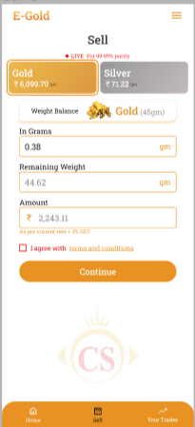

|  |  |  |  |
| --- | --- | --- | --- |
| **FIELDS** | **INPUT TYPE** | **MANDATORY / OPTIONAL** | **DESCRIPTION** |
| Live rates | Marquee tag | Mandatory | It will display live rates.  It will display gold and silver sell rate only. |
| Weight Balance in account | Text | Mandatory | It will be read only field.  It will display the total grams purchased / available in user’s account for gold & silver. |
| Sell weight in grams | Text | Mandatory | customer will enter the weight in grams which customer wants to sell. It should NOT accept value more than the weight balance in user’s account.  Below this text field, it will display the minimum and maximum grams / limit that customer can sell as set by tenant settings. (If customer has purchased 5 grams on 01/09 and 3 grams on 02/09. Suppose tenant has set setting that customer should sell weight after 48 hours of purchase. Then on 03/09 when customer is selling the grams then it should display the value that customer can sell only out of 5 grams (as 3 grams purchased haven’t passed 48 hours yet).  Validations:- It should accept value or weight more than the weight in customer’s weight balance. It should accept numbers only. It should accept single decimal point. It should accept only three digits after decimal point. |
| Remaining weight | Text | Mandatory | It will display weight that will remain in customer’s account after entering weight in selling field.  Remaining weight = weight balance - sell weight.  Validation:- It will be read only. It will display updated value as and when user enters different values in sell weight text field. |
| Calculated amount | Text | Mandatory | It will display calculated amount that customer will get into his account after selling the entered grams.  Sell amount = sell weight in grams * current sell rate.  Validation:- It will be read only. It will display updated amount as and when customer enters different values in sell weight text field. |
| Continue | Click | Mandatory | Once customer clicks on continue button, it will display the billing information of the sell and will have ‘proceed to sell’ button.  Once customer clicks on proceed to sell button, then rounded off total billing amount will be displayed and it will display the list of bank accounts that customer has added in application. customer will select the bank in which customer wants the payment to be done and will click on continue button.  Once customer clicks on continue button, customer will enter the pin and on clicking confirm, it will display the message as “Metal sold successfully. Amount will be transferred to your account soon!”.  As per sold metal, the weight balance in account should get updated and the transaction of sell should be displayed in ‘your trades’ menu. Each time when transaction is done about sell, then unique transaction ID should be generated and displayed in your trades along with receipt no.  Notification of sell should get sent to customer on SMS, whats-app and within app.  Notification should get sent to customer via SMS and within app once amount is credited in customer’s bank account. |

**12.7 Gold & Silver rates graph**

As per selected product group, it should display the graph of changing sell and purchase rate of each day. It should display date on y-axis and amount on X-axis.

When customer will scroll on the dates, it should display the per gram rate.

customer should be able to view rates of last year till current date.

**12.8 Delivery**

Through delivery option, customer can get the gold / silver physically delivered at his address. Customer can get egold delivered only out of the total weight balance in his account. It will have following fields:

* Grams
* Full name
* Mobile number
* Alternate mobile number
* Address
* Landmark
* Pin code
* State
* City
* ID proof
* Address type - residential / home
* Continue

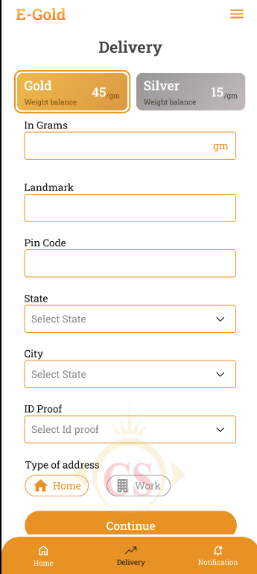

|  |  |  |  |
| --- | --- | --- | --- |
| **FIELDS** | **INPUT TYPE** | **MANDATORY / OPTIONAL** | **DESCRIPTION** |
| Product Group | Cards | Mandatory | It will display current buy rate.  Validation:- By default it will be clicked on Gold. |
| Grams | text | mandatory | Customer will enter the grams that he/she wants to get physically delivered at his address.  Validation:- it should accept value more than weight balance in account for particular product group. |
| Mobile number | text | mandatory | Customer will enter his mobile number.  Validation:- Only numbers should be accepted. Maximum 10 digits should be accepted. It should accept 6 /7 /8 / 9 only at the beginning. |
| Address | text | Mandatory | Customer will enter the address at which the e-gold will be delivered.  Validation:- It should accept max 250 characters. It should accept / - . , special character only. |
| Landmark | text | mandatory | Customer will enter landmark of the address.  Validation:- It should accept max 50 characters. It should accept / - . , special character only. |
| Pin code | text | mandatory | Customer will enter the pin code of the address.  Validation:- It should accept max 6 digits. It should accept only numbers. |
| state | Drop-down | mandatory | Customer will select state of the address.  Validation:- it will display active states from state master. It will be single select. |
| city | text | mandatory | Customer will select city of the address.  Validation:- it will display active cities from state master. It will be single select. |
| Id proof | Drop-down | mandatory | Customer will select the ID proof that will be checked by delivery person while delivery. (Pan card / aadhar card / driving license)  Validation- It will be single select. |
| Type of address | checkbox | optional | It will be either residential or official address. This will help delivery person during delivery.  Validation:- It will be single select. |
| Save | click |  | Once user clicks on save button, then billing information of the delivery will be displayed where delivery charges will be applied to the customer as per tenant’s setting. |
| Proceed to pay | Click |  | Once customer clicks on save button, it will display the details of the delivery. Delivery date will be displayed as per tenant’s settings.  Further, once user clicks on ‘proceed to pay’, list of banks will be displayed and payment gateway will open. Once payment is successful, message will be displayed and this transaction will be displayed in ‘your trades’.  Moreover, notification will be sent to customer within app and other medium (sms / email / whats-app) as per preference settings. |

Further, the status as delivered / not delivered will be updated by tenant through web app for keeping updates about delivery.

**12.9 Set rate trigger**

Customer can set amount when customer wish to get notification about change in rate on the same day. This will help customer to get instant notification when there is change in the current buy rate as expected by customer and thus helps customer to buy or sell metal instantly.

Once customer clicks on set rate trigger, it will display following fields:

* Product group
* When amount is above (in rupees)
* When amount in below (in rupees)
* Get notification on
* Save button
* Rate trigger history

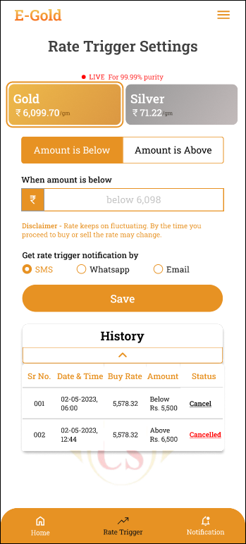

|  |  |  |  |
| --- | --- | --- | --- |
| **FIELDS** | **INPUT TYPE** | **MANDATORY / OPTIONAL** | **DESCRIPTION** |
| Product Group | Cards | Mandatory | User can set multiple rate trigger for gold and silver.  Validation:- By default it will be clicked on Gold. |
| When amount is above | Text | Optional | Customer will have to enter some value either in above or in below text field to save rate trigger.  Customer will enter the amount in comparison to the current buy rate trigger and will set that if the amount goes above specified amount, then notification will be sent to customer.  Example:- If current rate is 10000 and customer enters 11000 in ‘when amount is above’ field. Further, suppose current rate has been changed to 11499. Then customer will receive rate trigger notification.  Validation:- Once rate trigger notification is sent to customer, then this text field will be blank and the rate trigger which is/was set will be displayed in history. |
| When amount is below | Text | Optional | Customer will have to enter some value either in above or in below text field to save rate trigger.  Customer will enter the amount in comparison to the current buy rate trigger and will set that if the amount goes below specified amount, then notification will be sent to customer.  Example 1:- If current rate is 10000 and customer enters 9000 in ‘when amount is below’ field. Further, suppose current rate has been changed to 8888. Then customer will receive rate trigger notification.  Example 2:- If current rate is 10000 and customer enters 9000 in ‘when amount is below’ field. Further, suppose current rate has been changed to 9000. Then customer will receive rate trigger notification.  Validation:- Once rate trigger notification is sent to customer, then this text field will be blank and the rate trigger which is/was set will be displayed in history. |
| Get notification via | checkbox | optional | Customer will select the medium through which customer wish to get notification about rate trigger which he has saved.  Customer will receive rate trigger notification in application by default (it doesn’t have any setting). In addition to this, customer will choose notification medium as SMS / Whats-app and email.  Validation: It will be multi select. |
| Save | Click | Mandatory | Once customer enters details about rate trigger and clicks on submit, then successful message will be displayed.  Post condition:- Further, whenever there is change in current rate of selected product group, then notification will be sent to customer via whats-app, email, within application and SMS. If there is no change as per settings, then notification will not get sent to customer. |
| History | Text |  | It will display all rate triggers set by customer until 30 days only. It will display following details:   * Sr. No. * Product group * Date & time * Above / below * Amount * Notification sent yes / no |

**12.10 Profile**

It will display all details as entered by customer while registration. It will display following fields:

* Profile image
* Customer ID
* Customer Name
* Aadhar number
* Pan number
* KYC Information: Status, reason for rejection, aadhar number and attach, pan number and attach.
* Address
* Pin code
* Mobile number
* Whatsapp number
* Date of birth
* Gender
* Email
* Occupation
* Date of anniversary
* Change password - New password and confirm password
* Update button

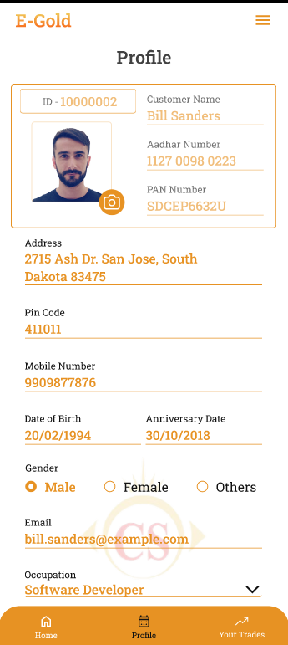

|  |  |
| --- | --- |
| **Field name** | **Editable : Yes / No** |
| Profile image | Yes |
| Customer ID and customer Name | No |
| Address | Yes |
| Pincode | Yes |
| Mobile Number | yes |
| Date of birth | yes |
| Gender | yes |
| Email | yes |
| Occupation | yes |
| Date of anniversary | yes |
| Aadhar card number | no |
| Pan card number | no |
| KYC Information | Yes. (Customer can attach files here only if his KYC status is **rejected with reason**) |

|  |  |  |  |
| --- | --- | --- | --- |
| **FIELDS** | **INPUT TYPE** | **MANDATORY / OPTIONAL** | **DESCRIPTION** |
| KYC Information | Text | Mandatory | It will display following fields:  Status:- Pending / Rejected. Initially when customer registers himself and logs into the system, then in profile it will display KYC status as ‘pending’. It will be changed to approved / rejected when tenant updates it from web. Customer can make transactions of sip / buy / sell only if KYC status is approved.  Once the status is approved, then customer should be able to only view KYC details fields.  Reason:- Initially this will be blank when customer has not done KYC process at all. Further, it will display the reason which tenant has mentioned while rejecting kyc from web. If reason is mentioned then user will be able to send KYC request again by re-entering aadhar number with its attachment and pan number with attachment.  Aadhar number:- Initially, it should pre-fill and display the aadhar number that customer has entered while registering. User should be able to edit it.  Aadhar attachment:- User will upload the single aadhar card image in jpg, jpeg, heic, png extension. User should be able to already attached file and upload another one.  Pan number:- Initially, it should pre-fill and display the pan card number that customer has entered while registering. User should be able to edit it.  Pan card attachment:- User will upload the single aadhar card image in jpg, jpeg, heic, png extension. User should be able to already attached file and upload another one.  Submit : Once user clicks on submit button, KYC request should be sent to tenant and will be displayed in customer master. Also, the fields will be read only until status gets changed to rejected with reason so that customer can re-enter the KYC details. |
| Change password | click |  | Customer should be able to reset password. Once user clicks on reset password button, it will display following text fields:   * Old password * New password * Confirm password   Validations: It should display on field error message if old password entered is incorrect or if new password doesn’t match with confirm password.  Once customer resets password and clicks on update button, user should be able to register with new password whenever he had logged out and tries to login. |

**12.11 Notifications**

It should display list of notifications, date & time when notification was sent and each notification should be clickable. Unread notifications should be highlighted. It should display notifications within application regarding:

1. Rate triggers as set by user
2. Buy successful & fail transaction
3. Sell successful & fail transaction
4. SIP started
5. Monthly SIP deductions
6. SIP updated
7. SIP canceled
8. Delivery charges successful & fail transaction
9. Delivery status updates
10. Offers
11. Egifts transaction
12. Updates in bank accounts when done
13. Updates in nominee when done
14. Any external notifications sent by the tenant
15. KYC approve / rejected updates

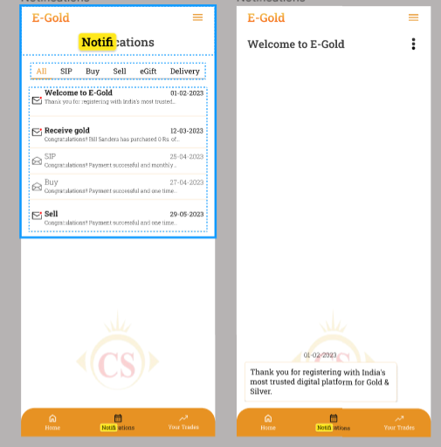

**12.12 Your Trades**

It will display the list of all trades i.e. transactions done by the customer till the date about sell as well as purchase (one time and monthly). It will display following fields:

* Weight Balance
* Filter
* Export
* List of trades

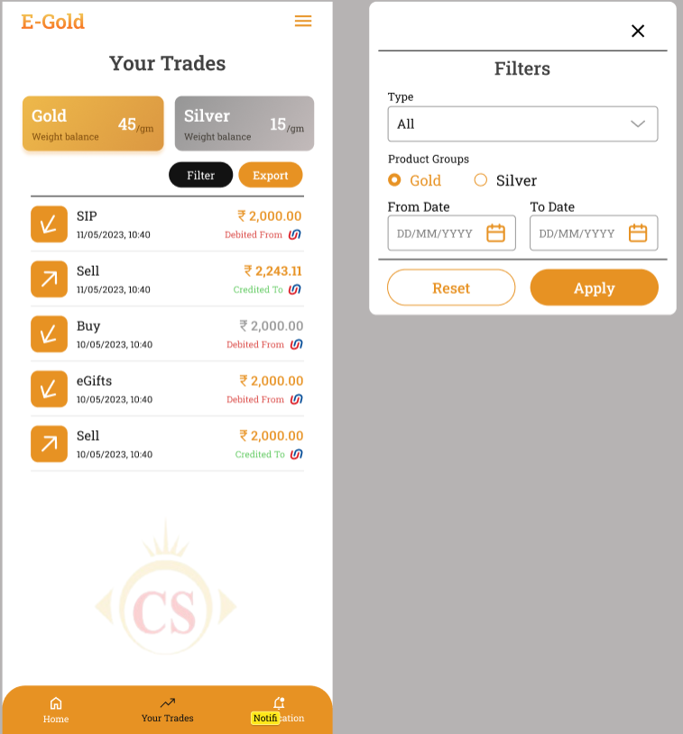

|  |  |  |
| --- | --- | --- |
| **FIELDS** | **INPUT TYPE** | **DESCRIPTION** |
| Weight Balance | Text | It will be read only field.  It will display the total weight in grams for gold and silver that customer has available in his account after making buy / sell / delivery / SIP transactions. |
| Filter | Drop-down | It will display following fields:   * Transaction type * Product Group * From date * To date * Apply button * Reset button   In transaction type, it will be display below list:   * All * Buy * SIP * Sell * Delivery * Sent Egifts * Received Egifts   These will be single select.  Product group will display radio buttons of gold / silver.  From date - It should display calender picker from which customer will select the date from which customer wants to view the trades. In ‘from date’ it will display the date from which customer registered into the application. Rest dates will be disabled from the calendar.  To date - It should display calender picker from which customer will select the date till which customer wants to view the trades. In ‘to date’ it will display the date till current date / today. Future dates will be disabled from the calendar.  As per selected filter options, once customer clicks on apply button then it should display list of trades accordingly. |
| Export | click | Once customer clicks on export button, it will download the excel file. If customer directly clicks on export, then it will display data of all transactions till the date. If customer applies filter and then clicks on export button, then in excel sheet, it will display data of transactions as per applied filter.  It will display data in following columns in downloaded file:  Sr No.  Receipt no.  Transaction date  Transaction time  Transaction type  Product group  Amount  Grams / metal weight in account  Payment mode  Payment ref no / UTR no.  Bank name  Credited / Debited |
| List of trades | View | For each trade, it should display following details on first view:  Trade Id I.e receipt ID  Date & time  Trade type (Buy /sell / SIP)  Amount of trade  Credited / debited  Bank name / symbol  Post condition:- Once customer clicks on each trade, it should display the detailed billing information of the trade done.   * Trade ID * Date & time * Trade type * Amount * Grams (grams purchased or grams sold in that trade) * Bank name * Payment reference number * Customer name * Customer ID * Download button * Share button   Through download button, customer should be able to download bill in pdf format.  Through share button, customer should be able to share bill in pdf format via any share mode available in mobile. |

**12.13 Settings**

A) Nominee settings

Customer can add only one nominee under his account.

Once customer clicks on add button, it will display following fields:

* Nominee name
* Full address
* Date of Birth
* Relation with nominee
* Aadhar number of nominee
* PAN number of nominee
* Mobile number
* Email ID
* Save button

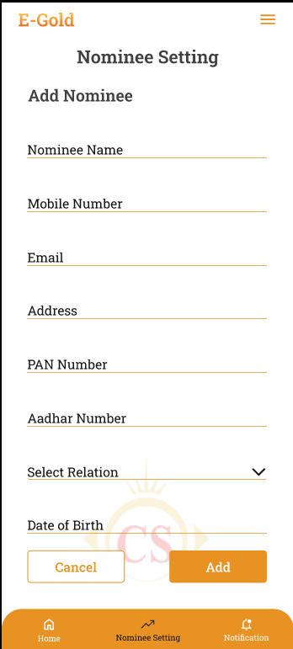

|  |  |  |  |
| --- | --- | --- | --- |
| **FIELDS** | **INPUT TYPE** | **MANDATORY / OPTIONAL** | **DESCRIPTION** |
| Nominee name | Text | Mandatory | Customer will enter the name of the nominee he wants to add.  It should accept characters and space only.  Maximum length of input field should be 50 characters.  This field shouldn’t be case sensitive. |
| Full Address | text | mandatory | Customer will enter the full address of the nominee.  It will accept maximum 250 characters / numbers. It should accept single space only after one word. It should accept . / - , special characters only. |
| Date of Birth | Calendar picker | Mandatory | customer will enter the date of birth of the nominee.  Future dates should be disabled.  Minor nominee (below 18 years till today’s date) shouldn’t get added. It should display on field error. |
| Relation with nominee | Text | Mandatory | Customer will choose his relation with the nominee from the drop-down as mother / father / sister / brother / daughter / wife / husband / etc. |
| PAN number | text | mandatory | Customer will enter 10 digit alphanumeric PAN No. of nominee.  One PAN no. should be used for registration only once. (each customer will have unique pan no.) .  It includes first five letters, followed by 4 numbers and last character.  In case of invalid pan card number format, it should display error message as “Invalid pan number”. |
| Aadhar card number of nominee | Text | Mandatory | customer will enter 12 digit Aadhar number of the nominee.  One Aadhar no. should be entered only once. customer will have to enter unique Aadhar no. Customer cannot mention same already entered aadhar number for another nominee. Also, it cannot be as same as registered user’s aadhar number.  In case of invalid aadhar card number format, it should display error message as “Invalid aadhar number”. |
| Nominee mobile no. | text | mandatory | Customer will enter nominee’s mobile number. |
| Nominee’s Email ID | text | Optional | Customer will enter nominee’s email ID. |
| Save | Click | Mandatory | Once customer enters one or more nominee details and clicks on save, it will save data and display the added details on ‘Nominee settings’ page. |

1. **Bank account settings**

customer will add the list of bank accounts into the application. The added bank accounts will be displayed while making payments. It will display list of bank accounts if added any and add more button. Once customer clicks on add more button, it will display following fields:

* Credit / Debit card number
* Card holder name
* Bank name
* IFSC code
* Save button

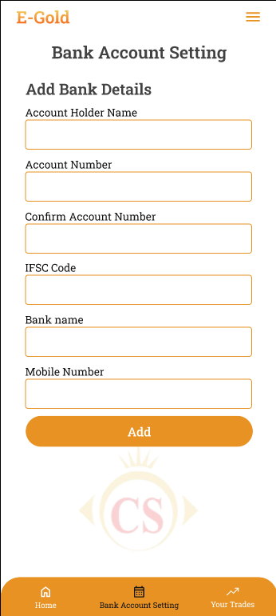

|  |  |  |  |
| --- | --- | --- | --- |
| **FIELDS** | **INPUT TYPE** | **MANDATORY / OPTIONAL** | **DESCRIPTION** |
| Credit / debit card number | Text | Mandatory | customer will enter the alphanumeric or only numeric bank account number.  It shouldn’t accept space. It should accept 19 digits. |
| Card holder name | Text | Mandatory | customer will enter the account holder name as on bank passbook or on card.  It should accept characters and space only.  Maximum length of input field should be 50 characters. |
| Bank Name | Drop-down | Mandatory | customer will select the bank name for the list. It will be single select. |
| IFSC number | Text | Mandatory | customer will enter 11 digit alphanumeric IFSC number. As per selected bank name and IFSC number, it should validate whether the IFSC number is correct or not and display error message in case it is incorrect. |
| Save | click | mandatory | Once customer enters one or more bank details and clicks on save, it will save data and display the added details on ‘Bank account settings’ page. |

1. **Preferences settings**

customer will set communication preferences. It will display following fields:

* Communication mode
* Call timings
* Communication language
* Notification permissions
* App unlock recognition

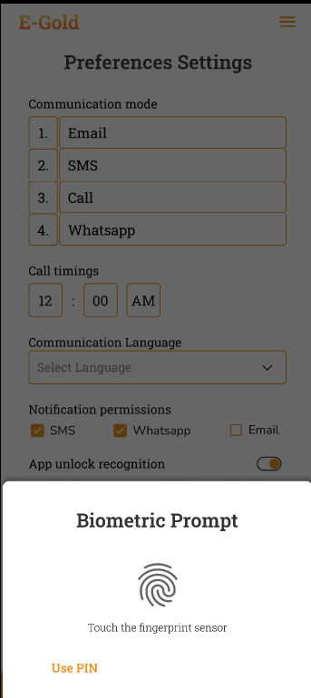

|  |  |  |  |
| --- | --- | --- | --- |
| **FIELDS** | **INPUT TYPE** | **MANDATORY / OPTIONAL** | **DESCRIPTION** |
| Communication mode | Drag & drop | Optional | customer will drag and drop his preferred communication mode in sequence. It will display following options email, SMS, call, Whats-app. |
| Call timings | Time | Optional | customer will mention his available ‘from and to’ timing so that support team can contact customer as per his preferred time. |
| Communication language | Drop-down | Optional | customer will select the language that he prefers to get call and messages. |
| Notification permissions | Permissions | Optional | customer will enable / disable communication preference by toggle.  It will have options as SMS, email and whats-app.  If customer disables any mode, then notification should get sent to customer on that medium and should get sent by the enabled medium.  However, within application notification will be sent to all by default. |
| App unlock recognition | Radio button | Optional | customer will select the option which he prefers while visiting the app each time and unlocking it.It will be either finger lock or pass-code.  After selecting option, setting recognition details and once customer clicks on save button, then later on when customer visits / opens app each time, customer will have to enter the pass-code/ scan finger and unlock the app. |

1. **Promo Codes & reference**

**Phase 2**

**12.14 eGifts**

Through eGifts, customer should be able to send metal in grams to his friends / relatives using mobile number. It will have following fields:

* Receiver’s Mobile number
* Receiver’s email ID
* Receiver’s Name
* Message
* Select grams
* Amount
* Send egift (button)

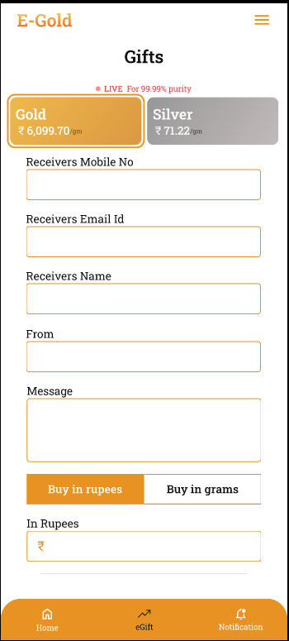

|  |  |  |  |
| --- | --- | --- | --- |
| **FIELDS** | **INPUT TYPE** | **MANDATORY / OPTIONAL** | **DESCRIPTION** |
| Mobile number | Text | Mandatory | customer will enter the valid mobile number of the person to whom customer wants to sent the egift.  Receiver may or may not be registered to our egold application. Link of egift will be sent to the receiver’s mobile number via SMS.  Validations:- Only numbers should be accepted. Maximum 10 digits should be accepted. It should be unique. Consecutive ten zeros or consecutive ten ones shouldn’t be accepted as a number. |
| Receiver’s name | Text | Mandatory | customer will enter the name of the person to whom customer wants to send the egift.  It should accept characters and space only.  Maximum length of input field should be 50 characters.  This field shouldn’t be case sensitive. |
| Message | text | optional | Sender will write the message here which will be displayed to the receiver when he adds the egift to his account.  Validation:- Max 250 characters. It should accept space, characters, numbers, special characters. |
| Grams | Text | Mandatory | customer will enter the weight of the metal in grams that customer wants to send to the receiver.  customer will manually enter |
| Amount | Text | Mandatory | It will be read only field.  As per selected product group and entered grams, it will calculate and display the amount.  Amount = grams entered * current rate of per gram + 3% GST . |
| Send egift | Click | Mandatory | Once customer enters above mandatory fields and clicks on ‘send Egift’ button, then it will display billing information on next page and have proceed to pay button.  Once customer clicks on proceed to pay button, it will display the list of bank accounts that customer has added in application and app account as options. customer will select the bank account through which customer wants to do payment and will click on confirm button.  Once customer clicks on confirm, it will display the message as “Egift sent successfully!”.  Once egift is sent by user, SMS will be sent to receiver’s number along with the link for application / his account.  Also, once egift is sent by customer himself, then it will be displayed in your trades menu of customer’s account. |

**12.15 Offers**

Offers is discount which tenant is giving to his customers. In offers menu, it will display the list of offers availed by tenant to customers. It will display following details of each offer:

* Offer image
* Offers information
* Terms and condition
* Copy Code action

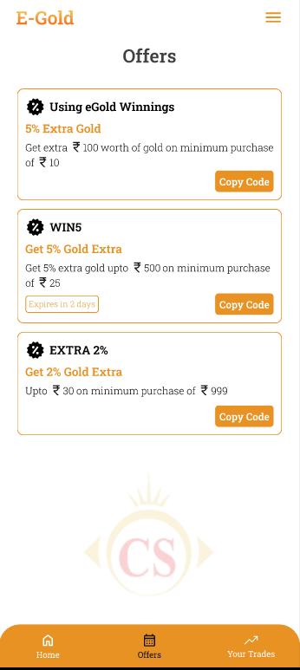

During buy / sell / egift action, customer should be able to apply the offer on billing page and the discount should get deducted from the total amount. Customer can apply one one offer at time for one transaction.

**12.16 Help Desk**

It will display two options as Call or email. Once customer clicks on **call**, then it will be connected to application support team of tenant.

If customer selects **email**, then it will display following fields:

* Query type
* Text box
* Submit button

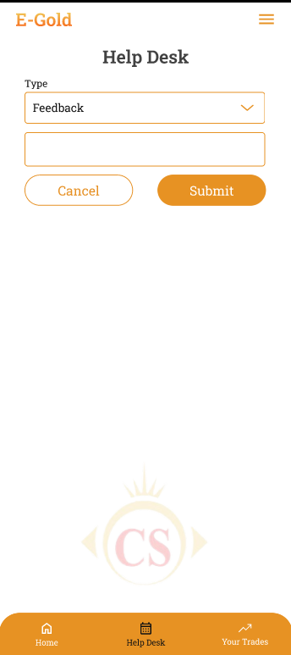

Query type list will be displayed in drop-down as per master from web. Query type will be drop-down displaying Concern, transaction issue, application issue, feedback and others in the list. Customer will write his concerns / feedback in the text field. Once customer clicks on submit, it will display message as “Your response has been sent to support team. You will receive an update within 24-48 hours”. And, email will get sent to application support team of tenant.

**12.17 About Us**

It will display information about the application, tenant, description of features, terms and conditions and will include sliders, images & videos. It will have social media links at the bottom, contact details and application share button.

The details / information in about us will be displayed as per tenant’s settings from web.

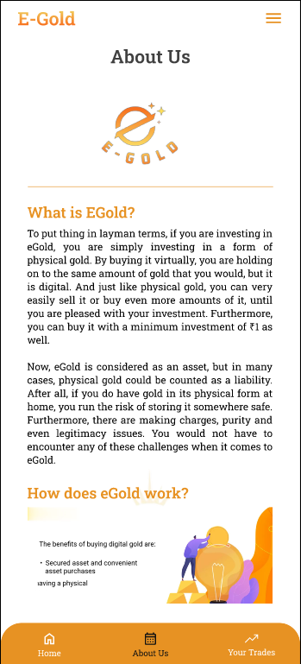

1. **WEB APPLICATION**

*Egold web application will have following features:*

* *Dashboard*
* *Profile*
* *Masters*
* *Tenant master*
* *Customer master*
* *Country master*
* *State master*
* *City master*
* *Occupation master*
* *Document master*
* *Bank master*
* *Transaction Reports*
* *Monthly SIP*
* *Buy*
* *Sell*
* *Delivery*
* *Default settings*
* *Tenant wise settings*
* *Privilege roles*
* *User management*
* *Menu management*

**13.1 Tenant Master**

Super admin will add tenant through web. Further, tenant will be able to log into web using their own credentials and will able to view data of their customers, transaction reports and update configurable settings which will get reflected on mobile application to their respective customers.

Tenant master will have following fields:

* Add tenant
* Edit action
* View action
* Tenant ID
* Tenant name
* Email
* contact no.
* Whats-app no.
* Contact person name
* Status : active or inactive
* Created at & by
* Updated at & by

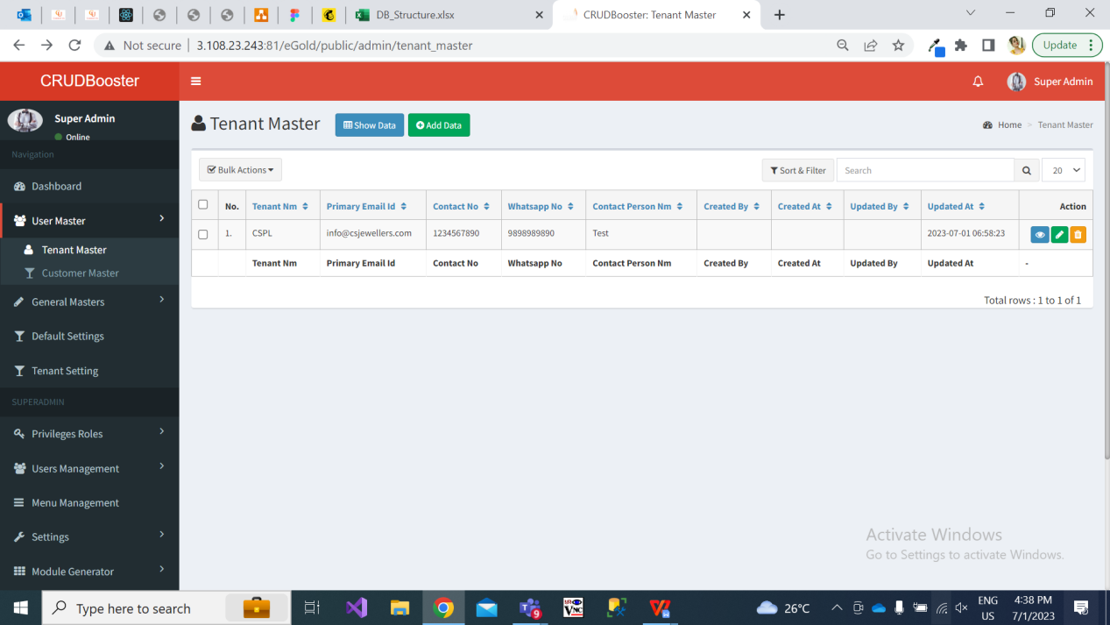

Once user clicks on add button to add new tenant, it will display following fields:

* Tenant name
* Email
* Contact no.
* Whats-app no.
* Contact person name
* GST no.
* PAN no.
* Address 1
* Address 2
* Pin code
* Country
* State
* City
* Password
* About Us
* Remark
* Is active
* Save and add more button
* Save button

Once tenant is added, successful message will be displayed and user will be direct to grid page of tenant master. Unique tenant ID will generated for added tenant and recently added tenant will be reflected on top row of **grid**.

Once user clicks on **view** action against added tenant, it will display following fields with tenant details as added / updated.

* Tenant ID
* Tenant name
* Email
* Contact no.
* Whats-app no.
* Contact person name
* GST no.
* PAN no.
* Address 1
* Address 2
* Pin code
* Country
* State
* City
* Password
* About Us
* Remark
* Status : active / inactive
* Created at & by
* Updated at & by

Once user clicks on **edit** action following fields will be displayed:

* Tenant ID - Read only
* Tenant name
* Email
* Contact no.
* Whats-app no.
* Contact person name
* GST no.
* PAN no.
* Address 1
* Address 2
* Pin code
* Country
* State
* City
* Password
* About Us
* Remark
* Status : active / inactive
* Save & add more button
* Save button

Further, the users of added tenant should be able to log into web application and should have access to data as per their privilege roles.

Moreover, if tenant is deactivated then its mapped customers shouldn’t be able to log into the mobile application and tenant shouldn’t be able to log into the web application.

**13.2 Customer master**

Once customer registers through their mobile against particular tenant, it will be displayed in customer master. It will display following fields:

* Export button
* View action
* Edit action
* Preferences action
* Customer ID
* Tenant name
* Customer name
* Mobile number
* Email
* KYC
* Status
* Created at & by
* Updated & by

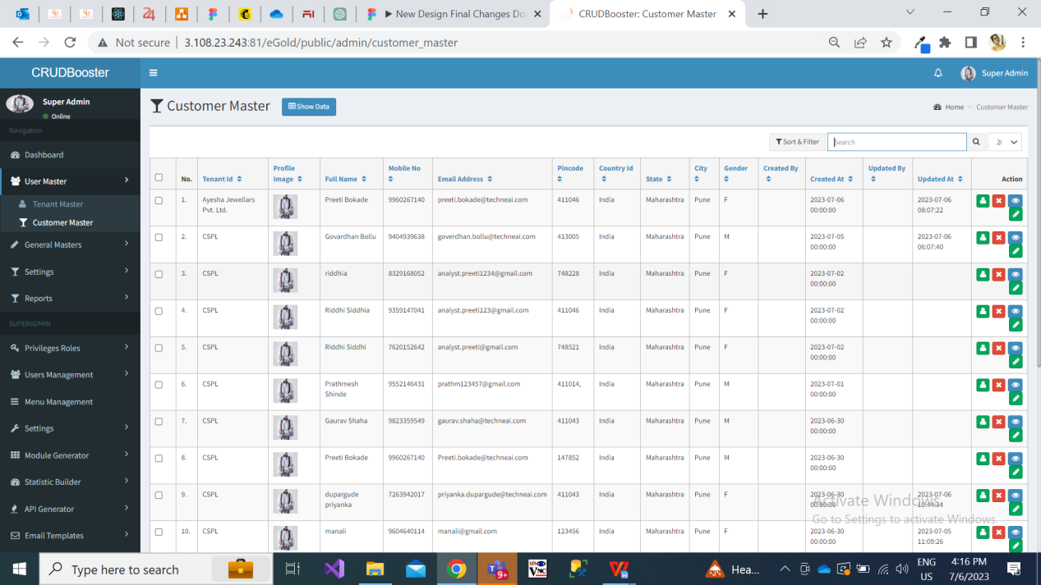

Recently registered customer will be displayed at top in the grid. Also, if any customer has updated his KYC process, then it will be displayed at top.

In **view** action, it will display following details of added customer:

* Customer ID
* Tenant Name
* Customer Name
* Address
* Pin code
* Country
* State
* City
* Mobile number
* Date of birth
* Gender
* Email
* Occupation
* Date of anniversary
* Referral Code
* Aadhar card number
* Pan card number
* Password
* Nominee name
* Nominee address
* Nominee’s DOB
* Relation with nominee
* Aadhar number of nominee
* PAN number of nominee
* Nominee’s Mobile number
* Nominee’s Email ID
* KYC status : pending / rejected
* KYC Rejection reason
* Pan attachment
* Aadhar attachment
* Status : active / inactive
* Created at & by
* Updated at & by

In edit action, it will display following details of added customer:

* Customer ID
* Tenant Name
* Customer Name
* Address
* Pin code
* Country
* State
* City
* Mobile number
* Date of birth
* Gender
* Email
* Occupation
* Date of anniversary
* Referral Code
* Aadhar card number
* Pan card number
* Password
* Nominee name
* Nominee address
* Nominee’s DOB
* Relation with nominee
* Aadhar number of nominee
* PAN number of nominee
* Nominee’s Mobile number
* Nominee’s Email ID
* KYC : pending / rejected / approved
* KYC rejected reason
* Pan attachment
* Aadhar attachment
* Status : active / inactive
* Save button

All above fields will get updated as and when customer updates from his profile from mobile application.

|  |  |  |  |
| --- | --- | --- | --- |
| **FIELDS** | **INPUT TYPE** | **MANDATORY / OPTIONAL** | **DESCRIPTION** |
| KYC | Radio button | Mandatory | Initially when customer registers, then customer will be reflected in customer master where KYC will be ‘pending’ by default.  Tenant will review pan card, aadhar card and photo attachment and will approve or reject. If customer approves, then in customer’s profile -> KYC status on mobile app will be displayed as “approved”.  If tenant rejects it, then it will be displayed in customer’s profile on mobile app. |
| KYC reason | text | Optional | KYC reason text field will be displayed only if tenant rejects KYC.  Once tenant rejects KYC and mentions reason, then it will be displayed in customer’s profile on mobile app. If reason is specified by tenant, then customer can do KYC process from their mobile login again. |

Once user clicks on preference action, it will display details as preference settings done by customer from mobile application. It will display following read only fields:

1. Communication mode
2. Communication language
3. Call timings
4. App unlock recognition
5. Save button

|  |  |  |  |
| --- | --- | --- | --- |
| **FIELDS** | **INPUT TYPE** | **MANDATORY / OPTIONAL** | **DESCRIPTION** |
| Communication Sequence | Text | Optional | Initially, it will be blank until customer hasn’t communication preference from mobile app.  Here, it will display the communication medium in sequence as set by the customer. It defines the sequence in which the tenant should contact the customer.  It will be editable as well. |
| Communication language | text | optional | Initially, it will be blank until customer hasn’t communication preference.  Later, it will display the language as selected by customer from the drop-down list of communication language.  It will be editable as well. |
| Call timings | Text | Optional | It will display from and to duration when tenant can contact the customer via call.  It will be editable as well. |
| App unlock recognition | Toggle button | Optional | It will display two options as ON / OFF as per settings done by customer.  If customer has set biometric or pin for app unlock, then ON will be displayed in back-end.  It will be editable as well. |
| Save | Click |  | If tenant makes any changes in preference settings and saves it, then the saved changes will be displayed in mobile application as well as in preference action of customer master. |

**13.3 Occupation Master**

List of active occupations will be displayed in occupation field to customers while registering. It will have following fields:

* Add
* View
* Edit
* Occupation name
* Remark
* Status
* Created at & by
* Updated at & by

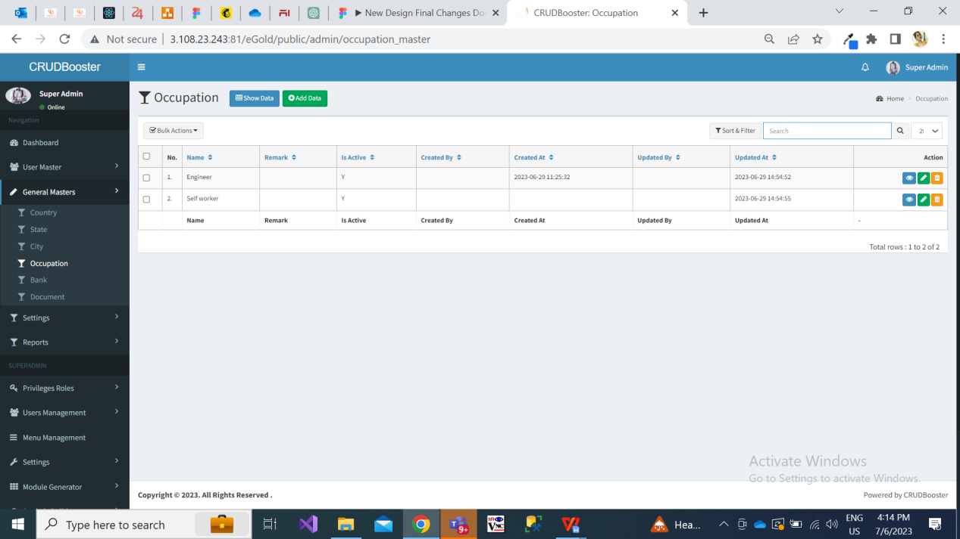

Fig: Occupation master

**13.4 Default Settings**

Initially, few menus / features will be displayed to customers of respective tenant as per default settings. Further as per applied settings, menus / features will be displayed to the customers.

Currently, below settings will be configurable as per tenant:

* Logo
* Background image on dashboard / all screens
* Dark mode
* Light mode
* Commodity - gold / silver
* Graph
* Banners
* SIP button and screens
* Buy button and screens
* Sell button and screens
* Rate trigger button and screens
* Features
* Booking time
* Buy - min amount & min grams for gold & silver
* Sell - min amount & min grams for gold & silver
* Delivery charges for gold and silver
* Delivery multiples for gold and silver
* Whats-app notifications - provider, number,
* Sms notifications - provider, sender ID
* Max amount in one transaction
* Pan card required up to limit
* TCS limit
* Refresh rates time
* Min age of customer for registration
* Min & max months of SIP
* Min & max amount of SIP
* Delivery date
* Delivery charges

Super admin will add default settings, it will display following fields:

* Module name
* Sub module name
* Setting name
* Setting data type
* Default value
* Possible values
* Sort order
* User can change
* Use encryption
* Remark
* Is active
* Save & add more button
* Save button

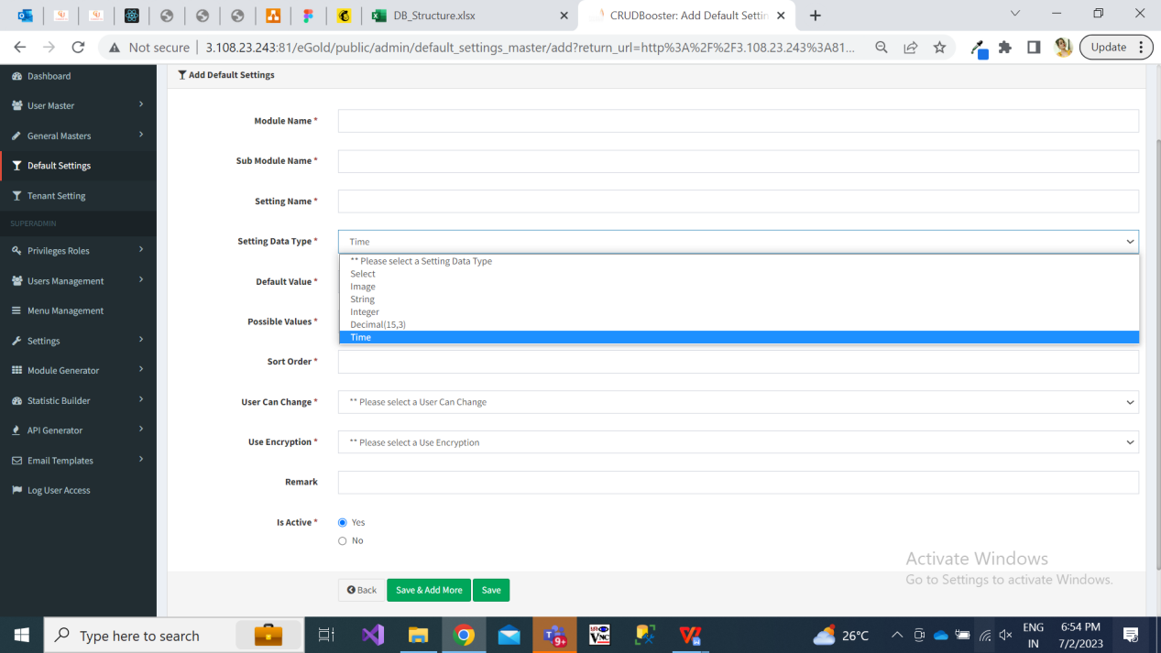

Fig: Add default settings

|  |  |  |  |
| --- | --- | --- | --- |
| **FIELDS** | **INPUT TYPE** | **MANDATORY / OPTIONAL** | **DESCRIPTION** |
| Module name | text | Mandatory | Super admin will enter the module name referring to which the setting is about. |
| Sub module name | text | Mandatory | Super admin will enter the sub-module name referring to which the setting is about. |
| Setting name | text | Mandatory | Super admin will enter the setting name referring to which the setting is about. |
| Setting data type | Drop-down | mandatory | It will be the data type of setting we are reffing to.  Image  Select  String  Int  Decimal  Time  Example: If setting is about image like displaying logo, then super admin will select data type as image.  If setting is about text field, then super admin will select string.  If setting is about timing, then super admin will select time. Example: If tenant wants to set start time and end time during which customers can make transactions, then tenant will select data type as time for such setting. |
| Default value | text | Mandatory | Super admin will enter the default value as per data type.  Means, by default which image / text should be displayed in the selected setting. |
| Possible values | text |  | This field will be displayed only if super admin selects data type as ‘select’. |
| Sort order | text |  |  |
| User can change | Drop down | Mandatory | It will display yes / no. Means, whether tenant can change it or not through tenant settings -> edit action. |
| Use encryption | Drop down | Mandatory | It will display yes / no to display encrypted data for selected field on customer’s page. |
| remark | text | Optional | Super admin will mention additional comments in this text field. |
| Is active | Radio button | mandatory | By default it will display as active.  Once the particular default setting is deactivated then this field won’t be editable to tenant. |
| Save button | click |  | Once super admin clicks on save button, then as per settings & development in database, the default setting will get added and the same will get reflected against each active tenant in tenant settings.   Also, default settings will be displayed to customers until their tenant hasn’t changed the particular setting from tenant settings. |

**13.5 Tenant settings**

Initially, tenant will get all default settings further which tenant can edit them. If any changes are not made in settings by tenant, then respective customers of that tenant will get view on application as per default settings.

As and when tenant is added by super admin in tenant master, then all active settings will get added in tenant settings against that newly added tenant.

Once tenant log into web application by their credentials, tenant will have access to tenant settings menu. It will have following fields in grid for each available setting:

* Tenant id
* Setting name
* Setting value
* Remark
* Is active
* Created at & by
* Updated at & by
* Edit action
* View action

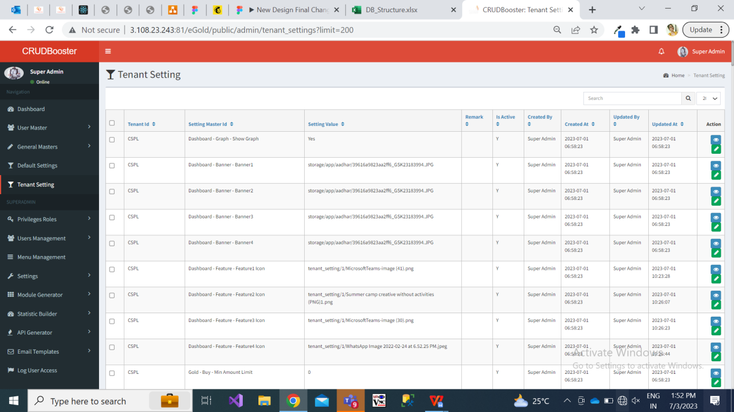

Fig: Tenant setting

Once user clicks on edit action of tenant setting, it will display following pre-filled fields:

* Setting name
* Setting value
* Remark
* Is active

Here, setting name will be read only field. In setting value, initially it will display the value as in default settings whereas tenant can change it. As per data type of that setting name, it will display the setting value field.

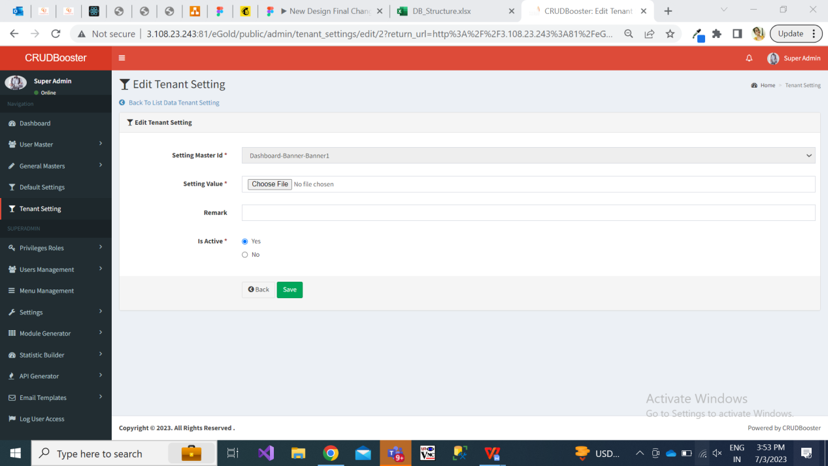

Fig: tenant settings edit action.

Further, as per changes done by tenant in particular configurable setting, it will get reflected to his mapped customers on mobile app. If any setting hasn’t been edited by tenant, then value as per default settings will be displayed to customers.

Further, if any default setting is deactivated by super admin, then that setting will be disabled in tenant setting as well. Whereas, that deactivated setting will be reflected as blank to new customers as well as already existing customers.

**13.6 Transaction - Buy Report**

As and when customers perform buy transaction it will be displayed to tenant in web -> reports. It will have following fields in grid:

* Sr no.
* View action
* Tenant ID
* Customer ID
* Customer name
* Transaction type as Buy
* Product Group
* Receipt no. / Transaction ID
* Transaction status
* Grams purchased
* Total bill Amount
* Transaction date
* Account Weight balance

Once tenant / super admin clicks on view action, it will display following read only fields:

* Tenant ID
* Customer ID
* Customer name
* Transaction type as Buy
* Product group
* Transaction ID / receipt no.
* Grams purchased
* Current rate - It will display the current rate of buy during which the purchase is done by customer.
* Metal amount
* GST amount
* Offer
* Total bill Amount
* Transaction date
* Transaction Time
* Bank name
* Account Weight balance - It will display the updated weight balance after this particular buy transaction was done by customer.
* Digital receipt - It should display hyperlink of the receipt which as in your trades against this particular transaction and should be downloadable.
* Unique device number - number of device from which the transaction was done by customer

**13.7 Transaction - Sell Report**

As and when customers undergo sell transaction it will be displayed to tenant in web -> reports. It will have following fields in grid:

* Sr no.
* View action
* Tenant ID
* Customer ID
* Customer name
* Transaction type as Sell
* Product Group
* Receipt no. / Transaction ID
* Grams sold
* Total bill Amount
* Transaction date
* Account Weight balance

Once tenant / super admin clicks on view action, it will display following read only fields:

* Tenant ID
* Customer ID
* Customer name
* Transaction type as Sell
* Product group
* Transaction ID / receipt no.
* Grams sold
* Current rate It will display the current rate of sell during which the sell transaction is done by customer.
* Total bill Amount
* Transaction date - The date on which customer sold the particular grams.
* Transaction Time
* Account Weight balance - It will display the updated weight balance after this particular sell transaction was done by customer.
* Digital receipt - It should display hyperlink of the receipt which as in your trades against this particular transaction and should be downloadable.
* Unique device number - number of device from which the transaction was done by customer
* Refunded to bank - It will display bank name to which refund was done.
* Refund date & time - Once amount is refunded to customer’s bank account, the refunded date & time should be displayed.

**13.8 Transaction - SIP Report**

As and when each monthly SIP amount is deducted by customers, it will be displayed to tenant in web -> reports. It will have following fields in grid:

* Sr no.
* View action
* Tenant ID
* Customer ID
* Customer name
* Transaction type as SIP
* SIP number
* Product Group
* Receipt no. / Transaction ID
* Grams auto-purchased
* SIP Amount
* Transaction date
* Account Weight balance

Once tenant / super admin clicks on view action, it will display following read only fields:

* Tenant ID
* Customer ID
* Customer name
* Transaction type as SIP
* SIP number
* Product group
* Transaction ID / receipt no.
* Grams auto purchased
* Current rate It will display the current rate of buy during which the purchase done by customer.
* Total SIP amount
* GST amount
* Transaction date - The date on which customer auto-purchased the particular grams by sip transaction.
* Transaction Time
* Account Weight balance - It will display the updated weight balance after this particular sip transaction was done by customer.
* Digital receipt - It should display hyperlink of the receipt which as in your trades against this particular transaction and should be downloadable.
* Unique device number - number of device from which the transaction was done by customer.

**13.9 Transaction - Delivery Report**

As and when customers undergo sell transaction it will be displayed to tenant in web -> reports. It will have following fields in grid:

* Sr no.
* View action
* Edit action
* Tenant ID
* Customer ID
* Customer name
* Transaction type as Delivery
* Product Group
* Receipt no. / Transaction ID
* Grams Delivery
* Delivery charges
* Transaction date
* Delivery Date
* Account Weight balance

Once user clicks edit action, it will display following read only fields:

* Tenant ID
* Customer ID
* Customer name
* Transaction type as Delivery
* Product Group
* Receipt no. / Transaction ID
* Grams Delivery
* Delivery charges
* Transaction date
* Account Weight balance
* Mobile number
* Alternate mobile number
* Address
* Landmark
* Pin code
* State
* City
* ID proof
* Type of address
* Delivery Status - Delivered / not delivered radio button will be provided and will be editable. Tenant will manually mark it as delivered once physical delivery of ordered product is handed over to the customer. Once delivery is marked as delivered, then ‘**delivery date**’ field should be displayed below. Tenant will mention the delivery date and click on save button
* Save button - If status and delivery date has been updated by tenant and once tenant clicks on save button, then notification of delivery should get sent to the customer within app and via medium as per preference.

Once user clicks on view action of delivery report, it will display following read only fields:

* Tenant ID
* Customer ID
* Customer name
* Transaction type as Delivery
* Product Group
* Receipt no. / Transaction ID
* Grams Delivery
* Delivery charges
* Transaction date
* Account Weight balance
* Mobile number
* Alternate mobile number
* Address
* Landmark
* Pin code
* State
* City
* ID proof
* Type of address
* Status
* Updated at date & time

1. **TEST DATA**



1. **ODUS ( Open Discussed Unhanded scenarios )**

Mobile App:-

|  |  |  |  |  |
| --- | --- | --- | --- | --- |
| **Sr. No.** | **Topic** | **Priority**  **(High / medium / low)** | **Remark** | **Status**  **(Open/**  **Closed)** |
| 1 | 26/06/2023 : Whether we need to display rate graphs or not. If yes, how to display back dated rates as our app is new. | low |  | open |
| 2 | 26/06/2023: Cancel or edit set rate trigger? | Medium | Cancel or active/inactive rate trigger from history | Closed on 27/06/2023 |
| 3 | 26/06/2023: Which payment gateway did Yogesh shah use last time? | medium | Cashfree as informed by yogesh sir. | Closed on 27/06/2023 |
| 4 | 27/06/2023: Rate trigger above and below fields exact requirement | high | Above or below will be radio buttons.  Customer will mention exact rate means if current rate is 6000, customer will enter amount in ‘below’ as 5500 that means cx should get notification when user will get notification when current rate amount will be 5500 or below that. Decimals can be ignored. | Closed on 27/06/2023 |
| 5 | 27/06/2023: Maximum how many nominees can be added in bank details?s | Medium | Max one nominee as informed by aditya sir | Closed on 27/06/2023 |
| 6 | 27/06/2023: Data / content / requirement for banners or sliders on dashboard. | Medium | Two banners:- one generic about egold application.   One about SIP | Closed on 27/06/2023 |
| 7 | 27/06/2023: Bank holidays if collapse on the date of SIP deduction, then amount should get deducted on another working day or not?  Also, which rate needs to be considered the rate of SIP date or on which the amount is actually getting deducted? | medium | Installments get deducted even on bank holidays / national holidays.  The current rate of the same sate should get considered. | Closed on 27/06/2023 |
| 8 | 02/07/2023: SIP first month payment while beginning for the first time. | High |  | open |
| 9 |  |  |  |  |

Web App:-

|  |  |  |  |  |
| --- | --- | --- | --- | --- |
| **Sr. No.** | **Topic** | **Priority**  **(High / medium / low)** | **Remark** | **Status**  **(Open/**  **Closed)** |
| 1 | 05/07/2023 : From where are we going to send SMS and whatsapp ? | Medium |  | open |
| 2 |  |  |  |  |

1. **REFERENCES**

|  |  |  |  |
| --- | --- | --- | --- |
| **User** | **Name** | **Mail** | **Contact number** |
| **Actual user** | Pritam Mehta  Aditya Shah  Yogesh Shah | [ia@csjewellers.com](mailto:ia@csjewellers.com)  [Aditya.shah@techneai.com](mailto:Aditya.shah@techneai.com)  sm@csjewellers.com |  |
| **Ticket created by (if any)** | Manali bhadirage | Manali.bhadirage@techneai.com |  |
| **Assigned business analyst** | Manali bhadirage | Manali.bhadirage@techneai.com |  |
| **Assigned developer** | Prathmesh shinde  Nikhil Bhosale  Dhirajsingh Chandel  Goverdhan Bollu | [Prathmesh.shinde@techneai.com](mailto:Prathmesh.shinde@techneai.com)  [Nikhil.bhosale@techneai.com](mailto:Nikhil.bhosale@techneai.com)  [Dhirajsingh.chandel@techneai.com](mailto:Dhirajsingh.chandel@techneai.com)  Goverdhan.bollu@techneai.com |  |
| **Assigned tester** | Priyanka Dupargude  Preeti bokade  Viashnavi khandwe | [Priyanka.dupargude@techneai.com](mailto:Priyanka.dupargude@techneai.com)  [Preeti.bokade@techneai.com](mailto:Preeti.bokade@techneai.com)  [Vaishnavi.khandwe@techneai.com](mailto:Vaishnavi.khandwe@techneai.com) |  |