BILL CHECKING - IMPS PAYMENT - IS ACTIVE FIELD

Manali Ashok Bhadirage

Manali.bhadirage@techneai.com

13.09.2023

**Handover Document**

**CONTENTS**

1. TICKET DETAILS 2

2. INTRODUCTION 2

3. BUSINESS REQUIREMENT 2

4. SCOPE 2

5. BUSINESS & SYSTEM RULES 3

6. ABBREVIATIONS & TERMS 3

7. GRAPHICAL REPRESENTATION 3

8. DEVELOPED SYSTEM 3

9. REFERENCES OF THE USERS 7

1. **TICKET DETAILS**

|  |  |
| --- | --- |
| **Ticket ID** | TT12988 |
| **Ticket description** | Please remove or hide check box ( is Active ) in imps payment |
| **Created by** | Rohan Shah |
| **Created on** | 07/06/2023 |
| **Priority** | Medium |

1. **INTRODUCTION**

IMPS payment, a sub-module in Connect US -> Bill Checking, is used during 12 URD purchase transactions done in Padm. The payments of URD purchases are processed through IMPS payment module i.e. we have to pay the mentioned payment amount to the customer. The user enters the document series number from Padm and the data as per document number gets displayed. Further these bills are assigned to another user. The authorized person verifies the bill and then changes the status hold / hold till audit / release / paid. Once payments status is changed to release then that bill gets displayed in list of download payment. Moreover, once user enters the bank file then the successful payments get displayed as paid in imps payment module.

1. **BUSINESS REQUIREMENT**

|  |  |  |  |
| --- | --- | --- | --- |
| **Requirement ID** | **Requirement Name** | **Short Description** | **Priority** |
| BR001 | Hide Is active button | We have to hide ‘is active’ field from edit action. Whereas have to display it in grid and view action |  |
| BR002 | Authority based | Create authority for ‘is active’ field. As per authority, it will be displayed in edit action to users.  Whereas, it will display as active by default. |  |

1. **SCOPE**

We have to create an authority for is active field in IMPS payment and it should be displayed only to the users having authority to it. User will enter the document number from Padm -> document -> 12 Gold URD Purchase and details will be displayed as per document. The bills should be displayed in grid of the assigned user, whereas the bill should be displayed in download payment list after its status is changed to release.

1. **BUSINESS & SYSTEM RULES**

* User should be registered in the system.
* User should be logged in.
* System should pop up a message, if any issues in the system is detected.

1. **ABBREVIATIONS & TERMS**

IMPS - Immediate Payment Service

IFSC code - Indian financial system code

1. **GRAPHICAL REPRESENTATION**

Assign bill to user and display in grid

Auto-fill & display fields from padm & submit

Enter doc series no.

Add

Display ‘is active field’ if user has authority

Edit bill

Fig: System Context Diagram

1. **DEVELOPED SYSTEM**

Once user clicks on add data in IMPS Payment, following fields will be displayed:

* Series
* Branch name
* Customer name
* Mobile no.
* Address
* Adjust amount
* Padm credit balance
* Payment amount
* Assign to
* Type
* Bank name
* Bank branch
* IFSC code
* Account number
* Confirm account number
* Attachments
* Remark
* Submit button

Once user enters series number and clicks on search then details from Padm will get auto-filled in branch name, customer name, mobile no., address, Padm credit balance and payment amount.

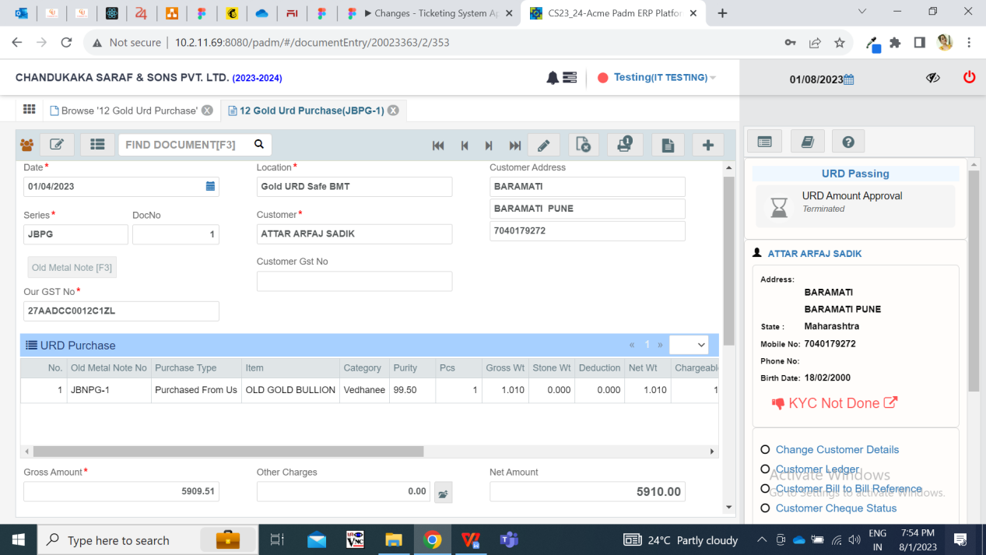

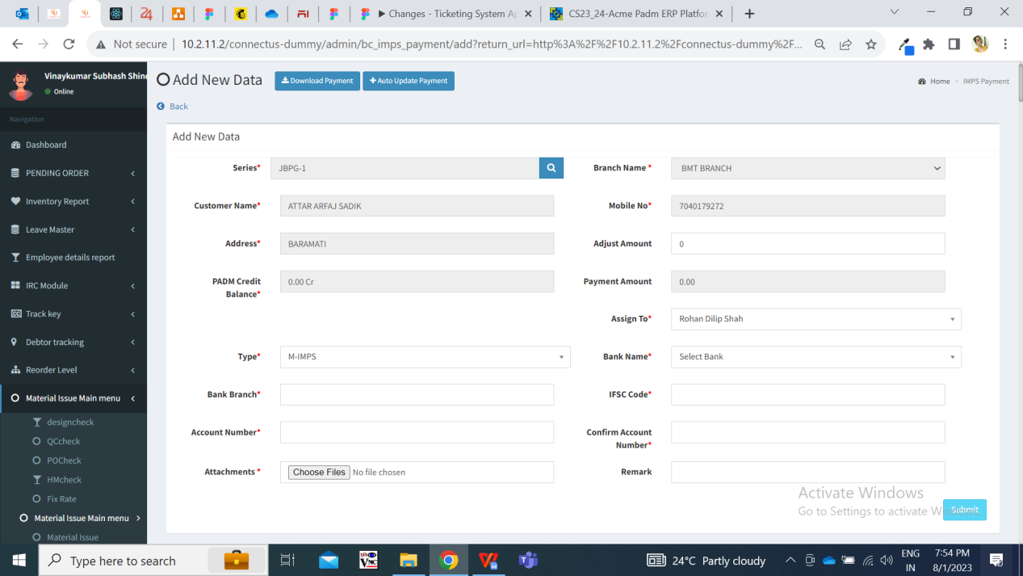

Once user enters other mandatory fields and submits, the bill gets added and assigned to the ‘assigned to user’ and gets displayed in the grid. Here, the bill status is displayed as ‘active’ in grid by default.

Once the bill gets displayed in grid, the assigned user and entry user can edit the bill. Once entry user and assigned user clicks on edit action, then following fields are displayed:

* Series
* Branch name
* Customer name
* Mobile no.
* Address
* Adjust amount
* Padm credit balance
* Payment amount
* Assign to
* Type
* Bank name
* Bank branch
* IFSC code
* Account number
* Confirm account number
* Attachments
* Remark
* Is Active (if unchecked, bill will be canceled)
* Submit button

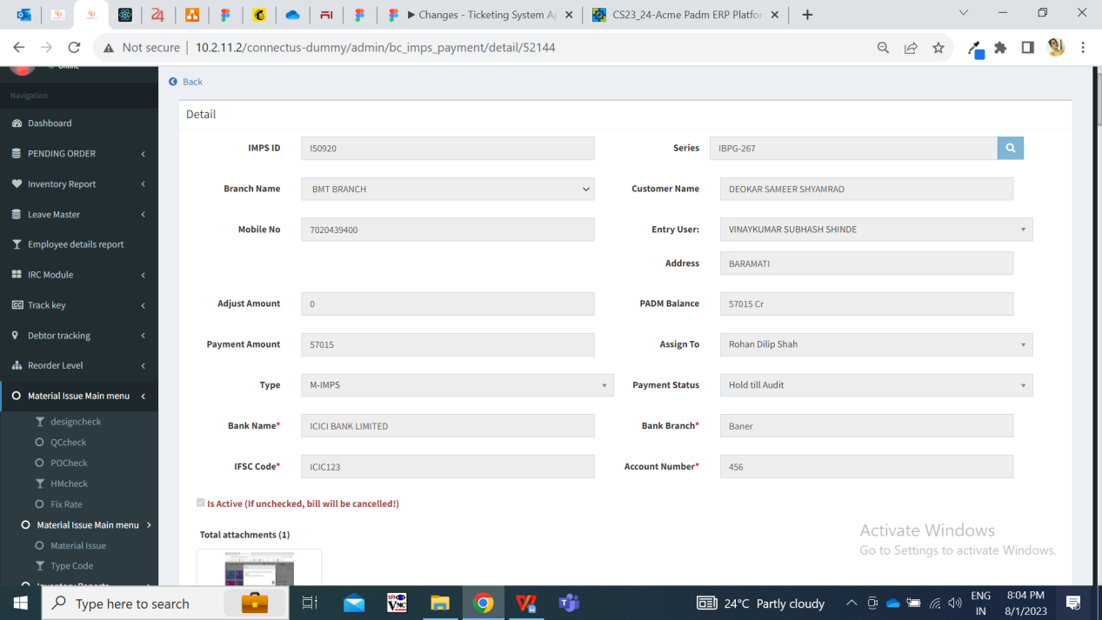

**Input table**

|  |  |  |  |
| --- | --- | --- | --- |
| **FIELDS** | **INPUT TYPE** | **MANDATORY/ OPTIONAL** | **DESCRIPTION** |
| Is Active (if unchecked, bill will be canceled) | Check-box | Optional | Once entry user or assigned user clicks on edit action, then ‘is active’ check-box will be checked by default.  This field should be displayed to the users based on the authority from masters -> login special auth.  If the entry user or assigned user has this authority, then they will be able to view this field as well will be able to check or un-check it. If un-check, then bill will be canceled. Once bill is canceled , it will be removed from grid whereas will be displayed from filter option with updated bill status.  Once user checks or un-checks this field, then its updated status as active / inactive will be displayed in view action and in grid.  Once ‘is active’ field is un-checked, its updated entry will be displayed in history action. |

Special authority has been created in masters -> general masters ->special authority masters.

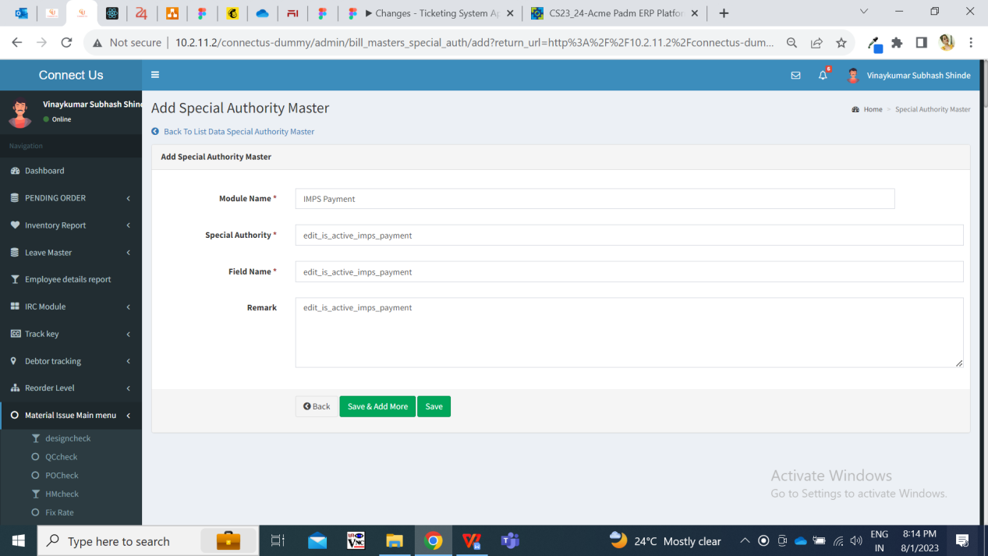

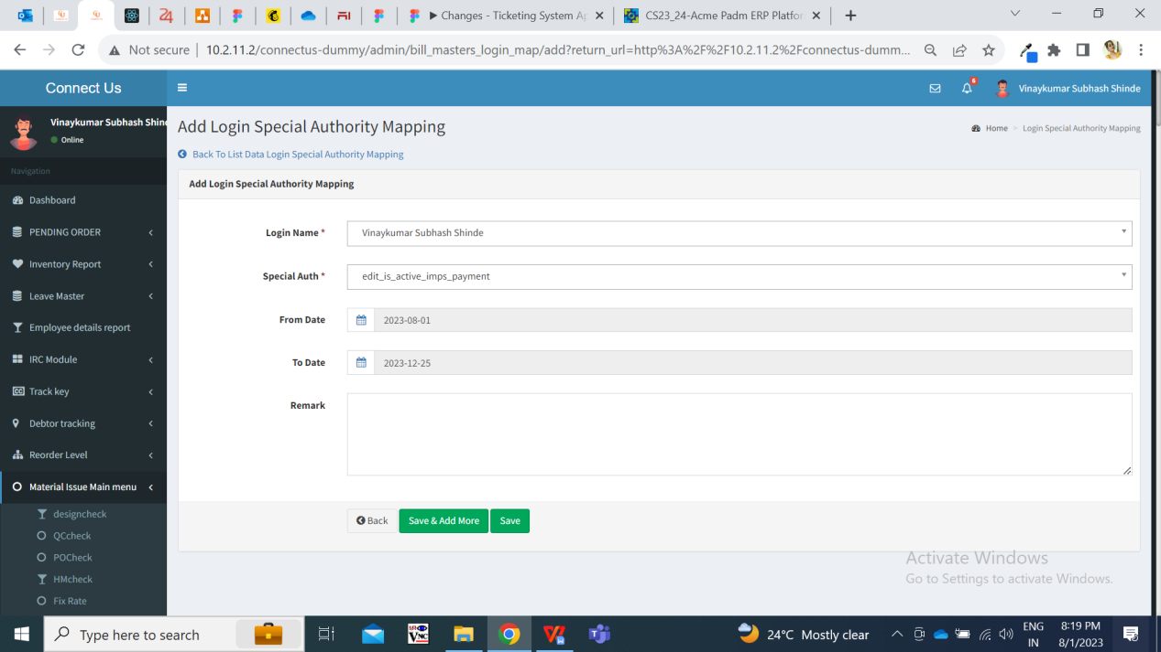

The users having this authority will be able to access ‘is active’ field in IMPS Payment -> edit bill and will be able to check / un-check it.

1. **REFERENCES OF THE USERS**

|  |  |  |  |
| --- | --- | --- | --- |
| **User** | **Name** | **Mail** | **Contact number** |
| **Actual user** | Rohan Shah | [brpayment@csjewellers.com](mailto:brpayment@csjewellers.com) | 2569 |
| **Ticket created by (if any)** | Rohan Shah | [brpayment@csjewellers.com](mailto:brpayment@csjewellers.com) | 2569 |
| **Assigned business analyst** | Manali bhadirage | Manali.bhadirage@techneai.com |  |
| **Assigned developer** | Yogita Jagtap  Prathmesh shinde | Yogita.jagtap@techneai.com |  |
| **Assigned tester** | Priyanka dupargude | Priyanka.dupargude@techneai.com |  |