IMPS PAYMENT- DOWNLOAD BUTTON

16.08.2023

Manali Ashok Bhadirage

Manali.bhadirage@techneai.com

**Handover Document**

**CONTENTS**

1. TICKET DETAILS 2

2. VERSION CONTROL 2

3. APPROVALS 2

4. ESTIMATION 2

5. INTRODUCTION 3

6. BUSINESS REQUIREMENT 3

7. SCOPE 3

8. BUSINESS & SYSTEM RULES 3

9. ABBREVIATIONS & TERMS 3

10. EXISTING SYSTEM 4

11. GRAPHICAL REPRESENTATION 4

12. PROPOSED SYSTEM 4

13. TEST DATA 11

14. ODUS 11

15. REFERENCES OF THE USERS 11

1. **TICKET DETAILS**

|  |  |
| --- | --- |
| **Ticket ID** | TT14064 |
| **Ticket description** | दिलेल्या फोटो प्रमाणे connect -us मध्ये payment file upload करताना त्याठिकाणी Total Amount आणि No. of payments add करून देणे |
| **Created by** | Firoj Shaikh |
| **Created on** | 12/07/2023 |
| **Priority** | medium |

1. **INTRODUCTION**

IMPS payment, a sub-module in Connect US -> Bill Checking, is used during 12 URD purchase transactions done in Padm. The payments of URD purchases are processed through IMPS payment module i.e. we have to pay the mentioned payment amount to the customer. The user enters the document series number from Padm and the data as per document number gets displayed. Further these bills are assigned to another user. The authorized person verifies the bill and then changes the status hold / hold till audit / release / paid. Once payments status is changed to release then that bill gets displayed in list of download payment. Moreover, once user enters the bank file then the successful payments get displayed as paid in imps payment module.

1. **BUSINESS REQUIREMENT**

|  |  |  |  |
| --- | --- | --- | --- |
| **Requirement ID** | **Requirement Name** | **Short Description** | **Priority** |
| BR001 | No. Of payments | Add serial number column in download payment button -> list view. | Medium |
| BR002 | Total payment amount | Display sum of payment amounts in the list. | Medium |

1. **SCOPE**

Download payment button should be displayed to the user based on authority from login special auth. Once the status of the bill is changed to ‘release’ from payment detail action, then released bills should be displayed in list from download payment button. We have to display number of bills that are in release status. Further, we have to display total payment amount of the released bills in the list.

1. **BUSINESS & SYSTEM RULES**

* User should be registered in the system.
* User should be logged in.
* All forms should have on field validations. System should display on field errors in case of incorrect inputs.
* Release / paid status will be provided based on authority. Download payment and auto-update payment buttons will be displayed based on authority.

1. **ABBREVIATIONS & TERMS**

IMPS - Immediate Payment Service

IFSC code - Indian financial system code

RTGS - Real time gross settlement

NEFT - national electronic fund transfer

1. **GRAPHICAL REPRESENTATION**

**Display released amount - bills in ‘download payment’ buttton list**

**Change payent status to release from edit action or payment detail action**

**Assign bill to assigned user**

**Add Bill**

**Display serial number for the bills in list & total payment amount**

Fig: Context Diagram

1. **DEVELOPED SYSTEM**

Once entry user **adds** the bill, it will display following fields:

* Series no. And search button
* Branch name
* Customer name
* Mobile no.
* Address
* Adjust amount
* Padm credit balance
* Payment amount
* Assign to
* Type
* Bank name
* Bank branch
* Ifsc code
* Account number
* Confirm account number
* Attachments
* Remark
* submit button

|  |  |  |  |
| --- | --- | --- | --- |
| **FIELDS** | **INPUT TYPE** | **MANDATORY/ OPTIONAL** | **DESCRIPTION** |
| Series number | text | Mandatory | User will enter the document number from Padm -> document -> 12 Gold URD purchase. |
| Branch name | text | Mandatory | It will display the branch name of the logged in person who is adding bill. It will display the branch of logged in person as mentioned in employee master against that logged in person.  It will be read only. |
| Customer name | Text | Mandatory | Once user enters the document number, then it will pre-fill and display the customer name from number against entered series number from padm. |
| Mobile number | Text | Mandatory | Once user enters the document number, then it will display the mobile number of the customer from number against entered series number from padm. |
| Address | Text | Mandatory | Once user enters the document number, then it will pre-fill and display the address of the customer from number against entered series number from padm. |
| Adjust amount | Text | Optional | User will manually enter the amount that is to be rounded off I.e. not to be considered for payment out of net payment. |
| Padm credit balance | Text | Mandatory | It will be read only.  It will display the net payment value as per entered series number. |
| Payment amount | Text | Mandatory | It will be read only.  Once document number is entered, it will display the value in net payment amount in this field.  Further, if any value is entered in adjust amount field, then it will calculate and display amount which is to be paid to the customer. Payment amount = padm credit balance - adjust amount |
| Assign to | Drop-down | Mandatory | It will display the name of the user to whom the bill is to be assigned. (currently we have only added Rohan shah name in the list as only this user is handling URD bills) |
| Type | Drop-dwon | Mandatory | By default it will display M- Imps from the list.  It has RTGS, NEFT and M IMPS in the list. |
| Bank name | text | Mandatory | User will enter the customer’s bank name.  Validation: Maximum 30 digits / characters should be accepted. It shouldn’t accept space. |
| Bank branch | text | Mandatory | User will enter the customer’s bank branch name.  Validation: Maximum 25 digits / characters should be accepted. |
| IFSC code | text | Mandatory | User will enter the bank IFSC code.  Validation: Maximum 25 digits should be accepted. |
| Account number | text | Mandatory | User will enter the customer’s bank account number.  Validation: Maximum 25 digits should be accepted. |
| Confirm account number | text | Mandatory | User will enter the customer’s bank account number as same as entered in above account number field.  Validation: Maximum 25 digits should be accepted. It should display on field error message if account number is not as same as account number field. |
| Attachments | Attach | Mandatory | User will attach the images of customer’s account document like passbook, cheque, purchase bill invoice, etc.  Validation: It should accept maximum 25 attachments. It should accept png, jpg, jpeg, pdf, doc, heic, webp file extensions only. |
| Remark | text | Optional | User will mention the additional comments in this section.  Validation: Maximum 250 chacacters / digits. |
| Submit | Click |  | Once bill is submitted, ID for bill will be created and bill will be displayed in the imps payment grid of the assigned person.  Also, it will be displayed in the logged in person’s grid as per branch assigned to him. |

Once bill is submitted, it gets display in the grid of the assigned user and in the grid of the users of their branch. Once bill is displayed in **grid**, it will display following columns in grid:

* View action
* Edit action
* History action
* Payment detail action
* ID
* IMPS ID
* Payment status
* Customer name
* Transaction
* Assigned to
* Branch name
* Payment date
* Customer account
* Series
* Payment amount
* Adjust amount
* IFSC code
* Bank name
* Entry user name
* Active
* Remark
* Entry time

Only the assigned user will get edit action for the bill and can edit it. Once assigned user clicks on **edit** action of the bill, it will display following pre-filled fields:

* IMPS ID
* Series
* Branch name
* Customer name
* Mobile no.
* Entry user
* Address
* Adjust amount
* Padm balance
* Payment amount
* Assign to
* Type
* Payment status
* Bank name
* Bank branch
* Ifsc code
* Account number
* Attachments (to attach)
* Delete / download already added attachments
* Remark
* Is active
* Submit button

Through payment status field, assigned user can change the status as hold / hold till audit / release / paid. Here, user needs authority to change release / paid status.

Further, all the bills or amount that is in release status through edit action those bills are reflected in ‘download payment’ button. Download button is displayed to the users based on authority.

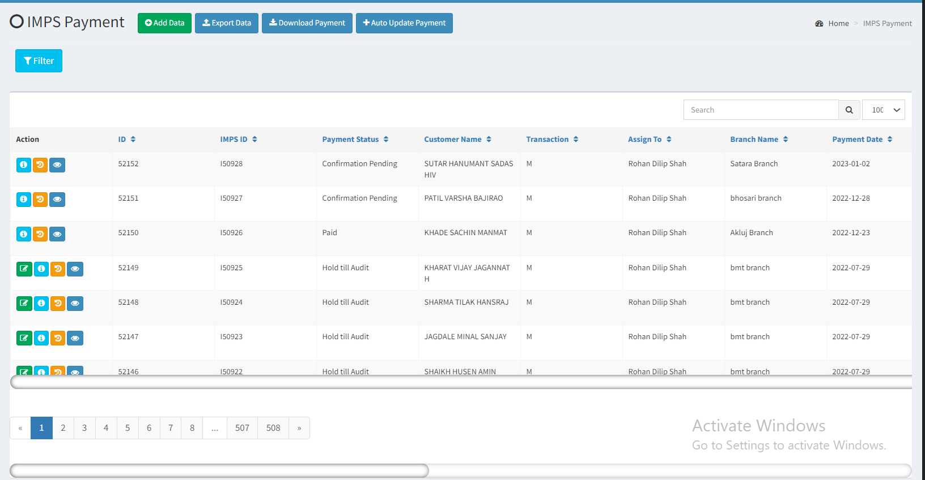

Fig: IMPS Payment Grid

Once user clicks on download button, it displays following fields:

* Download payment button
* Auto update payment button
* Till Date
* IMPS payment list

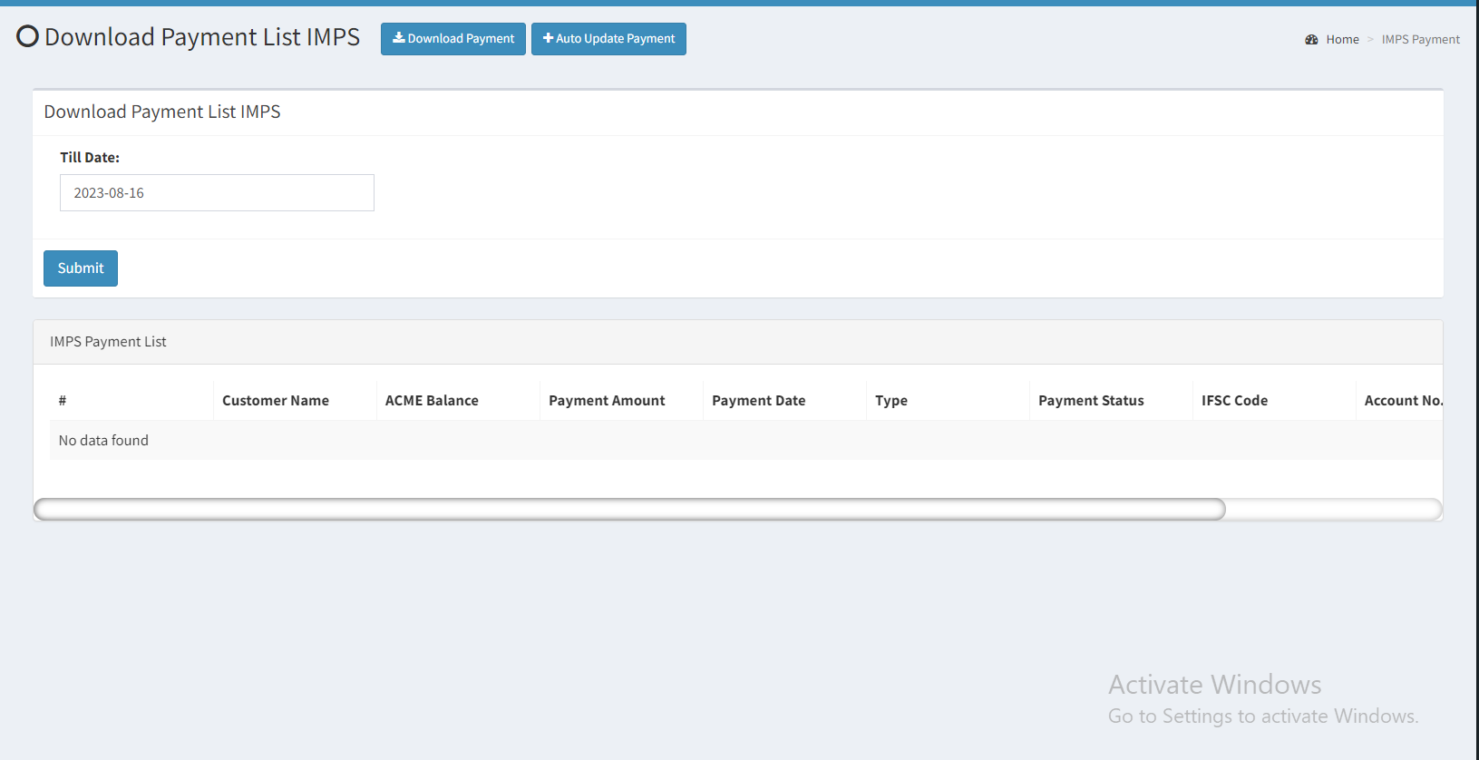

Fig: IMPS DOWNLOAD PAYMENT

Once user selects the date till which user wants to view the bills that are in release status, it will display the IMPS bills list in table. It will have following columns:

1. Sr. No.
2. #
3. Customer name
4. Acme balance
5. Payment amount
6. Paymnt date
7. Type
8. Payment status
9. IFSC code
10. Account no.
11. Mobile no.
12. Total payment amount
13. Download payment list

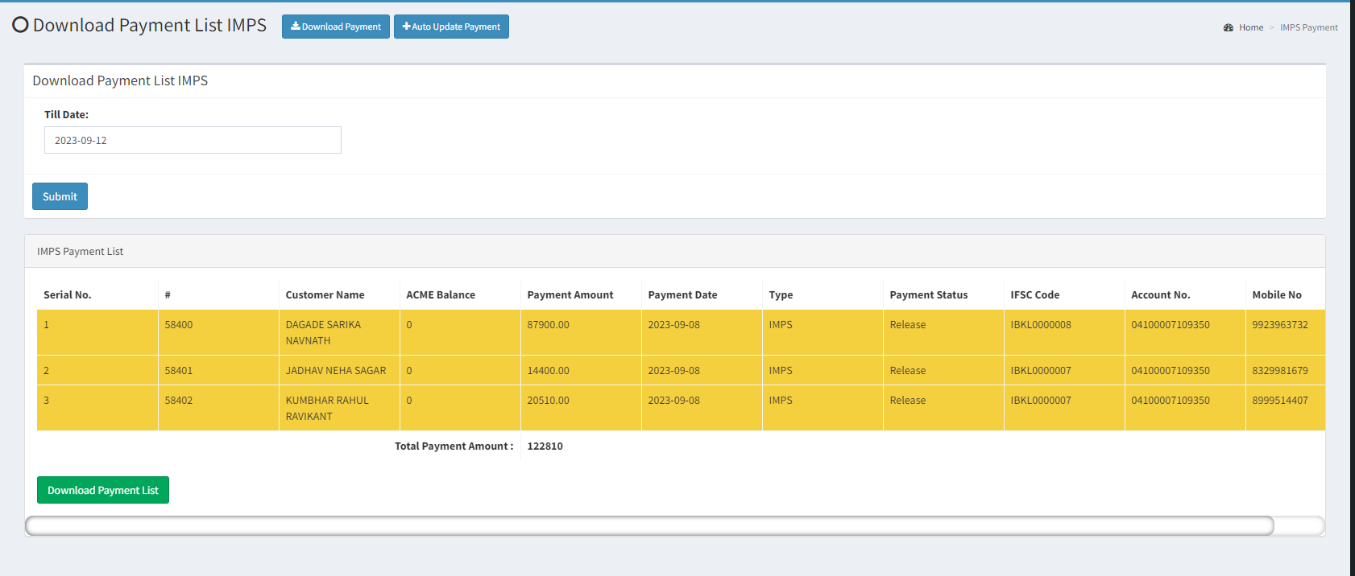

Fig: IMPS download payment list

|  |  |  |  |
| --- | --- | --- | --- |
| **FIELDS** | **INPUT TYPE** | **MANDATORY/ OPTIONAL** | **DESCRIPTION** |
| Sr. No. | text | Mandatory | It will display the total count of the released bills in incremental order in the withdrawn list.  (Note:- # is the serial number of the entry from entire imps system. This # will also be displayed in the payment detail action.  Whereas, sr. no. column will represent the number of the bills in the row.) |
| Total payment amount | Text | Mandatory | It will display the sum of payment amount of the released bills in the list till the date. |

Here, it displays the total payment amount for each customer in one row.

Once the user download the text file of the payment list, it displays details of all the bills which were in released.

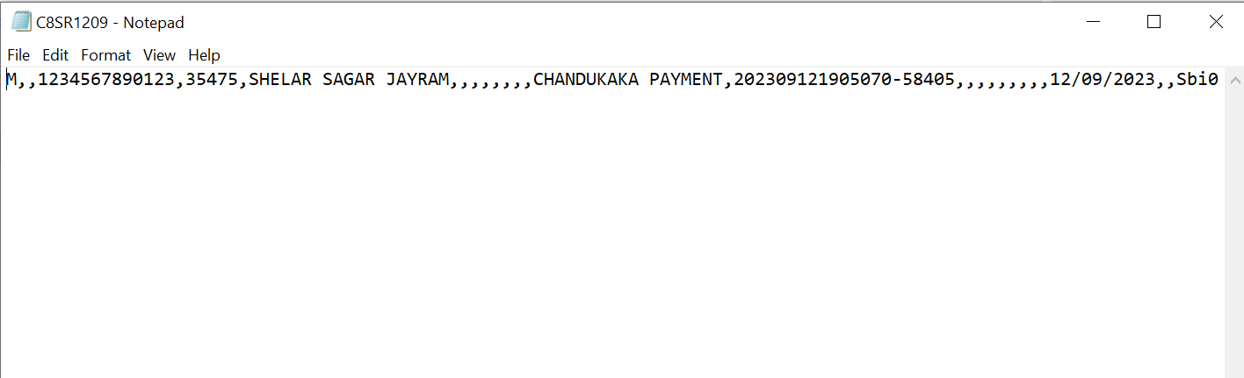

1. **REFERENCES OF THE USERS**

|  |  |  |  |
| --- | --- | --- | --- |
| **User** | **Name** | **Mail** | **Contact number** |
| **Actual user** | Firoj shaikh | brpayment@csjewellers.com | 2583 |
| **Ticket created by (if any)** | Firoj shaikh | brpayment@csjewellers.com | 2583 |
| **Assigned business analyst** | Manali bhadirage | Manali.bhadirage@techneai.com | 2965 |
| **Assigned developer** | Yogita jagtap |  |  |
| **Assigned tester** | Vaishnavi khandwe |  |  |