Want to create a new master .

Jewellery -> bank master

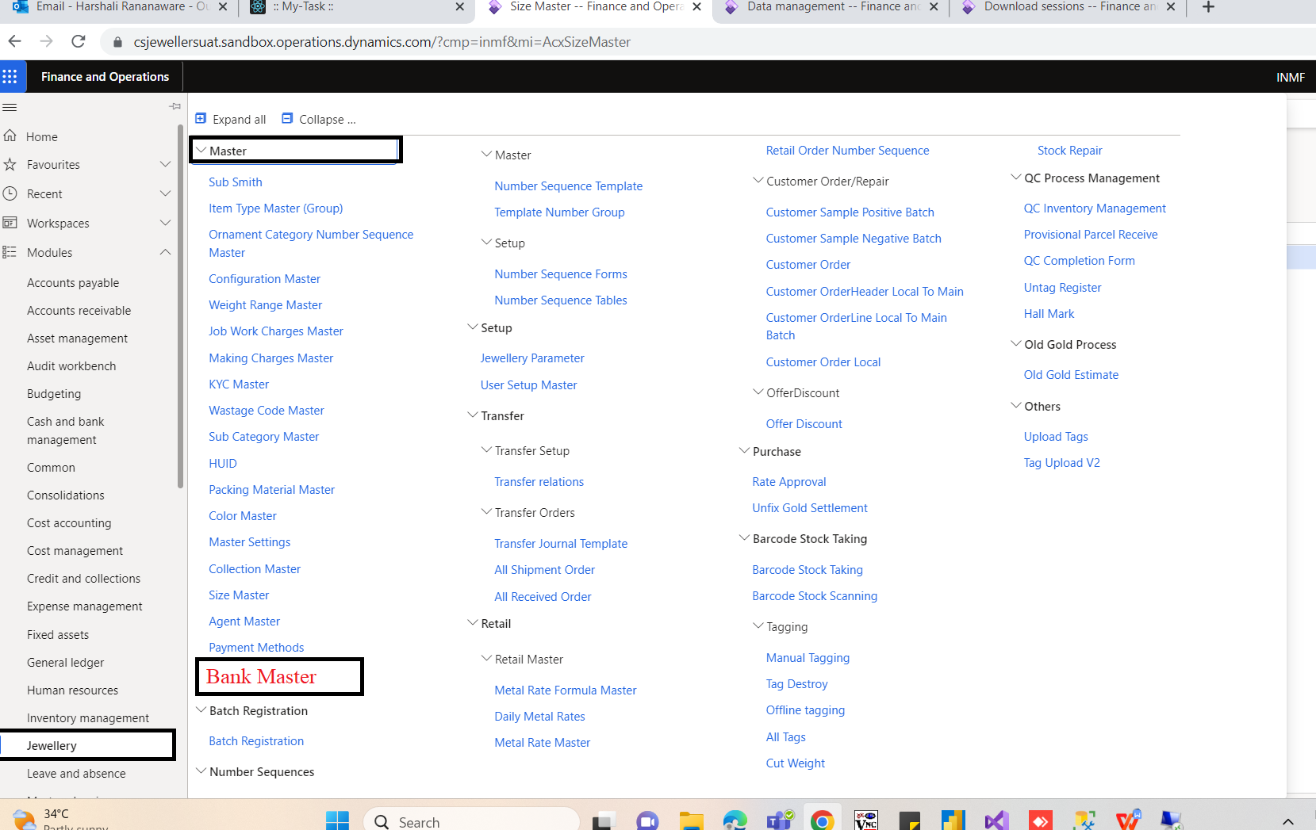

Table Name - ACXBANKMASTER

|  |  |  |
| --- | --- | --- |
| **field** | **validation** | **value** |
| bank name | limit 100 , mandatory , unique value | State Bnak of India |
| description | limit 100 | test |

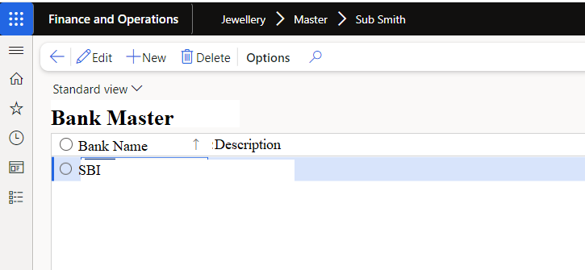

POS

|  |
| --- |
| EXT.ACXBANKMASTER |
| POS |
| bank name |
| State Bnak of India |