### Estimate and Invoice

### TCS applicable

In a one year customer amount is equal to grater than 50 Lack then tcs applicable field is enable. TCS will apply on the taxable value 1%.

### Auth Discount

Auth Discount field rename Auth Discount (In %).

₹ change to %.

### Payment method

Save payment then in line click on payment type then show popup for payment details which we filled. On popup fields are non editable.

Want the provision for the all payment mode.

**For example** refer the below screenshot

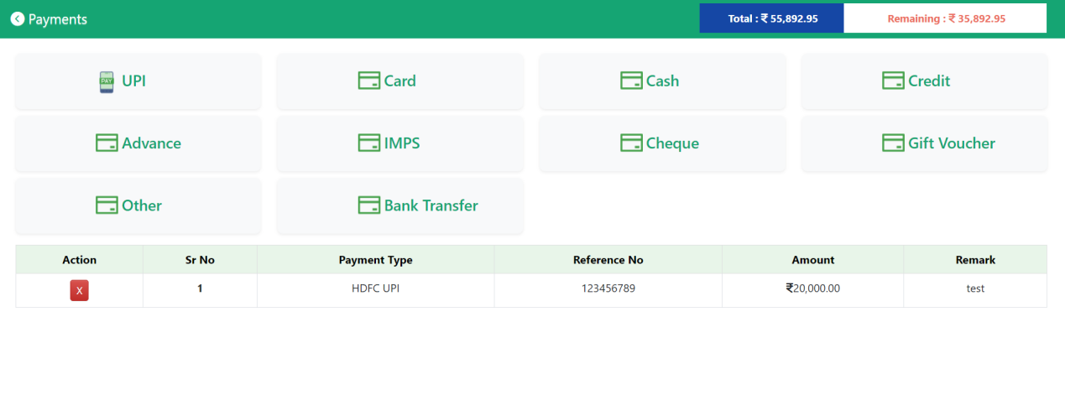

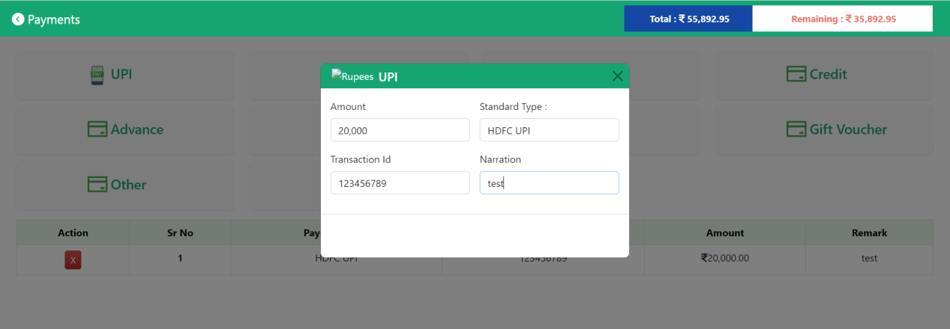

### Astrologer

In a tag stone or diamond is present then astrologer field is enable. And this field is auto copy from estimate to invoice.