## POS

Below changes are done in the estimate and invoice.



1. Making charges = Making charges (Net wt * Wastage Rate % * today's rate)
2. Add net wt column.
3. Making Charges = wastage amount + Other Charges



1. Remove the “Astrologer” field in estimate and invoice.



1. Add “Reference Person” field. This is mandatory field. Data fetch from “Jewellery -> Master -> agent master” where agent type = reference person. This data only show.

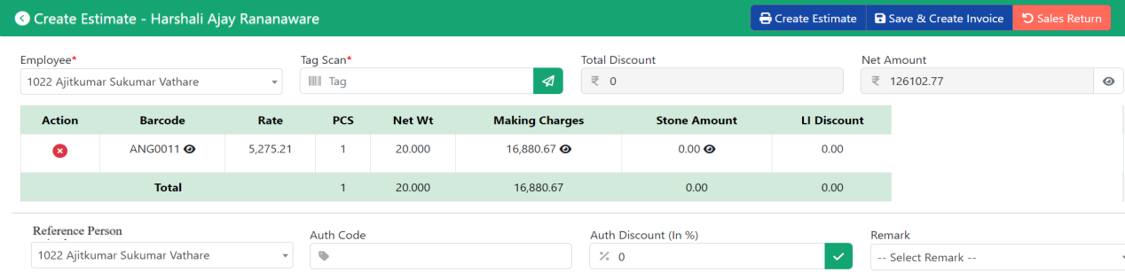

1. Item Category = “Synthetic and PreciousSt” then show field astrologer this is mandatory.

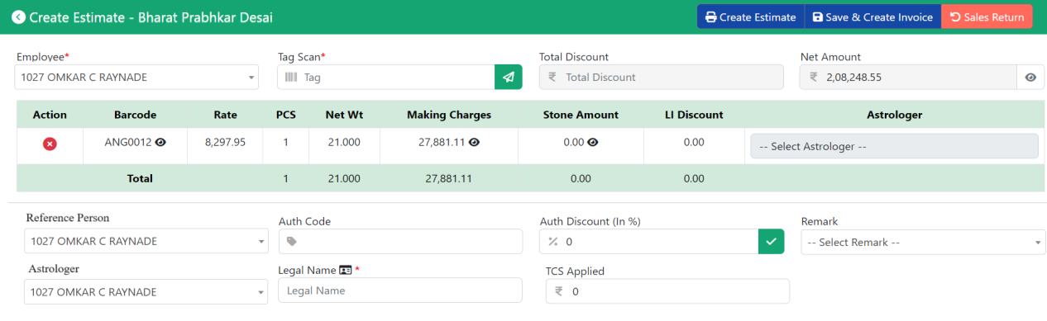

1. For MRP and Forming discount calculated on the item amount.
2. Round off to 5 is applicable only on cash payment mode. For other payment mode amount will be applicable in decimals only up to .50 previous digit more than .51 next digit as it is. Estimate amount show as it is. Invoice net amount show in round off.

|  |  |  |  |
| --- | --- | --- | --- |
|  |  | Mode Of Payment | |
| Net Amount | Round Off | Cash | Non Cash |
| 10.40 | 10 | 10 | 10 |
| 10.60 | 11 | 10 | 11 |
| 13.60 | 14 | 10 | 14 |
| 15.40 | 15 | 15 | 15 |
| 16.10 | 16 | 15 | 16 |
| 19.40 | 19 | 20 | 19 |
| 19.80 | 20 | 20 | 20 |

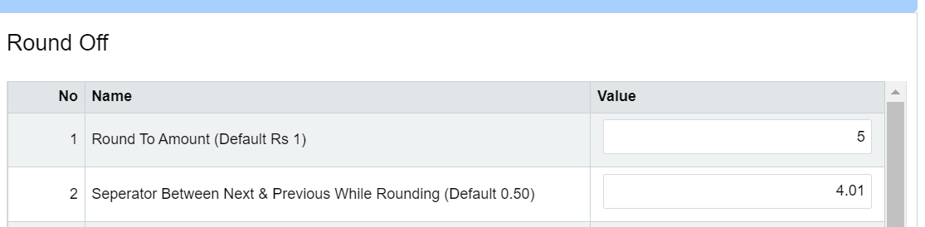

1. Other payment and UPI drop-down depends on the payment mode.
2. Attachment button add in the estimate page.