## Gift Voucher

Select customer name on POS. This name show on the above page.

Location show as per login.

Table Name - EXT.TA_GiftCardDetails

**Add** -

|  |  |  |  |  |
| --- | --- | --- | --- | --- |
| **Sr. No** | **Field name** | **Data Type** | **Description** |  |
|  | Ietm name | Text | Satrting no enter then this value fetch from the table. |  |
|  | Category | Text | Satrting no enter then this value fetch from the table. |  |
|  | Starting No | Text | User can enter the gift voucher no. |  |
|  | Qty | Int | User can add the quantity. |  |
|  | Ending No | Text | Qty enter then this value fetch from the table. |  |
|  | Rate | Int | Satrting no enter then this value fetch from the table. |  |
|  | Amount | Int | Qty enter then this value fetch from the table. |  |
|  | GV Validity date | Date | This value fetch from the setting. In setting we can add days.then date calculated from today's date + days |  |
|  | Cancel | Button | Data not save. |  |
|  | Save | Button | Save data and show on the line. |  |
|  | Remark | Drop-down | Remark master show.  “Retail and Commerce -> Channel setup -> Info codes” data fetch from this master. |  |
|  | View | Button | Show all details of the gift voucher. |  |
|  | Edit | Button | We can edit the details. Starting No and Qty. So as per change all details. |  |
|  | X | Button | Remove line from the bill. |  |
|  | Create Voucher | Button | Click on this then voucher will be create and payment page will be open. |  |
|  | Save and print | Button | Invoice save and print. |  |
|  | Signature | Button | Signature pad open. |  |

**Payment Table** :

|  |  |  |  |
| --- | --- | --- | --- |
| Sr. No | Field | Description |  |
|  | Digital Pay |  |  |
|  | Amount | Reaming amount will show auto. |  |
|  | Standerd type | This value fetch from D365. “Retail and Commerce -> Channels -> Stores -> All stores” Payment methods. |  |
|  | Transaction ID | User can enter the id. |  |
|  | Narration | User can add narration. |  |
|  | Card |  |  |
|  | Amount | Reaming amount will show auto. |  |
|  | Card name | This value fetch from D365.”Jewellery -> Master -> Bank Master” |  |
|  | Card type | enum |  |
|  | Card number | Enter 4 digit only. |  |
|  | Cash |  |  |
|  | Amount | Reaming amount will show auto. |  |
|  | Credit |  |  |
|  | Amount | Reaming amount will show auto. |  |
|  | Auth code | User can add auto code. |  |
|  | Reference Person | This is mandatory field. Data fetch from “Jewellery -> Master -> agent master” where agent type = Reference person. This data only show. |  |
|  | Credit days | User can add days upto 5. |  |
|  | Advance |  |  |
|  | Amount | Reaming amount will show auto. |  |
|  | Reference Person | This is mandatory field. Data fetch from “Jewellery -> Master -> agent master” where agent type = Reference person. This data only show. |  |
|  | Cheque |  |  |
|  | Amount | Reaming amount will show auto. |  |
|  | Bank name | This value fetch from D365.”Jewellery -> Master -> Bank Master” |  |
|  | Cheque number | User can add. |  |
|  | MICR code | User can add. |  |
|  | Cheque date | User can add. |  |
|  | Narration | User can add narration. |  |
|  | Other |  |  |
|  | Amount | Reaming amount will show auto. |  |
|  | Account type |  |  |
|  | Transaction ID | User can enter the id. |  |
|  | Narration | User can add narration. |  |

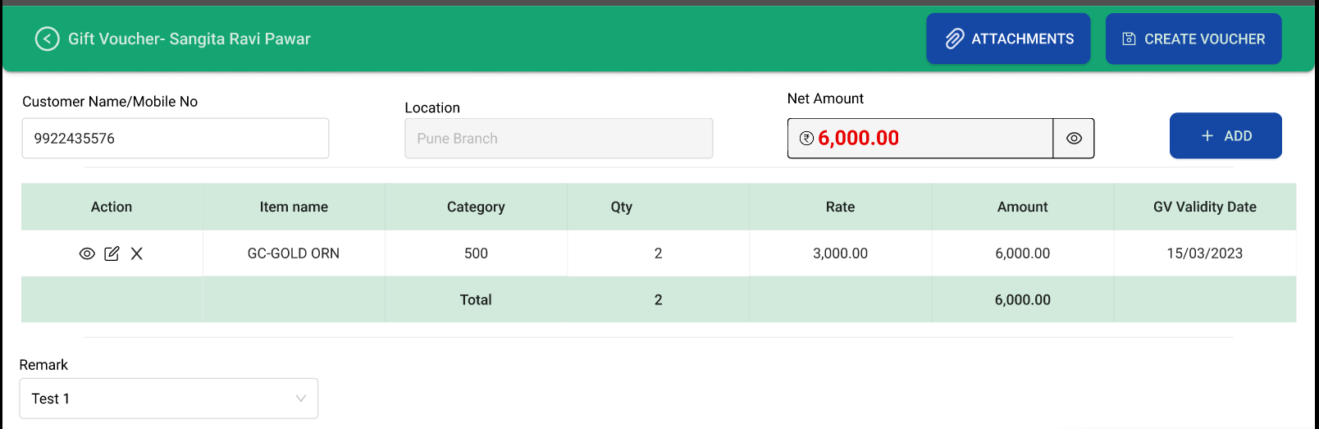

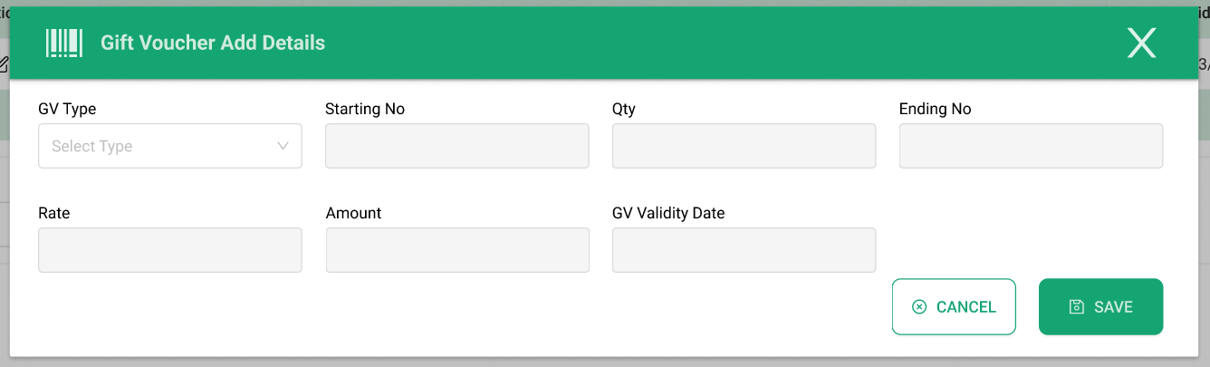

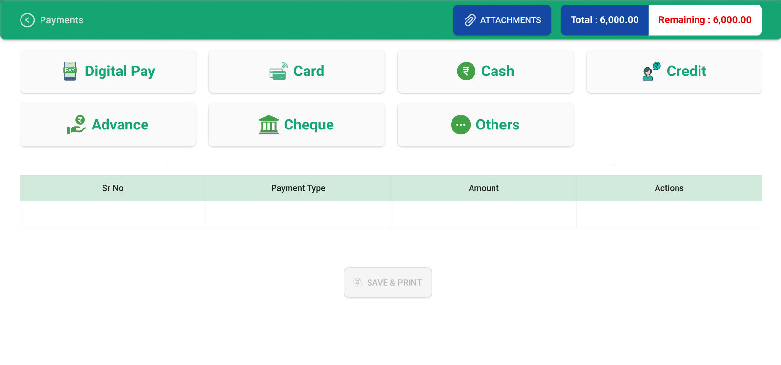

## Customer Account

POS will send customer code to d365 on issuance of gift card. If customer code is their, then this customer can redeem it. If customer code is blank then anyone can redeem it.

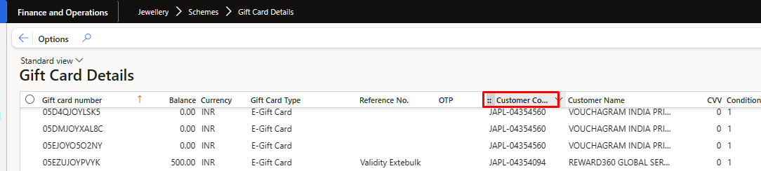

At the time of issuance POS will send the cash and non cash bifurcation to D365.

Retail and Commerce -> Channels -> Stores -> Gift cards -> All gift cards Gift voucher History tab add New field cash and non cash.

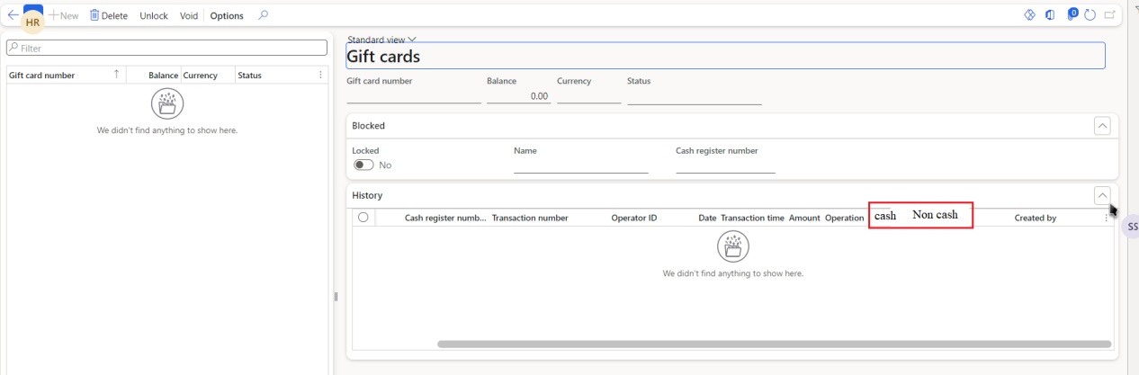

At the time of issuance POS will send a flag if gift card can be partially redeem or not. Expiry date also send to D365.

