### All store

Retail and Commerce -> Channels -> Stores -> All stores



Select the store in action click on “ Payment Method”.

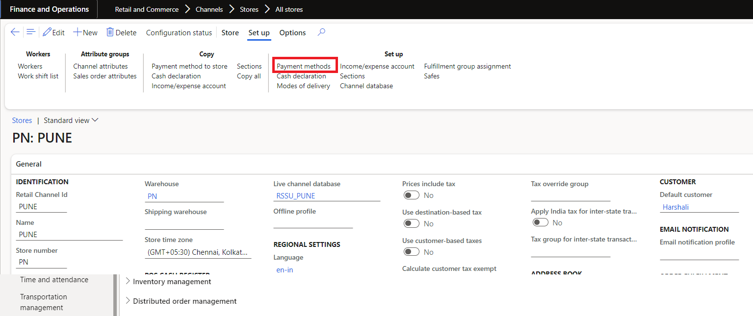

Payment Methods -> general tab -> “Payment Method” field create in a base table so want add in the new table “TAPaymentMethod”.

