Table create POS - AcxRetailStoreTenderTypeTable

Check screen short for the fields.

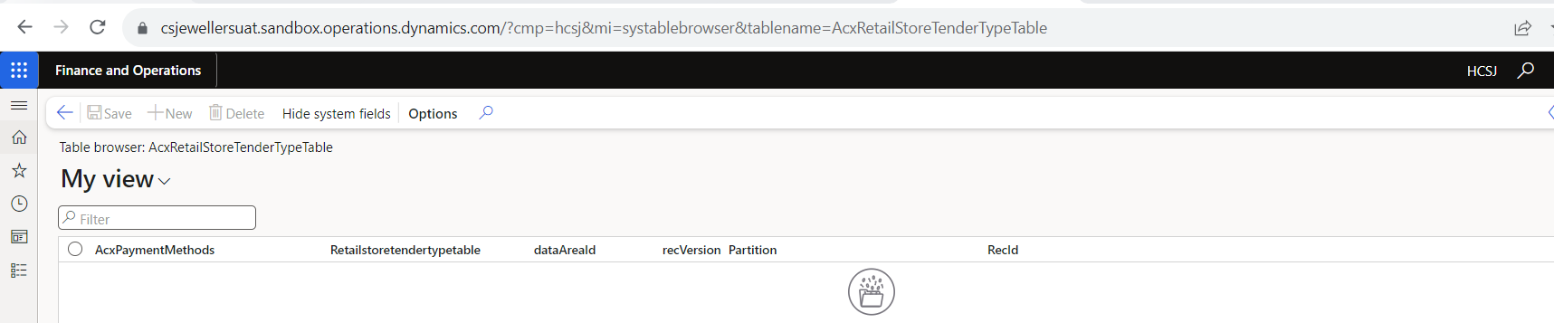

This table value want to show the payment mode option on POS.

**For example**

1. we can set the **method - UPI** then this value show in the drop down of “Standard type”.

Same as we can set then this value will reflect in the payment mode.

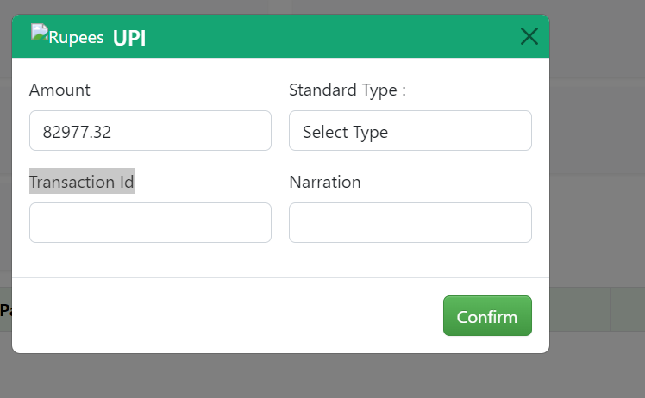

1. we can set the **method - Other** then this value show in the drop down of “account type”.

