Manali Ashok Bhadirage

Manali.bhadirage@techneai.com

12.10.2023

CU BILL CHECKING - EDIT LINK

**Handover Document**

**CONTENTS**

1. TICKET DETAILS 2

2. INTRODUCTION 2

3. BUSINESS REQUIREMENT 2

4. SCOPE 3

5. BUSINESS & SYSTEM RULES 3

6. ABBREVIATIONS & TERMS 3

7. EXISTING SYSTEM 3

8. GRAPHICAL REPRESENTATION 5

9. DEVELOPED SYSTEM 5

10. REFERENCES OF THE USERS 6

1. **TICKET DETAILS**

|  |  |
| --- | --- |
| **Ticket ID** | TT12815 |
| **Ticket description** | As per checking bill checking point any user link through point edit please find the attachment also same user successfully point send to other user reference id F3757 |
| **Created by** | Amar Landge |
| **Created on** | 02/06/2023 |
| **Priority** | Very high |

1. **INTRODUCTION**

Introducing "Bill Connect US": a seamless system that simplifies bill management for users. With this innovative platform, users can effortlessly submit vendor bills and facilitate swift payment processing. All payment records are meticulously maintained and audited to ensure transparency.

Integrating with Padm, "Bill Connect US" offers an added advantage by displaying the current balance of each vendor. This feature empowers entry users to make informed decisions when submitting bills, as they can analyze the available funds in the Padm account for each vendor. By having visibility into the vendor's balance, users can strategies their bill submissions, avoiding unnecessary work and streamlining the process.

In summary, "Bill Connect US" streamlines bill submissions and payment processing, providing valuable insights into vendor balances through integration with Padm. This empowers entry users to optimize their bill submissions and foster a more efficient workflow.

1. **BUSINESS REQUIREMENT**

Users will be able to edit the bills only which are assigned to them.

|  |  |  |  |
| --- | --- | --- | --- |
| **Requirement ID** | **Requirement Name** | **Short Description** | **Priority** |
| BR001 | Edit bill | User will be able to edit bills only which are assigned to him and are available in bill checking transaction -> grid once he logs in. | High |
| BR002 | Restrict access to edit bill by copying link or editing link | In case users are copying the link of edit action or accessing the edit action link of the bills which are not assigned to them, then it should display message that user doesn’t have privilege to access it. | High |

1. **SCOPE**

User shouldn’t be able to access or have access to the edit page if bill is not available in grid and is not assigned to the user. When user enters link of any bill, then system should check whether that bill is assigned to the logged in person or not and then grant access to perform edit actions accordingly. If user has entered edit link of any bill and if that bill is not assigned to user, then it should display error message.

If bill is not assigned to the user but user has ‘all update bill’ authority then user will be able to edit it.

1. **BUSINESS & SYSTEM RULES**

* User should be registered in the system.
* User should be logged in.
* System should display error message for incorrect details if entered.
* User will have access to edit bills if user has ‘all update bill’ authority even if that bill is not assigned to the user himself.

1. **ABBREVIATIONS & TERMS**

BC ID - Bill checking ID - system generated unique bill number

PO No. - Purchase Order number from Padm bill

GST - Goods Service Tax

TDS - Tax Deducted at Source

TCS - Tax Collection at Source

HOD - Head of Department

UTR - Unique Transaction Reference

1. **EXISTING SYSTEM**

When employee A assigns bill to employee B, then that assigned bill gets displayed in bill checking transaction -> grid of employee B. Here, only employee B gets edit action in grid for that assigned bill. Other users can search this bill from bill checking filter and they will get options of view, history, payment history, payment detail and bifurcate amount. However, other employees will not get edit action for this bill as it is assigned to employee B only.

Further more, when users click on view action of that bill and then edit the link by mentioning ‘edit’ word instead of ‘detail’ word, then users are able to edit the bill even when it is not assigned to them. Similarly, when users copy link of edit action and send to another user, then that user is able to edit the bill even when it is assigned to them / even when they don’t have authority.

Example: Vinaykumar user has added one bill E10791 and has assigned it to Divya user. When vinaykumar searches this bill from filter, then he can get the details of that bill but doesn’t get edit action authority because that bill is assigned to another user i.e. Divya. Vinaykumar doesn’t have authority to edit this bill as it is not assigned to him.

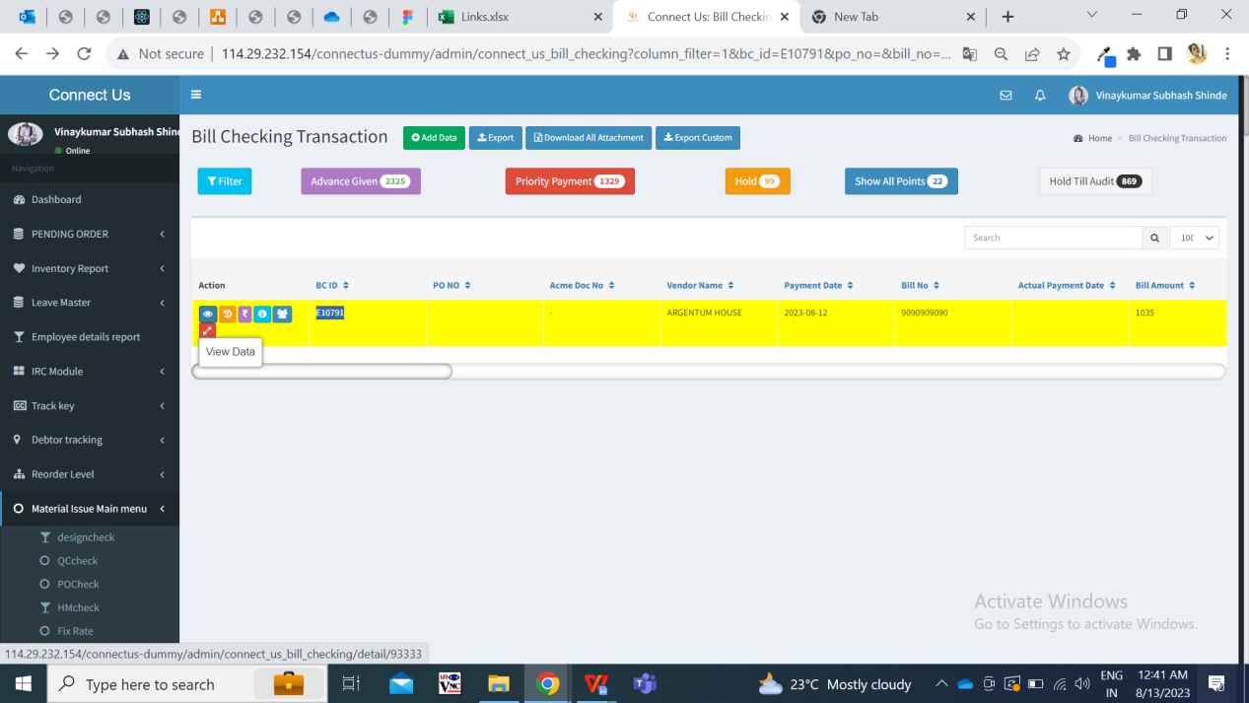

Fig: Vinaykumar’s login -> Bill checking transaction -> Filter -> BC ID E10791

Once assigned by Vinaykumar, this bill gets displayed in grid of Divya user where Divya has edit action authority for this bill.

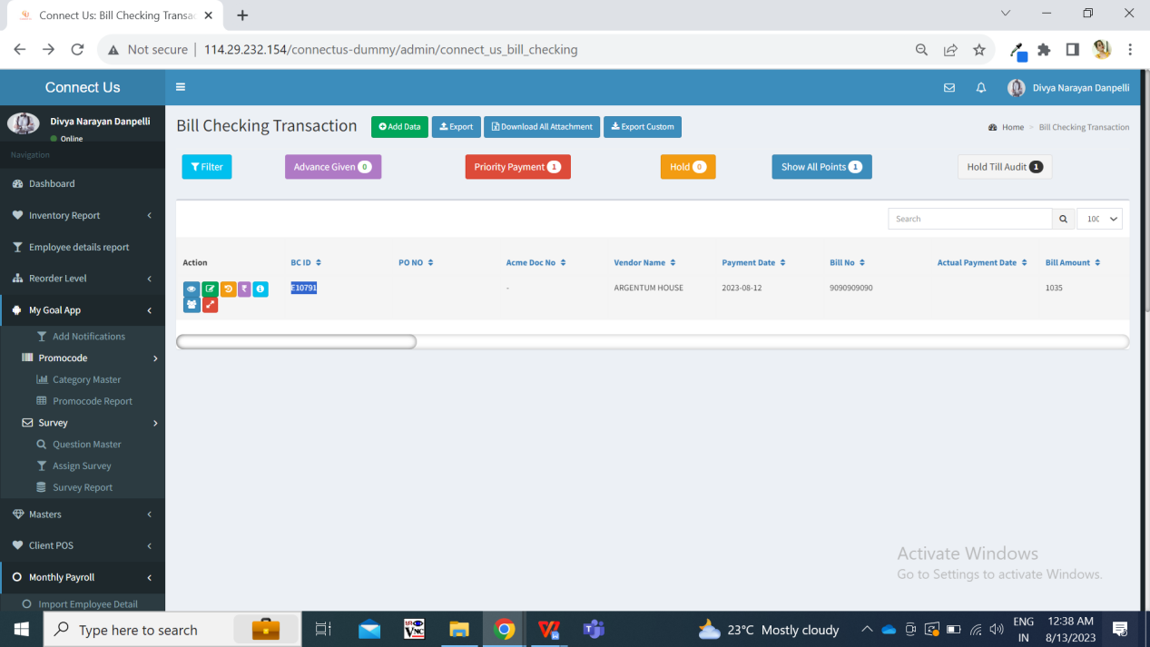

Fig: Divya’s login -> Bill checking transaction -> Grid

Further, once vinaykumar clicks on view action, it display the details of the bill.

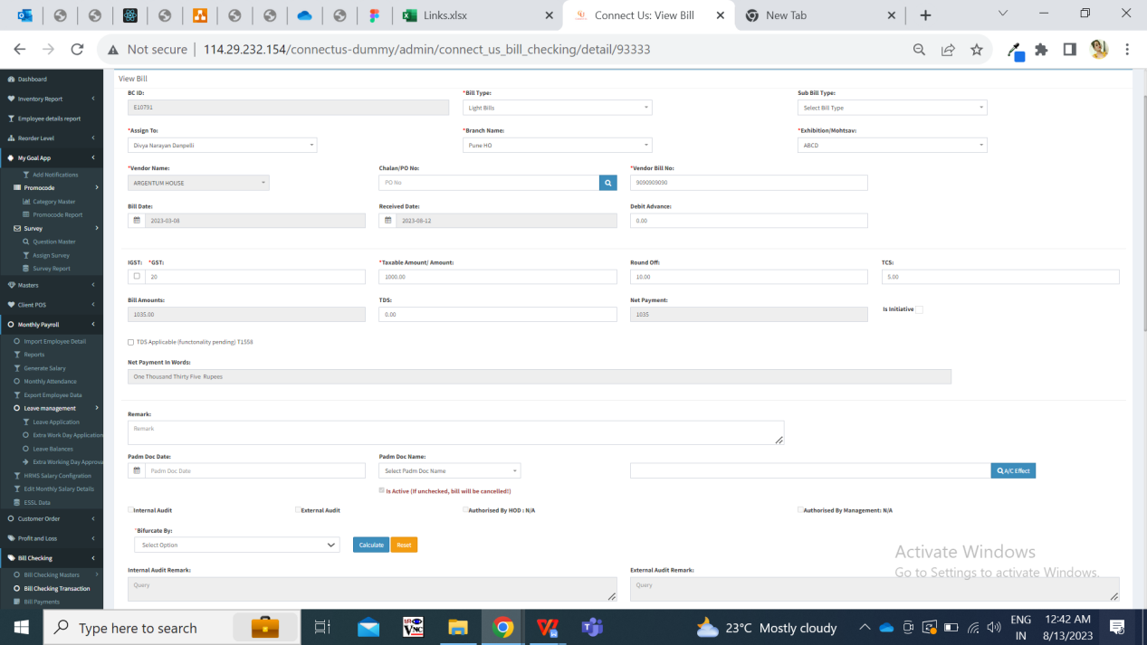

Fig: Vinaykumar’s login -> Bill checking transaction -> Filter -> BC ID E10791 -> view

Furthermore, when vinaykumar enters ‘edit’ word in the link in place of view action, then vinaykumar gets authority to edit the fields in bill and can submit it.

<http://114.29.232.154/connectus-dummy/admin/connect_us_bill_checking/detail/93333>

As <http://114.29.232.154/connectus-dummy/admin/connect_us_bill_checking/edit/93333>

Due to this issue, all users can get access to all the bills and can edit them even when they don’t have authority. This leads to malfunctioning and misuse of the system.

1. **GRAPHICAL REPRESENTATION**

Submit

Edit bill only if assigned to logged in person or has ‘all update bill’ authority

Display bill in grid of assigned user

Add bill and assign to user

Fig: Context Diagram

1. **DEVELOPED SYSTEM**

When users click on edit action or enters / pastes any browser link of edit action of any bill, it will be verified that if the bill is assigned to the logged in user or not. If assigned to person of the bill is logged in person, then user will be able to edit the bill and submit it.

If assigned person of the bill is not logged in person, then it should display error message on page as ‘**You are not authorized to access this bill**’.

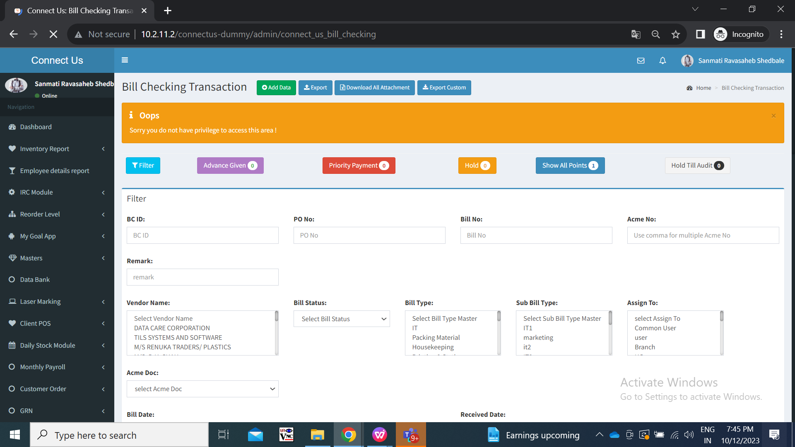

In addition to this, user will have access to edit bills if user has ‘all update bill’ authority even if that bill is not assigned to the user himself.

1. **REFERENCES OF THE USERS**

|  |  |  |  |
| --- | --- | --- | --- |
| **User** | **Name** | **Mail** | **Contact number** |
| **Actual user** | Amar landge |  |  |
| **Ticket created by (if any)** | Amar landge |  |  |
| **Assigned business analyst** | Manali bhadirage | Manali.bhadirage@techneai.com | 2965 |
| **Assigned developer** | Nikhil bhosale | Nikhil.bhosale@techneai.com |  |
| **Assigned tester** |  |  |  |