Manali Ashok Bhadirage

Manali.bhadirage@techneai.com

26.04.2023

CUSTOMER ORDER COMPLETE STATUS

**Functional Requirement Document**

**CONTENTS**

1. TICKET DETAILS 2

2. VERSION CONTROL 2

3. APPROVALS 2

4. ESTIMATION 3

5. INTRODUCTION 3

6. BUSINESS REQUIREMENT 3

7. SCOPE 3

8. BUSINESS & SYSTEM RULES 4

9. ABBREVIATIONS & TERMS 4

10. EXISTING SYSTEM 4

11. GRAPHICAL REPRESENTATION 4

12. PROPOSED SYSTEM 4

13. TEST DATA 6

14. ODUS 7

15. REFERENCES OF THE USERS 8

1. **TICKET DETAILS**

|  |  |
| --- | --- |
| **Ticket ID** | TT13069 |
| **Ticket description** | Customer ne shop madhe Order deli asel Ani customer te order ghevun gele astil tar Padm Madhe Customer chi Order Completed Dakhavate.Paratu Connect Us Madhe Order Status update Hot nahi.te Order Connect Us Madhe pan Auto Completed zhali Paheje. |
| **Created by** | Reshma Sayyad |
| **Created on** | 10/06/2023 |
| **Priority** | high |

1. **VERSION CONTROL**

|  |  |  |  |  |
| --- | --- | --- | --- | --- |
| **Sr. No** | **Version no** | **Version Date** | **User name** | **User department** |
| **1** | **1.0** | **15/09/2023** | **Reshma Sayyad** | **Operations Team** |
|  |  |  |  |  |
|  |  |  |  |  |

1. **APPROVALS**

|  |  |  |
| --- | --- | --- |
| **Field** | **Name of the User** | **Approved date by the user** |
| **Actual User Name Actual User Department Organization Name** | Reshma Sayyad  Operations  CSJ |  |
| **Assigned BA** | Manali bhadirage |  |
| **Assigned Developer** |  |  |
| **Assigned Tester** |  |  |

1. **ESTIMATION**

|  |  |  |  |  |
| --- | --- | --- | --- | --- |
| **Department name** | **Estimated Time (In hr)** | **Scheduled Date (Starting date)** | **Estimated date** | **Actual delivery date** |
| **BA** |  |  |  |  |
| **Development** |  |  |  |  |
| **Testing** |  |  |  |  |
|  |  |  |  |  |

1. **INTRODUCTION**

In the Padm system, order numbers are generated for customer orders, GTS scheme orders, and Kalptaru scheme orders. These orders are then added to the "Customer Order -> Order Detail" menu in Connect Us by branch officials. Subsequently, the Head Office (HO) assigns these orders to Karagirs / Sub-Karagirs. Once the order is ready, HO changes the status so that order could be dispatched to branch. When the orders are ready for pickup, branches update their status from "CU Customer Order -> Order Detail" to indicate readiness.

Once customers arrive at the branch to collect their orders, a sales bill is generated in Padm using the already assigned order number. Generating the sales bill marks the order as completed within the Padm system. Simultaneously, branches are expected to update the order's status to "complete" in the "CU Customer Order -> Order Detail" section.

1. **BUSINESS REQUIREMENT**

Once the order gets marked as completed in Padm, that order should instantly & automatically get displayed as completed in connect us -> customer order as well.

|  |  |  |  |
| --- | --- | --- | --- |
| **Requirement ID** | **Requirement Name** | **Short Description** | **Priority** |
| BR001 | Order detail -> edit | User should be able to change status of order as completed (as per current working) |  |
| BR002 | Order details -> status | Once order gets marked as completed in Padm then it should be displayed as completed in grid, edit, view, history and export action of connect us -> order details. | High |

1. **SCOPE**

Once order note is created in Padm, it should be displayed in order status menu as well. User should be able to add order number in connect us -> customer order - order detail. User should be able to change status as ‘completed’ of the order through edit action. Once sales is generated in Padm, then order status of that order should be displayed as completed in Padm. At the same time, status of that order should be displayed as completed in connect us -> customer order - order detail.

1. **BUSINESS & SYSTEM RULES**

* User should be registered in the system.
* User should be logged in.
* System should display error message for incorrect details if entered.
* As per current working system, users should be able to edit order even when order status is completed.
* User can still manually change the status to ‘completed’ through edit action as per current system. We have to just make an addition of automatically changing the status once it gets displayed as completed in padm. (Padm orders will be synchronized by 12-2am each day and then order status will get updated in Connect Us)

1. **ABBREVIATIONS & TERMS**

NA

1. **EXISTING SYSTEM**

In the current system, the order status remains unchanged to "completed" on Connect Us until a user from the branch manually updates it. Consequently, this lack of real-time status updates, troll-free users often contact customers to provide updates on their orders, only to discover from the customer that the order has already been collected by them. To prevent this unnecessary inconvenience to our customers, we need to ensure that the order status in Connect Us is promptly updated as soon as it is marked as completed in Padm.

1. **GRAPHICAL REPRESENTATION**

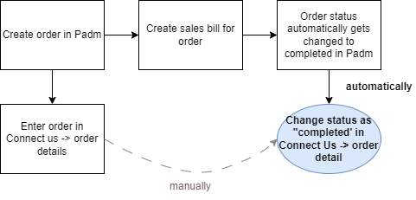

Fig: General Context Diagram

1. **PROPOSED SYSTEM**

Initially, order note is generated for any order at the branches through Padm -> customer order and order number gets displayed for it. Further, these orders are also added in connect us -> customer order -> order detail. In Connect Us order details -> action, it has following fields:

* Order number
* Order date
* Order delivery date
* Estimate pickup date
* Order pick up date
* Customer mobile no.
* Customer name
* Branch name
* Item name
* Category
* Wastage type
* Changed wastage
* Net wt
* Purity
* Salesman name
* Status
* Product group
* Tollfree remark
* Purchased from
* Salesbill no.
* Sales bill date
* Use
* Item details
* Catalog / stone / polish details
* Remarks / assign / receipt details
* Other details

Once order is added, its status is displayed as ‘unprocessed’ initially in grid, view and edit action. Further, branches inform HO about the order so that HO can look into this and change status of the order regularly through edit action of each order.

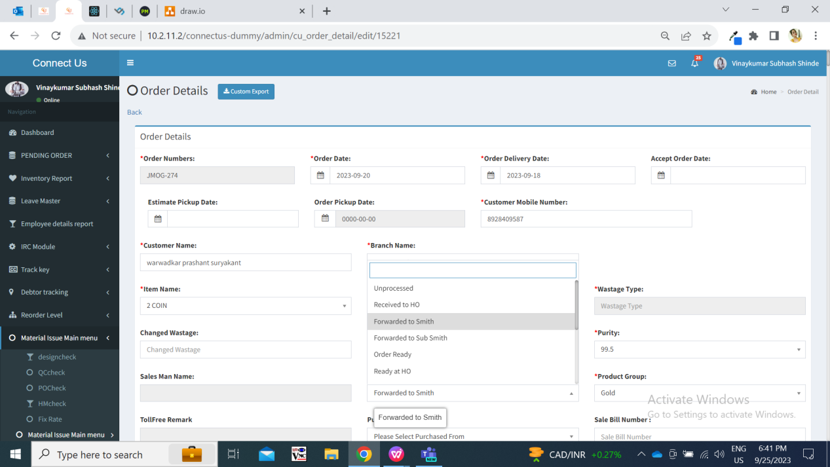

Once order is ready at HO, then further gets assigned to branch. Then branches changes the status of that order to ready at Branch so that customer can collect the order from branch. Once status is displayed as ‘ready at branch’ toll free users contact the customer to give update about collection of the order.

At the same time, the status of the order gets displayed as not completed on Padm -> order status till the time sales bill is not generated against that order number.

Once sales bill is generated for the order number in Padm, then the status of the order number gets automatically displayed as order completed in Padm.

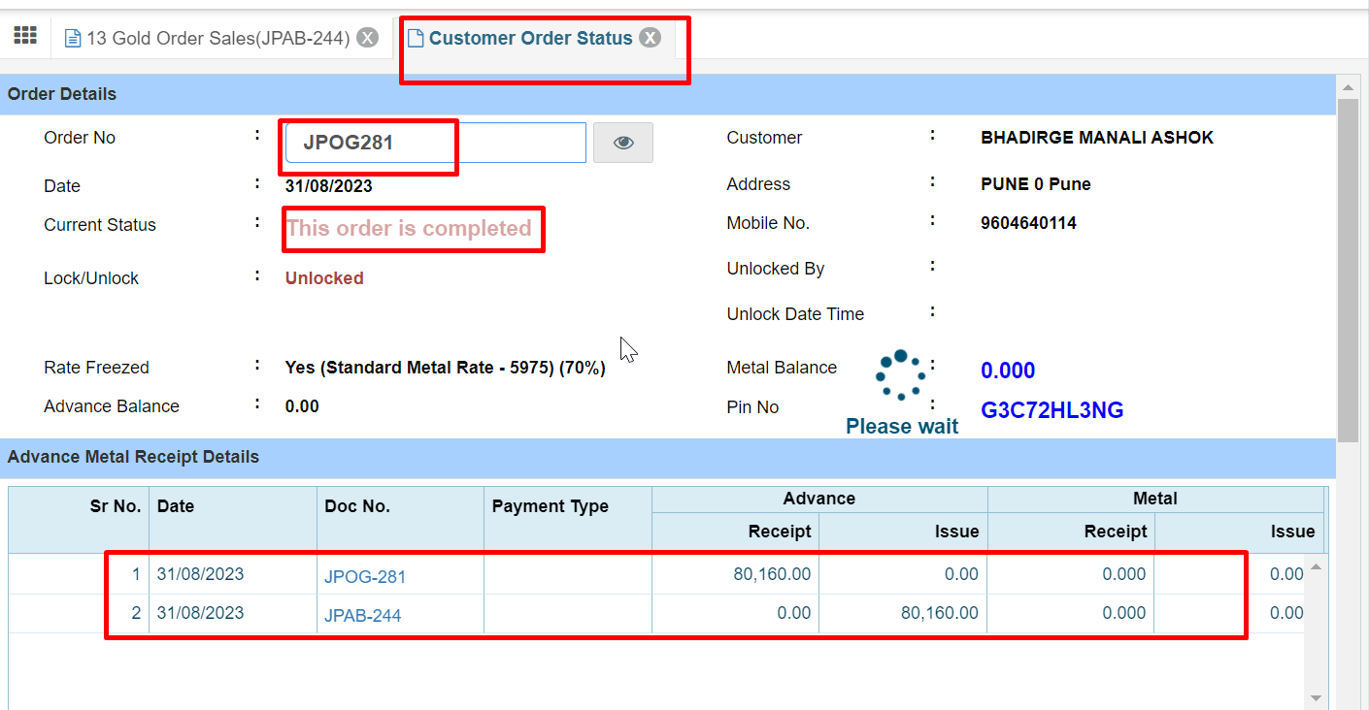

Once the order gets marked as completed in Padm, then all padm orders should be synchronized with Connect Us each day at 2 am and updated order status should be displayed as completed in Connect Us as well. Status should be displayed in grid, view, edit and export action.

1. **TEST DATA & SCENARIOS**

Completed silver orders:



Not completed orders:

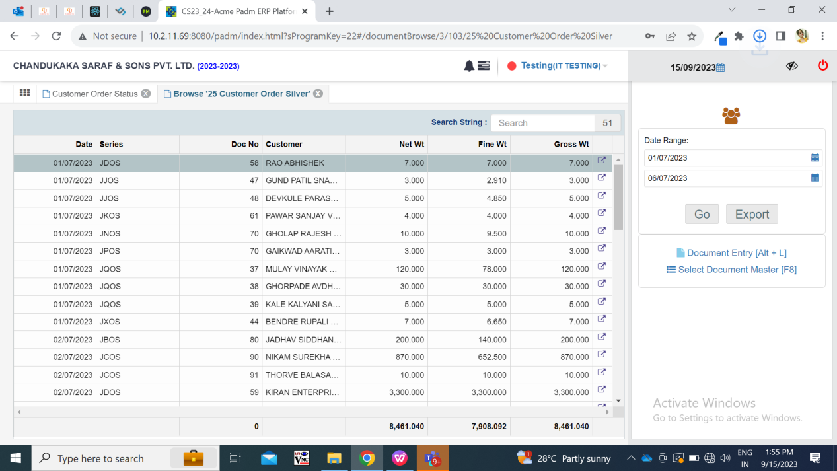

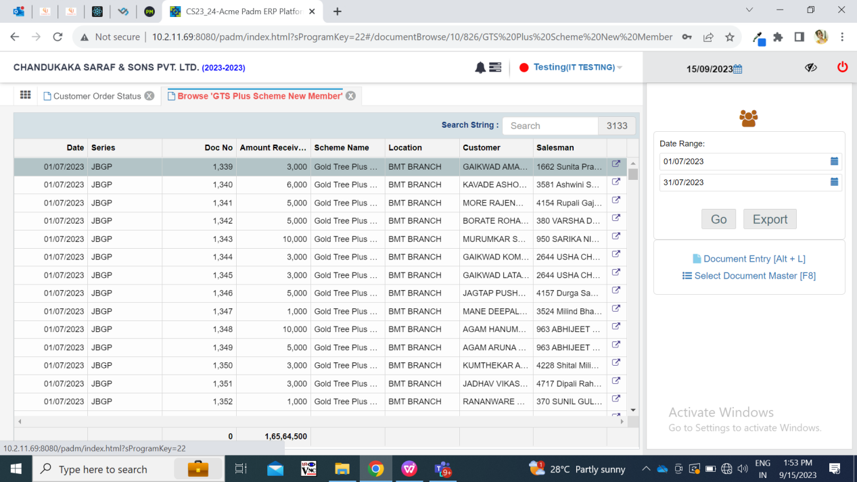

1. **ODUS ( Open Discussed Unhanded scenarios )**

|  |  |  |  |  |
| --- | --- | --- | --- | --- |
| **Sr. No.** | **Topic** | **Priority**  **(High / medium / low)** | **Remark** | **Status**  **(Open/**  **Closed)** |
| 1 | 29/09/2023: Can data be synchronized / updated orders status be displayed in real time? | High | Gaurav Shaha: Padm orders will be synchronized with connect us orders by Cron. Hence on same day the order status will not get updated in connect us -> order detail. Instaed the order status will get updated after cron by 2 am every day. | Closed |
| 2 | 03/10/2023: Steps for padm order. | High | Generate order note, then generate customer order using the order note number, further see order status using customer order number.  Gnerate order sales bill using customer order number, then order status for that customer order number will be displayed as completed. | Closed |
| 3 | 05/10/2023:If any order gets completed in Padm, then it will get completed on next day as completed in CU as weel.  Further if any user edits and changes the status of order (apart from completed) then again on next day synchronization will order get marked as completed or not? | Medium | Guarav Shaha: No. Synchronization of orders will be done for one day each and not for all data till now. | Closed |

1. **REFERENCES OF THE USERS**

|  |  |  |  |
| --- | --- | --- | --- |
| **User** | **Name** | **Mail** | **Contact number** |
| **Actual user** | Reshma sayyad | hobdd@csjewellers.com |  |
| **Ticket created by (if any)** | Reshma sayyad | hobdd@csjewellers.com |  |
| **Assigned business analyst** | Manali bhadirage | Manali.bhadirage@techneai.com |  |
| **Assigned developer** | Prathmesh shinde | Prathmesh.shinde@techneai.com |  |
| **Assigned tester** | Amreen shaikh | Amreen.shaikh@techneai.com |  |