Manali Ashok Bhadirage

Manali.bhadirage@techneai.com

25.09.2023

DIVINE DONOR - GOSHALA GOMATA PRAVESH FORM

**Functional Requirement Document**

**CONTENTS**

1. TICKET DETAILS 2

2. VERSION CONTROL 2

3. APPROVALS 2

4. ESTIMATION 2

5. INTRODUCTION 3

6. BUSINESS REQUIREMENT 3

7. SCOPE 3

8. BUSINESS & SYSTEM RULES 3

9. ABBREVIATIONS & TERMS 3

10. EXISTING SYSTEM 3

11. GRAPHICAL REPRESENTATION 3

12. PROPOSED SYSTEM 3

13. TEST DATA 4

14. ODUS 4

15. REFERENCES OF THE USERS 5

1. **TICKET DETAILS**

|  |  |
| --- | --- |
| **Ticket ID** | TT15662 |
| **Ticket description** | Implementation of Gomata Pravesh in Divine Donation |
| **Created by** | Mounika annamneedi |
| **Created on** | 06/09/2023 |
| **Priority** | Very high |

1. **VERSION CONTROL**

|  |  |  |  |  |
| --- | --- | --- | --- | --- |
| **Sr. No** | **Version no** | **Version Date** | **User name** | **User department** |
| **1** | **1.0** | **25/09/2023** | **Gaurav Shaha** |  |
|  |  |  |  |  |
|  |  |  |  |  |

1. **APPROVALS**

|  |  |  |
| --- | --- | --- |
| **Field** | **Name of the User** | **Approved date by the user** |
| **Actual User Name Actual User Department Organization Name** | CSJ |  |
| **Assigned BA** |  |  |
| **Assigned Developer** |  |  |
| **Assigned Tester** |  |  |

1. **ESTIMATION**

|  |  |  |  |  |
| --- | --- | --- | --- | --- |
| **Department name** | **Estimated Time (In hr)** | **Scheduled Date (Starting date)** | **Estimated date** | **Actual delivery date** |
| **BA** |  |  |  |  |
| **Development** |  |  |  |  |
| **Testing** |  |  |  |  |
|  |  |  |  |  |

1. **INTRODUCTION**

'Divine Donor' is a digital donation application to uncomplicate the donation process, help charities expand their support networks and make the app “the most thoughtful place on your mobile.” Through our donation app, user can safely and simply make donations under different organizations and tenants, share meaningful thoughts with the people they care and match words with good deeds by supporting each other’s favorite charities. It has provision to add multiple users & its organizations, to process donations and get reports of each donation type by just one click.

Through web application, super admin will add tenant first and then through mobile application, each tenant will be able to login & add their own users and organizations. Added organizations and users will be reflected in masters of web app as well as in report of mobile app. User will be mapped against organization and then user will able to fill donation details in the form. Added / processed donations will be reflected in mobile app report as well as web app report to that tenant.

1. **BUSINESS REQUIREMENT**

In existing divine donor mobile app, we need to add gomata pravesh form and gomata pravesh report for Goshala tenant. We need to add gomata pravesh form menu in web app as well.

|  |  |  |  |
| --- | --- | --- | --- |
| **Requirement ID** | **Requirement Name** | **Short Description** | **Priority** |
| BR001 | Mobile app - Add gomata pravesh form | We have to display one menu as gomata pravesh form through which user will add the details of the cows which are being donated at Goshala. | High |
| BR002 | mobile app- - gomata pravesh report | We have to display added gomata pravesh details in report | High |
| BR003 | Mobile app - view each gomata pravesh form | User should be able to view details of each entry in gomata pravesh report | Medium |
| BR004 | Web app - Add gomata pravesh form | We have to display one menu as gomata pravesh form through which admin and user will add the details of the cows which are being donated at Goshala. | High |
| BR005 | Web app - edit gomata pravesh form | Admin should be able to edit details of the added entry. | Medium |
| BR003 | Web app - view each gomata pravesh form | Admin and User should be able to view details of each entry in gomata pravesh report | Medium |

1. **SCOPE**

Once user is added by the Goshala tenant, then user should be log into mobile and web application. User should have access to gomata pravesh form and gomata pravesh report. User should be able to fill the gomata pravesh form through mobile app as well as web app. User should be able to view the added gomata pravesh form in report in mobile as well as web app. Goshala tenant - admin should be able to add gomata pravesh form as well as view and edit the gomata pravesh form report as added by their users in mobile as well as web application.

1. **BUSINESS & SYSTEM RULES**

* User should be registered in the system.
* System should display error message for incorrect details if entered.
* All forms should have on field validations. System should display on field errors in case of incorrect inputs.
* User should not be able to edit the gomata pravesh details. Only tenant - admin should be able to edit details.
* If the entered mobile number is available in donor master for that Goshala tenant then owners details should be displayed. Else, when user will enter the new mobile number then owner should get added in donor master as well in web.

1. **ABBREVIATIONS & TERMS**

DOB - Date of Birth

1. **EXISTING SYSTEM**

In existing system, we don’t have any customized form for each tenant. Hence we need to add gomata pravesh form and report in divine donor apk.

1. **GRAPHICAL REPRESENTATION**

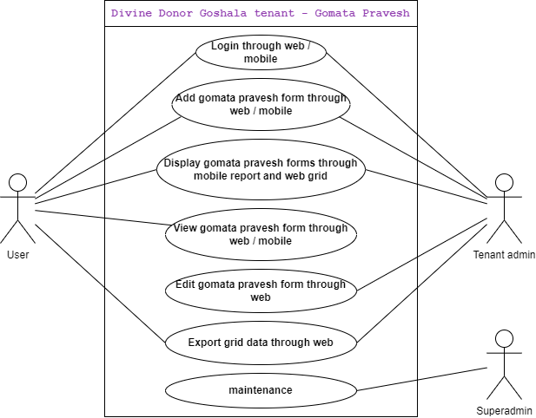

Fig: Use Case Diagram

1. **PROPOSED SYSTEM**

Once Goshala tenant user logs into mobile application, gomata pravesh form will be displayed in hamburger menu. User will add the details pf the donated cow by adding in the gomata pravesh form. It will display following fields:.

* Owner mobile
* Owner name
* Owner address
* Donation reason
* Owner photos
* Cow name
* Cow DOB
* Cow age
* Cow birthmark
* Cow color
* Cow type
* Cow delivered calves
* Cow disease detail
* Cow current health
* Is cow conceiving
* Cow daily milk (in ltrs)
* Cow market value
* Cows photo
* I agree checkbox
* Save
* Cancel

|  |  |  |  |
| --- | --- | --- | --- |
| **FIELDS** | **INPUT TYPE** | **MANDATORY/ OPTIONAL** | **DESCRIPTION** |
| Owner mobile | Int | Mandatory | The contact number of the owner of the cow will be entered.  If the entered mobile number is available in donor master for that Goshala tenant then owners details should be displayed. Else, when user will enter the new mobile number then the new owner should get added in donor master as well in web after submitting this gomata pravesh form successfully.  Validation:- Should accept maximum 10 digits. Should not accept special characters / characters / space. |
| Owner name | Text | Mandatory | It will display the name of the owner that means donor as per donor master if entered mobile number is existing. Else, user will manually enter the name of the donor.  Validation: It should accept maximum 50 characters. |
| Owner address | Text | Mandatory | It will display the address of the cow owner that means donor as per donor master if entered mobile number is existing. Else, user will manually enter the address of the cow owner.  Validation: It should accept maximum 100 characters. |
| Donation reason | Text | Mandatory | User will enter the reason for donating the cow is entered.  Validation: It should accept maximum 250 characters. |
| Owner photos | File upload | Mandatory | The owners photos along with his/ her cow will be attached here.  Validation: It should accept only one file with png / jpg / jpeg / pdf extensions ony. File size of maximum 5 MB should be accepted. |
| Cow name | Text | Mandatory | User will enter the cow name.  Validation: It should accept maximum 50 characters. |
| Cow DOB | Date picker | Mandatory | User will select the date of birth of the cow here.  Validation: It shouldn’t accept future dates. |
| Cow age | Text | Mandatory | The age of the cow will be automatically calculated from Today’s date to cow’s DOB as entered. It will display it in decimal for the months. |
| Cow birthmark | Text | Mandatory | User will enter cow’s birth mark or any detail information about cow’s identity.  Validation: It should accept maximum 250 characters. |
| Cow color | Drop down | Mandatory | The color of the cow will be selected from the drop down. The drop down will consists of the following list:   * Black * White * Red (maroon) * Copper * Golden * Silver * Brown * Black spotted * Red spotted * Grey spotted * Brown spotted   Validation: It will be single select. |
| Cow type | Drop down | Mandatory | User will enter the type of the cow from the drop down. The drop down options consists of the following list:   * Red neck * Desi khilar * Sahiwal * Geer * Tharparkar * Jersey * Sindhi * Red sindhi * Gavalau * Devani   Validation: It will be single select. |
| Cow delivered calves | Text | Mandatory | User will mention the number of calves that cow has delivered till now.  It will have increment and decrement button in this field so that user can directly click on it.  Validation: It should not accept any special character, letters, space. |
| Cow disease detail | Text | Mandatory | User will mention the diseases of the cow if any. If there is no disease, NA or null will be mentioned.  Validation: maximum 250 characters should be accepted. |
| Cow current health | Text | Mandatory | User will describe the current health of the cow.  Validation: maximum 250 characters should be accepted. |
| Is cow conceiving | Radio button | Mandatory | It will display radio button as yes or no to mention if the cow is pregnant.  Validation: it will be single select. |
| Cow daily milk (in ltrs) | text | Mandatory | User will mention the number litres that cow gives milk on daily basis if any. User will mention 0 if null.  Validation: It should not accept characters or space. It should accept decimal point as special character only. |
| Cow market value | text | Mandatory | User will mention the market price of the cow.  Validation: It should not accept characters or space. It should accept decimal point as special character only. |
| Cows photo | attach | Mandatory | User will attach the cow photos from gallery or camera.  Validation: Maximum 10 images should be accepted of 5 MB size each. It should accept pdf, jpg, jpeg, png, heic extensions only. |
| I agree | Check box | Mandatory | The I agree check box to agree the terms and conditions before the donation will be provided.  User will have to check this box on behalf for the owner which states ‘Yes. I am voluntarily giving full ownership of my cow to Dayoday Goshala and I am not taking any financial compensation in return.’  Validation: It will be un-checked at the beginning. User will have to check it while submitting the form compulsorily. |
| Save | Button | Optional | Once user fills mandatory fields and clicks on save button, the form will be submitted and successful message will be displayed.  The added form will be displayed in reports -> gomata pravesh list at the top of web as well as mobile application for user and tenant admin.  Valifdation: save button will be disabled until successful message is displayed so that current form will get added only once. |
| Cancel | Button | Optional | Once user clicks on cancel button, then all the prefilled fields will get refreshed and user will stay on the same existing adding cow details page only. |

Once form is submitted, it will be displayed at top in report -> gomata pravesh list menu. It will display following columns in grid:

* Search bar - to search by owner number and owner name
* Form Id
* Owner number
* Owner name
* Cow type
* View action

Once user clicks on view action, user will be able to view all the details of the gomata pravesh form which was added.

Further, once Goshala tenant user logs into web application, gomata pravesh menu will be displayed in hamburger menu. In web, it will display following fields:

* Export button
* Add button
* Form Id
* Owner number
* Owner name
* Cow type
* Cow DOB
* Created at and by
* Updated at and by
* View action

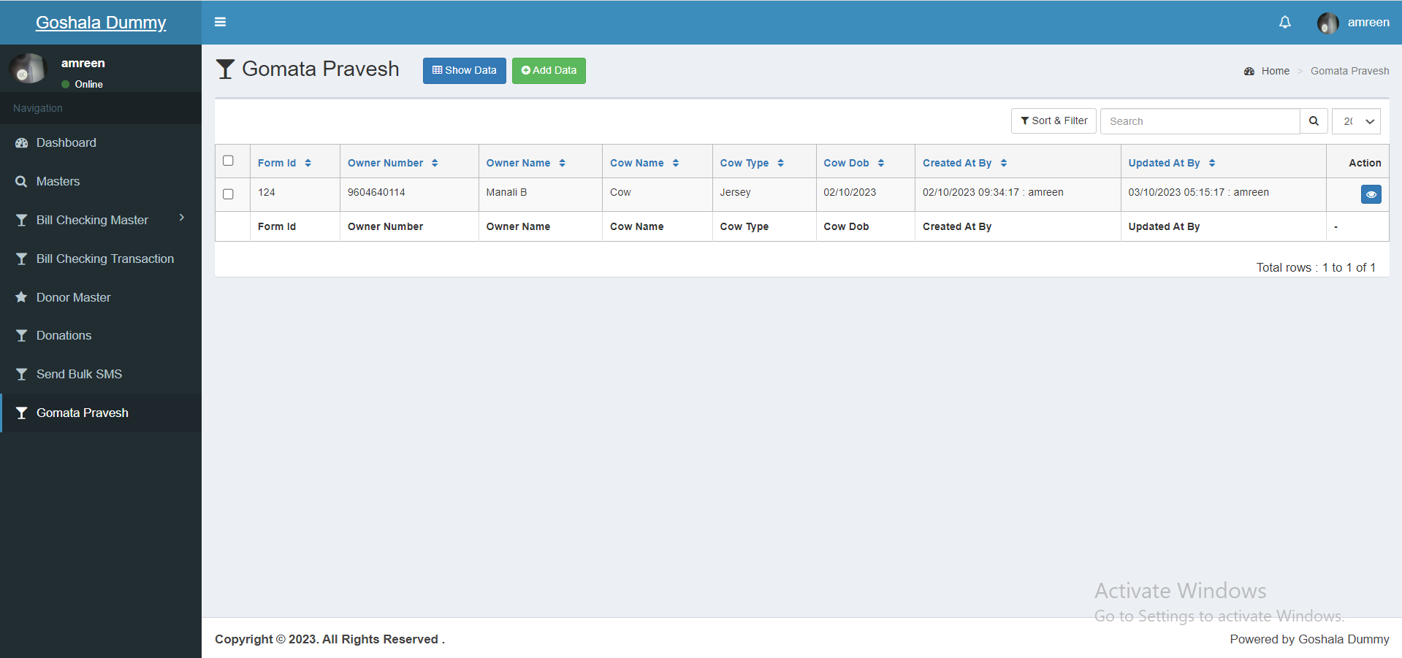

Details added by user through mobile application will be displayed in web grid here as well. In web, once user clicks on **add action** it will display following fields:

* Owner mobile
* Owner name
* Owner address
* Donation reason
* Owner photos
* Cow name
* Cow DOB
* Cow age
* Cow birthmark
* Cow color
* Cow type
* Cow delivered calves
* Cow disease detail
* Cow current health
* Is cow conceiving
* Cow daily milk (in ltrs)
* Cow market value
* Cows photo
* I agree checkbox
* Save
* Cancel

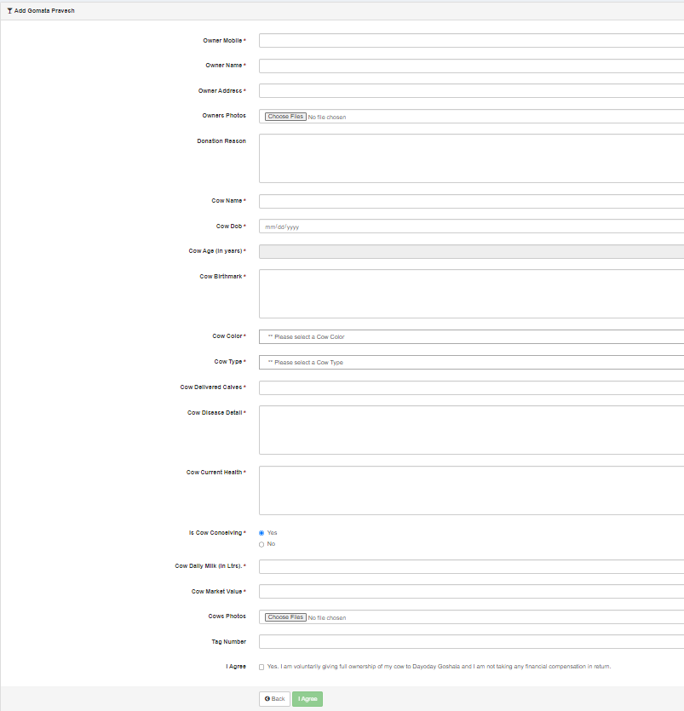

Once tenant admin logs into web application, it will display following fields in gomata pravesh menu -> grid:

* Add button
* Form Id
* Owner number
* Owner name
* Cow type
* Cow DOB
* Created at and by
* Updated at and by
* View action
* Edit action - User will not be able to edit the added details of gomata pravesh form, however tenant admin will be able to edit the added details.

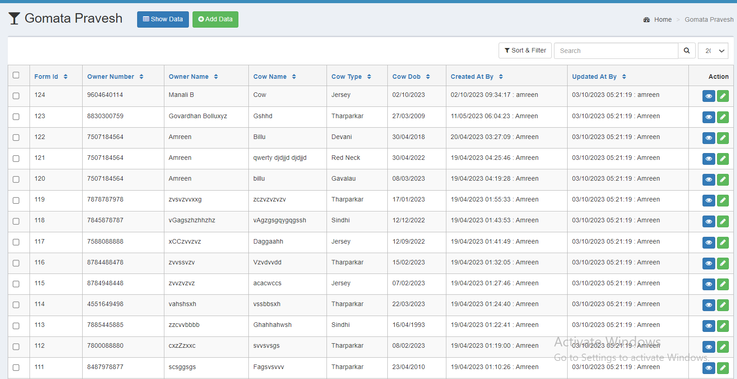

In view action, it will display following fields:

* Owner mobile
* Owner name
* Owner address
* Donation reason
* Owner photos - User / admin can download attached photos.
* Cow name
* Cow DOB
* Cow age
* Cow birthmark
* Cow color
* Cow type
* Cow delivered calves
* Cow disease detail
* Cow current health
* Is cow conceiving
* Cow daily milk (in ltrs)
* Cow market value
* Cows photo - User / admin can download attached photos.
* I agree

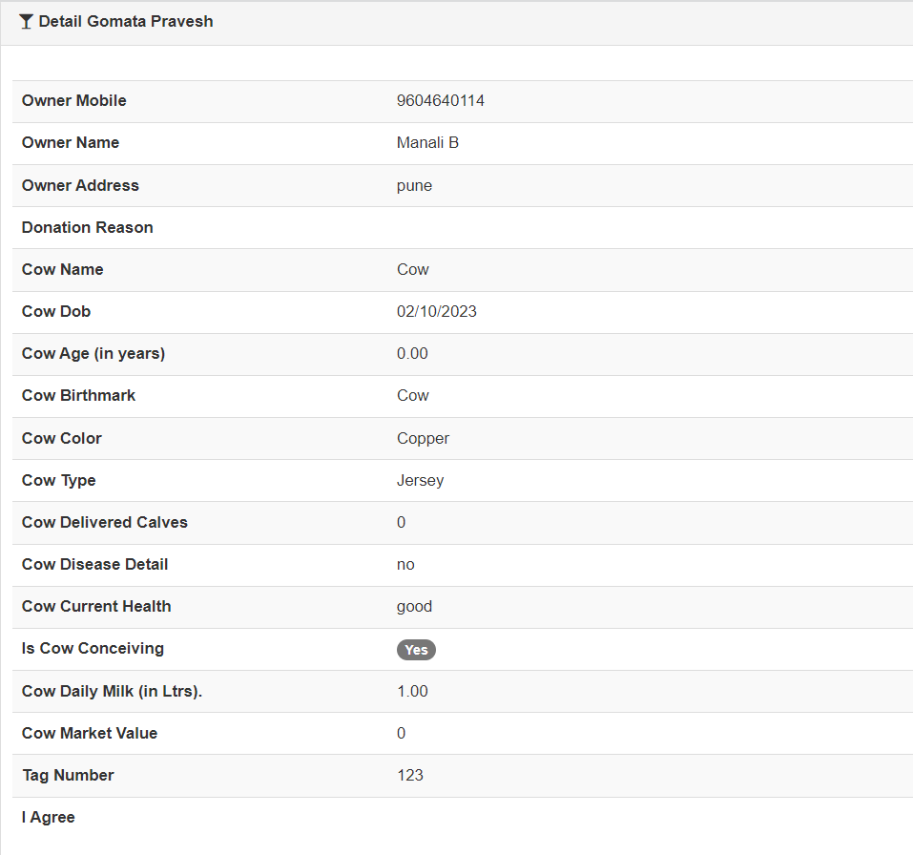

In edit action, it will display following fields:

* Owner mobile
* Owner name
* Owner address
* Donation reason
* Owner photos - user can delete already attached photo and upload another.
* Cow name
* Cow DOB
* Cow age
* Cow birthmark
* Cow color
* Cow type
* Cow delivered calves
* Cow disease detail
* Cow current health
* Is cow conceiving
* Cow daily milk (in ltrs)
* Cow market value
* Cows photo - user / admin can delete already attached photos and upload another.
* I agree checkbox
* Save
* Cancel

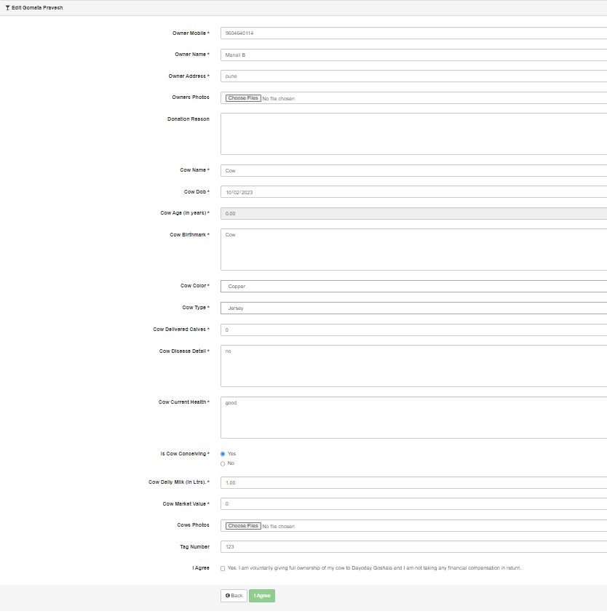

Once user or admin clicks on export button, it will download excel file having following columns and data as added:

* Sr. No.
* Owner mobile
* Owner name
* Owner address
* Donation reason
* Cow name
* Cow DOB
* Cow age
* Cow birthmark
* Cow color
* Cow type
* Cow delivered calves
* Cow disease detail
* Cow current health
* Is cow conceiving
* Cow daily milk (in ltrs)
* Cow market value
* I agree - yes / no
* Created at
* Created by
* Updated at
* Updated by

1. **TEST DATA & SCENARIOS**



1. **ODUS ( Open Discussed Unhanded scenarios )**

|  |  |  |  |  |
| --- | --- | --- | --- | --- |
| **Sr. No.** | **Topic** | **Priority**  **(High / medium / low)** | **Remark** | **Status**  **(Open/**  **Closed)** |
| 1 | 03/10/2023 : Do we have to send receipt to owner’s whats-app number about cow donation as details are added? | Low |  | Open |

1. **REFERENCES OF THE USERS**

|  |  |  |  |
| --- | --- | --- | --- |
| **User** | **Name** | **Mail** | **Contact number** |
| **Actual user** |  |  |  |
| **Ticket created by (if any)** | Mounika Annamneedi | Mounika.annmneedi@techneai.com |  |
| **Assigned business analyst** | Manali bhadirage | Manali.bhadirage@techneai.com |  |
| **Assigned developer** |  |  |  |
| **Assigned tester** |  |  |  |