18.07.2023

Tech Ticket Mobile App

Manali Ashok Bhadirage

Manali.bhadirage@techneai.com

**Functional Requirement Document**

**CONTENTS**

1. TICKET DETAILS 2

2. VERSION CONTROL 2

3. APPROVALS 2

4. ESTIMATION 2

5. INTRODUCTION 3

6. BUSINESS REQUIREMENT 3

7. SCOPE 3

8. BUSINESS & SYSTEM RULES 3

9. ABBREVIATIONS & TERMS 3

10. EXISTING SYSTEM 3

11. GRAPHICAL REPRESENTATION 3

12. PROPOSED SYSTEM 3

13. TEST DATA 4

14. ODUS 4

15. REFERENCES OF THE USERS 5

1. **TICKET DETAILS**

|  |  |
| --- | --- |
| **Ticket ID** | TT3711 |
| **Ticket description** | Ticketing system mobile application - Phase 1 |
| **Created by** | Mounika Annamneedi |
| **Created on** | 27/07/2022 |
| **Priority** | High |

1. **VERSION CONTROL**

|  |  |  |  |  |
| --- | --- | --- | --- | --- |
| **Sr. No** | **Version no** | **Version Date** | **User name** | **User department** |
| **1** | **1.0** | **18/07/2023** | **Mounika Annamneedi** | **IT Implementation** |
| **2** | **1.1** | **14/10/2023** | **Manali Bhadirage** | **IT implementation** |
|  |  |  |  |  |

1. **APPROVALS**

|  |  |  |
| --- | --- | --- |
| **Field** | **Name of the User** | **Approved date by the user** |
| **Actual User Name Actual User Department Organization Name** | Mounika Annamneedi  IT Implementation  Techne AI |  |
| **Assigned BA** | Manali Bhadirage |  |
| **Assigned Developer** | Goverdhan Bollu  Dhirajsngh Chandel |  |
| **Assigned Tester** | Preeti Bokade Priyanka Dupargude Disha Jadhav  Vaishnavi Khandwe |  |

1. **ESTIMATION**

|  |  |  |  |  |
| --- | --- | --- | --- | --- |
| **Department name** | **Estimated Time (In hr)** | **Scheduled Date (Starting date)** | **Estimated date** | **Actual delivery date** |
| **BA** |  |  |  |  |
| **Development** |  |  |  |  |
| **Testing** |  |  |  |  |
|  |  |  |  |  |

1. **INTRODUCTION**

Tech Ticket is tool designed for planning & managing your projects by creating tickets. It is easy to use IT software for scheduling tasks of team and increasing productivity of each member.

We need to develop user-friendly mobile application for tech ticket management, empowering users to log in and effortlessly access their assigned tickets and tasks. With the ability to conveniently pause and resume tasks at any point, users can have greater control over their workflow. Additionally, the application should enable instant report extraction for quick and efficient progress tracking.

1. **BUSINESS REQUIREMENT**

|  |  |  |  |
| --- | --- | --- | --- |
| **Requirement ID** | **Requirement Name** | **Short Description** | **Priority** |
| BR001 | Login | The registered user from web -> user master should be able to log into the application. | high |
| BR002 | Forgot password | User should be able to reset his password and log into the application. | high |
| BR003 | Profile | User’s details should be displayed in profile menu where user can update details. | Medium |
| BR004 | Notifications | Notifications should get sent within app to the relevant user related to tickets, tasks and duration. | Medium |
| BR005 | Dashboard | In sights and task list should be displayed on the dashboard.  Insights should display weekly overview of pending, completed, pending and total tasks. Whereas, task list should display today’s task, pending tasks and upcoming tasks. | High |
| BR006 | Create ticket | User should be able to create ticket and assign to another user. Created tickets should be displayed in my tickets -> created by me tab.   Once ticket is created then based on authority it should go for approval. Once ticket is passed then it should be displayed in ‘assigned to me tab’ of the assigned user. |  |
| BR007 | Edit ticket | The ticket owner should be able to edit the ticket details. | high |
| BR008 | View ticket | User should have authority to view ticket details that as assigned to their department, created by themselves or assigned to them. | Medium |
| BR009 | Ticket History | Any changes made in ticket should be reflected in ticket history and it should be displayed to ticket owner. | Medium |
| BR010 | Create basket | Ticket owner should be able create baskets and assign to others.  Ticket owner can also edit basket details. | high |
| BR011 | Create task | Ticket owners and basket owners should be able to create tasks under baskets assigned to them.  User can also edit task details until it is not completed. | high |
| BR012 | Filter tickets | From my tickets page, users should be able to search and filter tickets out of entire tech ticket system. | Medium |
| BR013 | Resource planning report | The resource planning report will present a clear overview of each user's daily workload, showcasing the total hours dedicated and the number of tasks assigned to them on a daily basis. This report aids in efficient resource allocation and helps in managing workload distribution effectively. | Medium |
| BR014 | Variance report | The variance report will provide users with a comprehensive analysis of all tasks, including their current status and the time taken for completion. This valuable information allows users to assess task performance and track any discrepancies effectively. | High |
| BR015 | Play and pause tasks | User should be able to play and pause added tasks from dashboard as well as from notifications list. | High |
| BR016 | Regularization request | Task owners can send regularization request to the ticket owners against tasks mentioning the time that they have actually worked on respective task.  Requests sent by tasks owners can be accepted or rejected by ticket owners. | Medium |
| BR017 | subtask | User should be able to add subtask in already created main task. Also, user should be able to delete or mark subtask as completed. | Medium |

1. **SCOPE**

The primary goal of this ticketing system project is to streamline project management processes, enhance collaboration, and improve overall project efficiency by providing a centralized platform for creating, assigning, and monitoring project tickets and tasks.

Ticket Creation: Users can create new project tickets with relevant details, such as the issue description, priority level, category, and due date.

Task Assignment: The system allows project managers or ticker owners to assign tasks to specific team members or users, ensuring clear responsibilities.

Prioritization and Categorization: The system should support the ability to prioritize tickets based on urgency and categorize them for better organization.

Task Dependencies: Users can set task dependencies, indicating which tasks must be completed before others can start, streamlining the project workflow.  
  
Time Tracking: Users can record the time spent on each task, facilitating accurate time management and billing processes.  
  
Reporting and Analytic: The system should offer reporting features that allow users to generate reports on ticket status, task completion, and overall project progress.  
  
User-Friendly Interface: The application should be intuitive and user-friendly, requiring minimal training for users to navigate and operate efficiently.

1. **BUSINESS & SYSTEM RULES**

* User should be registered in the system.
* System should display error message for incorrect details if entered.
* System should pop up a message, if any issues in the system is detected.
* Any changes made through the mobile application should be reflected in web application as well and vice versa.
* Only one tasks can be played at a time.
* Tickets must be marked as "resolved" only when the issue is fully addressed, and the user confirms the satisfactory resolution.
* Access to sensitive information and administrative functions should be restricted based on user roles and permissions.
* Ensure the system is mobile-friendly, allowing users to access and manage tickets from various devices.
* Functionality will be same for all android versions however the UI of fire-base notification may differ.

1. **ABBREVIATIONS & TERMS**

NA

1. **EXISTING SYSTEM**

Currently, the tech ticket system is available as a web application tool, and there is no mobile application counterpart for users. Unfortunately, users cannot play and pause tasks conveniently from the web application. To address this limitation and enhance user flexibility, a mobile application for tech ticket management is proposed.

With the mobile app, users will have the freedom to play and pause tasks at their convenience, regardless of their location or working hours. Additionally, the mobile app will empower users to create and add tasks even during non-working hours, ensuring seamless task management and improved productivity. Mobile application which will enable users to play and pause tasks efficiently and **remotely at any time**. Users can receive **real-time updates** on the status of their tasks, including progress updates, estimated resolution times, and notification when the issue is resolved.

1. **GRAPHICAL REPRESENTATION**

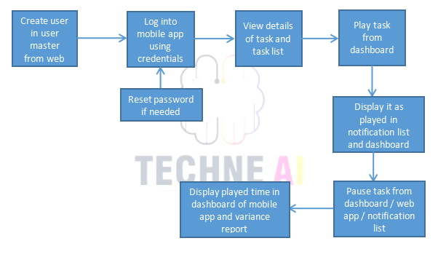

Fig: Phase 1 Context Diagram

1. **PROPOSED SYSTEM** 
   1. **Login**

Registered user from web should be able to login into the mobile application. Login page will have following fields:

* Logo
* Username
* Password
* Remember me check-box
* Forgot password button
* Login button

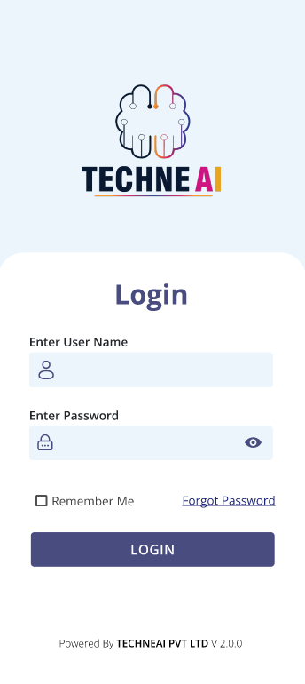

|  |  |  |  |
| --- | --- | --- | --- |
| **FIELDS** | **INPUT TYPE** | **MANDATORY/ OPTIONAL** | **DESCRIPTION** |
| User name | text | Mandatory | User will enter the user name as mentioned in the user master by the admin.  User can enter email address or username here. If entered email address has more than one users registered against it in the system, then it should display message to enter username.  Validation:- Max limit will be 25 characters. It shouldn’t accept space. It should be unique. |
| Password | Text | Mandatory | User will enter the password as provided by the admin as in user master.  It will have hide / expose button to view password or display it in encrypted format.  Validation:- Maximum limit would be 25 characters. It shouldn’t accept space. |
| Login | Click |  | Precondition:- User should be registered in system and should be active.  Post condition:- Once user enters valid username and password, it will display successful message and direct user on dashboard page of application. In case of invalid user name and password, user shouldn’t be able to log into the system.   Validation: login button should be disabled until user gets directed to dashboard page. |
| Remember me | Check box | Optional | This is to save the user name and password in the application, so that next time when user logs out and clicks on username then it will pre-fill the username and password.  It should saved all the passwords that are marked as remember me. As per username, it should fill the password field in encrypted format. |
| Forgot password | Click | Optional | Through forgot password button, code will get sent to the user’s registered number and email address and then user can reset his password.  Once user clicks on forgot password button, it will direct to next page where user will enter email / mobile number on which code will be sent to the user.    Once user enters mobile number / email and clicks on submit, code will be sent to the user. User will mention the correct code and will be able to further set new password.  Furthermore, after setting new password, user can log into the application using new password.  Validation: As few users have common email address but unique username, hence user name should be mandatory once user clicks on forgot password. |

* 1. **Dashboard**

Once user logs into the application, it will display insights and task list on the dashboard.

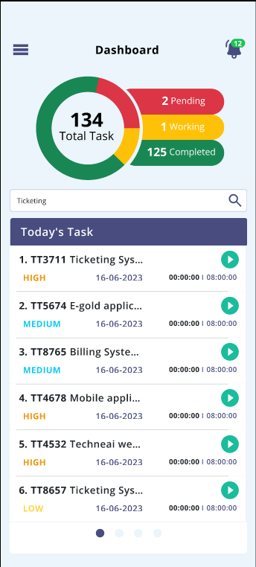

* **Insights**

It will display weekly analysis of tasks. It will display count of pending tasks of current week, in progress tasks, upcoming tasks, completed tasks and total tasks.

Total tasks = Pending + upcoming + in progress tasks + completed….. [provided none of the task is common]

These count will be displayed as and when the tasks are added from my tickets -> task -> add task for the current week.

If any task is being displayed in pending, today’s and current list then it will be counted as one tasks only and will be displayed as one in insights.

Tasks which are not played yet and has passed scheduled date, it will be displayed in pending count. Tasks which are in today’s list or upcoming list and are played even once, then it will be displayed in ‘in progress / working’ count. Tasks which are in upcoming list and not played even once, then it will be displayed in upcoming count.

* **Task list**

It will display the tasks in today’s list, pending list and upcoming list.

* Today’s tasks

It will display all the tasks whose start date is scheduled for the today’s date / current date. It will display following fields:

* Ticket ID - Task name
* Priority
* Date
* Task Played time
* Scheduled hours
* Play and pause button

All the details will be displayed as per task added by the user or any task that has been assigned to user by another person.

|  |  |  |  |
| --- | --- | --- | --- |
| **FIELDS** | **INPUT TYPE** | **MANDATORY/ OPTIONAL** | **DESCRIPTION** |
| Task Name | Click | Mandatory | It will display the ticket ID and the task name when user adds the task from my tickets -> task -> add task.  Whenever task name is edited by the user from my tickets -> edit task, then it should be reflected on dashboard task list as well.  It will be clickable. If user clicks on that task name then user should be directed to the manage tasks page to that respective ticket.  In addition to this, whenever future tasks are added and being displayed in upcoming list, then it will be displayed in today’s task list when the current date arrives as per task schedule and it will not be displayed in upcoming task list. |
| Priority | text | Mandatory | It will display high / medium / low priority as mentioned while adding the task. As and when task is edited and its priority is changed then its updated priority will be displayed on dashboard. |
| Date | Text | Mandatory | It will display today’s date as task is planned for today.  Whenever task date is edited by the user from my tickets -> edit task, then it should be reflected on dashboard task list as well. |
| Task played time | Timer | Mandatory | It will be display the actual time that user has worked on the particular task.  Initially it will display 00:00:00 when task is added and not played. Further when user clicks on play button, then timer will be displayed. Once user clicks on pause button, then timer won’t change. |
| Scheduled hours | Time | Mandatory | It will display the total time that has been scheduled by user while adding the task.  Whenever scheduled hours is edited by the user from my tickets -> edit task, then it should be reflected on dashboard task list as well. |
| Play and pause | Click | Mandatory | Through this user will play the task when user is actually working it.  Once play button is clicked, then timer will be displayed for that task. Once task is played from the dashboard / notification / manage task -> task, then it will display as paused in dashboard task list as well as in manage task -> task.  Once user plays the task, then it should be displayed in top of that list.  In addition to this, notification of task list will be displayed and the task will be played. Once task is paused from the notification, then it will display as paused in dashboard task list as well as in manage task -> task.  User shouldn’t be able to play / pause tasks whose status is completed.  Once task is marked as completed, then it will be removed from today’s task list. |

* Pending tasks

If any task is scheduled for the dates till yesterday and are not being completed, then it will be displayed in pending task list. It will display following fields:

* Ticket ID - Task name
* Priority
* Date
* Task Played time
* Scheduled hours
* Play and pause button

In date field, it will display the date for which that task was scheduled.

Once user plays the task, then it should be displayed in top of that list as well as in notification playlist.

Once task is marked as completed, then it will be removed from pending task list.

* Upcoming tasks

If any task is scheduled for the dates from tomorrow, then it will be displayed in upcoming task list. It will display following fields:

* Ticket ID - Task name
* Priority
* Date
* Task Played time
* Scheduled hours
* Play and pause button

In date field, it will display the date for which that task was scheduled. Once user plays the task, then it should be displayed in top of that list. Once task is marked as completed, then it will be removed from upcoming task list.

In addition to this, if start date and end date of task is such that task lies in pending, today’s and upcoming task list, then when user plays that task from any of the list then that task will get played from all three lists.

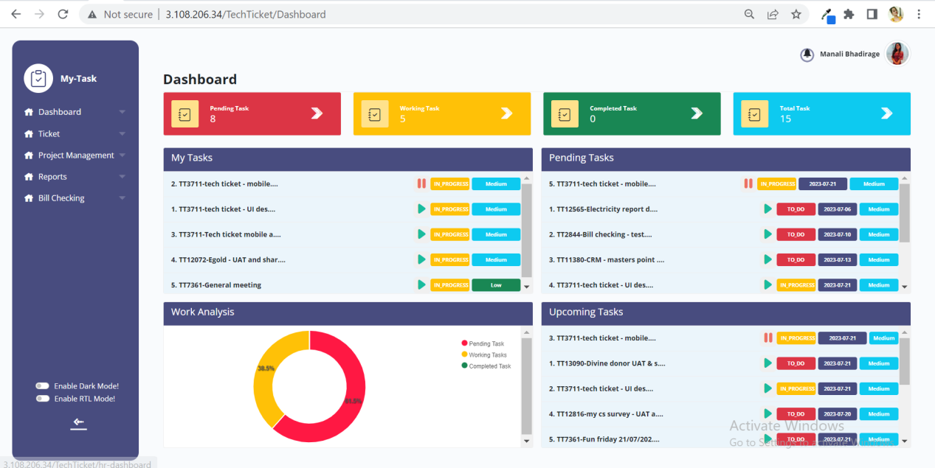

* Search button

Through search user can search the task from any of the three lists and can get directed to that list.

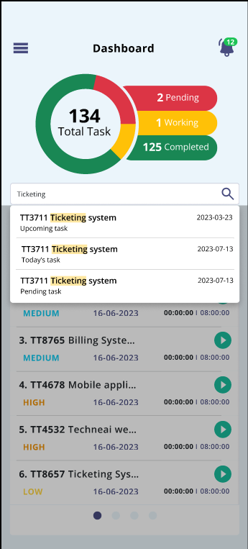

Once user enters task name or ticket id and if any task is available in any of the list - pending / today’s / completed, then it will display the relevant search results in the drop down. Further, once user clicks on the desired task from the search result, then user will be directed to that task list and that selected task will get highlighted.

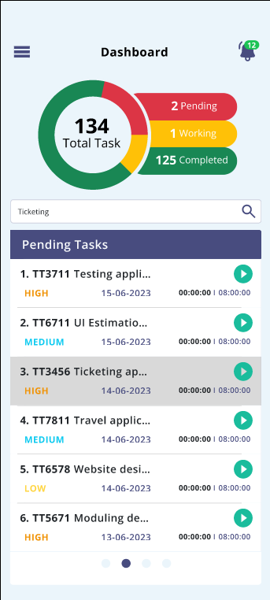

* 1. **Notification task play list**

Once user plays any particular task from manage task or from dashboard then task play list should be displayed in notification. It will display following fields:

* Task list name
* Task name
* Task played time & Scheduled hours
* Play button
* Pause button
* Next button
* Previous button
* Shuffle button

|  |  |  |  |
| --- | --- | --- | --- |
| **FIELDS** | **INPUT TYPE** | **MANDATORY/ OPTIONAL** | **DESCRIPTION** |
| Task list name | text | Mandatory | It will display today’s task / pending task / upcoming task as per the task which is being played. |
| Ticket ID - task name | Text | Mandatory | It will display the ticket ID and the task name that is being played. |
| Task played time and scheduled hours | Text | Mandatory | It should display the time that has been played and task scheduled hours in HH:MM:SS format. |
| Play | Click |  | User should be able to play the task. Whereas if any task in being played from the dashboard or manage task -> task, then it should display the played tasks as played in the notification as well.  If task is paused, then it will display play button. If tasks is already in played state, then it will display pause button against it. |
| Pause | Click |  | User should be able to pause the played task. Once task is paused, then updated timer should be displayed in dashboard as well as in variance report for that task. |
| Next | Click |  | When user clicks on next, then the next task of that task list should be displayed.  Further, suppose there are 10 tasks on today’s list and user has played first one. Then each time when user clicks on next button, then next task of today’s list will be displayed. Further, once user has reached to tenth task and clicks on next button, then it will go to first task again of today’s task list.  If there is only one task in any of the list, then there will be no option to click on next button for that list. |
| Shuffle | Click |  | User can shuffle entire task list from today’s task to pending task and to upcoming task.  User should be able to shuffle the list even when task from one of the list is played, however that played tasks should remain played I.e. shouldn’t get affected.  User can further also play and pause the task after shuffling the task list. |

Once the task is played from dashboard, then notification gets display regarding task played. However, the notification shouldn’t get cleared until the played task is paused.

* 1. **Profile**

The details in the user profile will be displayed as admin has entered while adding user in user master. As and when the details in user master are changed, then updated details will be displayed in profile. It will have following fields:

* Profile image
* Name
* Designation
* Departments
* Username
* Email address
* Contact no.
* Whatsapp no.
* Preferred communication
* New password
* Confirm password
* Update button

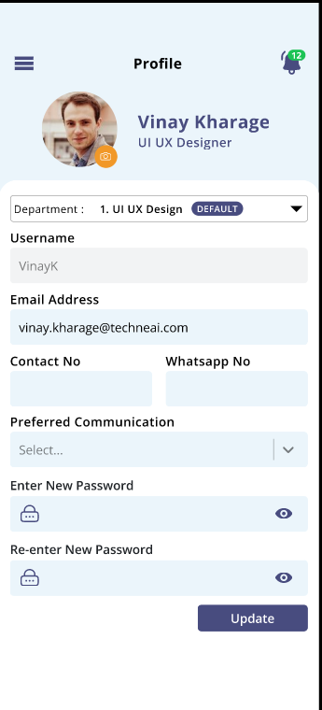

|  |  |  |  |
| --- | --- | --- | --- |
| **FIELDS** | **INPUT TYPE** | **MANDATORY/ OPTIONAL** | **DESCRIPTION** |
| Profile image | attachment | Mandatory | It will display user's profile image as added by admin in user master. Whereas, user can change the profile image by camera or by existing image in phone gallery. If image is not attached by admin or by user, then it will display profile image field as blank.  Validation: Should accept max one image only. It should accept jpg, png, jpeg, heic, webp extensions only. |
| Name | Text | Mandatory | It will display the name of the user as per first name and last name added in user master.  It will be read only. |
| Designation | Text | Mandatory | Designation of the user will be displayed as added in user master while adding the user.  It will be read only. |
| Departments | Text | Mandatory | It will display the list of departments that user is working on as per user master.  It will be read only. |
| Username | text | Mandatory | It will be read only text field where user name will be displayed as mentioned by the admin while adding this user in user master. |
| Email address | Text | Mandatory | It will be editable field where initially it will display the email address entered by the admin for this user. Whereas, user himself can edit the email address here.  Validation: It shouldn’t accept space. It should accept maximum 50 characters. It should accept . - @ _ special characters only. |
| Contact no. | Text | Mandatory | It will be editable field where initially it will display the contact no. entered by the admin for this user. Whereas, user himself can enter and edit the contact no. here. |
| Whatsapp no. | Text | Mandatory | It will be editable field where initially it will display the whatsapp no. entered by the admin for this user. Whereas, user himself can enter and edit the whatsapp no. here. |
| Preferred communication | Drop-down | Mandatory | It will display SMS/ email / Whatsapp in the drop-down. By default it will display SMS.  This will be used when OTP will be sent to the user. |
| New password | text | Optional | User can update and enter new password here. Once user updates password, then user can login using new password and username.  Validations: It shouldn’t accept space. It should accept maximum 25 characters. |
| Confirm password | text | Optional | User can update and enter new password here. Once user updates password, then user can login using new password and username.  Validations: It shouldn’t accept space. It should accept maximum 25 characters. |
| Update | click |  | Once user changes any fields in profile and clicks on update button, then changes will be successfully done in profile and will be reflected in user master page as well as in user’s profile. Also, user will be able to login with new password once password is updated. |

* 1. **My Tickets**It will display the summary of all the tickets that has been assigned to the user, created by him and are passed as well as not passed yet, assigned to his respective department and the tickets under which only the basket has been assigned to user.

User can search and view tickets from entire ticketing system using filter and search button. This helps to analyze the numbers of tickets that are assigned to each user and helps to allocate the tickets to different users. In addition to this, user can view each ticket, edit it, view its history, view baskets and tasks.

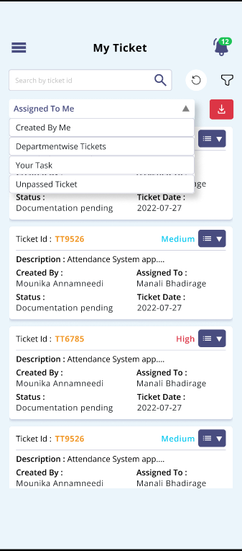

* **Assigned to me**

In assigned to me tab, it will display list of tickets that has been assigned to user himself. By default assigned to me tab will be displayed in drop-down and hence its tickets.

It will display following details in grid for each ticket:

* Export button
* Sr no.
* Ticket ID
* Priority
* View action
* Hamburger action - edit, history, basket / task
* Created by
* Assigned to
* Status
* Ticket date

|  |  |  |  |
| --- | --- | --- | --- |
| **FIELDS** | **INPUT TYPE** | **MANDATORY/ OPTIONAL** | **DESCRIPTION** |
| Export | Click |  | User can download list of tickets and it details in assigned to me tab.  It will display following columns in excel file: |
| Sr. no. | Text |  | It will display the no. Of ticket in the assigned to me tab.  It will be displayed in decremented manner I.e. recently assigned ticket will be displayed at top. |
| Ticket ID | Text |  | Whenever ticket is created, ticket ID gets generated to it and that will be displayed here. |
| Priority | text |  | While creating the ticket, the entry user selects the priority of the ticket and that will be displayed here when ticket is assigned to user. |
| View action | Click |  | To view details of the ticket, then user will have to click on the card. It will direct user to view details page of that ticket. It will display following details of each ticket in view page:   * Ticket ID * Created by * Ticket date * Expected solved date * Assigned Department * Assigned User * Type * Status * Priority * Passing status * Description * Attachments * **Ticket Chat** |
| Ticket Chat | Click |  | Through ticket chat, user can add updates / comments / attachments in this section.  It will display all the previous chats and attachments which were added through chat will be displayed in attachment field of view ticket page.  Chat and attachments can be entered through view ticket page as well as edit ticket page. |
| Edit action | Click |  | User can change few details in ticket through edit action. Once details are edited and saved then updated details will be displayed in view ticket page, edit ticket and history of edited details will be displayed in history action.  Edit page will display following fields:   * Ticket ID * Ticket date * Entry department * Entry user * Passed by * Passing date * Priority * Confirmation * Description * Query type * Expected solved date * Ref ID * Project * Module * Sub module * Reviewer * Assign department * Assign user * Attachment * Choose files * Submit button * Cancel button * Ticket Chat |
| History action | Click |  | As and when users updates the details in ticket through edit action of that ticket, it details will be displayed and highlighted in history action.  It will display following fields:  Ticket ID  Ticket Date  Entry dept  Entry user  Passed by  Passing date  Priority  Confirmation  Export button  Operation  Updated by  Updated date  Ticket type  Expected date  Assigned user  Assigned dept  Project name  Module name  Sub module name  Status  Attachment  Through export button, excel file will be downloaded displaying details of ticket history.  When ticket is created then first entry of ‘add / insert’ operation will be displayed in each ticket. Further, whenever changes are made in any of the editable field in ticket through edit action, it will be displayed in history and the made changes will be highlighted with colour.  Whenever new attachment is added, then it will display newly attached document in history which will be hyperlink / downloadable. |
| Basket action | Click |  | When ticket is not having any basket created in it, then ‘basket’ action will be displayed in drop-down of that ticket.  We can create multiple baskets under one ticket and assign each basket to each user. Then users can add tasks in their own assigned basket only. Whereas ticket owner can have access to all the baskets in that ticket.  Option to create basket should be displayed only to the ticket owner.  Once user clicks on basket option, it will display following fields to create basket:   * Basket name * Basket owner * From date * To date * Submit button * Reset button |
| Task action | Click |  | If atleast one basket is created in the ticket, then in my tickets page -> assigned to me tab -> task action will be displayed in the drop-down of each ticket.  Through task action, user I.e basket owner can add tasks in his own assigned basket whereas ticket owner can add tasks in all the baskets as he has access to all.  Once user clicks on task action, it will direct user to manage task page of that task. |
| Created By | Text | Mandatory | It will display the name of entry user in grid who has created the ticket. |
| Assigned to | Text | Mandatory | It will display the name of user in grid to whom the ticket is assigned to. (which means the logged in person as ticket has been assigned to him and hence is being displayed ‘assigned to me tab). |
| Status | Text | Mandatory | It will display the status as unsolved initially when ticket is newly created. Further, when assigned user changes the status from edit ticket -> status field, then updated status will be displayed in grid.  In edit action -> status field, it displays active statuses from status master in drop-down. |
| Ticket date | Text | Mandatory | It displays the date on which the ticket is created by the entry user. |

* **Created By Me**

It will display the tickets which have been created by the logged in person and have not been resolved yet. It will display following fields:

* Export button
* Sr. No.
* Ticket ID
* Status
* Action - history, confirm
* Description
* Created by
* Assigned to
* Status
* Ticket date

User can click on the card to view details of the ticket. It will display following details:

* Ticket ID
* Created by
* Ticket date
* Expected solved date
* Assigned Department
* Assigned User
* Type
* Status
* Priority
* Passing status
* Description
* Attachments
* **Ticket Chat**

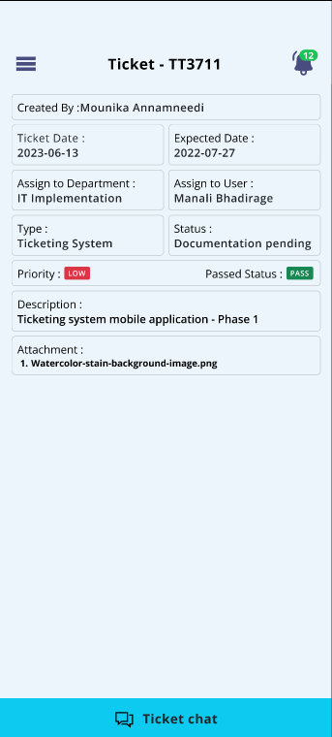

Once user clicks on **confirm** action, a pop-up message will be displayed from where user will mark ticket as solved and mention remark. Once tickets is amrked as solved by entry user, then that ticket will be removed from ‘assigned to me’ tab of assigned user as well as from ‘created by me’ tab of entry user.

* **Department-wise tickets**

It displays all the tickets that have been assigned to the department of the logged in person and have been solved yet. It will display following fields:

* Export button
* Sr. No.
* Ticket ID
* Status
* Action - edit action
* Description
* Created by
* Assigned to
* Status
* Ticket date

Once clicks on the card of each ticket, it will display following details:

* Ticket ID
* Created by
* Ticket date
* Expected solved date
* Assigned Department
* Assigned User
* Type
* Status
* Priority
* Passing status
* Description
* Attachments
* **Ticket Chat**

Further, **edit action** will be displayed to the logged in person to the tickets only which have been assigned to him. For rest of the tickets which are not assigned to the logged in user, he can only view ticket details and use ticket chat.

* 1. **Create ticket**
  2. **Reports**
* Resource planning report

Through resource planning report, users can view number of tasks that are planned for working for each user on each date. It has following fields:

* From date
* To date
* Users
* Search button
* Reset button
* Export button

|  |  |  |  |
| --- | --- | --- | --- |
| **FIELDS** | **INPUT TYPE** | **MANDATORY/ OPTIONAL** | **DESCRIPTION** |
| From Date | Calender picker | Mandatory | User will select the date from which he/she wish to view the planned tasks of employees.  Validation: Future dates will be disabled in the calender. It should be single select. |
| To Date | Calender picker | Mandatory | User will select the date till which he/she wish to view the planned tasks of employees.  Validation: Future dates will be disabled in the calender. Also, dates before ‘from date’ should be disabled. |
| Users | Drop-down | Mandatory | User will select the employees whose planned tasks he wants to view.  Validation: It will be multi select. It will display active users from user master. |
| Search | Click |  | Once user selects dates and chooses list of employees and clicks on search, then it will display list of tasks for each employee planned on each date.  It will display the list of tasks that have been added under tickets by employee or have been assigned by other person to that employee. (my tickets -> ticket task action -> add task)  Once user clicks on search button, it will display following fields:   * Date * Employee name * Ticket ID * Task name * Task duration   Search button should get disabled until the search results are displayed. |
| Export button | Click |  | User can download searched resource planning report in excel file. It will have following fields:  Sr no.  Date  Employee name  Ticket id  Task name  Task duration  Export button should be disabled until excel file gets downloaded successfully. |

User should be able to sort the reports data by ascending / descending order in case of user name and of date.

Once user clicks on the ticket ID from report then it will direct user on manage tasks page of that ticket where list of tasks are being displayed.

* Variance report

Through variance report, summarizes the tasks that were planned and the total number of task that have been completed. Along with it, time taken to completed the task and it status as delivered / completed on time will get displayed. This will help the users to analyze the duration that is required to perform particular task so that they can plan further accordingly.

It will have following fields:

* From date
* To date
* Users
* Search button
* Reset button
* Export button

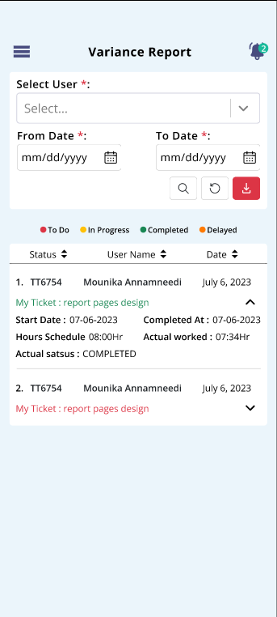

**Input table**

|  |  |  |  |
| --- | --- | --- | --- |
| **FIELDS** | **INPUT TYPE** | **MANDATORY/ OPTIONAL** | **DESCRIPTION** |
| From date | Calendar picker | Mandatory | User will select the date from which he/she wish to view the summarized report of each task of employees.  Validation: Future dates will be disabled in the calender. It should be single select. |
| To Date | Calender picker | Mandatory | User will select the date till which he/she wish to view the summarized report of each task of employees.  Validation: Future dates will be disabled in the calender. Also, dates before ‘from date’ should be disabled. |
| Users | Drop-down | Mandatory | User will select the employees whose planned tasks he wants to view.  Validation: It will be multi select. It will display active users from user master. |
| Search | Click |  | Once user clicks on search button, then the report will be displayed having following fields:   * Sr. No. * Ticket ID * Task name * User name * Start date * End date * Scheduled hours * Actual worked hours * Completed at * Status * Actual status   Here, actual status will be displayed in colour for the task name.  To Do - Red - When end date is not passed yet and task is not played yet.  In progress - Yellow - When end date is not passed yet and task is played.  Completed - Green - When end date is not passed and task is completed on or before end date.  Delayed - When task end date had passed and task is not marked as complete yet.  Search button should get disabled until the search results are displayed. |
| Export | Click |  | Through export button, user can downloaded searched report in excel file. It will have following fields:   * Sr. No. * Ticket ID * Task name * User name * Start date * End date * Scheduled hours * Actual worked hours * Completed at * Status * Actual status |

1. **TEST DATA**

Multiple examples can be mentioned in sheet. Provide multiple scenarios for each field in the module. Input value and expected output value should be specified. Live examples in existing or alternative system should be provided if possible.



1. **ODUS ( Open Discussed Unhanded scenarios )**

ODUS sheet will contain questions raised by team which needs to be confirmed from user, points to be discussed with user, confirmation of points which isn’t given from user yet.

|  |  |  |  |  |
| --- | --- | --- | --- | --- |
| **Sr. No.** | **Topic** | **Priority**  **(High / medium / low)** | **Remark** | **Status**  **(Open/**  **Closed)** |
| 1 | Application logo to be displayed currently as same as connect us because name is not decided yet. |  | Write solution which is decided by user or head or us. | Open for queries which are recently asked and which are pending. |
| 2 |  |  |  |  |
| 3 |  |  |  |  |
|  |  |  |  |  |
|  |  |  |  |  |

1. **REFERENCES OF THE USERS**

|  |  |  |  |
| --- | --- | --- | --- |
| **User** | **Name** | **Mail** | **Contact number** |
| **Actual user** |  |  |  |
| **Ticket created by (if any)** |  |  |  |
| **Assigned business analyst** |  |  |  |
| **Assigned developer** |  |  |  |
| **Assigned tester** |  |  |  |