|  |  |
| --- | --- |
| **Ticket ID** | T220500 |

Business Requirement:

In whatsapp, change of existing links of e-catalogue in option “3”.

Existing system:

In whatsapp, option “3” consists of old links related old CS jewellers website.

Output:

Option “3” is replaced with the following links for the 3 languages.

<https://www.csjewellers.com/catalog>

For English:

<https://csjewellers.com/ecatalog/download/eng/karnful/>

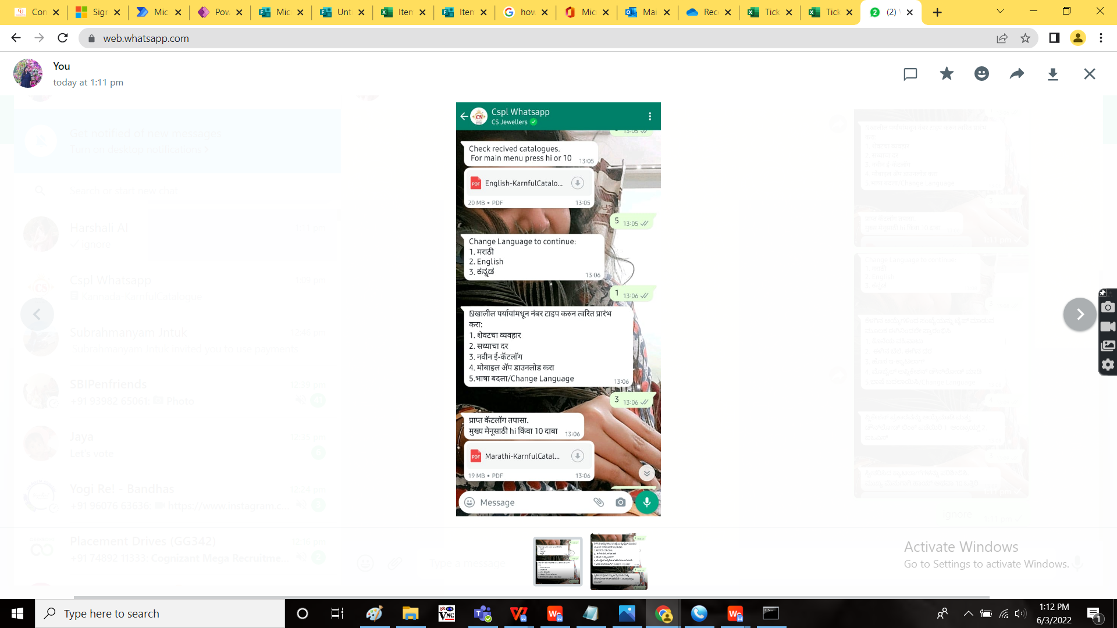

For Marathi:

<https://csjewellers.com/ecatalog/download/mar/karnful/>



For Kannada:

<https://csjewellers.com/ecatalog/download/kan/karnful/>

