|  |  |
| --- | --- |
| **Ticket ID** | TT3894 |
| **Ticket description** | Inventory Team require Catalogue App |
| **Created by** | Manali Bhadirage |
| **Created on** | 01/08/2022 |
| **Priority** | Very high |
| **Version** | 01 |

**Version**

|  |  |  |  |  |
| --- | --- | --- | --- | --- |
| **Sr. No** | **Version no** | **Version Date** | **User name** | **User department** |
| **01** | **1.0** | **02/08/2022** | **Tushar Nikam** | **Inventory Team** |
| **02** | **1.1** | **05/08/2022** | **Tushar Nikam** | **Inventory Team** |
|  |  |  |  |  |

**Approvals**

|  |  |  |
| --- | --- | --- |
| **Field** | **Name of the User** | **Approved date by the user** |
| **Actual User Name** | Tushar Nikam |  |
| **Actual User Department** | Inventory Team |  |
| **Organization Name** | CSJewellers |  |
| **Assigned BA** | Manali Bhadirage |  |
| **Assigned Developer** |  |  |
| **Assigned Tester** | Priyanka Dupargude |  |

**Estimation**

|  |  |  |  |  |
| --- | --- | --- | --- | --- |
| **Department name** | **Estimated Time (In hr)** | **Scheduled Date (Starting date )** | **Estimated date** | **Actual delivery date** |
| **BA** |  |  |  |  |
| **Development** |  |  |  |  |
| **Testing** |  |  |  |  |
|  |  |  |  |  |

**Introduction**

Catalogue App is intended for catalogue order placement from branches to inventory team and from inventory team to vendors as per the requirement. Also, uploading new catalogue from vendors side to design team. Thus, variety of catalogue can be made available at branches.

**Business Requirement**

Inventory team require Catalogue App.

**Abbreviations & terms**

Wt - Weight

**Existing system**

There is no such existing application / system.

**Proposed system**

**Step 1 - Login**

Following users will be signing in to the application:

* Vendors
* Design Team / Inventory
* Branches

Sign-in page will have following fields:

* Username
* Password
* Submit
* Remember me
* Forgot Password

|  |  |  |  |
| --- | --- | --- | --- |
| **FIELDS** | **INPUT TYPE** | **MANDATORY/ OPTIONAL** | **DESCRIPTION** |
| Username | Text | Mandatory | Username can be registered email address or registered phone number. Both should be accepted during sign in.  All special characters should be accepted.  Username shouldn’t be case sensitive.  Provide maximum size of 50 letters in this field.  In case of incorrect username, display notification above as “incorrect username”. |
| Password | Alphanumeric | Mandatory | It should also accept all special characters.  Password should be case sensitive.  Minimum length of password should be 6 characters and maximum length should be 10.  Password must have at least one capital letter, at least one special character and at least one number.  In case of incorrect password, display notification above as “incorrect password”. |
| Remember Me | Click | Optional | Remember me is to save credentials. If user has clicked Remember me, whenever user opens the application, credentials should get auto-filled. |
| Submit | Click |  | User should be able to successfully sign-in on correct credentials.  Submit button should be disabled once clicked. |
| Forgot Password | Click |  | Once user clicks on forgot password, it should direct user to page to enter registered email address. Once registered email address is entered and submitted, send existing password to user via email. Show notification as “password sent on registered email”. |
| New Registration | Click | Optional | New user can register himself through “New Registration” as vendor or as a branch.  Once registered, display message above as “Registration successful” and direct user to login page.  In case email address and contact details are already registered, show notification as “already exists” and suggest user to use forgot password or new email address & number. |

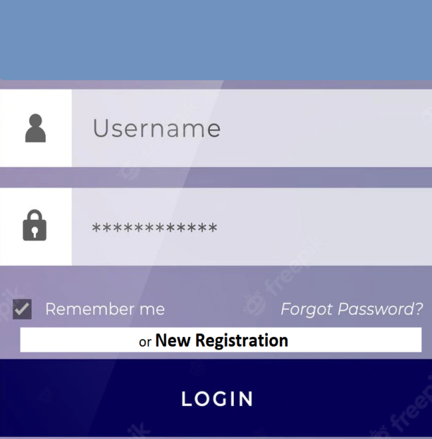

Fig: Login

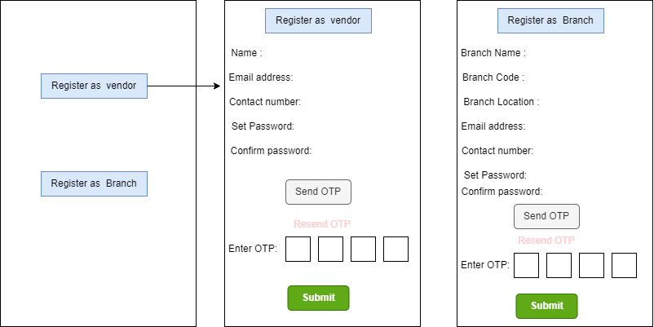

Fig: New Registration

Following are the fields in New Registration as a vendor and all fields as mandatory:

* Vendor Name
* Vendor Email Address
* Vendor Contact Number
* Password
* Confirm Password
* Send OTP - Once OTP is sent, this button should be disabled.
* Resend OTP
* Enter OTP
* Submit

|  |  |
| --- | --- |
| **FIELDS** | **DESCRIPTION** |
| Vendor Name | Only characters should be accepted.  Maximum length of input field should be 50 characters.  This field shouldn’t be case sensitive.  It should accept space in between if entered. |
| Vendor email address | This field should accept “ @ “ and “ . “ only as special characters.  It shouldn’t accept space anywhere. |
| Contact Number | Only numbers should be accepted.  Maximum 10 digits should be accepted. |
| Password | It should accept all special characters.  Password should be case sensitive.  Minimum length of password should be 6 letters and maximum length should be 10.  Password must have at least one capital letter, at least one special character and at least one number.  In case of incorrect password, display notification above as “incorrect password”. |
| Confirm password | This field should match with the inputs in Password field.  If inputs doesn’t match, it doesn’t display message below as “Password doesn’t match”. |
| Send OTP | Once clicked, send OTP button should be disabled. 4 digit OTP should be sent on both entered email and entered number.  Once clicked, 1 minute timer should be displayed in reverse manner. |
| Resend OTP | Resend OTP button should be activated after 1 minute timer has finished. |
| Enter OTP | Only digits should be accepted.  On entering correct OTP, submit button should be enabled.  On entering incorrect OTP, display message as “Please enter correct OTP”. |
| Submit | Once clicked, submit button should be disabled.  On successful registration, display message as “Registration successful” and direct user to sign in page. |

Following are the fields in New Registration as a vendor and all fields are mandatory:

* Branch Name
* Branch Code (Branch code will be selected from drop-down)
* Branch Location
* Branch Email Address
* Branch Contact Number
* Password
* Confirm Password
* Send OTP
* Resend OTP
* Enter OTP
* Submit

Details of all the users will be saved and viewed to Design Team (admin) in vendor master and branch master accordingly.

**Step 2**

On successful login, user will be directed to home page.

1. **Vendor**

Following are the fields displayed on home page for vendor:

* Upload
* View - It will have following fields:
* View
* Status
* Received Orders
* Orders Confirmed
* Log out

|  |  |
| --- | --- |
| **FIELDS** | **DESCRIPTION** |
| Profile | Profile field consists of following fields:   * Name - Name entered while registering should be displayed. * Email address - Email entered while registering should be displayed. It shouldn’t be editable as it was confirmed by OTP. * Contact number - Contact number entered while registering should be displayed. It shouldn’t be editable as it was confirmed in OTP. * Password - Password entered while registering should be displayed. * Change password button - Once clicked on change password button, text box should appear to enter password. Once vendor enters password and clicks on save, display message as “password changed successfully”. Password rule remains same as while registering. |
| Upload | Upload field enables vendor to upload catalogue and its details. |
| Edit | Vendor can view uploaded catalogue & details. Vendor can edit details and submit. Approved / Rejected status of the catalogue will be displayed. |
| Received orders | Vendor can view the details of the received orders. |
| Order Confirmed | Once the vendor confirms the order, notification will be sent to the design team. |
| Log out | Vendor can sign out of the application through this. |

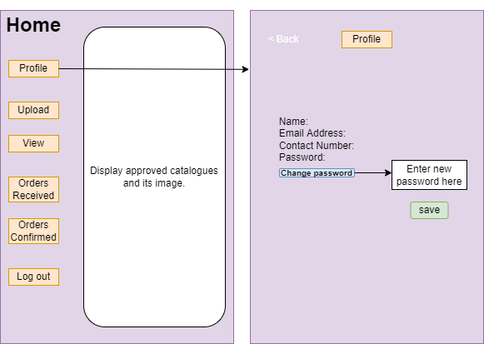

Fig: Vendor - Home page

Upload

Vendor can add the following details while uploading the catalogue:

* Product Group
* Design Code
* Item Name
* Gross wt
* Net wt
* Size
* Wastage Charges
* Value Range (only for forming and Diamond)
* Supplier Name
* Submit
* Image

|  |  |  |
| --- | --- | --- |
| **FIELDS** | **INPUT TYPE** | **DESCRIPTION** |
| Product Group | Drop-down | Vendor will select the Product groups from the drop down namely:   * Gold * Silver * Diamond * Forming |
| Design Code | Alphanumeric | Design code is the unique identifier of each catalogue. |
| Image | Upload | Vendor can upload one image of each catalogue. Format for the image can be PNG/JPG/JPEG with maximum size of 2MB. |
| Item Name | Text | Vendor can enter the name of the item for better understanding. |
| Gross wt | Numeric | Gross wt is the total weight of the item which includes weight of the metal, weight of the stones, weight of beads if any, etc.  Gross wt will be measured in grams. |
| Net wt | Numeric | Net wt is the weight of the metal only in ornament. It excludes weight of the stone, weight of beads, weight of thread, etc.  Net wt will be measured in grams. |
| Size | Numeric | Size are denoted in the number of item. It will be digit. |
| Wastage Charges | Numeric | Wastage charges is the amount of the wasted metal in the process.  Wastage charges of Forming product group should be mentioned in rupees.  Wastage charges of Gold, Silver and Diamond should be mentioned in percentage. It should accept decimal numbers. |
| Value Range | Numeric | If vendor selects, Forming and Diamond as product group then display value range option to vendor. |
| Supplier Name | Text | Vendor can add supplier name of each item.  This is auto fetch from login. (As vendor has signed to his account, here supplier name means vendors own name should appear) |
| Submit | Click | Save made changes and submit it.  On successfully uploading catalogue after clicking on submit, display message as “Catalogue Uploaded successfully” and direct user to home page.  Submit button should be disabled once clicked. |
| Exit | Click | Exit button at end should direct user to home page without saving any changes if made. |

Enable vendor with manual upload and bulk upload options at above.

In case of manual, vendor can upload one catalogue at a time. It will have following fields:

* Product Group
* Design Code
* Image
* Item Name
* Gross wt
* Net wt
* Size
* Wastage Charges
* Value Range (only for forming and Diamond)
* Supplier Name

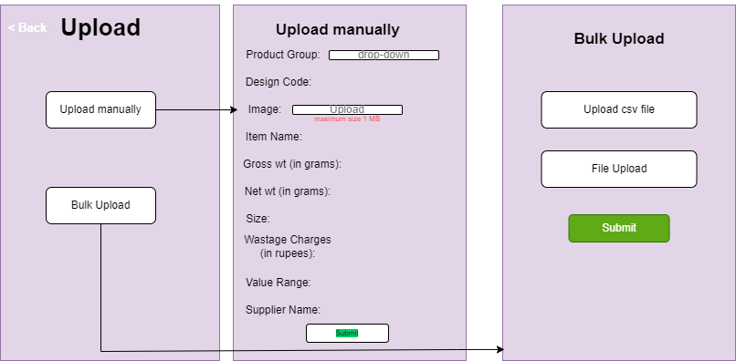

Fig: Vendor - upload page

In case of bulk upload, vendor can upload multiple catalogue through “upload csv file” button.

On bulk upload page, provide”Download csv format” , “upload csv file” button and “File upload” button.

CSV file will have following columns:

* Product Group
* Design Code
* Image name
* Item name
* Gross wt
* Net wt
* Size
* Wastage charges
* Value Range
* Supplier Name

Once vendor clicks on “Download CSV format”, CSV file will get downloaded which will have csv columns as mentioned above. Vendor can fill their catalogue in downloaded csv file and upload it.

In file upload, vendor can attach jpeg images of number of catalogue that vendor is uploading in csv bulk upload.

“Image name” field in csv file and the name of the image that vendor will be attaching in “File upload”, those should be same. Thus by same name, all the details and its image should get mapped correctly.

Maximum limit to upload catalogue in one csv file will be 1000.

View

All uploaded catalogue will be displayed in view field.

Enable “sort by” option at the top such that vendor can view catalogue by status - approved / rejected.

Image, design code and its status will displayed in front. However following fields will be displayed once vendor clicks on the catalogue:

* Image
* Product Group
* Design Code
* Item name
* Gross wt
* Net wt
* Size
* Wastage Charges
* Value Range
* Supplier Name
* Date
* Design team remark
* Back

Back button should direct vendor to earlier page (main view page).

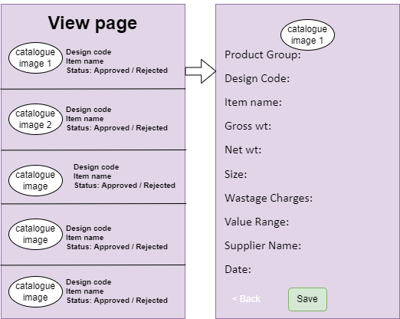

Fig: Vendor - view page

Received orders

Order requests confirmed and sent by inventory team should be reflected in received orders. Front page should display following fields of each item:

* Image
* Date (when order was received)
* Order number
* Product Group
* Design Code
* Total Pcs
* Branch Remark

Once the vendor clicks on each catalogue of received order page, vendor can view following details:

* Image
* Date
* Order number
* Product Group
* Design Code
* Item name
* Gross wt
* Net wt
* Size
* Wastage Charges
* Value range (in case of forming and diamonds only)
* Total Pcs ordered
* Branch Remark
* Back
* Confirm

Vendor can edit the total pcs ordered as per availability and the notification about the same will be sent to inventory team.

Back button should direct vendor to earlier page means on main received orders page.

Once confirm button is clicked, it should be disabled and display notification as “Order confirmed. Notification is sent.” And it should direct vendor to received orders page.

Once the order is confirmed, it should be removed from list of received orders page and should be displayed on orders confirmed page.

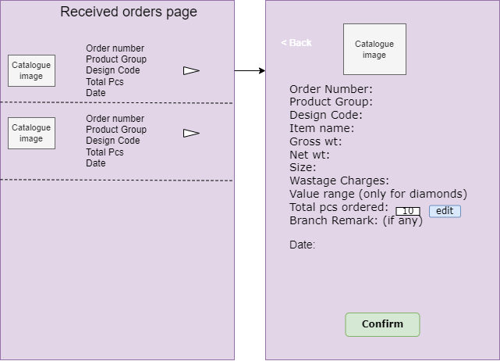

Fig: Vendor - received orders page

Enable “sort by” option at the top such that vendor can view orders by date from newest to oldest.

Orders Confirmed

All the confirmed orders and their details will be displayed in orders confirmed page.

Once the vendor confirms the order, the notification will be sent to inventory team. Also, the status of the order should be changed from “in process” to “confirmed” on branch side when vendor confirms it.

Back button at the top of orders confirmed page should direct user to home page.

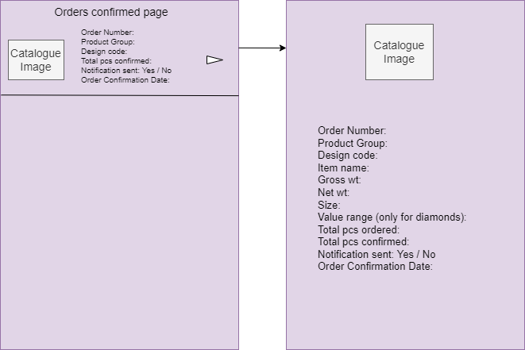

Fig: Vendor - Orders confirmed

1. **Design Team / Inventory team / HO (Admin)**

Design team will receive catalogue uploaded by vendors. They will review catalogue product group wise, further they will approve / reject it and the approved catalogue will be displayed to all branches.

Orders placed by branches will be reviewed by inventory team and will pass on to vendors.

Design team will manage catalogue and orders from back-end. However, on application design team will only login and view approved catalogue.

Design team can log in to app on a branch page so as to view displayed catalogue and details.

Back end system of design team / inventory team will have following fields:

* Dashboard
* Catalogue Requests
* Masters
* Vendor Master
* Branch Master
* Employee Master
* Item Master
* Orders
* Branch Orders
* Vendor Orders
* Reports
* Catalogue report
* Branch Orders report
* Notifications
* Logout

Dashboard

Dashboard will show product group wise total approved catalogue count and total rejected catalogue count of all the vendors.

Catalogue Requests

All the uploaded catalogue should be displayed in Catalogue Requests of Design Team. Following are the fields of Grid :

* Sr No
* Action - View, Approve, Reject.
* Select
* Product Group
* Design Code
* Image
* Item Name
* Gross wt
* Net wt
* Size
* Value Range (only if product group is forming and diamond)
* Wastage charges
* Supplier Name
* Design Team Remark
* Save
* Action done by - Name of the person who approved / rejected catalogue.

Select option is to perform action (approve / reject) for bulk catalogue. Design team can select multiple catalogue at a time and can approve / reject multiple catalogue through it. Once user selects bulk multiple rows, it should get bulk approve and bulk reject option under “bulk actions” button at top.

Catalogue which aren’t approved / rejected yet, they should be reflected at the top.

Once action (approved / rejected) is done, the catalogue should be reflected below the pending catalogue.

Status (Approved / Rejected) of each catalogue should be displayed to vendors view page.

Approved catalogue shouldn’t be uploaded again. It should be detected by design code as each catalogue will be having unique design code.

Vendor should be able to re-upload reject catalogue after making necessary changes.

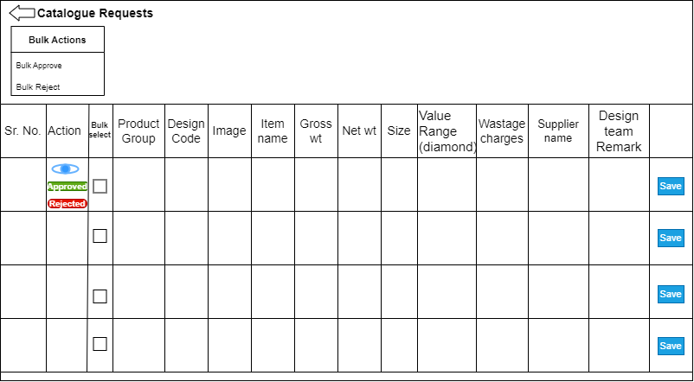

Fig: Design - Catalogue Requests

Masters

* Vendor Master

Registered vendors and their details will be displayed in vendor master. It will display following fields:

* Vendor Name
* Email address
* Contact Number
* Password
* Branch Master

Registered branches and their details will be displayed in branch master. It will consist following fields:

* Branch name
* Branch Code
* Branch location
* Email address
* Contact Number
* Password
* Employee Master

Employees of design team will be added by super-admin from back end through “Add Employee”option at top of the Employee master page. Employee details will be displayed below and consists of following fields:

* Employee name
* Email address
* Contact Number
* Employee Team Name - (design / inventory)
* Role
* Password
* Edit
* Item Master

Item master will include all the item details. Following details of each item should be displayed:

* Sr. No.
* Item name
* Is active
* Remark

Orders

It will display orders placed by branches under Branch orders and orders confirmed by vendors under vendor orders.

* Branch Orders -

It will have following fields:

* Sr. No
* Product Group
* Design Code
* Image
* Item Name
* Gross wt
* Net wt
* Size
* Value range
* List of branches
* Total
* Inventory
* Submit

|  |  |
| --- | --- |
| **FIELDS** | **DESCRIPTION** |
| List of Branches | All branches should be mentioned horizontally. Number of orders placed by each branch of catalogue should be mentioned under that branch.  If particular branch hasn’t placed order for item, it should be kept blank. |
| Total | Total orders from all the branches of each item should be mentioned under total. |
| Inventory | Inventory will manually enter the total pcs of each catalogue to be forwarded to vendor. |
| Submit | Submit button once clicked, the order of total number of pcs will be sent to vendor. |

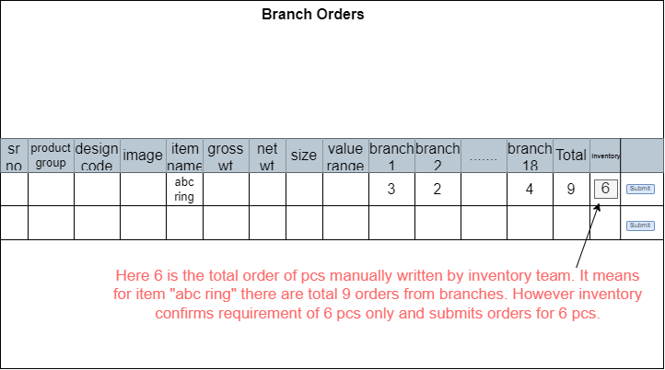

Fig: Branch Orders

* Vendor Orders

Orders confirmed by vendors should be displayed here. Provide following input fields:

* From Date
* To Date
* Product Group - Product Group will be selected from drop-down list having all, gold, silver, diamond and forming in it.
* Vendor
* Filter
* Reset
* Export

|  |  |
| --- | --- |
| **FIELDS** | **DESCRIPTION** |
| Filter | The Filter allows user to get selected data. If filter isn’t set, all the catalogue should be displayed in Grid below. |
| Reset | The Reset allows user to rest all the fields. |
| Export | The Export action allows user to extract the desired data in PDF/XLX/CSV format. |

Grid will display orders and its details in following format:

* Sr. No
* Date
* Order number
* Product Group
* Design Code
* Image
* Item name
* Gross wt
* Net wt
* Size
* Value range (only for forming and diamonds)
* Wastage charges
* Supplier name
* Branch ordered pcs
* Total pcs ordered
* Total pcs confirmed - It will display the count of orders confirmed by vendor.
* Status - in process / canceled

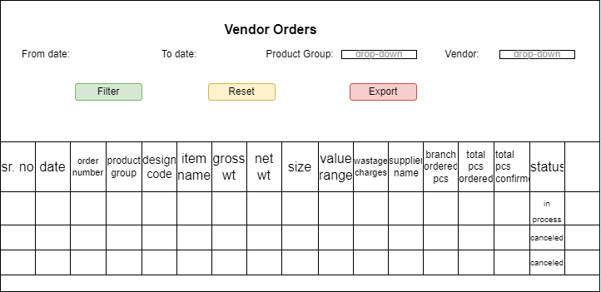

Fig:Vendor Orders

Report

* Catalogue Report

Report will include following input fields:

* From Date
* To Date
* Status - It will display approved and rejected in drop-down.
* Product Group - Product Group will be selected from drop-down list having all, gold, silver, diamond and forming in it.
* Filter
* Reset
* Export

|  |  |
| --- | --- |
| **FIELDS** | **DESCRIPTION** |
| Filter | The Filter allows user to get selected data. If filter isn’t set, all the catalogue should be displayed in Grid below. |
| Reset | The Reset allows user to rest all the fields. |
| Export | The Export action allows user to extract the desired data in PDF/XLX/CSV format. |

Below details will be displayed in form of grid. It involves below fields:

* Sr No.
* Date
* Product Group
* Design code
* Item name
* Gross wt
* Net wt
* Size
* Value range
* Wastage charges
* Supplier name
* Status
* Action done by
* Branch Orders Report

It will have following fields:

* From Date
* To Date
* Product Group - Product Group will be selected from drop-down list having all, gold, silver, diamond and forming in it.
* Branch
* Filter
* Reset
* Export

|  |  |
| --- | --- |
| **FIELDS** | **DESCRIPTION** |
| Filter | The Filter allows user to get selected data. If filter isn’t set, all the catalogue should be displayed in Grid below. |
| Reset | The Reset allows user to rest all the fields. |
| Export | The Export action allows user to extract the desired data in PDF/XLX/CSV format. |

Grid will display following fields:

* Sr. No
* Date
* Order number
* Product Group
* Design Code
* Item name
* Gross wt
* Net wt
* Size
* Value range (only for forming and diamonds)
* Branch Name
* Branch ordered pcs
* Total pcs ordered (of each catalogue) - Pcs submitted by inventory team.
* Total pcs confirmed - Pcs confirmed by vendor.
* Branch Remark - Additional comments added by branch while placing order.
* Action done by - Name of the person from inventory team who confirmed total ordered pcs

Notifications

Notification sent by vendor regarding order confirmation should be displayed here for design team.

Logout

Once user clicks on logout, pop-up notification should display asking “Do you want to logout?” If branch confirms by clicking on “yes”, it should exit and return to login page. If branch clicks “no”, system should stay on the same home page.

1. **Branch**

Branches will be able to view all the catalogue approved by inventory team and can place order as required.

Home page for the Branches will have following fields:

* Display all approved catalogue (front page)
* Search
* Filter
* Menu:
* Profile
* Your orders
* Wish list
* Log out

Display all approved catalogue (front page)

All the catalogue approved by the design team should be displayed to all branches.

On home page, Image, Product Group, Design code and Item name should be displayed about each catalogue and play order button at the bottom of catalogue.

If branch clicks place order from home page, it should direct branch to catalogue description page.

Each catalogue should have add to “wish list” button at upper right side corner. Moreover, each catalogue should be clickable and direct branch to description page. Catalogue description page of each item should display following details:

* Image
* Product Group
* Design code
* Item name
* Gross wt
* Net wt
* Size
* Value range (only for forming and diamonds)
* Total pcs button
* Branch Remark
* Place order button

|  |  |
| --- | --- |
| **FIELDS** | **DESCRIPTION** |
| Total pcs | Total count of each item to be ordered. Enable increment & decrement button. Keep by default count 1 at the beginning. |
| Branch Remark | Branch can enter additional notes if required while placing order.  It should be displayed to inventory team and vendor.  It should accept alphanumeric inputs.  This field is not mandatory. |
| Place Order | Branch can place order by one click through place order.  Once order is placed, direct branch to home page. |

Search

Search field enables branches to search desired catalogue by any of the following fields:

* Product Group
* Design code
* Item name
* Gross wt
* Net wt
* Value range (only for forming and diamonds)

Once clicked Search, application should display expected search results.

Filter

Filter field enables branches to search item by particular field. Branches can apply multiple filters at a time. Filter option should have below fields:

* Product Group
* Design code
* Gross wt
* Net wt
* Value range (only for forming and diamonds)
* Apply

|  |  |
| --- | --- |
| **FIELDS** | **DESCRIPTION** |
| Product Group | Product groups should further have options to click below fields:   * Gold * Silver * Diamond * Forming   Branches should be able to select multiple product groups at a time. |
| Design Code | Branches should get expected catalogue in search result on entering expected design code. This field should have text box and should accept alphanumeric values. |
| Gross wt | Branch can enter the range of the gross wt. Branch will enter their desired Gross wt in “From” and “To” fields.  It should accept Gross wt in decimal format as well and display expected search result. |
| Net wt | Branch can enter the range of the Net wt. Branch will enter their desired Gross wt in “From” and “To” fields.  It should accept Net wt in decimal format as well and display expected search result. |
| Value Range | Value range can only be set for Forming and Diamond Product Group. Branch can enter the desired numbers in “From” and “To” fields.  It should accept numeric values. |
| Apply | Once branch select desired filters and clicks apply, it should display desired search results. |

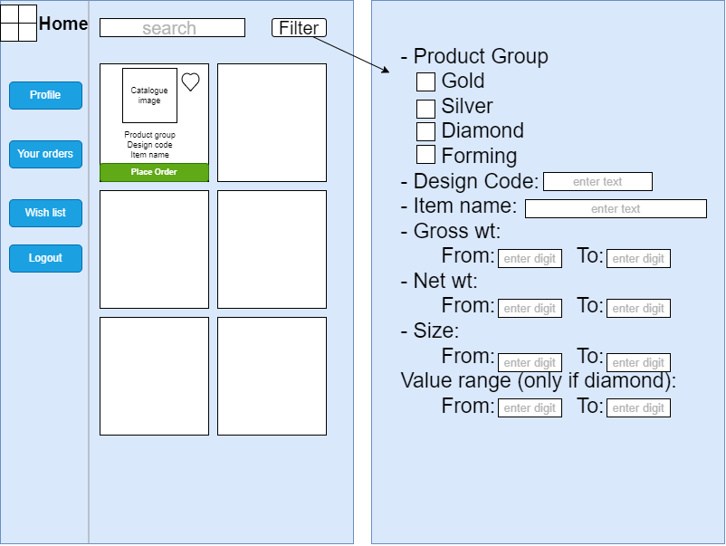

Fig: Branch - Home page & filter

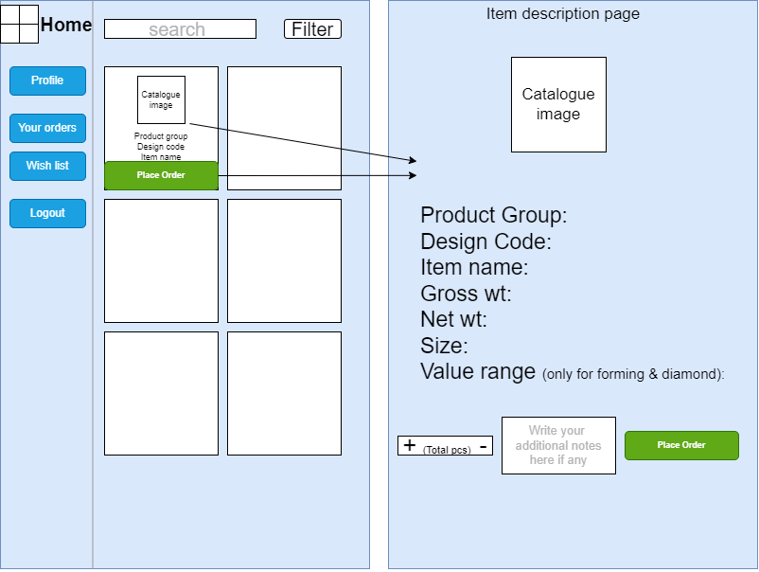

Fig: Branch - Item description page

Menu

Menu icon will have following fields:

* Your orders
* Wish list
* Log out

|  |  |
| --- | --- |
| **FIELDS** | **DESCRIPTION** |
| Your orders | Branch can view their placed orders. Each order should display image, product group, item name, date of order in front. And, once clicked on order it should display following details:   * Image * Order number * Product Group * Design code * Item name * Gross wt * Net wt * Size * Branch ordered pcs * Branch Remark * Status - In process / Canceled. * Cancel order button * Back   Provide search box at the top of your orders page so that branch can enter item name and search item if needed. It should show the relevant orders if exact item name is not entered in search box.  Order number will be auto-generated and unique for each order.  Cancel Order should be disabled after 24 hours.  Back button should direct branch to earlier page without saving any total pcs if selected. |
| Wish list | Branch can add catalogue to wish list. Wish list option menu should display all the items added to wish list. It should display the following fields:   * Image * Product Group * Design Code * Item name * Back - This back button at the top of page should direct user to home page.   Each catalogue added to wish list should be clickable and display following details on new page:   * Image * Product Group * Design code * Item name * Gross wt * Net wt * Value range (only for forming and diamonds) * Back - This should direct user to wish list page. |
| Logout | Once branch clicks on logout, pop-up notification should display asking “Do you want to logout?” If branch confirms by clicking on “yes”, it should exit and return to login page. If branch clicks “no”, app should stay on the same home page. |

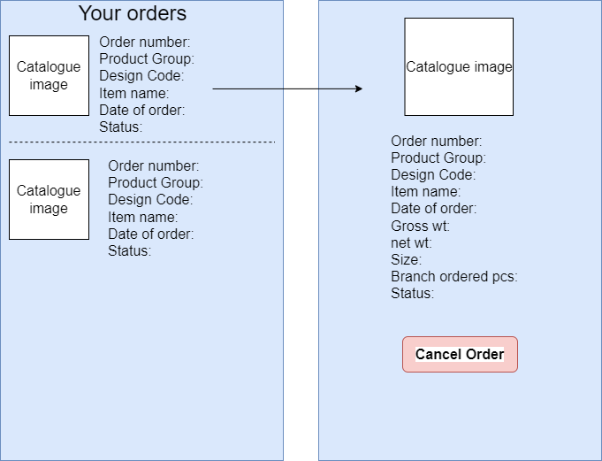

Fig: Branch - your orders

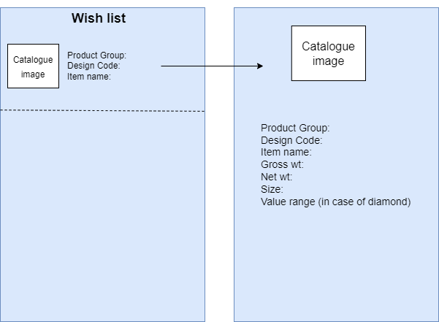

Fig: Branch - wish list

**References of the users**

|  |  |  |  |
| --- | --- | --- | --- |
| **User** | **Name** | **Mail** | **Contact number** |
| **Actual user** | Tushar Nikam | itinv@csjewellers.com | 2607 |
| **Ticket created by (if any)** | Tushar Nikam |  |  |
| **Assigned business analyst** | Manali Bhadirage | Manali.bhadirage@techneai.com | 2964 |
| **Assigned developer** |  |  |  |
| **Assigned tester** | Priyanka Dupargude | Priyanka.dupargude@techneai.com | 2964 |