|  |  |
| --- | --- |
| **Ticket ID** | TT3492 |
| **Ticket description** | Connect US Madhe Laser Marking Sathi New Report Create Karun Pahije Aahe Same As Weight Checking Module Type 1) Laser Marking History 2) User Wise Laser Report. |
| **Created by** | Manali Bhadirage |
| **Created on** | 21/07/2022 |
| **Priority** | Very high |
| **Version** | 1.0 |

**Version**

|  |  |  |  |  |
| --- | --- | --- | --- | --- |
| **Sr. No** | **Version no** | **Version Date** | **User name** | **User department** |
| 01 | 1.0 | 21/07/2022 | Tushar Nikam | Inventory |
| 02 | 1.1 | 26/07/2022 | Tushar Nikam | Inventory |

**Approvals**

|  |  |  |
| --- | --- | --- |
| **Field** | **Name of the User** | **Approved date by the user** |
| **Actual User Name** | Tushar Nikam | 29/07/2022 |
| **Actual User Department** | Inventory |  |
| **Organization Name** | CS Jewelers |  |
| **Assigned BA** | Manali Bhadirage |  |
| **Assigned Developer** |  |  |
| **Assigned Tester** | Priyanka Dupargude |  |

**Estimation**

|  |  |  |  |  |
| --- | --- | --- | --- | --- |
| **Department name** | **Estimated Time (In hr)** | **Scheduled Date (Starting date )** | **Estimated date** | **Actual delivery date** |
| **BA** |  |  |  |  |
| **Development** |  |  |  |  |
| **Testing** |  |  |  |  |

**Introduction**

Create Laser marking module in Connect Us which will enable users to add data, view and export data from List Data Laser marking (Grid) and create User Wise Laser report.

**Business requirement**

Connect US Madhe Laser Marking Sathi New Report Create Karun Pahije Aahe Same As Weight Checking Module Type 1) Laser Marking History 2) User Wise Laser Report.

**Abbreviations & terms**

Doc- Document.

Pcs- Pieces.

Wt- Weight.

**Existing system**

There is no such module in existing system.

**Proposed system**

* Create Laser Marking Module in Connect Us.
* Enable user to add data into Laser marking history.
* Enable user to view List Data Laser marking (Grid).
* Provision to user to search data, filter data and export data.
* Creation of User Wise Laser report in Laser marking.

Step 1- Laser Marking History

In Connect Us-> Laser Marking History-> Add Data

Through Laser marking history, user will get entire data of the laser marked Pcs along with their details. Following are the fields in Laser Marking history.

* Add data
* Filter
* Search and option for number of rows per page
* List Data Laser Marking (Grid).

|  |  |
| --- | --- |
| **FIELDS** | **DESCRIPTION** |
| Add Data | Add data permits user to add the details of the item that he will be laser marking. |
| Filter | Filter allows user to sort and get his desired data. |
| Search | The search field enables user to get data by entering any of the attribute values from Laser marking history. |
| Action | The action field consists of options namely history, cancel, restore, read, edit. |
| List Data Laser Marking (Grid) | The field consists of details of each data (in tabular form) added by user. |

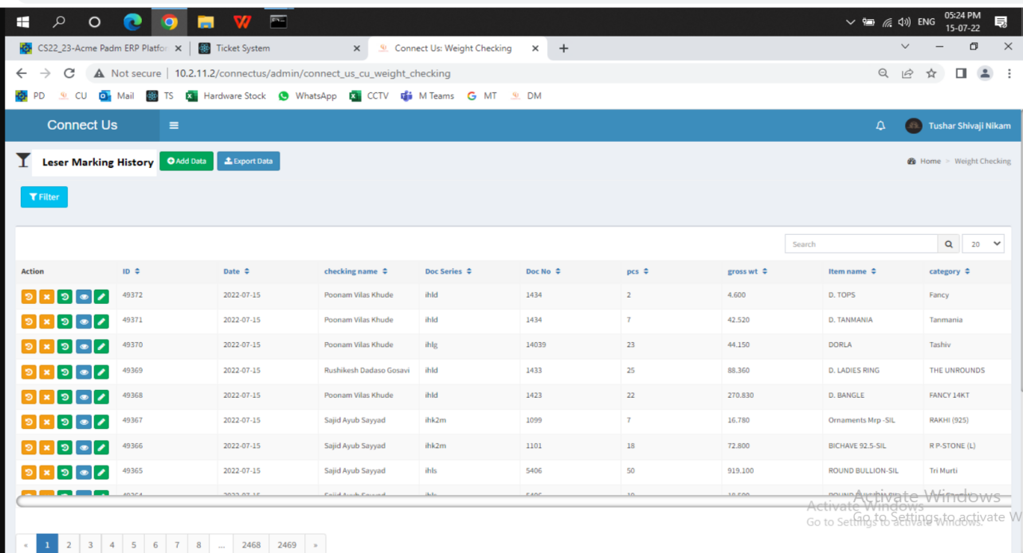

* **Add Data**

Add Data consists of the following fields:-

* Date
* Lot number
* Laser person name
* Product Group
* Remaining Pcs

|  |  |  |  |
| --- | --- | --- | --- |
| **FIELDS** | **INPUT TYPE** | **MANDATORY/ OPTIONAL** | **DESCRIPTION** |
| Date | Date | Mandatory | The Date field shows today’s date automatically. The Date field should be disabled. |
| Lot Number | Alphanumeric | Mandatory | The Lot number field will be in format of series-Doc number.  Series and Doc number need to be accessed through Stock Transfer and Labelling Voucher Gold, Silver, Diamond, MRP, Platinum document from Padm.  System should show pop-up notification as “Please enter correct Lot Number” in case of incorrect number or format. |
| Laser person name | Drop-down | Mandatory | The Laser person name field denotes the employee who will be marking the item and adding data.  Laser person name need to be selected from drop-down option.  It will have both employee ID and name of that employee.  (Like 1-Tushar Nikam  1 is employee ID of Tushar Nikam.)  The list of laser person name and its ID need to be accessed through employee masters from Connect Us. |
| Product Group | Text | Mandatory | System need to guess the product group from Padm documents and state whether it is Gold, Silver, Diamond, Platinum or MRP.  Group has been set against document and thus system should automatically specify the group accordingly.  (To know more, please refer Padm-> admin-> labeling voucher-> menu-> lineitem block configurations) |
| Remaining Pcs | Number | Mandatory | The should display remaining Pcs field means the count of Pcs which are not laser marked yet. The count of Pcs should be accessed by the system from Labelling Voucher Document.  Example- If we have total 100 Pcs in Lot number IHLG-14066 of item ring, category stone. Suppose, 60 Pcs are already laser marked by Tushar. Then whenever new person ABC enters the same Lot number IHLG-14066, ABC person should be able to see one row mentioning that 40 are remaining Pcs. Hence, he will start marking only those remaining 40 Pcs from Lot number IHLG-14066. |
| Submit | Click | Optional | Added data will get submitted once user fills details correctly and clicks submit.  Once submit should be disabled once it is clicked. |

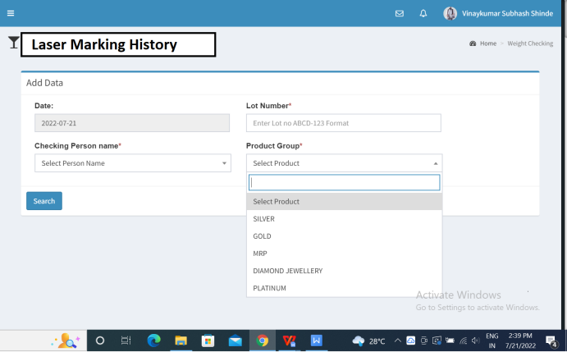

Step 2- Laser Marking Add Data

Once user adds data and clicks on submit, user will be directed to the page where below fields will be displayed:

* Sr. No.
* Date
* Doc number
* Gross wt
* Item name
* Category
* Product group
* Remaining Pcs
* Laser person name
* Marking Pcs
* Bar-code person name
* Narration
* Submit

The fields Sr. No, Date, Doc number, Gross wt, Item name, Category, Product Group, Remaining Pcs, Laser person name and Bar-code person name, these should be auto-filled by the system using documents from Padm.

|  |  |
| --- | --- |
| **FIELDS** | **DESCRIPTION** |
| Sr. No. | Sr. No should be incremental number of record. |
| Date | The Date field shows today’s date automatically. |
| Lot number | The Lot number field will be alphanumeric value in format of series-Doc number.  Series and Doc number need to be accessed through Stock transfer and Labelling Voucher Gold, Silver, Diamond, MRP, Platinum document from Padm.  System should show pop-up notification as “Please enter correct Lot Number” in case of incorrect number or format. |
| Gross wt | The field Gross wt specifies the total weight of the ornament. Gross wt should be displayed by system need to through Labeling Voucher Gold / Silver / Diamond / MRP / Platinum document from Padm. |
| Item name | The field item name should be auto-filled through Labelling Voucher Gold, Silver, Diamond, MRP, Platinum document from Padm. |
| Category | The field category should be auto-filled through Labelling Voucher Gold, Silver, Diamond, MRP, Platinum document from Padm. |
| Product Group | Product group should be automatically filled once user enters Lot number. |
| Remaining Pcs | The should display remaining Pcs field means the count of Pcs which are not laser marked yet. The count of Pcs should be accessed by the system from Labelling Voucher Document. |
| Laser Person name | The Laser person name field denotes the employee who will be marking the item and adding data.  Laser person name need to be selected from drop-down option. The list of laser person name need to be accessed through employee masters from Connect Us. |
| Marking Pcs | Marking Pcs is the difference between the number of items available for laser marking and number of Pcs mentioned in that Lot number.  User will enter this number while laser marking.  System should be designed such that if number of marking Pcs are entered more than remaining Pcs, then it should show pop-up notification as “Please enter valid value”.  System should not accept decimal values in this field. |
| Bar-code person name | Bar-code person name will be the person who is working on document. System need to access the bar-code person name from Audit trial of labelling voucher gold, silver, diamond, platinum, mrp documents and display the name on add data. |
| Narration | The narration field refers to the additional comments if any laser person wishes to mention.  The data should get submitted even if narration field is kept empty. |
| Submit | Added data will get submitted once user fills details and clicks submit.  Successfully submitted data should be displayed in Laser Marking History. |

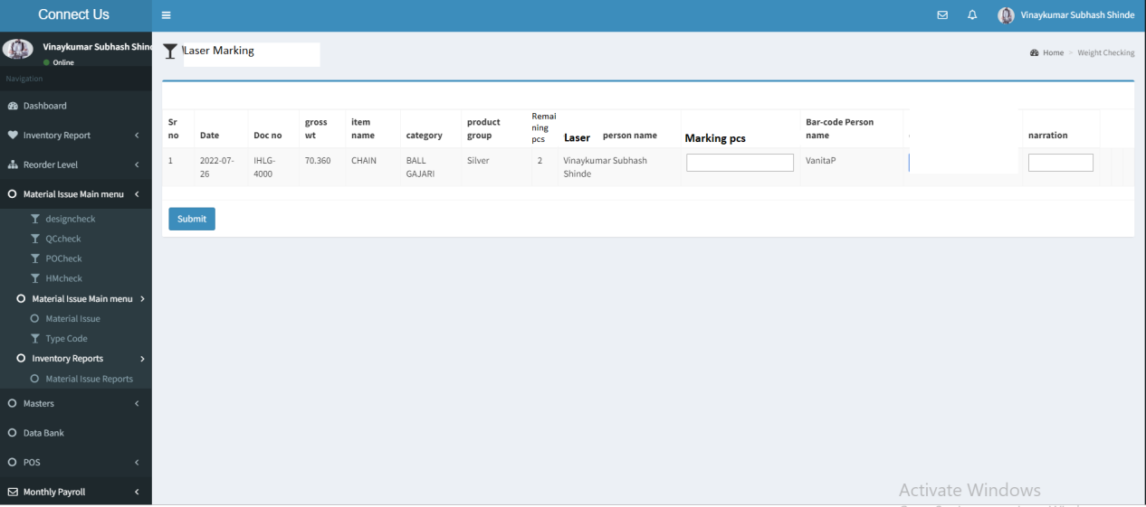

Fig: Laser Marking Add data (second step)

Only the already added data will be displayed in the List Data Laser Marking (Grid). In List Data laser Marking (Grid), following are the fields of table:

* Action
* ID
* Date
* Laser person name
* Doc series
* Doc number
* Items
* Gross wt
* Item name
* Category
* Marking Pcs
* Product Group
* Bar-code persona name
* Narration
* Is Cancel

Enable option to arrange data in ascending order for each field specified above.

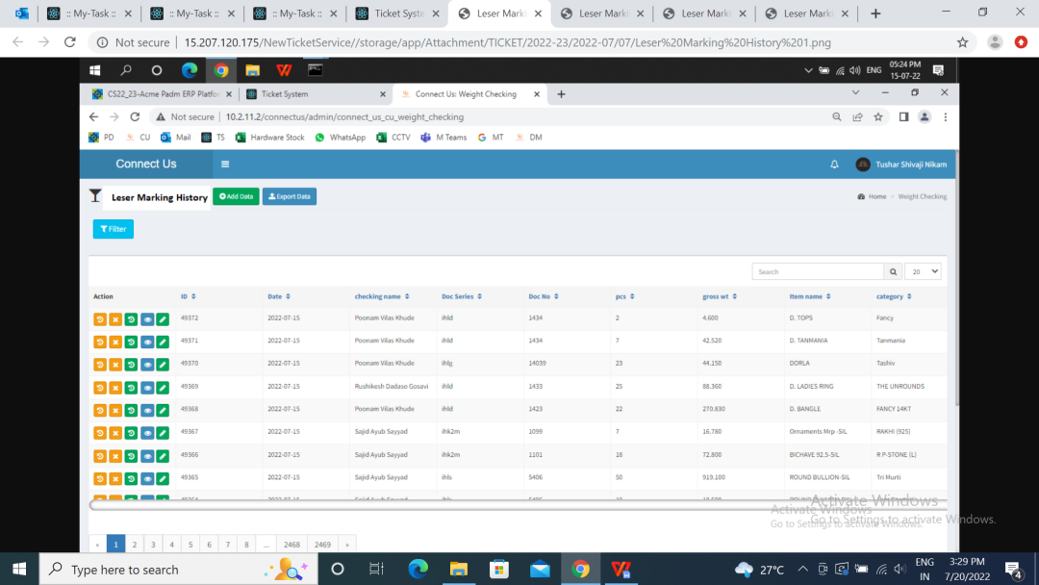

Fig: Laser making history (Refer Grid)

Action

The action field consists of the following fields:

* History
* Cancel
* Restore
* Detail
* Edit

Each data in a row of List Data Laser Marking (Grid) will individually have all of the above action fields available.

Enable Restore, Cancel and Edit actions based on authorities.

|  |  |
| --- | --- |
| **FIELDS** | **DESCRIPTION** |
| History | The history of data is displayed. It reflects when that data was added, when it was canceled, when it was restored. |
| Cancel | User can cancel the data if required.  Canceled data should be highlighted in List Data Laser Marking (Grid). Canceled data shouldn’t be displayed in Export Data report. |
| Restore | User can restore canceled data. |
| Detail | Detail Data / View Data will show the details for that particular data in a row. |
| Edit | User can edit his already added data. |

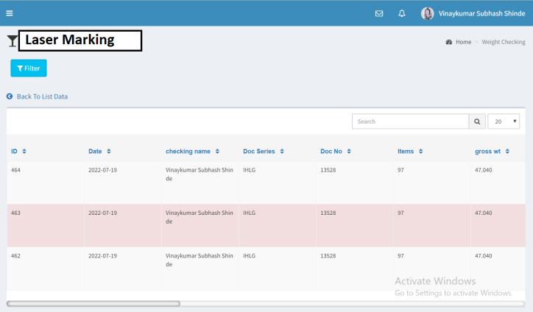

Fig: History

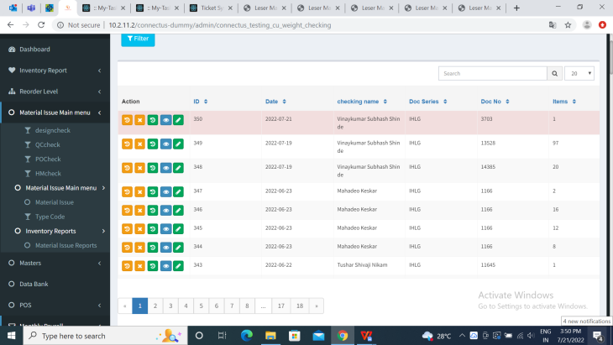

Fig: Cancel data

Detail data

Detail data / View Data action will be assigned to all the Laser marking employees.

Detail data consists of following fields:

* ID name
* Date
* Laser person name
* Lot number
* Doc number
* Pcs
* Gross wt
* Item name
* Category
* Marking Pcs
* Bar-code person name
* Narration

User can only read the details using detail data action. Once user views details, enable user with “Go back to List data Laser Marking” option at the above so as to return on Laser Marking History page.

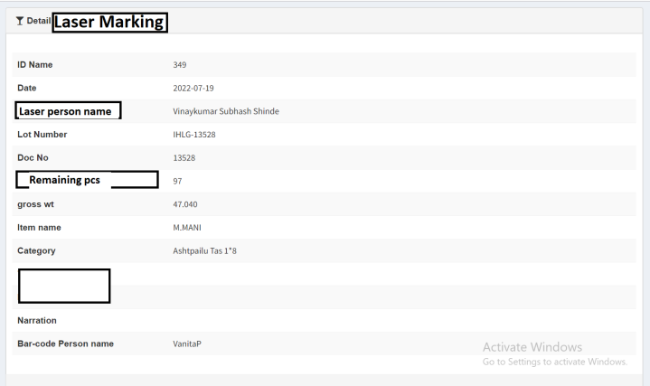

Fig: Detail Data

Edit Data

The edit data actions consists of following fields:

* ID
* Date
* Lot number
* Items
* Gross wt
* Item name
* Category
* Laser person name
* Product Group
* Marking Pcs
* Bar-code person name
* Narration

|  |  |
| --- | --- |
| **FIELDS** | **EDITABLE** |
| ID | No |
| Date | No |
| Lot Number | No |
| Gross wt | No |
| Item name | No |
| Category | No |
| Laser Person name | No |
| Product Group | No |
| Marking Pcs | Yes |
| Bar-code person name | No |
| Narration | Yes |

The Edit Date should have following options at the bottom:

* Save
* Back

|  |  |
| --- | --- |
| **FIELDS** | **DESCRIPTION** |
| Save | The Save option should save the edited details.  Once data is edited and saved, the same details should be displayed in List Data Laser Marking (Grid). |
| Back | The Back option should direct user back to the Laser Marking History main page. The recently added details by user shouldn’t get updated if user clicks Back button and didn’t click save. |

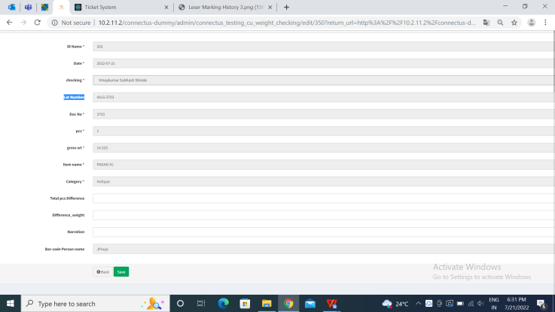

Fig: Edit Data

* **Filter Data**

The Filter Data field enables user to filer and view selective data from List Data Laser marking (Grid). User can filter the data from List Data Laser marking (Grid) by date, by Lot number, by Laser person name or by Product Group.

The Filter Data consists of following fields:

* From Date
* Till Date
* Lot number
* Laser person name
* Product Group

|  |  |
| --- | --- |
| **FIELDS** | **DESCRIPTION** |
| From Date | The From Date field enables user to select date from when he wishes to view data. |
| Till Date | Till Date field enables user to select the date till which he wishes to get data. User should enter both From Date and Till Date to get the data. In case, either From Date is selected or either Till Date is selected, the system should display pop-up notification as “Please enter valid Date”. |
| Lot Number | Lot Number is the combination of Series and Doc number. |
| Laser person name | The Laser person name field denotes the employee who has marked the item and added data. Laser person name need to be selected from drop-down option. The list of laser person name need to be accessed through employee masters from Connect Us. |
| Product Group | The product Group defines the type of the product namely Gold, Silver, Diamond, Platinum and MRP. |

Once user adds input in either of the above fields, enable user with below options:

* Filter
* Reset
* Export

|  |  |
| --- | --- |
| **FIELDS** | **DESCRIPTION** |
| Filter | The Filter allows user to get selected data. |
| Reset | The Reset allows user to rest all the fields. |
| Export | The Export action allows user to extract the desired data in PDF/XLX/CSV format. |

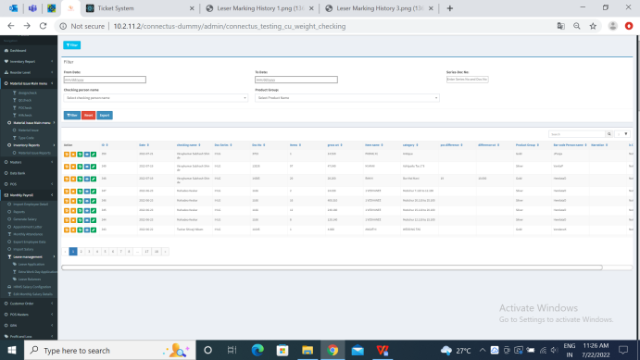

Fig: Filter Data

**User Wise Laser marking report**

User Wise Laser Marking Report is the sub-module of Laser Marking module.

User Wise Marking Report displays the details of the Pcs the selected user has laser marked. The fields in User Wise Marking Report are as follows:

* From Date
* Till Date
* Laser person name

|  |  |  |
| --- | --- | --- |
| **FIELDS** | **MANDATORY / OPTIONAL** | **DESCRIPTION** |
| From Date | Mandatory | The From Date field enables user to select date from when he wishes to view data. |
| Till Date | Mandatory | Till Date field enables user to select the date till which he wishes to get data. User should enter both From Date and Till Date to get the data. In case, either From Date is selected or either Till Date is selected, the system should display pop-up notification above as “Please enter valid Date”. |
| Laser person name | Mandatory | Laser person name need to be selected from drop-down option.  Also, enable “all” option in drop-down so that user can extract report for single laser name or else for all. |
| Total | Auto sum | The Total of Pcs should be done by the system and displayed at the bottom of the report. |

Enable user with the following options below the fields:

* Submit
* Reset
* Export

|  |  |
| --- | --- |
| **FIELDS** | **DESCRIPTION** |
| Submit | The Submit displays the data that user required.  The report of the submit should display report with following fields:   * Sr. No * Product Group * Laser Person name * Pcs |
| Reset | The Reset allows user to rest all the fields. |
| Export | The Export action allows user to extract report of the selected data in PDF/XLX/CSV format. |

Example:- Suppose ABC is laser person name and he/she has added data for 100 Pcs of Gold and 200 Pcs of Silver. One of the user wishes to export user wise laser marking report for ABC person. If user selects From Date as 01/07/2022, Till Date as 01/07/2022 and Laser person name as ABC and clicks submit, user should get data of silver and gold laser marked by ABC and its total at the end.

|  |  |  |  |
| --- | --- | --- | --- |
| **Sr. No.** | **Product Group** | **Laser person name** | **Pcs** |
| 1 | Gold | ABC | 100 |
| 2 | Silver | ABC | 200 |
| **TOTAL** |  |  | **300** |

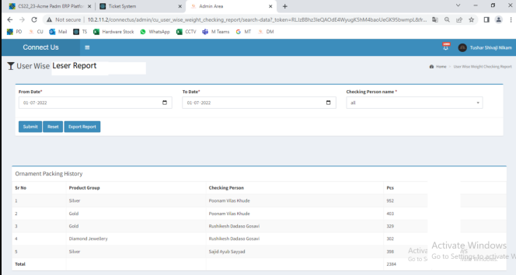

Fig: User Wise Laser Report

**References of the users**

|  |  |  |  |
| --- | --- | --- | --- |
| **User** | **Name** | **Mail** | **Contact number** |
| **Actual user** | Tushar Nikam | itinv@csjewellers.com | 2607 |
| **Ticket created by (if any)** | Tushar Nikam | itinv@csjewellers.com | 2607 |
| **Assigned business analyst** | Manali Bhadirage | Manali.bhadirage@techneai.com | 2964 |
| **Assigned developer** |  |  |  |
| **Assigned tester** | Priyanka Dupargude | Priyanka.dupargude@techneai.com | 2964 |