|  |  |
| --- | --- |
| **Ticket ID** | TT4345 |
| **Ticket description** | Padm cya customer Birthday asnarya data la Birthday che sms send zale pahije. provision karun dene. Template - Hope your special day brings you all that your heart desires! Chandukaka Saraf and Sons Pvt. Ltd. wishes you Happy birthday! Template ID - 1507160983010528998 |
| **Created by** | Vishal Patil |
| **Created on** | 19/08/2022 |
| **Priority** | Medium |
| **Version** | 1 |

**Version**

|  |  |  |  |  |
| --- | --- | --- | --- | --- |
| **Sr. No** | **Version no** | **Version Date** | **User name** | **User department** |
| 1 | 1 | 23.08.2022 | Vishal Patil | Operations Team |

**Approvals**

|  |  |  |
| --- | --- | --- |
| **Field** | **Name of the User** | **Approved date by the user** |
| **Actual User Name** | Vishal Patil | 19/08/2022 |
| **Actual User Department** | |  | | --- | | Operations Team | |  |
| **Organization Name** | C S Jewellers |  |
| **Sign-off** |  |  |
| **Assigned BA** | Mounika KrishnaVeni Annamneedi | 23.08.2022 |
| **Assigned Developer** | Nikhil Bhosale |  |
| **Assigned Tester** | Sayali V |  |

**Estimation**

|  |  |  |  |  |
| --- | --- | --- | --- | --- |
| **Department name** | **Estimated Time (In hr)** | **Scheduled Date (Starting date )** | **Estimated date** | **Actual delivery date** |
| **BA** | 3 | 23.08.2022 | 23.08.2022 |  |

**Business requirement**

To send an SMS to customers on their birthday based on Padm or Connect Us data.

**Existing system**

In the existing system, there is a provision earlier but had removed.

**Proposed system**

To implement the SMS provision - Sending the SMS to customers on their birthday.

Step - 1

In connect us - Report - Birthday report

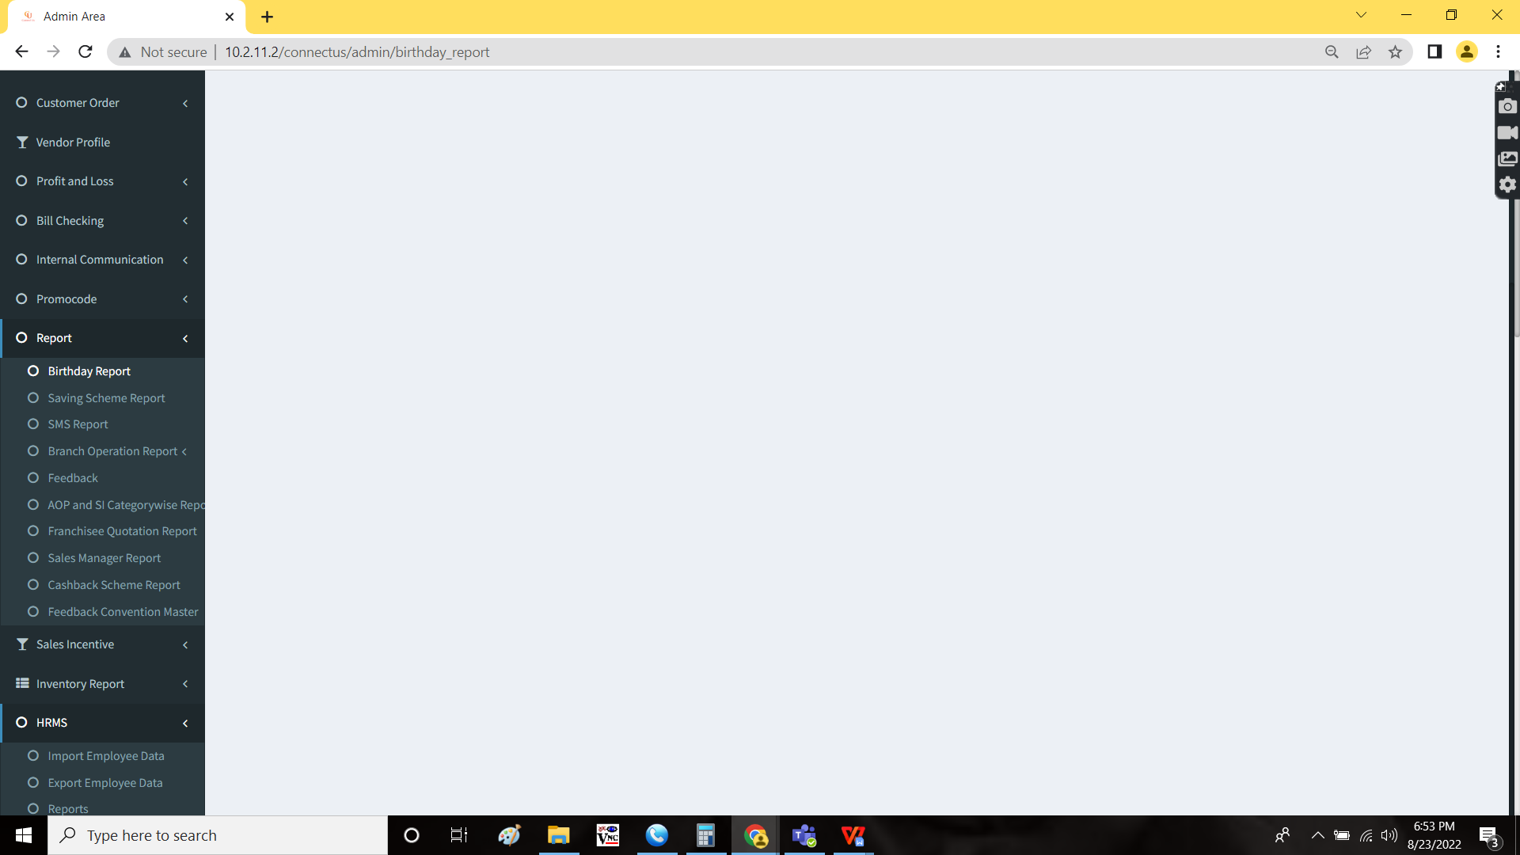

The birthday report of the customers is available. The customers have to receive the SMS wishing them on their birthday at 9AM on the respective day.

Template ID : 1507160983010528998

Text : Hope your special day brings you all that your heart desires! Chandukaka Saraf and Sons Pvt. Ltd. wishes you Happy birthday!

**References of the users**

|  |  |  |  |
| --- | --- | --- | --- |
| **User** | **Name** | **Mail** | **Contact number** |
| **Actual user** | Vishal Patil | HOBCS@csjewellers.com |  |
| **Assigned business analyst** | Mounika KrishnaVeni Annamneedi | Mounika.annamneedi@techneai.com | 9885900039 |