|  |  |
| --- | --- |
| **Ticket ID** | TT4380 |
| **Ticket description** | Ticketing system - restructuring (Tabs) |
| **Created by** |  |
| **Created on** | 23/08/2022 |
| **Priority** | High |
| **Version** | 1.0 |

**Version**

|  |  |  |  |  |
| --- | --- | --- | --- | --- |
| **Sr. No** | **Version no** | **Version Date** | **User name** | **User department** |
| **01** | **1.0** | **22/08/2022** |  |  |
|  |  |  |  |  |
|  |  |  |  |  |

**Approvals**

|  |  |  |
| --- | --- | --- |
| **Field** | **Name of the User** | **Approved date by the user** |
| **Actual User Name** |  |  |
| **Actual User Department** |  |  |
| **Organization Name** |  |  |
| **Assigned BA** |  |  |
| **Assigned Developer** |  |  |
| **Assigned Tester** |  |  |

**Estimation**

|  |  |  |  |  |
| --- | --- | --- | --- | --- |
| **Department name** | **Estimated Time (In hr)** | **Scheduled Date (Starting date )** | **Estimated date** | **Actual delivery date** |
| **BA** |  |  |  |  |
| **Development** |  |  |  |  |
| **Testing** |  |  |  |  |
|  |  |  |  |  |

**Introduction**

In Ticketing system, user can add tasks under the ticket and manage their tasks accordingly.

**Proposed system**

In TechTicket -> Ticket -> My tickets, following input fields will be displayed:

* Ticket ID
* Select User
* Select Department
* Select Status

|  |  |  |
| --- | --- | --- |
| **FIELDS** | **INPUT TYPE** | **DESCRIPTION** |
| Ticket ID | Alphanumeric | Each created ticket has unique Ticket ID.  Once the user enters the desired ticket ID in this field and clicks on search, all the ticket details will be displayed in the grid below. |
| Select User | Select from drop-down | User can search the tickets and its details by selecting user in this field.  Once the user (to whom the ticket is assigned to) is entered in this field, all the tickets & its details assigned to that user will be displayed in the grid below. |
| Select Department | Select from drop-down | User can search the tickets assigned to department. Once user selects the particular department in this field and clicks on search, all the tickets assigned to that department will be displayed in the grid below. |
| Select Status | Select from drop-down | User can search the ticket by its status and get its details. Till date, we have following list of statuses:   * Confirmation * FRS sign off * Documentation pending * Work * Test * Forwarded to testing * Forwarded to development * Work InProcess * Forwarded to ACME * Pending * Complete * Solved * In progress * Unsolved |

Further, below input fields we have search button and reset button.

|  |  |  |
| --- | --- | --- |
| **FIELDS** | **INPUT TYPE** | **DESCRIPTION** |
| Search | Click | Once the user enters details in any of the input box and clicks on search button, it should display the desired result in the grid below.  Once clicked on search button, following tabs will be displayed above grid:   * Search Result * Assigned to me * Created by me * Department-wise tickets * Your task * Unpassed tickets * Confirmation   And, user will be directed to “Search Result” tab and searched ticket details will be displayed here. |
| Reset | Click | Reset button once clicked should clear all the fields if anything is entered in input boxes.  Once clicked on reset button, following tabs will be displayed:   * Assigned to me * Created by me * Department-wise tickets * Your task * Unpassed tickets * Confirmation   Once clicked on reset button, user should be directed to “Assigned to me” tab and display all the ticket details assigned to user. |

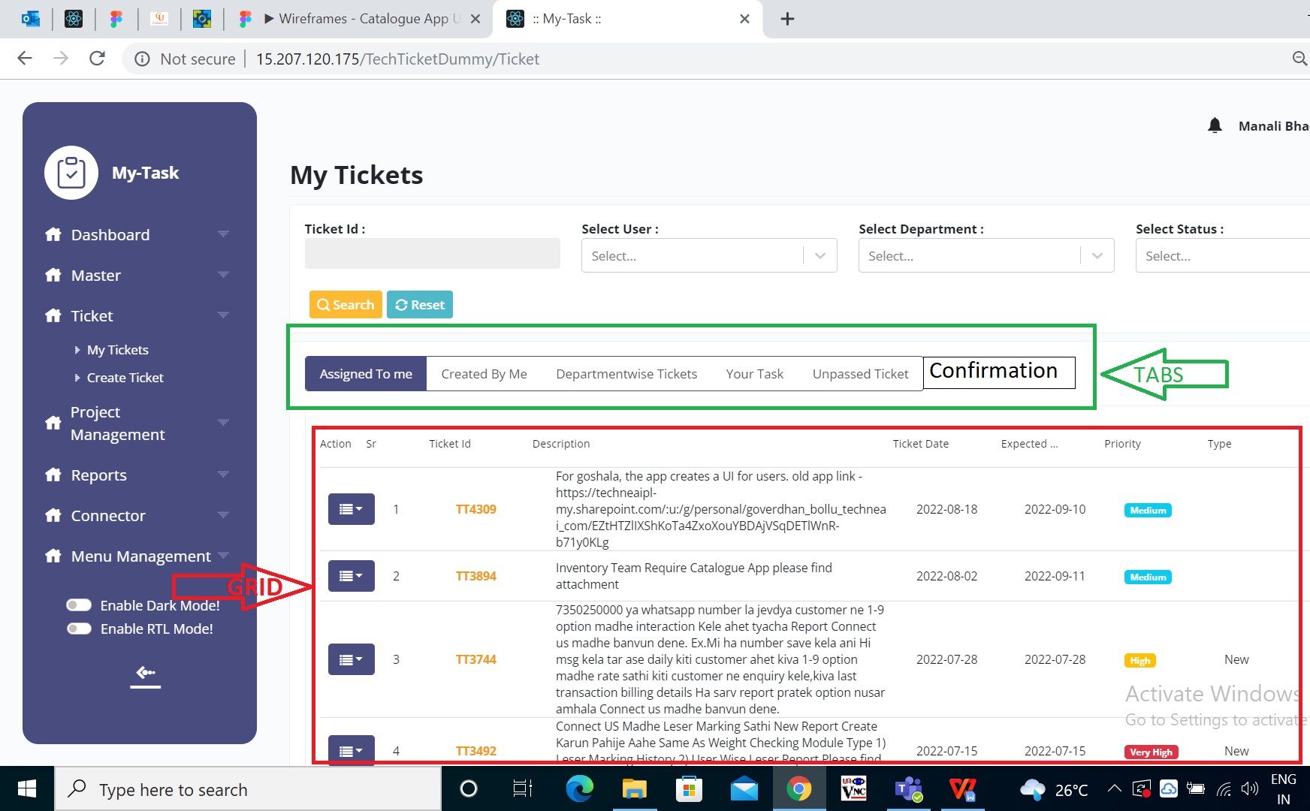

Fig: Tabs and Grid

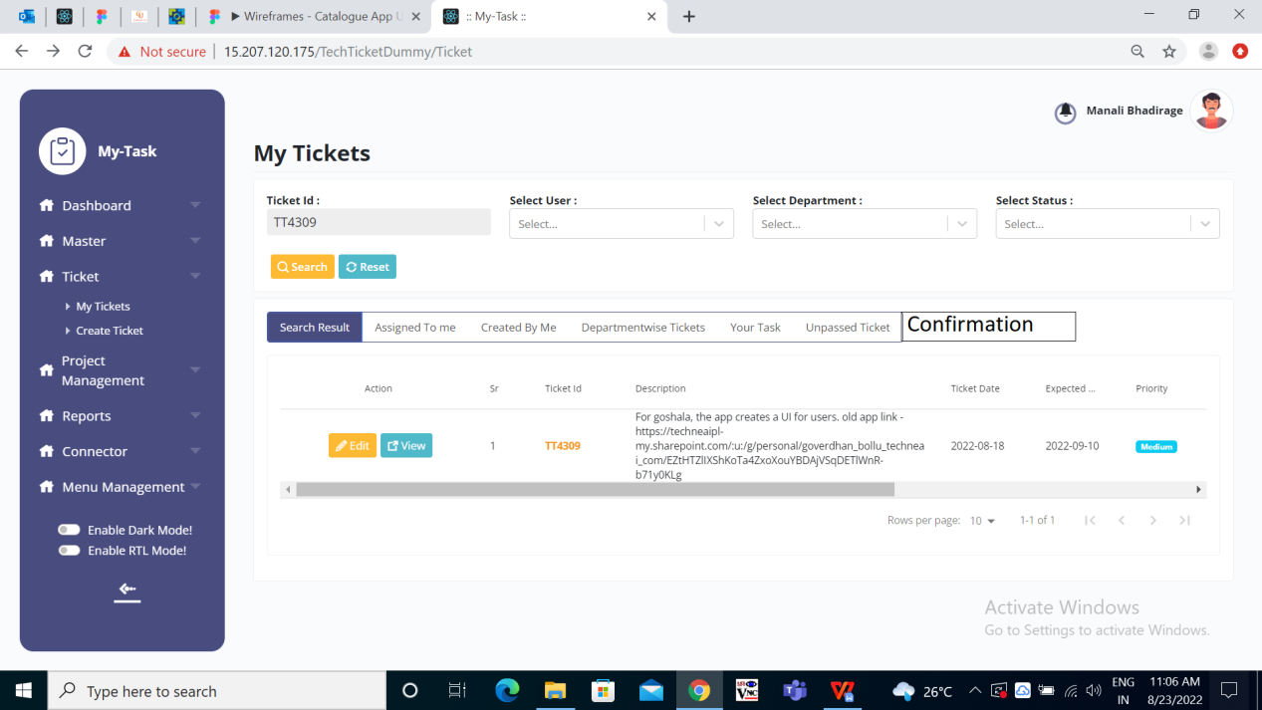

Fig: Search Result Tab

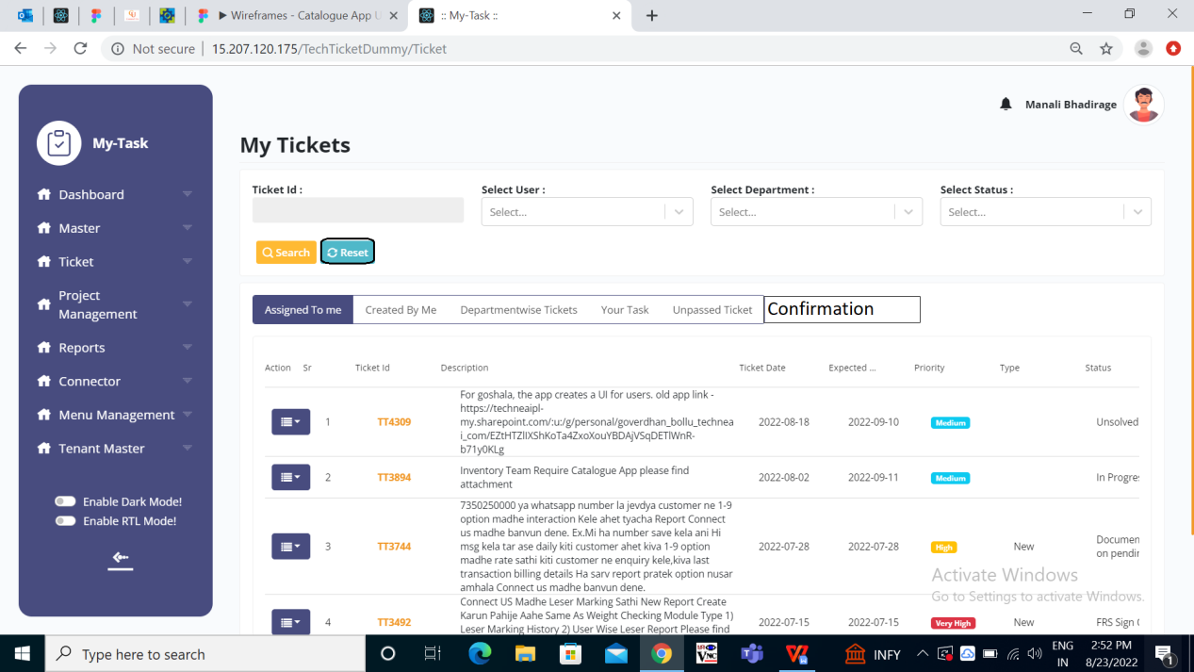

Fig: Reset & its tabs

Grid should display the following details of each ticket:

* Action :

This field consists of three actions namely Edit, View and Task. Edit action is displayed & enabled only to the user who is the owner of the ticket owner.

* Sr :

The serial number should be displayed in incremental order to each row of ticket.

* Ticket Id :

Once ticket is created, each ticket gets unique ticket ID.

* Description :

Description of the ticket which user has mentioned while creating the ticket, it will be displayed here.

* Ticket Date :

The date on which the ticket was created will be displayed here.

* Expected Date :

The date on which the user expects to get the ticket resolved is displayed here.

* Priority :

The priority of the ticket is set Very High / High / Medium / Low while creating the ticket and is displayed here accordingly.

* Type :

The type of the ticket will be New whenever new ticket is created by user.

* Status :

The status of the ticket is displayed here which can be Confirmation / FRS sign off / Documentation pending / Work / Test / Forwarded to testing / Forwarded to development / Work InProcess / Forwarded to ACME / Pending / Complete / Solved/ In progress / Unsolved.

* Assign To Team :

The department to whom the ticket is assigned to will be displayed here.

* Assigned To :

The user to whom the ticket is assigned to is referred as ticket owner.

* Created By :

The user who has created the ticket is referred as ticket creator.

On main page of My Tickets, following tabs are displayed above grid:

* Assigned to me
* Created by me
* Department-wise tickets
* Your task
* Unpassed tickets

|  |  |
| --- | --- |
| **FIELDS** | **DESCRIPTION** |
| Assigned to me | “Assigned to me” tab displays all the tickets in the grid assigned to the user.  As the user clicks on Tech Ticket -> Tickets -> My Tickets, the main page will display the ticket and details of “Assigned to me” tab. |
| Created by me | The person who has created the ticket will be referred as Ticket creator.  All the tickets created by the user will be displayed under “Created by me” tab. |
| Department-wise tickets | All the tickets of the department that user belongs to will be displayed under “Department-wise Tickets”.  Example: If user Manali belongs to IT Implementation department, then all the tickets of IT implementation department will be displayed to the user under “Department-wise Tickets” tab.  You can see assigned department of user from Masters -> User Master -> Edit action -> Departments tab. |
| Your task | Tickets which may / may not be assigned to you but includes basket or its task assigned to you, those tickets will be displayed under “Your Task” tab.  Example: TT0000 is created by person A and is assigned to person B. Here, if this ticket has one of the task for person C, then this ticket will be displayed to person C under “Your task” tab. |
| Unpassed tickets | Ticket once created by user will be submitted to Department head. The department head has the authority to pass / unpass the ticket.  The department head checks whether the same ticket is already created or not, checks whether the newly created ticket is required or not and then passes or unpasses it accordingly.  Department head is given authority to pass/ unpass tickets from Master -> User Master -> Edit action -> Departments tab -> Tick or untick button under ‘Ticket passing authority’ -> Update.  Under “Unpassed tickets”, department head has three options in action field namely View, Pass and Unpass.  If the department head passes the ticket, it will be displayed in “assigned to me” tab of user to whom the ticket is assigned to.  If the ticket isn’t passed by the department head, it will be displayed in “created by me” and “unpassed tickets” tabs of the user who created the ticket.  Users who don’t have authority to pass / unpass tickets, they won’t have action field in “Unpassed tickets” tab. Only the ticket details will be displayed to them. |
| Confirmation | Ticket once marked as resolved will be submitted to the department head for confirmation. Department head has the authority to confirm / reject the ticket.  Department head is given authority to confirm / reject tickets from Master -> User Master -> Edit action -> Departments tab -> yes or no under ‘confirmation authority’ -> Update.  Under confirmation tab, department head has three options in action field namely View, Confirm and Reject.  If the department head confirms the ticket, it will be dissolved from user’s grid. Ticket will not appear in any of the tabs once marked as confirmed.  If the ticket is rejected by the department head, it will be displayed to the user in “confirmation” tab with status as ‘rejected’. |

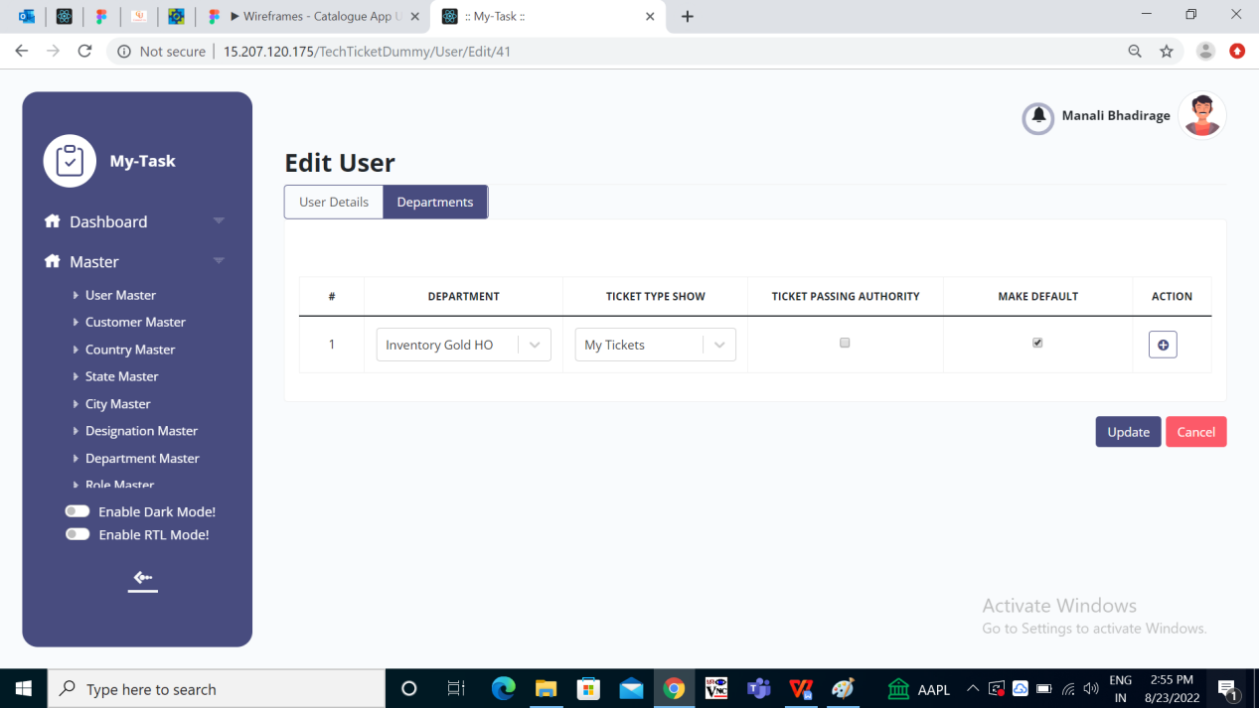

Fig: Master -> User Mater -> Edit -> Departments -> Ticket passing authority.

**References of the users**

|  |  |  |  |
| --- | --- | --- | --- |
| **User** | **Name** | **Mail** | **Contact number** |
| **Actual user** |  |  |  |
| **Ticket created by (if any)** |  |  |  |
| **Assigned business analyst** |  |  |  |
| **Assigned developer** |  |  |  |
| **Assigned tester** |  |  |  |