|  |  |
| --- | --- |
| **Ticket ID** | TT3744 |
| **Ticket description** | 7350250000 ya whatsapp number la jevdya customer ne 1-9 option madhe interaction Kele ahet tyacha Report Connect us madhe banvun dene. Ex.Mi ha number save kela ani Hi msg kela tar ase daily kiti customer ahet kiva 1-9 option madhe rate sathi kiti customer ne enquiry kele,kiva last transaction billing details Ha sarv report pratek option nusar amhala Connect us madhe banvun dene. |
| **Created by** | Manali Bhadirage |
| **Created on** | 04/08/2022 |
| **Priority** | High |
| **Version** | 1.0 |

**Version**

|  |  |  |  |  |
| --- | --- | --- | --- | --- |
| **Sr. No** | **Version no** | **Version Date** | **User name** | **User department** |
| 01 | 1.0 | 04/08/2022 | Reshma Sayyad |  |
|  |  |  |  |  |
|  |  |  |  |  |

**Approvals**

|  |  |  |
| --- | --- | --- |
| **Field** | **Name of the User** | **Approved date by the user** |
| **Actual User Name** | Reshma Sayyad |  |
| **Actual User Department** |  |  |
| **Organization Name** | CS Jewellers |  |
| **Assigned BA** | Manali Bhadirage |  |
| **Assigned Developer** |  |  |
| **Assigned Tester** | Priyanka Dupargude |  |

**Estimation**

|  |  |  |  |  |
| --- | --- | --- | --- | --- |
| **Department name** | **Estimated Time (In hr)** | **Scheduled Date (Starting date )** | **Estimated date** | **Actual delivery date** |
| **BA** |  |  |  |  |
| **Development** |  |  |  |  |
| **Testing** |  |  |  |  |
|  |  |  |  |  |

**Introduction**

Customers enquire on Whatsapp number 7350250000 where they enter the number of the query and get the information.

1. Last Transaction

2.Current Rate

3. Latest E-catalogue

4. Download mobile app

5. Change Language

6. Theme/Offer

7. Monthly Scheme

8. Store Location

9. Toll Free

**Business requirement**

7350250000 ya whatsapp number la jevdya customer ne 1-9 option madhe interaction Kele ahet tyacha Report Connect us madhe banvun dene. Ex.Mi ha number save kela ani Hi msg kela tar ase daily kiti customer ahet kiva 1-9 option madhe rate sathi kiti customer ne enquiry kele,kiva last transaction billing details Ha sarv report pratek option nusar amhala Connect us madhe banvun dene.

**Abbreviations & terms**

Enter all the abbreviations used in the document.

**Existing system**

There is no such existing system.

**Proposed system**

Step 1

Create WhatsApp Query Report in Connect Us.

Report page should have following fields:

* From Date
* To Date
* Query Name
* Filter
* Reset
* Export
* WhatsApp Query Report (Grid)

**Input table**

|  |  |  |  |
| --- | --- | --- | --- |
| **FIELDS** | **INPUT TYPE** | **MANDATORY/ OPTIONAL** | **DESCRIPTION** |
| From Date | Date | Mandatory | Date from which user wish to extract data, should be selected. |
| To Date | Date | Mandatory | Date till which user wish to get data, should be selected.  To Date should can be selected same as From date or above. |
| Query Menu | Select | Mandatory | Query Menu will display the drop-down. It will have following list:  All  1-Last Transaction  2-Current Rate  3-Latest E-catalogue  4-Download mobile app  5-Change Language  6-Theme/Offer  7-Monthly Scheme  8-Store Location  9-Toll Free  Multi select should be enabled. |
| Filter | Click |  | After entering mandatory input fields, filter button should display desired correct data in grid once clicked. |
| Reset | Click |  | Reset button once clicked should reset the input field values if entered any. |
| Export | Click |  | Export button should extract report in XLX sheet.  It should have following fields:   * Sr. No. * Date * Mobile Number * Customer Name * Query Number * Query Name |

WhatsApp Query Report (Grid)

WhatsApp Grid should display report query wise. Following are the fields:

* Query Number
* Query Name
* Total

|  |  |
| --- | --- |
| **FIELDS** | **DESCRIPTION** |
| Query Number | Query Number of query name should be displayed. |
| Query Name | Query Name should be displayed as selected in input fields. |
| Total | Total of that particular query name should be displayed. |

Once clicked on the maximize button near Query Name, it should display following fields:

* Sr. No.
* Date
* Mobile Number
* Customer Name
* Query Number
* Query Name

|  |  |
| --- | --- |
| **FIELDS** | **DESCRIPTION** |
| Sr. No. | Sr. No. should be displayed in auto-incremental manner. |
| Date | Date on which customer inquired via WhatsApp should be displayed. |
| Mobile Number | Customer’s mobile number through which query is inquired should be displayed. |
| Customer Number | Customer name on WhatsApp number should be displayed. |
| Query Number | Query Number by which customer inquired should be displayed. |
| Query Name | Query Name which relates to the query number should be displayed. |

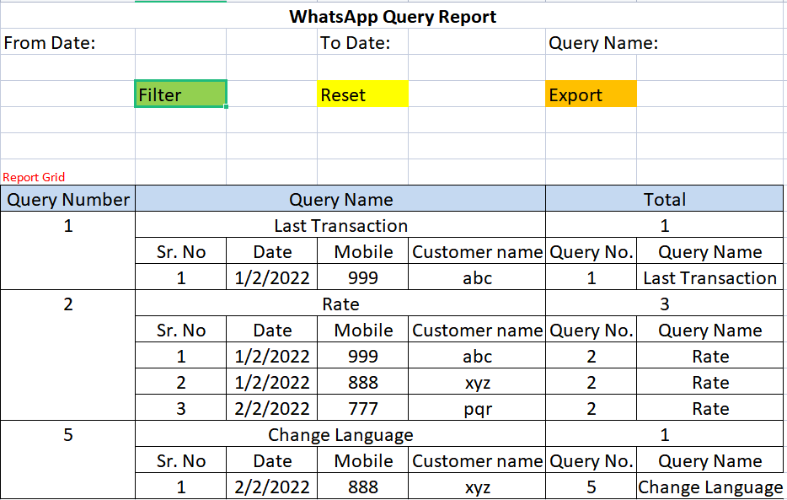

Excel report should be as follows:

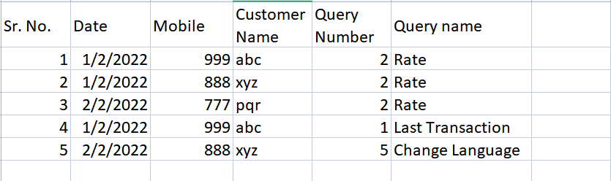

**References of the users**

|  |  |  |  |
| --- | --- | --- | --- |
| **User** | **Name** | **Mail** | **Contact number** |
| **Actual user** | Reshma Sayyad | hobdd@csjewellers.com | 2599 |
| **Ticket created by (if any)** | Reshma Sayyad | hobdd@csjewellers.com | 2599 |
| **Assigned business analyst** | Manali Bhadirage | manali.bhadirage@techneai.com | 2964 |
| **Assigned developer** |  |  |  |
| **Assigned tester** | Priyanka Dupargude | Priyanka.dupargude@techneai.com | 2964 |