**CITY MASTER**

The city master consists of all the city details which is easy to access the data. The following are the fields in city master.

* Search
* Reset
* Add City
* Sr
* City
* State
* Country
* Status
* Updated by
* Updated at
* Action

|  |  |
| --- | --- |
| Field | Description |
| Search bar | To search the fields |
| Reset button | To refresh the search bar |
| Add City button | To add a new city in the master |
| Sr | The serial count is displayed |
| City | The list of cities are displayed |
| State | The state in which the city is there is displayed |
| Country | The countries in which the state is there is displayed |
| Status | Whether the city is active or not is displayed |
| Updated by | Last updated by is mentioned |
| Updated at | The time on which it is updated last is displayed |
| Action | The action field consists of the edit button to edit the existing city |

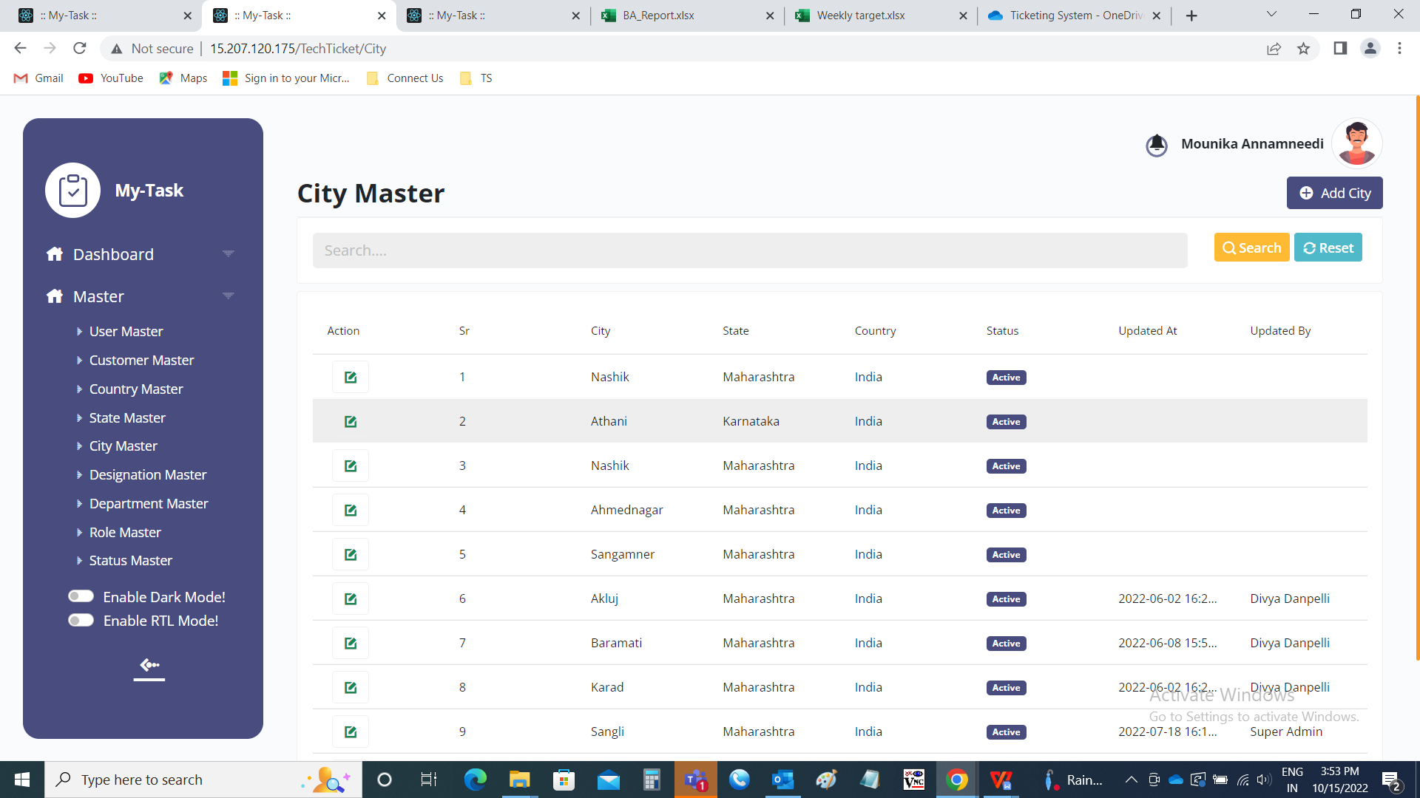

Add data:

The add page consists of the following fields.

* Country
* State
* City
* Remark
* Status
* Add
* Cancel

|  |  |  |  |
| --- | --- | --- | --- |
| **FIELDS** | **INPUT TYPE** | **MANDATORY/ OPTIONAL** | **DESCRIPTION** |
| Country | Drop down | Mandatory | The country to which the city is belonged is selected. The country is selected from the drop down options. The drop down options are fetched from the country master (in Ticketing system >> Masters >> Country Master). |
| State | Drop down | Mandatory | The state to which the city is belonged is selected. Based on the country selected, the states against that country are displayed. The drop down options are fetched from the state master (in Ticketing system >> Masters >> State Master). |
| City | Text | Mandatory | The city name is entered. |
| Remark | Text | optional | The remark if any is mentioned |
| Select status | Radio button | Mandatory | The radio button consists of active and de-active. By default, active is selected.  Active is selected if the city is active or else deactive is selected. |
| Add | Button | Optional | To create the city |
| cancel | Button | Optional | To navigate to the city master main page |

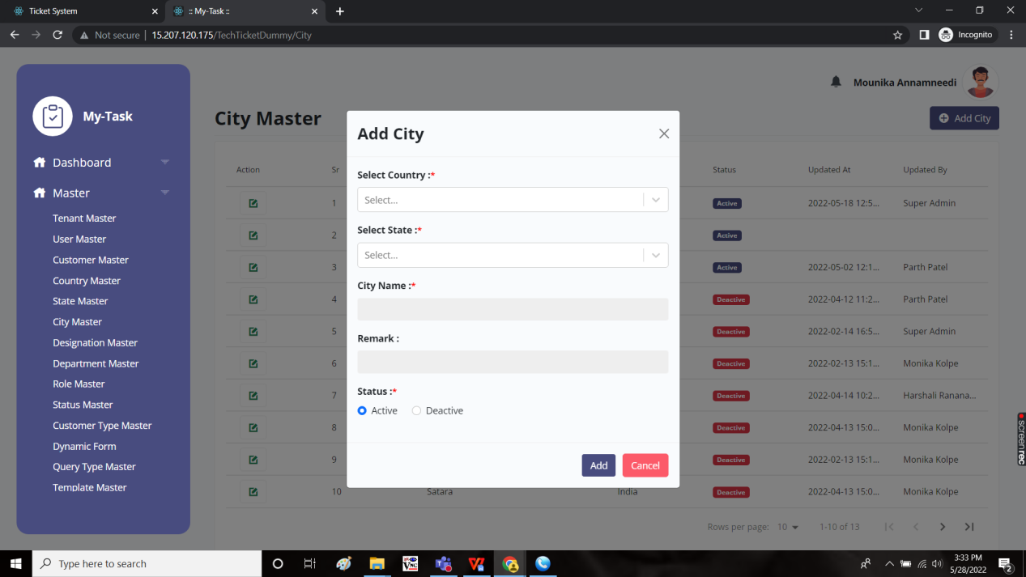

Edit page:

The edit page consists of the following and all fields can be edited if required.

* Country
* State
* City
* Remark
* Status
* Update
* Cancel

