**DEPARTMENT MASTER**

The department master refers to various departments in the organization which helps in easy access of the data. The following are the fields in department master.

* Search
* Reset
* Add Department
* Sr
* Department
* Status
* Updated by
* Updated at
* Action

|  |  |
| --- | --- |
| Field | Description |
| Search bar | To search the fields |
| Reser Button | To refresh the search bar |
| Add Department button | To add a new department in the master |
| Sr | The serial count is displayed |
| Designation | The list of departments are displayed |
| Status | Whether the department is active or not is displayed |
| Remark | Remark if any is displayed |
| Updated by | Last updated by is mentioned |
| Updated at | The time on which it is updated last is displayed |
| Action | The action field consists of the edit button to edit the existing department |

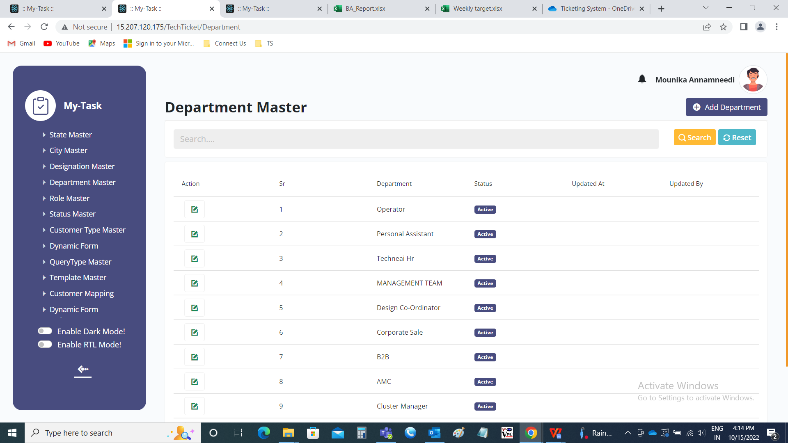

Add data:

The add page consists of the following fields.

* Department
* Remark
* Status
* Add
* Cancel

|  |  |  |  |
| --- | --- | --- | --- |
| **FIELDS** | **INPUT TYPE** | **MANDATORY/ OPTIONAL** | **DESCRIPTION** |
| Department | Text | Mandatory | The department name is entered. |
| Remark | Text | optional | The remark if any is mentioned |
| Select status | Radio button | Mandatory | The radio button consists of active and de-active. By default, active is displayed. Active is selected if the department is active or else deactive is selected. |
| Add | Button | Optional | To create the department |
| cancel | Button | Optional | To navigate to the department master page |

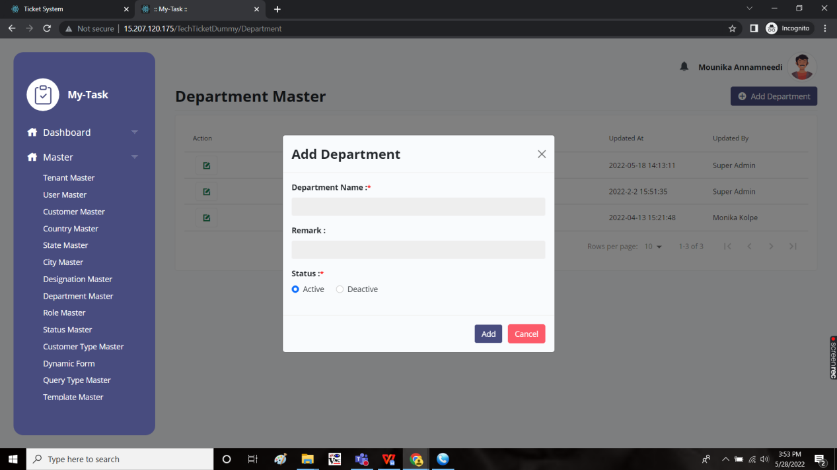

Edit page:

The edit page consists of the following and all fields can be edited if required.

* Department
* Remark
* Status
* Update
* cancel

