**DYNAMIC FORM**

The dynamic form of consists of fields to be created or applied on tickets based on query type. The following are the fields in query type master.

* Search
* Reset
* Add Form
* Sr
* Form Name
* Status
* Updated by
* Updated at
* Action

|  |  |
| --- | --- |
| Field | Description |
| Search bar | To search the fields |
| Reset Button | To refresh the search bar |
| Add Form button | To add a new form in the master |
| Sr | The serial count is displayed |
| Form name | The form name is displayed |
| Status | Whether the form is active or not is displayed |
| Updated by | Last updated by is mentioned |
| Updated at | The time on which it is updated last is displayed |
| Action | The action field consists of the edit button to edit the existing form name |

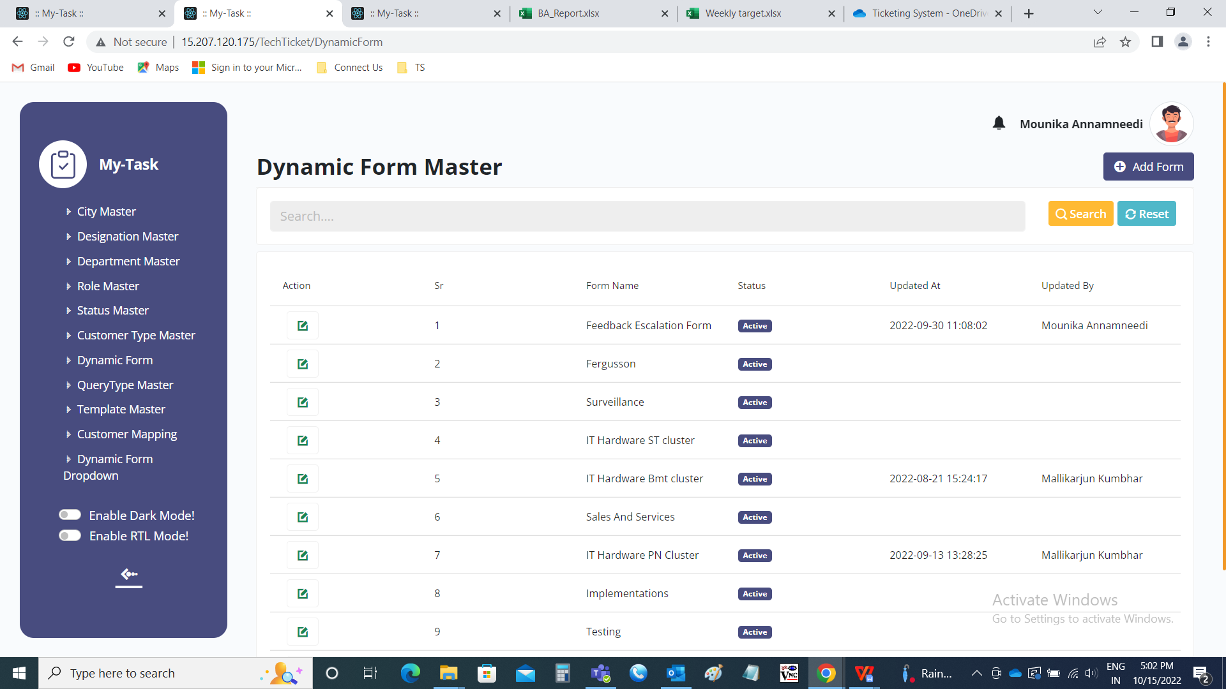

Add page:

The following are the fields in add page.

* Form name
* Sr
* Type
* Label
* Def value
* Add ons
* Action
* View form
* Submit
* cancel

|  |  |  |  |
| --- | --- | --- | --- |
| **FIELDS** | **INPUT TYPE** | **MANDATORY/ OPTIONAL** | **DESCRIPTION** |
| Form name | Text | Mandatory | The form name is mentioned |
| Sr | In-built | Optional | The serial count |
| Type | Drop down | Mandatory | The type of field is selected from drop down. The following are the fields in the drop down.   * Text - for small texts * Text area - for paragraphs * Number - for numbers * Date - for calender * Date time - for both date and time * Time - for time * Select - drop down from drop down master * Select master - drop down from existing masters |
| Label | Text | Optional | The label name if any is to be entered |
| Def value | Text | Optional | The def value refers to default value. The default value is used when we require any default value in that field. |
| Add ons | Drop down, calender, int | Optional | Based on the type, the add on’s are shown.   * Number - min to max required is entered * Date - the min date to max date required is entered * Time - the min time to max time required is entered * Select - the drop down names are shown which are fetched from the drop down masters (in Ticketing system >> Masters >> Drop down masters) * Select master - the drop down options are fetched from the existing masters (user, department, role). |
| Action | Button | Optional | The action button to add one more field. |
| View form | Button | Optional | The view form button is used to preview the form. When the form is edited, the when we click on “view form”, the form is previewed. To hide it again, “hide form” is selected, so that the form is hidden. |
| Submit | Button | Optional | The submit form is used to submit the data. |
| Cancel | Button | Optional | The cancel button is used to cancel the data. |

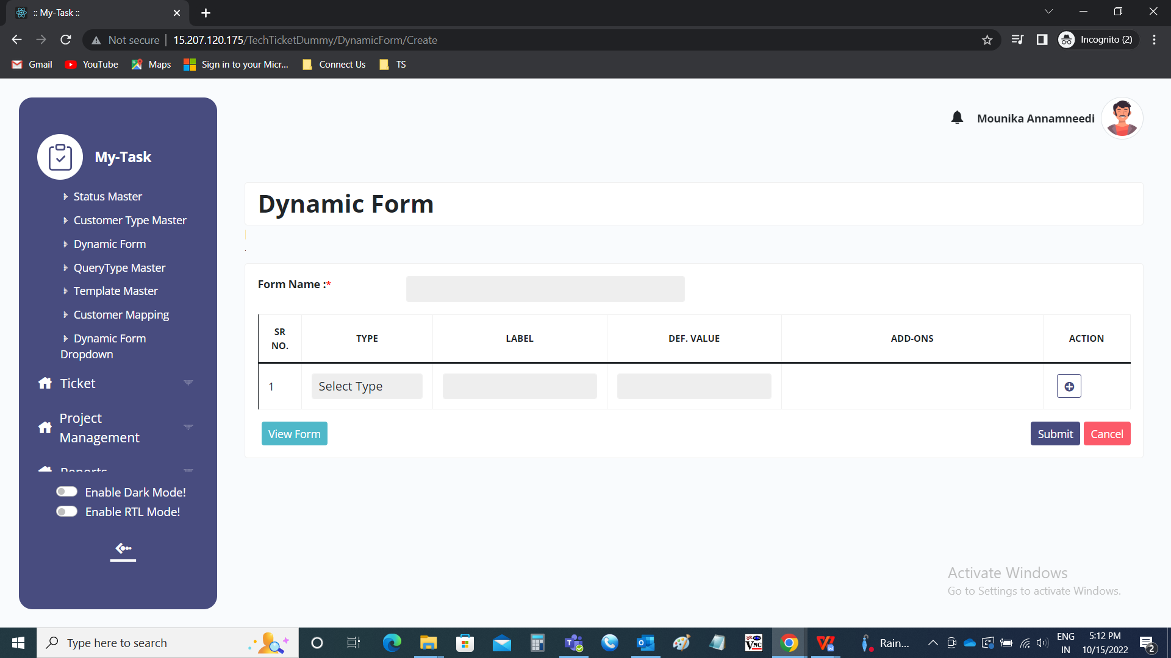

Form view:

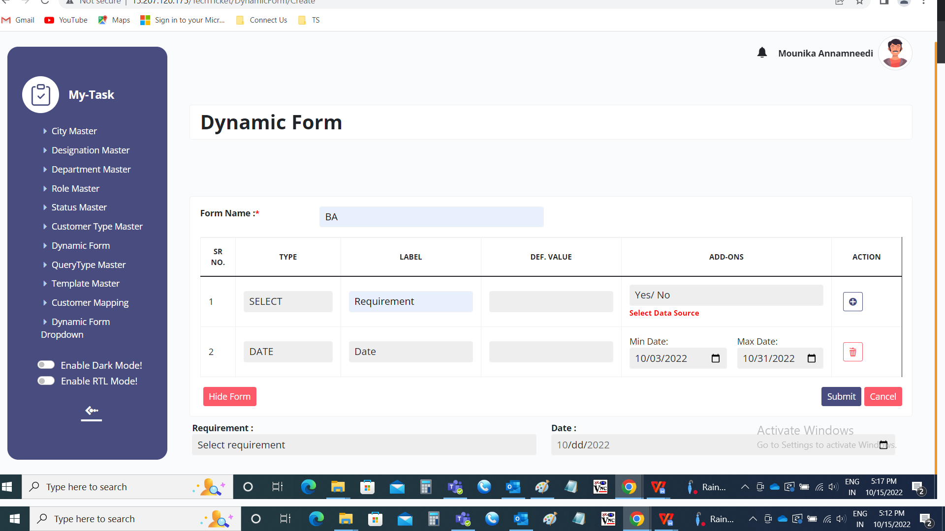

Edit data:

The edit data button is used to edit the data. The following are the fields in the edit page and all the fields can be edited.

* Form name
* Remark
* Status
* Sr no
* Type
* Label
* Def value
* Add ons
* Action
* View form
* Submit
* Cancel

