**ROLE MASTER**

The role master consists of all the roles available in the organization which helps in easy access of the data. The following are the fields in role master.

* Search
* Reset
* Add Role
* Sr
* Role
* Status
* Updated by
* Updated at
* Action

|  |  |
| --- | --- |
| Field | Description |
| Search bar | To search the fields |
| Reset bar | To refresh the search bar |
| Add Role button | To add a new role in the master |
| Sr | The serial count is displayed |
| Designation | The list of roles are displayed |
| Status | Whether the role is active or not is displayed |
| Updated by | Last updated by is mentioned |
| Updated at | The time on which it is updated last is displayed |
| Action | The action field consists of the edit button to edit the existing role |

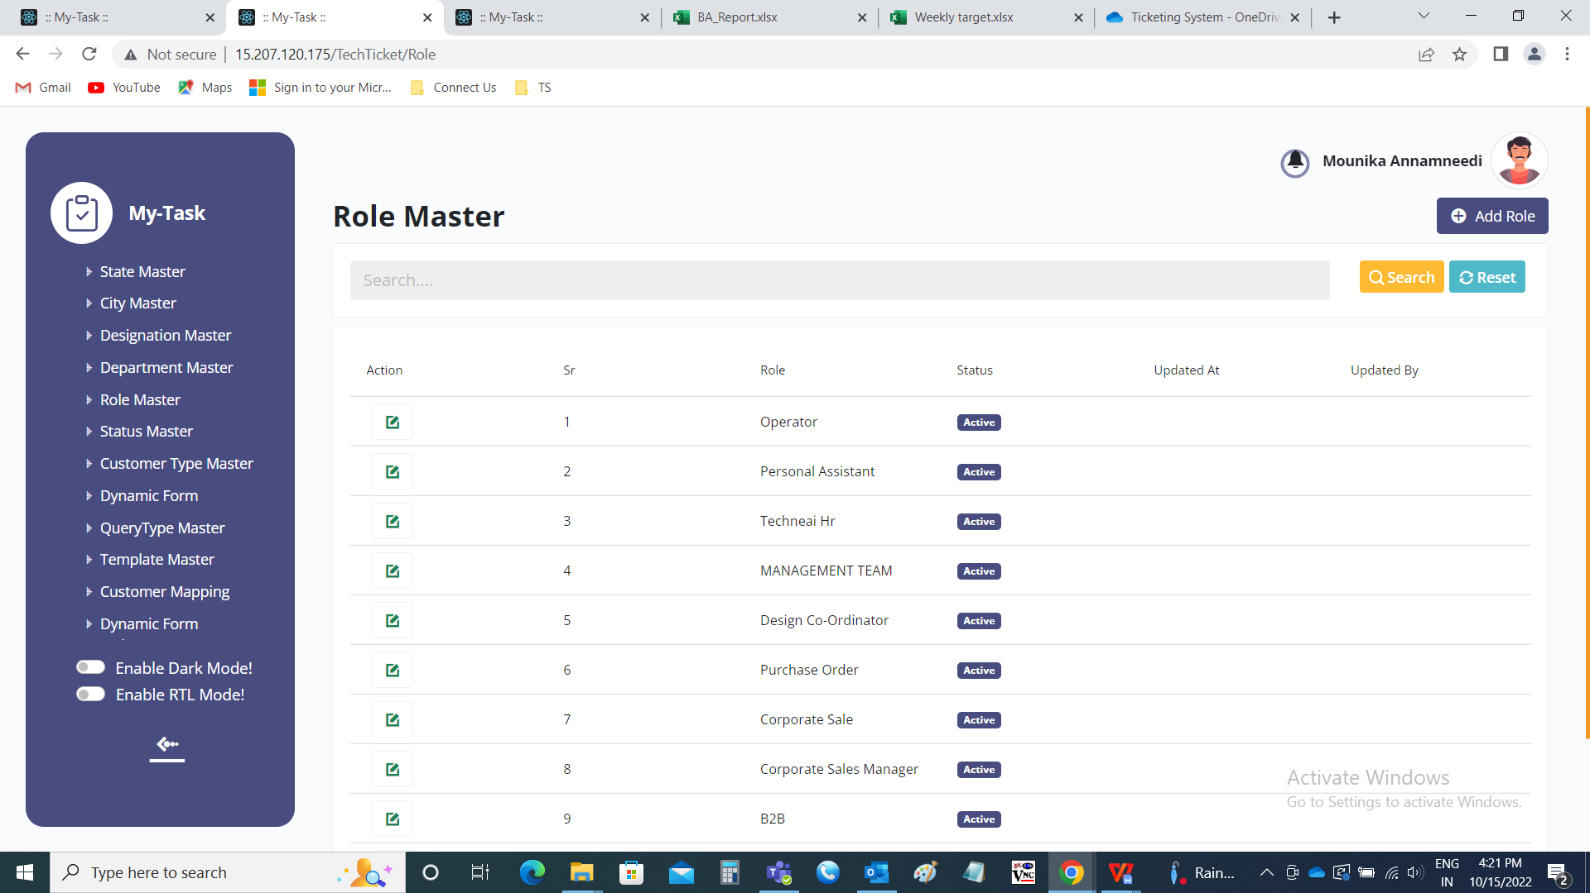

Add data:

The add page consists of the following fields.

* Role
* Remark
* Status
* Add
* Cancel

|  |  |  |  |
| --- | --- | --- | --- |
| **FIELDS** | **INPUT TYPE** | **MANDATORY/ OPTIONAL** | **DESCRIPTION** |
| Role | Text | Mandatory | The role name is entered. |
| Remark | Text | optional | The remark if any is mentioned |
| Select status | Radio button | Mandatory | The radio button consists of active and de-active. By default, active is selected.  Active is selected if the role is active or else deactive is selected. |
| Add | Button | Optional | To create the role |
| cancel | Button | Optional | To navigate to the role master page |

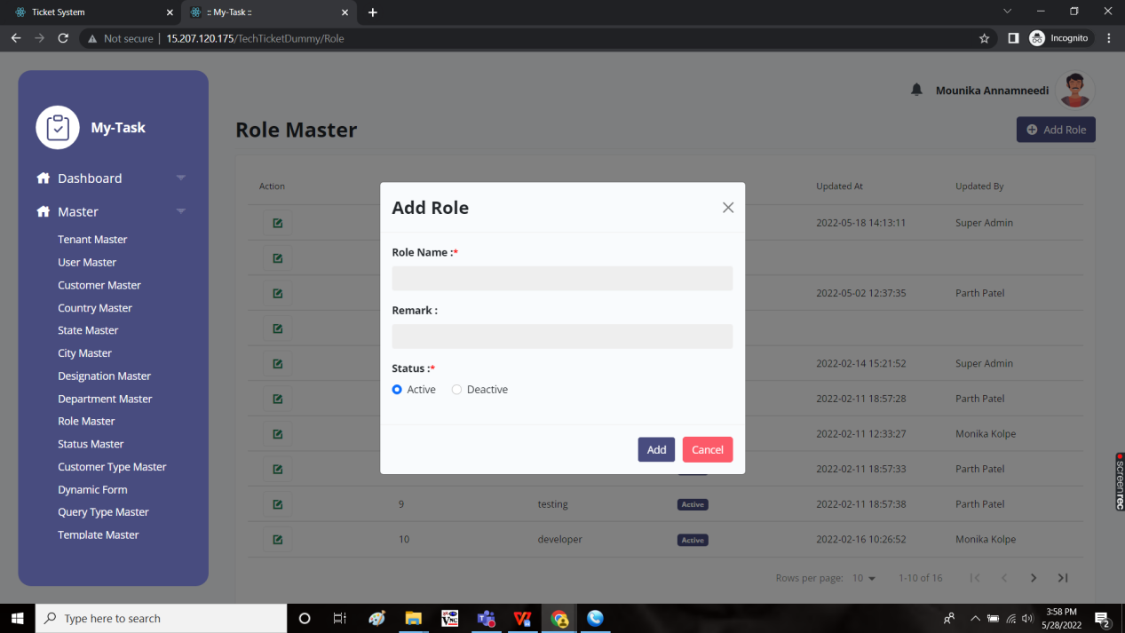

Edit page:

The edit page consists of the following and all fields can be edited if required.

* Role
* Remark
* Status
* Update
* cancel

